8/17/2026
Assessment 2
Project Management & Innovation

Module NaMe: Changemakers, Creativity and Value creation
Module Code: ACCA 5033
Student NAME: Ma. crystal pearl grajewski
Student ID: 2442405
Lecturer: dr. fahad ahmed

UNIVERSITY OF wales trinity saint david
london campus

Table of Contents
Introduction 2
Main Body 3
TASK 1 3
Project Management 3
1.1Project Management & Planning: 3
1.2 Project Design 8
Task 2: 15
2. Enterprise and Innovation 15
2.1 Enterprise 15
2.2 Evaluent Start-up 20
Task 3: 23
Reflection 23
References 26

Introduction
This assessment focuses on applying project management, enterprise planning, and personal reflection to a proposed technology project related to my programme of study. The project I selected for this report is Evaluent, a digital platform designed to support single mothers by providing opportunities to showcase their skills, promote small businesses, offer services, and connect with supportive communities. The assessment demonstrates how a project can be planned, designed, and managed from its initial concept through to implementation while considering business, technical, legal, and ethical factors.
To complete this assessment, I applied project management principles to define the project scope, identify the required technologies and resources, develop a project timeline, create a Gantt chart, and select an appropriate software development methodology. I also designed key project artefacts, including wireframes and system diagrams, to demonstrate how Evaluent would function in practice. In addition, I examined the enterprise aspects of the project by conducting PEST and SWOT analyses, identifying suitable business strategies, funding opportunities, and relevant legal and ethical considerations. Throughout the report, academic books, peer-reviewed journals, government publications, and industry guidance were used to support the discussion and justify the decisions made.
The overall purpose of this report is to demonstrate how theoretical knowledge gained throughout the module can be applied to the planning and management of a real-world technology project. By integrating project management techniques with enterprise planning and critical reflection, this report shows how Evaluent could be developed into a practical solution that creates both social and economic value for its intended users while developing my own understanding of managing digital innovation.

Main Body

TASK 1

Project Management
Effective project management is important for ensuring that project activities are properly planned, organised and controlled to achieve the intended project outcomes. Shahari highlights the importance of effective project management practices in supporting project success [1]
For the proposed Evaluent project, these principles will be applied to define the project scope, identify the required technologies and resources, establish a realistic schedule and manage potential constraints.

1.1Project Management & Planning:

Applying appropriate planning and management practices will help ensure that Evaluent remains achievable within the available time, resources and technical capabilities.
Project title: Evaluent
Problem: Many single mothers face financial hardship, limited employment opportunities, and balancing childcare with work.
Solution: Evaluent is a social media and marketplace platform where single mothers can showcase their skills, sell products, offer services, and build supportive communities.
Target users: Single mothers and women seeking flexible income opportunities.
Project Scope and Proposed Solution
Project scope defines the intended outcomes and functionality of a project in specific and measurable terms, making effective scope management an important factor in successful project delivery [2]
The project scope focuses on planning and designing the proposed Evaluent application as a social-media and digital marketplace concept for single mothers. The project aims to demonstrate how the proposed platform could address the identified problem of limited income opportunities by providing a space where users can showcase their skills, products and services while building supportive connections.
The project scope includes user registration and login, user profiles, a social-media feed, posts, likes and comments, marketplace functionality, product/service listings, search, messaging, notifications and community features. However, full payment processing, advanced artificial intelligence, international delivery systems and large-scale commercial deployment are outside the initial project scope.
Defining these boundaries is important because uncontrolled additions to a project can increase its complexity, time and resource requirements. The scope will therefore be reviewed throughout development to maintain focus on the main project objectives
Technologies and Resources
The proposed development of Evaluent would require several technical and human resources. Miro or Canva will be used for the current high-fidelity prototype and interface design, while Microsoft Excel can be used for project scheduling and the Gantt chart. Draw.io also used for drawing chart. For future development, technologies such as Flutter could be considered for mobile application development, with Firebase or another suitable database and cloud platform supporting authentication, storage and data management.
If Evaluent were developed as a real application, Flutter and Firebase could be considered as suitable technologies for implementation. Alfahri and Widarma demonstrated the use of Flutter and Firebase in developing a functional mobile application, showing that these technologies can be combined to support mobile application development. For Evaluent, Flutter could be used to develop the application interface, while Firebase could provide backend services for functions such as user authentication and data storage. Then connect it specifically to the proposed features: For example, Firebase could support user registration and login, while cloud-based storage could be considered for storing profile images, posts and product or service images. These technologies would therefore provide a possible technical foundation for the proposed Evaluent system [3]
Development could be undertaken using Visual Studio Code, while GitHub could be used for version control. Google Forms can also support user research and feedback. These resources would allow the project to progress from requirements gathering and interface design towards future implementation.

Project Timeline and Schedule

A clear project timeline is important because it establishes the time available for each activity and helps the project remain under control. Malotaux explains that project activities should be estimated against an available deadline so that potential timing problems can be identified before they affect the project [4]
For the proposed Evaluent project, a 12-week timeline is therefore used to organise the major activities from requirements analysis and interface design through development, testing, improvement and final documentation.
The project will be organised into stages beginning with research and requirements analysis, followed by project planning, interface design, database/system planning, development, testing, user feedback and final improvements.
Evaluent Project Timeline – 12 Weeks
Project Stage | Timeline
1. Research and Requirements Analysis | Weeks 1–2
2. Project Planning | Week 1
3. Wireframes and UI Design (Canva) | Weeks 3–4
4. Database Design (Firebase/Firestore) | Weeks 3–4
5. Development Environment Setup & Learning | Weeks 1–3
6. User Registration/Login | Weeks 4–5
7. User Profiles | Weeks 5–6
8. Post Creation Feature | Weeks 6–7
9. Comments and Likes | Week 7
10. Image Uploads/Storage | Weeks 7–8
11. Testing and Bug Fixing | Weeks 9–10
12. Final Improvements | Weeks 10–11
13. Documentation and Deployment | Weeks 11–12
The proposed 12-week schedule is presented in Figure 1, with the full Gantt chart included in the appendix. The schedule allows different activities to overlap where appropriate, such as learning development technologies while completing interface design. Regular monitoring of progress will help identify delays and allow activities to be adjusted when necessary.

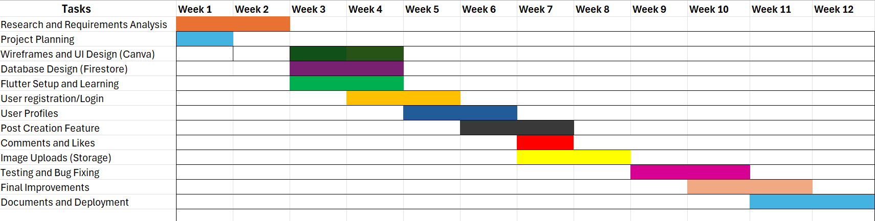
Figure 1 Gantt Chart

A Gantt chart is a project management tool used to visually represent project activities against a planned timeframe. It supports project planning, scheduling and monitoring by showing the duration of tasks, their dependencies and the allocation of resources. The use of Gantt charts can also improve project coordination and communication by providing a clear overview of the project's progress and planned activities [5]

Project Constraints
Several constraints may affect the project. The main constraints are time, budget, technical skills, access to suitable users for testing, data protection and project scope. Developing a complete social-media platform would require considerable technical resources, financial investment and ongoing maintenance. As this is an academic project, the practical implementation will therefore be limited to a prototype and proposed future development. Data protection is also an important consideration because a real Evaluent platform would process personal information and user-generated content.

Development Method

Agile is suitable because Evaluent is user-centred and may require changes after receiving user feedback. Rather than attempting to complete the whole application at once, development can be divided into smaller stages or iterations. For example, an initial sprint could focus on registration and profiles, followed by the social feed, marketplace, messaging and community features. Testing and user feedback can then be used to identify improvements before further development. This iterative approach supports flexibility and allows the project to respond to changing requirements while maintaining its overall objectives.
Agile methods provide organisations and development teams with flexibility to select and adapt software development principles and practices according to their specific needs, objectives, values, culture and the type of system being developed. It does not simply mean following a fixed set of practices, as the suitability of an Agile method depends on how well it supports the organisation's objectives and development requirements. It proposes that Agile methods should be assessed according to their adequacy, capability and effectiveness, considering whether the method is sufficient to achieve the intended objectives, whether the organisation has the necessary environment and ability to implement it, and whether the method can achieve the desired results. The reference therefore emphasises that Agile practices should be appropriately selected and adapted rather than applied in a rigid or standardised way. This provides a systematic approach to understanding the suitability and effectiveness of Agile software development methods and highlights the importance of matching the chosen approach to the specific characteristics and requirements of a project [6]
For Evaluent, this approach would allow the proposed application to be developed incrementally, with features such as user registration, profiles, posts, comments and image uploads being developed and tested in stages. Feedback from testing could then be used to identify improvements before moving towards the final version.

1.2 Project Design

- User Journey Flow Chart
- Storyboard
Flow Chart
The user journey flow chart illustrates the main user and system processes within Evaluent, beginning with registration or login and continuing to the user's profile and home feed. From the main interface, users can create posts, showcase products or services, search for other users and communicate with potential customers. The flow chart helps identify the sequence of activities and provides a clear overview of how the proposed system will operate. It can also help identify missing steps or unnecessary processes before development begins.
Storyboard
The second design artefact is a storyboard showing how a potential user could interact with Evaluent in a realistic situation. The storyboard follows a single mother who has baking skills but needs a flexible way to promote her services. She discovers Evaluent, creates a profile, uploads photographs of her cakes, lists her service, receives a message from a potential customer and gains an opportunity to make a sale. The final stage shows the user continuing to build connections and develop her small business through the platform.
The storyboard demonstrates how several Evaluent features work together rather than presenting them as separate functions. It connects the identified problem to the proposed solution and illustrates the intended user journey from showcasing a skill to creating an income opportunity. The storyboard and requirements specification therefore provide complementary design evidence: the requirements explain what the system needs to do, while the storyboard demonstrates how the proposed system could be used in practice.
.

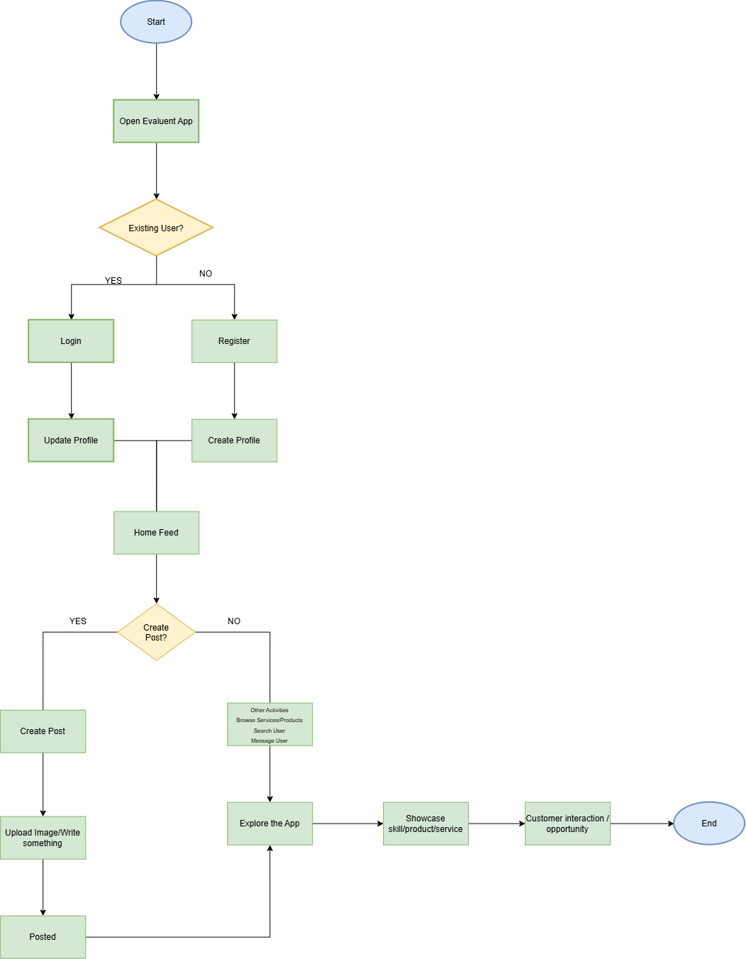
User Journey (Flow Chart)
Presenting the flowchart for the proposed Evaluent platform. The process begins when a user opens the application and either registers as a new user or logs into an existing account. After creating a profile, the user can access the home feed where they can create posts, upload products or services to the marketplace, browse listings, communicate through messaging, and participate in community groups. The flowchart demonstrates the main user journey and key functionality within the platform.

https://miro.com/app/live-embed/uXjVHy_TW3Q=/?embedMode=view_only_without_ui&moveToViewport=10696%2C-3343%2C5088%2C2352&embedId=268719889356
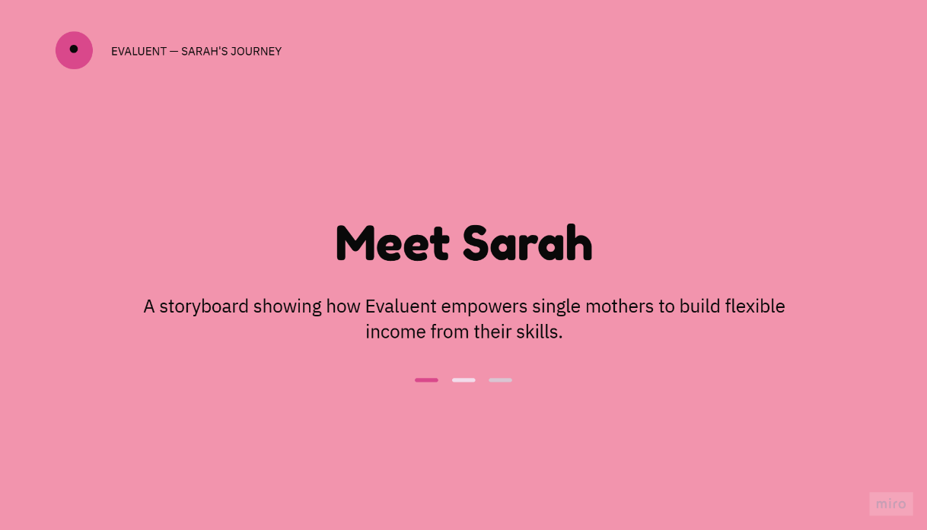
Storyboard

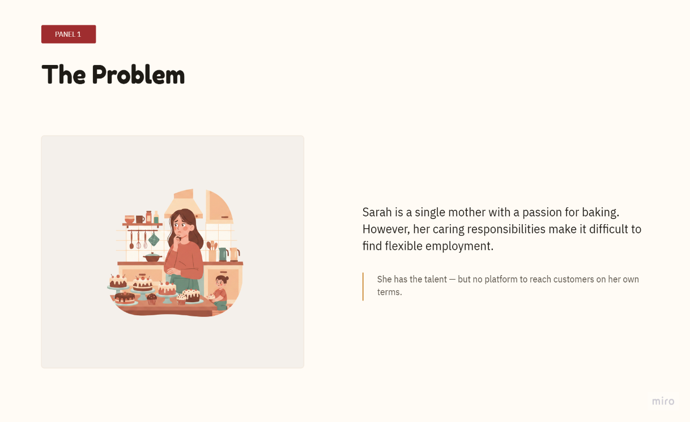

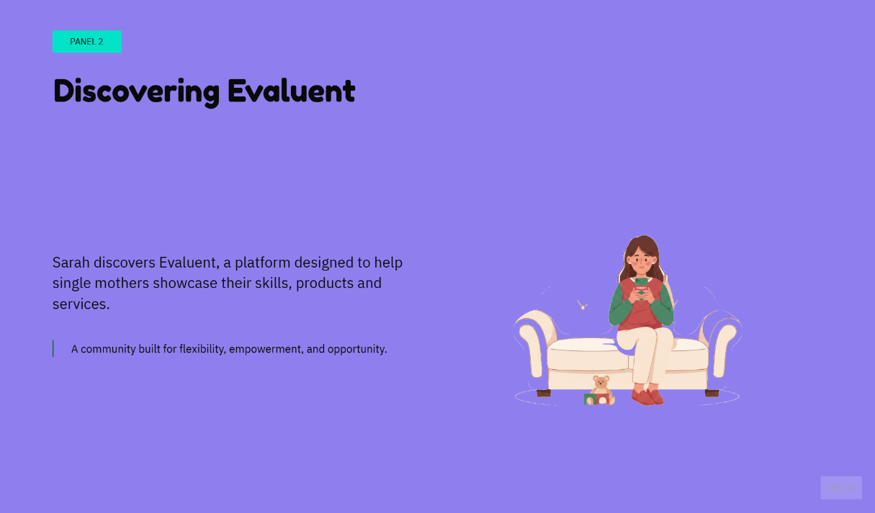

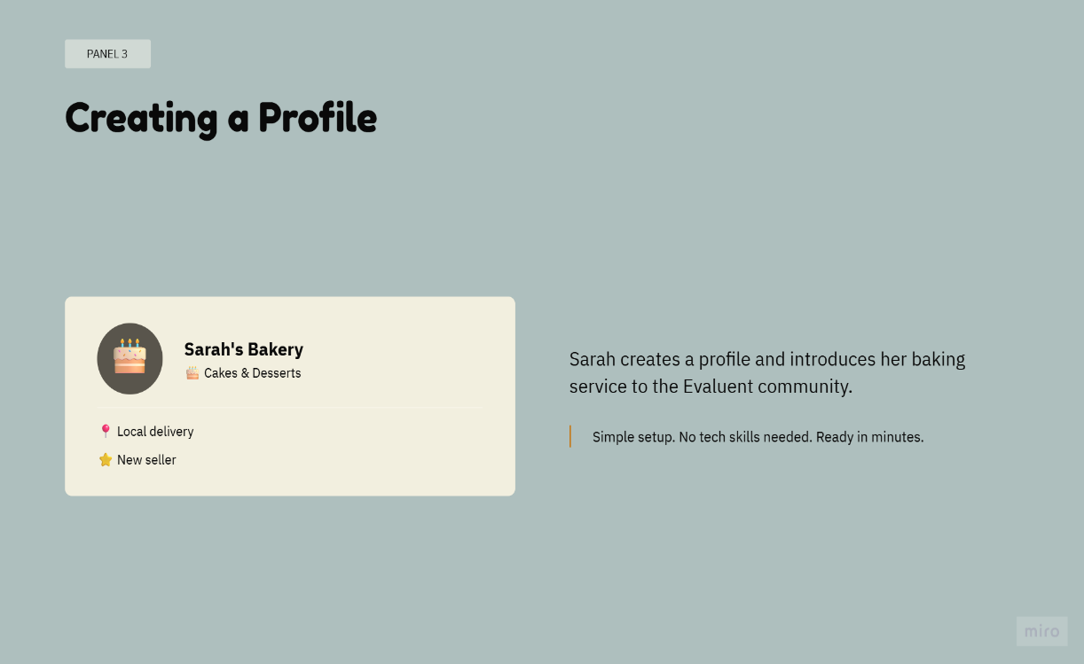



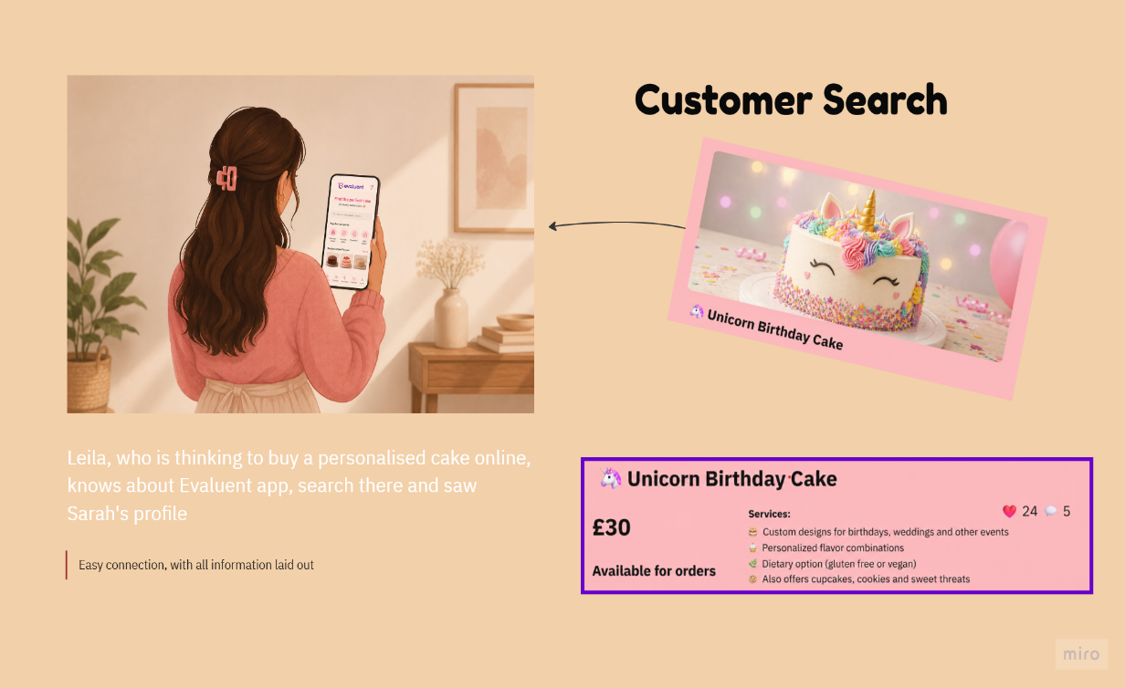

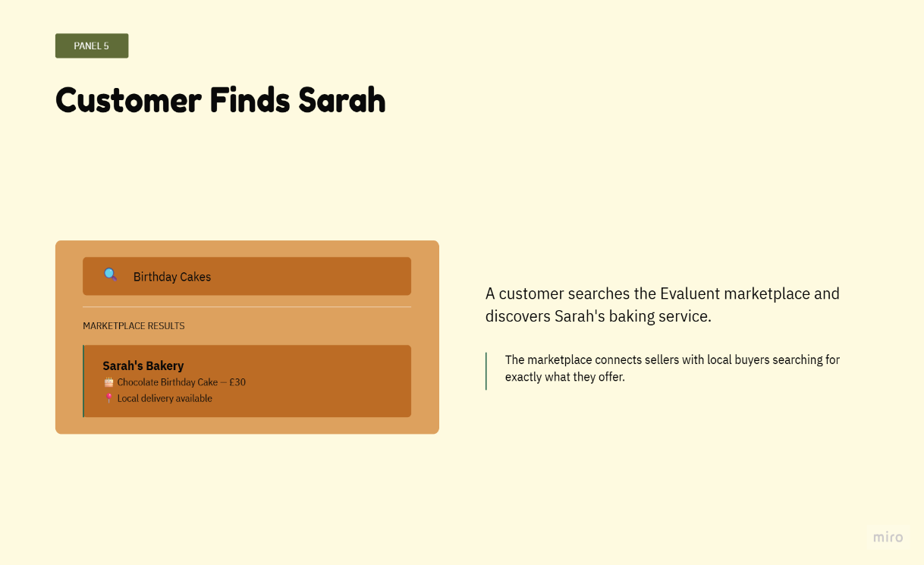

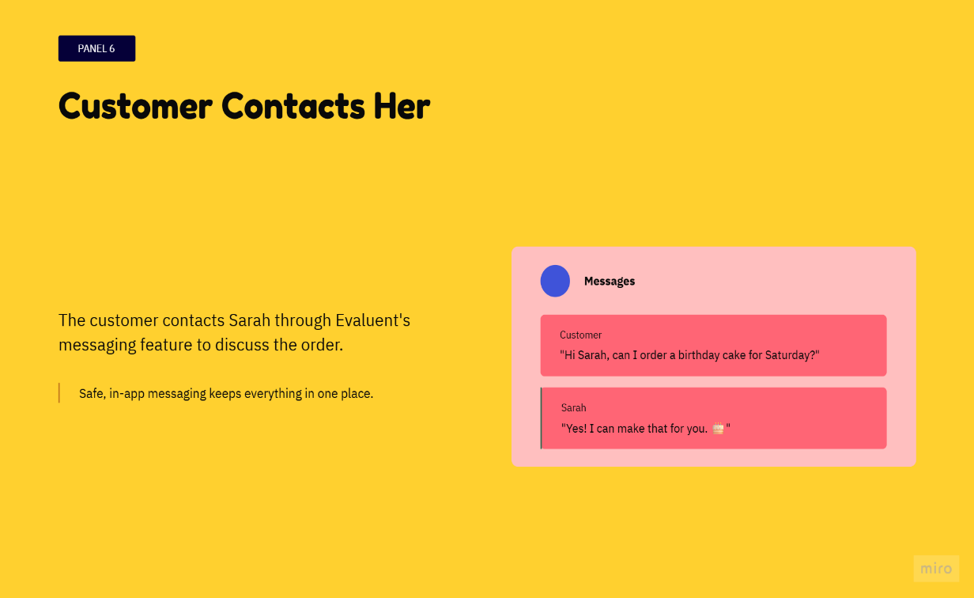

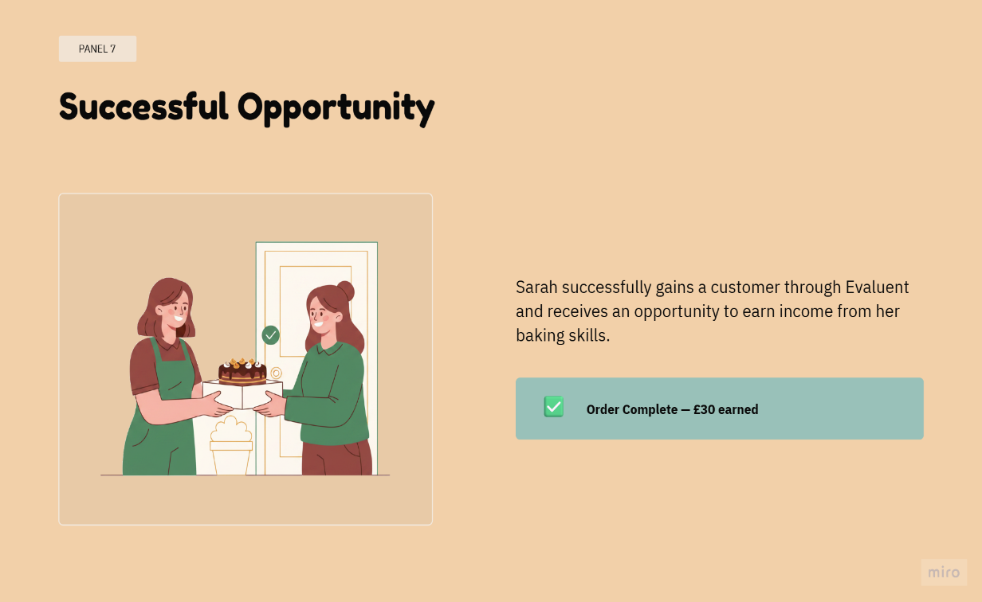

Task 2:

2. Enterprise and Innovation

2.1 Enterprise

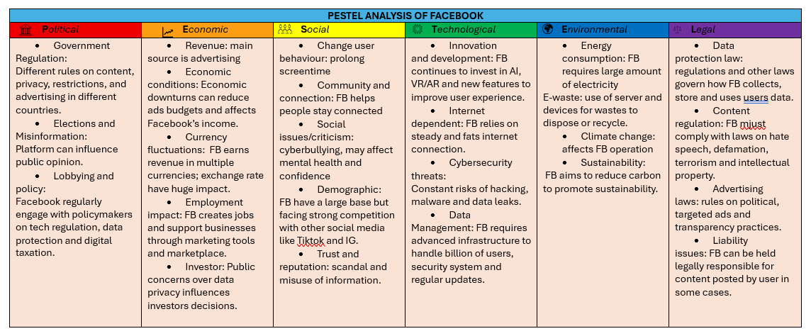
PEST Analysis
Figure 2

Political: Facebook is affected by political issues because its large global user base makes it an influential platform for political communication and public opinion. The spread of misinformation and fake news can influence political discussions and elections. In some countries, access to Facebook has also been restricted because governments are concerned about political organisation, misinformation and the influence of social media [7]
Economic: Facebook operates as both a social media platform and a business platform, allowing organisations and individuals to advertise, promote products and reach customers. Its financial performance can be affected by factors such as international currency changes, operating costs, investment confidence and concerns surrounding data breaches. At the same time, the platform can contribute to economic activity by supporting businesses, advertising and employment opportunities [7].
Social: Social trends strongly influence Facebook because its original purpose was to connect friends and families, but its role has expanded to include advertising, business promotion and Marketplace activities. This change can provide users with additional opportunities, but excessive advertising, algorithm-driven content and concerns about data privacy may affect users' trust and perceptions of the platform [7].
Technological: Facebook depends heavily on internet technology and continuously develops its digital services, including messaging and integration with other platforms. However, technological development also creates challenges related to cybersecurity, hacking attempts, data leaks and the protection of user information. The analysis therefore highlights the importance of maintaining strong security while continuing to develop digital services [7].
Environmental: Facebook's environmental impact is mainly associated with the energy consumption and emissions of its data centres. The analysis notes that data centres require significant energy and discusses the use of different energy sources. Increasing the use of renewable energy and reducing carbon emissions can help reduce the environmental impact of large-scale digital services [7]
Legal: Data protection and privacy regulations are important legal factors for Facebook. Data breaches and the handling of users' personal information can create legal and reputational risks. The introduction of the EU General Data Protection Regulation (GDPR) has increased requirements for organisations that process personal data, meaning that Facebook must comply with data protection requirements and could face penalties for non-compliance [7]

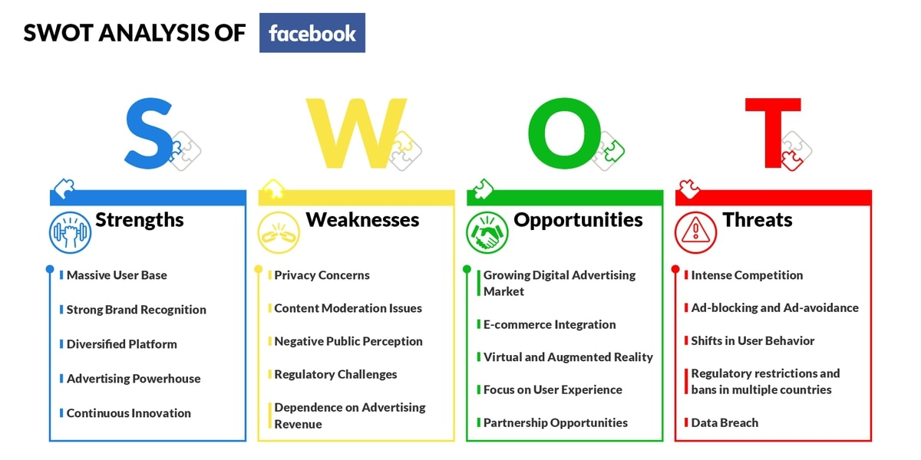
SWOT Analysis Facebook

Figure 3 [8].
Facebook’s SWOT analysis highlights its position as one of the world’s largest social media platforms. Its strengths include a massive global user base, strong brand recognition, a wide range of features, and a well-established advertising model. However, Facebook also has weaknesses, particularly concerns about user privacy and data protection, difficulties with content moderation, negative public perception, regulatory pressures, and its reliance on advertising revenue. There are several opportunities for Facebook, including the growing digital advertising market, e-commerce integration, virtual and augmented reality, improving user experience, and developing strategic partnerships. At the same time, Facebook faces threats from strong competition, the increasing use of ad-blocking tools, changes in user behaviour, government restrictions in some countries, and the risk of data breaches. Overall, the SWOT analysis shows that Facebook has significant opportunities for continued growth, but it must address these weaknesses and threats to maintain user trust and its competitive position [8].

Legal Considerations
Data protection and privacy
Facebook processes significant amounts of personal information. Under UK data-protection law, organisations processing personal information need an appropriate lawful basis and must meet their obligations as controllers or processors.
For Evaluent:
- Privacy policy
- User consent where appropriate
- Secure storage
- Data minimisation
- User rights
- Appropriate retention periods
Online safety
Because Evaluent would be a user-to-user platform, it would need to consider online safety obligations, including risks associated with illegal or harmful user-generated content. Ofcom's guidance explains that regulated services need to assess and manage relevant safety risks.
Intellectual property
Users could upload:
- photographs
- videos
- logos
- artwork
- music
- product descriptions
Evaluent would need rules concerning copyright and ownership of user-generated content.
Consumer protection
If Evaluent eventually facilitates commercial transactions, it would need appropriate rules and processes around sellers, advertising, transactions and consumer rights.

Ethical Considerations
Privacy: Users should understand what personal information is collected and why.
Transparency: Users should understand how recommendations, advertising or algorithms influence what they see.
Fairness: The platform should avoid unfairly disadvantaging users or businesses through its algorithms.
Accessibility and inclusion: platform should be designed so that people with different levels of digital ability can use it effectively.
Öhman and Aggarwal examine the ethical and legal issues associated with Facebook as a data-rich social media platform. The authors focus particularly on user data, privacy and data protection, considering what could happen to users’ personal information if Facebook were to close or fail. They argue that existing legal and governance frameworks may not provide sufficient protection for users in such circumstances. The study highlights the importance of responsible data management and stronger legal and ethical frameworks to protect individuals and society from potential harm [9].
Facebook provides a useful example for Evaluent because it demonstrates how social networking and marketplace functions can operate within the same platform. Facebook marketplace originally developed from users buying and selling through Facebook groups, demonstrating the potential value of combining community interaction with commerce. Evaluent adopts a similar concept but narrows the target audience to single mothers and focuses specifically on showcasing skills, services and small businesses. However, Evaluent would also need to learn from the legal and ethical challenges faced by large social-media platforms, particularly regarding privacy, online safety, scams, user-generated content and data protection.
Q2. Related to your project idea document a potential Tech Start-up name, Logo, Business type (Legal classification), a Business Strategy and initiatives that could fund your potential start-up.

2.2 Evaluent Start-up
Start-up Name: Evaluent
Meaning:
The name “Evaluent” is formed from the concepts of Earn, Value and Talent, which are reflected in the letters of the name. Conceptually, these ideas represent empowerment, connect and growth, reflecting the platform’s core values of empowerment, personal development and value creation. The name represents the platform’s aim to help single mothers develop income-generating opportunities by showcasing their talents, skills and services while building supportive connections within a community.
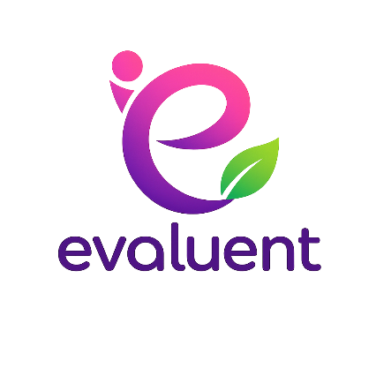
Logo
The Evaluent logo uses interconnected shapes representing community, support and growth. The colour palette uses purple and blue tones to represent trust, empowerment and creativity.

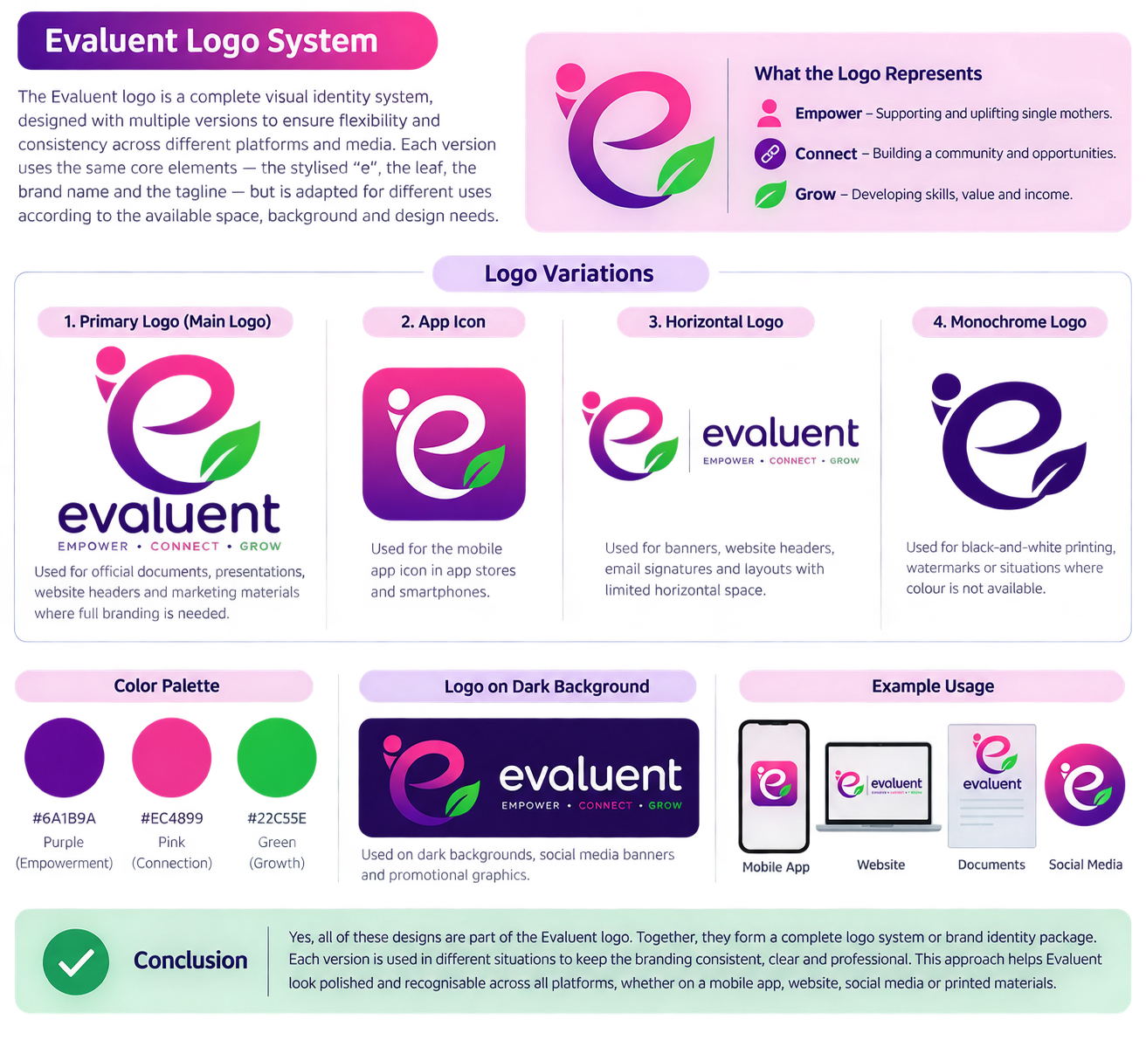
Used Chatgpt for the ideas of creating logos [10]
Prompt: “Give me ideas of logos appropriate for my app, consist of image and words”
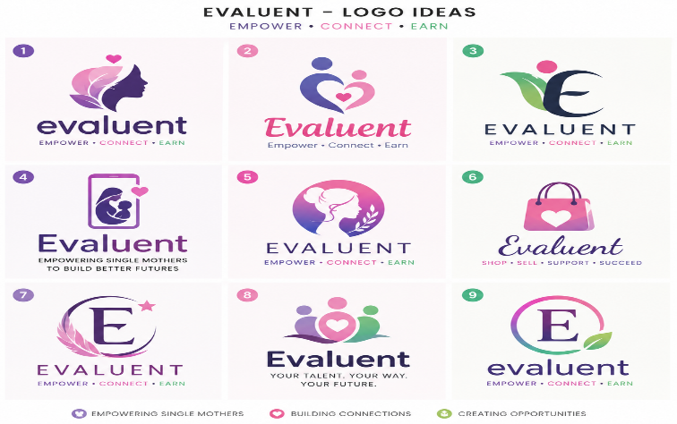

Prompt: “Choose no. 1 but can you make it a bit to see there is woman/women there”
Prompt: “Ok can you make the no.1 way more like ‘letter e’ and the leaf will be green, retain the pink and purple but the leaf will be green”
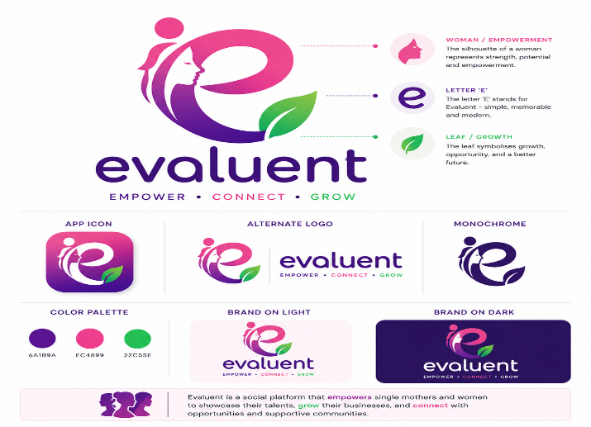

Propmt: “delete woman,but put person silhouette at the back, generate the no.1 way more like ‘letter e’ and the leaf will be green, retain the pink and purple but the leaf will be green”
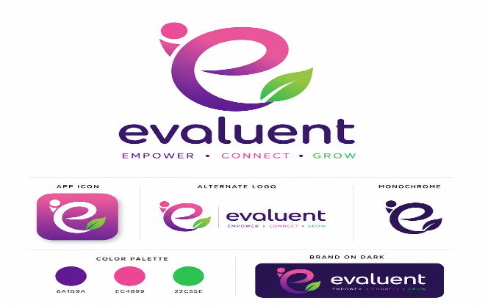

Business Type
I would use Private Limited Company (Ltd)
Reason: Evaluent would operate as a Private Limited Company because it offers limited liability protection for business owners while providing a professional structure suitable for future growth and investment.

Business Strategy
Mission
To empower single mothers through community support, networking and digital income opportunities.
Vision
To become the leading online platform connecting single mothers with customers, opportunities and supportive communities.
Objectives
- Build an active user community.
- Increase marketplace participation.
- Improve financial opportunities for users.
- Create a safe and supportive environment.
Funding Options
Government Start-Up Loans
The UK Start Up Loans programme
(One potential source of finance for the business is the UK Government-backed Start Up Loan. The scheme provides loans of between £500 and £25,000 to help individuals start or grow a business. Applicants are required to pass a credit check and provide supporting documents, including a business plan and cash-flow forecast. Successful applicants can also receive business guidance and mentoring, which could support the development and growth of the proposed business) [11]
Investors interested in social impact businesses: Search for potential investors online.
Crowdfunding
Discuss and offers friends or someone knows me, or someone I know who is interested on investing.
Grants
Women's enterprise grants and social enterprise funding programmes.

Task 3:

Reflection
To reflect on my experience of developing Evaluent, I will use Gibbs' Reflective Cycle (1988). The model provides a structured approach consisting of six stages: description, feelings, evaluation, analysis, conclusion and action plan. It will allow me to reflect on the decisions I made during the project, the challenges I experienced, the feedback I received and how these experiences contributed to my learning and development [12].
1. Description
For this project management assessment, I developed a proposal for Evaluent, a social media and digital marketplace platform designed to empower single mothers by providing opportunities to showcase skills, products and services while building supportive online communities. The project involved defining the project scope, identifying technologies, creating a development plan, producing design documentation and considering enterprise opportunities. Although Evaluent remains a proposed project rather than a fully developed application, the assessment allowed me to explore how technology can be used to address a real-world problem.
2. Feelings
At the beginning of the project, I felt enthusiastic because the idea was personally meaningful and focused on helping a specific group within society. I believed the concept had the potential to make a positive impact while also providing valuable learning opportunities. However, as the assessment progressed, I began to feel pressured by time constraints. As a student balancing multiple academic commitments, families and work, I found it challenging to complete the project planning, design work and supporting research within the available timeframe.
I also realised that if I wanted to develop Evaluent into a real application, I would need to learn several new technologies such as Flutter, Firebase and mobile application design. This initially felt overwhelming because developing a social media and marketplace platform is a complex task for a beginner. Despite these challenges, I remained motivated because I could see the value and purpose behind the project.
3. Evaluation
One positive aspect of the project was that it allowed me to apply project management concepts to a realistic technology solution. I gained experience in defining project requirements, creating project plans, designing system workflows and considering business factors that affect technology start-ups. The project also improved my understanding of how project management can help organise complex development tasks into smaller and more manageable activities.
Another positive outcome was recognising the social value of technology. Evaluent is not only intended to help users generate income but also to encourage networking, collaboration and community support.
The main negative aspect was the limited time available to complete the assessment. Due to academic deadlines, it was not possible to move beyond the planning and design stages. I also experienced difficulties estimating development timescales because I have limited experience with mobile application development technologies. As a result, some project planning assumptions were based on research rather than practical development experience.
4. Analysis
This project helped me understand that successful software development requires much more than programming skills. Project planning, time management, communication and risk management are equally important. One of the key lessons I learned is that large projects should be divided into smaller stages and milestones to make them more achievable.
The project also highlighted areas where I need to develop new skills. If Evaluent were implemented, I would need to improve my knowledge of Flutter, Firebase Authentication, Firestore databases, cloud storage and user interface design. The project therefore provides a clear learning pathway for future professional development.
From a social perspective, the project demonstrated how technology can be used to support individuals facing economic and personal challenges. By combining social networking features with a marketplace environment, Evaluent could provide opportunities for users to promote services, sell products and build supportive relationships. This could contribute positively to society by encouraging entrepreneurship, digital inclusion and community engagement.
Several risks were also identified. Competition from existing platforms such as Facebook Marketplace, Etsy and Fiverr may make it difficult to attract users. Security and privacy concerns are another challenge because users would share personal data and communicate online. These risks could be reduced through effective marketing strategies, strong security controls, user authentication and compliance with data protection regulations.
5. Conclusion
Overall, this assessment was a valuable learning experience. It improved my understanding of project management processes and helped me appreciate the amount of planning required before software development begins. While time pressures limited how far I could develop the concept, I gained useful knowledge in system analysis, project planning and business strategy. I have also identified several technical skills that I need to develop if I decide to take the project forward in the future.
6. Action Plan
If I were to continue developing Evaluent, my first priority would be to improve my technical knowledge of Flutter and Firebase through online tutorials and practical exercises. I would then create detailed wireframes, database designs and a minimum viable product (MVP) containing essential features such as registration, user profiles, posting and marketplace listings.
To improve my project management skills, I would create a more detailed project schedule using Agile methodologies and set weekly development goals. I would also seek feedback from potential users, particularly single mothers, to ensure the application meets genuine user needs. By following this approach, I would be better prepared to transform Evaluent from a project proposal into a functional platform capable of creating positive social impact.

References

[1] A. A. Shahari, "The Study of Project Management Practices to Enhance the Project Success," University of Malaya (Malaysia), Malaysia, 2022. [Online].
[2] M. M. Tuuli1a, E. Adaku, E. Z. Banye and A. S. Tettey, "Project Scope Management,"
[3] D. A. Alfahri and A. Widarma, "Implementation of Flutter and Firebase in Developing a Mobile News Portal Application," vol. 3, no. 1, pp.50–58, 2025,
[4] N. Malotaux and N. R. Malotaux-Consultancy, "TimeLine: Getting and Keeping Control over your Project", in SOFTWARE QUALITY CONFERENCE, pp. 77.
[5] K. Wadhwa, "The Role of Gantt Chart in the Project Management," 2024,
[6] S. Soundararajan, J. D. Arthur and O. Balci, "A Methodology for Assessing Agile Software Development Methods", in 2012 Agile Conference, pp. 51–54. doi: 10.1109/Agile.2012.24.
[7] PESTLEanalysis Team. "PESTLE/PESTEL analysis of Facebook: How politics and regulations affect the social media giant." https://pestleanalysis.com/. [Online]. Available: https://pestleanalysis.com/pestle-analysis-of-facebook/
[8] Daniel Pereira. "Facebook SWOT Analysis." https://businessmodelanalyst.com/.
[9] C. Öhman and N. Aggarwal, "What if Facebook goes down? Ethical and legal considerations for the demise of big tech," vol. 9, no. 3, pp.1–21, 2020,
[10] Gov.UK. "Apply for a Start Up Loan for Your Business." https://www.gov.uk/apply-start-up-loan.
[11] G. Gibbs and Great Britain. Further Education Unit.,Learning by doing : a guide to teaching and learning methods, London: FEU, 1988.

