Reflection on Study Skills

L4 – Study Skills for Electronics (ACDA4021)
HND/BEng Electronic Engineering/Embedded Electronics

Rhys Davies – 2407080
(2407080@students.uwtsd.ac.uk)

Contents

1. Introduction 2
2. Presentation skills 2
2.1. PowerPoint 2
2.2. Evaluation 5
3. Skill sets 6
3.1. Skills required for successful learning in a Higher Education environment 6
3.2. Generic, transferrable skills employers look for in prospective job candidates 7
4. Self evaluation and action planning 8
4.1. Strengths, weaknesses and personality types 8
4.2. Career Suggestions 12
4.3. Goals 13
5. Application 15
5.1. Looking after your data 15
5.2. Time management and self-organisation 16
6. Conclusion & Evaluation 19
7. References 20
8. Appendices 21

Introduction
For the assignment we were tasked with producing a report on reflection and evidence on the application of skills covered during the course. We are required to demonstrate and provide evidence of research activities, knowledge gained and exercises undertaken.
This module is set to provide new students with strategies that can accelerate learning and help with technical report writing. Skills and techniques include:
- Report writing.
- Data gathering and research.
- Referencing and plagiarism awareness.
- Presentation techniques.

Presentation skills

My name is Rhys Davies aged 34. Born in a town called Milford Haven and reside there now. Hobbies include playing football, playing video games, cycling and cooking. Currently work at a LNG storage facility as an Electrical Maintenance Technician. Strengths include problem solving, learning new skills or techniques and working under pressure. Weaknesses consist of speaking about myself, time management and concentration.

PowerPoint
A task was set to produce a five-minute powerpoint slideshow to briefly introduce and describe yourself to the academic group. The presentation must include:
- Name.
- Where do you live.
- Hobbies and interests.
- Likes and dislikes.
- Describe your personality.
- Strengths and weaknesses.
- What would you like to get out of the course.
- Where do you see yourself in 5-10 years.
Below are some screengrabs from the presentation.

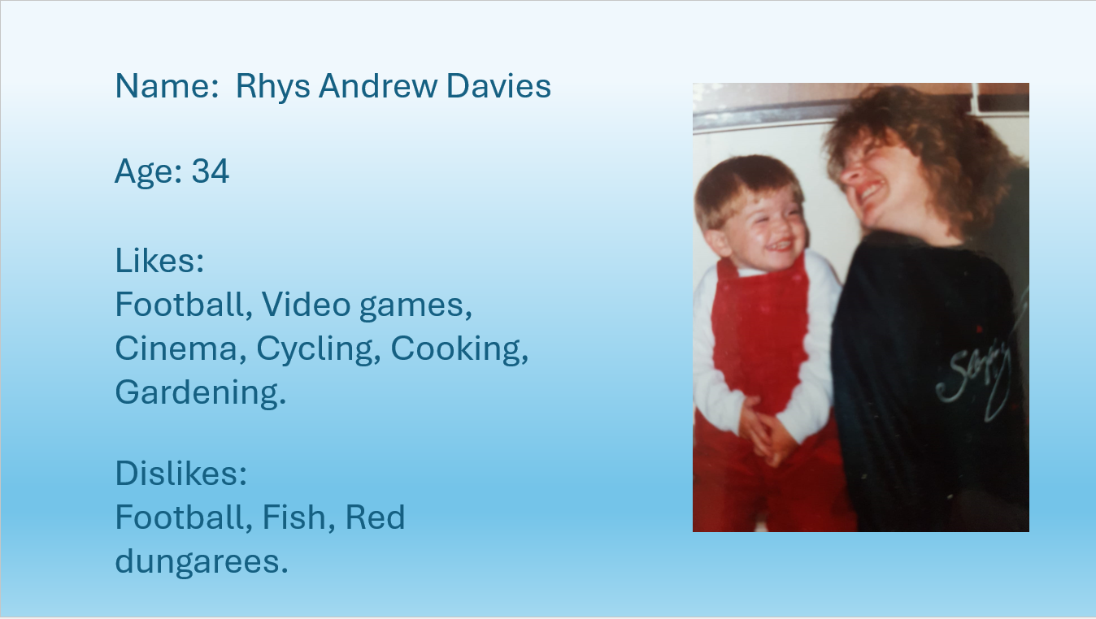
Figure 1: A slide taken from the powerpoint slideshow.

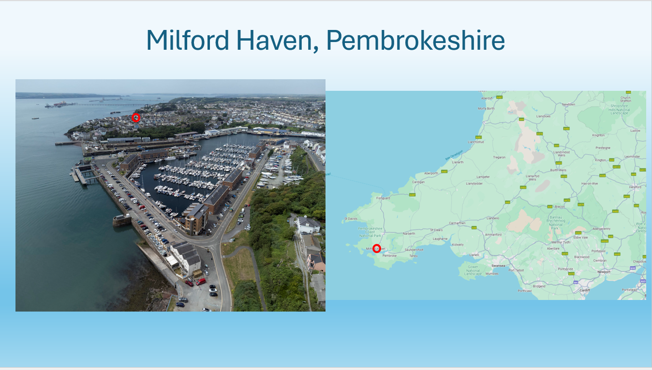
Figure 2: A slide taken from the powerpoint slideshow. Used visual representation, able to speak about comfortably without reading off the screen.

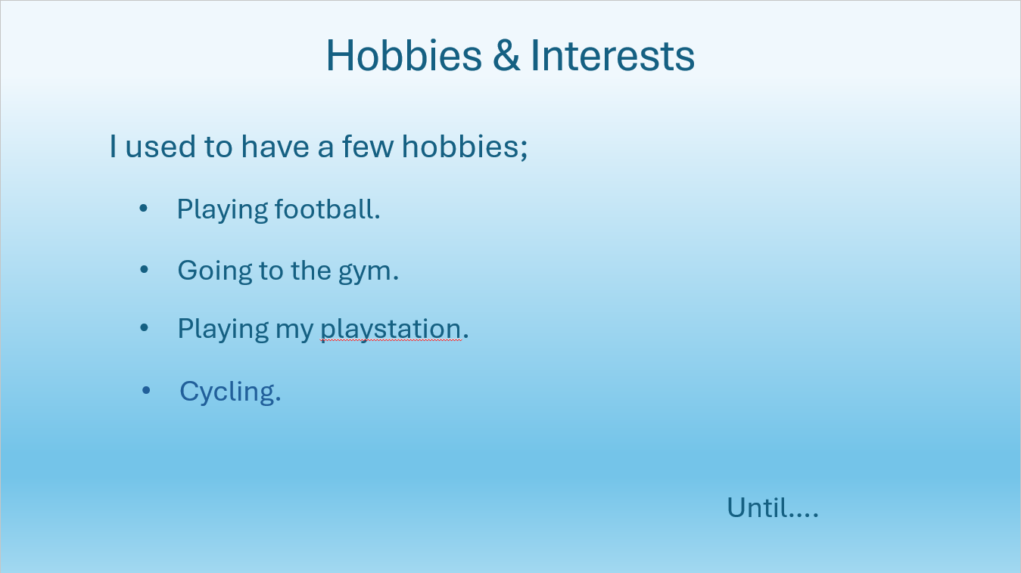
Figure 3: A slide taken from the powerpoint slideshow. Hobbies and interests.

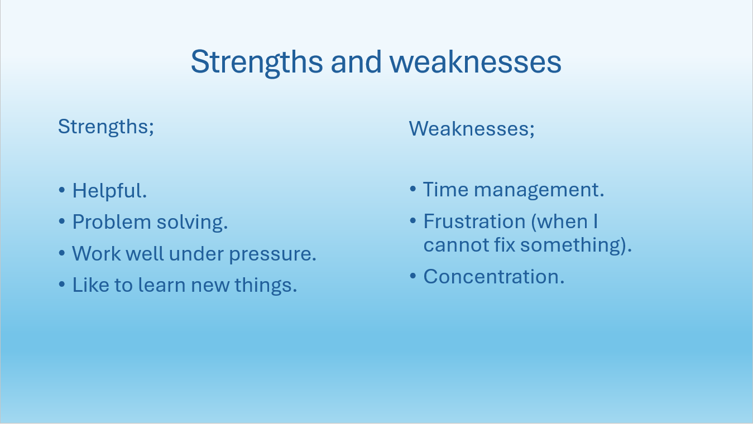
Figure 4: A slide taken from the powerpoint slideshow. Strengths and weaknesses.

Evaluation
‘Me’ by Me was the title of the presentation, this helped the break the ice and get rid of any nerves that first presented themselves. Having previous experience in presenting, a few things that were kept in mind when presenting:
- Keep it simple.
- Do not overcrowd the screen with information (prevents from reading off the screen).
- Use media available to you (photos, pictures, videos).
- Engage with the audience.
The feedback received after the presentation was mostly positive:
- Use of images was good.
- Fairly confident.
- Excellent timing (5 minutes, 5 seconds).
The use of additional images or illustrations on some of the pages that just included text could have improved the PowerPoint. This aspect could improve or enhance any future presentations.

Skill sets
Skills are a necessary part of life. Skills are learned in everyday life, education, and work practises. Overtime these skills can be developed and become tools that can lead to a successful career. This section will look at skills required to be successful in Higher Education and what skills employers and recruiters look for in prospective job candidates.

Skills required for successful learning in a Higher Education environment
Whether you are in school, college, university, or professional training, having relevant skills for studying makes you education experience easier and more enjoyable. [1]
As quoted:
Students will have more confidence, motivation, engagement and achieve goals. Therefore, using a skill-based approach can help students grasp concepts faster and strengthen what they already know. [2]
Skills that are found to be favourable to acquire or develop whilst in education:
- Communication: Express ideas verbally and in writing, be able to listen to others and understand instructions and information.
- Critical thinking: Ability to identify issues and understand concepts in an in-depth manner.
- Time management: Use of time to effectively meet deadlines and schedules. Management of workload.
- Problem solving: Skills to help you overcome challenges and find solutions.
- Teamwork: Ability to work within in a team will help develop relationships and collaborate within group projects.
- Organisation: Being well organised will help to become more productive and easier to complete work on time.
- Technology: The ability to navigate through software and technologies that enable us to complete tasks in a digital world.

Generic, transferrable skills employers look for in prospective job candidates
Transferrable skills are the skills that you use every day, in every job in every walks of life. Some of them are called hard skills which would be the technical skills that are job specific, others are called soft skills like communication and team working. Employers seek candidates with transferrable skills because those skills can be easily adapted to suit business needs. [3]
It is no shock that the soft skills listed in ‘Skills required for successful learning in a Higher Education environment’ are also found in the majority of employers’ job descriptions:
- Communication: A requirement for future employees to be able to communicate with coworkers within their team, as well as people outside of the team and the business.
- Critical Thinking and Problem Solving: Employers need employees who can solve problems, provide ideas and help improve the business.
- Technology: Pivotal set of skills that most employers will require.
- Teamwork: Employers will be looking at your individual contribution towards achieving common goals and creating working relationships.
Relevant work experience is also important to employers when finding a successful candidate, it can help show that applicants are serious about the role. [4]

Self evaluation and action planning
In this section we were asked to carry out self evaluation exercise to discover strengths and weaknesses, personality types and suitable career suggestions.

Strengths, weaknesses and personality types
I consider myself as being very comfortable with people, how to communicate with different types of people and how to approach certain difficult situations. I have found that I am very agreeable with others as to avoid awkward instances. I go out of my way to help others, even if that hinders my own plans and often do not reach my own goals or targets.
These types of self-assessments never really interested me, I didn’t like the thought of being put in box and being told that’s who you are, so was somewhat sceptical of these results.
The first test that was taken is called the ‘Big Five Personality Test’. In academic psychology there is a theory that there are five fundamental personality traits. The results are below.
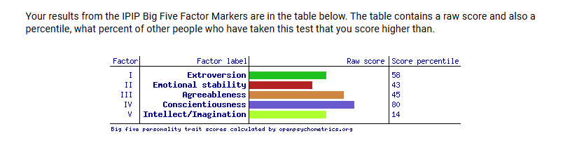
Figure 5: Screengrab from the Big Five personality test. Scores are represented in percentages.
Factor I – Extroversion
Extroversion is typically characterised by an individual’s tendency to seek out social interaction. Individuals who score high on this factor tend to be outgoing and sociable. Individuals who score low are more reserved and prefer to study the surroundings and understand how things work. Scoring centrally at 58% heading towards more extravert is an accurate representation of my personality, I do share some introvert tendencies and find myself observing rather than taking part in social situations.

Factor II – Emotional stability
Individuals who score high on emotional stability are described as being emotionally resilient, calm and able to cope with stressful circumstances. Individuals who score low tend to more prone to negative emotions such as anger, anxiety and depression. I would have to disagree with scoring lower at 43% in this factor and would consider myself to be in the higher percentile.
Factor III – Agreeableness
Individuals who score high on agreeableness are described as being warm, kind and considerate. They tend to be cooperative to maintain pleasant relationships. Those who score lower tend to be more competitive and sceptical, less interested in keeping social relationships pleasant. Scoring 45% in this factor is again accurate to my personality and share both tendencies on the higher and lower percentiles.
Factor IV – Conscientiousness
Individuals who score high conscientiousness are characterised as being reliable, hardworking and efficient. Those who score low have tendencies to be disorganised, impulsive and have difficulty setting or achieving goals. Scored very high at 80% in conscientiousness which I agree with, however I do have difficulty setting goals and find it awkward.
Factor V – Intellect/Imagination
Also known as openness to experience. High scorers in this field tend to be curious and open to new ideas and experiences. Individuals who score low have preferences to familiar and predictable experiences. Scoring very low at 14% in this field has made me think I need to be more open minded about new ideas and ways of completing tasks in a work based setting. [5]

Another test was then completed so that results could be compared and evaluated. This test is called the ‘Open Extended Jungian Type’. The personality types proposed by Carl Jung has become very popular and used in self help, business management and counselling. The results are below.
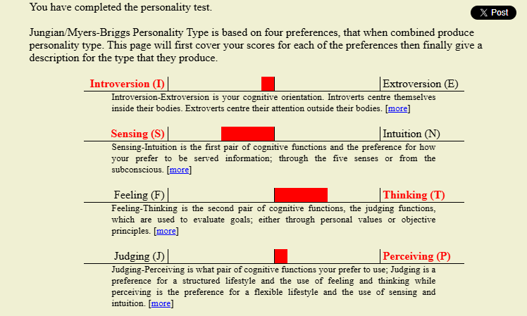
Figure 6: Visual representation of the results from the Open Extended Jungian Type test.

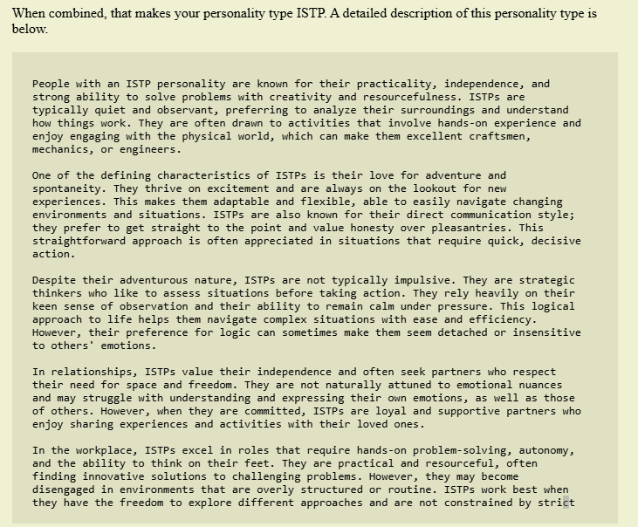
Figure 7: More in depth description of the personality traits after taking the Open Extended Jungian Type test.
The results show the personality type of ITSP.
Quoted;
ISTP (Virtuoso) is a personality type with the Introverted, Observant, Thinking, and Prospecting traits. They tend to have an individualistic mindset, pursuing goals without needing much external connection. They engage in life with inquisitiveness and personal skill, varying their approach as needed. [6]
The detailed description was very accurate to who I believe I am. The two different types of results received were accurate to the personality profile, however the Open Extended Jungian Type test results were found to be more personal and therefore more useful in evaluating my personality and using that to seek improvement.

Career Suggestions
Similar tests were taken, this time the results would display possible types of careers that would best suit your personality. The first test is called the 123 test, this consisted of different pictures that depicted a type of job or career that were selected by the participant. Results were then displayed in six main personality types. [7]
- Realistic: Practical, physical and tool orientated.
- Investigative: Intellectual, scientific and explorative.
- Artistic: Creative, independent and inventive.
- Social: Cooperative, helping and teaching.
- Enterprising: Leadership, competitive and persuasion.
- Conventional: Organising, clerical and detail.
The results are displayed below show that a job in the ‘realistic’ sector would be suited better, with investigative and social rating scoring high also.
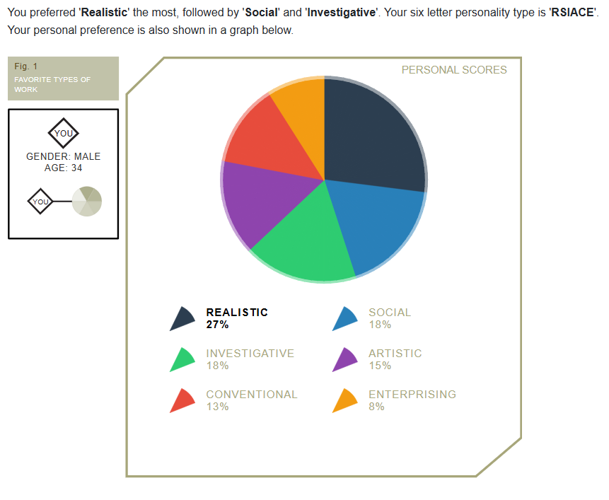
Figure 8: Screengrab of the career suggestion results.

Individuals who have taken the same test answered additional questions about their current job, preferences and interests, so that they can be compared to others with similar test outcomes. Below is a table that shows careers that individuals are in that scored similar in the test.
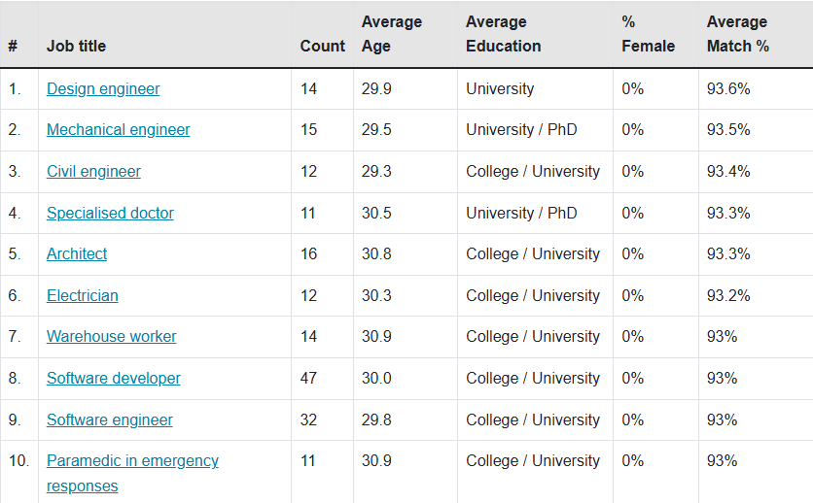
Figure 9: Screengrab of the combined results and personal information.
This is a good representation of the results and how accurate they can be in regard to preferred career paths based on personality traits.

Goals
In order to improve as person and a student, it is important that the information acquired by carrying out the personality tests. We can use the S.M.A.R.T guidelines to set targets and goals that can be measured and therefore achieved. S.M.A.R.T:
- Specific.
- Measurable.
- Achievable.
- Relevant.
- Time-bound.

The table below lists personal, academic and professional goals required to become more successful in those fields.
Goal | Specific | Measurable | Achievable | Relevant | Time-bound
Improve Fitness Level | I want to improve my cardiovascular fitness by running more regularly. | I will track my running distance and time using a fitness app. | I will start with 2 runs per week and gradually increase to 4 runs per week by the end of 3 months. | This goal supports my overall health and wellness plan. | I will reach a goal of running 5 kilometres within 30 minutes by the end of 3 months.
Improve Time Management and Organisation. | I want to improve my time management and organisational skills to become a better student. | I will track this by dedicating time outside of university and work to complete assignments on time. | I will set up a digital calendar, setting 2-4 hours a week additional to day release for studying.  Study time management and organisational methods. | This goal will help me manage my work more efficiently, reducing stress and increasing output. | I will consistently apply these methods in the first year and hope to become an improved student by the second year.
Advance in Career | I will complete an Electrical Engineering Degree. | I will track my progress by completing course modules and assignments. | I will dedicate 2-3 hours per week additional to my day release in University. | This certification is directly aligned with my career goal of moving into a Engineering position. | I will complete the Degree in 4 years.
Learn to play the guitar | I will learn to play basic chords and strumming patterns on the guitar. | Learn 5 basic chords in the first 2 weeks.  Master the up down strumming technique by week 3.  Play 3 simple songs using the chords learned by 1 month. | Dedicate 20 minutes of practise per day.  Follow online tutorials. | Learning the guitar will allow myself to play music for personal enjoyment.  Enhance creativity. | Week 1-2 learn 5 basic chords.  Week 3 master strumming patterns.  Week 4 play 3 simple songs.  Month 2 start learning more complex chords.
Table 1: Action plan showing four goals and methods on how to achieve them.

Application

Looking after your data
Creating a solid backup plan for your data is essential to prevent loss from hardware failure, accidental deletion, or other unexpected events. A back up plan was devised that is in line with the 3-2-1 rule. The 3-2-1 strategy requires:
- 3 copies of your data (1 primary and 2 backups).
- 2 different media types (external hard drives, cloud storage).
- 1 offsite backup (cloud storage or remote location).
Three copies of data have been made, one on a memory stick, one on a personal laptop and another within a workplace storage system. This adheres to three copies, one media type and one offsite backup. To ensure the back up strategy is at its strongest, another copy saved to cloud storage will be made. Cloud storage services include:
- Google Drive.
- Dropbox.
- OneDrive.
The type of data that would be of concern if it was lost or corrupt are the files created during study. Assignments, screengrabs, project drawings, table of results, if these were lost it would cause the biggest impact with regards assignment deadlines and the overall outcome of the qualification.
This type of strategy will only be successful if the data regularly updated and backed up. Laptops, desktops, memory sticks and external hard drives will all have a service life, how old the equipment is along with the condition will affect its reliability. Another way data will become corrupt or inaccessible is through a ransomware attack. Ransomware is a type of malicious software or virus that will prevent the victim from accessing their computer files, systems, or networks and will demand a ransom for their return. [8] The back up strategy described would protect the data and files from a ransomware attack, a cloud back up should be set up to solidify the protection.

Time management and self-organisation
One of the goals set in the action plan stated in section 4.3 was to improve time management and organisation. One of the actions to improve this was to set up a digital calendar. The screengrab below shows the early stages of what the calendar would look like. Only two items have been entered which are reoccurring events. The next steps are to set time for the other goals, improve fitness, learn the guitar and study time, along with family events so that the digital calendar can be used correctly and more effectively.

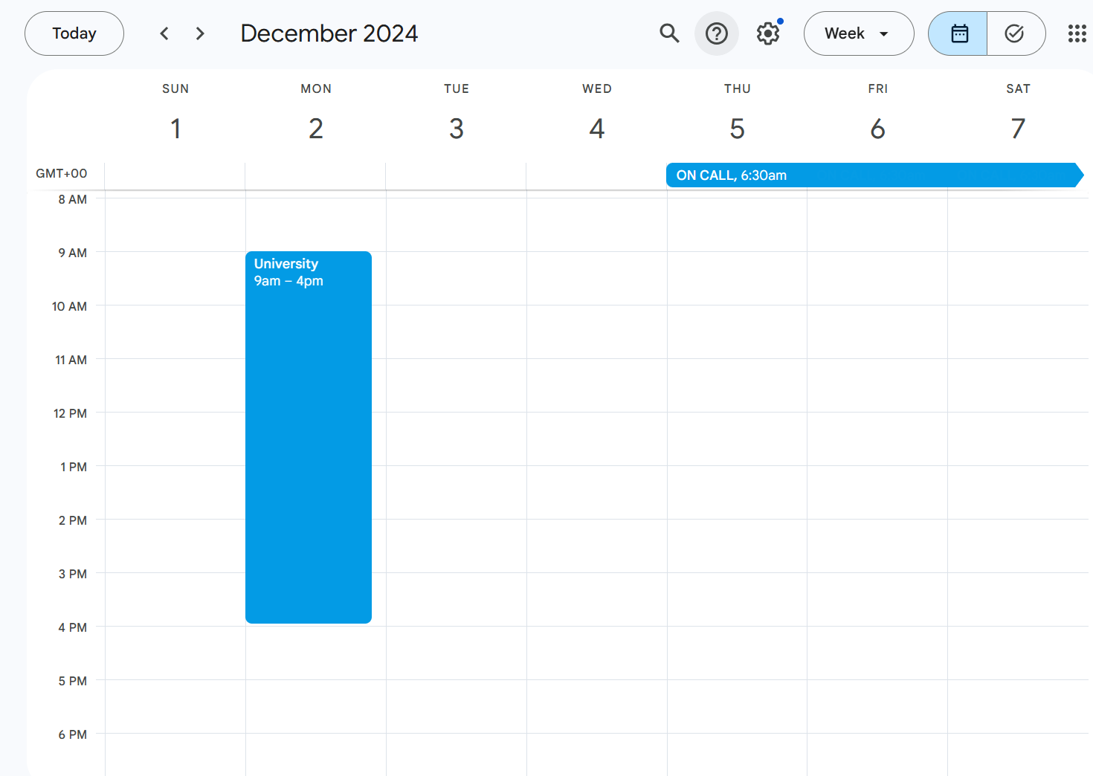
Figure 10: Screengrab of the early stage digital calendar.

The next step to was to improve overall organisation, again this was a goal set in section 4.3. This was pivotal in the back up strategy, so in order to adhere to both back up strategy and an organisational goal it was decided to create a e-Portfolio. Below is a screengrab of the e-Portfolio and what it looks like, it has been split up into three sections:
- DLNG (Employer/place of work): Where Annual performance reviews (APR’s), Personal development plans (PDP) and work based certification can be saved.
- Education: Where assignments, class notes, research for the higher education can be saved.
- Personal: Where certificates, CV’s, photographs, copies of personal information can be saved.
This is still a work in progress and more information and files will be added in the future and as studying continues.
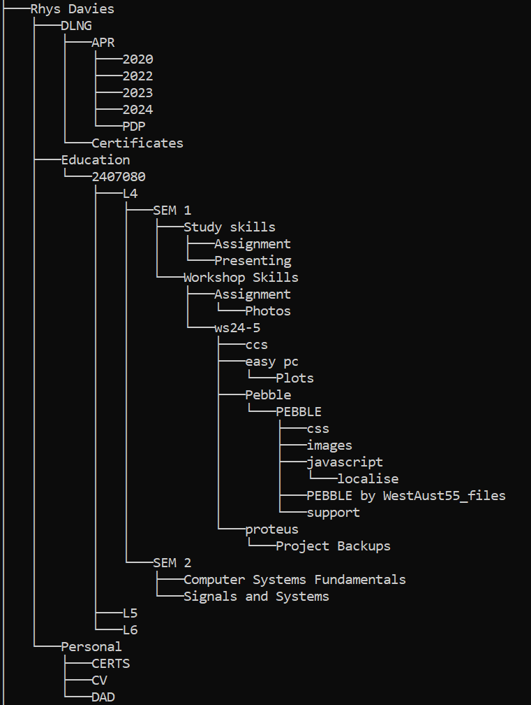
Figure 11: Screengrab of e-portfolio captured using a file tree command.

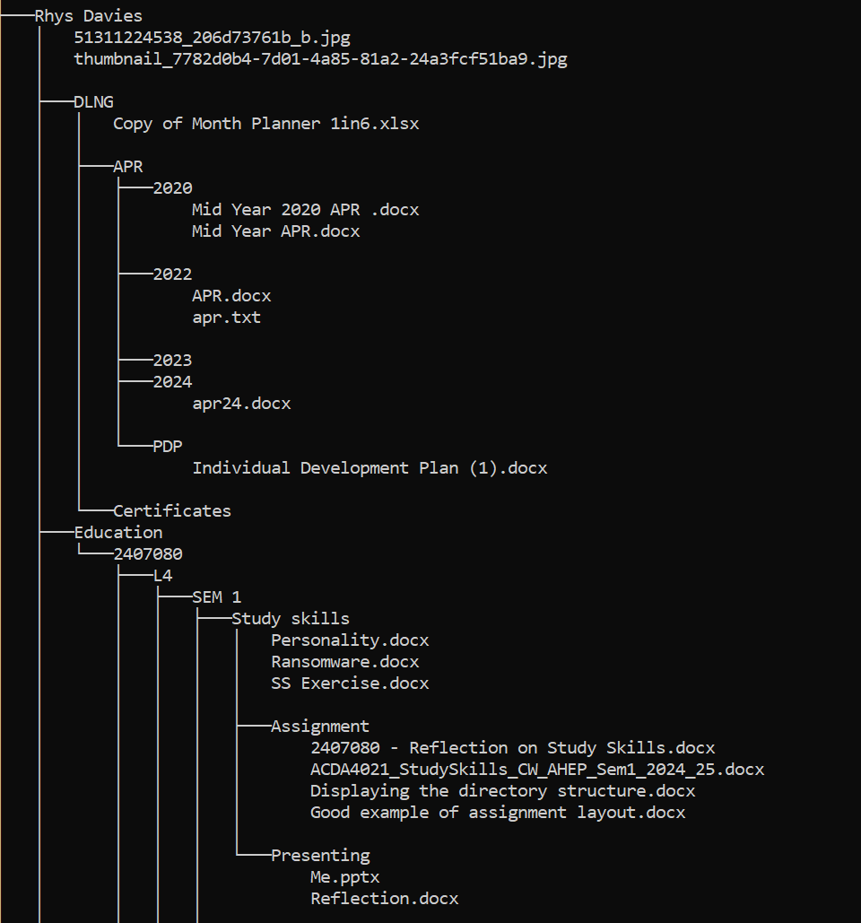
Figure 12: Screengrab of the e-Portfolio, with documents being shown within the folders.

Conclusion & Evaluation
To conclude, the areas that have been that require improvement to become a better student:
- Time management.
- Organisation.
It is believed that these areas of improvement are more habitable and can be managed. Using an action plan is a very useful strategy to achieve goals and making goals or targets less daunting.
It was stated in section 4.1 that personality tests did not interest me, however after participating and evaluating the results it has been realised that these are useful tools when looking to improve or even looking for reasons why:
- Why do I do things this way?
- Why do I find this difficult?
Technology skills have improved along with general study skills, which was the main concern when participation of the engineering degree was first confirmed.
During my study and certainly within the class setting I have found a newfound interest in learning and bettering my knowledge of everything, this has led me to want to read more books. I will look to broaden my way of understanding and thinking after a small lecture on Plato’s Allegory of the cave.

References

[1] | I. E. Team, “12 student skills that are useful for your studies,” 02 06 2024. [Online]. Available: https://uk.indeed.com/career-advice/career-development/student-skills. [Accessed 07 01 2025].
[2] | “Podar education network,” 19 04 2021. [Online]. Available: https://www.podareducation.org/blog-importance-of-skill-development-curriculum-in-school. [Accessed 12 12 24].
[3] | R. Pelta, “Flexjobs,” [Online]. Available: https://www.flexjobs.com/blog/post/transferable-skills.
[4] | R. Swain, “Prospects,” 01 06 2023. [Online]. Available: https://www.prospects.ac.uk/careers-advice/applying-for-jobs/what-skills-do-employers-want. [Accessed 12 12 2024].
[5] | “Openpsychometrics,” 15 10 2019. [Online]. Available: https://openpsychometrics.org/. [Accessed 24 11 2024].
[6] | “16 Personalities,” [Online]. Available: https://www.16personalities.com/istp-personality. [Accessed 24 11 2024].
[7] | “123 TEST,” [Online]. Available: https://www.123test.com/report/5TMEYGRTGAFBZLWSBV/. [Accessed 24 11 2024].
[8] | [Online]. Available: https://www.fbi.gov/how-we-can-help-you/scams-and-safety/common-frauds-and-scams/ransomware. [Accessed 11 11 2024].
[9] | S. L. H. &. K. Daniels, “Employability: what is the university’s responsibility?,” 11 10 2021. [Online]. Available: https://www.hepi.ac.uk/2021/10/11/employability-what-is-the-universitys-responsibility/. [Accessed 12 12 2024].

Appendices
16 personalities: https://www.16personalities.com
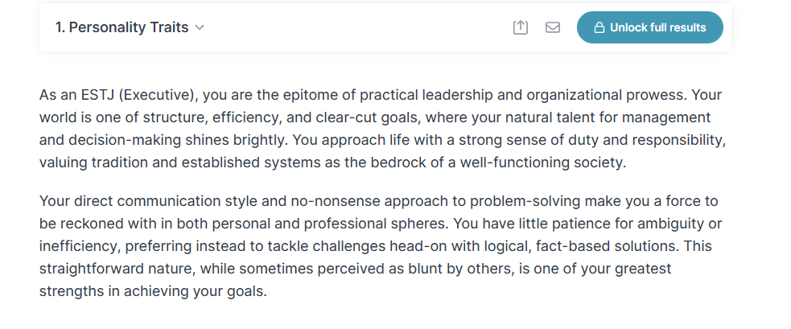
Figure 13: Results from the 16 personalities questionnaire.
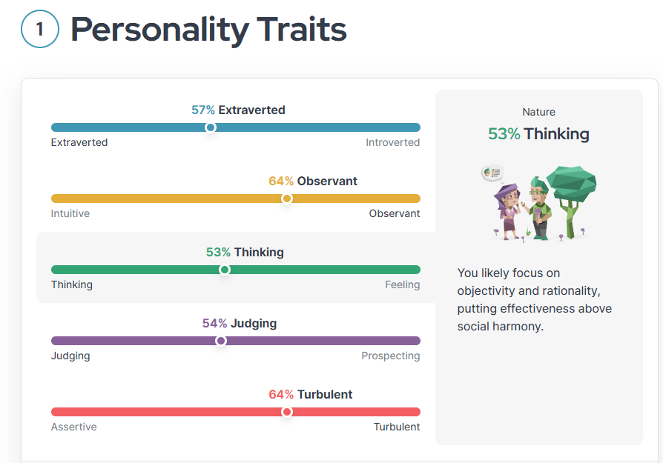
Figure 14: Visual representation of results from the 16 personalities questionnaire.

Guardian – What job would make you happiest: https://www.theguardian.com/lifeandstyle/2014/nov/11/-sp-questionnaire-what-job-would-make-you-happiest
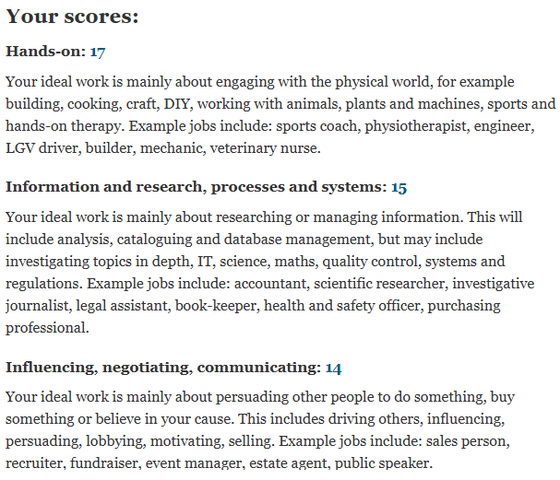
Figure 15: Results from the Guardian questionnaire.

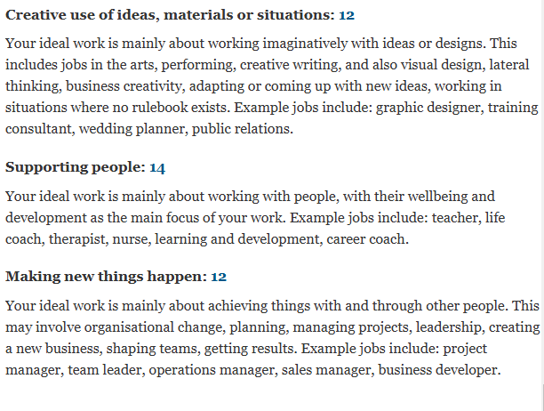
Figure 16: Results from the Guardian questionnaire.

