
University of Wales Trinity Saint David
School of Engineering
Transient Thermal Diffusion Model using the Finite Difference Method
Paul Michael Williams
P151245
27/01/2020
Advanced Computational Methods, Matlab
M6X00408
Dr. Arnaud Marotin

Table of Contents
1 Introduction 3
2 Constitutive Equation 4
2.1 Numerical Method Used for Discretization 4
2.2 Initial and Boundary Conditions Applied 6
3 Details of Finite Difference Method Script 8
4 Analysis of Code Results 13
5 Limitations of the Model and Suggested Improvements 19
6 Conclusion 21
7 Appendices 22
7.1 Appendix 1 22
7.2 Appendix 2 24
8 References 26

Figure 1 Specific Initial and Boundary Conditions to the previously stated problem 7
Figure 2 Grid Spacing Convention for use in the aforementioned problem 7
Figure 3 Pertaining to the setup of the user defined data capture 8
Figure 4 Script Part Two 10
Figure 5 Script Part Three 11
Figure 6 Script Part Four 11
Figure 7 Script Part Five 12
Figure 8 Base line, 0.01 mesh and 0.01s time-step (Ideal Solution) 13
Figure 9 Results table of 0.01 mesh and increasing time-step 14
Figure 10 Table of result relating to Figure 9 14
Figure 11 Final Result from last line of Figure 10 15
Figure 12 Results of fixed 0.01 time-step and increasing mesh size 15
Figure 13 Table of results relating to Figure 12 16
Figure 14 Result from final line of Figure13 16
Figure 15 End results with both mesh and time-step increasing as shown in graph below 17
Figure 16 Results table for rising mesh and time-step 17
Figure 17 Final result of final line in Figure 16 18

Introduction
The problem under consideration for this report is, create a model for an experiment, heat diffusion through a 2-D aluminium plate over time. The task will involve, calculating the temperature distribution through the plate over time. The temperature calculations will be done using the explicit method. Explicit methods calculate the state of a system at a later time using the current state. The model should be completed within the Matlab software environment. The model should include the following parameters.
- User defined x axis length of plate
- User defined y axis length of plate
- User defined time step
- The stability criterion should not be able to be broken
- User defined grid spacing (mesh)
- Grid spacing should comply with the size of the plate
- Temperatures of the plate should be calculated at each timestep
- Temperatures of each node at each time step should be displayed
- The program should stop when thermal equilibrium is reached
Further visual parameters can be seen below in Figures 1 and 2.

Constitutive Equation
The constitutive equation for this specific problem is the heat diffusion equation as stated below.
$$∇^{2}T=\frac{1}{α}.\frac{∂T}{∂t}$$
The $∇^{2}$ is the Laplacian operator which in terms of cartesian coordinates is.
$$∇^{2}=\frac{∂^{2}}{∂x^{2}}+\frac{∂^{2}}{∂y^{2}}+\frac{∂^{2}}{∂z^{2}}$$
In the context of a 2-D problem, then the z coordinate is neglected to leave the equation.
$$∇^{2}=\frac{∂^{2}}{∂x^{2}}+\frac{∂^{2}}{∂y^{2}}$$
Therefore, leaving the following equation when the Laplacian operator is substituted in.
$$\frac{∂^{2}T}{∂x^{2}}+\frac{∂^{2}T}{∂y^{2}}=\frac{1}{α}.\frac{∂T}{∂t}$$
The heat equation is a partial differentiation equation, these equations can’t be solved linearly by software. Therefore, the differential parts of the equation, first order in time and second order in space, will need to be discretised.
(Lewis, et al., 1996)

Numerical Method Used for Discretization
The finite difference method (hereafter FDM) has been specified within the task brief as the method to be used for this problem, more specifically the explicit FDM. The explicit method refers to the fact that the unknown temperatures are calculated based on the previously explicitly known temperatures. The FDM discretises the differential parts of the heat equation. The method involves using forward, backward and central difference formulae in replacement of the differential parts of the equations. In this case the first order differential of time is replaced by the forward difference and the second order differential of space is replaced by the central difference. (Recktenwald, 2011)
The approximations for this to be possible, come from using the Taylor series expansion. The Taylor series is a tool that expresses a value of a function at one point in terms of the value of the function and its derivatives at a different point. In layman’s terms Taylor series in the case of the forward formula, will tell us the approximations of temperature as time progresses. The Taylor series equation follows, as will its relation to the heat equation and FDM. When the function is equal to zero the Taylor series becomes a Maclaurin Series, such as when the initial time would be zero in the heat equation.
$$f\left(x\right)=\sum_{n=0}^{∞}{f^{\left(n\right)}\left(x_{0}\right).\frac{{\left(x-x_{0}\right)}^{n}}{n!}}$$
Taylor series compact form, and Maclaurin series when $x_{0}$ = 0.
$$f\left(x\right)=f\left(x_{0}\right)+f^{'}\left(x_{0}\right).\frac{{\left(x-x_{0}\right)}^{1}}{1!}+f^{''}\left(x_{0}\right).\frac{{\left(x-x_{0}\right)}^{2}}{2!}+f^{'''}\left(x_{0}\right).\frac{{\left(x-x_{0}\right)}^{3}}{3!}+f^{\left(4\right)}\left(x_{0}\right).\frac{{\left(x-x_{0}\right)}^{4}}{4!}+⋯$$
Full Taylor series notation.
$$f^{'}\left(x_{0}\right)≈\frac{f\left(x_{0}+h\right)-f\left(x_{0}\right)}{h}$$
Forward difference approximation after the Taylor series was rearranged.
$$f^{'}\left(x_{0}\right)≈\frac{f\left(x_{0}\right)-f\left(x_{0}-h\right)}{h}$$
The backwards difference approximation can be obtained in a similar manner.
$$f^{'}\left(x_{0}\right)≈\frac{f\left(x_{0}+h\right)-f\left(x_{0}-h\right)}{2.h}$$
The central difference approximation can be obtained by combining the forward and backwards approximations to yield an improved approximation.
$$\frac{∂^{2}T}{∂x^{2}}=\frac{T_{O}^{n}-2.T_{P}^{n}+T_{I}^{n}}{h^{2}}$$
$$\frac{∂^{2}T}{∂y^{2}}=\frac{T_{E}^{n}-2.T_{P}^{n}+T_{W}^{n}}{h^{2}}$$
$$\frac{∂T}{∂t}=\frac{T_{P}^{n+1}-T_{P}^{n}}{∆t}$$
These are the Taylor series substitutions that will made into the heat equation for a 2-D plate.
$$\frac{1}{F_{0}}T_{P}^{n+1}=T_{O}^{n}+T_{I}^{n}+T_{E}^{n}+T_{W}^{n}-\left(4-\frac{1}{F_{0}}\right).T_{P}^{n}+\frac{h^{2}.Q}{k}$$
The result of the substitutions, with the following stability criterion.
$$0<F_{0}≤\frac{1}{4} in 2D$$
F₀ is Fourier’s number, a dimensionless expression widely used for the prediction of temperature responses within transient heat or cooling problems.
$$F_{0}=\frac{α.∆t}{h^{2}}$$
(Rapp, 2015) (Recktenwald, 2011)

Initial and Boundary Conditions Applied
When the experiment is time dependant, such as it is in this case, the initial conditions must be specified. The initial conditions for this experiment are shown in Figures 1 and 2. Since time is first order in the heat equation, only one condition need be specified. When the coordinates are considered, the initial temperature array can be equated mathematically as.
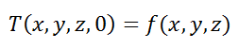
The function f(x,y,z) represents the temperature within the material at time = 0.

Within this problem, there are several types of boundary conditions at play. The northern edge has a Dirichlet boundary condition. The Dirichlet boundary condition is named after mathematician Peter Gustav Lejeune Dirichlet (1805–1859). When applied to a differential or partial differential equation and in particular the heat equation. The condition corresponds to a given surface temperature value. The surface temperature values are known and can be seen in Figure 1.
Another boundary condition is applied to the other three sides. The Neumann boundary condition is used, named after mathematician Carl Neumann (1832–1925). Usually when Neumann conditions apply to heat transfer, they correspond to a given rate of change of temperature. In this case there is a special application of the boundary condition, as the three sides in question are adiabatic, or perfectly insulated. When perfect insulation exists theoretically, then ∂T/∂x = 0. (Nuclear-power.net, n.d.)

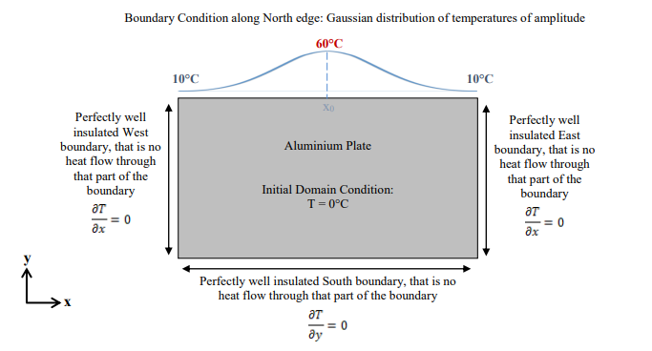
Figure 1 Specific Initial and Boundary Conditions to the previously stated problem

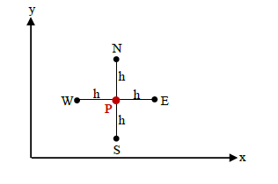
Figure 2 Grid Spacing Convention for use in the aforementioned problem

Details of Finite Difference Method Script
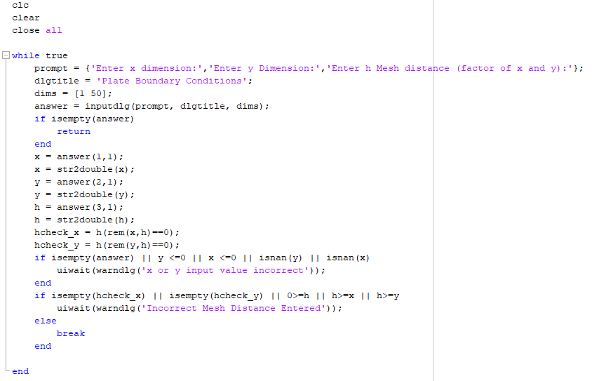
Figure 3 Pertaining to the setup of the user defined data capture
- The first three lines clear the command window, removes items from the workspace and clears all figures.
- A while loop is setup, that will loop until the criteria within are satisfied true
- Prompt, requests user defined inputs, the info in the brackets that follows are the questions asked.
- Dlgtitle sets the name of the dialogue box.
- Dims sets the size of the answer box in characters.
- Answer then creates an input dialogue box with the three previous steps incorporated.
- An if statement with an isempty condition for the dialogue box is started, this will return the input dialogue box if any input field is left empty and will end when all fields are filled.
- The next lines call the user defined inputs and converts them to double precision numbers, as they were characters previously. This creates the input values as a usable number in the workspace.
- The h value is the mesh distance between nodes, this needs to be a factor of both x and y distances (the plate dimensions). The next two lines check that h is a factor of both x and y. If h isn’t a factor of x or y, then their answer fields are returned empty.
- The next if statement checks that the entered values for x and y are firstly entered, that x and y are greater than zero and are numbers. The if statement is a true check, i.e. y<=0 checks if y is a negative number and if so returns a true answer, the next line will then return a warning dialogue box linked to the x and y inputs and then return the input dialogue box for re-enter only if there is a true answer to the if statements.
- The next if statement is very similar to the last one, it checks if the hcheckx and y fields are empty, if h is a positive number and whether the mesh distance could be the same value as x or y. If any of these ring true, then a warning will be displayed, and a re-entry of data will be required.
- The break function will break the if loop if satisfied and return you to the next part of the code.
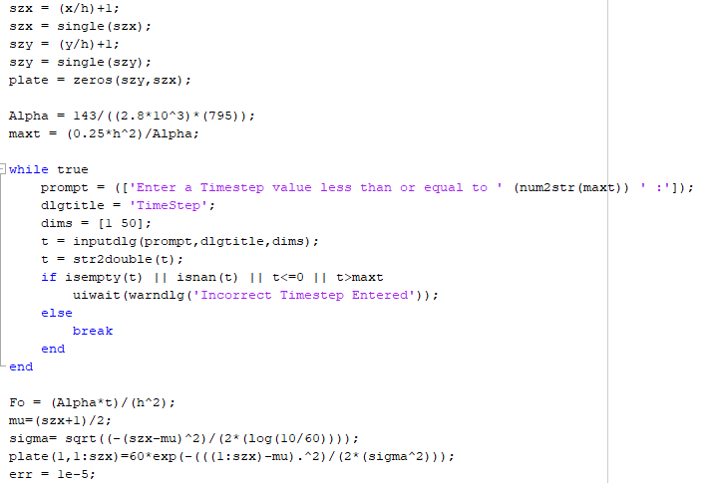
Figure 4 Script Part Two
- The next four lines set the dimensions of the plate by the number of nodes, h, the lines with single are setting the array to single as when testing the code, a weakness was found. Prior to the single lines being added, if a user input less than 1x10⁻³ for h or timestep then a warning dialogue box would be triggered and unable to function.
- Next, we create the plate, by creating a matrix of zeroes to the dimensions set by szx and szy.
- Alpha calculates the thermal diffusivity of aluminium.
- Maxt calculates a max timestep in relation to the mesh size entered plus a max Fourier’s number of 0.25.
- The while loop sets up an input dialogue box much as previously set out. This one asks the user to input the timestep. It will return the dialogue box for re-entry if the timestep is higher than the suggested max set out as previously set up.
- The if loop checks whether the timestep entered reaches the criteria on this line and returns the input again if not.
- The next line calculates the Fourier’s number using the material properties for aluminium entered into the alpha statement and also the mesh height entered for h.
- Mu sets the centre coordinate as shown in Figure 2.
- The sigma calculation calculates a gaussian distribution of temperatures between 10 and 60 degrees.
- The line starting plate, distributes the gaussian temperatures over the dimensions of the plate along the northern edge.
- The err is setting up a minimum value for equilibrium.

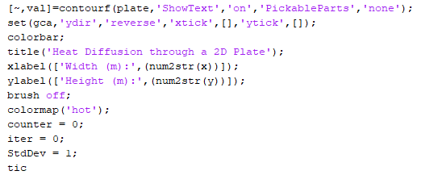
Figure 5 Script Part Three
- This section is fairly simple, the first 8 lines setup a contour plot and all the settings that go with it. All self-explanatory, title, text, axis labels colour scheme etc.
- Counter and iter are setting the initial loop for plotting and iteration counter.
- Stdev sets an array for use as standard deviation.
- Tic starts a timer for the calculations within the next while loop, purely set as a matter of interest with no bearing to the results of the plots.

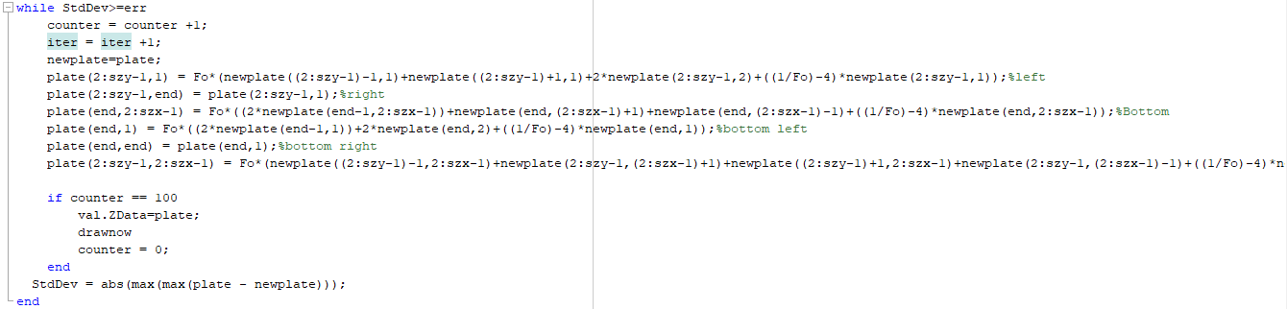
Figure 6 Script Part Four
- This while loop starts the calculations for all the nodes specified in the plate.
- Firstly, the true statement limits the standard deviation between iterations to the previously set err. For instance, the while loop will break as StdDev gets lower than err. This is set to ensure the model doesn’t perform needless calculations after the model has reached hypothetical equilibrium.
- The next two lines add one to the counter and to the iter counter.
- Next, a new plate is created based on previous plate, the set of calculations are carried out on the results of the last plate.
- The next lines are the calculations based on the discretised finite difference method version of the heat equation as mentioned previously.
- The if statement will draw a plot every 100 counts of counter and then reset counter to 0. Within the if loop, the val.ZData defines the plate as the matrix of data that makes up the contour plot.
- Lastly the Stdev is set as the difference from the last plate and the next one calculated.
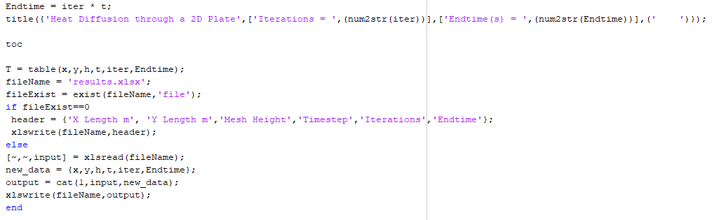
Figure 7 Script Part Five
- Next a real-world end time is estimated as, iterations times by timestep.
- Then a title is created for the plot dialogue box, showing end time in seconds and iterations.
- Toc stops the calculation time of the plot, purely for reference during optimisation testing.
- The next lines have no bearing on the results or the calculations thereof, they create an excel spreadsheet, write a new line showing an extra line of results per every run of the plot. This is purely for analysis, to save time gathering results over entering them manually.

Analysis of Code Results
In the case of analysis, certain criteria will be held for the sake of continuity and comparison. For instance, the dimensions of the plate will be 1m by 1m. The main reason would be the fact that if a similar experiment were to be carried out in real life, then a 1m plate would be more realistic to a 10m or 100m plate. Also, when using a smaller plate than 1m the mesh and timestep become slightly hard to visualise for a layman i.e. 0.01 as oppose to 1x10-5. The moving criteria will be the time-step and mesh distance, the analysis will study their effects upon the FDM model. The theory states that the closer to zero that mesh distance and timestep then the smaller the truncation error will become. So, with that stipulation, the base line for the analysis will be a mesh size of 0.01 or 1cm and time-step of 0.01s. This base line has been set with the notion that the results are closest (within reasonable calculation time) to a true solved heat equation, if it were solvable. The next step will be to incrementally raise the time-step while holding the mesh size at base, then increase the mesh size while holding time-step at base and finally increasing both incrementally.
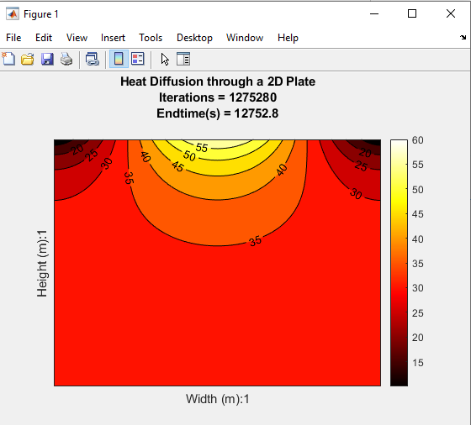
Figure 8 Base line, 0.01 mesh and 0.01s time-step (Ideal Solution)
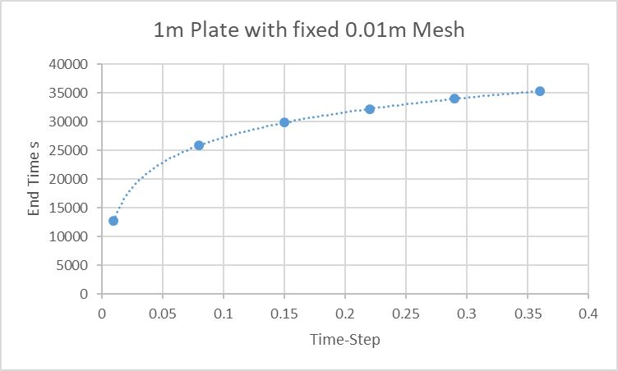
Figure 9 Results table of 0.01 mesh and increasing time-step

X Length | Y Height | Mesh Height | Timestep | Iterations | End time s
1 | 1 | 0.01 | 0.01 | 1275280 | 12752.8
1 | 1 | 0.01 | 0.08 | 323399 | 25871.92
1 | 1 | 0.01 | 0.15 | 198918 | 29837.7
1 | 1 | 0.01 | 0.22 | 146608 | 32253.76
1 | 1 | 0.01 | 0.29 | 117230 | 33996.7
1 | 1 | 0.01 | 0.36 | 98224 | 35360.64
Figure 10 Table of result relating to Figure 9

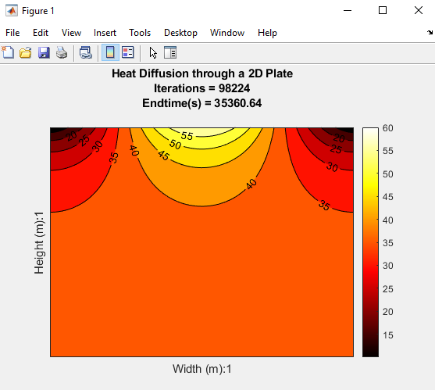
Figure 11 Final Result from last line of Figure 10

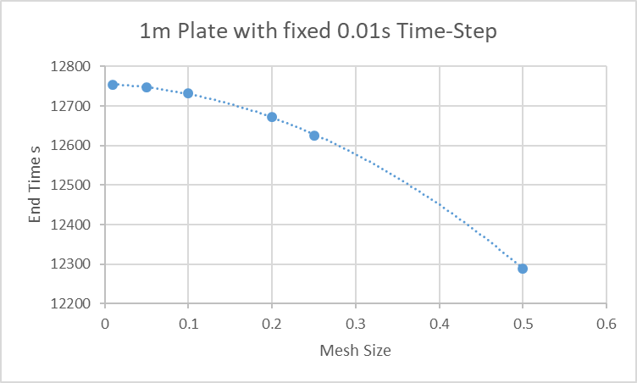
Figure 12 Results of fixed 0.01 time-step and increasing mesh size
X Length | Y Height | Mesh Height | Timestep | Iterations | End time s
1 | 1 | 0.01 | 0.01 | 1275280 | 12752.8
1 | 1 | 0.05 | 0.01 | 1274802 | 12748.02
1 | 1 | 0.1 | 0.01 | 1273304 | 12733.04
1 | 1 | 0.2 | 0.01 | 1267220 | 12672.2
1 | 1 | 0.25 | 0.01 | 1262572 | 12625.72
1 | 1 | 0.5 | 0.01 | 1228910 | 12289.1

Figure 13 Table of results relating to Figure 12
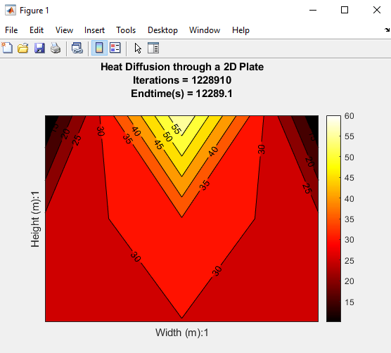
Figure 14 Result from final line of Figure13
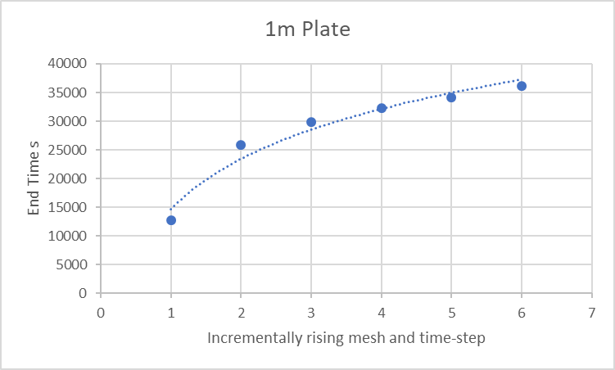
Figure 15 End results with both mesh and time-step increasing as shown in graph below
X Length | Y Height | Mesh Height | Timestep | Iterations | End time s
1 | 1 | 0.01 | 0.01 | 1275280 | 12752.8
1 | 1 | 0.05 | 0.08 | 323420 | 25873.6
1 | 1 | 0.1 | 0.15 | 199018 | 29852.7
1 | 1 | 0.2 | 0.22 | 146973 | 32334.06
1 | 1 | 0.25 | 0.29 | 117739 | 34144.31
1 | 1 | 0.5 | 0.36 | 100267 | 36096.12

Figure 16 Results table for rising mesh and time-step
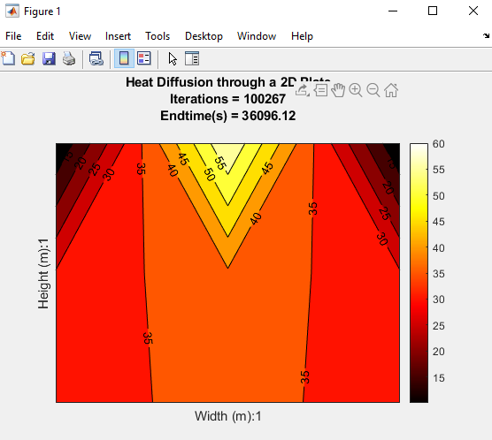
Figure 17 Final result of final line in Figure 16

During the setup and refining phase of the Matlab coding exercise, the err or convergence value was tested thoroughly. Values of between 1x10⁻¹ and 1x10⁻¹⁰ were tested and a happy medium of 1x10⁻⁵ was settled upon. This is because, with a too high convergence the plot wouldn’t reach hypothetical equilibrium and too low the plot would overrun and make unnecessary computations that would skew the end results.

Limitations of the Model and Suggested Improvements
There were several limitations encountered within the analysis portion, chief among them was the truncation error. Truncation error is the amount the results would diverge away from the realistic results as certain variables would also diverge from zero. In this particular case the closer the time-step and mesh size are to zero the lower the overall truncation error. The truncation error is compounded over mesh size and time step. This point is clear to see in Figures 15 to 17, the ideal solution (Figure 8) shows an end time of 12752s but as both time-step and mesh size veer away from zero the end time gets further from the ideal. Figure 17 shows an end time of 36096s, a considerable amount of error from 12752. Also, as can be seen in Figure 16 the end plot has diverged vastly from the ideal solution in Figure 8.
The truncation error of mesh size and of time-step have two different effects. The truncation error for time-step was tested as shown in Figures 9 to 11. In this test the mesh size was kept to the presented ideal 0.01m and the time-step was incrementally increased to its maximum. The results show that when a truncation error is introduced only into time-step then the results diverge vastly from the ideal solution but only via the end time calculation, visually the end plot looks close to the ideal. This is not a great situation as the visual plot could lead a person to believe that this result is accurate but in reality, the end time is far from ideal.
The same situation was tested for the mesh size with the time-step kept to an ideal of 0.01. Figures 12 to 14 show the affects of introducing truncation error into mesh size but not time-step. This produced end times within an acceptable range of the ideal, though reducing slightly with each rise in mesh size. On the other side, visually this produced a plot that has diverged vastly from the ideal (Figure 8), Figure 14 looks to be inaccurate visually but the end time calculation is fairly coherent. This would again lead to some confusion as to the accuracy of the result.
A possible solution to the overall truncation error problem could be to reduce the range of possible inputs for mesh size and time-step. Setting the input ranges for these two variables to between 0.001 and 0.2 would yield lower overall truncation error.
As for solving the mesh truncation and time-step truncation, a possible improvement would be to relate them in some way, when one rises so does the other. That way the visual results in the plot will correlate to the end time results and not provide false positives on one side or the other. One such solution could be to tie both variables to the material properties of the plate, size, specific heat etc.
(Recktenwald, 2011)
The convergence value can greatly affect the results within the FDM problem. When the value is high then the plot cannot come to equilibrium and when too low the plot over calculates producing higher than anticipated estimated end times. An improvement could be to link the convergence value to the size of the mesh (total number of nodes) in question. This would need further study as to find an optimum relationship between mesh size and convergence value but could improve the model and as such the user would not have to test the convergence over and over.

Conclusion
In conclusion, the analysis shows that within this FDM model, there lies truncation errors of different sorts. The first being a time-step related one that distorts the end time estimations, this comes into particular relief when a near to zero mesh spacing is paired with it. This situation yields a plot that looks accurate but is not accurate in terms of the estimated end time. The second truncation error found in analysis is related to the mesh distance, when paired with a near zero value for time-step produces a fairly close to ideal end time though more sharply falling from the ideal as mesh size rises (Figure 12). A compounded truncation error has been demonstrated in Figures 15 to 17, as the mesh and time-step move further from zero both the end time and visualisation of the plot both veers farther from the ideal results. This corroborates the suggestion that if the mesh size and time-step were linked to rise and fall together the visual and calculated results would show coherent results and create less confusion.

Appendices

Appendix 1
Final code for the diffusion problem.
clc
clear

while true
prompt = {'Enter x dimension:','Enter y Dimension:','Enter h Mesh distance (factor of x and y):'};
dlgtitle = 'Plate Boundary Conditions';
dims = [1 50];
answer = inputdlg(prompt, dlgtitle, dims);
if isempty(answer)
return
end
x = answer(1,1);
x = str2double(x);
y = answer(2,1);
y = str2double(y);
h = answer(3,1);
h = str2double(h);
hcheck_x = h(rem(x,h)==0);
hcheck_y = h(rem(y,h)==0);
if isempty(answer) || y <=0 || x <=0 || isnan(y) || isnan(x)
uiwait(warndlg('x or y input value incorrect'));
end
if isempty(hcheck_x) || isempty(hcheck_y) || 0>=h || h>=x || h>=y
uiwait(warndlg('Incorrect Mesh Distance Entered'));
else
break
end

end
szx = (x/h)+1;
szx = single(szx);
szy = (y/h)+1;
szy = single(szy);
plate = zeros(szy,szx);

Alpha = 143/((2.8*10^3)*(795));
maxt = (0.25*h^2)/Alpha;

while true
prompt = (['Enter a Timestep value less than or equal to ' (num2str(maxt)) ' :']);
dlgtitle = 'TimeStep';
dims = [1 50];
t = inputdlg(prompt,dlgtitle,dims);
t = str2double(t);
if isempty(t) || isnan(t) || t<=0 || t>maxt
uiwait(warndlg('Incorrect Timestep Entered'));
else
break
end
end

Fo = (Alpha*t)/(h^2);
mu=(szx+1)/2;
sigma= sqrt((-(szx-mu)^2)/(2*(log(10/60))));
plate(1,1:szx)=60*exp(-(((1:szx)-mu).^2)/(2*(sigma^2)));
err = 1e-5;

[~,val]=contourf(plate,'ShowText','on','PickableParts','none');
set(gca,'ydir','reverse','xtick',[],'ytick',[]);
colorbar;
title('Heat Diffusion through a 2D Plate');
xlabel(['Width (m):',(num2str(x))]);
ylabel(['Height (m):',(num2str(y))]);
brush off;
counter = 0;
iter = 0;
StdDev = 1;
tic
while StdDev>=err
counter = counter +1;
iter = iter +1;
newplate=plate;
plate(2:szy-1,1) = Fo*(newplate((2:szy-1)-1,1)+newplate((2:szy-1)+1,1)+2*newplate(2:szy-1,2)+((1/Fo)-4)*newplate(2:szy-1,1));%left
plate(2:szy-1,end) = plate(2:szy-1,1);%right
plate(end,2:szx-1) = Fo*((2*newplate(end-1,2:szx-1))+newplate(end,(2:szx-1)+1)+newplate(end,(2:szx-1)-1)+((1/Fo)-4)*newplate(end,2:szx-1));%Bottom
plate(end,1) = Fo*((2*newplate(end-1,1))+2*newplate(end,2)+((1/Fo)-4)*newplate(end,1));%bottom left
plate(end,end) = plate(end,1);%bottom right
plate(2:szy-1,2:szx-1) = Fo*(newplate((2:szy-1)-1,2:szx-1)+newplate(2:szy-1,(2:szx-1)+1)+newplate((2:szy-1)+1,2:szx-1)+newplate(2:szy-1,(2:szx-1)-1)+((1/Fo)-4)*newplate(2:szy-1,2:szx-1));

if counter == 100
val.ZData=plate;
drawnow
counter = 0;
end
StdDev = abs(max(max(plate - newplate)));
end
Endtime = iter * t;
title({'Heat Diffusion through a 2D Plate',['Iterations = ',(num2str(iter))],['Endtime(s) = ',(num2str(Endtime))],(' ')});

toc

T = table(x,y,h,t,iter,Endtime);
fileName = 'results.xlsx';
fileExist = exist(fileName,'file');
if fileExist==0
header = {'X Length m', 'Y Length m','Mesh Height','Timestep','Iterations','Endtime'};
xlswrite(fileName,header);
else
[~,~,input] = xlsread(fileName);
new_data = {x,y,h,t,iter,Endtime};
output = cat(1,input,new_data);
xlswrite(fileName,output);
end

Appendix 2
Plate code with left side boundary condition of 50°C.
clc
clear

while true
prompt = {'Enter x dimension:','Enter y Dimension:','Enter h Mesh distance (factor of x and y):'};
dlgtitle = 'Plate Boundary Conditions';
dims = [1 50];
answer = inputdlg(prompt, dlgtitle, dims);
if isempty(answer)
return
end
x = answer(1,1);
x = str2double(x);
y = answer(2,1);
y = str2double(y);
h = answer(3,1);
h = str2double(h);
hcheck_x = h(rem(x,h)==0);
hcheck_y = h(rem(y,h)==0);
if isempty(answer) || y <=0 || x <=0 || isnan(y) || isnan(x)
uiwait(warndlg('x or y input value incorrect'));
end
if isempty(hcheck_x) || isempty(hcheck_y) || 0>=h
uiwait(warndlg('Incorrect Mesh Distance Entered'));
else
break
end

end
szx = (x/h)+1;
szy = (y/h)+1;
plate = zeros(szx,szy);

Alpha = 143/((2.8*10^3)*(795));
maxt = (0.25*h^2)/Alpha;

while true
prompt = (['Enter a Timestep value less than or equal to ' (num2str(maxt)) ' :']);
dlgtitle = 'TimeStep';
dims = [1 50];
t = inputdlg(prompt,dlgtitle,dims);
t = str2double(t);
if isempty(t) || isnan(t) || t<=0 || t>maxt
uiwait(warndlg('Incorrect Timestep Entered'));
else
break
end
end
Fo = (Alpha*t)/(h^2);
boundtemp=linspace(50,0,szx);
plate(:,1)=50;
plate(1,:)=boundtemp;
plate(szy,:)=boundtemp;
newplate = plate;
num= 0;
count= 0;
err = 1e-10;
while true
num = num + 1;
count = count + 1;
plate= newplate;
for j = 2:szy-1
for i = 2:szx-1
newplate(j,i) = Fo*(plate(j-1,i)+plate(j,i+1)+plate(j+1,i)+plate(j,i-1)+((1/Fo)-4)*plate(j,i));
end
end
if count==10
contourf(newplate,'ShowText','on');
drawnow;
colorbar;
count=0;
end
StdDev = newplate-plate;
if StdDev<err
break
end
end
Endtime = num * t;
title({'Heat Diffusion through a 2D Plate',['Iterations = ',(num2str(num))],['Endtime(per second) = ',(num2str(Endtime))]});

References
Lewis, R. W., Morgan, K., Thomas, H. R. & Seetharamu, K. N., 1996. The Finite Element Method in Heat Transfer Analysis. s.l.:John Wiley & Sons.
Nuclear-power.net, n.d. Heat Equation – Heat Conduction Equation. [Online]
Available at: https://www.nuclear-power.net/nuclear-engineering/heat-transfer/thermal-conduction/heat-conduction-equation/?fbclid=IwAR2S72DDm7yjEXM816cSAAB8OAgL1k4dmZ0m7QdrbV-SocSpN8bM0RuRxDw
[Accessed 17 January 2020].
Rapp, B. E., 2015. Taylor Series. [Online]
Available at: https://www.sciencedirect.com/topics/engineering/taylor-series
[Accessed 25 January 2020].
Recktenwald, G. W., 2011. Finite-Difference Approximations to the Heat Equation, Portland: Portland State University.

