Reflective Journal –
1st February
Today I had the first sessions for Introduction to Fieldwork. There were two different sides to this module, one for Anthropology and History students, and another for Archaeology students. The Introduction to Fieldwork session for Anthropology and History students did not appeal to me in the slightest. I swiftly realised that there wouldn’t be enough History involved with this side of the module. The fieldwork for this side of the module was to go to on a retreat to an Ashram. While this would have been interesting, I realised that I wanted to study the history of the local area, and in doing my research, I realised that the other side of the module, aimed at Archaeological students, would be more what I was looking for. To me, graveyards are incredible places, from looking at graveyards, one is able to gain a thorough understanding of the local history, including the local families, the general ages of death, if any immigrants moved to the town, and when etc.
8th February
Today I had my fist proper lesson for Introduction to Fieldwork. In this lesson, we looked at reading maps, and using Ordinance Survey Maps. This was a useful lesson as it taught us all about how to read maps, and how to write coordinates for guiding someone to a point on a map. As a part of this lesson, we were given a task using maps of the local area. The task involved reading points from the sheet, finding them on the map and looking at what was in that area. For some tasks, we were asked to find a certain road, and follow it to a certain point. I found this quite a simple task to complete, as map coordinates are not as difficult as some people think. Once I was finished with this task, I was able to help other students with their work. From this task, we learnt the skills of map reading, and understanding coordinates. We were then able to put the knowledge to practice in the task.
We started the next lesson by looking at how to create a cross section of a hill along line XY. We did this by aligning some paper on the line and marking where the changes in elevation occurred. Then the paper was lined along the graph and the marks transferred to their heights. The marks were then joined together, to create a 2D cross section of the hill. This is an invaluable skill to have, as if you only have a map, you are able to create a 2D, or even 3D cross section, and then visualise the area a lot better.

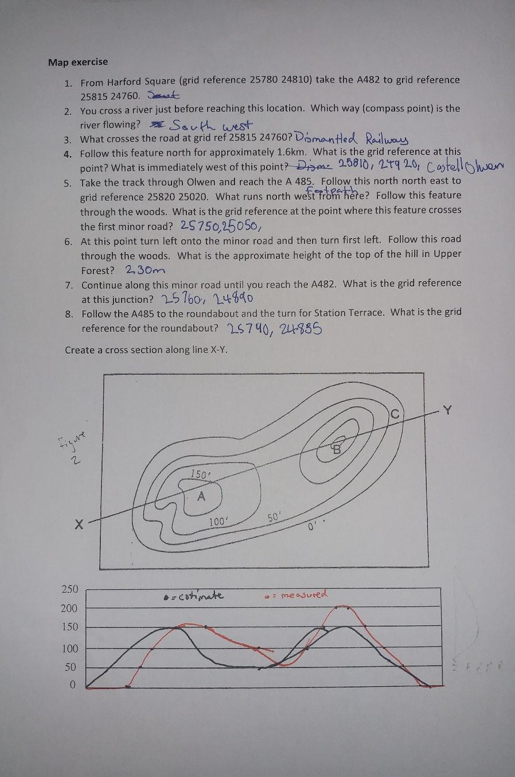
Figure 1 - Map Exercise
15th February
In this lesson, we looked at how to set out a grid on an excavation site. The previous lesson, we had learnt about OS Maps, and the grid system they used, so it was simple to equate the OS system of gridding to gridding out an excavation site. When we had completed this section, we looked at how to begin surveying a site with a dumpy level. We also looked at making sketch maps. Sketch maps are a way of making a quick reference guide of the area that you are working in. We were separated into groups of two, and set off on the campus to make a sketch map. The drawing below is our completed sketch map. Prior to the task, we were not given any specific instructions, and as such the class ended up with a lot of variance of how people approached this task. For my group, I nominated myself as the artist, and we began walking around. Instead of using a scale and measuring the lengths of walls, we instead chose to eyeball the buildings, and compared them to other walls or buildings around. In hind sight, we should have used a scale, perhaps even just a stride would have been a good measurement. Having a regular, unchanging scale that we could use would have helped us immensely. Using our method though did prove to be successful. Comparing the buildings and the roads to one another enabled us to gain an understanding of the architecture and the surrounding area. From this lesson I learnt how to read a dumpy level, and use one to find the height of the are you are surveying. I also learnt how to make a sketch map, and that in the future, I should add more information such as the artists name, the name of the area (For example on this map, it would be Lampeter Campus), and what the scale is.
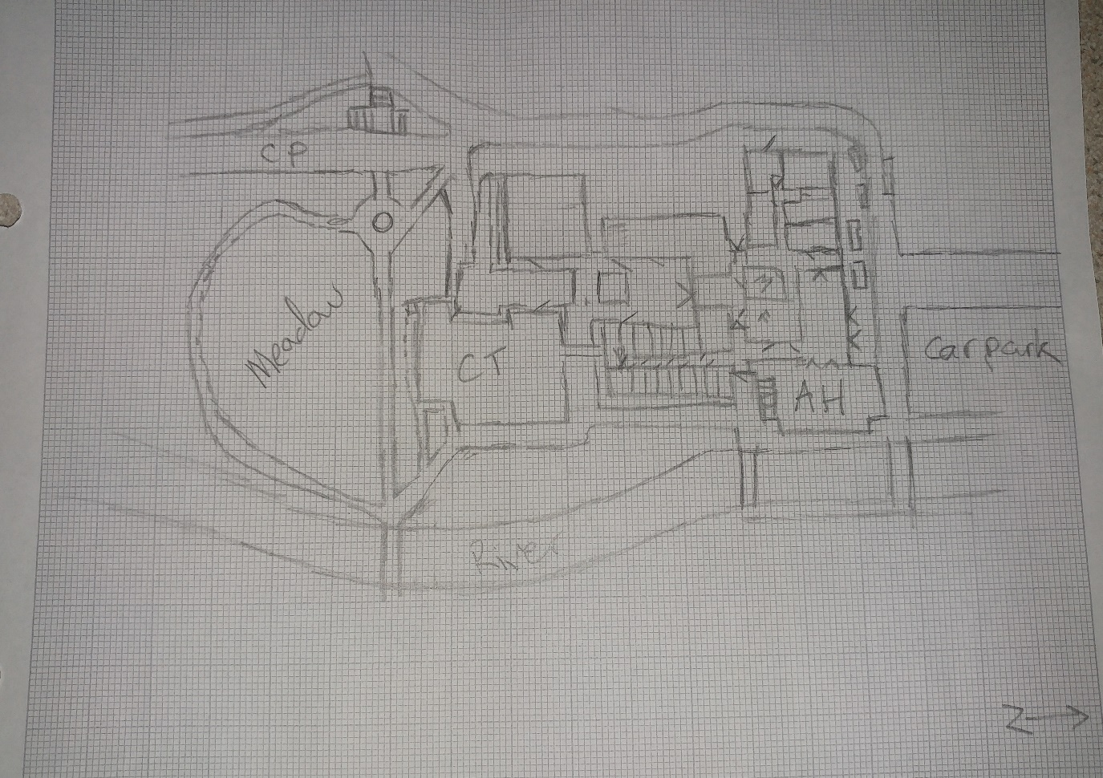
Figure 2- Sketch Map

8th March
In this lesson we used the information we learnt about last week. We learnt how to use a dumpy level, and how to get the elevation of the area. Before we left the classroom, we ran through some health and safety information, such as never carrying the tripod with the spikes facing outwards (The spikes must always face towards the game). Another important piece of information is that the dumpy level should be wiped down after use, to make sure no water is getting into the box. This is useful because the dumpy levels are expensive, and therefore should be kept in as good condition as possible. Once out in the field, we were divided into groups, and were told how to set up the dumpy level, to ensure that it is level in all orientations. We then chose a hill, and set up our equipment. We chose a point across the river in which to set our benchmark. We set it at an arbitrary 100m because we did not know the exact height above sea level. From this point, we found our Foresight by measuring the reading on the measuring stick that was held at the point. In our case, the foresight was set at 0.48m, which meant that we had an Instrument height of 100.48m. We were then able to use that information to establish the elevation along the hill. We started at 0m and moved our way along the tape measure to 7m, taking a reading at every 50cm. Once we read the height at each point on the measuring stick, we were able to subtract that from 100.48m, to give us the exact elevation of the point on the ground. We continued this process until all readings had been taken. From this exercise, we learnt the valuable skills of teamwork. One or two of us would read the dumpy level and tell that to the scribe, who would write it down. We would carry out the mathematics on the go, just in case we got back to the classroom and the information was wrong.
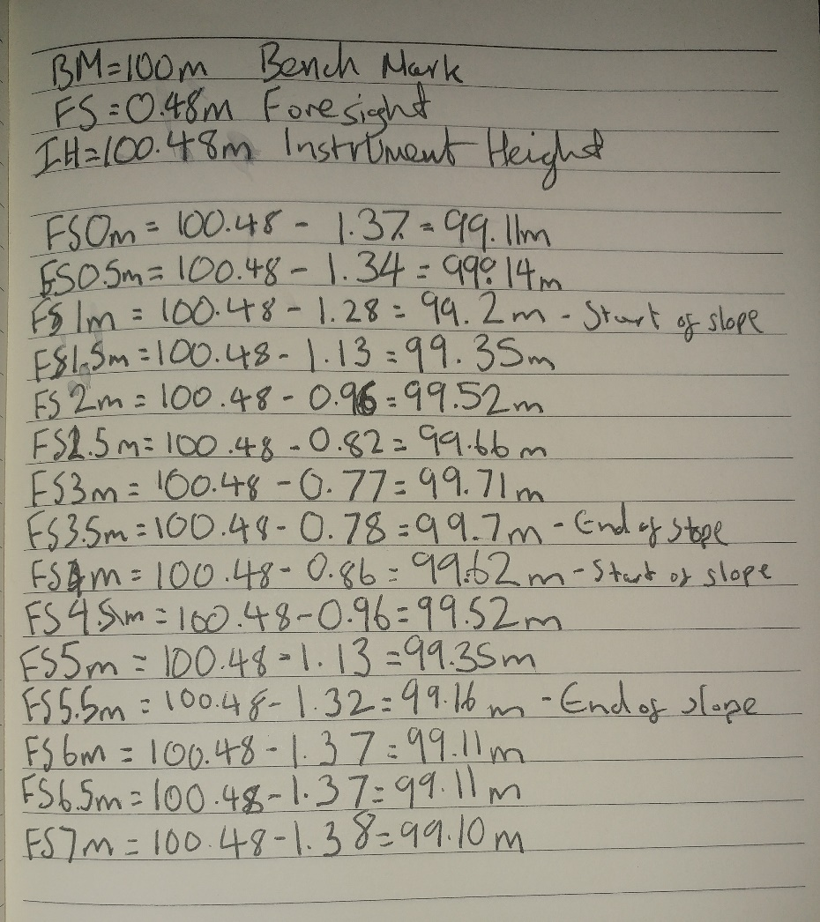
Figure 3 - Dumpy Level Readings
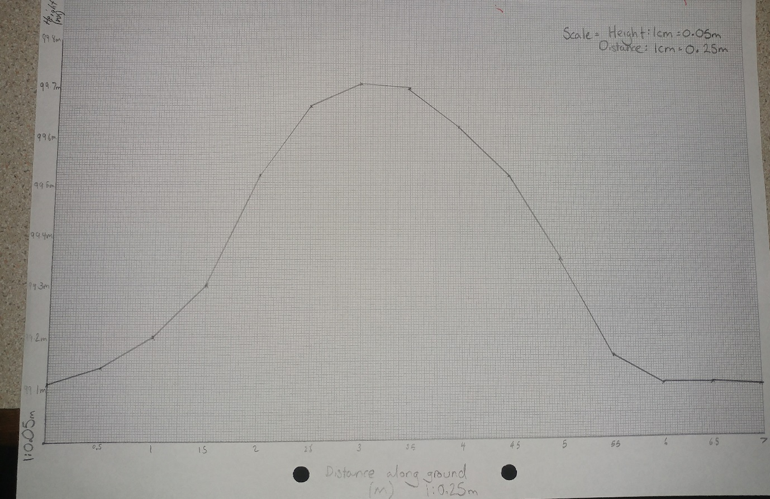
Figure 4 - Results plotted on a graph
15th March
At the start of this lesson, we took the numbers we obtained last lesson, for the elevation of our hill that we measured with a Dumpy level, and plotted it onto a graph. On the vertical scale, we chose to go with a 1:0.05 scale, where one centimetre on the graph paper was equivalent to 5cm in real life. On the horizontal side we chose a 1:0.25 scale, where one centimetre was equivalent to 25cm in real life. This led to a slightly skewed graph that was not shaped like the real hill, but given our material constraints, I felt like we did a good job accurately representing the hill.
In this lesson we also learnt about the different types of hachure lines. These are lines you can use when drawing a site and are used to indicate the direction of a slope. We learnt how to use the simplest hachure lines (a triangle showing the direction of the slope and a line extending the length of the slope) and then set out onto the campus to record an area of the school. We chose an area that had a varied layout, including some sloped areas, and some flat areas. We had one member of our team go out into the area and walk with an estimated metre stride. With this member on the ground, we took a vantage point that was overlooking the entire area. We then set about drawing the area. We would call out an area to the member on the ground to walk to, measuring the approximate length in metres. As the ground member went along, he was able to explain to us the level of the sloped ground, indicating where certain features began and ended. The picture below shows our first attempts at drawing an area using hachure lines. Of course, there is room for improvement, but our group believed that we had completed a fairly competent diagram. After talking with our lecturer, we were told that hachure lines cannot be curved, as we had done. Upon realisation of this, we made sure to make a note of this in our notebooks for future reference.

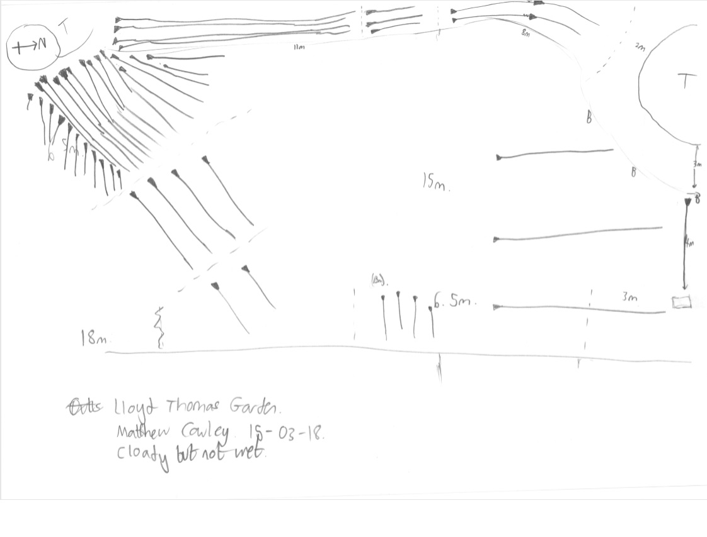
Figure 5 - Hachure Lines

22nd March
This week we looked at drawing to scale. We began by looking at the different scales that are commonly used, and where it is appropriate to use them. For maps, it is often best to use a 1:25000 or a 1:50000 scale, as you want to get as much of the area in as possible. For closer up drawings, one wants to use a much smaller scale. For example, if you were drawing the plans to a house, you might use a 1:20 scale, or a 1:50 scale, depending on the size of the house. For the drawing of smaller finds, such as a fine-toothed comb, or a mosaic, you might want to use a 2:1 scale, or a 3:1 scale. This would allow the artist to capture a lot of detail, and in turn learn more about the object that he might have missed. For the purposes of our exercise, we were using a 1:10 scale, whereby one centimetre on our paper was equivalent to 10 centimetres in real life. For the exercise I was laid on the floor with tape measures by my side, and then I was drawn by my classmates. From watching them drawing me, I learnt how difficult drawing to scale can be, especially when working in a team. Good coordination is essential. We learnt that it was best to have whoever was drawing call out areas of the body to measure, and two people would give the location by measuring from my body to the tape measure, which would give them a location on the paper, or first how high up the tape measure to start, and then how far along to go. Obviously, this method of measuring larger objects will take some time to get used to, but I think that I could successfully handle a task like this if it were given to me now.
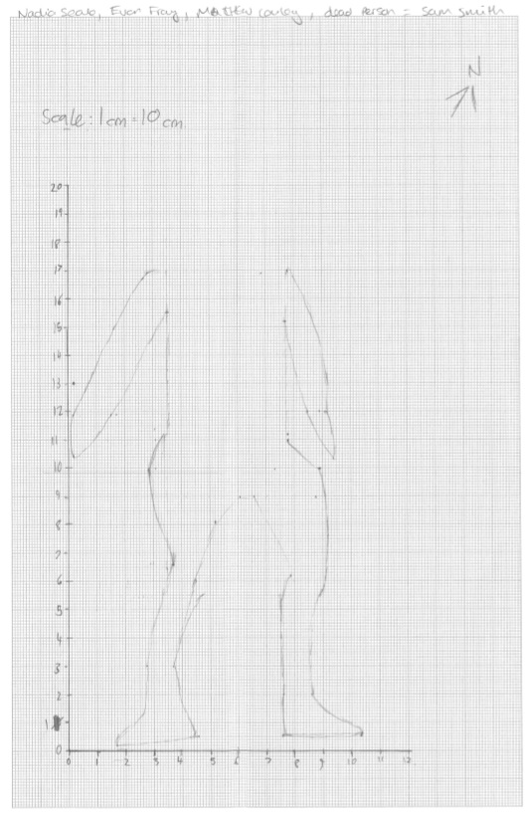
Figure 6 - Drawing to Scale 1:10

Overall, I am really enjoying this course, and am thoroughly looking forward to surveying St. Peters Cemetery. I Wasn’t expecting to find so much enjoyment from this course, but learning how to survey a site, how to lay out a grid, and use a dumpy level and turning all that information into graphs and tangible information has been an interesting learning experience. The thing that is interesting me most, as a history student is still going to be learning the local history from the graveyard, but I am now looking forward to putting everything that I have learned in class to use.

