Gabriel Dunning

Engineering Project management Assignment
BEng Embedded Electronic Systems
ACDA5025A

Device/Product description:
The device that this proposal is based on is a portable GPS tag that can be attached to objects like phones or apparel, which can then be located with an app that’s downloadable from the android app store. This will enable people to locate the tag and by extension, whatever they’re attached to. The tag will come in a variety of different versions which can be used for different purposes, these include tags with adhesive backing to allow them to be stuck onto flat surfaces like phone cases as well as tags designed to be fixed to keychains. There will also be “low profile” versions of these tags as well, these versions will be smaller than the regular variant with the aim of providing the consumer with a smaller, less conspicuous alternative, making the device incredibly versatile and usable on a variety of different items. Finally, there will be a third variant that will have a Bluetooth speaker that can play sounds to help locate items in close proximity. The associated app for the device will be available on the android app store and will enable users to track and manage any of the tags the connect to their account. It will enable users to own multiple tags, with the ability to track different tags on the same account seamlessly.

Device Specifications:
The device should be a disk shape of approximately 1.5 Inches in diameter, The sticky variant should have a flat face to allow it to stick to other surfaces more effectively. The smaller model should reduce this size by 0.5 inches in ideal circumstances however this target can be changed to 0.25 inches if required, the device is to be made from stainless steel to allow for greater durability.
The device should have an ideal battery life of 1 year without requiring a battery change or recharge. Due to the target size of the tag, implementing a charging port may prove challenging, so using a CR2032 Lithium coin battery seems like the more appropriate option. The reason this battery type has been selected is that it’s used by similar products on the market and is thus a proven success for this purpose, these batteries are also incredibly cheap and have high availability, so they’ll be easy to purchase in bulk. Given that they’re so cheap, it means that they’ll also be easily replaceable as well.
The device should be locatable at least on a national level, given that it’ll be using GPS to ping it’s location, this should be easily achievable.
There will also be a variant of the tag that has a limited ability to play sound in close proximity, to enable locating items in, small but cluttered environments. This feature necessitates the inclusion of a small speaker, as well as short range Bluetooth capabilities. In ideal circumstances the operating distance for this Bluetooth capability should be approximately 20 feet in open air, this should also allow a relatively large range within an environment with lost of obstructions such as a house. It should be noted that including these features into this variant of the GPS tag will demand that the total size of the tag is increased to approximately 2.5 – 3 inches in order to accommodate the extra electronics. This feature will also require that the accompanying app used to monitor the tags, has a feature that enables sounds to be played from the Bluetooth speaker from the app.

Tasks Involved/Task list:
There are a number of tasks involved in the creation of this device. The tasks and their sub tasks are as seen below
- Health and Safety – 1 Week
- Identify possible safety and security risks
- Compare existing safety and security policies against identified risks.
- If current policies are deemed insufficient, identify and implement appropriate mitigations.
- Procurement – 2 Weeks
- Identify materials and equipment required to complete the project
- Identify appropriate materials and tools for the most reasonable price
- Use approved procurement pathways to purchase materials and equipment
- Role Delegation/Clarification – 4 Hours
- Assemble all project members and begin delegating roles and responsibilities
- Ensure that everyone is clear on their R & R
- Begin Project – 2 Hours
- The project team splits into two sub teams, the hardware team and the Software team. The hardware team will be responsible for creating the physical tag and its variants, whilst the software team will be responsible for creating the app.
- Phase 1 – 3 Weeks
- Once materials have arrived, The hardware team will set about constructing a basic prototype of the GPS system that’ll be used going forward.
- The Software team will utilise this time to plan out and begin creating the skeleton of the app, including things like a basic UI.
- Phase 2 – 2 Weeks
- The hardware team begins designing and constructing the housing for the GPS tag, issues encountered here can be fed back into the specification where the spec can be altered if necessary to accommodate limitations.
- The software team will use the prototype developed in phase 1 to integrate and test the ability to track a GPS tag via the app, they will also continue to implement UI features and begin working on the UX.
- Phase 3 – Weeks
- Once the base model of the tag is complete, the hardware team will split into two teams, one of which will begin working on the Bluetooth speaker variant and the other team will make the miniaturised version of the tag.
- The software team will begin finalising the first build of the app and begin QA and bug testing.
- Phase 4 – 4 Weeks
- Both hardware teams finish up with their respective variants, the Bluetooth team hand their variant to the software team to enable integration into the app.
- The software team takes the Bluetooth variant and integrates it into the app, this will then lead to another set of QA testing to iron out bugs.
- Phase 5
- The Software team finalise the app into its 1.0 version and both the product and app get pushed out to market.
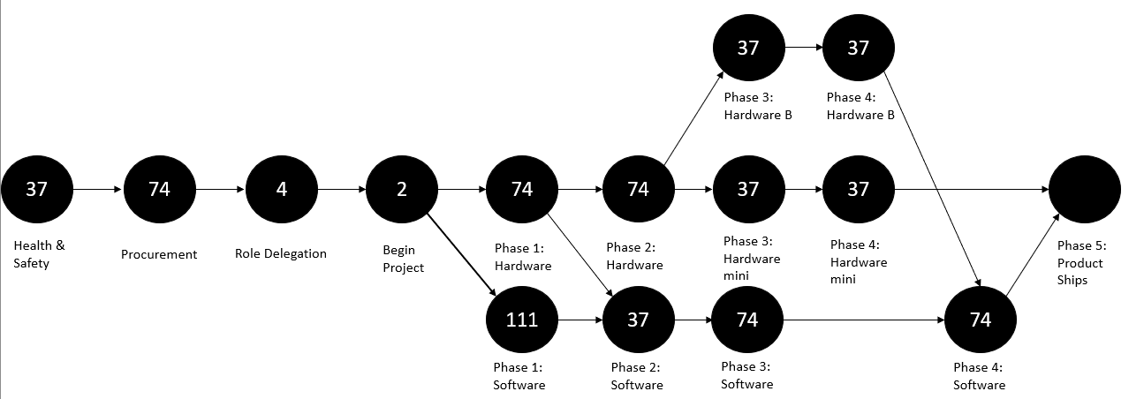
Figure 1: A critical path analysis showing the workflow of the project.
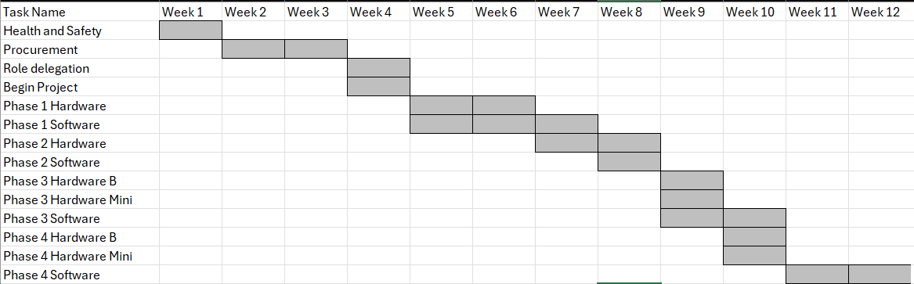
Figure 2: A Gantt chart of the project's tasks alongside their time scale.

Key Milestones and Deliverables:
The first key milestone of the project is the start of phase 1, this is because phase 1 is considered the “true start” of creating the product, as everything before is preparation in order to ensure the actual manufacture process goes as smoothly as possible.
Phase 2 is considered the next milestone as it indicates that the GPS tag prototype is complete and has been handed over to the software team. The GPS Prototype is also the first deliverable of the project, as it enables the software team to begin their task in earnest.
The beginning of phase 3 is the next milestone as it signifies the completion of the base model of GPS tag and the beginning of each of the variant models beginning development. The deliverable for this phase is the successful completion of the base model of tag.
The next milestone in the process is phase 4 where the deliverable is the completion of both variant models of the tag. Phase 4 signifies the end of the hardware section of development, with the only main task left to complete is the full integration of the Bluetooth model with the app as well as a final round of QA testing.
The Final deliverable of the project is a combination of all the finished tag models, as well as the final 1.0 build of the app all being ready to be pushed out the door. This signifies the end of the development process in this project.

Possible risks and mitigations:
There are a variety of risks associated with undertaking a project like this, the first of which is the people involved having a lack of clarity in regards to roles and responsibilities, this can cause delays in delivering project work as well as duplication of effort. This problem is mainly caused by poor communication to and between project teams as well as poor management of project resource. This project proposal has mitigated against this by having a dedicated “prep phase” at the beginning where all project members are given their roles and responsibilities as well as allowing for further clarification should anyone be unsure. This potential risk is also less likely to affect this project as the teams performing the technical work are fairly separate with little crossover, the only exception being the hardware team splitting in two after completion of the base model.
Another possible risk that could affect this particular project is material stock and lead times. This can cause serious delays in projects when suppliers are out of stock for specific components, this is especially true when the required components are relatively niche and only a limited number of suppliers stock them. The mitigations in place in this project proposal is that the project is structured so that all the necessary materials, components and equipment will be identified and procured prior to the work beginning. This should hopefully minimise the risk of delays in getting materials stopping technical work dead in it’s tracks .
There are also health and safety risks that can possibly affect this project too, this ranges from risks inherent to technical hardware work like burns and fumes from soldering, all the way to back problems from incorrect display screen equipment. These can all pose a risk to the project as, they can result in team members needing to take time off or for the project to be paused while an investigation takes place. The way this project is structured to mitigate this risks is by taking tine during the “prep phase” to identify potential health and safety risks and compare them to the current health and safety policies that the organisation already employs. If it’s found that these policies and practices already cover the identified risks as well as being deemed sufficient mitigation, then the work can continue. However if there aren’t any appropriate policies or risk assessments in place, then the time must be taken prior to work beginning for sufficient mitigations to be implemented. This has the obvious benefit of protecting members of the project team whilst also minimising the chance of development being halted due to an easily foreseeable accident.
The final risk to the project is a legal risk. The legal risk is incredibly important to consider as in certain circumstances, failure to do so can incur more cost than that of the entire project. The legal risk can be caused by any number of factors, from failing to appropriately credit and compensate those involved in the development of a product to failing to adhere to patents and copyright laws. The legal risk can also be posed by failing to adhere to relevant regulations such as ISO standards as well as legislation such as the health and safety at work act. The best way to mitigate this risk is once again, to take the time before commencing work in order to identify relevant regulations and laws pertaining to the development work taking place, and to work with the project team throughout the duration to ensure that these are continually adhered to.
Environmental impact:
As with the production of anything, there is an environmental impact to consider, given that the main body of the device is crafted from stainless steel, its entirely plausible that the manufacturing of this steel could have a negative impact on the environment, Its important to ensure that, during development and manufacture, the steel used is sourced from a reputable seller who is just as conscious of the environmental impact of steel manufacture. A possible way of mitigating the environmental impact of using steel, is to source it from a manufacturer who supplies recycled steel, whilst not a perfect solution, this is still a better method than doing nothing at all.
Another environmental issue that could be caused by the production of the tag device is the usage of disposable batteries rather than rechargeable ones. This is obviously negative for the environment as it leads to more waste and improper disposal can lead to harmful chemicals seeping into the soil and groundwater. Unfortunately due to the target dimensions of the tag, implementing rechargeable batteries may not be possible, This means that the best way we can seek to mitigate the impact that using disposable batteries generates is by ensuring that all batteries disposed of during development and manufacture of the tag are disposed of in an appropriate manner, adhering to all relevant legislation regarding the use and disposal of said batteries.
Ethical Concerns and societal impact:
Finally, it’s important to consider the ethical and societal concerns of a product like this, the main issue being that as the tag is essentially a GPS tracker, it’s plausible that some people would use it for malicious purposes like tracking people’s movements and could lead to things like stalking. In addition there is also the risk that bad actors could somehow manage to track other people’s tags and use the information to rob people and steal their valuables. Its also possible that data scrapers could take the tracking data of people’s movements with tracked items and sell the information on to 3rd parties, this could also result in a data breach which could be catastrophic for the company both in terms of monetary damage and reputational damage. The best way to combat against some of these issues is to ensure that the app used to track the tags has incredibly robust security in order to prevent hackers and data scrapers.

Appendix:



