LIVING WITH DIABETES, AN INFORMATION BOOKLET FOR SERVICE USERS AND HEALTHCARE PROFESSIONALS IN THE UK

Executive Summary
One of the significant burdens on UK healthcare is diabetes. According to Diabetes UK, nearly 6 million individuals have diabetes with over 4.7 million diagnosed and an approximate number of 1.3 million with undiagnosed type 2 diabetes. A further 6.9 million people are at risk. This document is intended to help diabetics, their families, their carers and their medical staff living with diabetics. It explains diabetes, its prevalence, causes and impacts on mental wellbeing. It details the NHS assistance, such as medicines, education, diabetes technology, weight management and the Type 2 Diabetes Path to Remission Programme. It further analyses the NHS House of Care, WHO model, policies and NICE guidance, and identifies gaps and advocates person-centred, culturally sensitive, multidisciplinary care via earlier diagnosis, prevention and equal access.
Table of Contents

1. Introduction 1
1.1 Purpose and Scope of the Booklet 1
1.2 Target Audience and Rationale for Topic Selection 1
2. Understanding Diabetes, Definition, Burden and Aetiology 2
2.1 Definition and Clinical Features 2
2.2 Global Prevalence and Burden 3
2.3 UK Prevalence and Burden (NHS Data 2025 to 2026) 4
2.4 Risk Factors and Aetiology 5
2.4.1 Genetic and Biological Factors 5
2.4.2 Lifestyle and Metabolic Factors 5
2.4.3 Ethnicity and Sociodemographic Considerations 6
3. Impact of Diabetes and Evidence Based NHS Treatments 7
3.1 Physical Impact on the Individual 7
3.2 Psychological Impact on the Individual 7
3.3 Social Impact on the Individual 8
3.4 Wider Implications for Families and Carers 8
3.5 Evidence Based NHS Treatments 9
3.5.1 Pharmacological Management (including insulin therapy) 9
3.5.2 Lifestyle and Behavioural Interventions 10
3.5.3 Structured Education, Diabetes Technology and Specialist Services 10
3.5.4 Mental Health Support Pathways 11
4. Theoretical Perspectives and Models for Improved Outcomes 12
4.1 UK Model, NHS House of Care Framework 12
4.2 International Model, WHO Innovative Care for Chronic Conditions (ICCC) Framework 12
4.3 Critical Comparison and Application to Diabetes Care 14
5. Local and National Policy Agendas 15
5.1 National Agendas 15
5.1.1 NHS Long Term Plan and 10 Year Health Plan 15
5.1.2 NICE Guidance Relevant to Diabetes 15
5.2 Local Agendas (Integrated Care Systems and Local Diabetes Networks) 15
5.3 Critical Examination of Policy Implementation Gaps 16
6. Recommendations for Person Centred Care 17
6.1 Person Centred and Culturally Sensitive Approaches 17
6.2 Self Management Support Strategies 17
6.3 Multidisciplinary and Lifelong Care Considerations 17
6.4 Complication Prevention and Later Life and End of Life Care Planning 18
7. Conclusion 19
Reference List 20

1. Introduction

1.1 Purpose and Scope of the Booklet
This is an evidence based booklet on diabetes in the UK which provides clear information on it. It discusses definitions and risk factors, physical, psychological and social effects, NHS interventions, care models, existing policy and guidelines. It concentrates on England, where national audit data have been most secure, and is generalised to the wider UK where it is possible.

1.2 Target Audience and Rationale for Topic Selection
The booklet targets individuals living with diabetes, their families and carers as well as health workers. Diabetes was selected due to the fact that there are continuously growing numbers. The IDF Diabetes Atlas, in 2024, indicates one in nine adults (589 million) as having diabetes worldwide (International Diabetes Federation, 2025). The NHS in the UK incurs an estimated yearly cost of 10.7 billion to it and 60% of this expenditure goes into complications.

2. Understanding Diabetes, Definition, Burden and Aetiology

2.1 Definition and Clinical Features
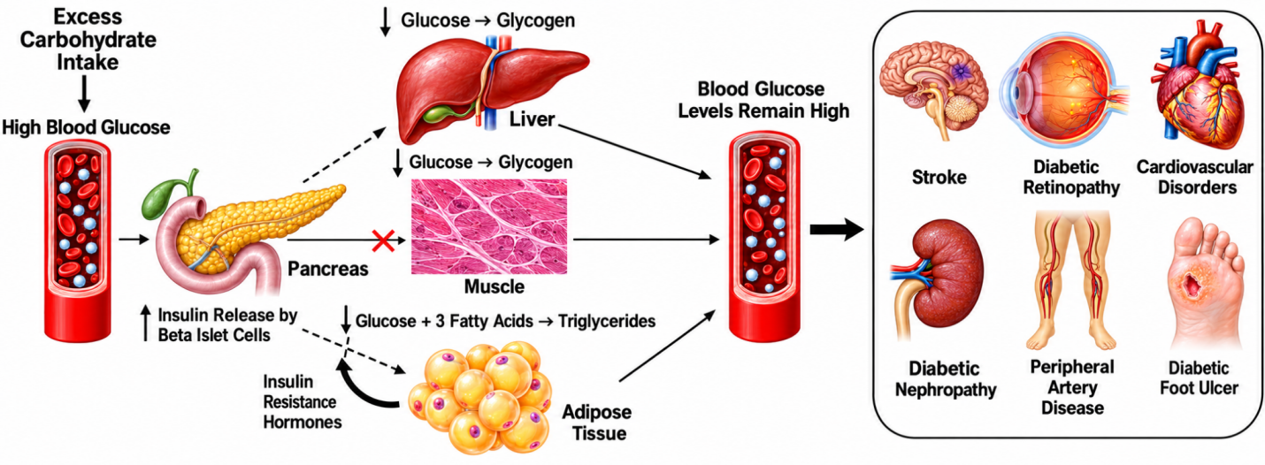
Figure 1: Diabetes Effect on the body
(Source: Wu et al., 2022)
Diabetes is a chronic illness where glucose levels remain at an excessively elevated level as a result of the body being unable to either produce enough insulin, or the insulin is not used effectively. Type 1 diabetes involves the destruction of the cells producing insulin by the immune system. Type 2 occurs due to the resistance to insulin of the body and its decreasing production with time (International Diabetes Federation, 2021). Gestational diabetes is a manifestation in pregnancy. According to Diabetes UK, approximately 90% of those diagnosed with diabetes type 2, only a few with type 1 (8%) and other types that are rarer (2%) (Men’s Health Forum, 2025).

2.2 Global Prevalence and Burden
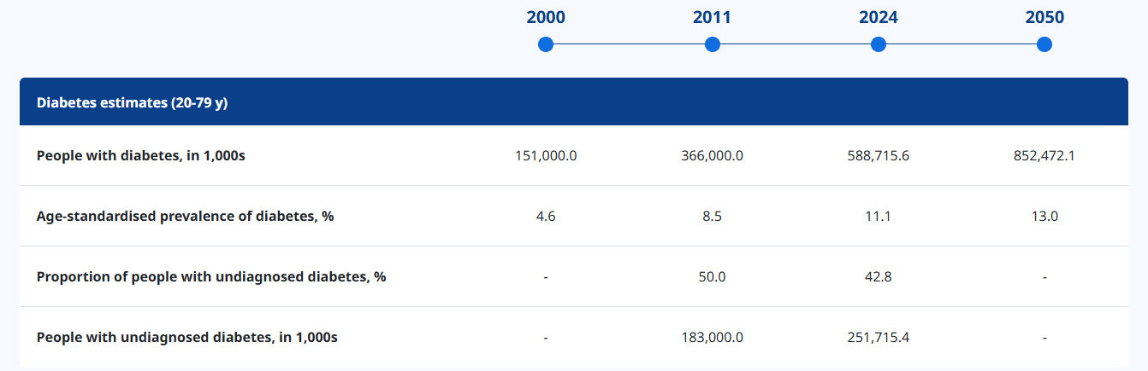
Figure 2: Diabetes estimates (20-79 y)
(Source: International Diabetes Federation, 2025)
The IDF Diabetes Atlas 11th edition is estimated to indicate that there are 589 million adults aged 20 to 79 years living with diabetes in 2024. One of every nine adults. It has been estimated to be 853 million by the year 2050. Some 252 million of them are unaware of their having the condition. On average, 3.4 million deaths occurred in 2024 in diabetes, or about one person per six seconds.

2.3 UK Prevalence and Burden (NHS Data 2025 to 2026)
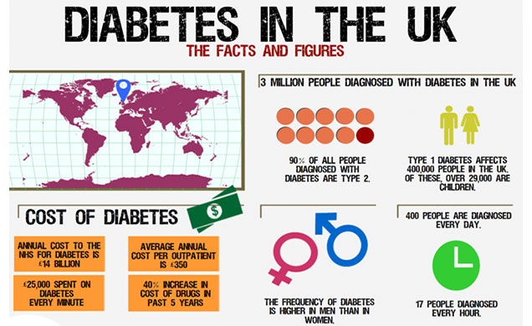
Figure 3: Burden of Diabetes in UK
(Source: Men’s Health Forum, 2025)
The latest estimation by Diabetes UK shows that there are nearly 6 million individuals in the UK with diabetes. Over 4.7 million have a diagnosis and 2024/25 registrations have increased by 155,804 the previous year (Diabetes UK, 2025). It is estimated that there are nearly 1.3 million individuals with type 2 diabetes that are undiagnosed and 6.9 million are at a high risk. There are more than 12 million adults who have diabetes or prediabetes. The cost to the NHS of diabetes in 2035 is estimated by Diabetes UK to be almost 18 billion, assuming the prevalence continues to increase at the same pace (Diabetes UK, 2026).

2.4 Risk Factors and Aetiology
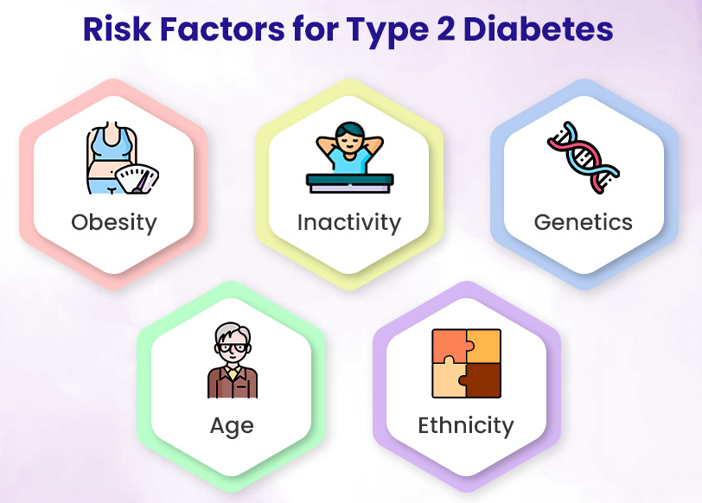
Figure 4: Risk Factor for the Diabetes
(Source: EliteCare Health Centers, 2023)

2.4.1 Genetic and Biological Factors
Family history, age and ethnicity are risk factors. There is immune and genetic susceptibility of type 1 diabetes. Family history of type 2 diabetes predisposes people to develop type 2 diabetes and the risks increase with age (EliteCare Health Centers, 2023).

2.4.2 Lifestyle and Metabolic Factors
These are the type 2 diabetes contributors that are bound by living with overweight or obesity. Adopting a combination of lifestyle modifications such as diet, exercise and long-term weight reduction have been found to reduce the chances of occurrence of type 2 diabetes by approximately half in certain individuals (Chandrasekaran and Weiskirchen, 2024).

2.4.3 Ethnicity and Sociodemographic Considerations
Asians (as well as Indian, Pakistani and Bangladeshi), Chinese, Black African and Black Caribbean individuals are two to four times more prone to diabetes than Whites and usually get type 2 at lower weights (Binur Orazumbekova et al., 2025). There is a strong association between higher risk and income, education, housing, access to healthy food and poor access to healthcare. In June 2025, a government statement in the House of Lords (2025) reported a 51% increase in type 2 diabetes in under 40s in England over eight years.

3. Impact of Diabetes and Evidence Based NHS Treatments

3.1 Physical Impact on the Individual
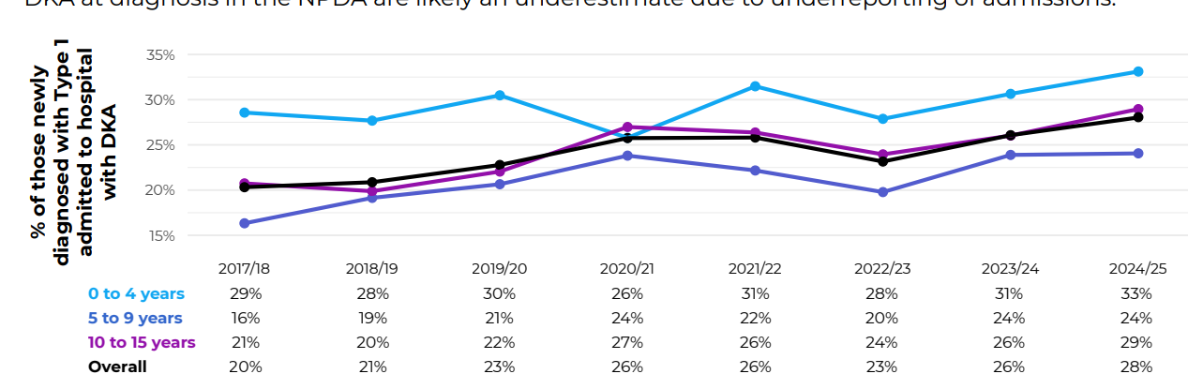
Figure 5: Percentages of children and young people aged 0 to 15 years newly diagnosed with Type 1 diabetes admitted with DKA
(Source: Royal College of Paediatrics and Child Health, 2026)
Unremittingly elevated glucose harms blood vessels and nerves and its effects extend to the eyes, kidneys, feet and heart. According to Diabetes UK, every week, there are 184 amputations due to diabetes, over 1,010 strokes, 700 heart attacks and 3,340 heart failures (Diabetes UK, 2026a). Type 1 diabetes may come as suddenly as well. The National Paediatric Diabetes Audit identified that children and young people were diagnosed with diabetic ketoacidosis in 2024/25 (22%-28% of total), with the highest figures seen in the youngest age groups (Royal College of Paediatrics and Child Health, 2026).

3.2 Psychological Impact on the Individual
Being a diabetic is a psychologically burdensome thing. The 2026 survey of stigma conducted by the charity Diabetes UK revealed nearly 8 in 10 individuals with type 1 and more than 7 with type 2 diabetes feel blamed and judged due to their condition. Almost 6 out of 10 stated that it hurts their confidence and more than half states that they internalise the shame and are inclined to think that they are wrong (Diabetes UK, 2025b).

3.3 Social Impact on the Individual
Stigma accompanies people in their daily life. In the identical survey in 2026, 1 in 5 persons indicated that they encounter it in the workplace every couple of weeks. Black Africans, Black Caribbean and South Asians are more susceptible to diabetes stigma that serves as an additional social burden to an underlying increased biological risk (Hassan et al., 2023). Both the opportunity to get type 2 diabetes as well as the capacity to manage the condition depend on income as well as housing and access to healthy food.

3.4 Wider Implications for Families and Carers
Most of the day to day load is put on the families. Parents with children with type 1 diabetes are on insulin dosage, glucose monitoring and tapping. The 2024/25 paediatric audit reveals the extent to which support is important. A quarter of young people (28%) aged 12 and above with type 1 and 60% with type 2 have missed one or more of the recommended health checks (Chemist4U, 2025).

3.5 Evidence Based NHS Treatments

3.5.1 Pharmacological Management (including insulin therapy)
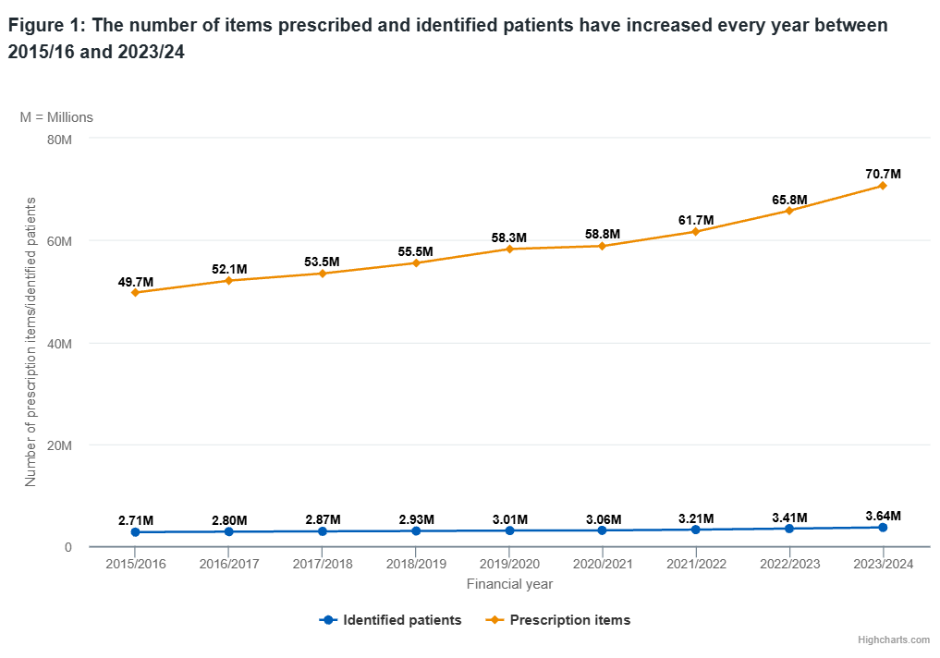
Figure 6: The number of items prescribed and identified patients have increased every year between 2015/16 and 2023/24
(Source: NHS, 2024)
Every type 1 diabetic is in need of insulin. In the case of type 2, in 2026 NICE changed its NG28 guideline, and replaced a glucose centred, stepwise model with a heart and kidney protection first diagnostics approach (NICE, 2026). On individuals who require it, now, modified release metformin and an SGLT2 inhibitor are provided together, unless contraindicated. Previous glucose-lowering peptide 1 receptor agonists or trispeptide should also be used in certain populations, such as adult diabetes, and previously diagnosed with the condition (before 40). The 71 million diabetes items prescribed in England has increased by 21 million since 2015/16 (NHS, 2024).

3.5.2 Lifestyle and Behavioural Interventions
Prevention is prior to diagnosis. The NIHR evidence shows that people who had been referred to the NHS Diabetes Prevention Programme were 20% less likely to get type 2 diabetes compared to other people similar to them, who had not been referred (Ravindrarajah et al., 2025). The NHS Type 2 Diabetes Path to Remission Programme offers total dieting replacement then behavioural support to individuals who have been diagnosed. Early real world outcomes indicated that 27% of the individuals who got two HbA1c results were at remission after 12 months, with a weight loss of 14.8 kg (Brown, 2025). NHS England announced a procurement notice in 2025 to keep up the programme from April 2026 (NHS England, 2026).

3.5.3 Structured Education, Diabetes Technology and Specialist Services
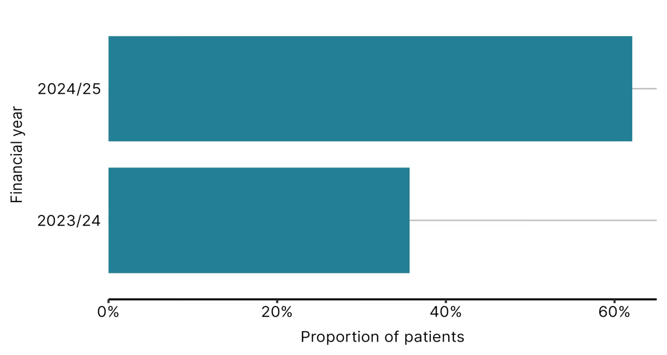
Figure 7: Proportion of children and young people with Type 1 diabetes using a hybrid closed loop system
(Source: NICE, 2025)
The basis is education. By 2024/25, 87.6% of individuals with type 2 diabetes in England will have received some structured education within 12 months of diagnosis (NHS England, 2026b). Care is in transition with technology. Some adults with insulin treated type 2 diabetes who use continuous glucose monitoring would be encouraged to use this technique by NICE guidelines. In children and the youth with type 1 diabetes, the 2024/25 paediatric audit reports show an increasing rate of technology uptake, and hybrid closed loop systems have been associated with improved HbA1c, and technology usage results (NICE, 2025).

3.5.4 Mental Health Support Pathways
Included in routine diabetes care and not an appendix should be emotional support. People in England may self refer to NHS Talking Therapies, or ask their GP or diabetes team. Diabetes UK also runs a helpline on 0345 123 2399 (Diabetes UK, 2026a). Services must inquire about emotional wellbeing at all reviews, and not wait to be notified to identify who has avoided appointments due to stigma as more than half of the individuals queried in 2026 indicated this reason.

4. Theoretical Perspectives and Models for Improved Outcomes

4.1 UK Model, NHS House of Care Framework
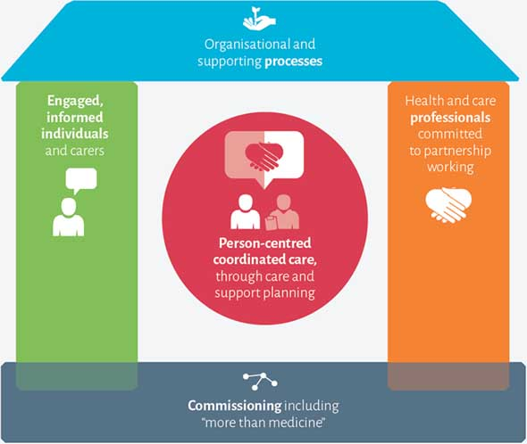
Figure 8: NHS House of Care Framework
(Source: NHS, 2025)
The NHS House of Care framework provides a basic image of joined up long term condition care. The two walls are composed of informed, engaged and, thus, committed professionals and people who have diabetes information and, therefore, are willing to form partnerships (NHS, 2025). The floor and the commissioning form comprise supportive organisational and clinical processes and roof respectively. Individualised care planning is in the centre. There is a national audit reason as to why this is important. Only 58.2% of the diabetic type 2 patients in England in 2024/25 recorded all the eight care processes (Office for Health Improvement and Disparities, 2026).

4.2 International Model, WHO Innovative Care for Chronic Conditions (ICCC) Framework
The WHO Framework of Innovative Care to Chronic Conditions is viewed at a broader scope. It works at three levels. The micro level refers to the individual and his family, the meso level refers to the health organisations and communities and the macro level refers to policy and funding. It calls upon each and every level to collaborate (WHO, 2026).
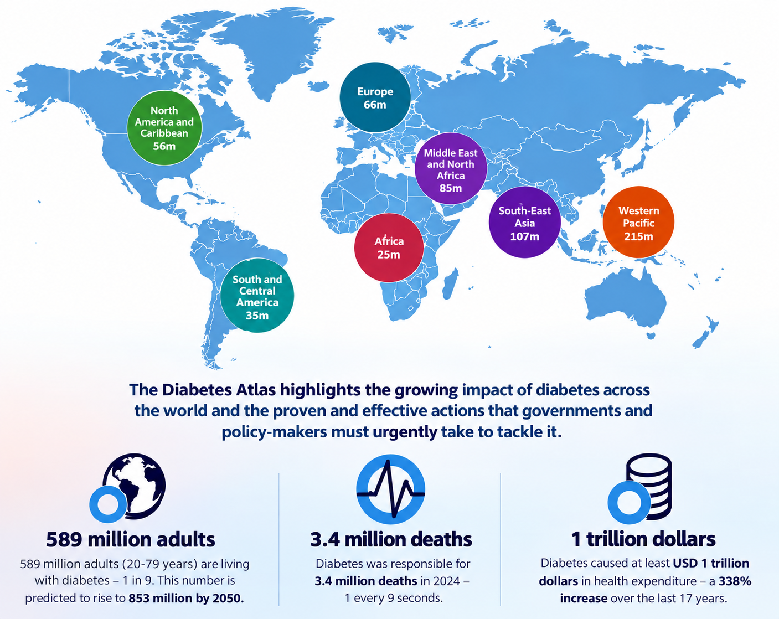
Figure 9: Diabetes Statistics around the world
(Source: Kanmani Bharathi, 2025)
The world statistics reveal the reasons as to why that is important. According to the IDF Diabetes Atlas the number of adults who are living with diabetes is estimated to be 589 million and that 252 million of them do not even know that they have diabetes. In 2024, 3.4 million deaths were the result of diabetes (Kanmani Bharathi, 2025).

4.3 Critical Comparison and Application to Diabetes Care
The two models respond to various questions. The question that House of Care poses is what a good, inside-the-NHS diabetes appointment and care plan would be. ICCC poses a question on what that entire system will have to facilitate that appointment. House of Care may be used alone leaving the food environment, income and community of a person unaltered.
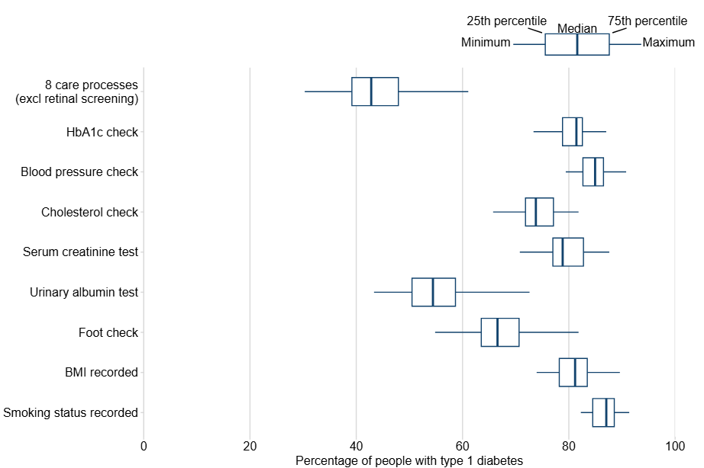
Figure 9: Percentage of people with type 1 diabetes that received care processes, ICBs in England
(Source: Office for Health Improvement and Disparities, 2026)
Both gaps are indicated by audit data. The variation in the 58.2% completion rate with all the eight care processes is large, with 73.5% as the highest and 38.6% as the lowest, respectively, in the Integrated Care Board. Only 45.2% of the patients with type 2 diabetes achieved all three targets of the treatment of blood pressure, glucose and cholesterol in the blood. That constitutes a delivery gap, and the House of Care addresses it (Office for Health Improvement and Disparities, 2026).

5. Local and National Policy Agendas

5.1 National Agendas

5.1.1 NHS Long Term Plan and 10 Year Health Plan
The NHS Long Term Plan has increased the Diabetes Prevention Programme. The 10 Year Health Plan for England issued on 3 July 2025, will make three shifts, between hospital and community, between the analogue and the digital and as between the sickness and prevention. It is not disease specific (GOV.UK, 2025). Much to the point, a Lords response of June 2025 stated so explicitly, whilst acknowledging that the shifts have conformed to the priorities of Diabetes UK.

5.1.2 NICE Guidance Relevant to Diabetes
In 2026 NICE revised its type 2 diabetes guideline NG28. Key developments include a primary line combination of modified release metformin and an SGLT2 inhibitor in a larger population needing drugs, initial availability of GLP 1 receptor agonists or tirzepatide in specific groups, and a cautious and individualised strategy regarding frailty, where the initial drug used is modified release metformin (Omniamed Communications, 2026). NG17 applies to type 1 diabetes in adults whereas NG18 applies to children and young people.

5.2 Local Agendas (Integrated Care Systems and Local Diabetes Networks)
Integrated Care Boards design and buy their diabetes services with a target population and the audit allows them to view their performance. The spread is indicated in the 2024/25 National Diabetes Audit. The hospital had a range of 38.6 to 73.5% completion of all the eight care processes of the patients with type 2 diabetes based on the ICB. The overall success rates of all three treatment goals (responses to treatments) were between 40.7 and 50.0% (NHS England, 2026b).

5.3 Critical Examination of Policy Implementation Gaps
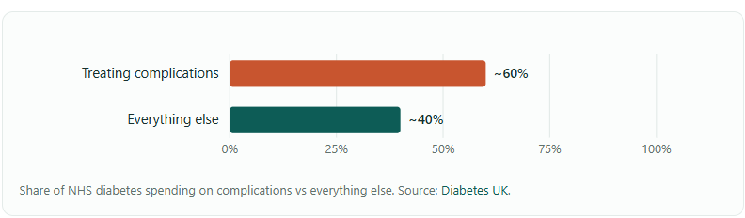
Figure 10: Share of NHS diabetes spending on complications vs everything else.
(Source: Health Insurance UK, 2026)
Policy is ahead of delivery. Less than every sixth patient with type 2 diabetes gets all the eight processes of care and less than half of them achieve all three treatment objectives. Youths have fallen through the net and in 2024/25, 60% of individuals with type 2 diabetes will have missed at least one check (Molnár, Kiss and Wittmann, 2025). Given that the 10 Year Health Plan is not a disease specific plan, priorities of diabetes will be based on how it is implemented locally. In the meantime NHS has 60% of its spending on complications in diabetes, suggesting that the money is spent late not early (Health Insurance UK, 2026).

6. Recommendations for Person Centred Care

6.1 Person Centred and Culturally Sensitive Approaches
The starting of care should be person-centered. The former population (such as Asian, Black African and Black Caribbean) is two to four times more susceptible to diabetes and may get type 2 at a lower weight, so it needs to be considered in risk evaluation and guidance (Katangwe-Chigamba et al., 2024). Services require interpreters, culturally appropriate food education and community-based education. The use of neutral language and avoiding blame should be the best approach because of the 2026 stigmas findings. More than 40% respondents of the 2026 poll reported stigma at times makes them skip appointments and therefore emotional wellbeing must have a spot in any diabetes team (Zaman, 2025).

6.2 Self Management Support Strategies
Educated structuring is not effective unless individuals embrace it and apply it. The question is next attendance and quality as 87.6% offer it in 2024/25. Technology, as well, means self management. CGM, where appropriate according to the NICE advice, provides people with real time information and digital tools are session appropriate to the 10 Year Health Plan theme of the analogue to digital shift. Individuals ought to be aware of their risk (Volčanšek, Janež and Srpčič, 2026). The diabetes UK has provided an online risk score of type 2 diabetes. Path to Remission programme targets individuals who have been recently diagnosed with type 2 diabetes, therefore it must be referred to early and not many years after glucose had been escalating (Valabhji et al., 2024).

6.3 Multidisciplinary and Lifelong Care Considerations
The management of diabetes is a lifetime team work. A role is involved with GPs, practice nurses, diabetes specialist nurses, dietitians, podiatrists, pharmacists, psychologists and eye screening teams. Youngsters require a timed shifting out to adult services, due to the numbers that fail to show up within their teens and early twenties (Rosina et al., 2024).

6.4 Complication Prevention and Later Life and End of Life Care Planning
There are 60% complications leading to NHS spending on diabetes, therefore the biggest lever is to prevent it. NICE now considers the prevention of heart and kidney problems since the diagnosis. Individualisation in treating older individuals This group of people and those who are frail should have their treatment goals being individualised, which the 2026 NICE update cautiously considers (Lam et al., 2026). In end-stage disease, discussions on priorities and less complicated regimes of treatment should begin early.

7. Conclusion
In the UK alone, diabetes has a presence among nearly 6 million and this number has been on the increasing trend. A lot of what works is already known in the system. Risk is mitigated by prevention programmes, structured education widely available, NICE makes heart and kidney protection an outcome of diagnosis and technology is growing. The areas of weakness include delivery and fairness (NHS England, 2026a). Less than six out of ten individuals with type 2 diabetes receive all of the eight care processes, less than half of them achieve all three treatment goals, and young people lack checks. Sealing these disparities implies finding the 1.3 million individuals unaware of their possession of it, culturally sensitive treatment, and emotional assistance in every check-up.

Reference List
Binur Orazumbekova, Hamdani, T., Hodgson, S., Samuel, M., Stow, D., Spreckley, M., Finer, S., Siddiqui, M.K. and Mathur, R. (2025). Evidence of ethnic variations in the relationships between routinely recorded clinical factors and T2D: A systematic review and meta-analysis. International Journal of Obesity. [online] doi:10.1038/s41366-025-01848-9.
Brown, P. (2025). Diabetes remission in the real world. Diabetes & Primary Care, [online] 26(4), Sept., pp.145–7. Available at: https://diabetesonthenet.com/wp-content/uploads/145.-Distilled_Real-world-remission.pdf
Chandrasekaran, P. and Weiskirchen, R. (2024). The role of obesity in type 2 diabetes mellitus—An overview. International Journal of Molecular Sciences, [online] 25(3), pp.1882–1882. doi:10.3390/ijms25031882.
Chemist4U (2025). UK diabetes statistics. [online] Guides. Available at: https://www.chemist-4-u.com/guides/diabetes/diabetes-statistics/
Diabetes UK (2025a). One in five adults now live with diabetes or prediabetes in the UK. [online] Diabetes UK. Available at: https://www.diabetes.org.uk/about-us/news-and-views/one-five-adults-now-live-diabetes-or-prediabetes-uk
Diabetes UK (2026a). Diabetes UK helpline. [online] Diabetes UK. Available at: https://www.diabetes.org.uk/support-for-you/helpline
Diabetes UK (2026b). How many people in the UK have diabetes? [online] Diabetes UK. Available at: https://www.diabetes.org.uk/about-us/about-the-charity/our-strategy/statistics
Diabetes UK. (2025b). 86% Of people with type 1 and 75% of people with type 2 experience judgement for their condition. [online] Available at: https://www.diabetes.org.uk/about-us/news-and-views/86-people-type-1-and-75-people-type-2-experience-judgement-their-condition
Diabetes UK. (2026c). Investing in diabetes care. [online] Available at: https://www.diabetes.org.uk/investing-in-care
EliteCare Health Centers (2023). 5 Common risk factors for type 2 diabetes | EliteCare HC. [online] EliteCare Health Centers. Available at: https://www.elitecarehc.com/blog/5-common-risk-factors-for-type-2-diabetes/
GOV.UK (2025). 10 Year health plan for England: Fit for the future (easy read). [online] GOV.UK. Available at: https://www.gov.uk/government/publications/10-year-health-plan-for-england-fit-for-the-future-easy-read
Hassan, S., Gujral, U.P., Quarells, R.C., Rhodes, E.C., Shah, M.K., Obi, J., Lee, W.-H., Luwi Shamambo, Mary Beth Weber and K.M. Venkat Narayan (2023). Disparities in diabetes prevalence and management by race and ethnicity in the USA: Defining A path forward. The Lancet Diabetes & Endocrinology, 11(7). doi:10.1016/s2213-8587(23)00129-8.
Health Insurance UK (2026). The cost of diabetes: £10Bn a year, and most of it preventable. [online] Healthinsuranceuk.net. Available at: https://www.healthinsuranceuk.net/research/diabetes-care-cost-international
House of Lords (2025). Written Evidence submitted by Izzy Roberts at Diabetes UK. [online] Available at: https://committees.parliament.uk/writtenevidence/147728/pdf/.
International Diabetes Federation (2021). What is diabetes? [online] International Diabetes Federation. Available at: https://www.ncbi.nlm.nih.gov/books/NBK581938/
International Diabetes Federation (2025). Global. [online] Diabetes Atlas. Available at: https://diabetesatlas.org/data-by-location/global/
Kanmani Bharathi (2025). Diabetes: A rapidly growing global health challenge. [Post] LinkedIn. Available at: https://www.linkedin.com/posts/kanmani-bharathi-j_diabetes-publichealth-globalhealth-activity-7388185085931393024-IGI8
Katangwe-Chigamba, T., Kumud Kantilal, Hartley-Palmer, J., Salisu-Olatunji, S.O., Seeley, C., Naughton, F. and Chester, R. (2024). Diet and physical activity interventions for people from minority ethnic backgrounds in the UK: A scoping review exploring barriers, enablers and cultural adaptations. Journal of Racial and Ethnic Health Disparities. doi:10.1007/s40615-024-02112-y.
Lam, C.S.P., Bozkurt, B., Cherney, D.Z.I., Ezekowitz, J.A., Jardine, M.J., Khan, S.S., Madero, M., ter Maaten, J.M. and Cheung, M. (2026). Kidney disease and heart failure: Recent advances and current challenges. JACC: Heart Failure, [online] 14(4), p.102943. doi:10.1016/j.jchf.2026.102943.
Men’s Health Forum (2025). Diabetes FAQs. [online] Menshealthforum.org.uk. Available at: https://www.menshealthforum.org.uk/diabetes-faqs
Molnár, G.A., Kiss, Z. and Wittmann, I. (2025). Young patients with type 2 diabetes have high relative risks for complications in a country with middle-high sociodemographic index, similarly to those countries with high index. Frontiers in Endocrinology, [online] 16. doi:10.3389/fendo.2025.1638565.
NHS (2024). PfD England summary. [online] Amazonaws.com. Available at: https://nhsbsa-opendata.s3.eu-west-2.amazonaws.com/pfd/pfd_summary_narrative_2023_24_v001.html
NHS (2025). House of Care (print version). [online] Whittington.nhs.uk. Available at: https://www.whittington.nhs.uk/default.asp?c=31000&print=1
NHS England (2026a). Classification: Official publication reference: PRN02124 2026/27 NHS Standard Contract Technical Guidance. [online] Available at: https://www.england.nhs.uk/wp-content/uploads/2026/01/nhs-standard-contract-2026-to-2027-technical-guidance-updated-17-April-2026.pdf
NHS England (2026b). National Diabetes Audit Core Report 1: Care Processes and Treatment Targets 2024-25 Underlying data. [online] Available at: https://digital.nhs.uk/data-and-information/publications/statistical/national-diabetes-audit/report-1-cp-and-tt-data-release-2024-25/nda-report-1-cp-and-tt-data-release-2024-25.
NICE (2025). ‘Artificial pancreas’ transforming the lives of thousands of children and young people with type 1 diabetes. [online] NICE website: The National Institute for Health and Care Excellence. Available at: https://www.nice.org.uk/news/articles/-artificial-pancreas-transforming-lives-of-thousands-of-children-and-young-people-with-type-1-diabetes
NICE (2026). Type 2 diabetes in adults: management Pharmacological management of type 2 diabetes. [online] Available at: https://www.nice.org.uk/guidance/ng28/evidence/committee-discussion-pdf-15607227709.
Office for Health Improvement and Disparities (2026). Diabetes profile: Statistical commentary, april 2026. [online] GOV.UK. Available at: https://www.gov.uk/government/statistics/diabetes-profile-update-april-2026/diabetes-profile-statistical-commentary-april-2026
Omniamed Communications (2026). Editorial: A major change to NICE type 2 diabetes guidance - DiabetesontheNet. [online] DiabetesontheNet. Available at: https://diabetesonthenet.com/diabetes-primary-care/editorial-march-2026/
Ravindrarajah, R., Sutton, M., Bower, P. and Kontopantelis, E. (2025). Variation in effectiveness of the NHS Diabetes Prevention Programme in people diagnosed with non‐diabetic hyperglycaemia by age, sex, BMI, and deprivation: A matched cohort analysis of 69,801 people. Diabetic Medicine, 42(7). doi:10.1111/dme.70037.
Rosina, R., McMaster, R., Lovecchio, V. and Wu, C.J. (2024). Young people transitioning from child and adolescent to adult mental health services: A qualitative systematic review. International Journal of Mental Health Nursing, 34(1). doi:10.1111/inm.13439.
Royal College of Paediatrics and Child Health (2026). National paediatric diabetes audit annual report 2024-25: Care processes and outcomes. [online] London: Royal College of Paediatrics and Child Health (RCPCH). Available at: https://www.rcpch.ac.uk/sites/default/files/2026-08/RCPCH_NPDA_Summary%20report%20on%202026%20data_R7.pdf
Valabhji, J., Gorton, T., Barron, E., Safazadeh, S., Earnshaw, F., Helm, C., Virr, M., Kernan, J., Crowe, S., Aveyard, P., Wilding, J., Willis, T., Ells, L., O’Neill, S., Robertson, E., Jebb, S., Taylor, R. and Chirag Bakhai (2024). Early findings from the NHS type 2 diabetes path to remission programme: A prospective evaluation of real-world implementation. The Lancet Diabetes & Endocrinology, [online] 12(9). doi:10.1016/s2213-8587(24)00194-3.
Volčanšek, Š., Janež, A. and Srpčič, M. (2026). The evolving role of continuous glucose monitoring in hospital settings: Bridging the analytical and clinical needs. Diabetology, [online] 7(1), p.6. doi:10.3390/diabetology7010006.
WHO (2026). DSpace. [online] Who.int. Available at: https://iris.who.int/bitstreams/4aea436e-9fc6-4e1f-a0c5-9d57a9213b21/download
Wu, H., Norton, V., Cui, K., Zhu, B., Bhattacharjee, S., Lu, Y.W., Wang, B., Shan, D., Wong, S., Dong, Y., Chan, S.-L., Cowan, D., Xu, J., Bielenberg, D.R., Zhou, C. and Chen, H. (2022). Diabetes and its cardiovascular complications: Comprehensive network and systematic analyses. Frontiers in Cardiovascular Medicine, [online] 9. doi:10.3389/fcvm.2022.841928.
Zaman, M. (2025). Survey Calls Out the Harms of Diabetes Bias . [online] Available at: https://www.healthcentral.com/news/type-1-diabetes/survey-calls-out-the-harms-of-diabetes-bias .

