1802975

CHANGEMAKERS: CREATIVITY AND VALUE CREATION

Table of Contents
Task 1: Moodle Unit 1 – Section 1 & Mind Map 2
Task 2: Moodle Unit 1 – What’s the Problem. Sections 2-4 and Qs 1-3 4
Task 3: Moodle Unit 2 – The worst possible idea. Sections 1, 2 & 4 and Qs 1-4 6
References 8
Appendices 10

Figure 1 Welcome Page 2
Figure 2 Task 1 - Image 1 2
Figure 3 Task 1 - Image 2 3
Figure 4 Task 1 - Image 3 3
Figure 5 Task 2 - Image 1 4
Figure 6 Task 2 - Image 2 4
Figure 7 Task 2 - Image 3 5
Figure 8 Task 2 Image 4 5
Figure 9 task 3 - Image 1 6
Figure 10 Task 3 - Image 2 6
Figure 11 Task 3 Image 3 7

Link to E-Portfolio : https://chagemakers1802975.squarespace.com/
I have added Gareth and Divya to be members of the sign using the University Email. This is due to the ‘Square Space’ advertising being misleading and the site cannot be hosted public for free, even within the 14 day trail period.

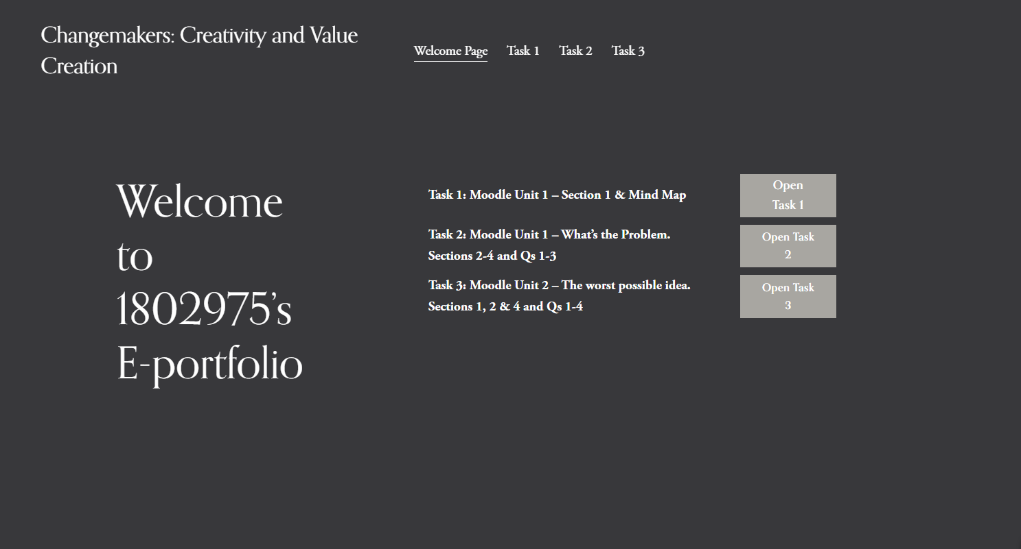
Figure 1 Welcome Page
Task 1: Moodle Unit 1 – Section 1 & Mind Map
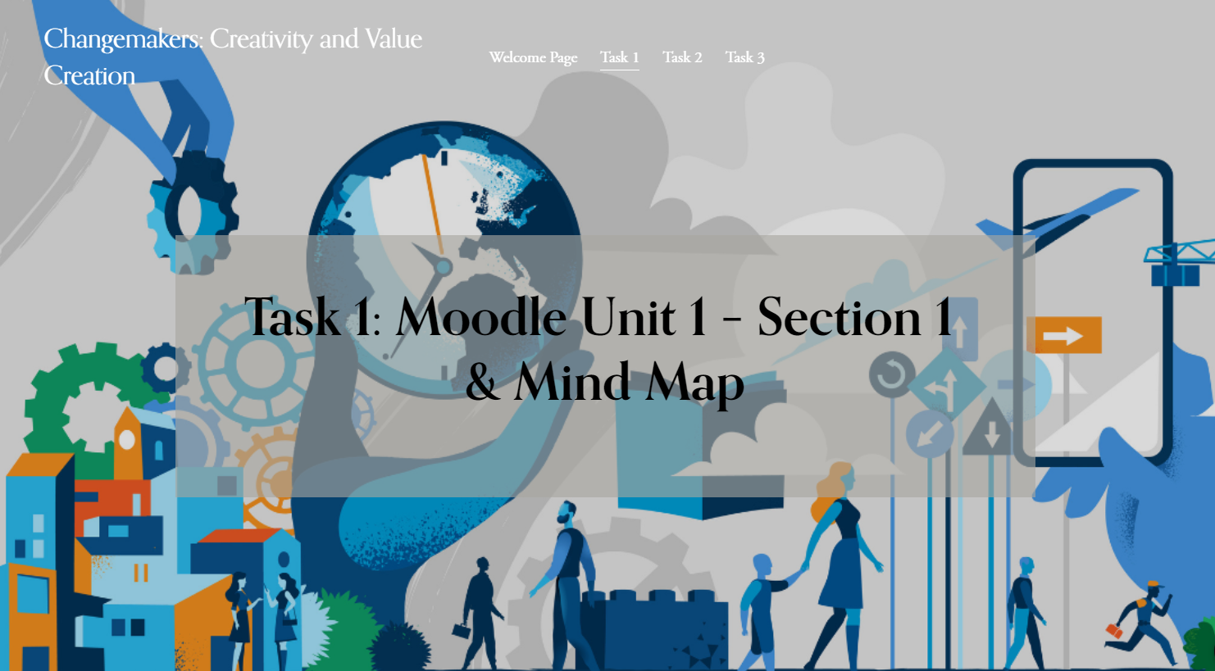
Figure 2 Task 1 - Image 1
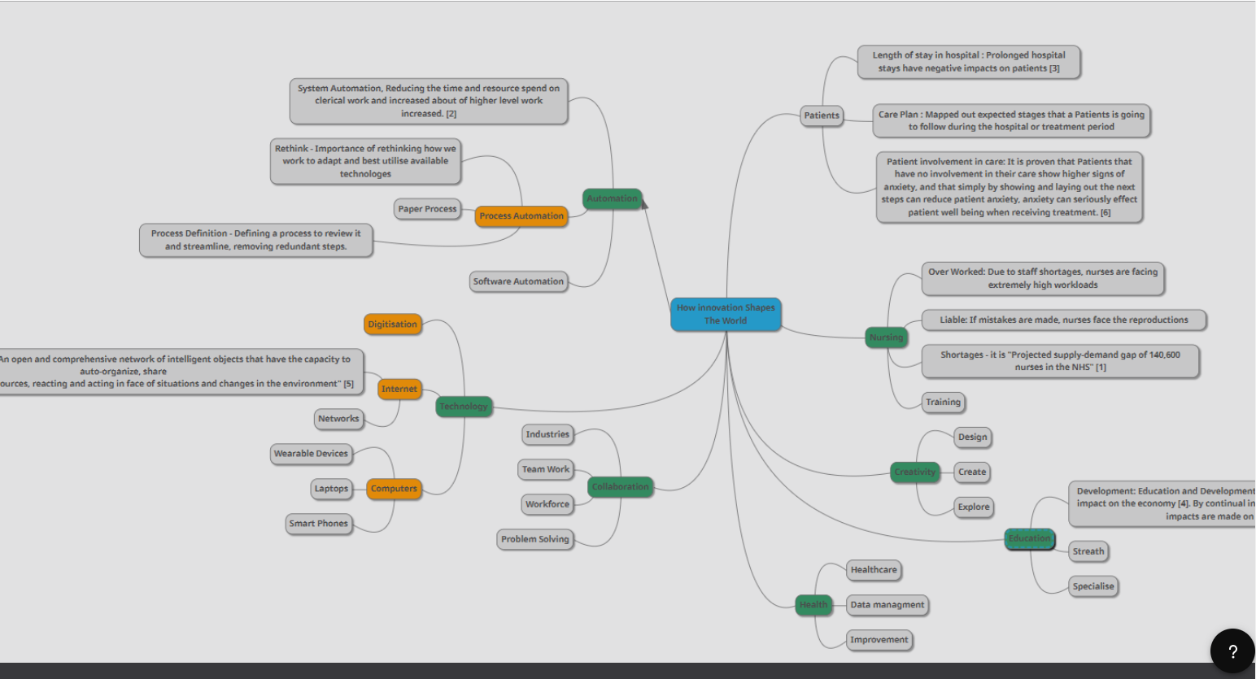
Figure 3 Task 1 - Image 2
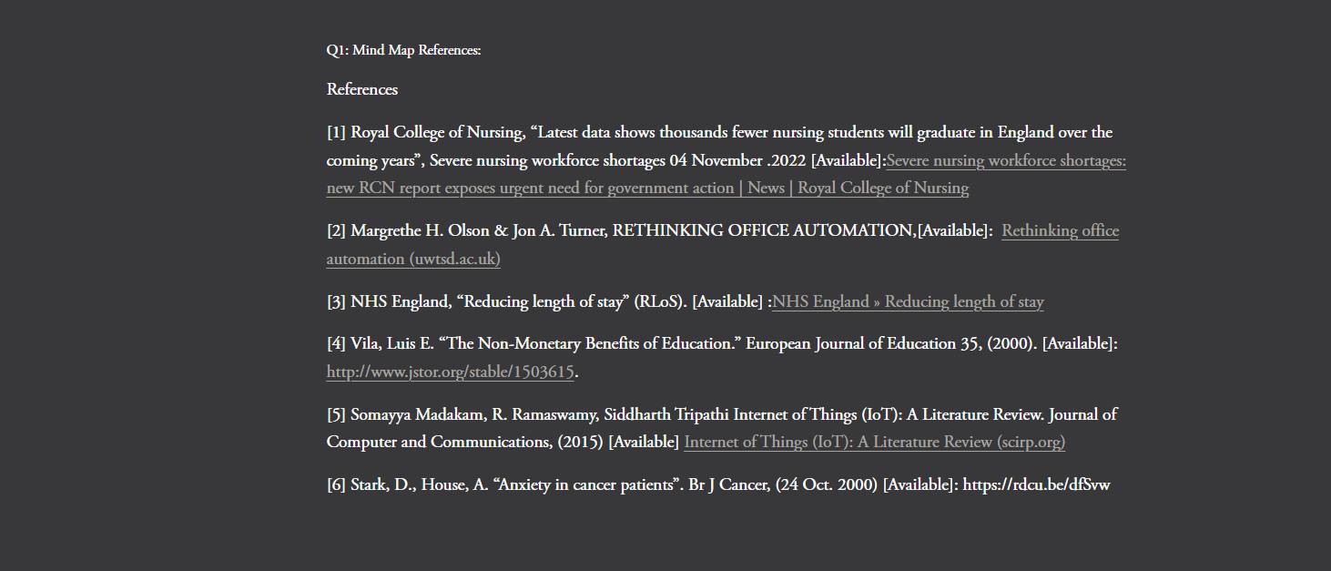
Figure 4 Task 1 - Image 3
Task 2: Moodle Unit 1 – What’s the Problem. Sections 2-4 and Qs 1-3
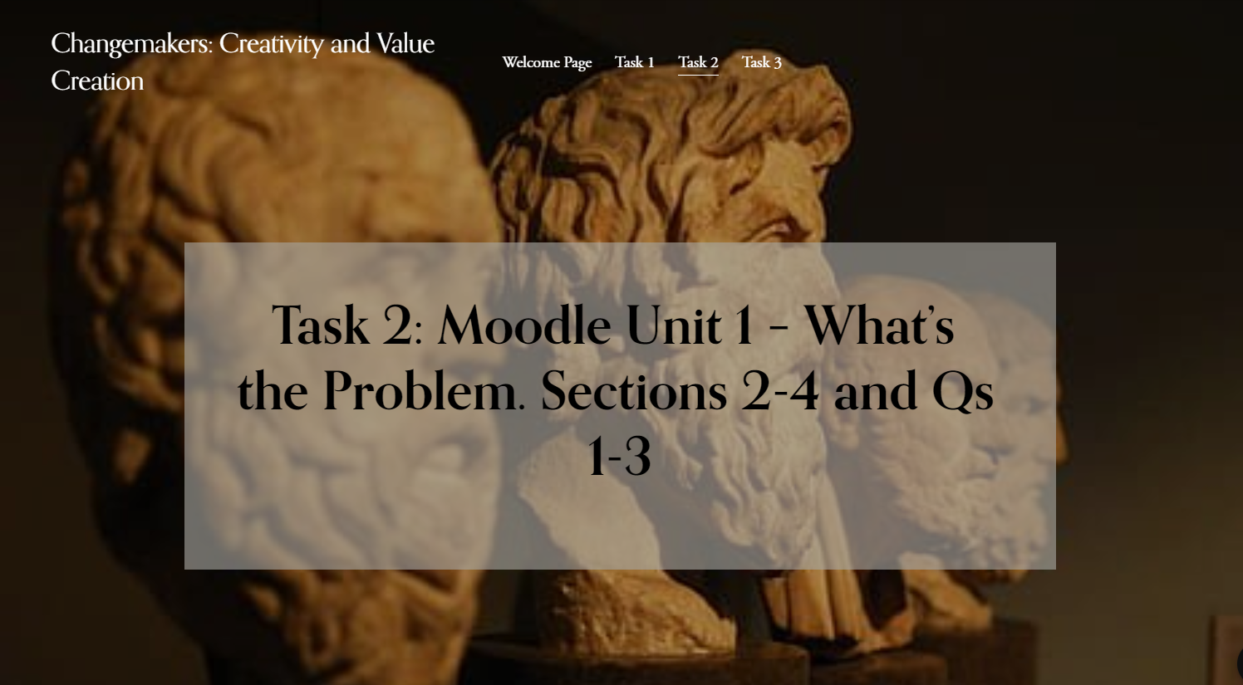
Figure 5 Task 2 - Image 1
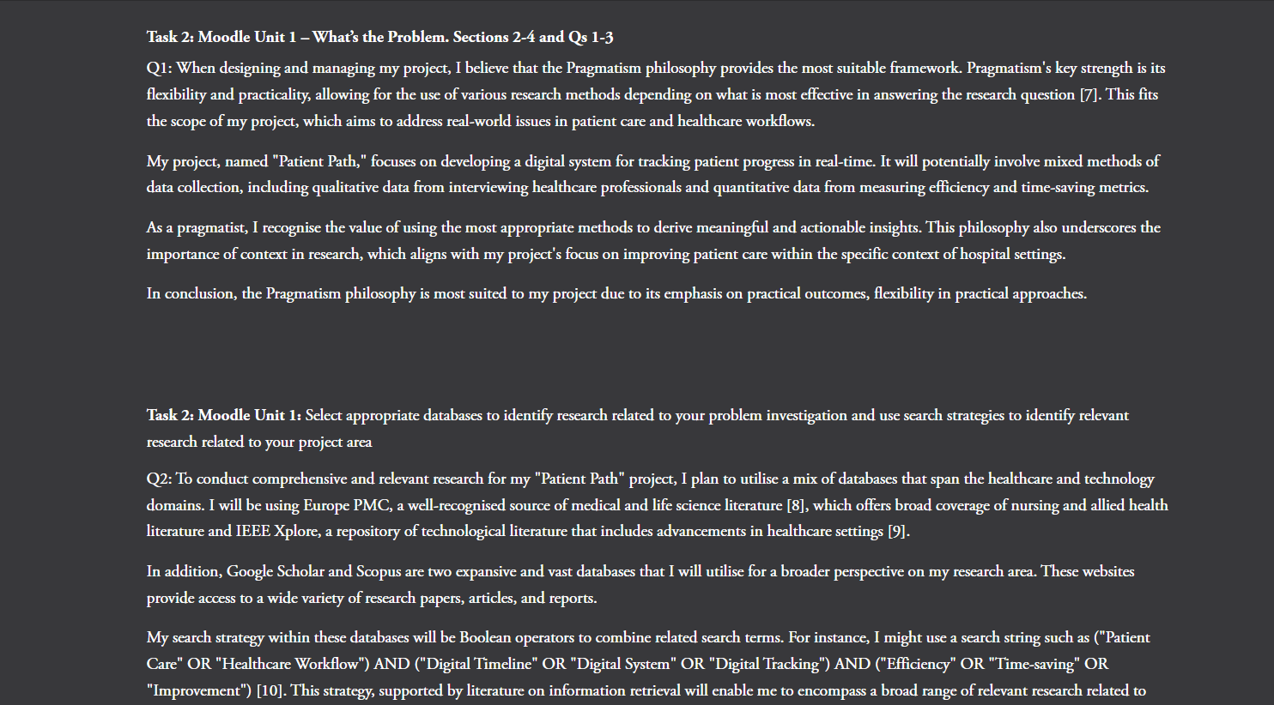
Figure 6 Task 2 - Image 2
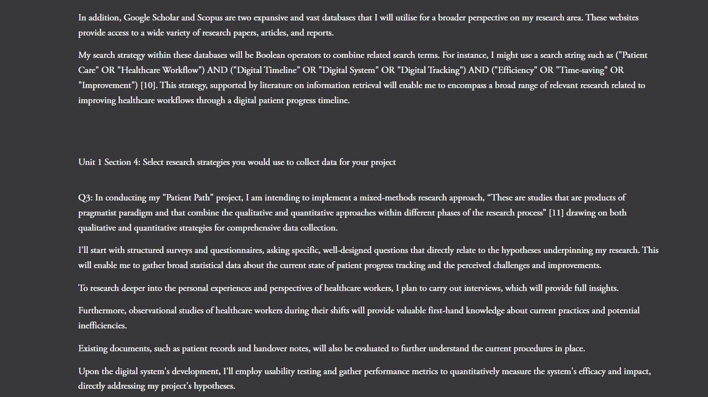
Figure 7 Task 2 - Image 3
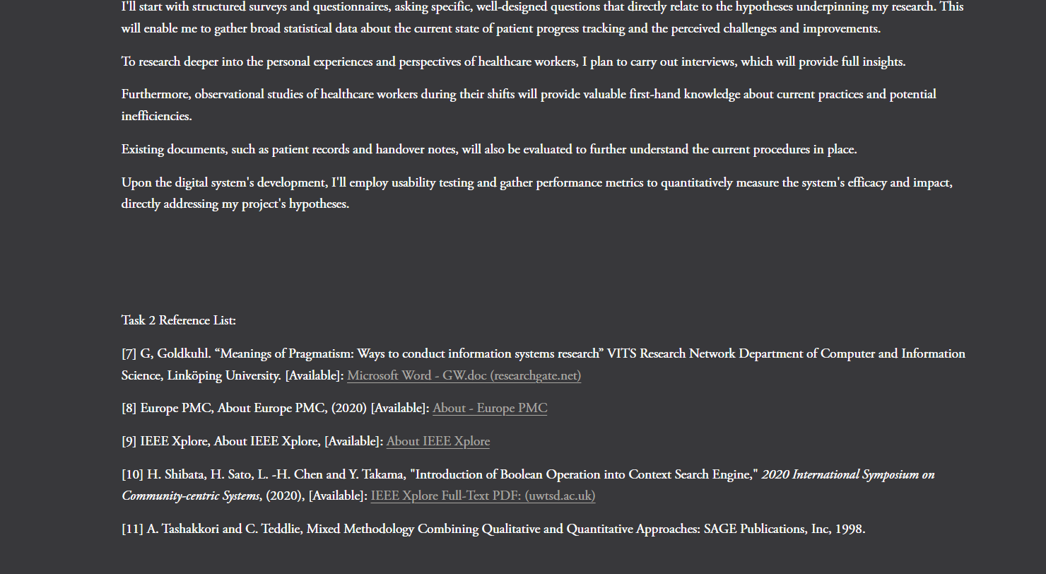
Figure 8 Task 2 Image 4

Task 3: Moodle Unit 2 – The worst possible idea. Sections 1, 2 & 4 and Qs 1-4.
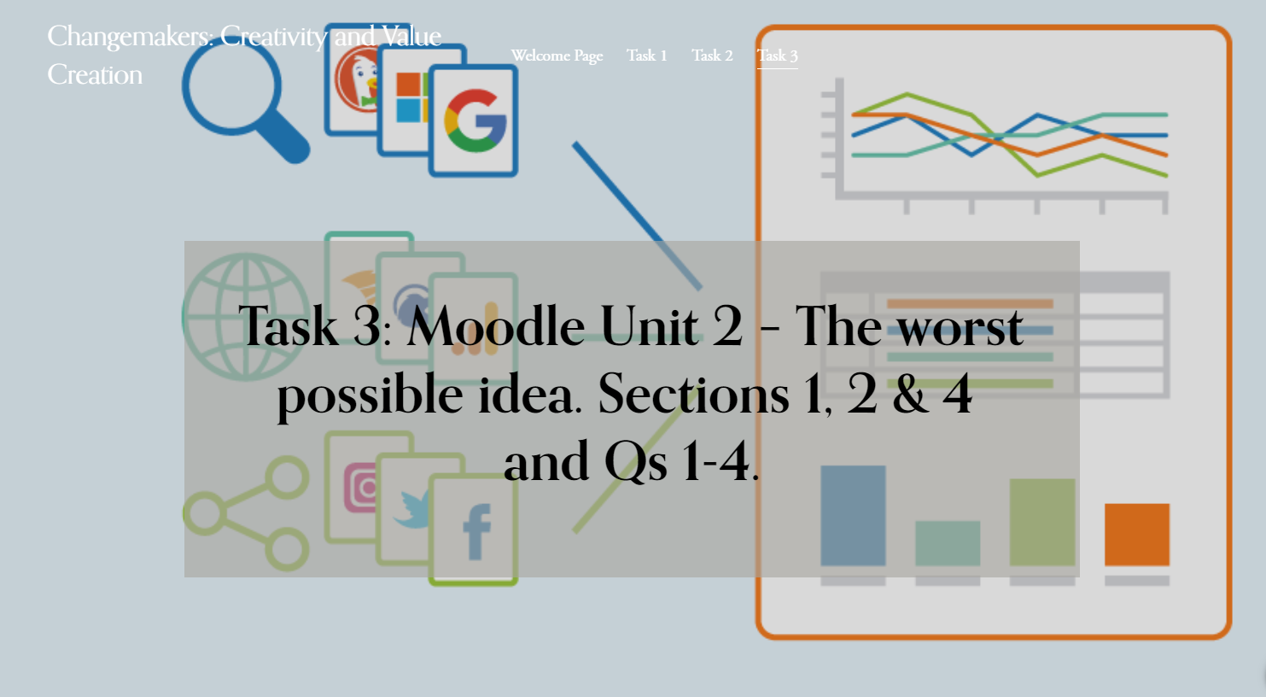
Figure 9 task 3 - Image 1
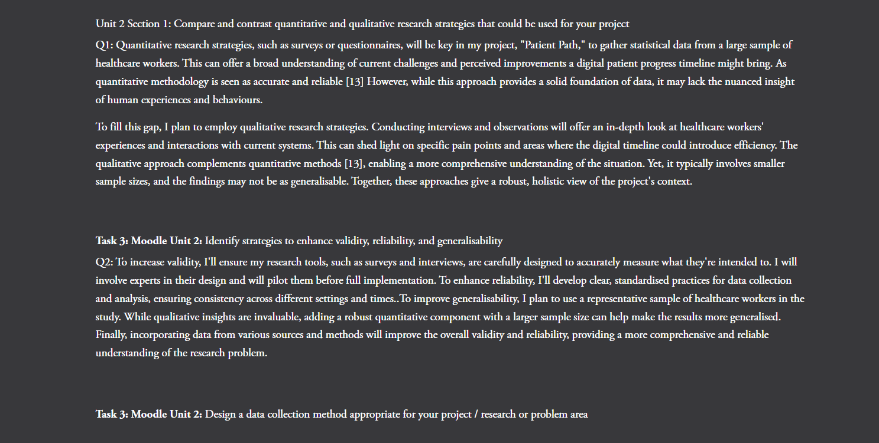
Figure 10 Task 3 - Image 2
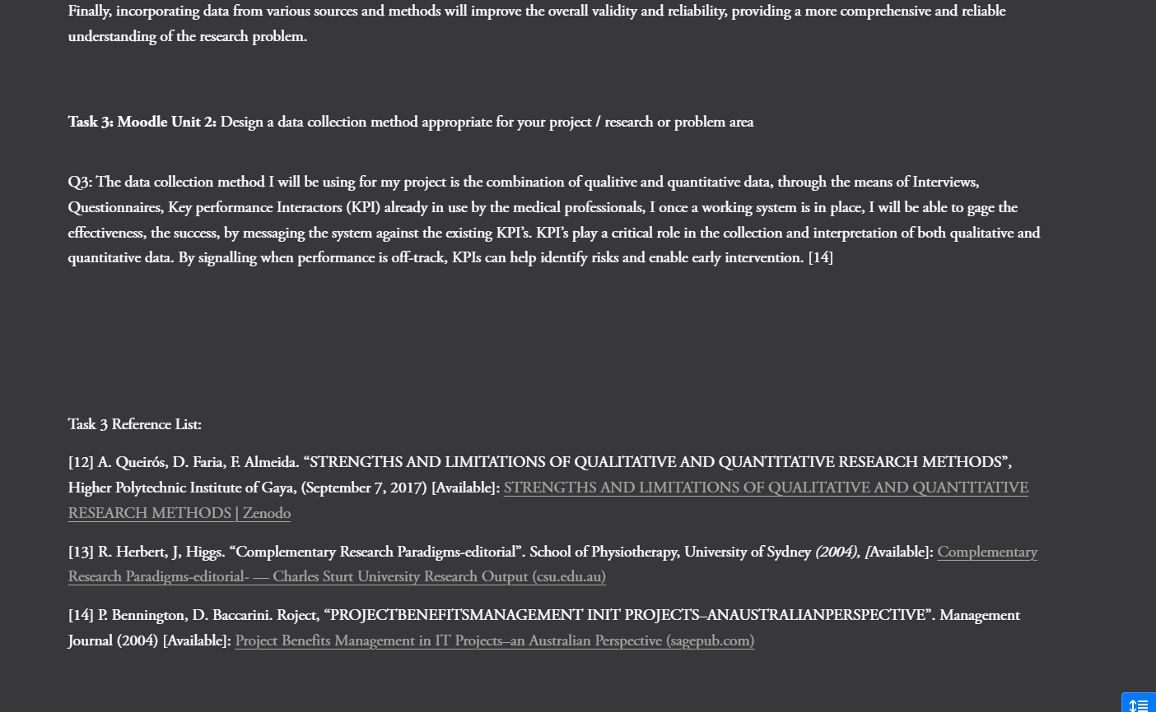
Figure 11 Task 3 Image 3

References
[1] Royal College of Nursing, “Latest data shows thousands fewer nursing students will graduate in England over the coming years”, Severe nursing workforce shortages 04 November .2022 [Available]:Severe nursing workforce shortages: new RCN report exposes urgent need for government action | News | Royal College of Nursing
[2] Margrethe H. Olson & Jon A. Turner, RETHINKING OFFICE AUTOMATION,[Available]: Rethinking office automation (uwtsd.ac.uk)
[3] NHS England, “Reducing length of stay” (RLoS). [Available] :NHS England » Reducing length of stay
[4] Vila, Luis E. “The Non-Monetary Benefits of Education.” European Journal of Education 35, (2000). [Available]: http://www.jstor.org/stable/1503615.
[5] Somayya Madakam, R. Ramaswamy, Siddharth Tripathi Internet of Things (IoT): A Literature Review. Journal of Computer and Communications, (2015) [Available] Internet of Things (IoT): A Literature Review (scirp.org)
[6] Stark, D., House, A. “Anxiety in cancer patients”. Br J Cancer, (24 Oct. 2000) [Available]: https://rdcu.be/dfSvw
[7] G, Goldkuhl. “Meanings of Pragmatism: Ways to conduct information systems research” VITS Research Network Department of Computer and Information Science, Linköping University. [Available]: Microsoft Word - GW.doc (researchgate.net)
[8] Europe PMC, About Europe PMC, (2020) [Available]: About - Europe PMC
[9] IEEE Xplore, About IEEE Xplore, [Available]: About IEEE Xplore
[10] H. Shibata, H. Sato, L. -H. Chen and Y. Takama, "Introduction of Boolean Operation into Context Search Engine," 2020 International Symposium on Community-centric Systems, (2020), [Available]: IEEE Xplore Full-Text PDF: (uwtsd.ac.uk)
[11] A. Tashakkori and C. Teddlie, Mixed Methodology Combining Qualitative and Quantitative Approaches: SAGE Publications, Inc, 1998.
[12] A. Queirós, D. Faria, F. Almeida. “STRENGTHS AND LIMITATIONS OF QUALITATIVE AND QUANTITATIVE RESEARCH METHODS”, Higher Polytechnic Institute of Gaya, (September 7, 2017) [Available]: STRENGTHS AND LIMITATIONS OF QUALITATIVE AND QUANTITATIVE RESEARCH METHODS | Zenodo
[13] R. Herbert, J, Higgs. “Complementary Research Paradigms-editorial”. School of Physiotherapy, University of Sydney (2004), [Available]: Complementary Research Paradigms-editorial- — Charles Sturt University Research Output (csu.edu.au)
[14] P. Bennington, D. Baccarini. Roject, “PROJECTBENEFITSMANAGEMENT INIT PROJECTS–ANAUSTRALIANPERSPECTIVE”. Management Journal (2004) [Available]: Project Benefits Management in IT Projects–an Australian Perspective (sagepub.com)

Appendices
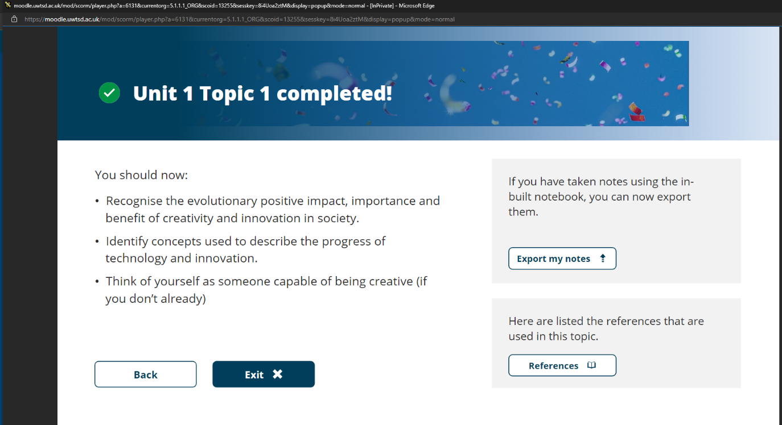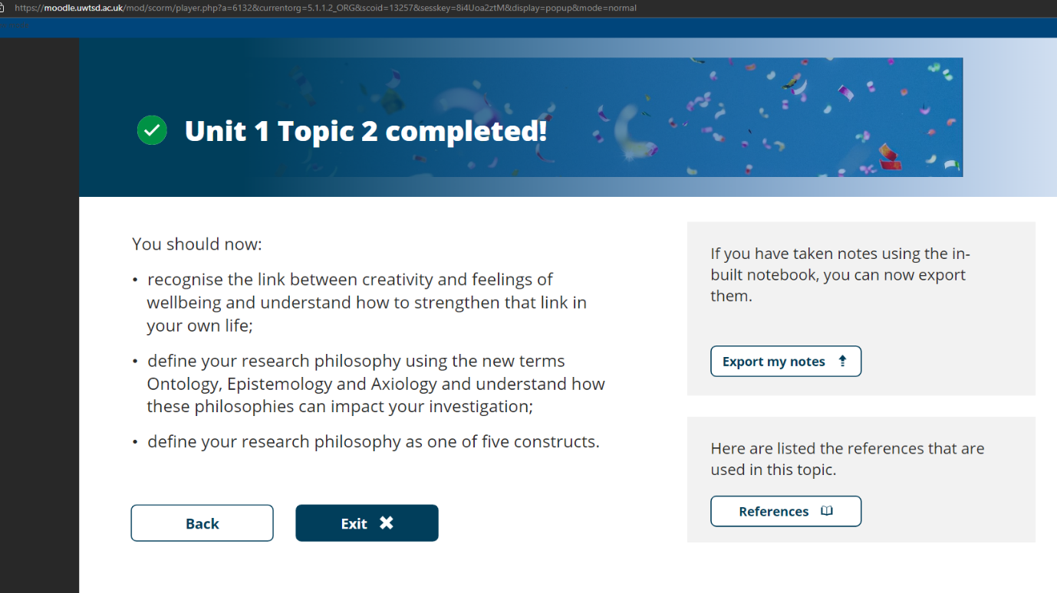
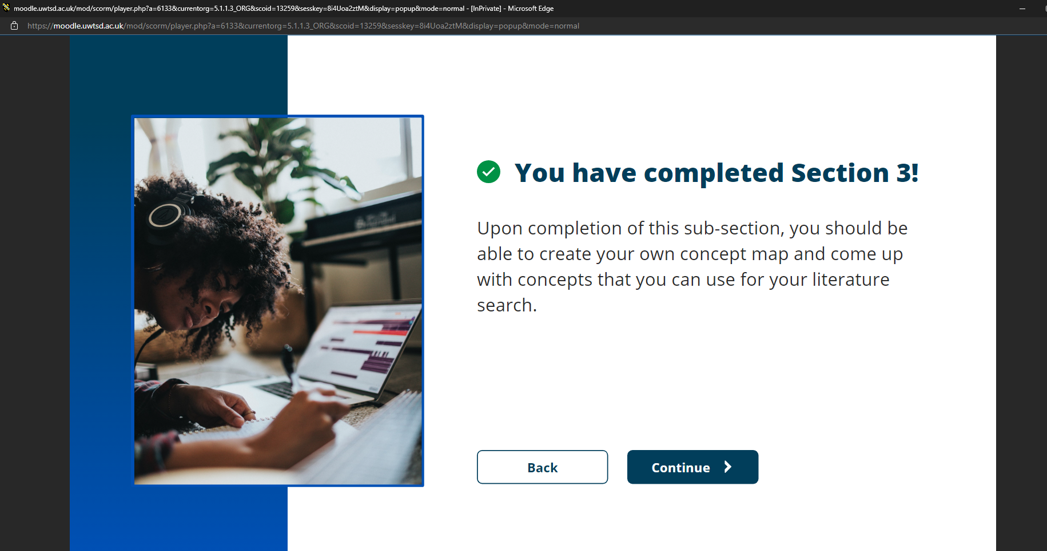
Would not let me progress to get Unit 1 section 3 Complete screen. 

