University of Wales Trinity Saint David (UWTSD)
Unit /Module: End User Computing
Module Code: M6X01097
Lecturer: Beverley Holland
Assignment Title: Evaluating a GIS as an alternative EUD Submission Date: 04-05-2018
Table of Contents

Table of Figures 1
Introduction 2
What is a GIS 2
Using thematic maps to display data 3
Geo-visualisation based on socio-demographic data 3
Case study using GIS and Excel 3
Using GIS to gather data 3
Measles Mumps and Rubella (MMR) Vaccine 7
Using Excel to gather data 15
Conclusion 18
References 18

Table of Figures

Figure 1 - Townsend Data Bridgend 4
Figure 2 - Not Deprived 5
Figure 3 – Deprived 1 Dimension 5
Figure 4 - Deprived 2 Dimension 6
Figure 5 - Deprived 3 Dimension 6
Figure 6 – Deprived 4 Dimension 7
Figure 7- Age 2 FY 13/14 8
Figure 8 - Age 2 FY 14/15 9
Figure 9 - Age 2 15/16 9
Figure 10 - Age 2 16/17 10
Figure 11 - Age 5 FY13/14 10
Figure 12 - Age 5 FY14/15 11
Figure 13 - Age 5 15/16 11
Figure 14- Age 5 16/17 12
Figure 15 - Age 16 FY14/15 12
Figure 16 - Age 16 FY15/16 13
Figure 17 - Age 16 FY16/17 13
Figure 18 - Age 16 2nd Dose FY14/15 14
Figure 19 - Age 16 2nd Dose FY15/16 14
Figure 20 - Age 16 2nd Dose FY 16/17 15
Figure 21 - Example of 3D Map 16
Figure 22 - map showing MMR Immunisation data in Bridgend area from Health in Wales data 16
Figure 23 - Map showing population data Bridgend 0 to 24 year olds from UK Data Service 17
Figure 24 - Power View example 18

Introduction
This report demonstrates the use of Geographical Information System (GIS) software to analyse socio-economic information from data sources such as; The UK Data Services, Health Maps Wales, Health in Wales and Local Authorities. The deprivation and healthcare data that has been demonstrated in this report can be used to inform policy makers and enable them to make changes based on data and information which builds into strategic planning within the NHS and local authorities.
There are many application areas that use GIS such as; Defence Agencies, Commerce and Business, Utilities, and Environmental Management [1]. For this report I have concentrated on Socio-economic/government to demonstrate how GIS can be powerful.
The emergence of GIS was to replace manual cartography with a digital solution and by 1995 many paper maps had been digitised by the Ordinance Survey organisation.

What is a GIS
There are many definitions of GIS, and these vary depending on who has given it, what their background is and their particular views [1]. To summarise, a GIS based on the various definitions is that; it is a computer system that can handle and use databases of information that describes objects or places on the earth’s surface. It can provide a model of geographical reality and can tell us if there are any geographical patterns and if any changes have occurred over a given time period. It can bring together locations, patterns and trends [1].
GIS could be a useful recourse to help someone to make a decision about moving to a particular area. They could look at if there are good schools in the area, if it’s close to public transport, close to a motorway or if it has adequate health provisions such as hospitals or doctors surgeries in the area. It would be likely that housing developers would use GIS when investigating the possibility of building houses in a particular area and if it would appeal to people. People are likely to buy property if there are schools, healthcare provisions and train stations nearby. GIS could be a useful application to help with this sort of analysis.
GIS uses two elements; Aspacial and Spacial. Aspacial giving the population of an area. Spatial giving the number of those people in that populated area who own a car.

Using thematic maps to display data
To display and pull together the spacial data, maps can be used to visually digest the information. Maps have been around a very long time, the Babylonian map as early as 1400BC. Every map has a purpose and reason to be created, using maps for GIS can help to identify spacial patterns and trends. By using the tool Mapinfo this can allow the user to create various thematic maps built up in unique layers of data. It is possible to display the same data in different representations to look at it in different ways.
The data can be displayed in various formats such as; coloured ranges, bar charts, pie charts, symbols, dot density, individual and on a grid. I will demonstrate various ways below within the case study on how the thematic data can be displayed. [2]

Geo-visualisation based on socio-demographic data
The importance of carrying out geo-visualisation based on socio-demographic data is paramount in influencing policy and change in society. The value of analysing areas of high deprivation can be highly beneficial it can work towards improving health, education, employment, housing, social support and wellbeing which in return could result in an improved society for future generations. It can be used to carry out health surveillance and can highlight what is happening in an area. It is important to demonstrate that these highly deprived areas need work and investment otherwise you will never see any improvements and there will continue to be vast pressures on the economy especially in an ageing population as it increases. This can result in vast pressures on the NHS and social care services, local government and other areas of the public sector.

Case study using GIS and Excel
The case study in this report is a representation of deprivation and immunisation data captured and displayed using GIS and Excel. Demonstrating the benefits and drawbacks of each tool when analysing data and the quality of the data that can be delivered using each system.

Using GIS to gather data
GIS data is represented in layers demonstrating data in various different ways. Figure 1 below shows the Townsend data within the Bridgend area. Townsend scores are calculated using the population base to measure deprivation using the UK Data Service with calculations on a spreadsheet using indicators of home ownership, unemployment, car ownership and household overcrowding to create a Zscore and overall Townsend Score.
Figure 1 is demonstrating that the higher deprived areas in Bridgend are coloured in red and orange and the more affluent areas being dark green.
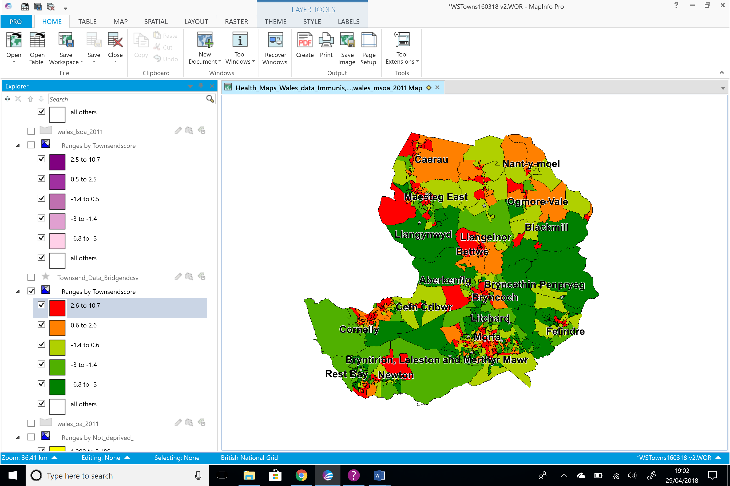
Figure 1 - Townsend Data Bridgend
Figures 2 to 6 shows the various dimensions of deprivation within the Bridgend area in separate layers. The deprivation data is a measurement of multiple deprivation at a lower layer super output area level known as the LSOA.

The data shows that there is little or no deprivation in Penprysg, Felindre (Pencoed), Rest Bay, Newton, Cefn Cribwr, Bryntirion, Laleston and Merthyr Mawr.

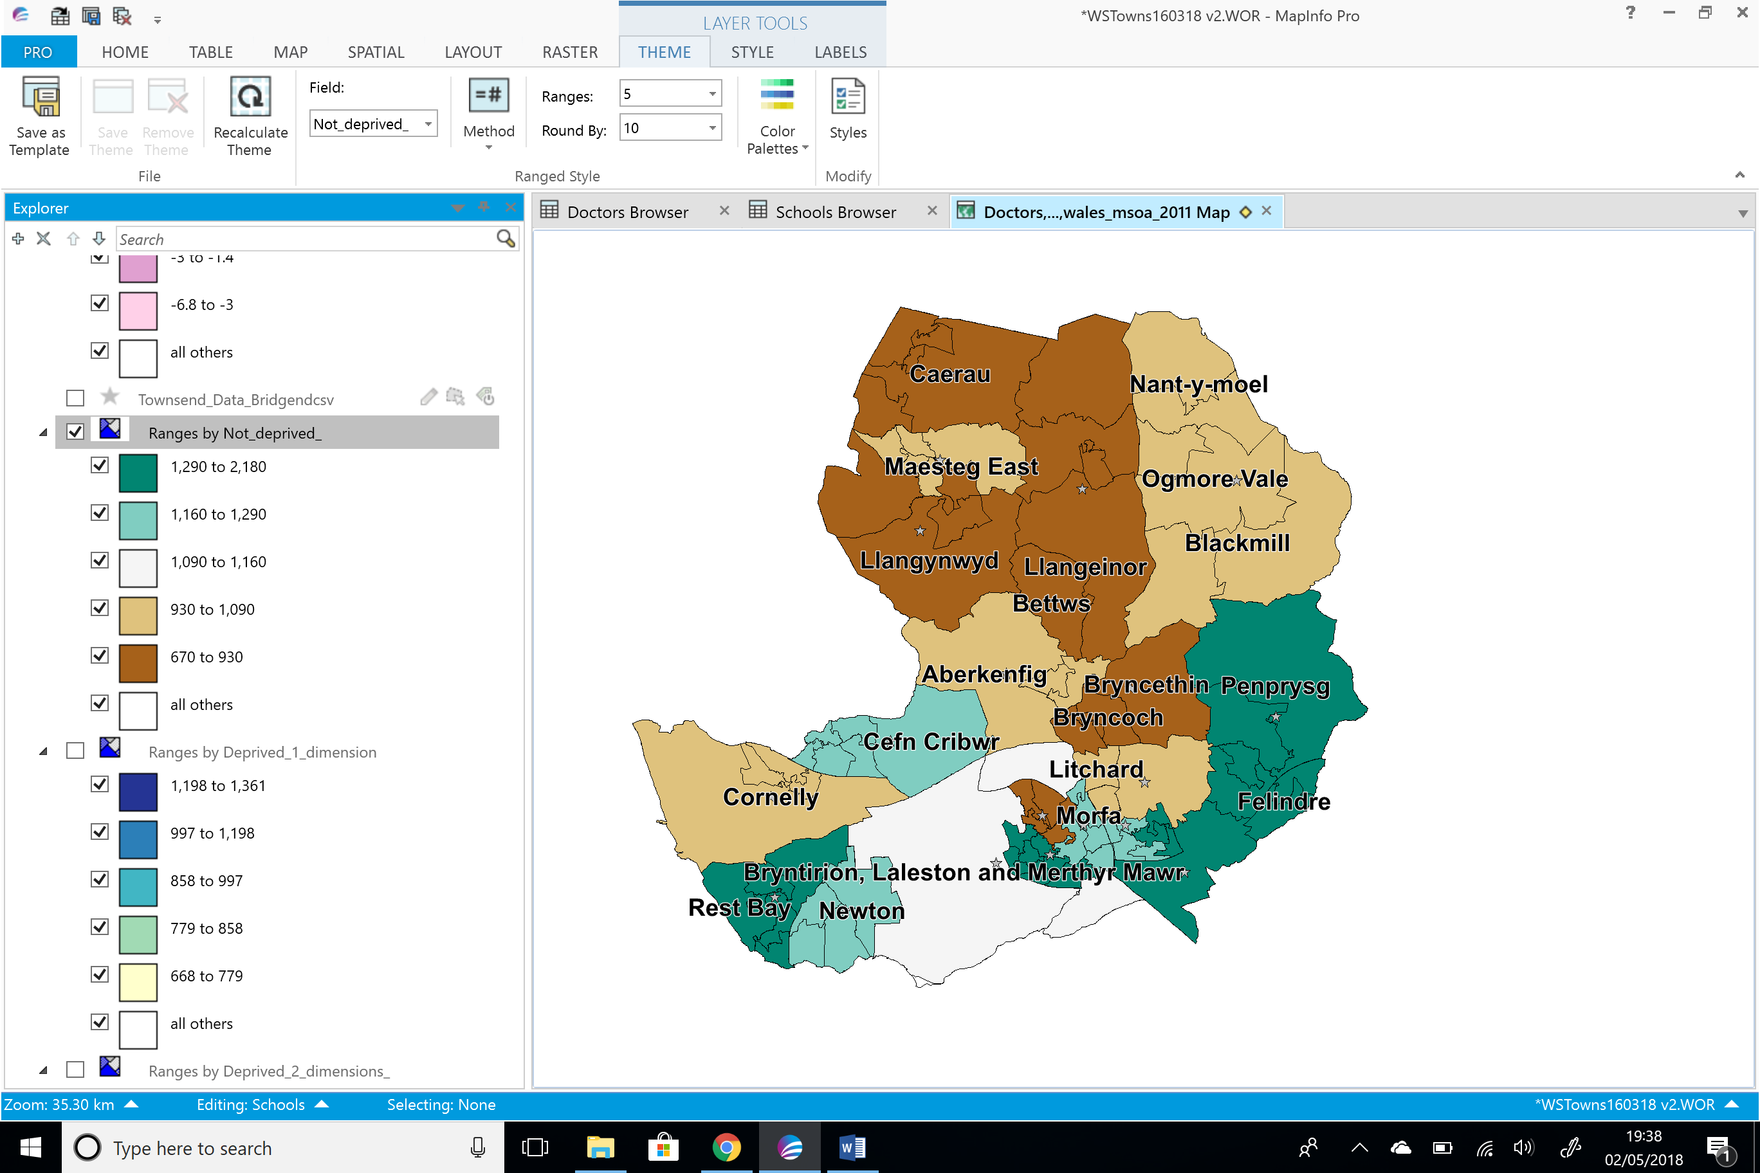

Figure 2 - Not Deprived

The data shows that the highest areas deprived in 1 dimension are; Rest Bay, Cefn Cribwr, Morfa, Penprysg/Felindre (Pencoed), Blackmill, Ogmore Vale and Nant-y-moel.

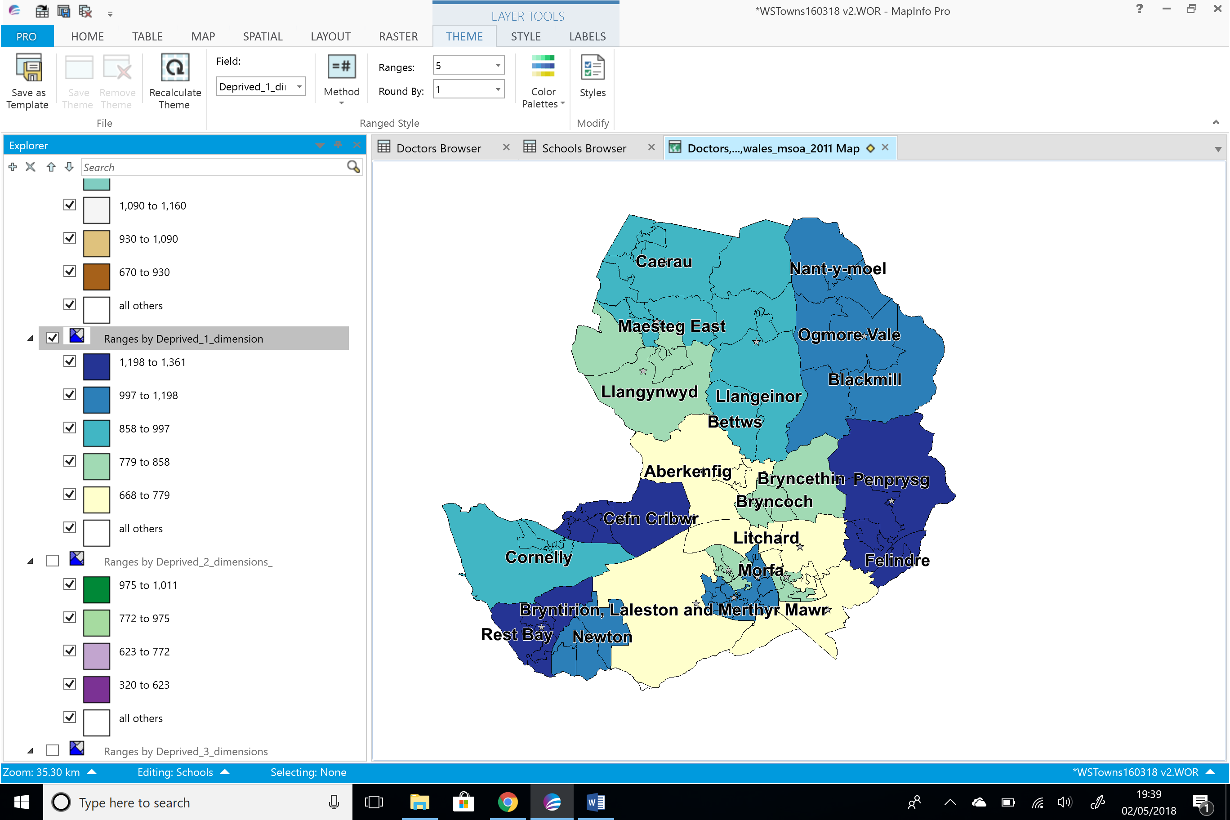

Figure 3 – Deprived 1 Dimension

The data shows that the highest areas deprived in 2 dimensions are; Nant-y-moel, Ogmore Vale, Blackmill, Llangeinor, Bettws, Cefyn Cribwr, Morfa, Caerau/Maesteg, Penprysg/Felinder (Pencoed).

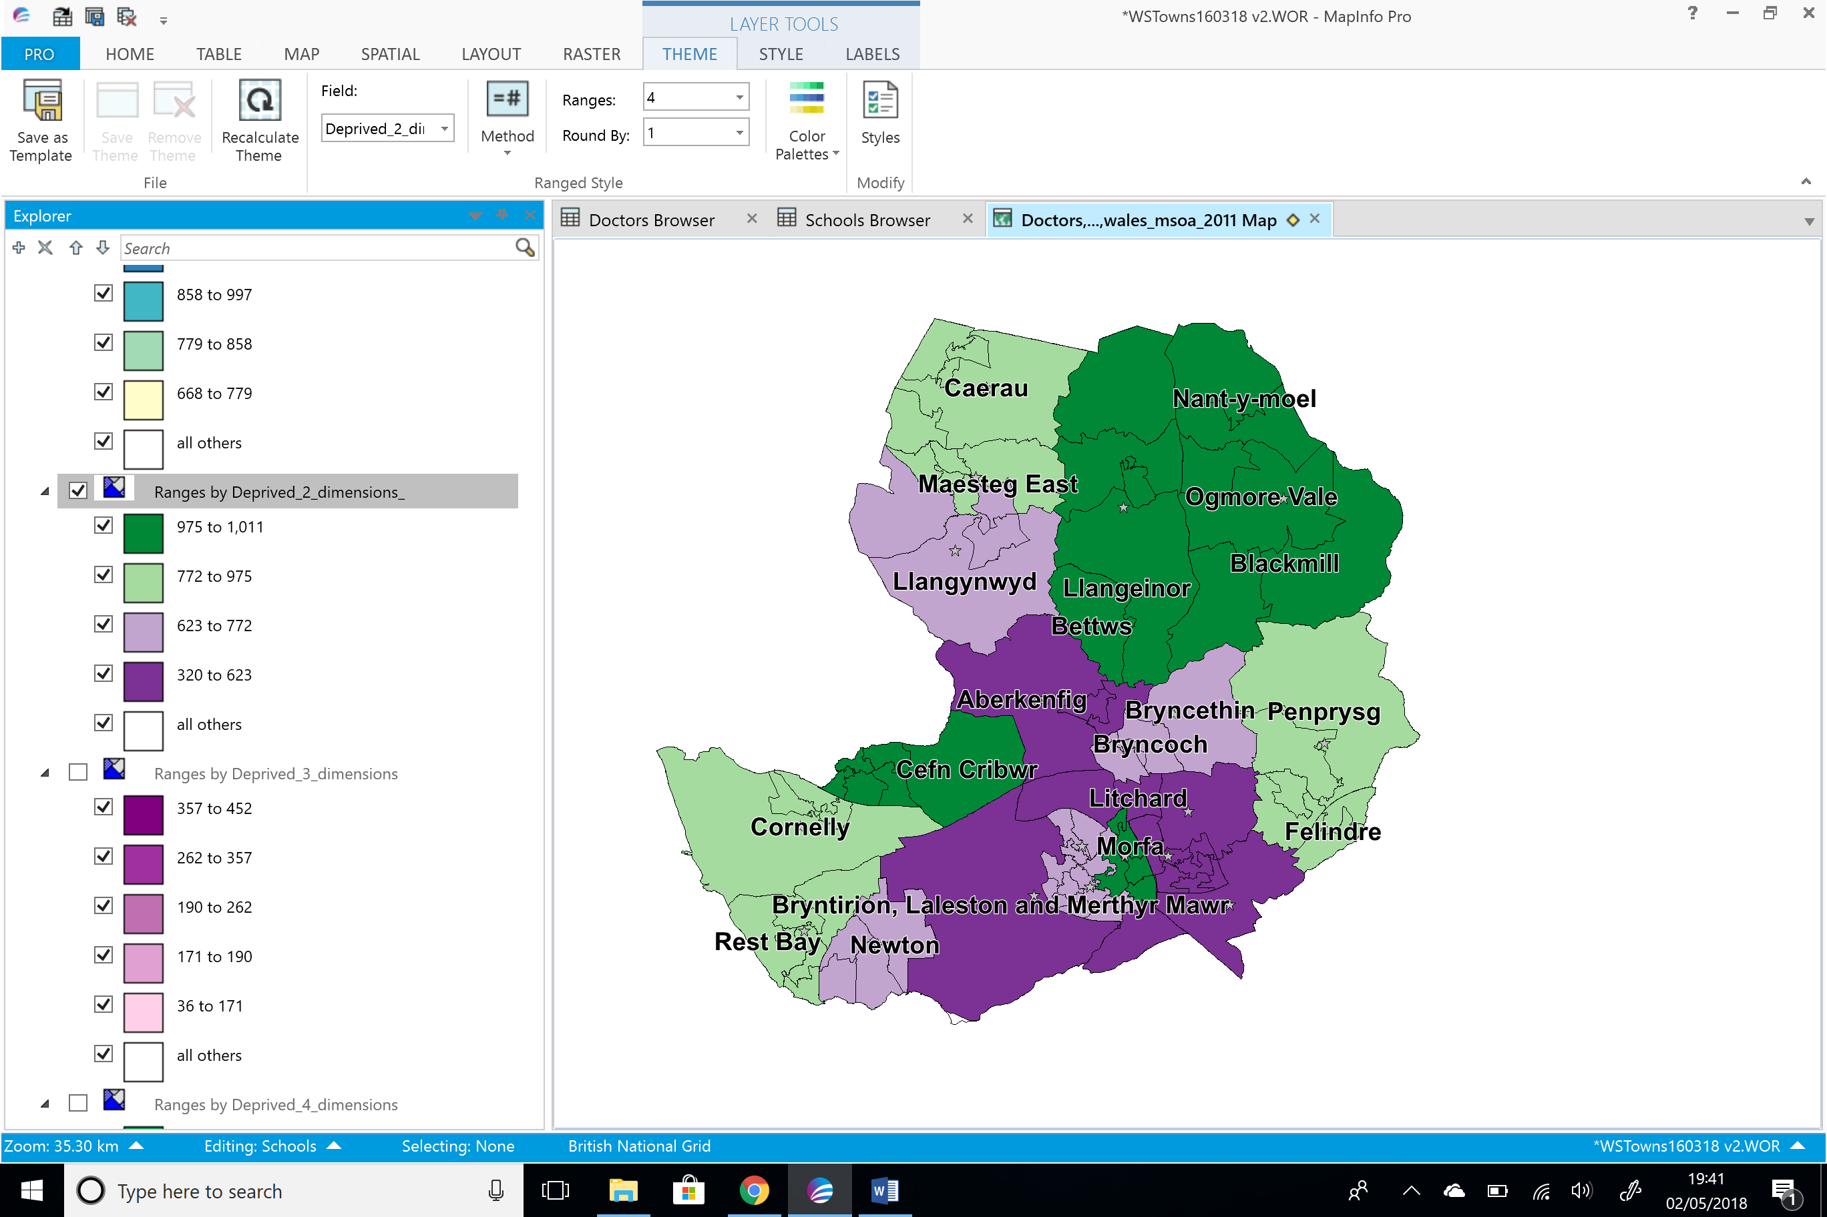

Figure 4 - Deprived 2 Dimension

The data shows that the highest areas deprived in 3 dimensions are; Caerau, Maesteg, Cefn Cribwr, Cornelly, Morfa, Nant-y-moel, Ogmore Vale and Blackmill.

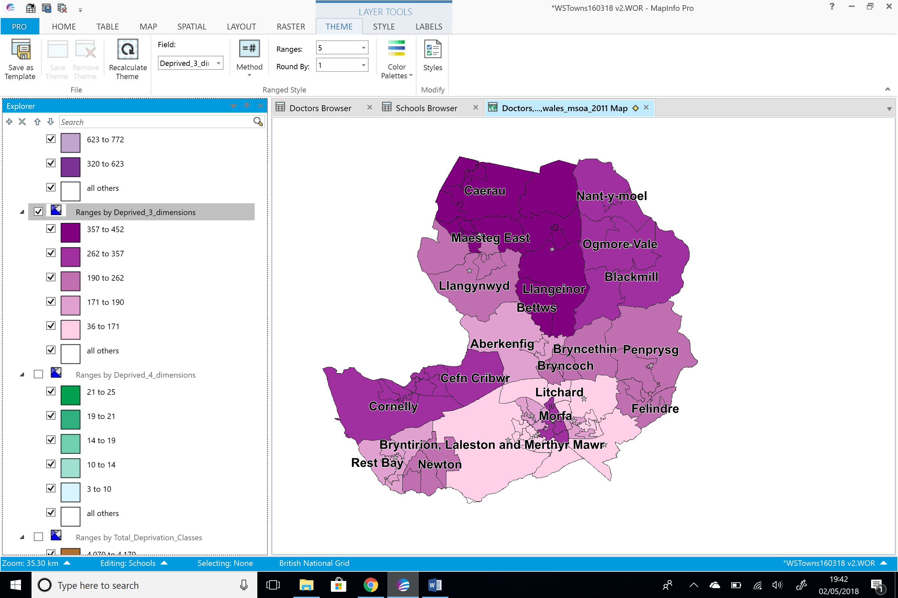

Figure 5 - Deprived 3 Dimension

The data shows that the highest areas deprived in 4 dimensions are; Maesteg, Caerau, Llangeinor, Bettws, Nant-y-moel, Ogmore Vale, Blackmill, Penprysg/Felindre (Pencoed), Morfa and Newton.

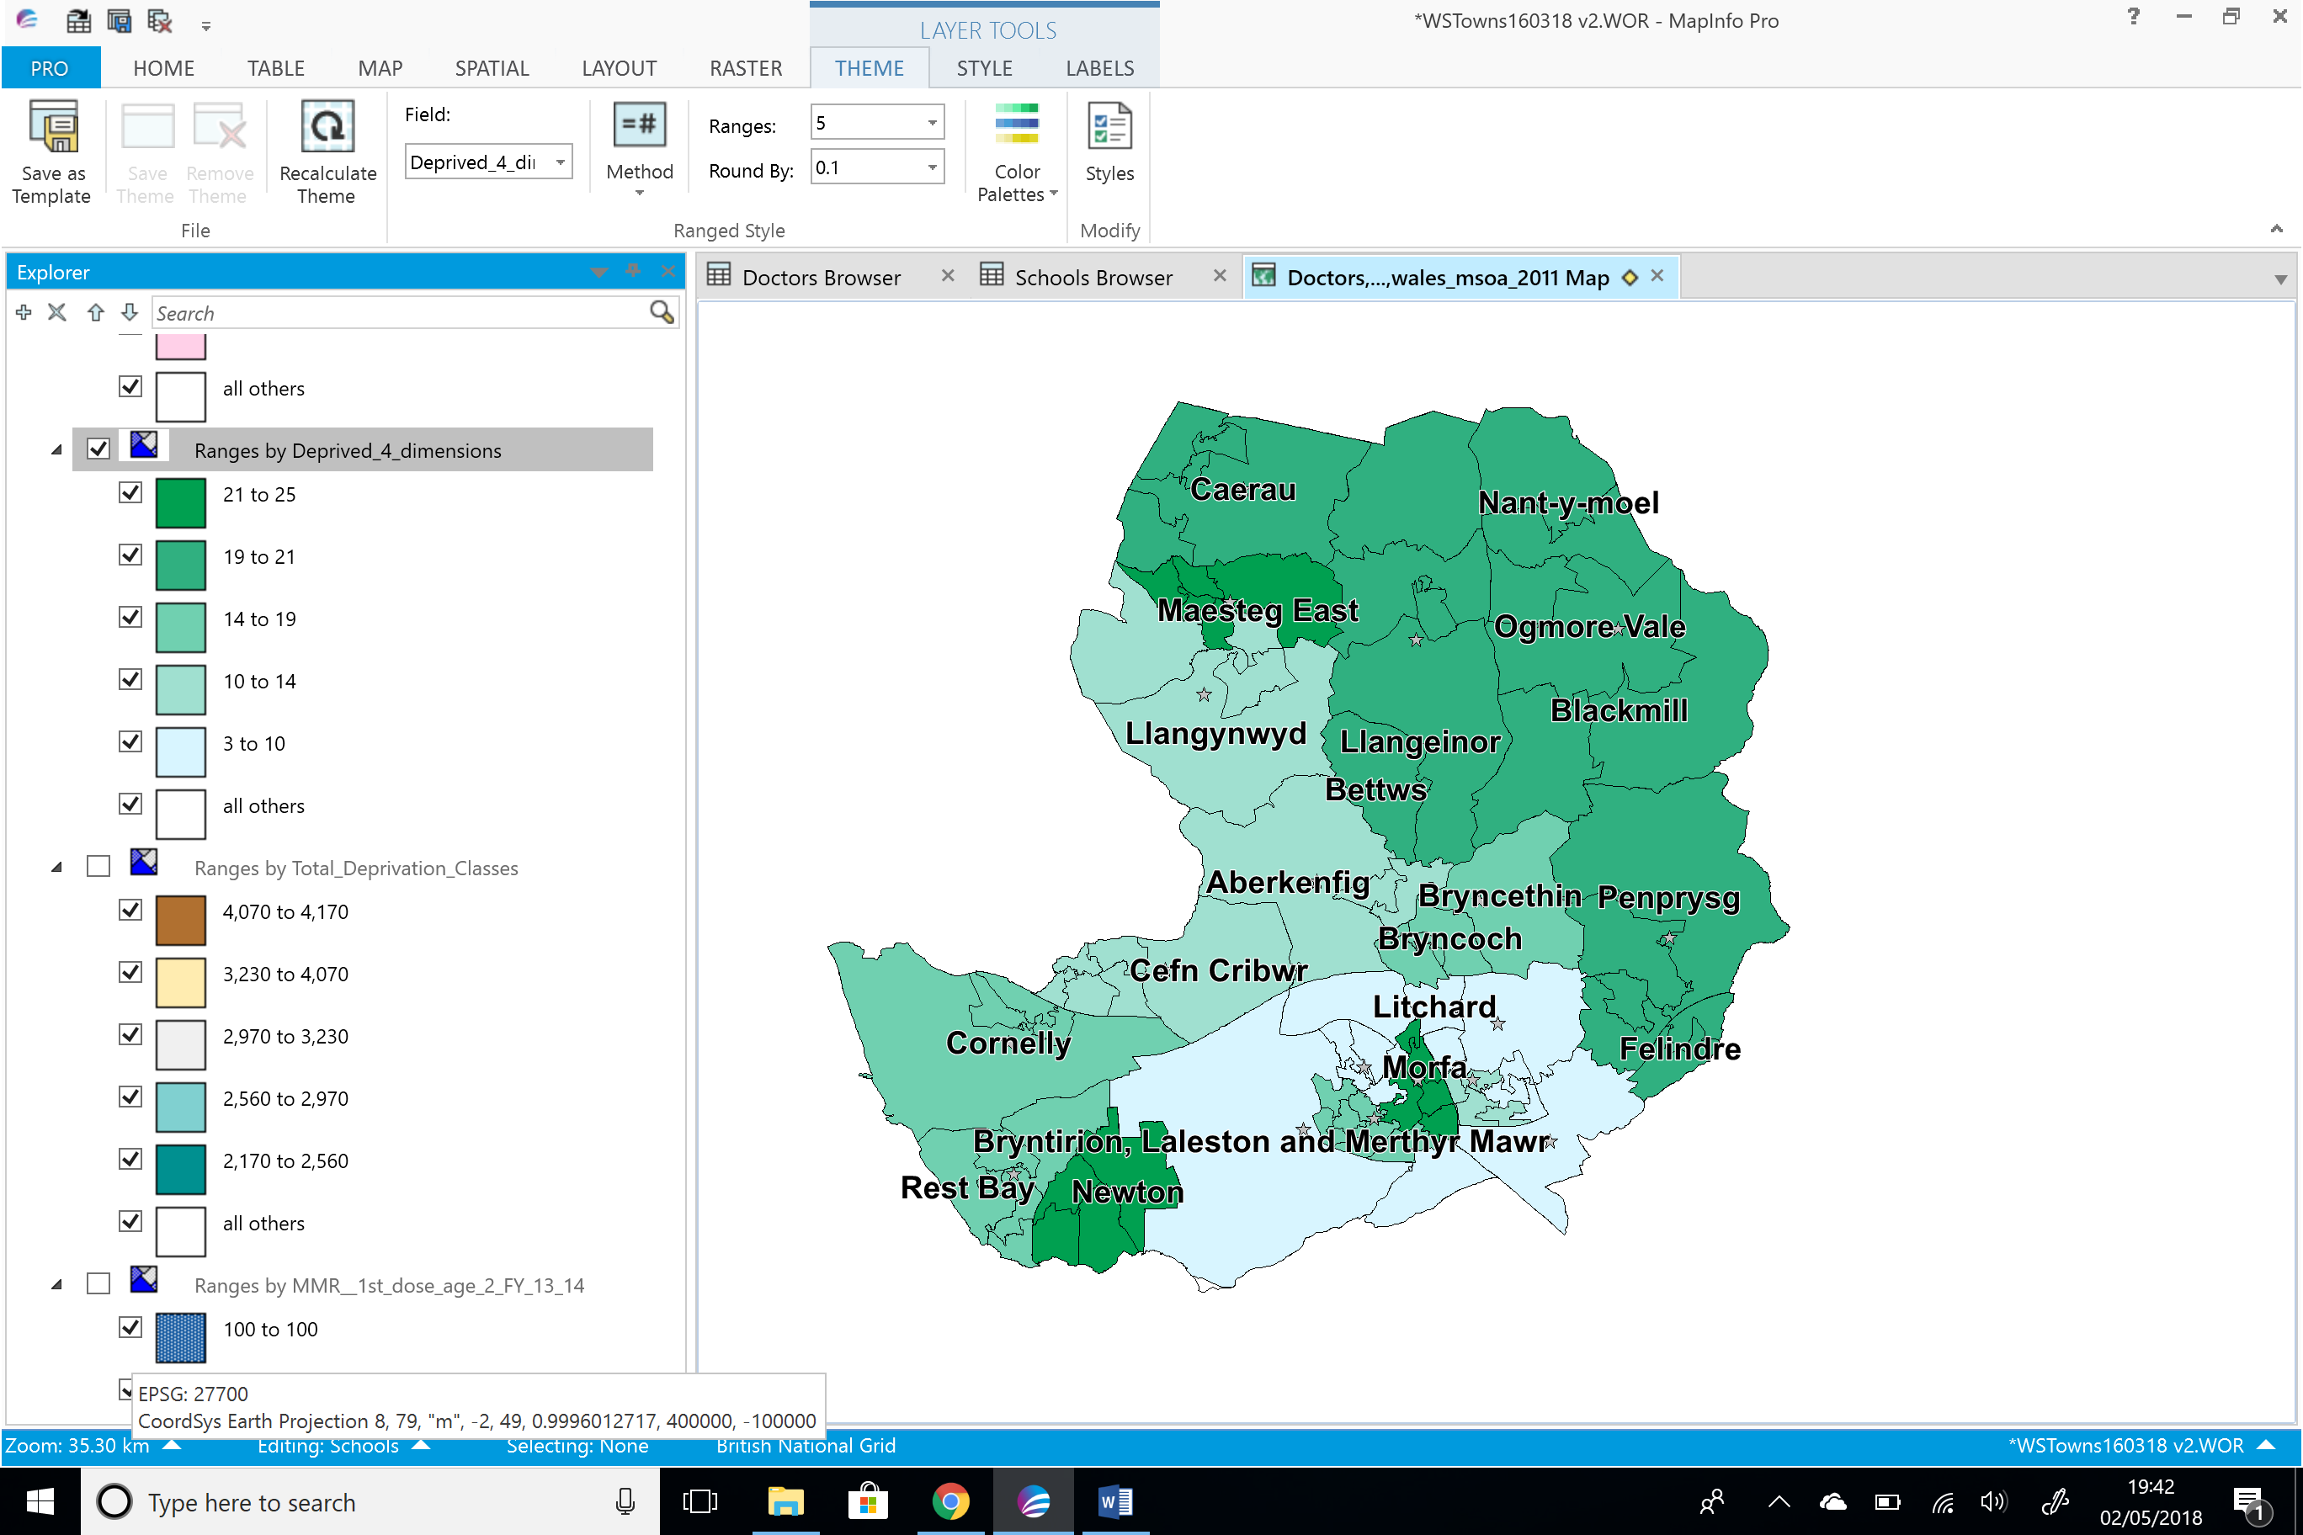
Figure 6 – Deprived 4 Dimension

Measles Mumps and Rubella (MMR) Vaccine
Before the first measles vaccination in 1968 there were between 160,000 and 800,000 notifications of measles in the UK. By mid-1980 this dropped to between 50,000 and 100,000. Following the introduction of the MMR vaccination in October 1998, notifications of measles fell to its lowest levels. In 2006 these notifications started again believed to be the result of media reports stating that the MMR vaccine was linked to autism, where people decided to stop having their children immunised against measles. Collection and interpretation of data is a key feature in surveillance and identifying key trends to ensure that outbreaks are prevented. [3] This can be done using GIS.
Figures 7 to 10 shows the areas of uptake for the MMR vaccine 1st dose by the age of 2 years for financial years 13/14 to 16/17. The data shows that some areas have a very poor uptake, particularly around the area of Maesteg, Caerau, Cefn Cribwr, and Cornelly. These areas are the more deprived areas as shown as shown in figure 1. The chart also shows where the doctor’s surgeries and schools are in the area. With there being schools in the area children could be at risk of spreading the disease. These areas also have doctors surgeries situated in the areas so there is no issue with lack of facilities to take the children to be vaccinated.
The data also shows that there are areas where there is a good uptake despite being a deprived area such as Llangeinor and Betws.
The area of Llangynwyd has a good uptake of the vaccine despite not having a doctor’s surgery in that particular area with them having to travel to nearly villages for their registered doctors surgery.
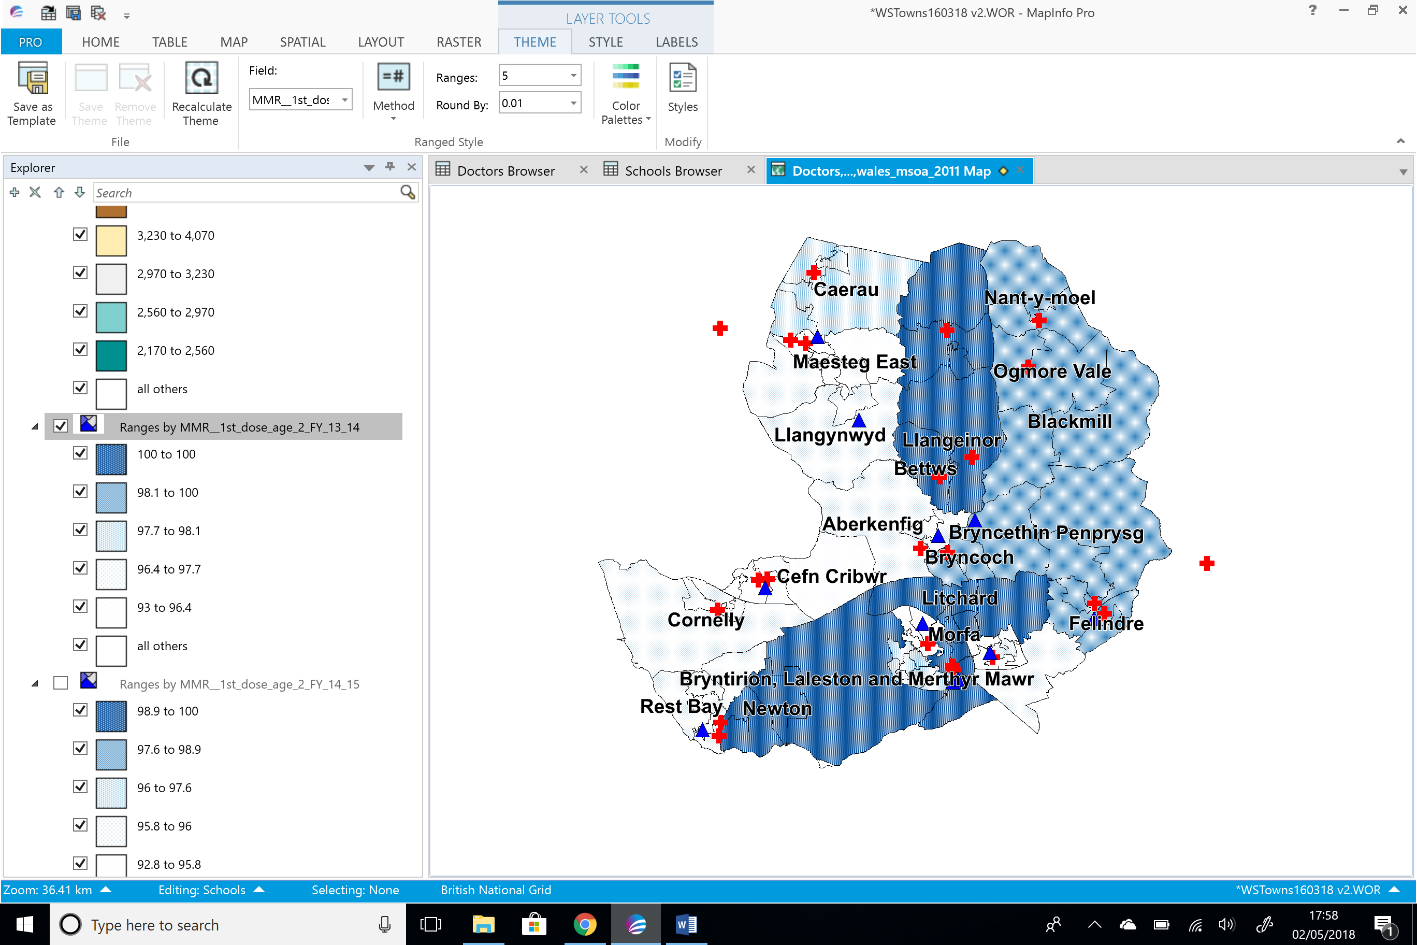
Figure 7- Age 2 FY 13/14

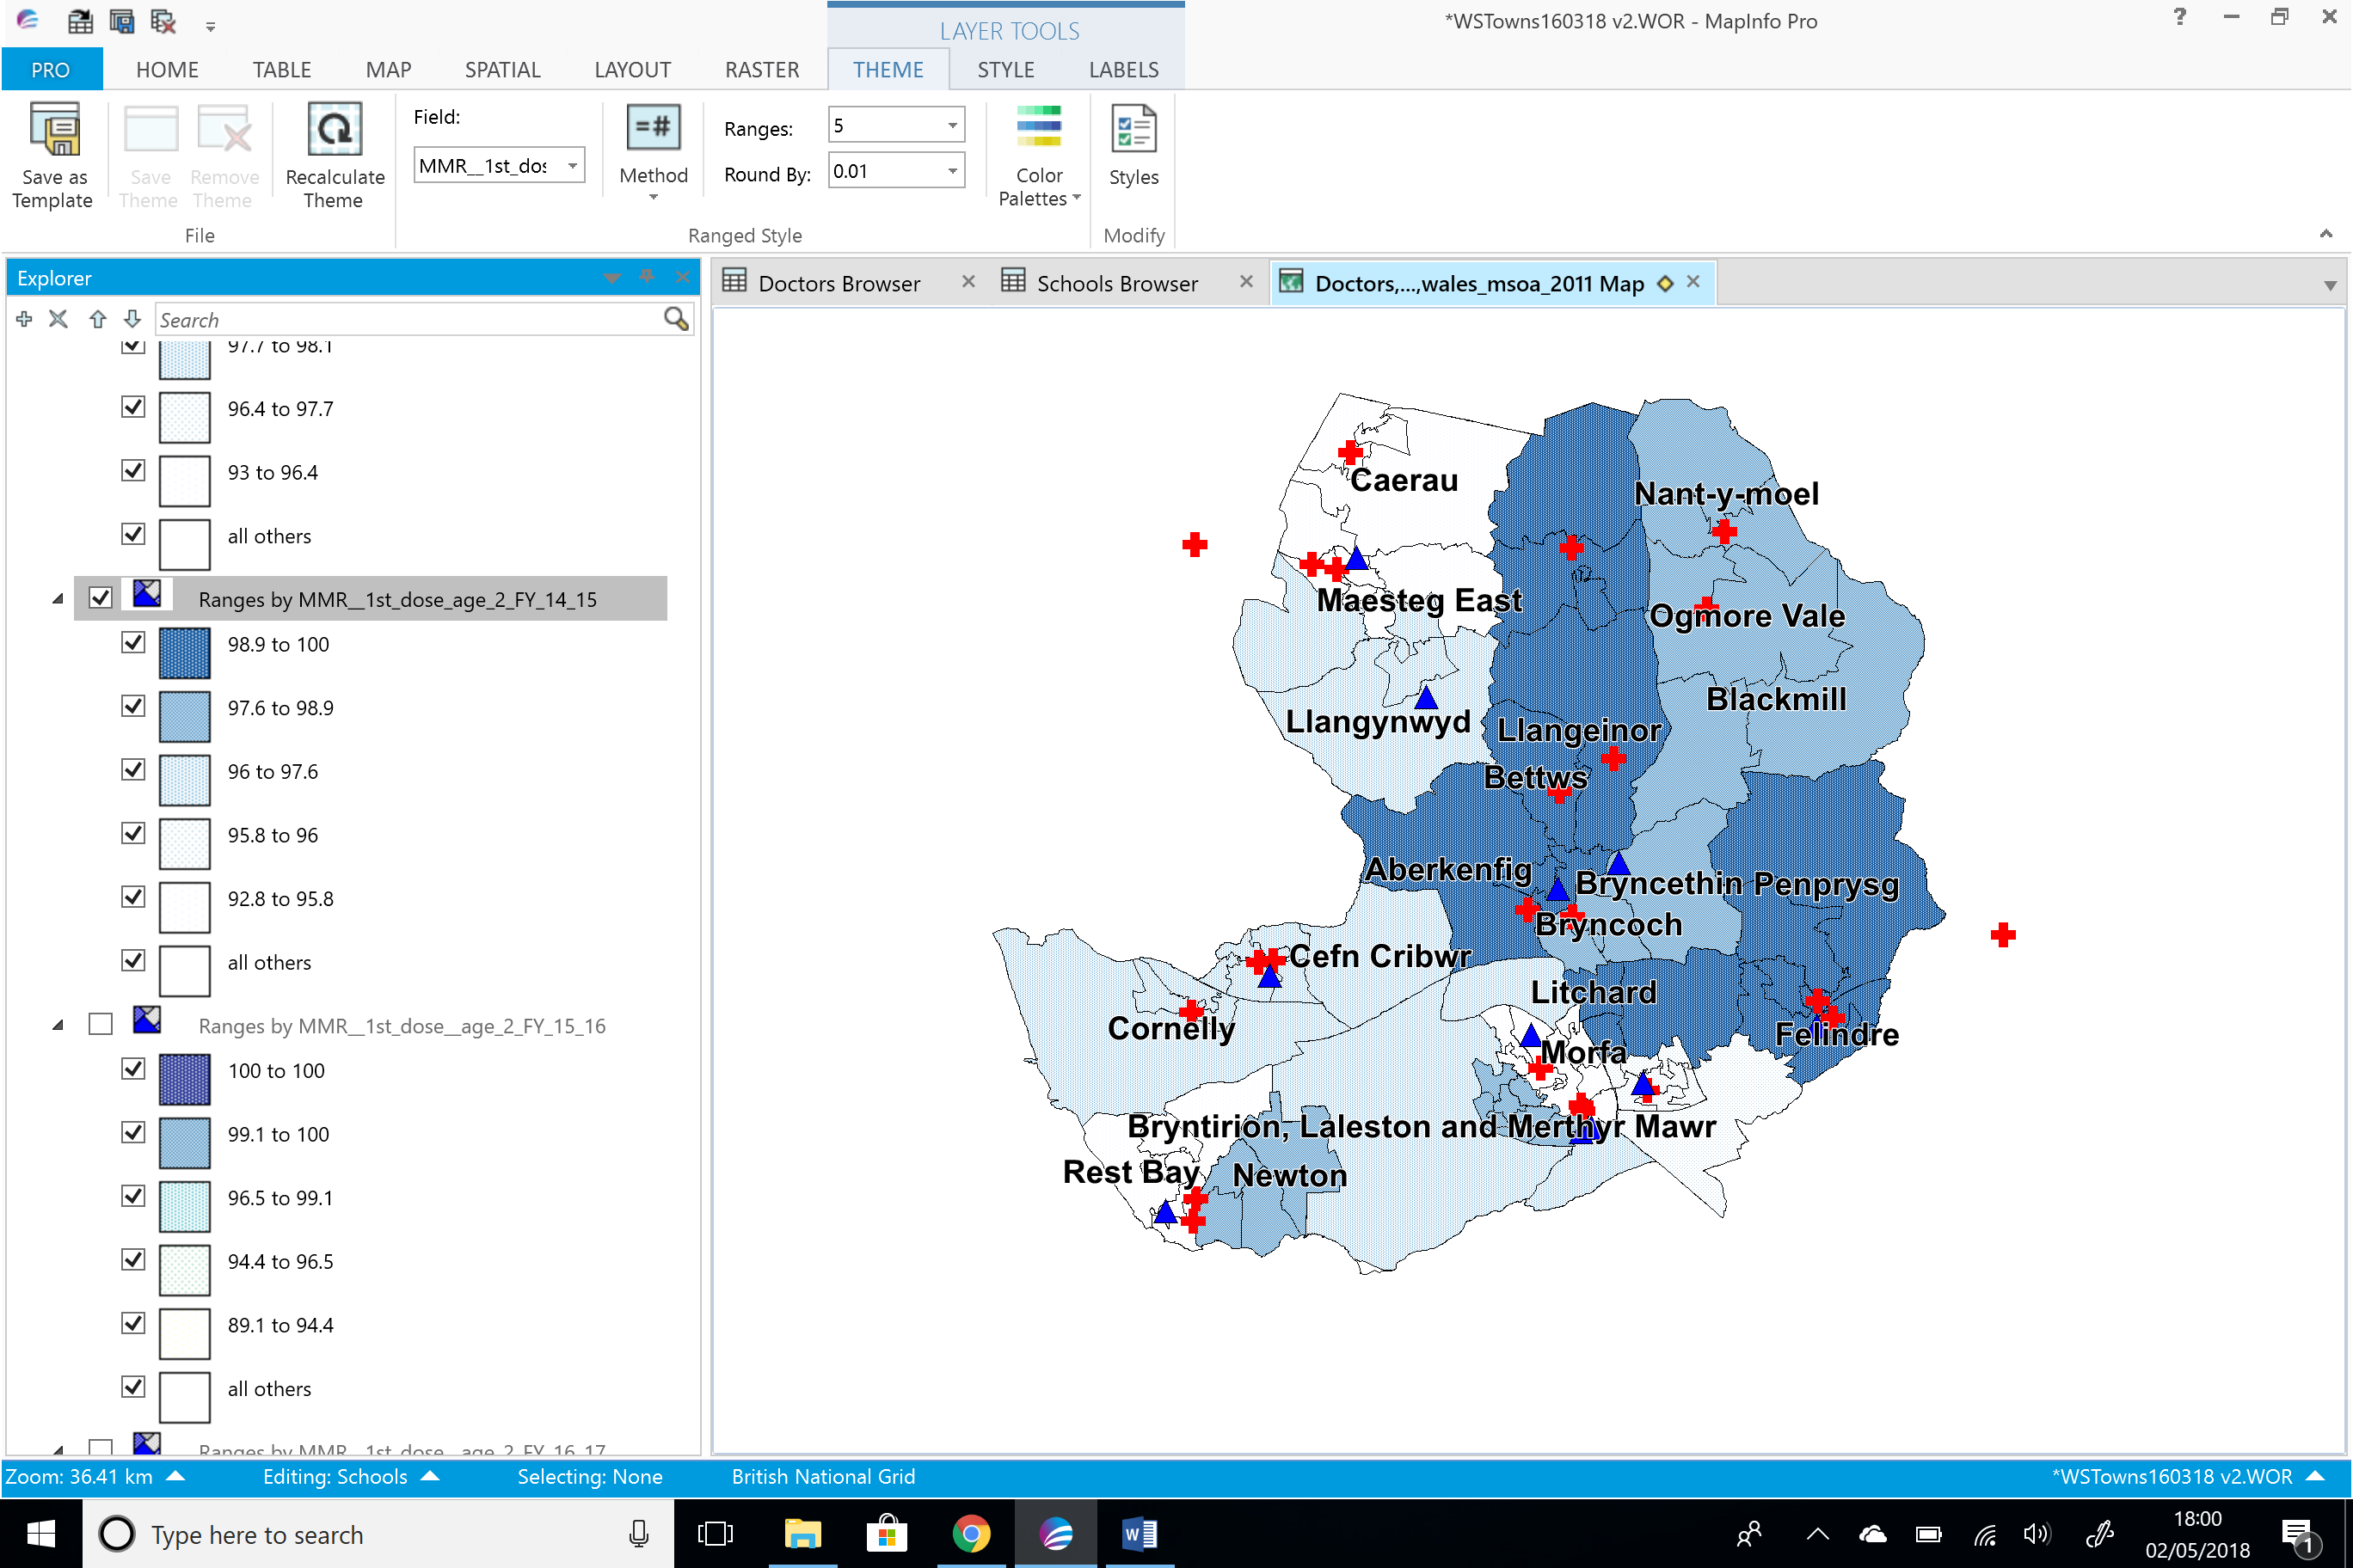
Figure 8 - Age 2 FY 14/15

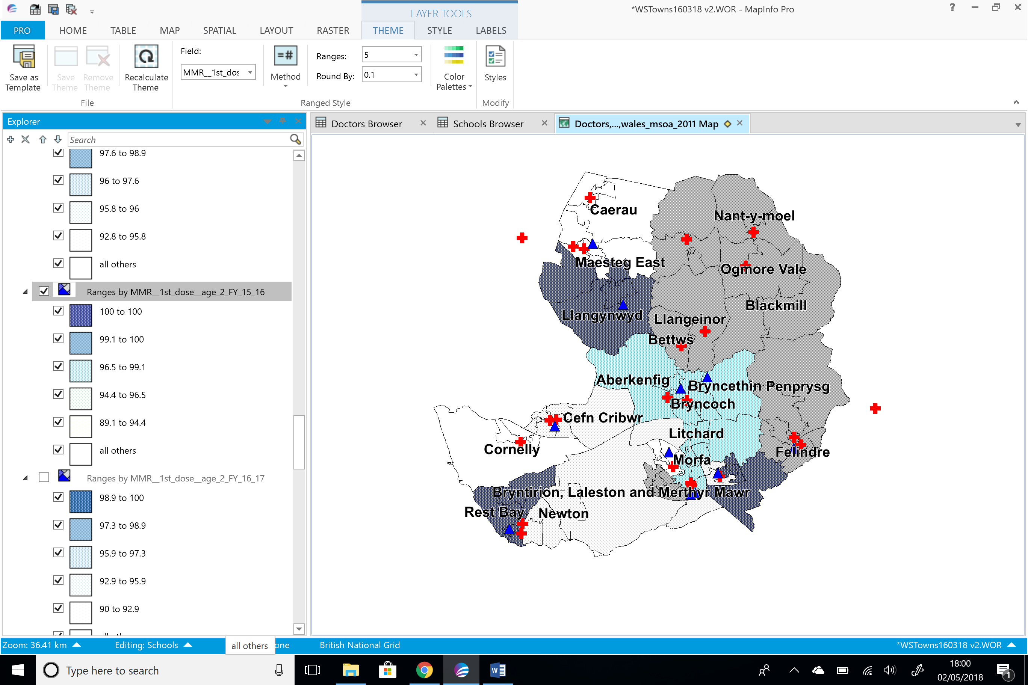
Figure 9 - Age 2 15/16
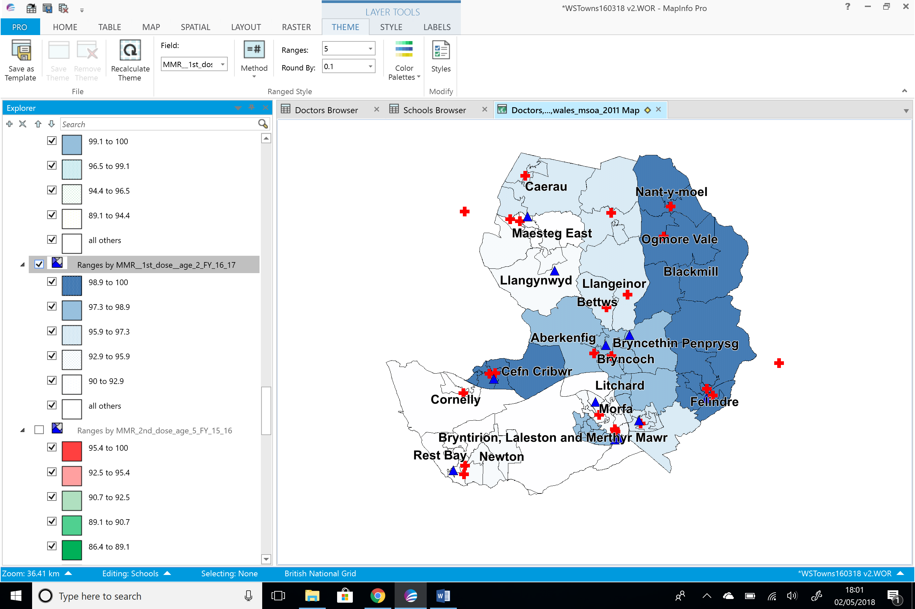
Figure 10 - Age 2 16/17
Figures 11 to 14 shows the areas of uptake for the 2nd MMR vaccine by the age of 5 years for financial years 13/14 to 16/17. Again there is not a good uptake of the vaccine by the age of 5 in some areas. It is alarming that there are consistently areas of Bridgend that are not immunised. This could potentially result in an outbreak of measles if the children are not vaccinated.
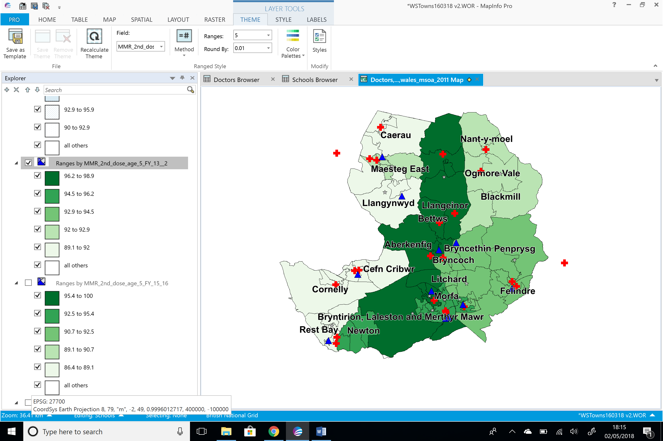
Figure 11 - Age 5 FY13/14

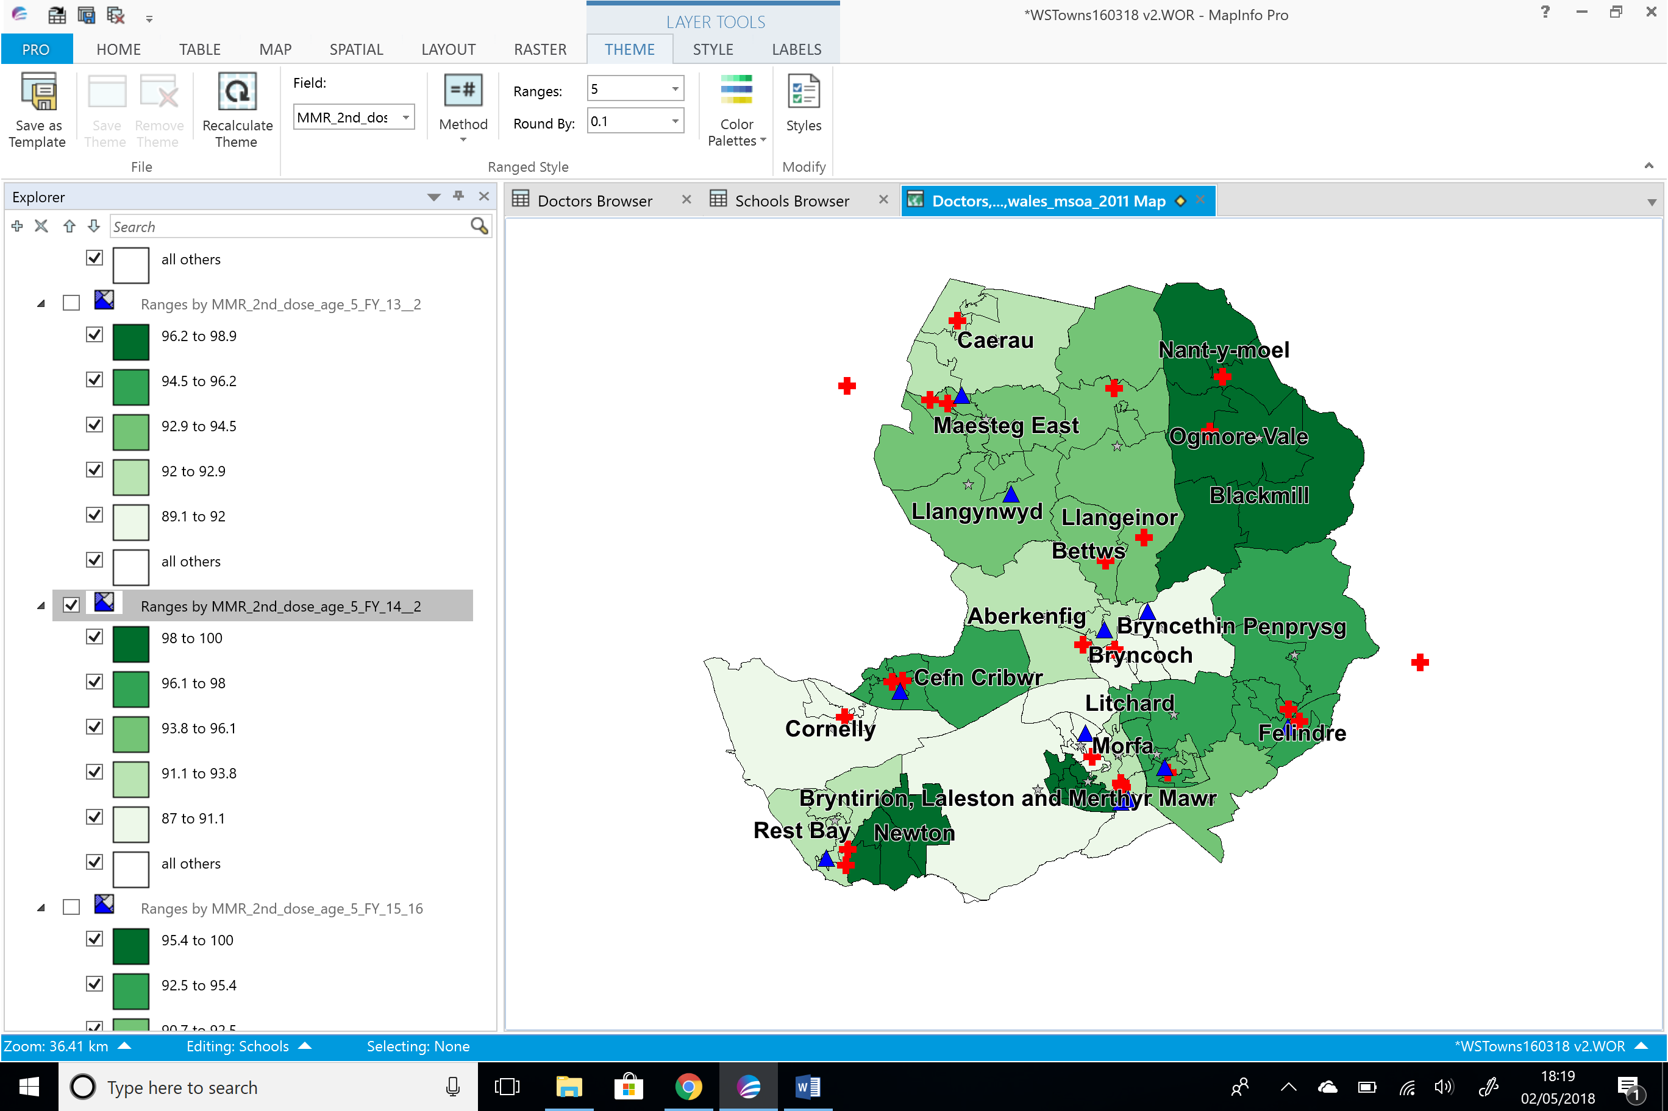
Figure 12 - Age 5 FY14/15

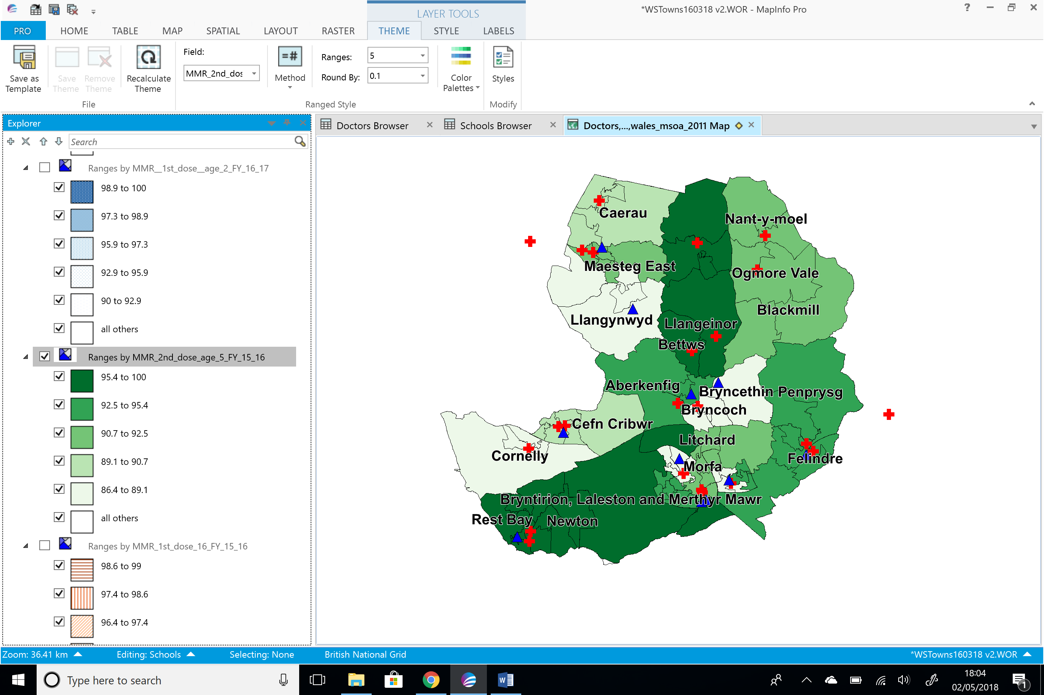
Figure 13 - Age 5 15/16

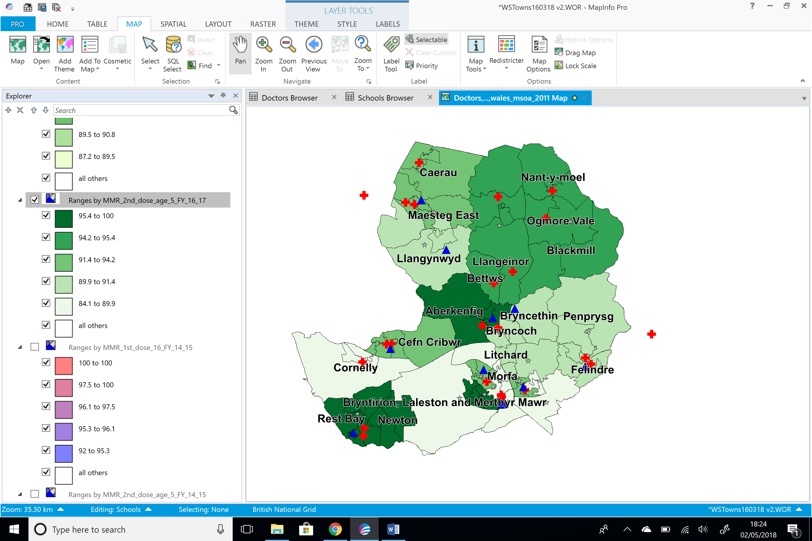
Figure 14- Age 5 16/17
In figures 15 to 20 below the data shows at the age of 16 (1st and 2nd dose) there is a higher uptake in the more deprived areas, and a less uptake in the more affluent areas. This could be as a result of media attention following the measles outbreak that occurred in Swansea in 2013. Where efforts amongst health boards were made to target teenagers who hadn’t previously been vaccinated. The more affluent areas may have already received the vaccine.
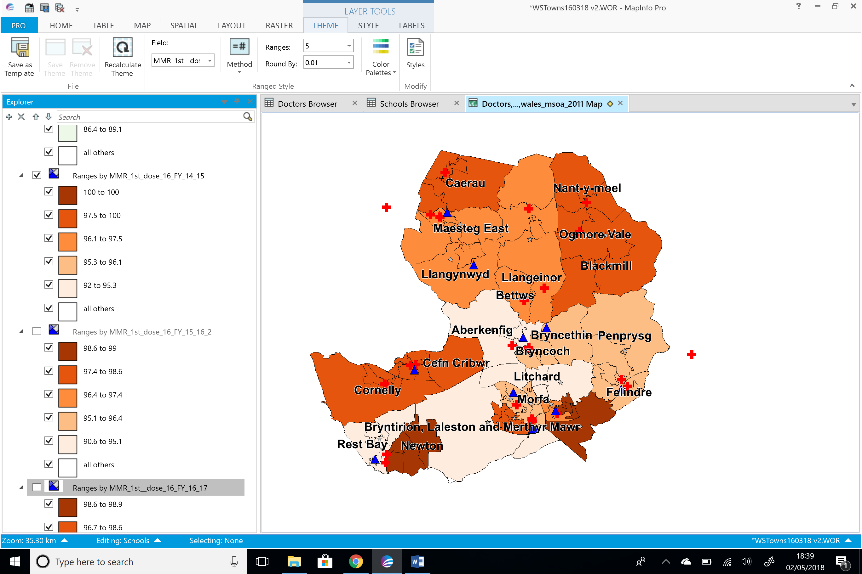
Figure 15 - Age 16 FY14/15

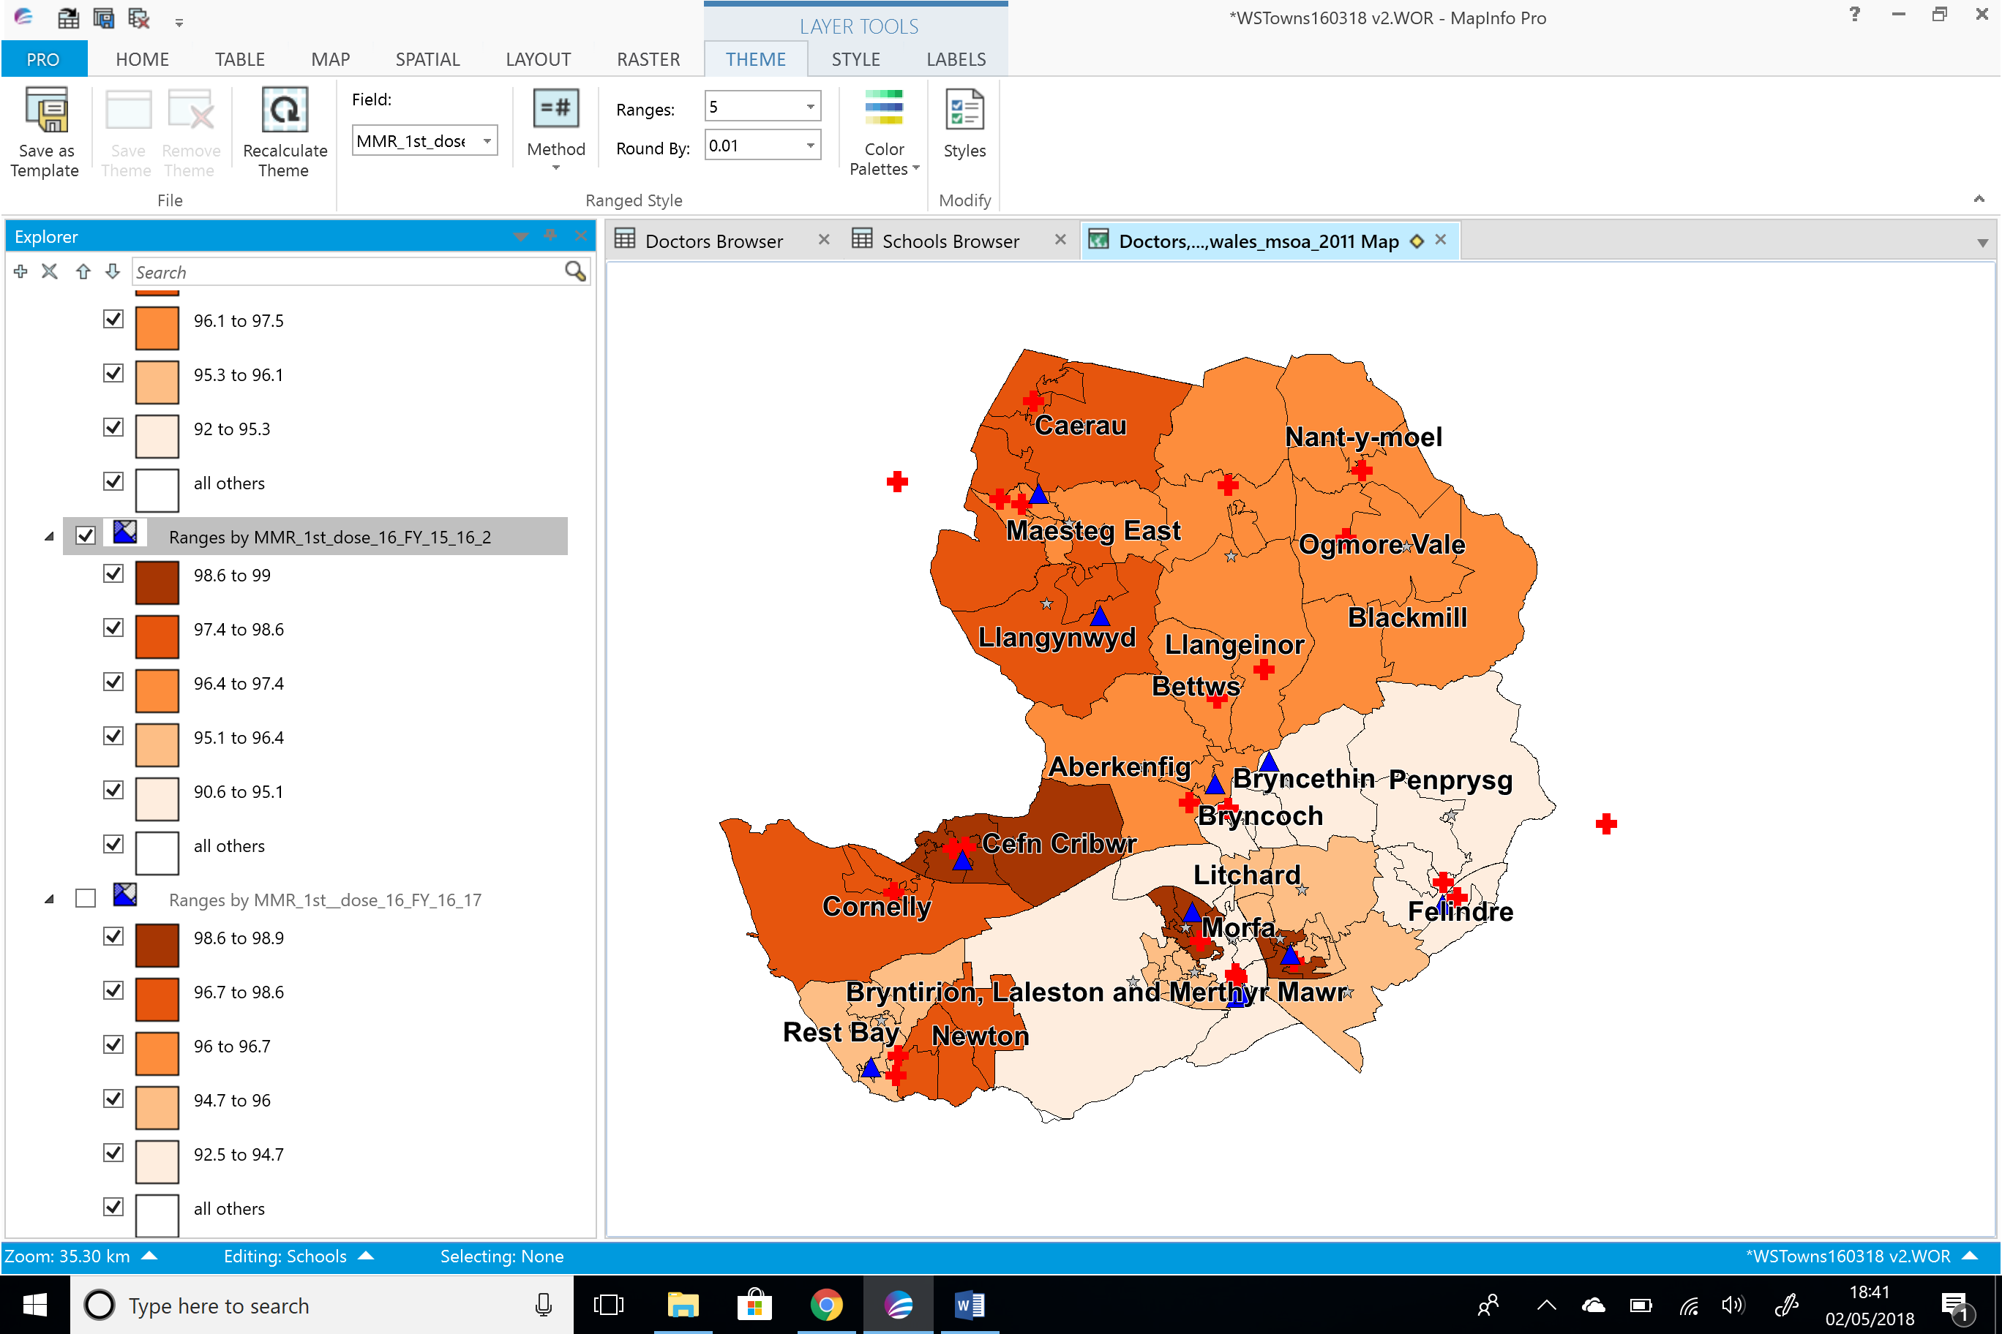
Figure 16 - Age 16 FY15/16

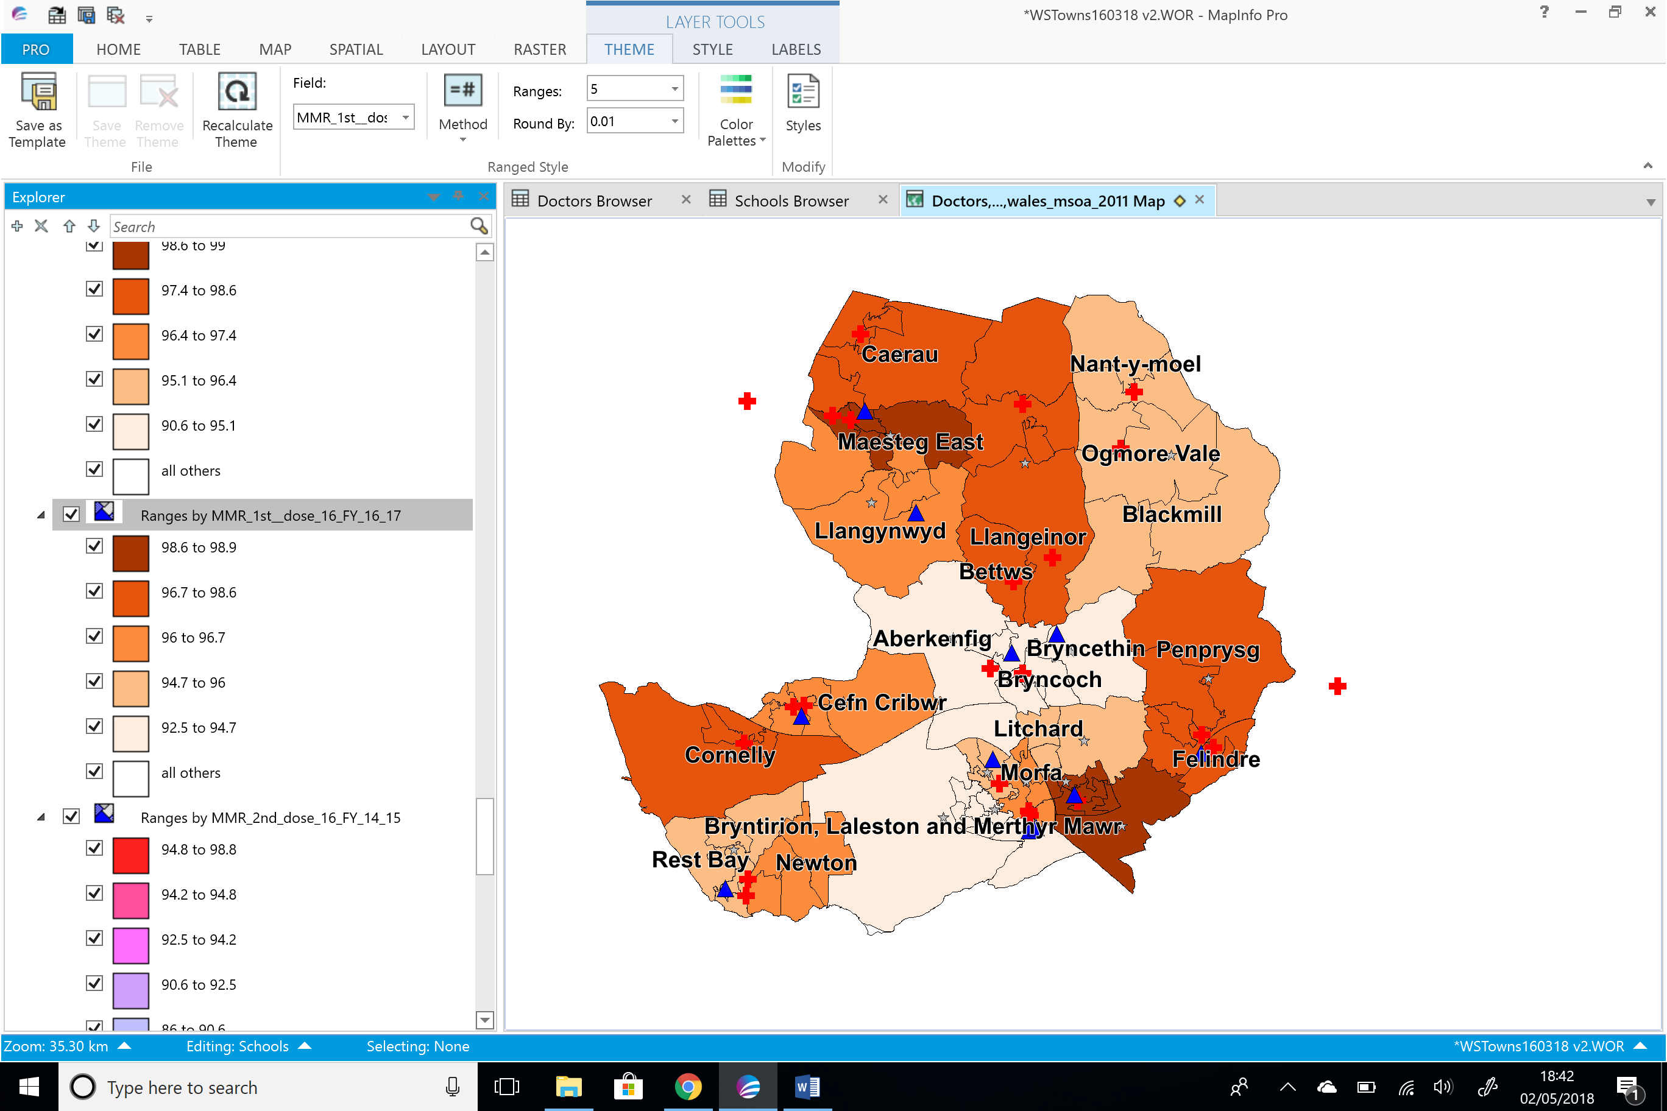
Figure 17 - Age 16 FY16/17

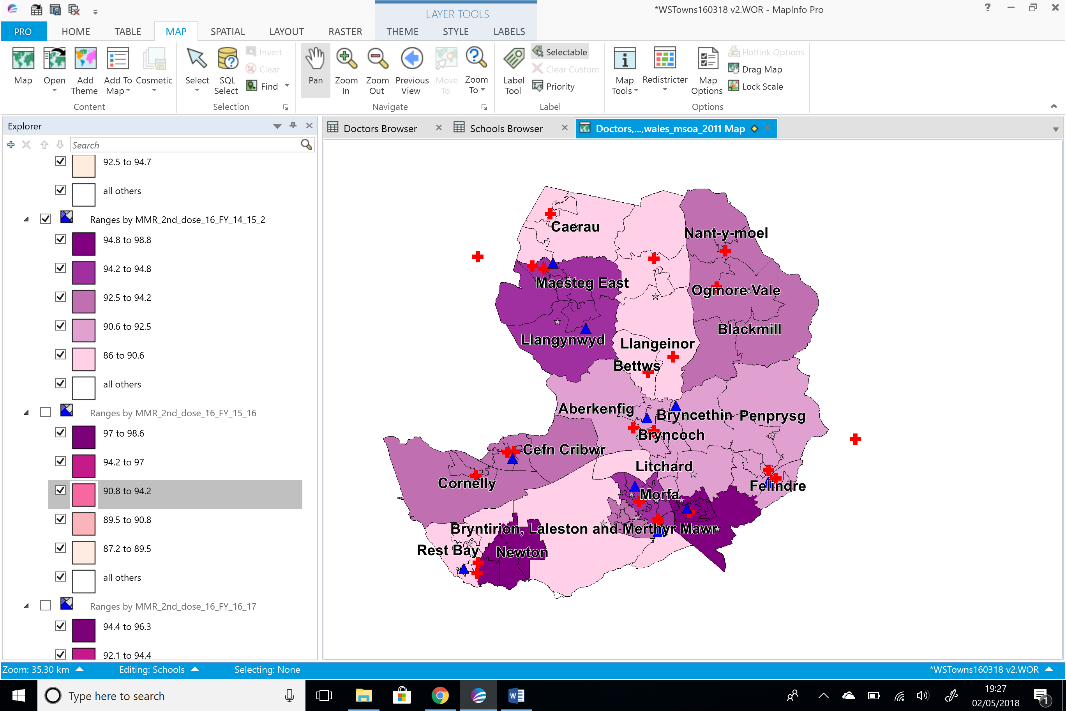
Figure 18 - Age 16 2nd Dose FY14/15

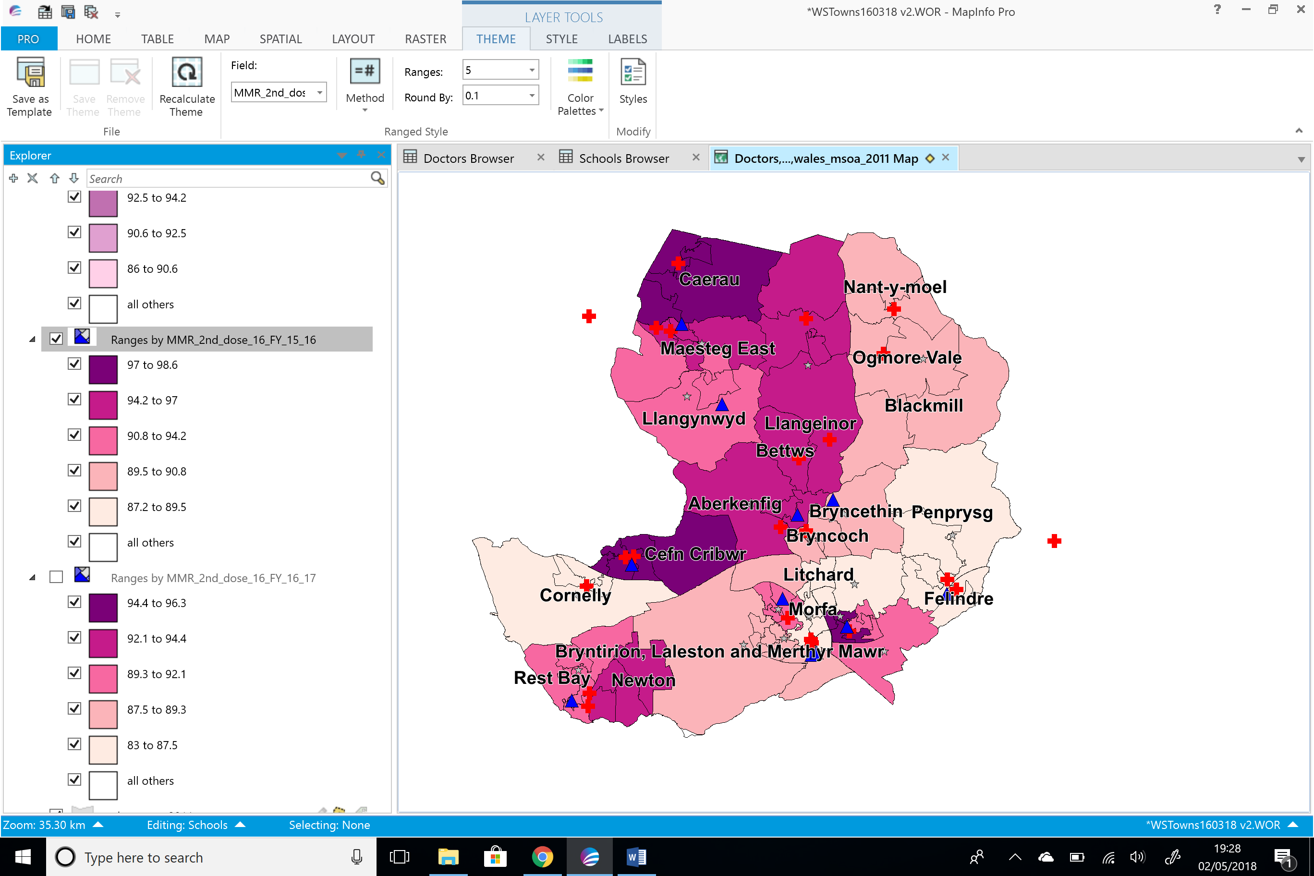
Figure 19 - Age 16 2nd Dose FY15/16

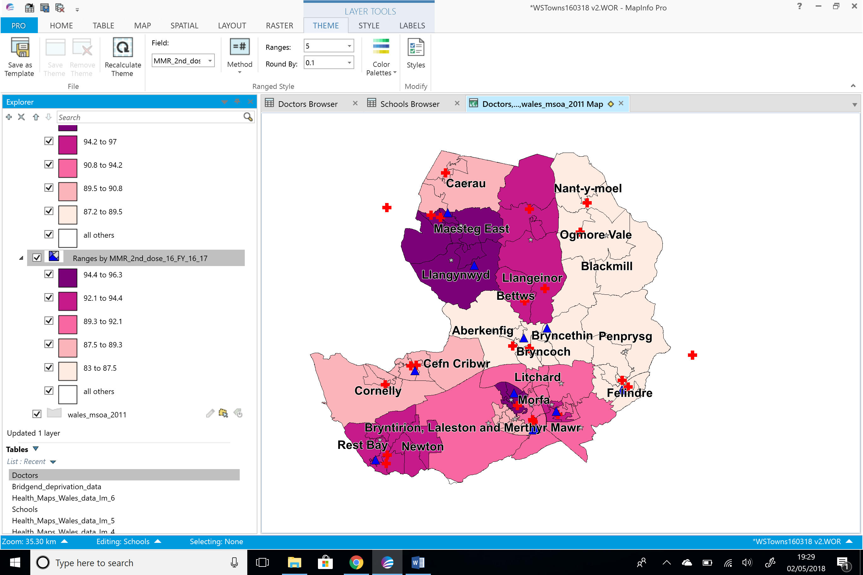
Figure 20 - Age 16 2nd Dose FY 16/17

Using Excel to gather data
As an alternative to GIS, Microsoft Excel is a popular system used to analyse data, which requires very little training to use. You can import data from the UK Data Service and Health Maps in Wales as you do when analysing data in GIS.
The data can be visually displayed showing Immunisation data in Bridgend, below is an example demonstrating how the data can be visualised in an Excel 3D map. In comparison to the GIS presentation of the data the 3D map in excel representation of the data is poor. This is not giving detailed information as the GIS data representation and it is difficult to show any correlations in the data with deprived areas and the MMR vaccination data.
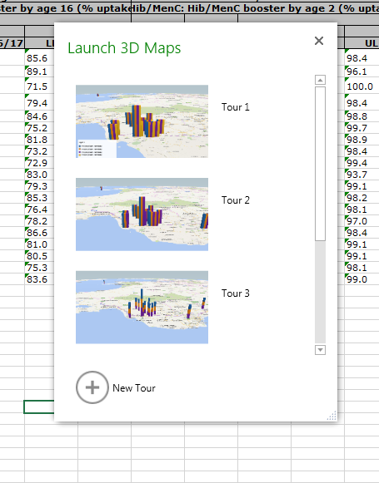
Figure 21 - Example of 3D Map
Another drawback of using 3D maps is that the plotting of the locations are not accurate, this doesn’t give you good data to work with. It would be difficult to demonstrate the data in the aim to influence change with inaccurate data.
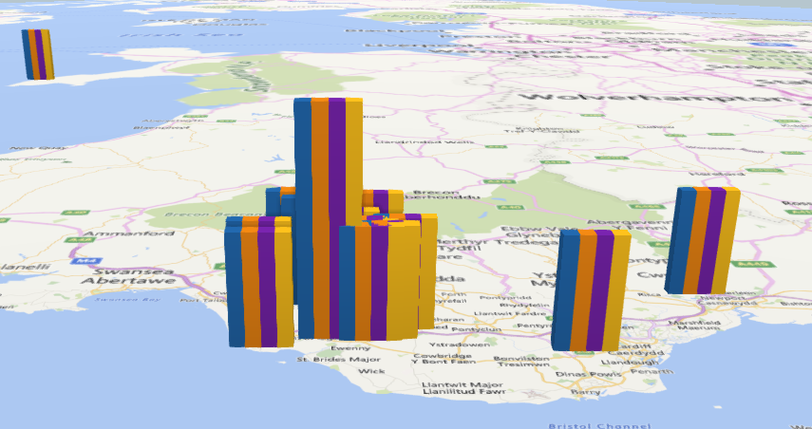
Figure 22 - map showing MMR Immunisation data in Bridgend area from Health in Wales data
Figure 23 below shows the Bridgend population data of 0 to 24 year olds on a map of the UK from UK Data Service dataset, this is the same dataset used in GIS. However in GIS there are errors in where the data is plotted on the map. These areas are showing in incorrect locations and it isn’t giving a true reflection of the population data in Bridgend.
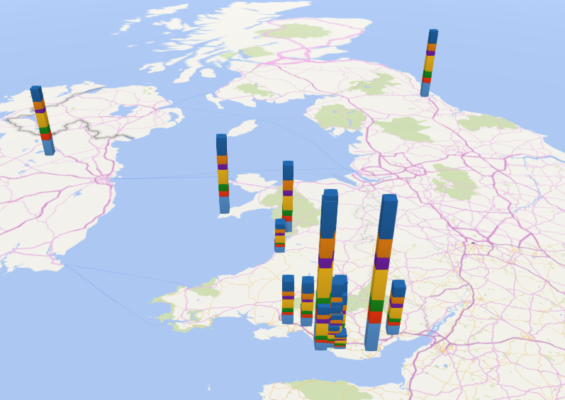
Figure 23 - Map showing population data Bridgend 0 to 24 year olds from UK Data Service

Figure 24 is showing an alternative example of using Power View in Excel to present data in a dashboard format. The example shows a table of immunisation data and a chart showing the population data. This way can show the relationship of the data between the population size and the number of immunisations in a separate table and chart. The data shows us the areas which have a good update in the MMR vaccine overall but it doesn’t give as much detail as the GIS information and it is hard to visualise the data.
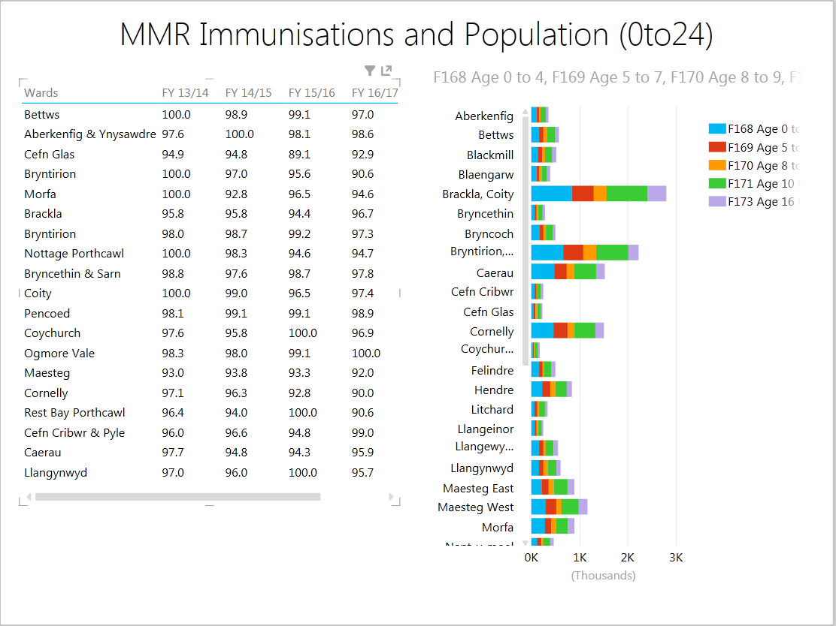
Figure 24 - Power View example

Conclusion
This report has reviewed analysing data using two different information systems; a GIS system and also by using Excel to analyse and visually display data. It is clear that the GIS version provides more detail in its layered functionality displaying the data in many different ways and incorporating points on a map such as doctor’s surgeries and schools within that area. The Excel application is lacking in powerful data visualisation unlike the GIS version.
The data used in the case study has shown that within areas of deprivation in Bridgend there is a poor uptake of the MMR vaccination by age 5. This could potentially result in an outbreak of measles in the area if the children are not vaccinated. The GIS data demonstrated in this report shows that although at the age of 16 the uptake improved in the deprived areas, work is required in these areas to ensure that children are vaccinated by age 5. The data set out in this report could be used by the health board to request additional funding, instigate campaigns or additional resources that may be required to increase uptake in the Bridgend area. It is evident that work is required to ensure good health in these areas of deprivation.

References
[1] Heywood, I., Cornelius, S. & Carver, S. (2011) An Introduction to Geographical Information Systems, Prentice Hall
[2] Map InfoProfessionalUser Guide. [Online] Available at: http://reference1.mapinfo.com/software/mapinfo_pro/english/12.0/MapInfoProfessionalUserGuide.pdf [Accessed 03/05/18]
[3] Public Health Wales: Measles. [Online] Available at: http://www.wales.nhs.uk/sitesplus/888/page/43749. [Accessed 03/05/18]

