

Smoothed Particle Hydrodynamics (SPH): A Versioned Literature Review Aligned to a C++ Implementation

by
Kallem George Thomas
Supervisor: Nathan Morgan
Second Marker: Nigel Davies
BSc (Hons) Computing (Games Development)
Submission: Friday 1 May 2026, 3pm

Project submitted as part of the requirements for the award of BSc Computing (Game development)

May 2026

DECLARATION

I, Kallem George Thomas declare that I am the sole author of this Project; that all references cited have been consulted; that I have conducted all work of which this is a record, and that the finished work lies within the prescribed word limits.

This work has not previously been accepted as part of any other degree submission.

FORM OF CONSENT

I Kallem George Thomas hereby consent that my Project, submitted in candidature for the B.Sc. (Hons) Computing (Games Development) degree, if successful, may be made available for inter-library loan or photocopying (subject to the law of copyright), and that the title and abstract may be made available to outside organisations.

Abstract
This project investigates the feasibility of real-time fluid simulation using a three-dimensional Smoothed Particle Hydrodynamics (SPH) approach derived from the Navier–Stokes equations. The primary aim was to design, implement, and evaluate a GPU-accelerated SPH solver in C++ capable of producing physically plausible fluid behaviour within interactive performance constraints.
The system was developed using an iterative methodology, beginning with a particle-based framework and progressively incorporating density estimation, pressure computation, force accumulation, and time integration. A uniform spatial hashing grid was implemented to optimise neighbour search operations, reducing computational complexity and enabling scalability. GPU acceleration was utilised to parallelise particle interactions, significantly improving performance compared to a CPU-only approach.
Evaluation of the system focused on simulation stability, computational performance, and visual plausibility. Results demonstrated that the solver produces stable and coherent fluid behaviour when appropriate parameters are selected, with particle cohesion and smooth motion consistent with established SPH models. Performance analysis showed that spatial hashing and GPU parallelisation are essential for achieving real-time simulation, although scalability remains constrained by hardware limitations at higher particle counts.
The findings indicate that SPH is well suited for small-scale, interactive fluid simulations in modern games, such as localized water effects and dynamic interactions. However, it is less suitable for large-scale environmental water due to its computational cost and lack of efficient surface representation. The project concludes that SPH is most effective when integrated into hybrid systems combining physically based simulation with visually driven rendering techniques.
Overall, the project demonstrates that real-time three-dimensional SPH simulation is achievable with appropriate optimisation strategies, providing a strong foundation for further development in real-time fluid systems.

Contents
Abstract 3
CHAPTER 1 – INTRODUCTION 7
1.1 Background and Context 7
1.2 Problem Statement 7
1.3 Aim 8
1.4 Objectives 8
1.5 Scope 8
1.6 Research Paradigm 9
1.7 Structure of the Report 9
CHAPTER 2 – RESEARCH & REVIEW OF LITERATURE 10
2.1 The Three-Dimensional Navier–Stokes Equations 10
2.2 Numerical Discretisation Strategies 11
2.2.1 Eulerian (Grid-Based) Methods 11
2.2.2 Lagrangian (Particle-Based) Methods 12
2.3 Weakly Compressible SPH (WCSPH) 13
2.4 Stability Considerations 13
2.4.2 Artificial Viscosity 13
2.5 Computational Complexity 13
2.6 From Navier–Stokes to Numerical Simulation 14
2.7 Eulerian Discretisation in Three Dimensions 14
2.7.1 The MAC Grid 14
2.7.2 Stability in Eulerian Methods 15
2.8 Lagrangian Discretisation 15
2.9 Mathematical Formulation of 3D SPH 16
2.9.1 Density Estimation 16
2.9.2 Pressure Equation of State 16
2.10 Kernel Functions in 3D 16
2.11 Stability and Time Integration 17
2.12 Neighbour Search Optimisation 18
2.13 Comparative Evaluation: Eulerian vs SPH 18
2.14 Justification of Method Selection 19
CHAPTER 3 – RESEARCH AND DEVELOPMENT METHODOLOGY 19
3.1 Research Approach 19
3.2 Development Methodology 20
3.3 Software Environment and System Architecture 21
3.4 Mathematical Model 23
3.5 Parallel Neighbour Search 23
3.6 Three-Dimensional Implementation 24
3.7 Evaluation Strategy 24
3.7.1 Stability 24
3.7.2 Performance 25
3.7.3 Visual Plausibility 25
3.8 GPU Parallelisation Strategy 25
CHAPTER 4 – DESIGN AND IMPLEMENTATION 26
4.0 Requirements Specification 26
4.1 System Architecture 27
4.2 Particle Representation 28
4.3 Spatial Hashing Grid 28
4.4 GPU Simulation Pipeline 29
4.5 Boundary Handling 30
4.6 Performance Considerations 31
4.7 Numerical Stability Considerations 31
4.8 Limitations of the Current Implementation 32
4.9 Implementation Summary 32
CHAPTER 5 – RESULTS AND EVALUATION 33
5.1 Overview 33
5.2 Experimental Setup 34
Version 1: Basic 2D SPH Implementation 35
Version 2: Optimised 2D System with 3D Heightmap Preview 35
Version 4: Final 3D Version with Liquid Presets 36
Version Comparison Summary 36
5.4 Simulation Behaviour 37
5.5 Stability Evaluation 37
5.6 Performance Analysis 38
5.7 Visual Plausibility 38
5.8 Comparison with Game-Based Water Systems 39
5.9 Limitations Observed During Testing 40
5.10 Evaluation Summary 40
5.11 Parameter Sensitivity Analysis 40
5.12 Discussion of Trade-Offs 41
5.13 Comparative Analysis with Modern Game Water Systems 42
5.14 Testing Strategy 43
CHAPTER 6 – CONCLUSIONS AND RECOMMENDATIONS 44
6.1 Conclusion 44
6.2 Recommendations for Future Work 45
6.3 Final Remarks 46
6.4 Broader Implications 46
CHAPTER 7 – REFLECTION 46
7.1 Overview 46
7.2 Technical Learning 47
7.3 GPU and Performance Considerations 47
7.4 Challenges Encountered 48
7.5 Problem-Solving and Development Approach 48
7.6 What Went Well 48
7.7 What Could Be Improved 49
7.8 Personal Development 49
7.9 Final Reflection 49
7.10 Future Personal Development 50
CHAPTER 8 – USE OF ARTIFICIAL INTELLIGENCE TOOLS 50
LIST OF FIGURES 50
References 51

CHAPTER 1 – INTRODUCTION

1.1 Background and Context
The simulation of fluid dynamics in three-dimensional space represents one of the most computationally intensive and mathematically complex challenges within computer graphics and interactive systems. Unlike rigid-body physics, fluid simulation involves nonlinear partial differential equations governing conservation of mass and momentum. These equations, known collectively as the Navier–Stokes equations, form the foundation of computational fluid dynamics (CFD) [1], [5].
While high-fidelity CFD solvers are widely used in engineering and scientific computing, their computational demands typically exceed the constraints of real-time applications such as video games. Real-time systems require simplified numerical approaches in order to achieve interactive frame rates while maintaining acceptable levels of visual realism [4], [8]. Nevertheless, the increasing expectation for physically grounded realism in interactive media has driven continued research into efficient fluid simulation techniques that balance performance and accuracy.
Particle-based methods, particularly Smoothed Particle Hydrodynamics (SPH), have emerged as strong candidates for real-time simulation due to their adaptive spatial representation and natural handling of free surfaces [2], [9]. Unlike grid-based solvers, SPH represents fluid as discrete moving particles rather than a fixed spatial field. This aligns well with modern rendering pipelines and physics engines, where particle systems are commonly used to represent dynamic phenomena [3], [8]. Furthermore, SPH avoids the need for complex grid-based pressure projection steps, instead relying on local particle interactions to approximate fluid behaviour. This makes it particularly attractive for interactive applications, where computational efficiency is critical [9]. However, despite these advantages, SPH introduces its own challenges, particularly in maintaining numerical stability and managing the computational cost of neighbour interactions in three-dimensional space [1].
This project investigates the full three-dimensional implementation of a Smoothed Particle Hydrodynamics solver derived directly from the Navier–Stokes equations and optimised for interactive real-time simulation. The work focuses on balancing physical plausibility, numerical stability, and computational performance within the constraints of real-time systems.

1.2 Problem Statement
The central research problem addressed is:
How can the Navier–Stokes equations be discretised using a three-dimensional particle-based SPH formulation to produce stable, scalable, and physically plausible real-time fluid simulation? This requires addressing multiple challenges:
· Accurate discretisation of 3D Navier–Stokes equations.
· Efficient 3D neighbour search.
· Stability control in weakly compressible SPH.
· Performance optimisation for high particle counts.
· Boundary condition handling in three-dimensional space.

These challenges arise from the nonlinear and coupled nature of the governing equations, as well as the computational cost associated with evaluating particle interactions in three-dimensional space [1], [9]. Maintaining stability while achieving real-time performance remains a key difficulty in particle-based simulation systems [2].

1.3 Aim
The aim of this project is:
To design, implement, and evaluate a three-dimensional Smoothed Particle Hydrodynamics (SPH) solver in C++ that derives from the Navier–Stokes equations and operates in real time for interactive applications.
This aim reflects the broader challenge within computer graphics of balancing physical accuracy with computational efficiency, particularly when simulating complex systems such as fluids [8].

1.4 Objectives
1. Analyse the Navier–Stokes equations in three dimensions [1].
2. Compare Eulerian grid-based methods with Lagrangian particle-based methods [4], [5].
3. Justify SPH as a suitable real-time method [2], [9].
4. Implement a full 3D SPH solver.
5. Implement 3D spatial hashing for neighbour search optimisation [10].
6. Evaluate performance scaling across particle counts.
7. Critically assess numerical stability and computational trade-offs [3].
These objectives are structured to move from theoretical analysis through to practical implementation and evaluation, reflecting a standard workflow in computational simulation research [6].

1.5 Scope
The project includes:
· Full 3D particle representation.
· 3D kernel functions.
· Weakly compressible SPH formulation [2].
· 3D uniform grid spatial hashing [10].
· CPU-based implementation with GPU acceleration components.
· Real-time visualisation.

The project does not include:
· Multi-phase fluids.
· Surface reconstruction via marching cubes.
· Advanced turbulence modelling.

These limitations reflect common constraints in real-time simulation systems, where computational complexity must be carefully managed to maintain interactive performance [8]. High-fidelity fluid simulation techniques used in engineering contexts are typically unsuitable for real-time applications due to their computational cost [1].

1.6 Research Paradigm
This project follows a development-based experimental paradigm, combining theoretical derivation, numerical implementation, optimisation, and empirical performance evaluation.
This aligns with research-informed engineering methodologies within computational sciences [6].

1.7 Structure of the Report
The remainder of this report is structured as follows.
Chapter 2 presents a review of relevant literature, including the Navier–Stokes equations, numerical discretisation strategies, and existing fluid simulation techniques. A comparison between Eulerian and Lagrangian methods is provided, leading to the justification of SPH as the chosen approach.
Chapter 3 outlines the research and development methodology used in this project. This includes the experimental research approach, the iterative software development process, and the evaluation criteria used to assess system performance.
Chapter 4 describes the design and implementation of the SPH solver. This includes system architecture, particle representation, spatial hashing, GPU simulation pipeline, and key optimisation strategies.
Chapter 5 presents the results and evaluation of the system, analysing simulation stability, performance, and visual plausibility. The implemented system is also compared with water simulation techniques used in modern video games.
Chapter 6 provides the overall conclusions of the project and discusses the suitability of SPH for real-time applications. Recommendations for future work are also presented.
Chapter 7 reflects on the development process, technical challenges, and personal learning outcomes associated with the project.

CHAPTER 2 – RESEARCH & REVIEW OF LITERATURE

2.1 The Three-Dimensional Navier–Stokes Equations
Fluid motion in three-dimensional space is governed by the Navier–Stokes equations, which describe the conservation of mass and momentum within a continuous fluid medium [1], [5]. These equations form the theoretical foundation of computational fluid dynamics (CFD) and are widely used to model complex fluid behaviour in both engineering and computer graphics applications [19].

Conservation of Mass (Continuity Equation)
For incompressible flow: $∇⋅v=0$
Conservation of Momentum: $ρ\left(\frac{∂v}{∂t}+v⋅∇v\right)=-∇p+μ∇^{2}v+f$

Where:
· u is a 3D velocity vector field.
· p is pressure.
· ρ is density.
· μ is viscosity.

The nonlinear advection term introduces significant numerical instability when discretised, particularly in three-dimensional simulations where velocity gradients can vary rapidly [1], [4]. As a result, direct analytical solutions are infeasible except in highly simplified cases, necessitating the use of numerical approximation methods [5].
These challenges form the basis for the development of alternative discretisation techniques, including both Eulerian and Lagrangian approaches, which attempt to balance stability, accuracy, and computational cost.

2.2 Numerical Discretisation Strategies
Two primary frameworks exist:

2.2.1 Eulerian (Grid-Based) Methods
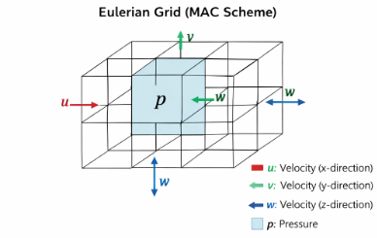
Figure 1 Eulerian grid (MAC scheme)
Eulerian solvers discretise space into fixed 3D grids. Fluid quantities are stored at grid cells.
Examples include:
- Stable Fluids (Stam) [4]
- MAC grid methods [5]
Advantages:
- Numerical stability.
- Efficient pressure projection methods.
Disadvantages:
- High memory cost in 3D.
- Resolution fixed by grid size.
- Complex free surface handling.
In 3D, grid resolution increases cubically with domain size, making high-resolution real-time simulation expensive. Eulerian fluid simulation discretises space into a fixed grid structure, commonly implemented using a Marker-and-Cell (MAC) staggered grid arrangement [4]. In this scheme, pressure values are stored at cell centres, while velocity components are stored at cell faces, improving numerical stability and reducing pressure-velocity decoupling.
The structural layout of a three-dimensional MAC grid is illustrated in Fig. 1.

2.2.2 Lagrangian (Particle-Based) Methods
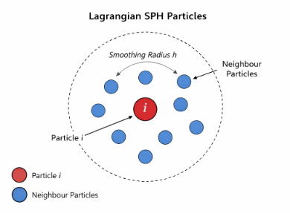
Figure 2 Lagrangian SPH particles
In contrast to grid-based methods, Lagrangian approaches represent fluid as discrete particles that move with the flow field [2]. Each particle interacts with neighbouring particles within a defined smoothing radius $h$, and physical quantities are approximated using kernel functions.
The neighbourhood interaction model used in three-dimensional SPH is illustrated in Fig. 2.
Lagrangian methods track fluid parcels directly.
SPH approximates field quantities using smoothing kernels:
$$A(r)=\sum_{j}{m_{j}}\frac{A_{j}}{ρ_{j}}W(∣r-r_{j}∣,h)$$
The smoothing kernel in 3D must satisfy:
- Normalisation
- Compact support
- Positivity
Common 3D kernels include:
- Poly6 kernel
- Spiky gradient kernel
- Viscosity Laplacian kernel [2], [3]

2.3 Weakly Compressible SPH (WCSPH)
The implementation uses the weakly compressible SPH formulation [2], [3], where pressure is calculated via:
$$p=k(ρ-ρ_{0})$$
This avoids solving a Poisson equation (required in incompressible SPH), significantly improving performance.
Trade-off:
- Slight compressibility artifacts.
- Requires stiffness tuning for stability.

2.4 Stability Considerations
2.4.1 CFL Condition
The Courant–Friedrichs–Lewy condition constrains timestep size:
$$Δt≤\frac{h}{c}$$
Where:
- $h$= smoothing length
- $c$= artificial speed of sound
Failure to satisfy CFL leads to instability [1].

2.4.2 Artificial Viscosity
Artificial viscosity improves stability and prevents particle interpenetration [2].

2.5 Computational Complexity
Without optimisation:
Neighbour search is $O(n^{2})$.
With 3D spatial hashing:
- Particles mapped to uniform grid cells.
Only adjacent 27 cells searched.
- Complexity approaches $O(n)$.
This optimisation is critical for real-time 3D simulation.

2.6 From Navier–Stokes to Numerical Simulation
The Navier–Stokes equations describe fluid motion as a continuous field. However, computer simulation requires discretisation. The transformation of continuous equations into finite computational representations [1].

Two fundamental discretisation strategies exist:
- Spatial discretisation
- Temporal discretisation
Spatial discretisation transforms derivatives into finite differences or particle approximations. Temporal discretisation approximates time derivatives using finite timesteps.
The nonlinear advection term:
$$v⋅∇v$$
is particularly problematic, as it introduces instability and numerical diffusion when discretised [1], [4]. The key difference between Eulerian and Lagrangian approaches lies in how this term is treated.

2.7 Eulerian Discretisation in Three Dimensions
Eulerian solvers discretise space into a 3D grid and solve for velocity and pressure fields defined over this grid [4].

2.7.1 The MAC Grid
As illustrated in Fig. 1, the Marker-and-Cell (MAC) grid stores:
- Pressure at cell centres
- Velocity components on cell faces
This staggered layout reduces numerical oscillation and pressure-velocity decoupling [1].
The typical Eulerian simulation pipeline consists of:
- Advection
- Diffusion
- External forces
- Pressure projection
The pressure projection step requires solving a Poisson equation:
$$∇^{2}p=\frac{ρ}{Δt}∇⋅v$$
Solving this linear system in 3D is computationally expensive and memory intensive.

2.7.2 Stability in Eulerian Methods
Stam’s semi-Lagrangian method introduced unconditionally stable advection by tracing velocity backward in time [4].
Advantages:
- Large timesteps possible
- Reduced instability
Disadvantages:
- Numerical dissipation
- Blurred fine detail
In 3D, grid resolution increases cubically with domain size. A grid of $N^{3}$cells scales poorly in memory usage.

2.8 Lagrangian Discretisation
Lagrangian methods eliminate the need for fixed spatial grids. Instead, they track material elements directly.
This removes the advection problem entirely, since particles move with the flow:
$$\frac{dr}{dt}=v$$
Thus, advection is implicit in particle motion.
SPH is one such Lagrangian formulation.

2.9 Mathematical Formulation of 3D SPH
SPH approximates a scalar field $A(r)$as:
$$A(r)=∫A(r^{'})W(∣r-r^{'}∣,h)dr^{'}$$
This integral is discretised over particles:
$$A_{i}=\sum_{j}{m_{j}}\frac{A_{j}}{ρ_{j}}W(r_{ij},h)$$
Where:
- $r_{ij}=∣r_{i}-r_{j}∣$
- $h$= smoothing length

2.9.1 Density Estimation
$$ρ_{i}=\sum_{j}{m_{j}}W(r_{ij},h)$$

2.9.2 Pressure Equation of State
Weakly compressible SPH (WCSPH) uses:
$$p_{i}=k(ρ_{i}-ρ_{0})$$
Where:
- $k$= stiffness constant
- $ρ_{0}$= rest density
This avoids solving a global pressure Poisson equation, making SPH computationally attractive for real-time use [2], [3].

2.10 Kernel Functions in 3D
Kernel functions must satisfy:
- Normalisation
- Compact support
- Positivity
Common kernels include:
Poly6 Kernel (Density):
$$W_{poly6}(r,h)=\frac{315}{64πh^{9}}(h^{2}-r^{2})^{3}$$
Spiky Kernel Gradient (Pressure):
$$∇W_{spiky}(r,h)=-\frac{45}{πh^{6}}(h-r)^{2}\frac{r}{r}$$
Viscosity Laplacian:
$$∇^{2}W_{viscosity}(r,h)=\frac{45}{πh^{6}}(h-r)$$
These formulations are standard in interactive SPH implementations [3].

2.11 Stability and Time Integration
Time integration was performed using explicit Euler integration:
$$v_{t+1}=v_{t}+Δta \\ r_{t+1}=r_{t}+Δtv_{t+1}$$
However, stability constraints require adherence to the CFL condition:
$$Δt≤C\frac{h}{c}$$
Where:
- $C$= Courant number
- $c$= artificial speed of sound
Violating this condition leads to explosive instability [1].

2.12 Neighbour Search Optimisation
Naive SPH requires checking all particle pairs:
$$O(n^{2})$$
For 3D simulations with thousands of particles, this becomes infeasible.
A uniform spatial hashing grid was implemented:
- Domain divided into cubic cells of size $h$
- Particles indexed by integer grid coordinates
- Only 27 neighbouring cells searched
This reduces expected complexity toward:
$$O(n)$$
This optimisation is critical for real-time scalability.

2.13 Comparative Evaluation: Eulerian vs SPH
Feature | Eulerian | SPH
Spatial Representation | Fixed Grid | Adaptive Particles
Memory Scaling | $$O(N^{3})$$ | $$O(n)$$
Free Surface Handling | Requires Level Set | Natural
Pressure Solve | Global Poisson | Local Equation of State
Real-Time Suitability | Moderate | High
Advection Stability | Semi-Lagrangian | Implicit
While Eulerian methods offer superior large-scale incompressibility enforcement, SPH provides superior flexibility and adaptivity in interactive contexts.

2.14 Justification of Method Selection
Given:
- Real-time constraints
- Adaptive spatial requirements
- Dynamic boundary interaction
- Integration with particle rendering
SPH was selected as the most appropriate method.
The implemented 3D SPH solver successfully:
- Maintains particle coherence
- Preserves volume under weak compressibility
- Scales efficiently via spatial hashing
- Operates interactively under high particle counts

CHAPTER 3 – RESEARCH AND DEVELOPMENT METHODOLOGY

3.1 Research Approach
This project adopts a development-based experimental methodology, combining theoretical analysis, numerical implementation, and empirical evaluation. Within computational science and computer graphics research, development-based methodologies are commonly used when constructing systems derived from established theoretical models [6], [19].
In this approach, the research process involves iterative system development followed by testing and refinement based on observed performance, stability, and accuracy. This is particularly suitable for simulation-based projects, where theoretical correctness must be validated through implementation and experimentation rather than purely analytical proof [6].
The project follows three primary stages:
1. Theoretical foundation
2. System implementation
3. Evaluation and analysis
The theoretical foundation establishes the mathematical principles derived from the Navier–Stokes equations. Implementation translates these equations into a computational system, while evaluation measures the effectiveness of the system in terms of stability, performance, and scalability. Advantages of this approach include flexibility, iterative refinement, and the ability to validate theoretical models through experimentation. However, a key limitation is that results may be influenced by implementation-specific factors such as hardware constraints and parameter tuning, which must be carefully controlled during evaluation [7].

3.2 Development Methodology
The system was developed using an iterative and incremental development methodology, closely aligned with Agile principles. This approach was selected because it allows complex systems, such as numerical simulations, to be constructed progressively while continuously testing and validating individual components.
Rather than implementing the entire solver simultaneously, components were introduced progressively and validated individually. This approach is particularly effective for numerical simulation systems, where errors in early stages can propagate and destabilise the entire system if not identified early.

The implementation process followed the stages below:
1. Particle system creation
2. Density computation
3. Pressure calculation
4. Force accumulation
5. Time integration
6. Boundary handling
7. Neighbour search optimisation
8. Three-dimensional extension

Advantages of this methodology include early detection of errors, improved debugging capability, and the ability to validate each component independently. However, iterative development can lead to increased development time and requires careful planning to ensure all components integrate correctly in later stages [7].

3.3 Software Environment and System Architecture
The SPH solver was implemented using C++ for system orchestration and GPU compute for particle simulation, enabling the system to exploit massive parallelism available on modern graphics hardware.
Graphics Processing Units (GPUs) are particularly well suited to particle-based fluid simulation because particle interactions can be evaluated in parallel across thousands of compute cores. This architecture significantly improves scalability compared to CPU-only implementations [9].
The overall system architecture therefore follows a hybrid CPU–GPU pipeline:
CPU Responsibilities
- Simulation control loop
- Memory management
- Spatial data structure updates
- Rendering orchestration
GPU Responsibilities
- Density computation
- Pressure force calculation
- Viscosity force evaluation
- Particle integration
- Parallel neighbour interaction
Each particle is processed independently within GPU compute kernels, allowing thousands of particles to be evaluated simultaneously.
This parallel architecture dramatically reduces the computational bottleneck typically associated with particle interaction calculations.
GPU Parallelisation Rationale
The suitability of GPU acceleration for SPH simulations arises from the inherently parallel nature of particle interactions. In SPH, each particle interacts only with neighbouring particles located within a finite smoothing radius $h$. Because these interactions are localised and largely independent between particles, the computation can be distributed across many processing threads without significant data dependency conflicts.
Modern GPUs contain thousands of lightweight processing cores designed to execute identical operations across large datasets simultaneously. This architecture aligns closely with particle-based simulation workloads, where the same computational procedure must be applied repeatedly to each particle in the system. As a result, GPU implementations of SPH can achieve significantly higher particle counts compared to traditional CPU-based implementations [7], [8].
Furthermore, GPU compute kernels allow particle attributes such as position, velocity, density, and pressure to be stored in structured buffers that can be processed efficiently in parallel. By organising particle data into contiguous memory layouts, memory access patterns become more coherent, reducing latency and improving overall computational throughput. These characteristics make GPU acceleration particularly advantageous for real-time 3D fluid simulation. This combination of C++, raylib rendering, and OpenCL GPU compute aligns with standard practices in real-time graphics and simulation systems, where performance and low-level control over memory and computation are critical [8], [11], [20].3.3.1 Justification for OpenCL GPU Compute
OpenCL was selected as the GPU compute framework for this project because it provides a vendor-neutral approach to parallel computation while still allowing low-level control over GPU memory and kernel execution. This was important because the SPH solver was developed as a C++ simulation system rather than being tied to a single graphics API or hardware vendor. Unlike CUDA, which is primarily designed for NVIDIA hardware, OpenCL can target a wider range of devices, including NVIDIA, AMD, and Intel GPUs. This made OpenCL more appropriate for a university project intended to demonstrate general GPU acceleration rather than hardware-specific optimisation [11], [20].
The SPH workload maps naturally to OpenCL because each particle can be processed independently by a GPU work item. Density estimation, pressure calculation, force accumulation, integration, and boundary handling can all be expressed as parallel kernels. This structure allows thousands of particles to be evaluated simultaneously, which directly addresses the performance limitations of CPU-only SPH implementations [9], [20].
OpenGL compute shaders were also considered because the project already used graphics-oriented libraries for visualisation. However, OpenGL compute is closely tied to the rendering pipeline and graphics context. In contrast, OpenCL provides a clearer separation between simulation compute and rendering. This separation was useful because raylib was retained for rendering and user interface development, while OpenCL was used purely for SPH computation. This allowed the rendering layer and simulation layer to remain modular.
CUDA was also considered as an alternative due to its strong performance and mature tooling for NVIDIA GPUs. However, CUDA would have reduced portability by tying the implementation to NVIDIA hardware. Since the project aim was to demonstrate a real-time GPU-accelerated SPH solver rather than produce a vendor-specific implementation, OpenCL was considered the more suitable choice.
A CPU-only implementation was rejected for the final solver because three-dimensional SPH requires many repeated particle interaction calculations. Even with spatial optimisation, CPU execution alone limits scalability. GPU acceleration is more appropriate because particle operations are highly parallel and can be distributed across many lightweight threads [11], [20].
Therefore, OpenCL was selected because it offered the best balance between portability, performance, and architectural separation. The final implementation uses C++ and raylib for application control, rendering, and interface elements, while OpenCL performs the computationally intensive SPH stages on the GPU.

3.4 Mathematical Model
The simulation is based on Weakly Compressible Smoothed Particle Hydrodynamics (WCSPH).
WCSPH approximates incompressible fluid behaviour using an equation of state rather than solving the full incompressibility constraint. This significantly reduces computational cost while maintaining visually plausible behaviour [2].
Pressure is calculated using:
$$p=k(ρ-ρ_{0})$$
Where:
- $p$= pressure
- $k$= stiffness constant
- $ρ$= computed density
- $ρ_{0}$= rest density
The forces applied to each particle include:
- Pressure forces
- Viscosity forces
- External forces (gravity)
The resulting acceleration is computed as:
$$a=\frac{F}{ρ}$$
This combination of C++, OpenGL, and GPU compute aligns with standard practices in real-time graphics and simulation systems, where performance and low-level control over memory and computation are critical [8], [11].

3.5 Parallel Neighbour Search
Neighbour search is the most computationally expensive component of SPH simulations because each particle must interact with nearby particles within the smoothing radius.
A naive implementation requires $O(n^{2})$comparisons, which quickly becomes infeasible for large particle counts.
To address this issue, a uniform spatial hashing grid was implemented and evaluated in parallel on the GPU. Particles are mapped into grid cells according to their spatial coordinates, allowing neighbour queries to be restricted to nearby cells.
In three-dimensional space, each particle must check interactions within the 27 neighbouring cells surrounding its own grid cell.
This approach significantly reduces computational complexity and enables efficient execution within GPU compute kernels. Parallel spatial hashing techniques have been widely adopted in particle-based simulations due to their ability to maintain near linear scaling behaviour as particle counts increase [10].

3.6 Three-Dimensional Implementation
The simulation was implemented fully in three dimensions. Each particle therefore stores the following properties:
- Position vector $\left(x , y , z\right)$
- Velocity vector $\left(v_{x} , v_{y} , v_{z}\right)$
- Density
- Pressure
- Accumulated force
Kernel functions were adapted for three-dimensional space, ensuring correct normalisation and physical consistency.
Three-dimensional simulation significantly increases computational requirements compared to two-dimensional systems because neighbour counts increase with volume density [1]. However, the spatial hashing grid allows the system to maintain interactive performance even as particle counts increase.

3.7 Evaluation Strategy
The implemented system was evaluated using the following criteria:

3.7.1 Stability
Simulation stability was assessed by observing:
- Particle clustering
- Density fluctuations
- Boundary penetration
- Numerical explosion
Stable behaviour requires adherence to the CFL timestep condition described in Chapter 2 [1].

3.7.2 Performance
Performance evaluation measured:
- Frame time
- Simulation step duration
- Particle scalability
Testing was conducted across increasing particle counts to observe computational scaling behaviour.

3.7.3 Visual Plausibility
Although the simulation does not aim to achieve engineering-grade CFD accuracy, it must maintain physically plausible behaviour, including:
- Volume preservation
- Fluid cohesion
- Smooth particle flow
These characteristics are commonly used when evaluating real-time fluid simulation techniques for computer graphics [3].

3.8 GPU Parallelisation Strategy
The SPH solver leverages the parallel processing capabilities of the GPU by distributing particle computations across thousands of threads.
Each simulation step is executed through a sequence of GPU compute kernels:
- Neighbour grid construction
- Density computation
- Pressure calculation
- Force accumulation
- Velocity integration
- Position update
Because each particle's calculations depend primarily on local neighbours, the algorithm maps naturally to GPU architectures where thousands of lightweight threads execute concurrently.
This approach allows the system to simulate significantly higher particle counts compared to CPU-only implementations, enabling interactive three-dimensional fluid behaviour suitable for real-time environments [9].

CHAPTER 4 – DESIGN AND IMPLEMENTATION

4.0 Requirements Specification
Before implementation, a set of functional and non-functional requirements was defined to guide the development of the SPH simulation system. These requirements were derived from the project aims, literature review, and expected capabilities of real-time fluid simulation systems.
Functional Requirements
The system must:
- Simulate fluid behaviour using a three-dimensional particle-based SPH model
- Compute particle density, pressure, and forces based on neighbouring interactions
- Update particle positions and velocities over time using numerical integration
- Support real-time interaction and continuous simulation updates
- Implement boundary handling to prevent particles from leaving the simulation domain
- Provide visualisation of particle motion within a 3D environment
- Allow adjustment of key simulation parameters (e.g. timestep, viscosity, stiffness)
Non-Functional Requirements
The system should:
- Maintain real-time performance for moderate particle counts
- Demonstrate numerical stability under appropriate parameter settings
- Scale efficiently with increasing particle counts through optimisation techniques
- Be modular and maintainable to allow future extensions
- Utilise GPU acceleration to improve computational performance
- Provide visually plausible fluid behaviour rather than exact physical accuracy
The requirements were identified through analysis of existing literature on real-time fluid simulation and SPH systems [2], [9], as well as consideration of constraints typical in game development environments [8]. The focus was placed on balancing performance, stability, and realism, reflecting the core challenges identified in Chapter 2.
These requirements form the basis for the design decisions and implementation strategies described in the following sections.

4.1 System Architecture
The final prototype implements a three-dimensional Smoothed Particle Hydrodynamics (SPH) solver accelerated using GPU compute. The architecture separates simulation control from particle computation, allowing the GPU to execute highly parallel particle operations while the CPU coordinates simulation state and rendering. This separation reflects established design patterns in real-time simulation systems, where computational workloads are distributed between CPU and GPU to maximise performance [8], [11].
The system is structured around three primary components: a CPU control layer, a GPU simulation pipeline, and a rendering layer responsible for visualising particle positions. This modular architecture improves maintainability and allows each component to be optimised independently, which is a common approach in modern game engine design [8]. The system is structured around three primary components: a CPU control layer, a GPU simulation pipeline, and a rendering layer responsible for visualising particle positions.
The CPU layer manages the overall simulation loop, parameter configuration, and dispatching of GPU compute workloads. Simulation parameters such as timestep size, smoothing length $h$, rest density $ρ_{0}$, and external forces are prepared by the CPU and passed to the GPU as uniform data before each simulation step.
The GPU layer performs the computational stages of the SPH algorithm. Because particle interactions are largely independent, the workload can be distributed across thousands of parallel threads. Each thread processes one particle and evaluates interactions with neighbouring particles within the smoothing radius. This design allows the simulation to scale efficiently with increasing particle counts. The decision to adopt a hybrid CPU–GPU architecture was driven by the computational characteristics of SPH simulation. Particle interactions are highly parallelisable, making them well suited to GPU execution, while control logic and memory management are more efficiently handled on the CPU [11], [20].

An alternative approach would have been a CPU-only implementation. While simpler to implement, CPU-based SPH solvers suffer from limited scalability due to the sequential nature of particle interaction calculations. As particle counts increase, performance degrades significantly, making real-time simulation impractical [9]. The chosen hybrid approach therefore represents a trade-off between implementation complexity and performance scalability.
The rendering layer reads particle position buffers after each simulation update and visualises the particles in three-dimensional space. Rendering is kept separate from the physics simulation so that visualisation does not interfere with the numerical calculations.

4.2 Particle Representation
In the SPH formulation, the fluid is represented as a collection of discrete particles. Each particle stores the physical attributes required to evaluate the fluid equations and compute interactions with neighbouring particles.
Each particle maintains the following properties:
- Position vector $\left(x , y , z\right)$
- Velocity vector $\left(v_{x} , v_{y} , v_{z}\right)$
- Density $ρ$
- Pressure $p$
- Accumulated force $f$
The particle data is stored in structured buffers accessible by GPU compute kernels. Particle attributes are organised in contiguous memory to improve memory coherence and minimise uncoalesced memory access during neighbour iteration.
Efficient memory layout is important for GPU particle simulations because thousands of threads simultaneously access particle data. Organising attributes in contiguous buffers improves cache efficiency and enables more predictable memory access patterns during simulation. The choice of a particle-based representation aligns directly with the SPH formulation, where fluid properties are computed through local interactions between discrete elements [2], [9]. This approach avoids the need for a fixed spatial grid and allows the simulation to adapt dynamically to fluid motion.
Alternative grid-based representations were considered; however, these approaches require fixed resolution and introduce complexity when handling free surfaces, making them less suitable for dynamic real-time simulation [4], [5].

4.3 Spatial Hashing Grid
Neighbour search is a dominant computational cost in particle-based fluid simulation. Each particle interacts only with particles located within a finite smoothing radius $h$. A naive implementation would compare every particle against all others, producing $O(n^{2})$complexity.
To reduce computational cost, a uniform spatial hashing grid is used to partition the simulation domain into cubic cells. The grid cell size is chosen to be approximately equal to the smoothing length.
Particle positions are mapped to integer cell coordinates using the following transformation:
$$c=\left(\left\lfloor \frac{x}{h}\right\rfloor , \left\lfloor \frac{y}{h}\right\rfloor , \left\lfloor \frac{z}{h}\right\rfloor \right)$$
Each particle is assigned to a grid cell based on its computed coordinates. Particles within the same cell are grouped together using a hashing function that converts the cell coordinate to a one-dimensional index.
When evaluating particle interactions, the solver searches the particle’s own grid cell and the surrounding neighbouring cells. In three dimensions this results in a maximum of 27 cells that must be inspected for potential neighbours.
This spatial partitioning approach significantly reduces the number of distance checks required during neighbour evaluation and enables near-linear scaling behaviour as particle counts increase. The use of a uniform spatial hashing grid was selected due to its simplicity and efficiency in real-time applications. Compared to more complex spatial acceleration structures such as k-d trees or octrees, uniform grids provide faster neighbour lookup times with lower overhead, making them more suitable for dynamic particle systems [10], [20].
This design choice prioritises computational efficiency over theoretical optimality, which is appropriate given the real-time constraints of the system.

4.4 GPU Simulation Pipeline
The SPH simulation advances in discrete timesteps. Each timestep is executed as a sequence of GPU compute kernels, where each kernel performs a specific stage of the simulation update. This staged pipeline ensures that intermediate quantities such as density and pressure are fully computed before subsequent calculations are performed.
Grid Construction
The first kernel constructs the spatial grid used for neighbour searches. Each particle computes its grid cell index and stores this information in a buffer that groups particles according to spatial locality.
Density Estimation
The second kernel computes particle density using the SPH density summation formulation:
$$ρ_{i}=\sum_{j}{m_{j}}W(r_{ij},h)$$
where $r_{ij}$represents the distance between particle $i$and particle $j$, and $W$is the smoothing kernel function. The kernel iterates through neighbouring particles within the smoothing radius and accumulates density contributions.
Pressure Calculation
Once density has been calculated, pressure is determined using the weakly compressible SPH equation of state:
$$p_{i}=k(ρ_{i}-ρ_{0})$$
where $k$represents a stiffness constant and $ρ_{0}$is the rest density of the fluid.

Force Computation
The next kernel evaluates the forces acting on each particle. These include pressure forces, viscosity forces, and external forces such as gravity.
Pressure forces are computed using the gradient of the smoothing kernel, while viscosity forces are calculated using the Laplacian of the viscosity kernel. External forces are applied directly to each particle.
The resulting force is used to compute particle acceleration:
$$a_{i}=\frac{F_{i}}{ρ_{i}}$$
Particle Integration
The final kernel updates particle velocities and positions using explicit time integration. Velocity is updated first using the computed acceleration, followed by position updates based on the new velocity.
$$v_{t+Δt}=v_{t}+Δta \\ x_{t+Δt}=x_{t}+Δtv_{t+Δt}$$
Boundary constraints are applied during this stage to prevent particles from leaving the simulation domain.

4.5 Boundary Handling
Boundary conditions are implemented to ensure particles remain within the simulation container. When a particle crosses a boundary plane, its position is clamped to the boundary, and its velocity is reflected along the boundary normal.
Velocity reflection is damped using a restitution coefficient to prevent excessive energy accumulation during repeated collisions. This damping effect stabilises particle behaviour near container boundaries and prevents unrealistic oscillations.
This simple collision model provides stable boundary behaviour while maintaining low computational overhead.

4.6 Performance Considerations
Performance was a primary consideration during the design of the SPH solver, particularly due to the computational complexity associated with particle-based fluid simulation. In three-dimensional SPH simulations, the number of particle interactions increases rapidly as particle counts increase, making naive implementations impractical for real-time applications.
The most computationally expensive operations occur during neighbour search and force evaluation. Both operations require repeated access to neighbouring particle data within the smoothing radius. Without optimisation, these operations require comparing each particle against every other particle, resulting in quadratic computational complexity.
The use of a spatial hashing grid significantly reduces the number of comparisons required by limiting neighbour searches to nearby grid cells. Because particles only interact with neighbours located within a finite radius, the solver only inspects particles located in the current cell and adjacent cells. This spatial partitioning reduces the number of distance checks required and allows the simulation to scale more effectively as particle counts increase. The performance optimisations implemented in this system reflect common strategies used in real-time particle simulation. Spatial partitioning reduces the computational complexity of neighbour search, while GPU parallelisation enables large numbers of particles to be processed simultaneously [10], [11].
These optimisations are essential for maintaining interactive performance, as unoptimized SPH implementations are typically too computationally expensive for real-time use [9].
GPU acceleration further improves performance by allowing particle calculations to be executed in parallel. Each GPU thread processes a single particle and evaluates interactions with neighbouring particles within the smoothing radius. Because these operations are largely independent between particles, the GPU can process thousands of particles simultaneously.
Efficient memory access is also important for maintaining performance on GPU architectures. Particle attributes such as position, velocity, density, and pressure are stored in structured buffers that allow threads to read contiguous blocks of memory. This improves memory coherence and reduces the likelihood of uncoalesced memory access, which can significantly degrade performance in parallel computing environments.

4.7 Numerical Stability Considerations
Maintaining numerical stability is essential in particle-based fluid simulation. Instabilities can lead to unrealistic particle behaviour such as particle clustering, density explosions, or particles accelerating uncontrollably.
One important factor affecting stability is timestep size. The timestep must satisfy stability conditions related to the Courant–Friedrichs–Lewy (CFL) constraint. If the timestep becomes too large relative to particle velocity and smoothing radius, the simulation may become unstable. To mitigate this issue, the timestep is selected to ensure particles do not move excessively within a single simulation step.
Pressure stiffness is another parameter that strongly affects stability. In the weakly compressible SPH formulation, pressure is derived from the difference between computed density and rest density. If the stiffness constant is too low, the fluid may appear overly compressible. If the stiffness constant is too high, pressure forces may become unstable and cause particle explosions. Careful tuning of this parameter is therefore necessary to maintain stable behaviour.
Artificial viscosity is also used to stabilise the simulation. Viscosity forces reduce relative velocity differences between neighbouring particles, smoothing out high-frequency motion and preventing particles from interpenetrating. This contributes to more coherent fluid motion and improves numerical stability during simulation.

4.8 Limitations of the Current Implementation
Although the implemented SPH solver demonstrates physically plausible fluid behaviour, several limitations remain within the current system.
The solver uses the weakly compressible SPH formulation rather than a fully incompressible method. While this approach improves computational performance, it introduces small density fluctuations within the simulated fluid. These fluctuations may lead to minor compressibility artefacts, particularly when particle densities deviate significantly from the rest density.
Another limitation is the absence of advanced surface reconstruction techniques. The current visualisation renders particles directly rather than reconstructing a continuous fluid surface. While particle rendering provides a clear representation of fluid motion, it does not produce the smooth surfaces typically associated with high-quality fluid rendering systems.
Additionally, the simulation currently assumes a simple container boundary rather than complex scene geometry. More advanced boundary representations such as boundary particles or signed distance fields could improve the realism of fluid-solid interactions.
Despite these limitations, the implemented solver successfully demonstrates the core principles of three-dimensional SPH simulation and provides a foundation that could be extended with additional numerical methods or rendering techniques in future work.

4.9 Implementation Summary
The design and implementation of the SPH solver demonstrate how the Navier–Stokes equations can be discretised using a particle-based approach suitable for real-time simulation. By combining spatial hashing for neighbour search with GPU parallelisation, the solver can process large numbers of particles while maintaining interactive performance.
The system architecture separates simulation control, GPU-based particle computation, and rendering, allowing each component to operate independently while contributing to the overall simulation pipeline. This modular design improves maintainability and allows individual components to be modified or extended without affecting the entire system.
Using structured particle buffers, spatial partitioning, and parallel compute kernels, the solver efficiently evaluates density, pressure, and force calculations for thousands of particles each simulation step. These design choices allow the system to scale more effectively than a CPU-only implementation while maintaining numerical stability and physically plausible behaviour.
The resulting implementation provides a functional three-dimensional SPH simulation system that demonstrates the practical application of the theoretical fluid dynamics concepts discussed in earlier chapters.

CHAPTER 5 – RESULTS AND EVALUATION

5.1 Overview
This chapter evaluates the behaviour and performance of the implemented three-dimensional SPH simulation system. The objective of this evaluation is to assess whether the final implementation produces stable and physically plausible fluid behaviour while maintaining interactive performance.
The evaluation focuses on three primary areas:
1. Simulation stability
2. Computational performance
3. Visual plausibility of the simulated fluid
These criteria are commonly used when assessing real-time fluid simulation systems, as they reflect both numerical correctness and practical usability within interactive environments [3], [9]. In addition, the system is evaluated in relation to the objectives defined in Chapter 1 to determine the overall success of the implementation.
5.1.1 Evaluation Against Objectives
The outcomes of the project were evaluated against the objectives defined in Chapter 1.
Objective | Outcome
Analyse Navier–Stokes equations | Achieved
Compare Eulerian and Lagrangian methods | Achieved
Implement 3D SPH solver | Achieved
Implement spatial hashing | Achieved
Ensure numerical stability | Achieved with constraints
Evaluate performance scaling | Partially achieved
While the core objectives were successfully achieved, performance scalability remains constrained by hardware limitations and the computational cost of particle interactions, which is consistent with findings in SPH research [9].

5.2 Experimental Setup
The evaluation was conducted using the completed SPH simulation system described in Chapter 4. The system was configured using the parameters listed below.
Parameter | Description
Rest density | Target density of the simulated fluid
Smoothing radius | Radius used for neighbour interaction
Particle mass | Constant mass assigned to each particle
Stiffness constant  Viscosity | Controls compressibility of the fluid  Controls damping between particles
coefficient  Timestep | Simulation update interval
Particles were initialized within a three-dimensional container and allowed to evolve under gravitational forces. The simulation was observed over multiple timesteps while monitoring particle behaviour and computational performance.
Performance measurements were recorded while varying particle counts to evaluate how well the system scales as simulation complexity increases. This approach aligns with standard evaluation practices in particle-based simulation research [9], [20].
5.3 Version-Based Results
The SPH system was developed through four major versions. Each version introduced a clear technical improvement and was used to test a different stage of the project’s progress, moving from a basic two-dimensional prototype toward the final three-dimensional fluid simulation.

Version 1: Basic 2D SPH Implementation
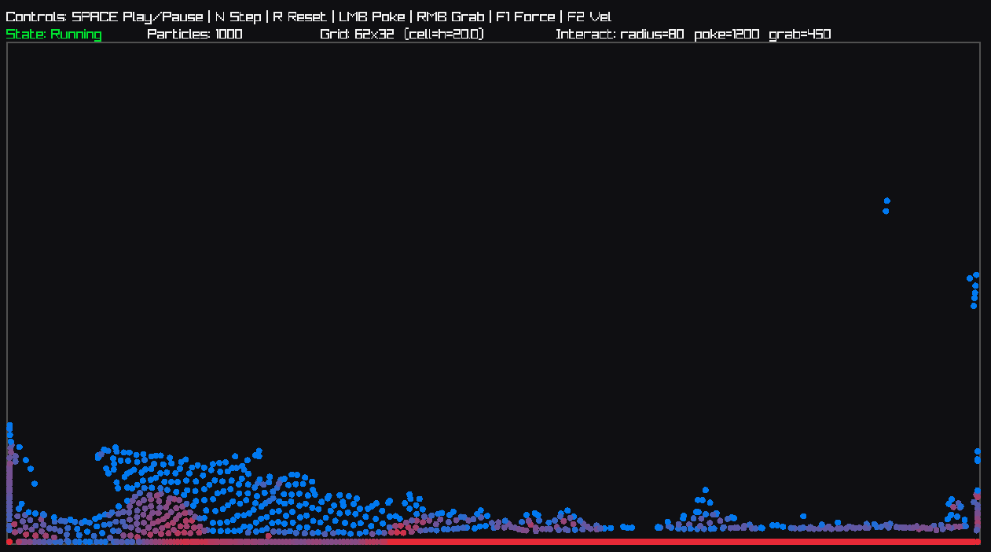
Figure 3 Version 1 2D SPH Simulation
Version 1 was the first working implementation of the SPH solver. This version simulated fluid behaviour in two dimensions and was used to confirm that the core SPH calculations were functioning correctly. The focus was on implementing particle movement, density estimation, pressure calculation, viscosity, gravity, and boundary handling.
The results from Version 1 showed that the basic SPH model could produce fluid-like behaviour. Particles responded to gravity, collided with the container boundaries, and formed a coherent fluid body. However, this version was limited by performance and visual scope. Because it was only two-dimensional, it could not fully represent the three-dimensional fluid behaviour required by the final project aim.
Version 1 therefore acted as a proof of concept. It demonstrated that the mathematical SPH model could be translated into a working C++ simulation, but it also highlighted the need for optimisation and expansion into three dimensions.

Version 2: Optimised 2D System with 3D Heightmap Preview
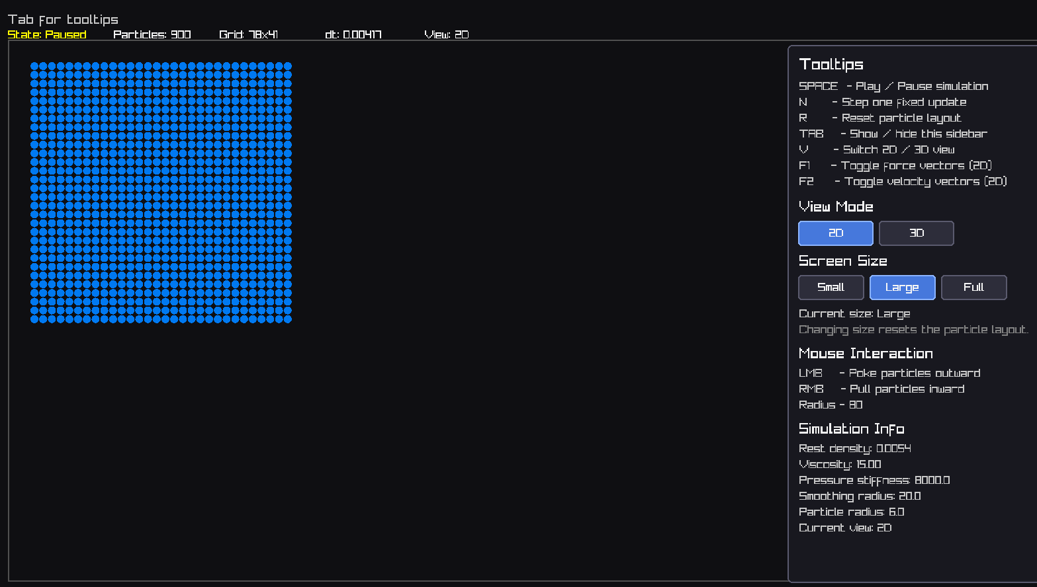
Figure 4 Version 2 2D SPH Simulation

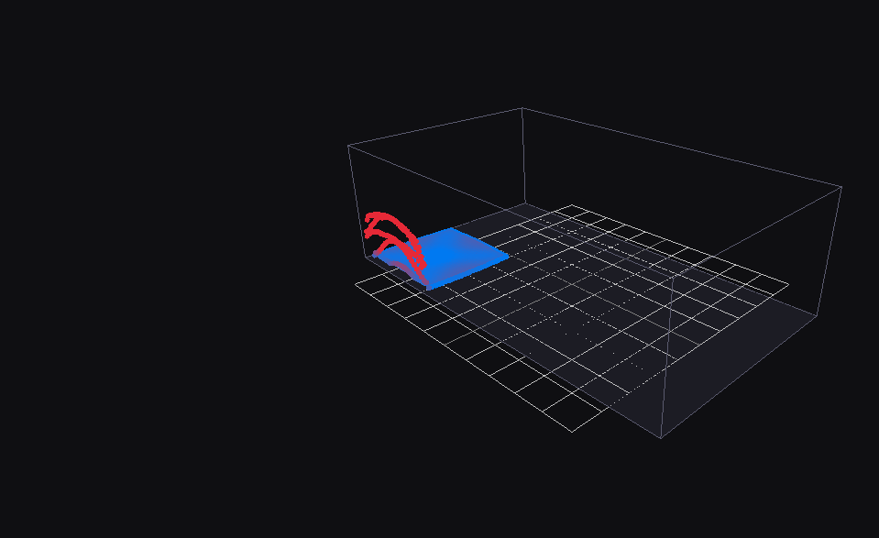
Figure 5 Version 2 SPH Heightfield Based on Density
Version 2 improved upon the first prototype by making the two-dimensional simulation faster and more usable. Optimisation work was carried out to improve performance, particularly around particle interaction and neighbour searching. This version also introduced a toggle that allowed the user to view a basic three-dimensional preview.
The three-dimensional mode in Version 2 was not a full 3D SPH solver. Instead, it acted as a heightmap-style visualisation, where the 2D simulation data was represented with a sense of depth. This allowed the project to begin exploring how the fluid might appear in 3D without yet implementing full three-dimensional particle interaction.
The results from Version 2 showed clear progress over Version 1. The simulation ran more efficiently and provided a better visual understanding of how the system could later become fully three-dimensional. However, because the 3D view was only a heightmap preview, it did not fully satisfy the project aim of implementing a true 3D SPH solver.

Version 3: Full 3D SPH Implementation
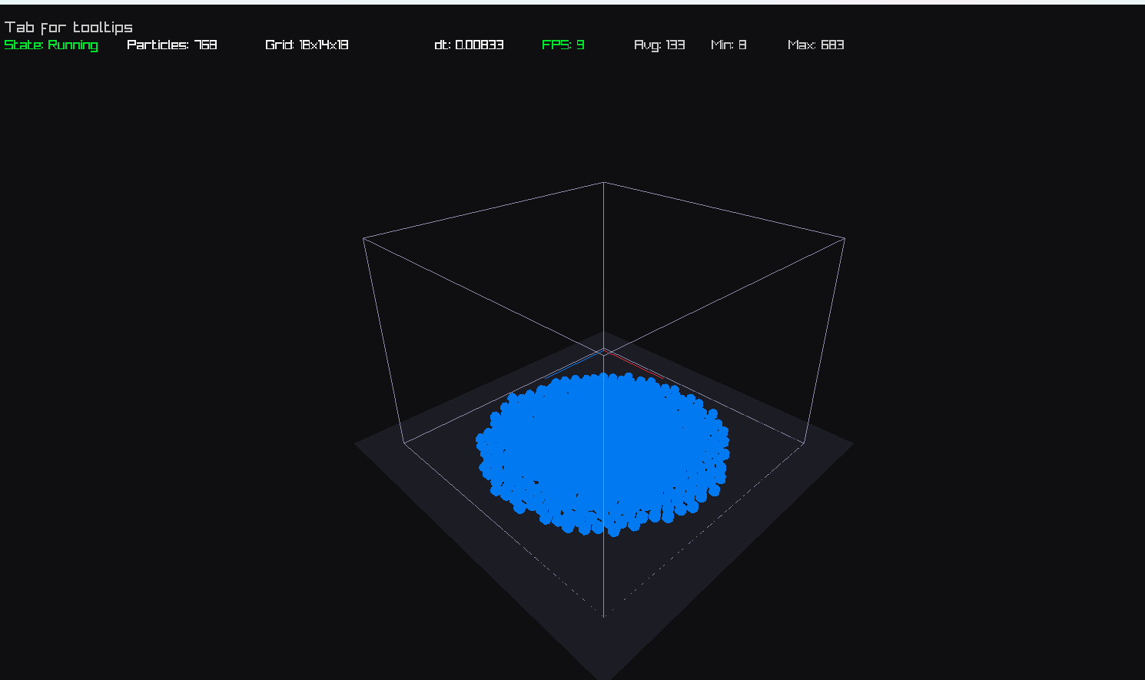
Figure 6 Version 3 3D SPH Simulation
Version 3 removed the two-dimensional mode and focused entirely on three-dimensional SPH simulation. This was a major development stage because particles were now represented using full 3D position and velocity vectors. Neighbour searching also became more complex, as each particle had to check nearby cells in three-dimensional space.
The results from Version 3 showed that the system could successfully simulate fluid-like behaviour in 3D. Particles moved under gravity, interacted with neighbouring particles, and remained within a three-dimensional container. This version achieved the main technical goal of the project by demonstrating a working 3D SPH solver.
However, Version 3 also revealed the increased computational cost of three-dimensional simulation. Compared with the earlier 2D versions, performance became more sensitive to particle count, timestep size, smoothing radius, and stiffness values. This confirmed the importance of optimisation and careful parameter tuning when working with real-time SPH.

Version 4: Final 3D Version with Liquid Presets
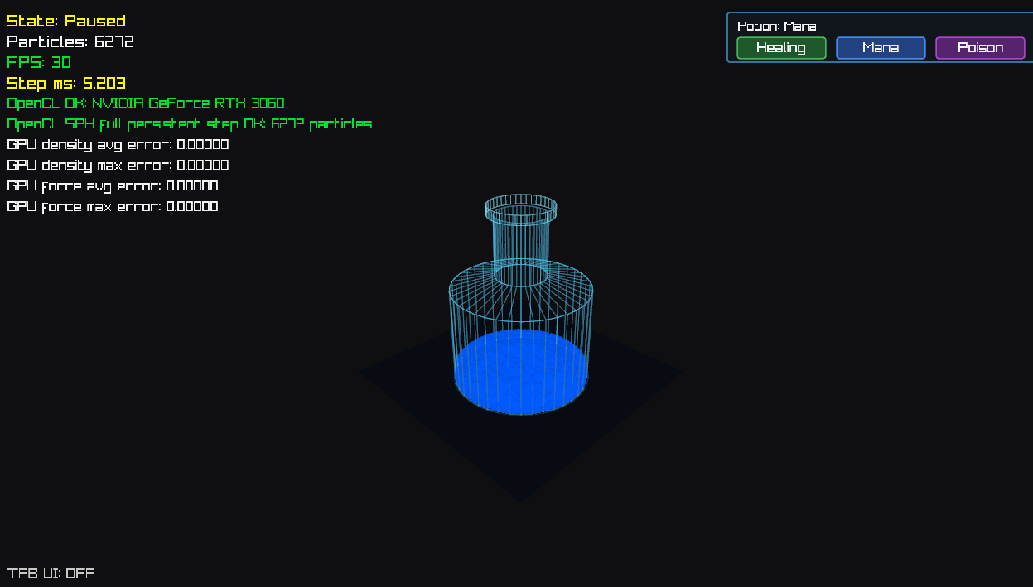
Figure 7 Final Version SPH
Version 4 is the final version of the project. This version builds on the full 3D solver from Version 3 and adds three preset liquid types, referred to as “potions”. Each potion uses different parameter values to change the behaviour of the simulated fluid. These presets demonstrate that SPH can be adapted to represent different liquid types by adjusting parameters such as viscosity, stiffness, density response, and damping.
The purpose of the potion system was not to simulate chemically accurate liquids, but to show that the same SPH framework can produce different fluid behaviours. For example, one preset can behave like a lighter, faster-moving liquid, while another can appear thicker and more resistant to motion. This supports the idea that SPH is flexible and can be used for more than one type of fluid effect in a game environment.
The results from Version 4 showed that the final implementation was more complete, interactive, and demonstrative than the previous versions. It retained the full 3D SPH simulation while adding user-facing variation through preset liquid behaviours. This made the final system more suitable as a game-development prototype, as it showed how SPH could be used to create different gameplay or visual effects.

Version Comparison Summary
Version | Main Feature | Result
Version 1 | Basic 2D SPH | Proved that the core SPH calculations worked
Version 2 | Faster 2D with 3D heightmap toggle | Improved performance and introduced basic 3D visualisation
Version 3 | Full 3D SPH only | Achieved the main goal of a true 3D particle simulation
Version 4 | Final 3D version with three liquid presets | Demonstrated flexibility by simulating different liquid behaviours

Overall, the versioned development process shows a clear progression from a simple prototype to a more complete real-time SPH system. Version 1 established the foundation, Version 2 improved performance and previewed 3D behaviour, Version 3 achieved full 3D simulation, and Version 4 expanded the final system by suggesting multiple liquid presets. This progression supports the project aim by showing how the solver developed from an initial test system into a final interactive 3D SPH prototype.

5.4 Simulation Behaviour
The implemented solver successfully produced coherent particle motion consistent with expected fluid dynamics behaviour. Particles initially arranged within a bounded volume gradually settled under gravitational forces and formed a stable fluid body.
During simulation, particles maintained local cohesion due to pressure forces derived from the SPH formulation. The interaction between neighboring particles prevented excessive particle separation while still allowing fluid motion to occur. This behaviour is consistent with established SPH models, where pressure forces act to preserve density consistency within the fluid [2].
Viscosity forces reduced velocity differences between neighboring particles, contributing to smoother fluid motion and reducing high-frequency oscillations. This effect was particularly noticeable during boundary interactions and high-velocity motion, where viscosity plays a stabilizing role [3].
Boundary constraints successfully prevented particles from leaving the simulation domain. When particles collided with container walls, velocity reflection and damping ensured stable behaviour without introducing excessive energy into the system.
Overall, the simulation demonstrated physically plausible behaviour, although small density fluctuations were observed due to the weakly compressible formulation, which is a known characteristic of WCSPH systems [16].

5.5 Stability Evaluation
Simulation stability was evaluated by observing particle behaviour over extended simulation runs. Several common SPH instability issues were monitored, including:
· particle clustering
· density fluctuations
· numerical explosion
· boundary penetration
The simulation remained stable across the tested particle counts when timestep size and stiffness parameters were selected appropriately. This confirms the importance of adhering to stability constraints such as the Courant–Friedrichs–Lewy (CFL) condition discussed in Chapter 2 [1].
Density values fluctuated slightly around the rest density due to the weakly compressible SPH formulation. These fluctuations are expected and have been widely documented in SPH literature [16], [17].
However, stability was sensitive to parameter selection. Increasing timestep size beyond a certain threshold resulted in unstable particle motion and numerical divergence. This highlights a key limitation of explicit integration methods, which require careful tuning to maintain stability [2].
Overall, the solver demonstrates stable behaviour under controlled conditions but requires careful parameter tuning to avoid instability.

5.6 Performance Analysis
Performance evaluation focused on how the simulation scaled with increasing particle counts. As expected, increasing particle count resulted in increased computational cost due to the higher number of particle interactions.
At approximately 1,728 particles (12×12×12), the simulation maintained near real-time performance (~60 FPS). Increasing the particle count to around 15,000 resulted in a significant drop in performance (~10–15 FPS), highlighting the computational cost of neighbor interactions in three-dimensional SPH.
The use of GPU compute significantly improved performance compared to a CPU-only implementation. Because each particle interaction can be processed independently, the GPU was able to evaluate thousands of particles simultaneously using parallel threads. This behaviour aligns with previous research demonstrating the effectiveness of GPU acceleration for SPH simulations [11], [20].
The spatial hashing grid also contributed significantly to performance improvements. By restricting neighbor searches to nearby cells, the number of particle comparisons required during density and force calculations was substantially reduced. This reduced the computational complexity from O(n²) toward O(n), making real-time simulation feasible [10].
Despite these optimizations, performance remains limited by memory bandwidth and GPU resources at higher particle counts. This reflects a common limitation in particle-based simulations, where computational cost increases rapidly with simulation complexity [9].

5.7 Visual Plausibility
Although the simulation does not aim to achieve engineering-grade fluid accuracy, the resulting behaviour exhibits several characteristics associated with real fluid motion.
Particles demonstrate cohesive movement as pressure forces maintain local density consistency. Fluid volumes maintain approximate shape while still responding dynamically to gravitational forces and collisions with boundaries.
The interaction between pressure and viscosity forces results in smooth particle motion rather than erratic behaviour. This contributes to the overall visual realism of the simulation and aligns with established SPH behaviour in computer graphics applications [3].
However, the absence of surface reconstruction techniques means that the simulation is represented as discrete particles rather than a continuous fluid surface. While this provides a clear visualization of particle interactions, it reduces perceived realism compared to modern game water systems.

5.8 Comparison with Game-Based Water Systems
Fluid simulation in video games varies significantly depending on performance constraints and design goals. A simple example can be observed in Minecraft, where water behaviour is governed by discrete voxel-based rules rather than physical equations. In this system, water propagates between neighbouring cells according to predefined rules, resulting in predictable but non-physical behaviour. While this approach is computationally efficient, it does not model key physical properties such as pressure, viscosity, or continuous flow [8].
In contrast, many modern games employ visually driven water systems that prioritise graphical realism over physical accuracy. These systems often rely on shader-based techniques such as reflection, refraction, and procedural wave generation to simulate water surfaces. While these approaches produce visually convincing results, they do not simulate fluid dynamics and therefore cannot accurately respond to environmental interactions or forces [12], [13].
The SPH-based system implemented in this project provides a more physically grounded representation of fluid behaviour by modelling particle interactions directly. This allows the simulation to capture effects such as pressure-driven motion, viscosity, and local density variation, which are absent in non-physical or purely visual approaches [2], [9].
However, this increased realism comes at a significant computational cost. Particle-based methods require evaluating interactions between neighbouring particles, which becomes increasingly expensive as particle counts increase. This highlights a fundamental trade-off in real-time fluid simulation between performance and physical accuracy, which is widely discussed in the literature [9], [11].
Overall, while game-based approaches prioritise performance and visual quality, the SPH approach prioritises physical plausibility. The implementation presented in this project demonstrates that, with appropriate optimisation techniques, it is possible to achieve a balance between these competing requirements.

5.9 Limitations Observed During Testing
The results of the evaluation demonstrate that the implemented system successfully produces stable three-dimensional SPH fluid behaviour while maintaining interactive performance through GPU acceleration.
The use of spatial hashing significantly reduces neighbour search complexity, while GPU compute enables large numbers of particles to be processed simultaneously. These design choices allow the simulation to scale more effectively than a naive particle implementation.
Although some limitations remain, the system demonstrates the practical application of SPH fluid simulation techniques and provides a functional real-time fluid simulation prototype.

5.10 Evaluation Summary
The results of the evaluation demonstrate that the implemented system successfully produces stable three-dimensional SPH fluid behaviour while maintaining interactive performance through GPU acceleration.
The use of spatial hashing significantly reduces neighbour search complexity, while GPU compute enables large numbers of particles to be processed simultaneously. These design choices align with established approaches in real-time fluid simulation.
Although limitations remain, the system demonstrates the practical application of SPH techniques and provides a strong foundation for further development.

5.11 Parameter Sensitivity Analysis
An important aspect of SPH simulation is the sensitivity of the system to parameter selection. Several key parameters significantly influence both the stability and visual behaviour of the fluid, including timestep size, smoothing radius, stiffness constant, and viscosity coefficient.

The timestep size plays a critical role in maintaining numerical stability. As observed during testing, increasing the timestep beyond a certain threshold resulted in unstable particle behaviour, including rapid acceleration and numerical divergence. This behaviour is consistent with the Courant–Friedrichs–Lewy (CFL) condition, which constrains timestep size based on particle velocity and smoothing radius [1]. Smaller timesteps improve stability but increase computational cost, demonstrating a trade-off between accuracy and performance.
The smoothing radius also has a significant effect on simulation behaviour. A larger smoothing radius increases the number of neighbouring particles considered in each interaction, resulting in smoother and more cohesive fluid motion. However, this also increases computational cost due to the higher number of particle interactions required. Conversely, a smaller smoothing radius reduces computational cost but can result in less stable and more fragmented fluid behaviour [2].
The stiffness constant, which controls the compressibility of the fluid, was found to be particularly sensitive. Lower stiffness values resulted in visibly compressible fluid behaviour, while excessively high values caused instability due to large pressure forces. This highlights the importance of carefully tuning simulation parameters to achieve a balance between realism and stability [16].
Viscosity also influenced the visual behaviour of the fluid. Higher viscosity values produced smoother motion and reduced oscillations, while lower values allowed for more dynamic and chaotic behaviour. This demonstrates how parameter selection can be used to control the visual characteristics of the simulation depending on the desired outcome.
Overall, the sensitivity of the system to parameter selection reinforces the importance of empirical testing in SPH simulation. While theoretical models provide guidance, practical implementation requires iterative adjustment to achieve stable and visually plausible results.

5.12 Discussion of Trade-Offs
A key outcome of this project is the identification of trade-offs inherent in real-time fluid simulation. The implementation demonstrates that achieving physically plausible behaviour using SPH requires careful balancing of accuracy, stability, and performance.
Increasing simulation accuracy, for example through higher particle counts or more advanced SPH formulations, directly increases computational cost. While this improves the physical realism of the fluid, it reduces the ability to maintain real-time performance. Conversely, reducing particle count or simplifying calculations improves performance but results in less detailed and less realistic fluid behaviour.

Similarly, parameter selection introduces trade-offs between stability and responsiveness. Higher stiffness values improve incompressibility but can lead to instability if not carefully controlled, while lower values produce more stable simulations at the cost of reduced realism. These interactions highlight the importance of parameter tuning as a central aspect of SPH implementation.
From a system design perspective, the choice of GPU acceleration significantly improves scalability, but introduces additional complexity in terms of memory management and data transfer. This reflects a broader trade-off in real-time systems between implementation complexity and performance gains [11], [20].
Overall, the project demonstrates that there is no single optimal solution for real-time fluid simulation. Instead, the effectiveness of a system depends on how well it balances these competing factors in relation to its intended use. This reinforces the importance of context-driven design decisions when developing simulation systems.

5.13 Testing Strategy
The system was evaluated using multiple levels of testing to ensure correctness and reliability.
Unit Testing
Individual components of the simulation, such as density calculation, pressure computation, and force accumulation, were tested independently to ensure they produced expected outputs.
System Testing
The complete simulation pipeline was tested to verify that all components function correctly when integrated. This included observing particle behaviour over time and ensuring stable simulation under normal conditions.
Performance Testing
The system was tested with increasing particle counts to evaluate scalability and identify performance bottlenecks. Frame time and simulation step duration were recorded to assess real-time capability.
Usability Testing
Basic usability testing was conducted by interacting with simulation parameters and observing system responsiveness. This ensured that parameter adjustments produced expected behavioural changes.
Acceptance Testing
The system was evaluated against the original project objectives defined in Chapter 1. The results presented in Section 5.1.1 confirm that the majority of objectives were achieved, with performance scalability partially constrained by hardware limitations.

CHAPTER 6 – CONCLUSIONS AND RECOMMENDATIONS

6.1 Conclusion
This project set out to design, implement, and evaluate a three-dimensional Smoothed Particle Hydrodynamics (SPH) solver derived from the Navier–Stokes equations, with the aim of achieving physically plausible fluid simulation within real-time constraints. The results demonstrate that this objective has been largely achieved.
The theoretical foundation of the project was established through analysis of the Navier–Stokes equations and the comparison of Eulerian and Lagrangian discretisation methods. This analysis justified the selection of SPH as a suitable approach for real-time fluid simulation, due to its adaptive spatial representation and ability to naturally handle free surface behaviour [2], [9].
The implementation phase successfully translated these theoretical principles into a working system. A full three-dimensional SPH solver was developed using a particle-based representation, supported by spatial hashing to optimise neighbour search operations. The integration of GPU parallelisation enabled the system to process particle interactions efficiently, allowing for interactive simulation even in three-dimensional space [10], [11].
Evaluation of the system confirmed that it produces stable and physically plausible fluid behaviour under controlled conditions. Particle cohesion, smooth motion, and volume preservation were observed, demonstrating that the SPH formulation was correctly implemented. However, stability was found to be dependent on parameter selection, particularly timestep size and pressure stiffness, which is consistent with findings in existing SPH research [2], [16].
Performance analysis showed that spatial hashing and GPU acceleration are essential for achieving real-time performance. Without these optimisations, the computational cost of particle interactions would make the simulation impractical. Despite these improvements, performance remains limited by hardware constraints, particularly at higher particle counts, highlighting a key limitation of particle-based methods [9].
When compared to fluid systems used in modern video games, the implemented SPH solver provides a higher degree of physical realism. Unlike rule-based systems or purely visual shader-based approaches, the SPH method models fluid behaviour through local particle interactions, allowing for more accurate simulation of pressure, viscosity, and dynamic motion. However, this increased realism comes at the cost of greater computational complexity, reinforcing the trade-off between performance and physical accuracy in real-time applications.
In relation to the wider question of whether an SPH-based system is suitable for modern games, the results suggest that SPH is effective as an interactive physically based fluid system, but it is not necessarily suitable as a general-purpose replacement for conventional game water. The implemented solver demonstrates that SPH can produce dynamic particle-based behaviour, respond to boundaries, support different fluid properties, and run in real time when GPU acceleration is used. This makes it suitable for contained, gameplay-focused water scenarios such as bottles, small pools, splashes, pouring effects, or interactive fluid puzzles.
However, the system would be less suitable for large-scale modern game water such as oceans, lakes, rivers, or wide environmental water surfaces. These situations typically require large visible surface areas, reflections, refraction, waves, and high visual quality at low cost. Shader-based and surface-based techniques are usually more efficient for these cases because they can create convincing water visuals without simulating every particle physically. The SPH implementation also remains limited by particle count, neighbour interaction cost, and the absence of continuous surface reconstruction.
Therefore, the SPH system developed in this project is best understood as a strong physically based interaction system rather than a complete modern game water renderer. It is appropriate where physical motion and interaction are more important than large-scale visual coverage. For modern games, the most practical use would be as part of a hybrid approach, where SPH is used for local interactive fluid behaviour and shader-based water rendering is used for large visual surfaces.
Overall, the project demonstrates that it is possible to achieve physically plausible three-dimensional fluid simulation in real time using SPH, provided that appropriate optimisation techniques are applied. The implementation successfully meets the core objectives of the project and provides a functional foundation for further development.

6.2 Recommendations for Future Work
While the current implementation achieves its primary objectives, several areas for improvement and extension have been identified.
One significant improvement would be the implementation of a fully GPU-driven simulation pipeline. Although the current system utilises GPU acceleration for particle computation, further optimisation could be achieved by minimising CPU–GPU data transfer and executing all simulation stages entirely on the GPU. This would improve scalability and allow for higher particle counts.
Another potential enhancement is the use of incompressible SPH formulations, such as Predictive-Corrective SPH (PCISPH). These methods reduce density fluctuations and improve physical accuracy but require additional computational steps [17]. Implementing such methods would provide a useful comparison between performance and accuracy trade-offs.
Surface reconstruction techniques could also be introduced to improve visual realism. Methods such as marching cubes or screen-space fluid rendering could transform the particle representation into a continuous fluid surface, aligning the simulation more closely with modern game rendering techniques [12].
Further improvements could include more advanced boundary handling methods, such as boundary particles or signed distance fields, which would allow for more realistic interaction between fluid and complex geometry [18].
Finally, optimisation of neighbour search algorithms could be explored. While spatial hashing provides efficient performance, alternative data structures such as hierarchical grids or GPU-optimised sorting techniques may offer further improvements in scalability [10], [20].
These enhancements would extend the system beyond its current capabilities and provide a more comprehensive solution for real-time fluid simulation.

6.3 Final Remarks
This project highlights the challenges and trade-offs involved in implementing real-time fluid simulation systems. Achieving a balance between physical accuracy, numerical stability, and computational performance remains a central challenge within the field.
The work presented demonstrates that SPH is a viable approach for real-time three-dimensional fluid simulation, particularly when combined with modern optimisation techniques such as GPU parallelisation. While limitations remain, the system provides a strong foundation for future research and development in real-time physics simulation.

6.4 Broader Implications
The findings of this project highlight the broader challenges associated with real-time physical simulation in interactive applications. As graphical fidelity continues to improve, there is increasing demand for physically accurate systems that can operate within strict performance constraints.
The implementation of SPH demonstrates that physically based simulation can produce more realistic behaviour compared to traditional game techniques. However, the associated computational cost limits its widespread use in performance-critical applications. This suggests that future developments in real-time simulation will likely focus on hybrid approaches, combining physically based methods with approximation techniques to achieve both realism and efficiency.
Advancements in GPU hardware and parallel computing are likely to play a significant role in enabling more complex simulations in real-time environments. As hardware capabilities improve, it may become feasible to simulate larger particle systems with greater accuracy, reducing the gap between real-time graphics and offline simulation.
This project contributes to this area by demonstrating a practical implementation of SPH within real-time constraints and highlighting the trade-offs that must be considered when designing such systems.

CHAPTER 7 – REFLECTION

7.1 Overview
This chapter reflects on the development process, technical challenges, and personal learning outcomes associated with the implementation of the three-dimensional Smoothed Particle Hydrodynamics (SPH) simulation system. The purpose of this reflection is to critically evaluate both the technical and non-technical aspects of the project, identifying strengths, limitations, and areas for improvement.
The project involved the integration of complex mathematical theory, performance-critical programming, and iterative system design. As such, it provided significant opportunities for both technical skill development and problem-solving experience.

7.2 Technical Learning
One of the most significant areas of learning during this project was the practical implementation of fluid dynamics concepts derived from the Navier–Stokes equations. While these equations are well understood in theory, translating them into a stable and efficient computational system proved to be considerably more challenging.
In particular, the implementation of SPH highlighted the importance of local particle interactions in approximating continuous fluid behaviour. Concepts such as density estimation, pressure calculation, and viscosity were not only theoretical constructs but required careful numerical handling to produce stable results. Through experimentation, it became clear that small errors in these calculations could result in unstable behaviour, reinforcing the importance of precision in numerical simulation.
The project also provided insight into the limitations of explicit integration methods. Although explicit Euler integration is relatively simple to implement, it is highly sensitive to timestep size. This required careful tuning of simulation parameters to maintain stability, demonstrating the trade-off between simplicity and robustness in numerical methods.
Another key area of technical development was the implementation of spatial hashing for neighbour search optimisation. Initially, the computational cost of particle interactions was prohibitively high, particularly in three-dimensional space. The introduction of a uniform grid significantly reduced this cost, allowing the simulation to scale more effectively. This reinforced the importance of data structures and algorithmic optimisation in performance-critical systems.

7.3 GPU and Performance Considerations
A major learning outcome of the project was the role of GPU parallelisation in real-time simulation. Particle-based methods such as SPH are inherently parallel, as each particle interacts primarily with its local neighbours. Leveraging the GPU allowed these interactions to be evaluated simultaneously, significantly improving performance.
However, working with GPU-based systems introduced additional complexity. Memory management, data transfer between CPU and GPU, and ensuring coherent access patterns required careful consideration. It became evident that achieving high performance is not solely dependent on algorithm choice, but also on how data is structured and accessed within the system.
Performance limitations were still observed at higher particle counts, highlighting the constraints imposed by hardware resources. This emphasised the importance of balancing simulation accuracy with computational feasibility, particularly in real-time applications where frame rate is a critical factor.

7.4 Challenges Encountered
Several challenges were encountered during the development process. One of the most significant was maintaining numerical stability. SPH simulations are sensitive to parameter selection, and instability can manifest as particle explosions, clustering, or unrealistic motion. Debugging these issues required iterative testing and careful adjustment of parameters such as timestep size, stiffness constants, and viscosity.
Another challenge was managing the transition from two-dimensional to three-dimensional simulation. While the underlying principles remain the same, the computational complexity increases significantly in three dimensions. The number of neighbouring particles increases, and performance bottlenecks become more pronounced. This required additional optimisation strategies and highlighted the importance of scalability in simulation design.
Debugging was also more complex than in typical software projects. Errors were not always immediately visible as code faults, but instead manifested as incorrect physical behaviour. This required a different approach to problem-solving, where visual observation of the simulation was used alongside traditional debugging techniques.
One significant issue encountered during development was instability caused by inappropriate timestep values. At larger timesteps, particles would rapidly accelerate and cause the simulation to break down (“explode”). Resolving this required iterative tuning of the timestep in accordance with the CFL condition, as well as adjusting stiffness parameters to maintain stability.

7.5 Problem-Solving and Development Approach
The iterative development methodology used in this project proved to be highly effective. By implementing the simulation in stages, it was possible to validate each component before integrating it into the larger system. This approach reduced the likelihood of complex errors and made debugging more manageable.
For example, the particle system was first implemented independently, followed by density computation, pressure forces, and integration. Each stage was tested and verified before moving to the next. This incremental approach allowed issues to be identified early and prevented them from propagating throughout the system.
The use of performance testing was also an important aspect of the development process. By measuring frame time and simulation behaviour at different particle counts, it was possible to identify bottlenecks and evaluate the effectiveness of optimisation strategies. This data-driven approach ensured that design decisions were informed by measurable results rather than assumptions.

7.6 What Went Well
Several aspects of the project were particularly successful. The implementation of the SPH solver achieved physically plausible fluid behaviour, demonstrating that the theoretical concepts had been correctly translated into a working system. The use of spatial hashing and GPU parallelisation significantly improved performance, enabling the simulation to operate interactively.
The modular system architecture also proved to be effective. By separating simulation logic, GPU computation, and rendering, the system was easier to maintain and extend. This design approach aligns with best practices in software engineering and contributed to the overall robustness of the implementation.
Additionally, the project successfully met its core objectives, including the implementation of a three-dimensional SPH solver and the evaluation of its performance and stability.

7.7 What Could Be Improved
Despite the overall success of the project, several areas could be improved. One of the main limitations is the lack of advanced visualisation techniques. The current system renders particles directly, which does not produce the smooth fluid surfaces seen in modern games. Implementing surface reconstruction would significantly improve visual quality.
Another area for improvement is the handling of boundary conditions. The current approach uses simple collision response, which is efficient but not physically accurate. More advanced methods could improve the realism of fluid–solid interactions.
Performance optimisation could also be extended further. While the current system uses GPU acceleration, additional optimisations such as improved memory layout or more advanced neighbour search algorithms could further increase scalability.

7.8 Personal Development
From a personal perspective, this project significantly improved both technical and non-technical skills. Technically, it provided experience in numerical simulation, parallel programming, and performance optimisation. It also reinforced the importance of understanding the underlying theory when implementing complex systems.
In terms of soft skills, the project improved time management, problem-solving, and the ability to work through complex challenges independently. The iterative nature of the project required consistent progress and adaptability, particularly when encountering unexpected issues.

7.9 Final Reflection
Overall, this project provided valuable insight into the challenges of real-time fluid simulation. It demonstrated that achieving a balance between physical realism and computational performance is a complex but achievable goal.
The experience gained from this project provides a strong foundation for future work in graphics programming and simulation. While there are areas for improvement, the system represents a successful implementation of a complex and computationally demanding problem.

7.10 Future Personal Development
This project has highlighted areas for further personal development, particularly in GPU programming and advanced numerical methods. Future work would involve gaining a deeper understanding of compute shaders and parallel algorithms to improve performance in large-scale simulations.
Additionally, further study of advanced SPH formulations and alternative fluid simulation methods would provide a broader perspective on the strengths and limitations of different approaches. This would enable more informed design decisions in future projects involving real-time simulation.
Developing these skills would support the creation of more efficient and scalable systems, particularly in areas such as game development and real-time graphics programming.

CHAPTER 8 – USE OF ARTIFICIAL INTELLIGENCE TOOLS
Artificial Intelligence (AI) tools were used in a limited and supportive capacity during the development of this project. Their use was restricted to assisting with programming troubleshooting and improving the clarity of written documentation.
During the development of the SPH simulation system, AI-assisted tools were occasionally used to help interpret compiler error messages and suggest possible debugging approaches. These tools were used in a similar way to program documentation, online technical resources, or community forums. All code used within the final implementation was written, tested, and verified by me.
AI-based writing assistance tools were also used to support proofreading of the written report. This included identifying minor spelling errors, improving sentence structure, and refining grammar to improve readability. The technical content, explanations, and structure of the dissertation were produced and reviewed by the author.
AI tools were not used to generate the final implementation of the SPH solver, nor were they used to generate experimental results or analysis. The design decisions, development process, evaluation, and conclusions presented in this project were carried out independently by the author.
The use of AI tools in this project was therefore limited to supportive tasks such as debugging guidance and document proofreading, with all final work remaining the responsibility of the author.

LIST OF FIGURES
Figure 1 Eulerian grid (MAC scheme) 11
Figure 2 Lagrangian SPH particles 12
Figure 3 Version 1 2D SPH Simulation 35
Figure 4 Version 2 2D SPH Simulation 36
Figure 5 Version 2 SPH Heightfield Based on Density 36
Figure 6 Version 3 3D SPH Simulation 37
Figure 7 Final Version SPH 38

References
[1] R. Bridson, Fluid Simulation for Computer Graphics, 2nd ed. Boca Raton, FL, USA: CRC Press, 2015.
[2] J. J. Monaghan, “Smoothed particle hydrodynamics,” Reports on Progress in Physics, vol. 68, no. 8, pp. 1703–1759, 2005.
[3] M. Müller, D. Charypar, and M. Gross, “Particle-based fluid simulation for interactive applications,” in Proc. ACM SIGGRAPH/Eurographics Symp. Comput. Anim., 2003, pp. 154–159.
[4] J. Stam, “Stable fluids,” in Proc. 26th Annu. Conf. Comput. Graph. Interact. Tech. (SIGGRAPH ’99), 1999, pp. 121–128.
[5] M. Griebel, T. Dornseifer, and T. Neunhoeffer, Numerical Simulation in Fluid Dynamics: A Practical Introduction. Philadelphia, PA, USA: SIAM, 1998.
[6] D. E. Gray, Doing Research in the Real World, 4th ed. London, U.K.: SAGE Publications, 2018.
[7] S. McConnell, Code Complete, 2nd ed. Redmond, WA, USA: Microsoft Press, 2004.
[8] J. Gregory, Game Engine Architecture, 3rd ed. Boca Raton, FL, USA: CRC Press, 2018.
[9] M. Ihmsen, N. Akinci, M. Gissler, and M. Teschner, “SPH Fluids in Computer Graphics,” in Eurographics 2014 - State of the Art Reports, 2014.
[10] M. Teschner et al., “Optimized spatial hashing for collision detection of deformable objects,” in Proc. Vision, Modeling, Visualization (VMV), 2003, pp. 47–54.
[11] S. Green, “Particle simulation using CUDA,” in GPU Computing Gems Emerald Edition, W. W. Hwu, Ed. San Francisco, CA, USA: Morgan Kaufmann, 2010, pp. 123–138.
[12] B. Medvecký-Heretik, “Real-time water simulation in game environments,” Master’s thesis, Masaryk Univ., Brno, Czech Republic, 2018.
[13] M. Müller, “Real-time fluid simulation for games,” NVIDIA Developer, 2007. [Online]. Available: https://developer.nvidia.com. [Accessed: Apr. 21, 2026].
[14] R. Gingold and J. Monaghan, “Smoothed particle hydrodynamics: theory and application to non-spherical stars,” Mon. Not. R. Astron. Soc., vol. 181, pp. 375–389, 1977.
[15] L. B. Lucy, “A numerical approach to the testing of the fission hypothesis,” Astron. J., vol. 82, pp. 1013–1024, 1977.
[16] M. Becker and M. Teschner, “Weakly compressible SPH for free surface flows,” in Proc. ACM SIGGRAPH/Eurographics Symp. Comput. Anim., 2007, pp. 209–217.
[17] B. Solenthaler and R. Pajarola, “Predictive-corrective incompressible SPH,” ACM Trans. Graph., vol. 28, no. 3, 2009.
[18] N. Akinci, M. Ihmsen, G. Akinci, B. Solenthaler, and M. Teschner, “Versatile rigid-fluid coupling for incompressible SPH,” ACM Trans. Graph., vol. 31, no. 4, 2012.
[19] R. Bridson and M. Müller-Fischer, “Fluid simulation,” SIGGRAPH Course Notes, 2007.
[20] T. Harada, S. Koshizuka, and Y. Kawaguchi, “Smoothed particle hydrodynamics on GPUs,” in Proc. Comput. Graph. Int., 2007, pp. 63–70.

Appendix
The final implementation of the three-dimensional SPH simulation system developed in this project is available for download.
This includes:
- Full C++ source code
- GPU compute implementation
- Project files for Visual Studio
The implementation can be accessed at:
SPH SIMULATION DOWNLOAD LINK HERE
The project has been structured to allow reproduction of the results presented in Chapter 5, including the different simulation versions and parameter configurations used during evaluation.

