Specialism Report- 2400 words
Directing and Cinematography (DOP)

Introduction

I don’t have much of experience as a film director, but I do have loads of ideas for how I could be a better director using the knowledge I have gained through photography and cinematography. I have always kept in mind the phrase so called ‘director vison’ and what I am trying to do with this film, do I want it the scene to be exhilarating or inspiring? Perhaps even making the audience cry. As a director of this project, I wanted to bring out the purpose of each scene and having a clear image with specific details and make the scene look authentic as possible.

Being in an existing comfortable role as cinematographer and wanting to move forward to director, it’s becoming a challenge. When I started getting involved in filmmaking, I used to shoot flexible and not have any clue what I’m filming or for what purpose, as I didn’t care as long as the shoot looked appealing in an artistic way. But I wanted to move forward, by seeing wider into the picture and to be more concerned with what I am trying to achieve and then working through on how to actually get to that point. Reflecting on new ways of thinking has now changed my mind set on film and enhanced my skills from being just an obsessed gear head with cinematography equipment, to actually filming and constructing ideas. As in the past I had only photography experience, the role of cinematographer helped me to act on the person that I am, to be able to oversee the imagery and now being able to see the relationship between a cinematographer and a director.

I work best spontaneously, but when performing a role of a cinematographer, I adapt my skills and my attitude towards the creative process and work through the contrast and evolve. Now, I do it more significantly with the thought of how I would approach a director’s most ambitious and traditional development venture, detailing and understanding shot lists and storyboards. I have created storyboards in previous projects of how I imagine the film to look like and try to work on the establishing shot while trying to create the ideal element of professionalism to deliver the intended visualisation to the director.
However some of my cinematography skills come from artistic background. When studying arts, one will learn that composition and framing are the most crucial elements, same in photography and cinematography.

A source of inspiration for this project came from the Netflix series “The Disappearance of Madeline McCann’ which is a crime documentary, directed by Chris Smith. This documentary gave me an idea to embark on a journey to develop my idea into a documentary style film, rather than another scripted drama, with heavy narrative.

Being a director for this project and a director of photography (DOP), simply I had to produce it in a way that I could oversee and actively getting some of the best work possible I could have ever done, in order to bring that story to life on screen, for an audience. This can be for any format, whether that be online media, programmes for television, short films or features. Over the course of the last three years on this educational programme, opportunities have arisen to develop leadership and communication skills with others as part of a crew. This, partnered with a thirst for wanting to take this knowledge into personal and professional endeavours has enabled a desire to capture the moment and seize every opportunity.

With this in mind, the last three years have allowed opportunities to be involved in a variety of different crew roles, all leading to a choice in specialism for the Major Project. The immediate thought for a specialism role was to choose Cinematography, due to previous background experience in photography. In this photography experience however, there was a lack of control of the story; a title was provided and an image had to be captured to show that story. Despite this hesitation, I became interested in the technology of the camera and a desire to pursue Cinematography grew from consistent workshops with the tech team however, there was still a lack of confidence in visualising ideas from other scripts. Similar to the photography experience, I had to film what was asked of me and not my own visions.
Through the taught modules on this course, more understanding has been gained on the importance of storytelling in film. However, scriptwriting and screenplays are not my strongest suit and find that I’m better at visualising a story, rather than writing it.

A director shouldn’t get in the way of the movie, the story should.
- Frank Darabont

I found that I do this through storyboards and rip-o-matic, which allows me to envision the story and show others the story that’s in my head. In this way, I have more control as a director, over the artistic and dramatic aspects of the film I am working on and found this to be the role best suited to my talents as I am free to express the stories and visions that are in my head, as I’m in complete control of the project. This ultimately decided that the specialism for this project going forwards, was Directing with Cinematography.

I’m a freelance filmmaker. The creative process began when I had the power in my head. Directing. The creating process involving people and getting conceptions to occlusion is what ii want to achieve my artistic directing style. However I was influenced by some wonderful directors in this industry. One of the best directors I look up too is Kenneth Branagh (Murder on the orient express) using 65m lens.

Genre (Docudrama)
Crime Scene- The Reality

Conventions

Docudrama is a form of blending documentary and a film drama conventions in performing realism, representations and recognitions. Choosing this was the best way to bring up the topic and the mise-en-scene to invite judgment in relation to the crime scene investigation and show the viewers and the audience, the representation of the actual processes and share the knowledge. This came through research and through existing forensic knowledge and the crime scene investigators themselves. Watching iconic crime dramas helped me to adapt the convention and show the differences between performances and invest in the audience emotions and involve them in fictional naturalism and even melodrama. However looking back through the research, in that of documentary practice results showed that documentary dramas usually follows a cinematic narrative structure and I believe I have achieved that in my short docudrama.

Narrative

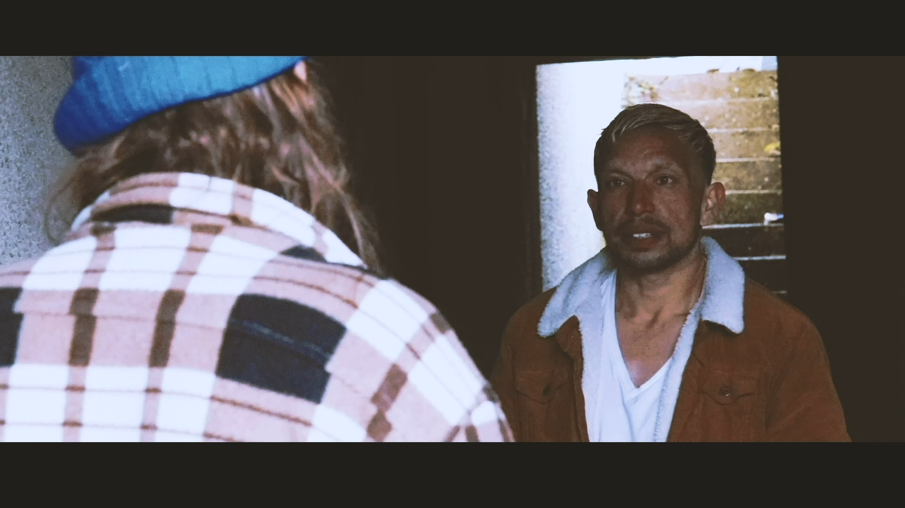
The narrative of this story that I wanted to intend for this project was to show the reality of what truly happens in an investigation after a crime has been committed. To show this to the audience I wanted to experiment by showing a simple cause of crime, that’s when ‘The Deal’ came in place. I based the story between dealer and a customer as this is usually the cause of crimes such as this. The dealer, when time came to pick up the money, is losing his patience as he is being pressured by time and had other plans to attend to. However, I wanted to show that the dealer had a bit of patience and had a bit of joker side to him and breaking the time was the only way he had to kill the time. Then we have the customer, taking his time to arrive. Calm and angry at the same time. When met, the money is handed to the dealer. However the customer didn’t have any idea that the money that was given him were mostly fake and made out of newspaper. When dealer realised the deal went absurdly wrong, both got angry, and a fight ensues, and the dealer in rage and anger, stabbed him and creates a deep wound in his stomach. However, the customer tried to run away and found the abandoned place where they met available for hiding. Running for his life, the dealer runs after him. When the dealer finds him, still in anger and rage, the first thing that was found, which was a hammer, grabbed it and smashed him in the cortex of his head and killing the customer instantly.

In terms of narrative, this is a common theme for there to be a struggle between two or more people at the scene of a crime and for there to be some kind of weapon involved.

Character settings

For the dealer I wanted to the character to have a major personality such as:
- -Gang mentality
- -Harsh language
- -Smoker
- -And addiction

For the customer
- -Stubborn
- -Dress to impress
- -Victim
- -Addiction
- -Gangster mentality

I wanted to centre the narrative and the theme on a forensic team and crime solvers to investigate and walk through the same patch of how the crime happened to solve it with locating and identifying evidence and their process of uncovering the truth of the events. Usually they show the killers identity but in the narrative I wanted to show immediately who the killer was, in a way giving the story away, but with a realistic explanation of how the investigation is done and how evidence is collected.

Codes and conventions

I started with a chase, this time it was money then I went for the environmental, where I wanted to be unknown and it shows its somewhere away from public view. I started by introducing the first props which in this case it was the knife. Before I already had introduced to the villain, the main protagonist, and then the victim. With these two characters, I wanted to show vulnerabilities within a gang. And then proceeded with the conflicts and difference perspectives and betrayals.

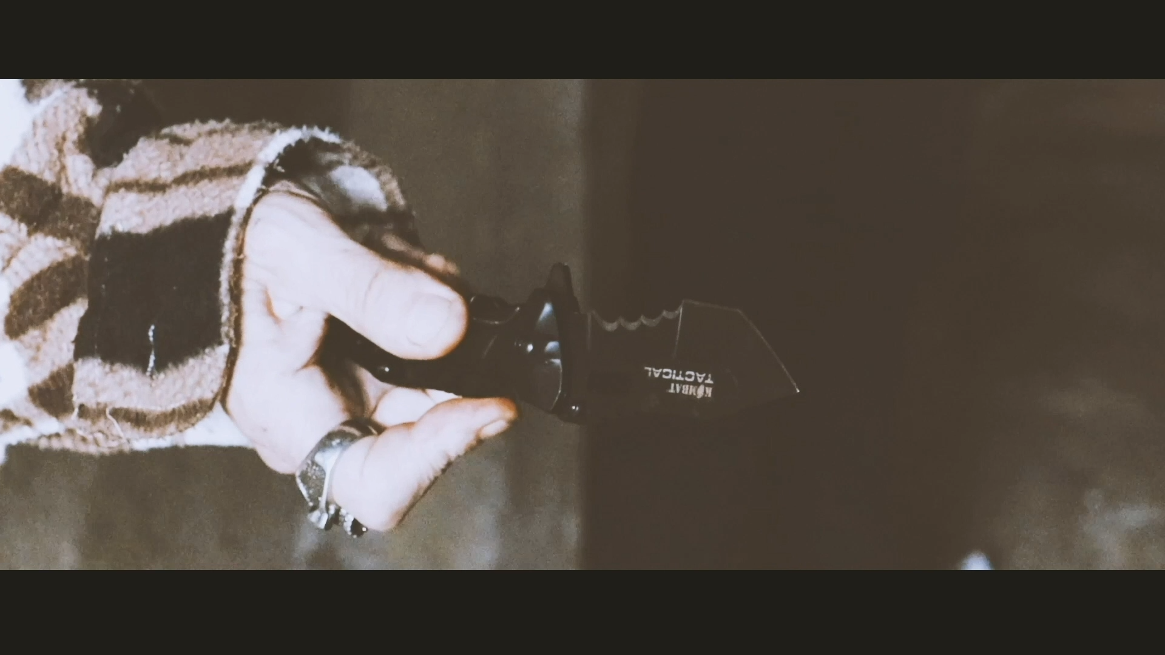
In tending to capture all this I went for tilt shots to show certain important face expressions and features of the characters. This common in other drama shows featuring fight scenes and this is something I wanted to have the opportunity to direct as I had not had to chance to choreograph a fight scene in previous projects. The point of view shots, in this case I used it to show the knife. Which in this case it become my establishing shot in helping to setup the scene as well to set up the fighting sequence. For this, I went over the shoulder if the dealer to have that sense of conversion. And at the end I showed an aerial shot to show the victim’s body when he has been murdered on the floor. It was a simple way and a best technique I could use to not confuse the audience.

Lenses

Choice I made for this docu-drama, were with the intention of being as close to action as I possibly could and get that depth of field. Yes, I still had a wider lens for wider shots, but primarily I had 300mm lens to get as close to the action as possible and highlight specific details like the blood fibres, the eyes, hair, fingerprints, also its a common convention in documentary to be intimate on screen and be close to the subject and bring out the characterisation of the character or subject. I used these lenses to have the narrative be almost like an observational documentary similar to the history in the direct cinema and Cinéma vérité movement in 1960s. Where it involved no intervention, no commentary and no –re-enactment, it is an essence to observe the action and see narrative happens and unfolds in front of you. The choice of lens and framing, captured all that.
“a discovery of the “Other,” an exploration of difference.”
― Jean Rouch (Goodreads.com, n.d.)
- Canon EF 70-300mm f/4-5.6L IS USM telephoto lens – Extreme close ups
- Sigma EF 105mm f2.8 ex DG OS HSM macro lens – Close ups
- Canon EF-S 18-55mm f/3.5-5.6 - Wider shots
Lighting

For this project, when it came to choose lighting, through the eyes of my cinematography skills, I wanted to use the technique using soft diffused light from the front and some shots from the back, with a bit of fill light. In this way, I could capture stranger and more directional light from the back so the subject could have definite edge. I focused more on the back light so the soft frontal light will be a fill light and use it as background. I wanted to leave darkness in the area. Such as the scene that I shoot for the main character.

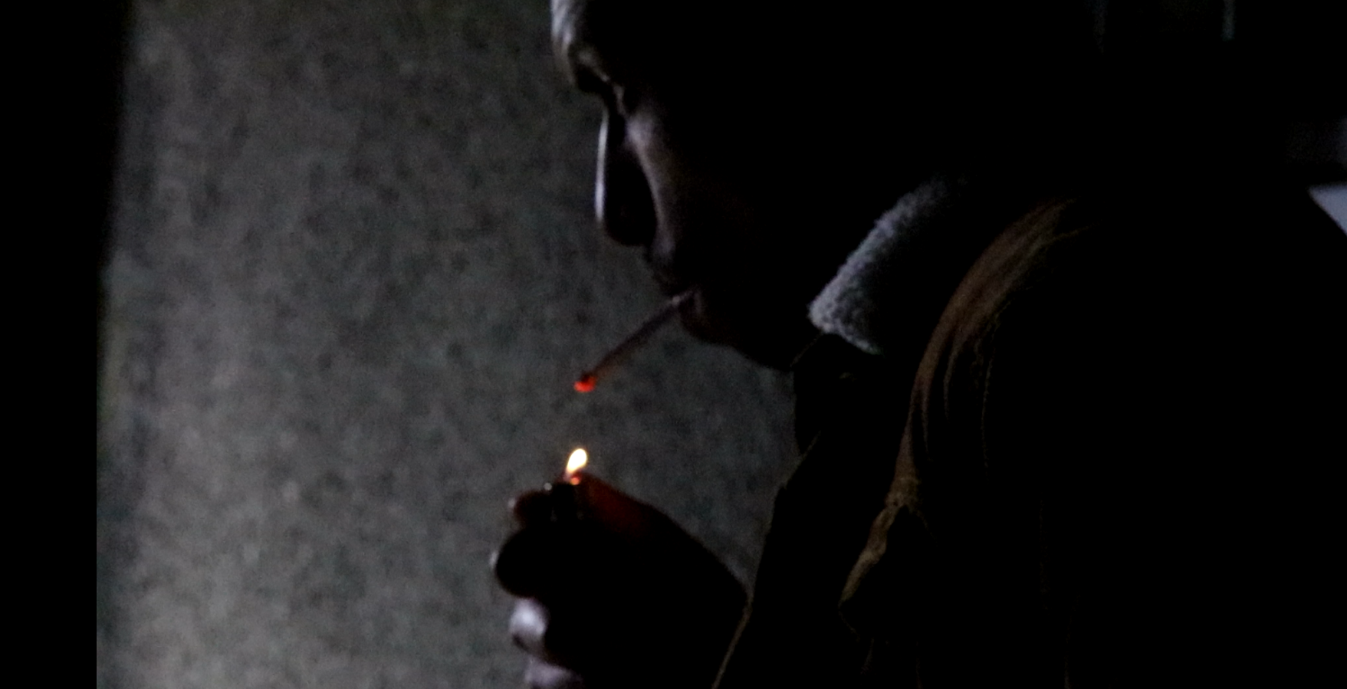
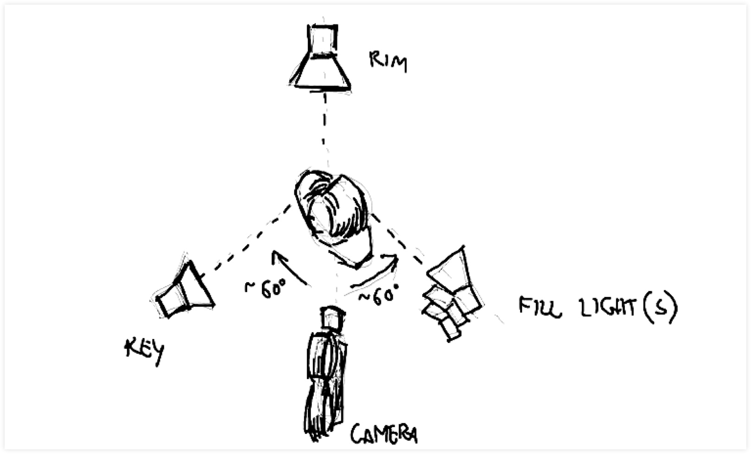
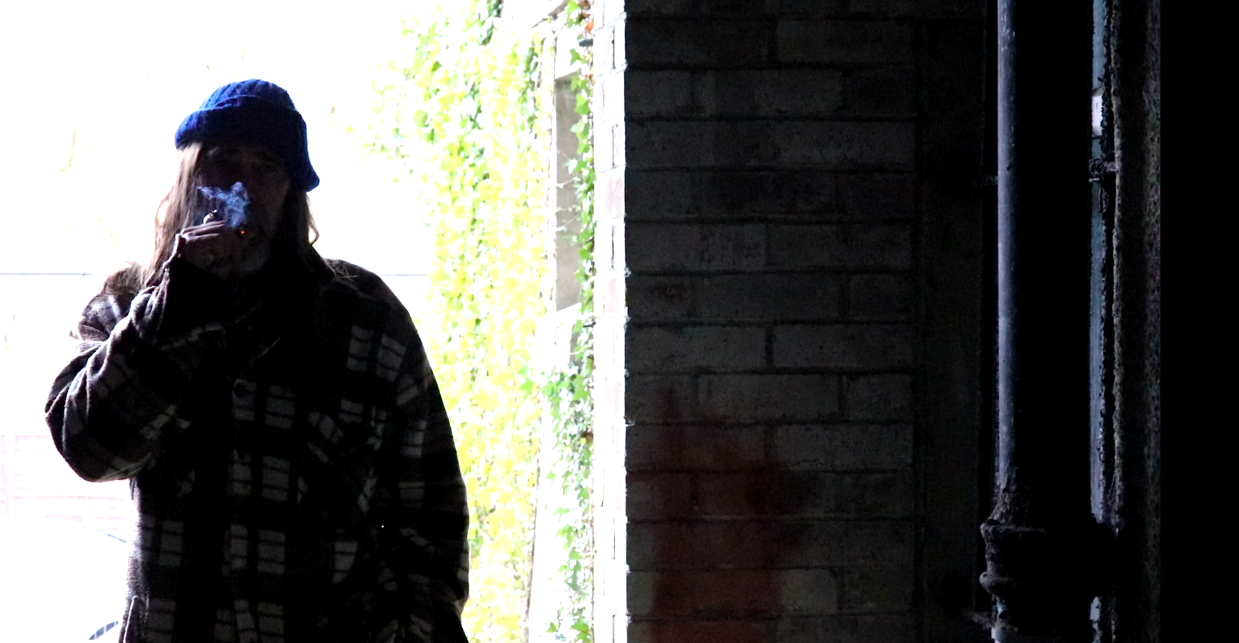

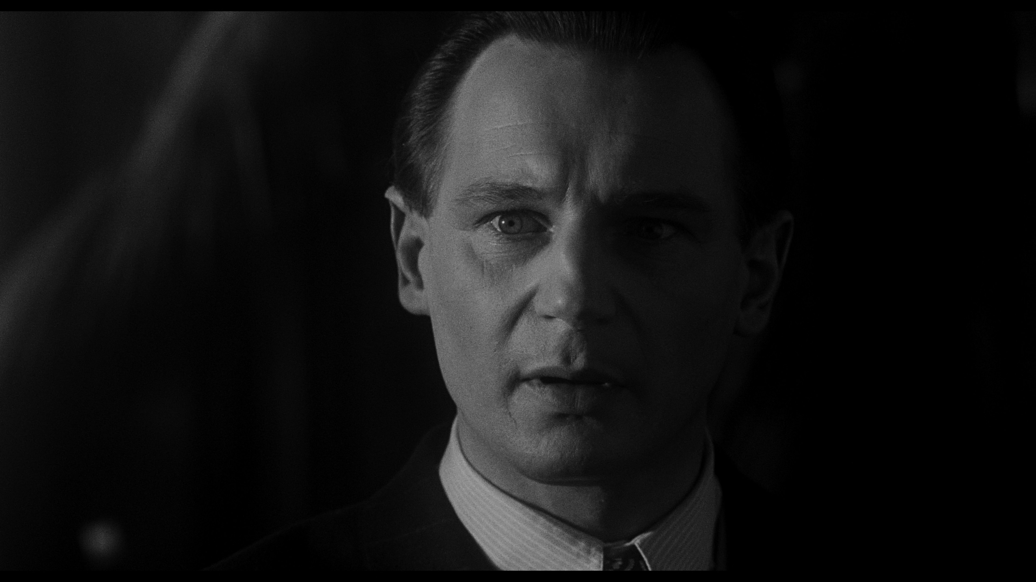The idea came from two through inspirational movies, ‘Schindler’s List directed by Steven Spielberg. When I looked at the production design, it was shot like a documentary style, leaving out all the stylistic shoots and shot the drama, leaving it unfolding in front of the audience. And that inspired me to do something similar. Steven Spielberg enhanced that being a director one can volunteer out of difficult details.

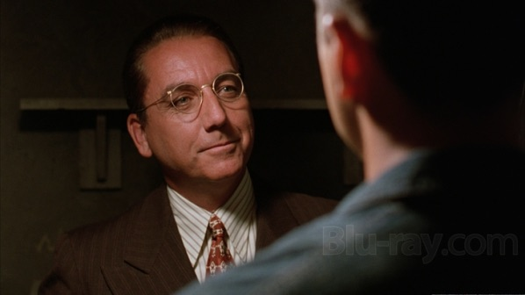
Another American drama that insured me regarding some shots and lighting, was of that ‘Shawshank Redemption’, directed by Frank Darbont. The lighting used was of natural occurring light through most of the movie. But I also noticed that they used a lot of low-key lighting. Since this movie is a crime drama, on the same genre I work on, I took more of an interest in the build up, suspenseful low-key lighting and natural lighting for the inspiration for my shoots. However, in the project when it came to fighting scene, I used low-key lighting, leaving a dark background and again low key when the subject shows blood after being stabbed. All the low key lighting and natural lighting was to express dull/ depressing colours and set the mood of the story.

(Shawshank Redemption) Andy in the warden’s office)

Colour Cinema palates

An example of this, I chose that of the hanging scene. (As grim as the hills) Shawshank Redemption, an inspiration pallet to the set the tone. It interest me and amazes me how a colour palate can say so much about the film’s mood, just with colours. So, I wanted to bring that to my story. Grim. For my major project’s colour palate, I had to look at other docu-dramas to see what type of colour scheme they have put on. I have looked through BBC documentaries and other sources of media.

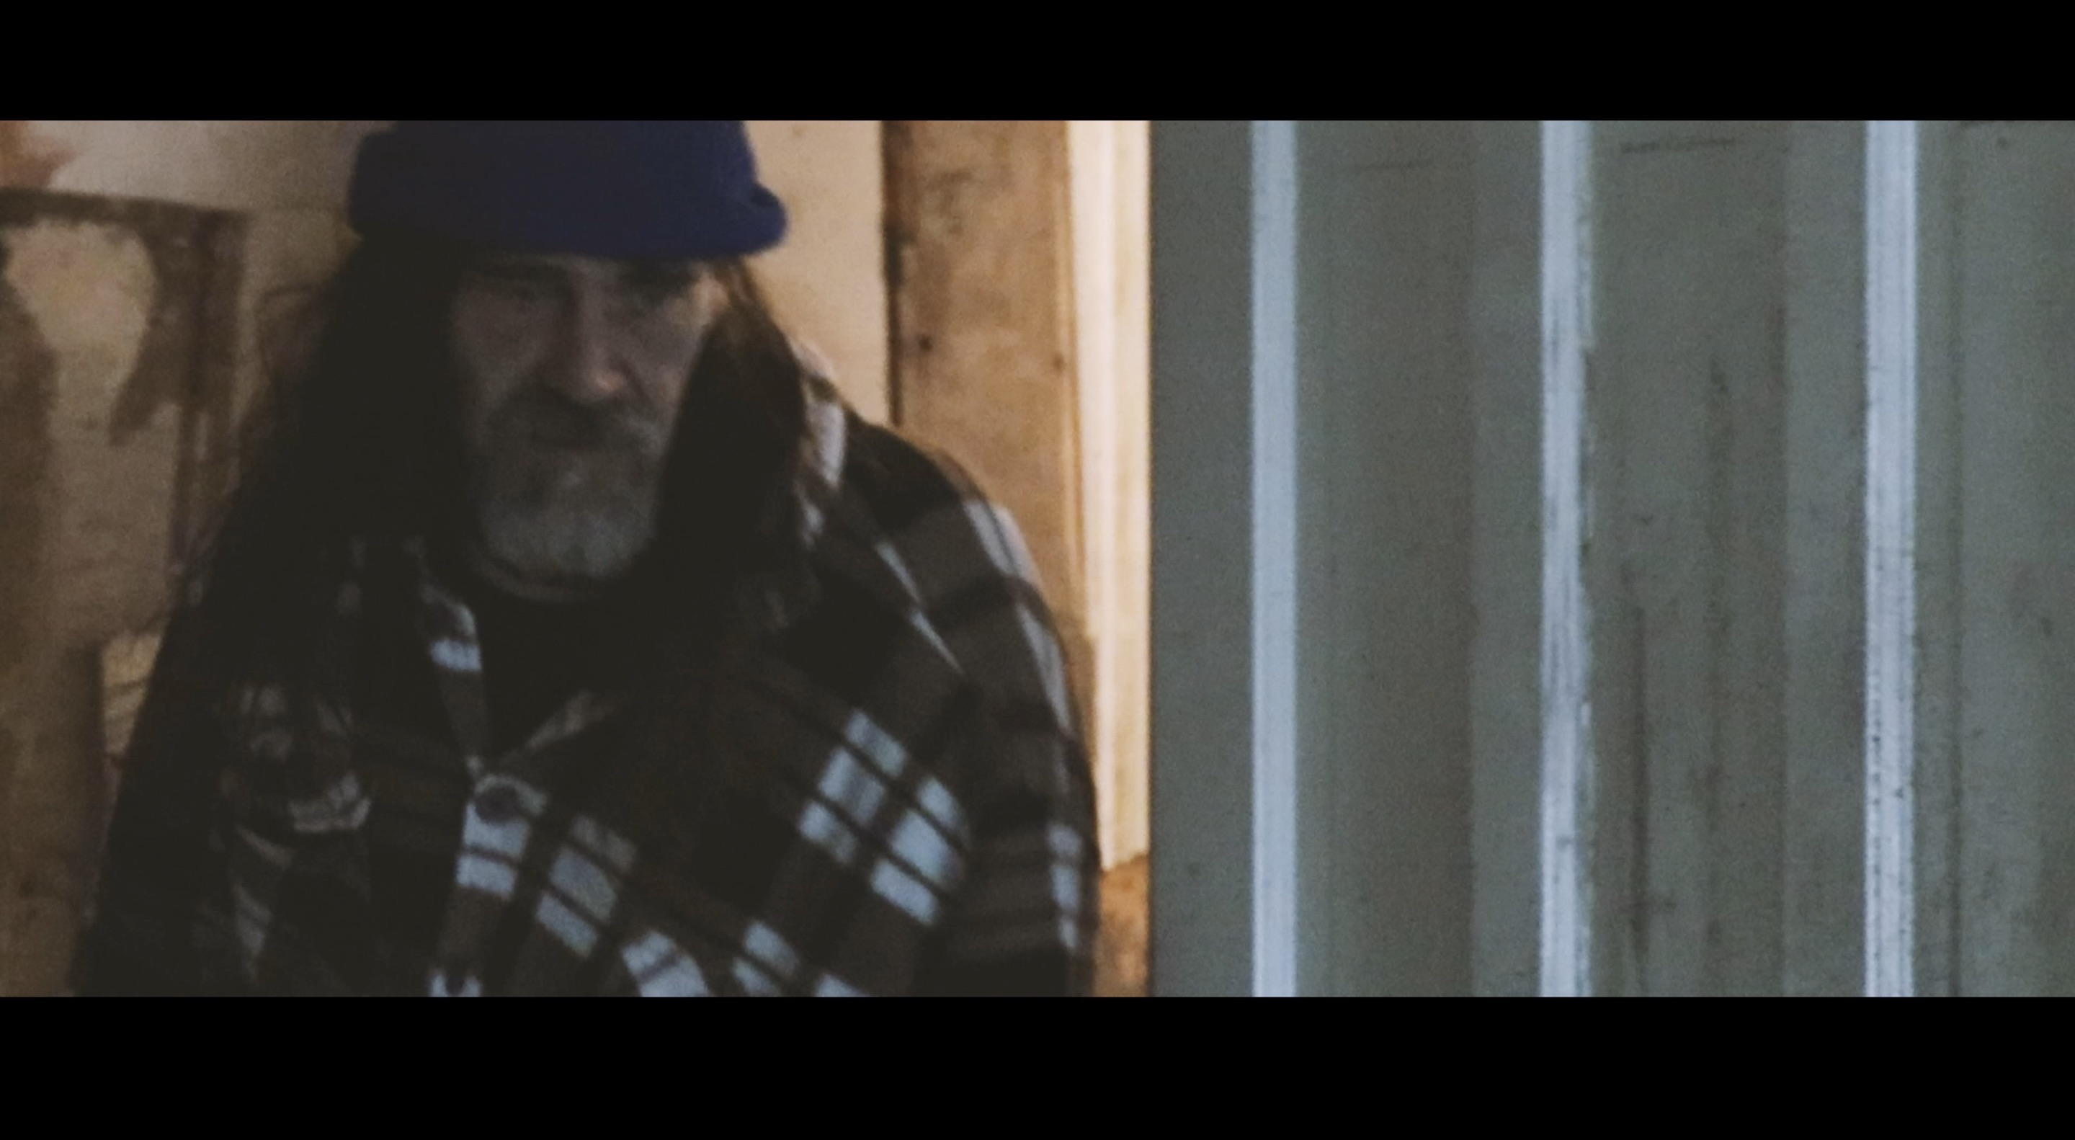
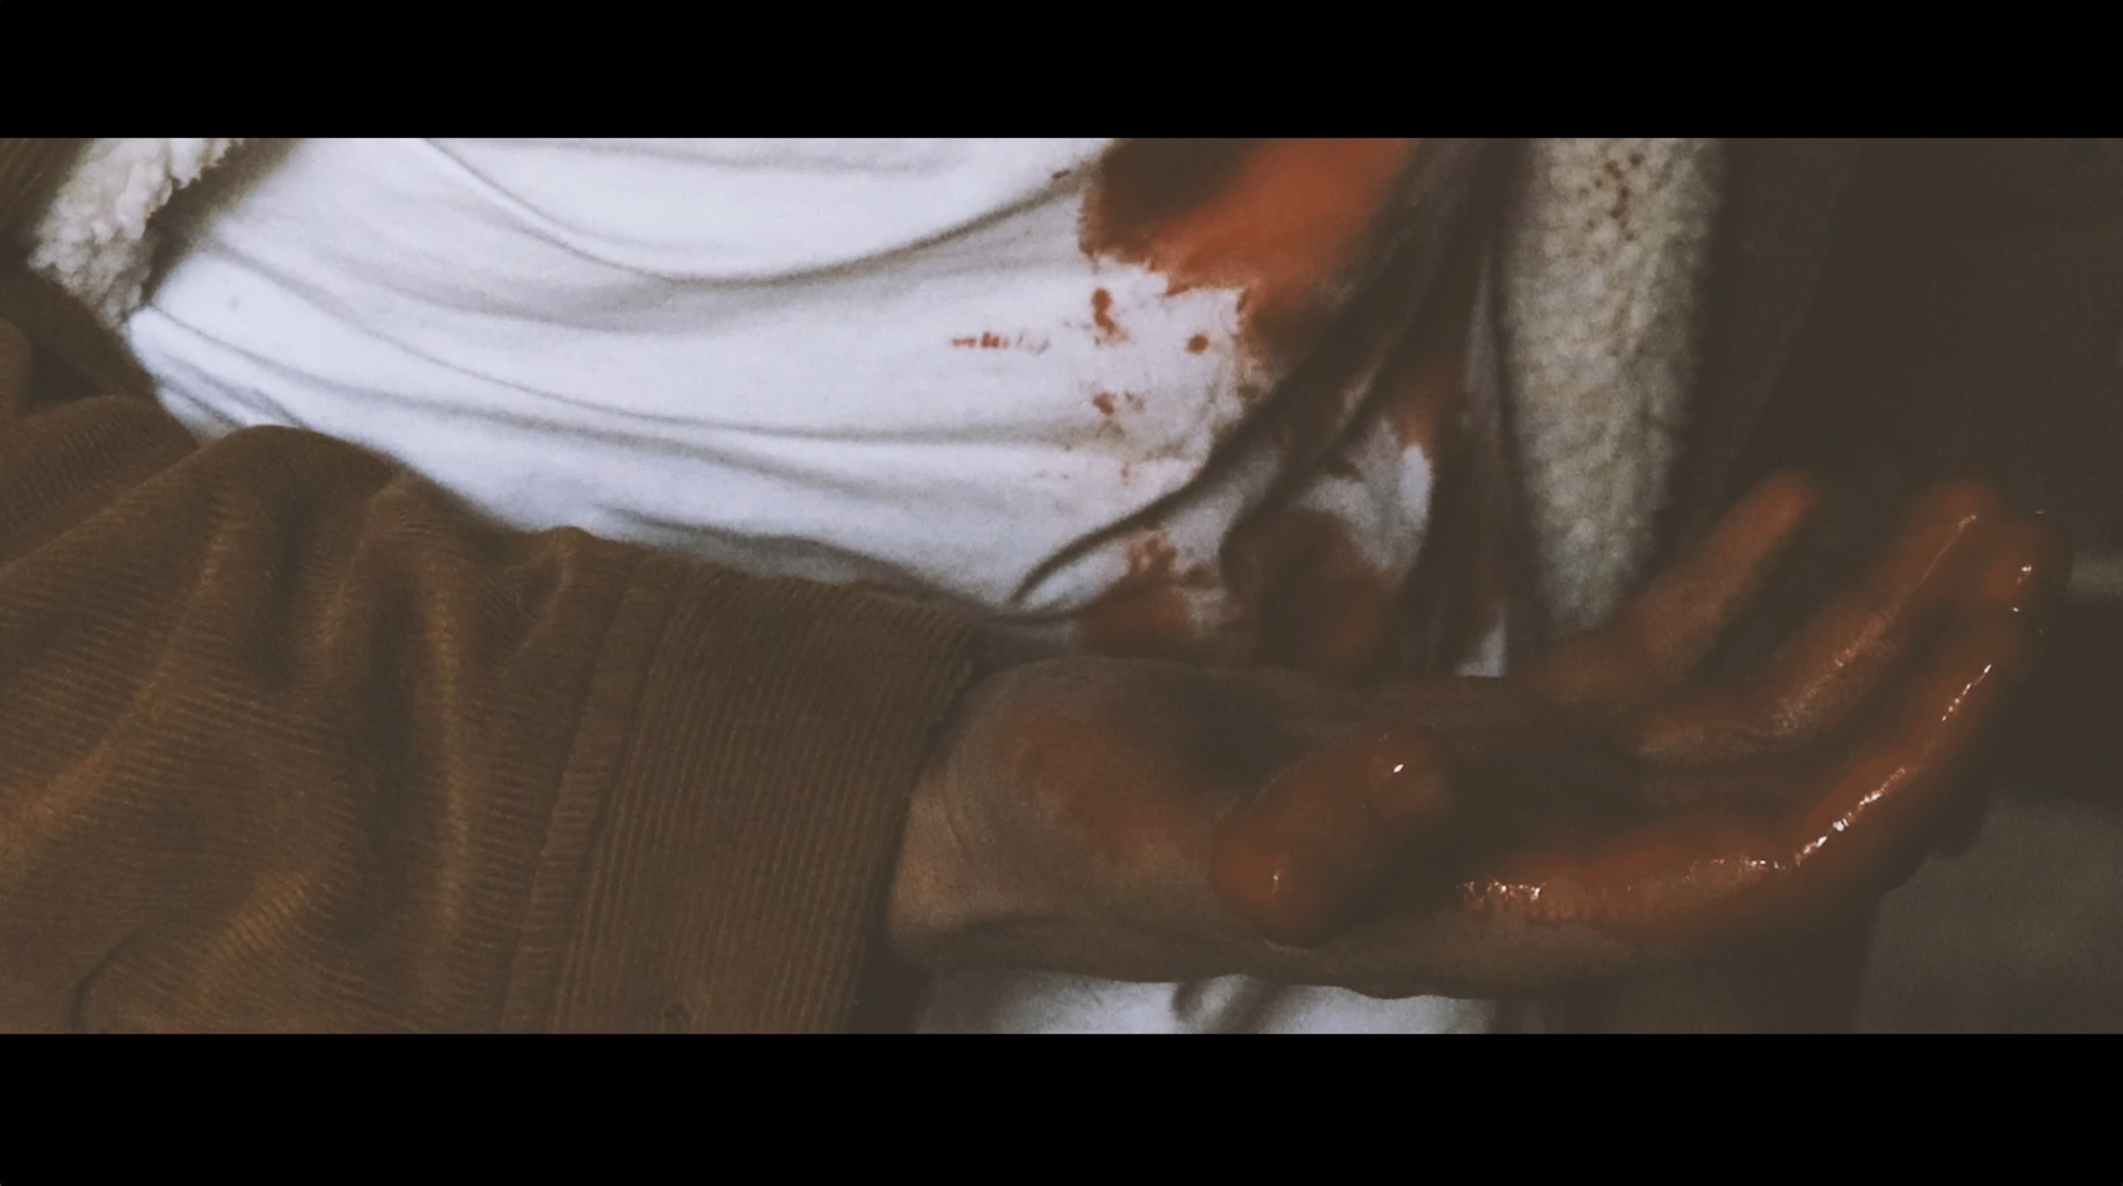



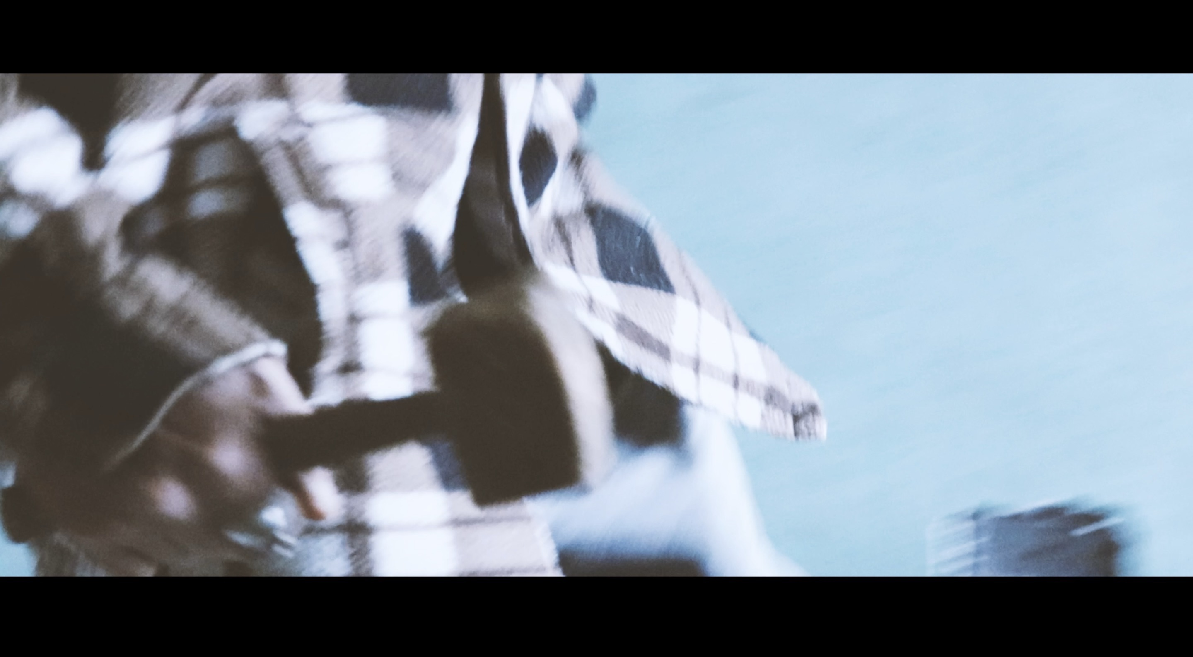
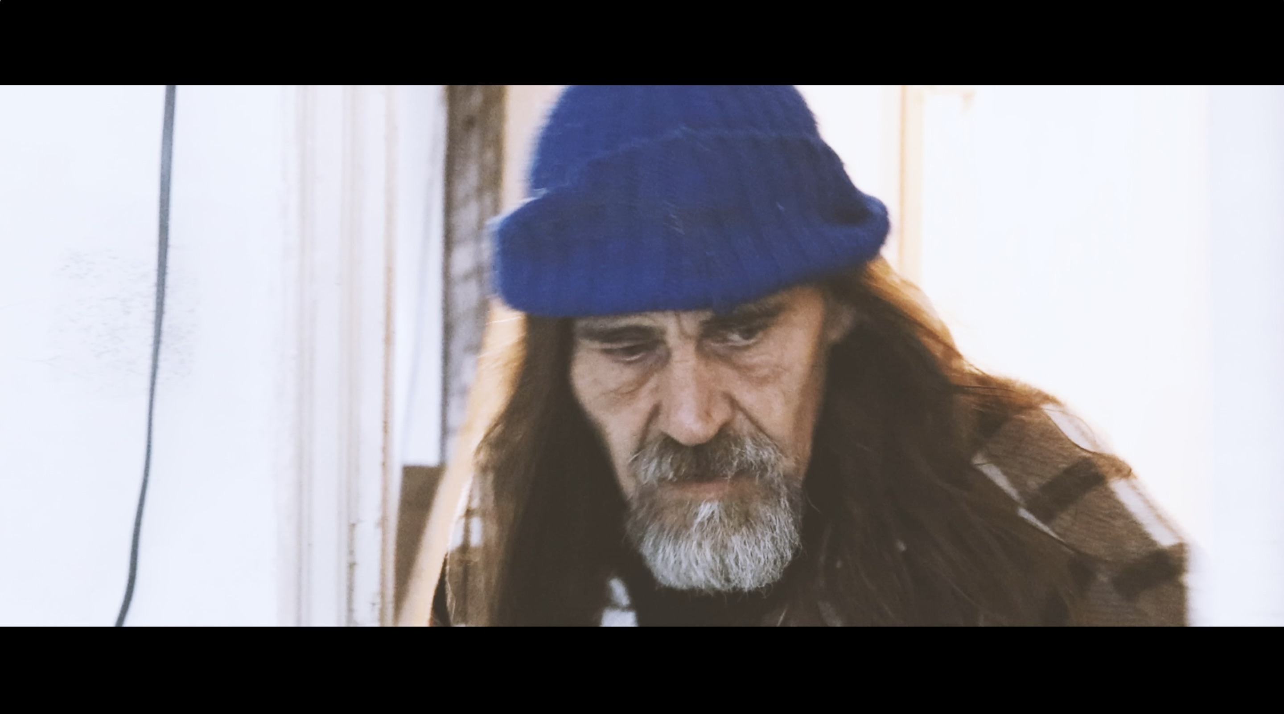



In the major project stage one, I had problems in focusing and finding time to complete certain tasks, which is something I imagine most directors struggle with. When I was looking for actors, I couldn't find the image of persons I had in mind and even if I did find, I had a problem in demanding for funding as I was already suffering with issues with personal financing and was reluctant to ask for money through campaigning. When started working on ‘Crime Scene: The Reality’, I marked and took on board and started creating a portfolio with all my research will be presented. I had people and police helping in my research and actual forensic teams on board but there was a last minute change of place. This lead to a change in genre from procedural drama to documentary drama. Showing the reality of crime scene investigations and forensics. When I was about to film, the team I was going to film and work with, actual forensic teams dropped out from filming due to their superiors, so I had to solve the problem. With all this I had to explain how I wanted everything to be filmed. The first thing we did after finding actors, was going through my research with them and explain what I am going to need to do for them to give me the results I want. I wanted this film to be as realistic as possible. The props seen in the film were from genuine CSI suppliers who also advised me on the correct equipment for the procedures I wanted to show on screen.

Conclusion

For this project and the roles I have specialised in, it’s clear that there were a number of areas I had to look into and prepare for the shoot, which was something I had not anticipated, especially as a director. The cinematography preparation came easily to me as this was an area I was highly familiar, due to external previous experience with photography, but directing this project came as a challenge. However, I believe that I have directed this piece successfully, as the intention has been executed well and the vision I had for this piece has been brought to life, thanks to the cinematography.

Bibliography

Goodreads.com. (n.d.). Cinema Verite Quotes (3 quotes). [online] Available at: https://www.goodreads.com/quotes/tag/cinema-verite [Accessed 16 May 2019].

References

Glynne, A. (2008). Documentaries.... and how to make them. Harpenden: Creative Essentials.

Hall, J. (1991). Realism as a Style in Cinema Verite: A Critical Analysis of "Primary." Cinema Journal, [online] 30(4). Available at: https://www.jstor.org/stable/1224885?seq=1/analyze [Accessed 16 May 2019].

