Name: Edward Walden
Student Number: 2203426
Date: 3/12/2023
Module: Workshop and Practice
Module Code: ACHA4011
Assignment Title: Engineering Technical Report


Table of Contents
Introduction…………………………………………………………………………3

Chapter 1……………………………………………………………………………..4

Chapter 2……………………………………………………………………………..6

Chapter 3……………………………………………………………………………..7

Chapter 4……………………………………………………………………………..9

Chapter 5……………………………………………………………………………10

Conclusion………………………………………………………………………….13

References………………………………………………………………………….14

Introduction:
In this technical report, the topics of health and safety, risk assessment will be covered, using a real-life task recently undertake as an example of these topics. Additionally, there will be a discussion on an engineer’s role in society aswell as problem solving methods and team structure in the context on an engineering environment.

Chapter 1:
The task that will be used to provide an example for Personal Protective Equipment (PPE) worn in a workshop and necessary/relevant risk assessment will be machining a piece of cylindrical metal to fit certain specifications, provided by a workshop drawing, using a Lathe provided by the University of Wales Trinity Saint David.

Personal Protective Equipment:
- CSA Certified Safety Glasses Government of Canada, C.C. for O.H. and S. (2020)

Wearing certified safety glasses are an essential part of 5the safety equipment required to be worn when working on a lathe. This is because the small offcuts of metal, named swarf, are cut from the metal, and occasionally fly up from the piece of metal, due to the rotation of the lathe. Not only are these pieces of swarf sharp, but due to the friction between the piece of metal and the cutting tool these pieces of swarf can also be very not. Not only does this mean that the swarf can cut into a person’s eyes, but the person has an increased risk of permanent eye damage or blindness due to the heat of the swarf, which emphasises the importance of wearing approved eye protection to avoid injuries of this nature.

- Approved Protective Clothing (Overalls, Overcoat etc.)

Wearing approved protective clothing is also important for similar reasons as the CSA Certified Safety Glasses. Although the injuries are not as severe, the swarf can still cause fine cuts, which can cause substantial amounts of bleeding but can also burn a person’s skin because the swarf that comes off the metal once in contact with the cutting tool on the lathe is not only very sharp but also extremely hot. Which, as stated, may not cause blindness but it is within the best interest of the lathe operator to prevent all injuries.

Risk Assessment:
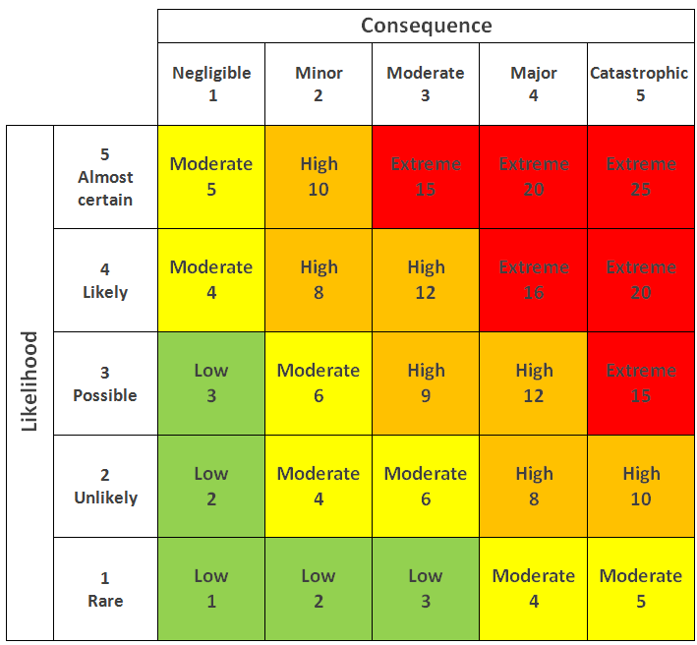
Pictured to the right is a standard 5x5 Risk Assessment Matrix. It denotes the level of risk using two factors: The Likelihood of Injury, and the Consequences of The Injury. The Likelihood of Injury increases and decreases depending on the safety precautions on both the operator and the machine itself. For example, if the operator is wearing the aforementioned safety equipment (See PPE list above) then the likelihood of injury is decreased, and it’s the same situation if the machine itself has safety features, for example a kill switch, foot brake and/or a safety guard which prevents the lathe from being turned on when not in the correct position. Once a Likelihood of Injury and a Consequence of Injury has been established, the risk level of the task can then be found using the coloured boxes, like those on Figure 1.
Figure 1: A Standard Risk Assessment Matrix

Using the information on PPE and the Risk Matrix (Figure 1) it can be decided that the Likelihood of Injury for this task is Rare (1) and the Consequences of Injury can be established to be Major (4) as incorrect equipment or usage of the lathe can cause serious bodily harm. Using the Risk Matrix, the risk of conducting this task is shown as Moderate, meaning that injury is still able to occur, but correct equipment and correct usage of the lathe is important in making sure they do not.

Chapter 2
Engineers Role in Society:
Engineers in the modern day are vital to many different aspects of daily life and the industries that people both need and enjoy. These engineers must now adhere to a defined set of rules, known as the Engineers Code of Conduct, which defines how an engineers should go about their work, and their attitude towards whatever field they decide to be a part of. Different sources have different versions of the Code of Conduct but all are in the better interest of the engineers and the people their work affects.
The Engineering Council have their own published Code of Conduct, one part of which states, “Engineers have a duty to obey all applicable laws and regulations” (Engineering Council). Applying this to the subject of Motorcycle Engineering, specifically the motorsport aspect. The following of “laws and regulations” are vital, as many of the current rules and regulations in motorsport are in place to keep the driver safe, and infringements of these rules could possibly cost a rider their life if the part(s) implemented were to go wrong.
Aswell as this, the National Society of Professional Engineers has their own version of the Code of Conduct. In their NSPE Code of Ethics for Engineers they say that “Engineers shall perform services only in the areas of their competence” (NSPE Code of Ethics, National Society of Professional Engineers). Applying this to the subject of Motorcycle motorsports, this ensures that engineers will not attempt to complete work which they are not qualified to perform, this makes sure that parts on the motorcycle are only done by the engineers that know what they are doing, ensuring quality of what is made. IF engineers who weren’t competent to make certain parts made those parts, it could cause a catastrophic failure of not only the part, but the entire motorcycle, which could lead to the rider’s injury, or even death.

Chapter 3:
Problem Solving
It is not uncommon for an engineer to made aware of a fault in their product, requiring them to face a problem-solving situation. And when this happens it is essential to be efficient, cheap and create a product which solves the problem. So Problem-Solving Techniques are required to achieve this.
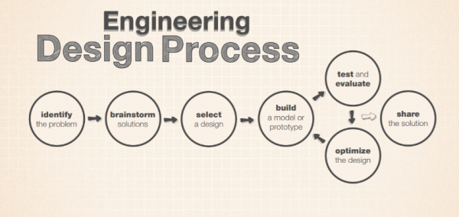
The above flow diagram denotes an Engineering Design Process which can be used in these problem-solving scenarios to reach the goal of solving the problem.
Figure 2: Engineering Design Process (California Institute of Technology, NASA/JPL)

Engineering Design Process
- Identify the Problem
First the engineers must decide what the actual problem is, to prevent them from designing and creating a solution which doesn’t actually solve the issue.
- Brainstorm Solutions
In order to brainstorm effectively, multiple engineers must get together and debate their ideas on how to solve the problem.
- Select a Design
Once ideas have been brainstormed, the engineers need to pick one solution they think will best solve the problem.
- Build a Prototype
At this stage a first version of the product is made, features of this first design will most likely change when it comes to testing, as the engineers may find further improvements or a setback.
- Test and Evaluate
The product must now be tested to make sure that it not only solves the original problem, but also to make sure that the new product causes any new problems to arise.
- Optimize the Design
If any issues do arise, or the engineers find areas they can improve the product, they now need to make a new design which implements their new ideas.
- The stages Build a Prototype, Test and Evaluate and Optimize the Design, must now be repeated in order to create the final product, which the engineers believe resolve the problem best, and won’t cause any new problems once installed.
- Share the Solution
Once a final design has been reached, the design must be shared in order for manufacturing and processing to happen. Then soon after the changes will be implemented and the old product can be recalled.
This system is designed to make problem solving efficient, cost effective and achieves the goal it was made to do.
Chapter 4:
Team Structure:
In this chapter I will use the example of my own time in the workshop, and use it to demonstrate methods of working as a team in a workshop environment. The task I had to perform was making a machined piece of metal to given specifications.
The way we worked as a team was to oversee each other when making the measurements, double checking to make sure any cuts or holes we made in the metal were not only the correct size but in the correct placements. Aswell as this, when the lecturer was supervising us on the milling machine, he would show one of us what we had to do by starting the trim of the metal and allowing us to finish, this also provided the other person with the correct instructions to do the same with their piece. This was so both of us knew exactly what to do and how to do it, as a mistake could cause us to be outside the tolerance we were given when first given the drawing of the design. This method worked well in the situation as we were both able to effectively understand the methods and goals we had, which led us both to produce a machined part, within the given tolerances.
Another method of teamwork we could have used in this situation is given by the ESILV Graduate School of Engineering. They use research, provided by “Dr. Meredith Belbin” (ESILV Graduate School of Engineering, 2019), there is a method of teamwork that allows for people within the project to take on “roles”. For example, these roles can range from “Coordinators” who “calmly listen to teammates before organising them to undertake tasks according to the skills they bring” (ELSIV Graduate School of Engineering, 2019) to “shapers” whose role it is to “challenge the way things are done” and find alternative ways to “improve both the process and the outcome” (ELSIV Graduate School of Engineering, 2019). This method is effective as it allows people who excel in certain areas to make the most of their skills within the project, however a drawback of this teamworking method is that if it is a small team, it may be difficult to assign roles to team members if it isn’t where their skills would be most appropriate, additionally this method requires one person to be essentially places ‘in charge’ of the other team members, which may cause conflict between the team members as a teamworking environment can lead to a lot of tension between team members.

Chapter 5:
Personal Development Plan:
Below is a personal development plan, detailing both my long and short term goals over the next 10 years. I am aware that my goals are not simple, however these goals are what would be ideal for me personally however they are susceptible to change as time goes, depending on the situation changes over time.

Name - Edward Harry Walden
Degree – Motorcycle Engineering BEng
Previous Qualifications – Mathematics and Physics A levels
Previous Experience – Army Cadets, Kitchen Chef and Bartender in a busy country pub.
Long Term Goals (5 to 10 years)
- Become a pit crew member in a high class of motorsport, for example MotoGP or Formula 1
- Open a motorcycle repair shop for high end motorcycles
- Make connections in the motorsport field to further my chances at achieving a position in a larger class of motorsports

Short Term Goals (0 to 5 years)
- Finish and earn my Bachelor’s Degree in Engineering
- Find myself a pit crew position with a motorcycle motorsport team

Goal | Objective | Resources Required | Measurement | Target Date
Finish and earn my Bachelor’s Degree in Engineering | At a very minimum, pass my course, with the main goal to achieve the highest grade I can | The University, Library Access for projects/technical reports. | Final grade achieved after my final exams | September 2026
Find myself a pit crew position with a motorcycle motorsport team | Use connections I have to ask and see if there are any teams that need a new pit crew member, even if it’s a starting position as a tyre runner | Connections for the teams, a car in order to take myself to and from the racing events, money to fund it in case the position starts off as unpaid | The role I am able to undertake at any possible motorcycle motorsport teams, and whether the position is paid or if it is a work experience deal | January 2027
Make connections in the motorsport field to further my chances at achieving a position in a larger class of motorsports | Once I have become part of a pit crew, my goal is to make connections with other teams as well as companies in order to hopefully use those connections to get a position in a pit crew in a higher class of motorcycle motorsports | Position in a pit crew, chances to speak and make connections with other teams | The role I am able to get myself after using the connections I make during my time as a pit crew member | 2029
Become a pit crew member in a high class of motorsport, for example MotoGP or Formula 1 | It is my penultimate goal to get a position working in either MotoGP or Formula 1, as I have a passion for both of those motorsports, so working in that field would be a dream come true | Experience working in a pit crew, an understanding of motorsport mechanics in order to benefit the team with the job(s) I will be doing | The status ad performance of the team, whether it be a low performing, midfield or high performing team | 2033
Open a repair shop for high end motorcycles | This would be a nice side project for me to have, especially during summer/winter breaks of the racing season, where I can still put my degree to good and effective use | Money, a space to open the repair shop, an understanding of business models in order to make sure that the business becomes profitable | The amount of money and status the repair shop gets, the number of customers and their status | 2033

Conclusion:
To conclude, covered in this technical report is health and safety procedures and risk assessment an engineer must carry out on projects, as well as a engineer’s role in society following a ‘Code of Ethics’ in order to make sure their work is not only to a high standard but also to a safe standard. Additionally, problem solving techniques and team working techniques were covered, both of which an engineer must be prepared to use during their projects.

References:
Government of Canada, C.C. for O.H. and S. (2020). Metalworking Machines - Lathes: OSH Answers. www.ccohs.ca. Available at: https://www.ccohs.ca/oshanswers/safety_haz/metalworking/lathes.html

‌Figure 1- Kaya, G.K. (2018). ResearchGate. Available at: https://www.researchgate.net/figure/A-standard-risk-matrix_fig7_323570642
www.engc.org.uk. (n.d.). Engineering Council. Available at: https://www.engc.org.uk/ethics#:~:text=Engineering%20professionals%20have%20a%20duty%20to%20obey%20all%20applicable%20laws

National Society of Professional Engineers (2019) NSPE Code of Ethics for Engineers. Available at https://www.nspe.org/resources/ethics/code-ethics
California Institute of Technology. NGSS Engineering in the Classroom. NASA/JPL Edu. Available at: https://www.jpl.nasa.gov/edu/teach/resources/engineering-in-the-classroom.php
ESILV (2019). Engineering Teamwork 101 – ESILV Graduate School of Engineering, Paris. Available at: https://www.esilv.fr/en/engineering-and-teamwork-3-fundamental-skills/

