Principles of learning and teaching
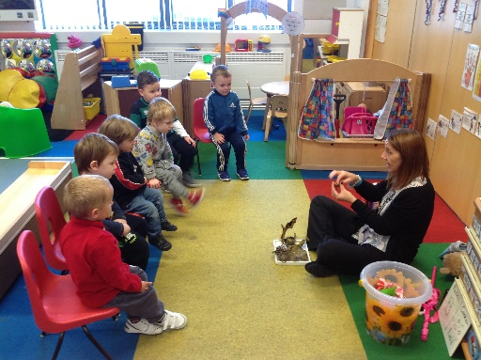
This academic scrapbook will demonstrate an understanding of the effective application of three educational theories, with reference to classroom observation and practice. The three practices chosen to observe are; The attention to autism (Bucket), Pre-teaching topic vocabulary and Visible Learning. Providing insight into each practice and the impact of each approach that support effective teaching and learning within the setting.
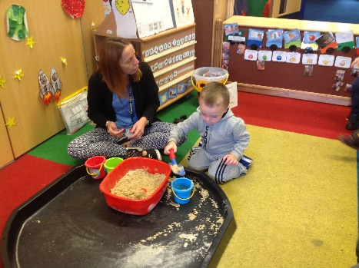

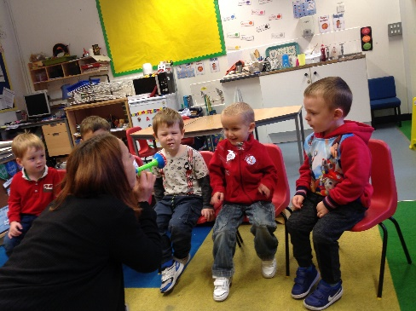
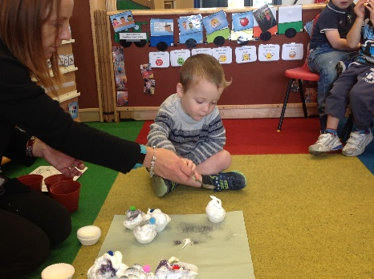

The attention to autism approach was developed by Gina Davies a specialist speech and language therapist. To help build communication, attention and interactive learning skills for children on the autistic spectrum. Children with ASD find it difficult to share attention socially. These sessions were originally introduced to the school by our designated speech and language therapist. To engage children that were not solely on the autistic spectrum but would benefit from its approach to help aid children with fleeting attention disorders. Activities are created to be fun, so they hold a child’s attention with minimal speech being used, words that are used are simple, repetitive and child led. Sign language is also used alongside for reinforcement and understanding. At the beginning of each session the children sit in a semi-circle in front of the teacher, they are encouraged to stay seated although some may find this difficult initially. The lead teacher may comment on another child or adult that is modelling good behaviours and make comments such as; good sitting or good waiting. Albert Bandura’s social learning theory suggests ‘If a child imitates a model’s behaviour and the consequences are rewarding, the child is likely to continue performing the behaviour’ (McLeod, 2016). At the start the teacher writes on a whiteboard what is going to happen throughout the session using first, next and last. This visual aid can help eliminate anxieties as the child will be able to see what is coming next and when the session will end. It is also referred to throughout with the teacher putting a cross through the activity to show it has finished. The programme is organised into four activities these are; Stage one: Focus (bucket activity), Stage two: Sustain (The attention builder), Stage three: Attention Shift (the interactive game) and Stage 4: Attention shift (Watch, learn & do). Children will progress through these stages according to their capabilities. Currently the observed group are at stage one & two. The session always commences with a song whilst the teacher retrieves a highly interesting item from the bucket (such as bubbles or a wind-up toy), using lots of big gestures and facial expressions to draw attention to the object. Children can only watch not touch! An important part of the session as it helps to develop their focus and attention. Leading into an attention building activity (such as flour shaking or making shaving foam cakes) using simple language that matches what you are doing whilst visually stimulating the child to hold their attention for a longer period. Pattern & Watson discussed ‘by sharing a common focus, children hear words matched to their interest in that moment, enabling them to learn language associated with that experience. Joint attention is a very important skill because it’s used to connect with others and is predictive of language development’. (Da Silva, B. 2017). It can also involve getting rather messy – which the kids love even more! It is at this point that you can introduce topic related class activities, concepts, seasons or celebrations to enrich their language skills further and make links to the environment around them. Creating an opportunity elevate curiosity and joy in a shared activity whilst accessing the curriculum.
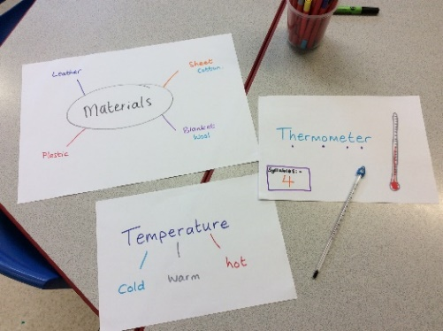
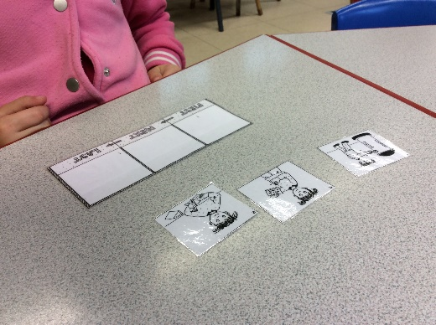
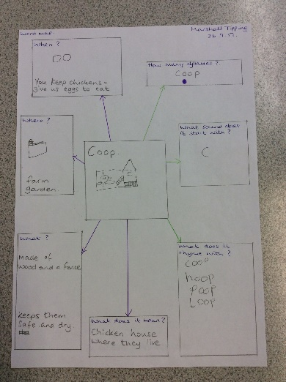

Many Additional Learning Needs (ALN) students find the introduction of a new topic rather problematic, inducing new vocabulary that is unfamiliar or unknown can lead to misunderstandings and the inability to link to other concepts. Word maps are an excellent resource in supporting new vocabulary, they explore semantic (word meaning) and phonological knowledge (word structure) at the same time. Writing is kept to a minimum as drawings and colour will aid the visual memory. The levels of processing model by Craik & Lockhart 1972, identifies how deep and shallow processing affects memory recall, in addition ‘The idea that the way information is encoded affects how well it is remembered. The deeper the level of processing, the easier the information is to recall’. (McLeod, 2007). The student will be encouraged to think of a meaning for example; What do you do with it? Where would you find it? When would you use it? This will generate general knowledge or semantic information about the word. Following this they are encouraged to think of sound for example; the number of syllables, what does it start with? What does it rhyme with? This provides the phonological awareness and structure of the word. In addition to the pre-teaching of vocabulary sequencing of language is introduced using the concepts; first, next and last. These are the fundamentals in re-telling events and storytelling. Primarily, a three-step sequence is introduced, by the means of three pictures/photos by randomly observing each one in detail. They are then laid out on the table with the child being asked which comes first? Next? Last? Once all pictures are in order the child is encouraged to re-tell the story. The main aim over time is to re-tell a wide range of events/stories that show the correct sequence.
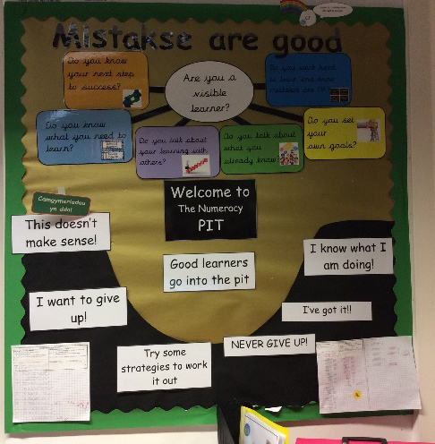
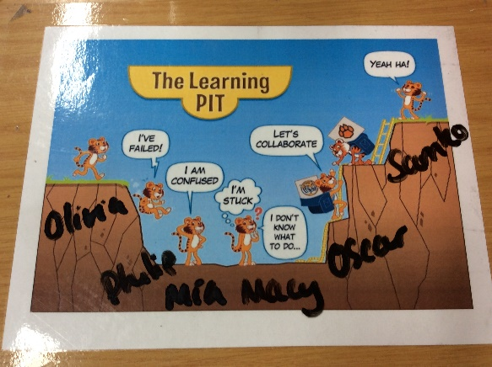

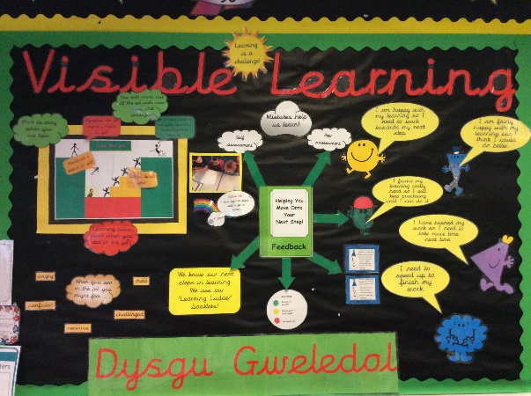

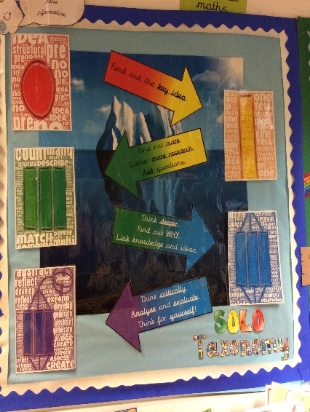
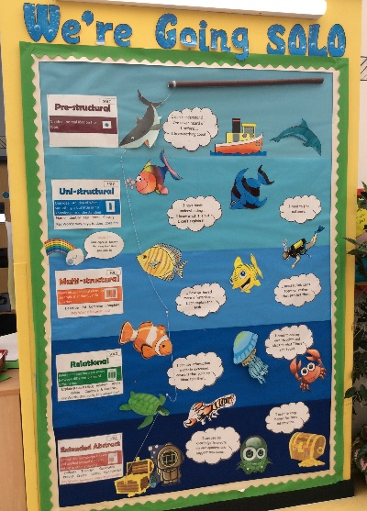
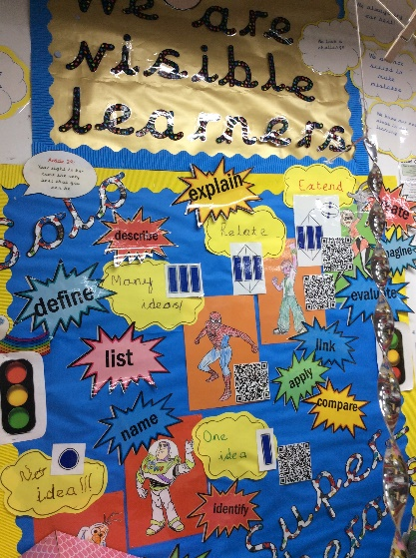
Visible Learning, a self-centred approach to teaching and learning, it was introduced throughout the school setting in June 2014. Originally devised by John Hattie who suggested that ‘Visible Learning and Teaching occurs when teachers see learning through the eyes of students and help them become their own teachers.’ (Waack, 2017). Vygotski and Piaget theories are influential throughout this model of learning, whereas Piaget implied that cognitive development was based on what the child knew and the environment around them, ‘a progressive reorganization of mental processes as a result of biological maturation and environmental experience.’ (Mcleod. 2015). Whereas, Vygotski placed more emphasis that social influences enhanced cognitive development, ‘much important learning by the child occurs through social interaction with a skillful tutor’. (McLeod. 2014). During each introduction to a new topic, students are encouraged to place themselves within the learning pit – a visual used to reinforce that its acceptable to find things difficult and reflect on strategies needed to succeed (climb out). For example, activating prior knowledge or interacting with their peers. In addition, students are clear on their learning intentions (objectives) and learning outcomes (success criteria), both providing clear direction to their learning. Therefore, creating independence as they can refer to these throughout the task for clarity allowing them to become successful. Subsequently, on completion of the task students are encouraged to give feedback and feedforward comments. These are stipulated on their learning intentions slip within their book either in the form of; self-assess, peer assess, or teacher assess. For instance, self-assessment is when the student awards personal feedback and feedforward comments based on the success criteria. The comment will be structured so they know where they have been successful and what their next step in their learning journey will be. It is also an opportunity for teachers to gain knowledge of their teaching, has the work been set at the correct level to the student have they been challenged. In comparison was the work set unachievable as the challenge was too great. Solo Taxonomy, SOLO stands for Structure of Observed Learning Outcomes a model used within the Visible Learning structure, when used within the classroom it can help students to move from surface to deep learning. Originally devised by Biggs & Collins 1982, it indicates levels of understanding by challenging students to think more deeply. Throughout the school different approaches are used to gauge where a child see’s their surface level. To demonstrate, Pre-structural (misses point), Uni-structural (identify), Multi-structural (describe), Relational (apply) and Extended Abstract (reflect). The younger children use superheroes each character represents a level, they can inform the teacher whilst undertaking their work on where they see themselves. Whilst the majority of the school use a number system to indicate their level. This allows the teacher to devise questions that deepens their knowledge and link to other concepts and ideas. What’s more it is a tool used by teachers to differentiate learning tasks and success criteria.

To conclude the practices are successful in supporting effective teaching and learning as students are being given strategies to encourage inclusive participation. In every aspect students are challenged and motivated to achieve their learning outcomes. These are ongoing practices, which will have an advantageous impact to the students. Assisting them to require new skills and strategies to become successful learners.

References
Da Silva, B. (2017) Supporting Attention in Children with ASD. https://www.hanen.org/SiteAssets/Articles---Printer-Friendly/Clinical---Program-Support/Supporting-Attention-in-Children-with-ASD---PF.aspx. (Accessed: 10 November 2017).
McLeod, S.A. (2016) Bandura - Social Learning Theory. http://www.simplypsychology.org/bandura.html. (Accessed: 7 November 2017).
McLeod, S.A. (2007) Levels of Processing http://www.simplypsychology.org/levelsofprocessing.html. (Accessed: 8 November 2017).
McLeod, S.A. (2014) Lev Vygotsky. www.simplypsychology.org/vygotsky.html. (Accessed: 9 November 2017).
McLeod, S.A. (2015) Jean Piaget. www.simplypsychology.org/piaget.html. (Accessed: 9 November 2017).
Waack, S. (2017) VISIBLE LEARNING What works best for learning. https://visible-learning.org. Accessed: 9 November 2017.

