
An Aerodynamic investigation into the drag implications of vehicle roof storage boxes and their design – Seminar Paper
Cerys Frowen P146126


Contents
1. Technical Abstract – Page 3
1.2. Abstract – Page 3
2. Introduction – Page 4
3. Aerodynamic Fundamentals – Page 5
3.1 Direction of Travel – Page 5
3.1.1 Drag – Page 5
3.2 Types of Flow – Page 6
3.3 Boundary Layer – Page 6
3.4 Separation – Page 7
3.5 equations used in Aerodynamics – Page 7
3.5.1 Reynold’s Number – Page 7
3.5.2 Bernoulli’s Equation – Page 7
4. Methodology – Page 8
4.1 Wind Tunnel for Drag – Page 8
4.1.1 Wind Tunnel Set Up – Page 8
4.1.2 Set Up for Car Model – Page 9
4.1.3 Stage 1 – Different Parameters – Page 9
4.1.4 Stage 2 – Different Height – Page 9
4.1.5 Stage 3 – Different Positions – Page 9
4.1.6 Wind Tunnel for Yaw/Side Wind – Page 9
4.2 Computational Fluid Dynamics (CFD) – Page 10
4.3 Numerical Analysis – Page 10
5. Preliminary Results – Page 11
6. Conclusion – Page 11
7. References – Page 12
7.1 Work Cited – Page 12
7.2 References – Page 12
1. Technical Abstract
This paper takes an insight into the fundamentals of aerodynamics and how these will be related to the investigation and importantly how these effect the automotive industry. With regulations becoming stricter on emissions and the desire for a high fuel economy manufacturers are turning towards aerodynamics in order to fulfil the criteria of governing bodies and consumers. They are recognising that engine technologies and efficiencies are towards their peak performance whilst also being affordable and need to turn to other areas which aid in the process without being directly linked and has therefore resulted in the vast popularity of being aerodynamic, a relatable opinion of that of Richard Wood of SOLUS Technologies who expresses the need of aerodynamic vehicles for commercial use. This paper touches on how industry uses aerodynamics not just for the private car use but also being used across the entire transportation sector to save on fuel across the nation as the threat of fuels running out become more severe and technology/industry isn’t fully ready to use alternative powers.
However as cars become more aerodynamic are the accessories regular used with them also following this pattern or are they drastically undoing to work of aero teams across the industry? The methods in which are being used to show the aerodynamic properties through practical, simulation and numerical practices are described and how the future of this investigation will pan out to analyse the effects roof top storage boxes have on the characteristics of drag, lift, side wind/yaw stabilities and the effects of fuel consumption as a result.

1.2 Abstract
This investigation is being conducted due the problems the modern car industry is facing in order to be environmentally friendly by reducing the emissions cars pollute and with how much petrol/diesel is being used to run them. As the technology used in engines to make them efficient is as best it can be without being expensive they are researching into other areas which will aid the goal of becoming more ecological through aerodynamics, the study of air on the vehicles, being the most popular currently.
This paper provides a description on the methods it will use to investigate the aerodynamics of roof top storage boxes and how different aspects affect the airflow on them in order to see if these are drastically counteracting the work done on improving cars, and therefore not improving conditions once installed. It will be done by analysing the lift, drag and stability of the car in a wind tunnel and through a simulation programme to explain the results experienced.

2. Introduction
Aerodynamics is the study of air flow around an object and how the shape of the object affects this flow. It is used throughout industries from planes to cars and even buildings. Although they all use aerodynamics it is for very different reasons, for planes to be able to fly, cars to steer around corners without rolling and reduce the risk of buildings in high wind areas being blown over. There are 4 directions in which aerodynamics focuses on: Lift which is up upward force, weight which is a downward force, thrust is the forward movement and drag is the backwards movement.
Aerodynamics plays a key role in the motorsport industry with some considering it the most important to perfect. Nowadays with engine power being limited speed has to come from other elements and aerodynamics increases speed in various ways and makes a drastic difference. Not only will an aerodynamic car travel fast generally but it will also create a lot of downforce to increase corning speeds and make overtaking easier if the car is positioned on track correctly.
However these aren’t vital in the automotive industry but aerodynamics has become increasingly important. The environmental factors are what are encouraging companies to produce more aerodynamic vehicles with regulations demanding more efficient cars and consumers wanting more miles per gallon. They are achieving this by reducing drag in cars where possible so less work is done to drive the car forward, therefore less fuel/power is required to overcome the resistive forces experienced whilst driving. With less power needed to drive the cars this also means smaller engines can be used which further improves the fuel economy but also results in fewer emissions also regulated by law. The use of drag reduction methods has reduced drag by 40% and fuel economy by 40% as expressed by Richard Wood (2015) of SOLUS Solutions and Technologies. Productions are using aerodynamics in order to achieve improvements as engine technologies are as efficient as they can be and keeping the industry affordable. This is also happening with public transport vehicles and lorries so they’re saving fuel and are seen as environmentally friendly with streamlined lorries, trains and buses becoming very popular within the last decade.
Cars are becoming more aerodynamic but how will this be affected if accessories are to be added such as roof top storage boxes? This investigation will be looking into the drag implications of boxes and the racks needed to install them using the MIRA Reference Car as the car model. Looking into multiple different parameters and how much drag is reduced when a single change is made from a standard cuboid shape in addition the positioning of the roof box. How the side wind/yaw stability of the car is affected by adding a roof box and how it changes with each modification. The effects these changes would have the car’s fuel consumption will also be assessed.

3. Aerodynamic Fundamentals
Aerodynamics is the study of air flow and how it behaves, it is what allows a plane to fly and a car to remain on the road. A basic knowledge on typical air flow behaviours needs to be established in order to understand what is happening in the wind tunnel and explain certain characteristics of flow that occur.
3.1 Direction of Travel
There are 4 main directions (Fig.1) in which a body can move: up, down, forwards and backwards. However these have different terms within aerodynamics with them being lift, weight/downforce, thrust and drag respectively. Wight being used for aeronautical use and downforce for automotive use. Rotation is also an occurrence with there being 3 rotational directions (Fig.2): pitch around the side to side axis, roll around the front to back axis and yaw on the vertical axis.
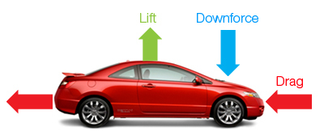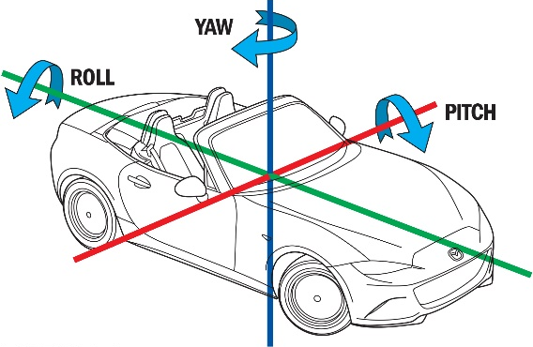
(Fig.2 dsportmag.com)
(Fig.1 gr8autotech.wordpress.com)

3.1.1 Drag
As the main aerodynamic characteristic being measured in this investigation is drag the different types experienced shall be looked into further and categorised as so:
- Total Drag – The force acting against the momentum of the vehicle from all aspects experienced
- Skin–Friction Drag – The drag experience and the surface of the body and what is affected by the viscosity of the fluid, resulting in the boundary layer produced.
- Profile Drag – The drag experienced from the shaper of the body and the boundary layer included
- Form Drag – The difference between the Skin-Friction Drag and the Profile Drag
- Pressure Drag – Drag produced by varying pressures across a body, related to Berounelli’s equation
- Induced Drag –
- Wace Drag – Drag created through shockwaves fur high velocities, aeronautics rather than automotive
(E.L. Houghton, Aerodynamics for Engineering Students, Page 35, 2004)

3.2 Types of Flow
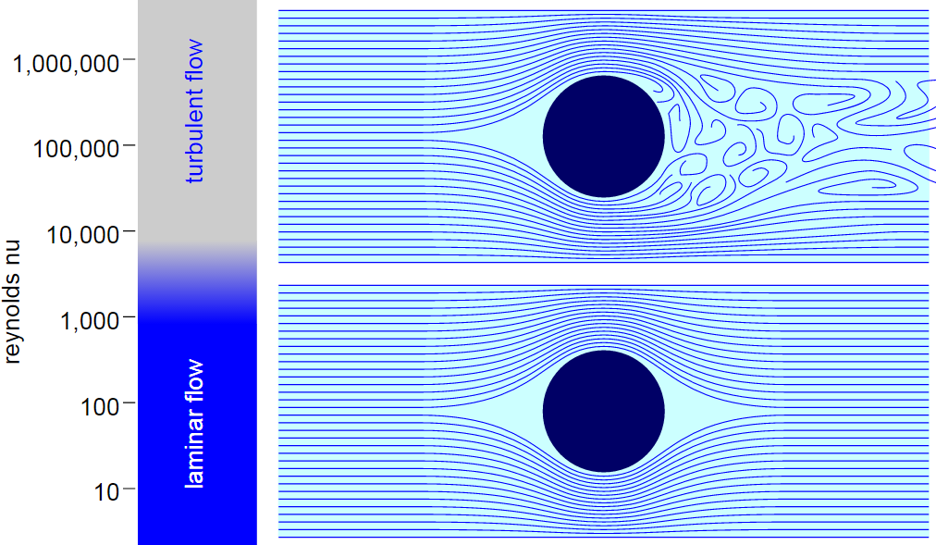
There are two main types of flow, these are laminar and turbulent. Laminar flow (Fig.3) is when air moves smoothly over the body and can be referred to as streamlined whereas turbulent flow (Fig.4) is disturbed and flows irregularly. Laminar flow is the desired option where there are no disruptions and
results less drag. However this is rarely the case as many variables create a turbulent flow such as the skin-friction coefficient, eddies and pressures etc. and results in increased drag. Turbulence occurs at a certain point along the body called the “transition point” and where this occurs is dependent on the variables involved. For instance a body with a rough surface or high friction will experience the transition point sooner than that of a smooth material. Turbulent flow is an issue in terms of fuel consumption and performance that NASA have dedicated projects since the 1930’s to purely creating laminar flow over aeroplane
wings (A.Bowers, 2011). The turbulent flow experienced behind the body is referred to as the “wake” where the turbulent flow from above and below then mix together and turbulence increases. The wake is the air that is felt after a move vehicle has passed.
(Fig.4)
(Fig.3)
(Nuclear-Power.net)

3.3 Boundary Layer
As air flows over a body it would seem that it would flow along the outer face. However the air flow doesn’t hit the body directly as stationary air molecules build up a layer against the body known as the “boundary layer”. The thickness of this layer is dependent on multiple variants as well as the thickness affecting some flow characteristics. The main reason for boundary layer build up is the viscosity of the fluid, or the stickiness and a higher viscosity leads to a thicker boundary layer. Depending on the shape of the body the boundary layer may be uneven, for example circular curves on a model can have an oval curve boundary layer and therefore the shape has changed that the moving air is passing.
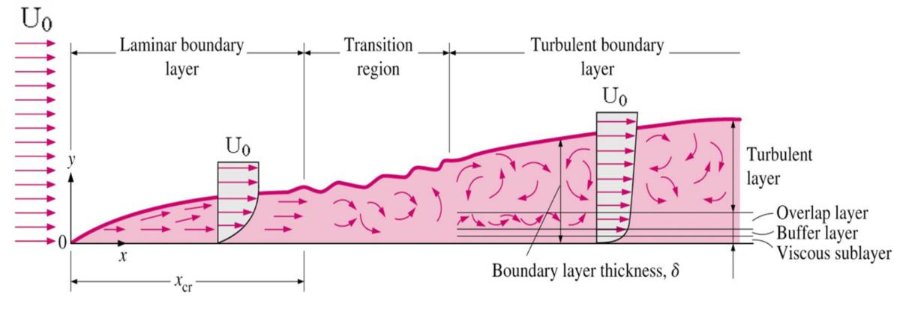
Fig.6 photo shows the boundary layer slowly builds up and as the flow becomes turbulent the layer is thicker.

Fig.6
(Aero space engineering blog, 2016)

3.4 Separation
Separation is the occurrence when there is a difference in pressure and causes some molecules to act against the direction of airflow and therefore is reversed. This separation causes larger eddies in the wake and within automotive this doesn’t cause much of an issue but for aeroplanes the result could be fatal for aeroplanes traveling in the same direction and the air has not settled. There are two ways to reduce separation and these are to either make the flow as laminar as possible or according to University of Sydney (2005) it is done by making a more turbulent flow that would cancel out this separation due to the more energy and momentum turbulent flow possesses. However a more turbulent flow is not what is desirable due to the higher drag, and since drag reduction is the aim it would be a poor decision to do this.

3.5 Equations Used in Aerodynamics
3.5.1 Reynold’s Number
“The Reynolds number is physically a measure of the ratio of inertia forces to viscous forces in a flow and is one of the most powerful parameters in fluid dynamics.” John D. Anderson Jr., “Fundamentals of Aerodynamics”, (1991).
Reynold’s number is a popular measurement within aerodynamics. It is the ratio of the inertial forces of a fluid against the viscous forces and dependant on the number the prediction of flow can be used. The higher the Reynold’s number the more viscous the fluid is and therefore more turbulent and a lower number gives a laminar result. Reynold’s number is calculate as follows:
RE =ρVL/ μ

3.5.2 Bernoulli’s Equation
Bernoulli’s equation simply expresses:
Total Pressure = Static Pressure + Dynamic Pressure
ρV²
2
Pt = Ps +
This equation is a calibration of airspeed and is how pilot tube measurements are acquired for systems that use this selection of data reading.

4. Methodology
Throughout this investigation practical and simulation testing will take place in order to understand the effects adding a roof top box has along with how much drag different shapes/positions create. There will be 3 main methods with each being its own category. For practical testing a wind tunnel will be used with the MIRA Reference Car model with rack/box attachments; simulation through Computational Fluid Dynamics (CFD) to compare/validate wind tunnel results and finally mathematical equations to numerically/graphically compare data.
In order to understand how these boxes affect the car results will be conducted in 3 stages by changing:
- Different parameters individually and finally as a combination
- The distance between the rack bars and the car roof
- The position of the roof box in relation to the car roof
4.1 Wind Tunnel for Drag
The wind tunnel in use for this investigation is the Armfield C2 wind tunnel which has a stated max speed of 26ms¯¹ / 58mph. A scaled down 3d printed model of the MIRA Reference Car will be used within the wind tunnel as a baseline model and then have the accessories added to it with each addition being measured. These being the rack “notches” that the bars sit on, the rack bars themselves and then the selected roof box. The rack and boxes shall be 3D printed for measurement accuracy and repeatability.
Visuals can be used in the wind tunnel such smoke which will indicate the overall flow of the vehicle for use in photography and comparison or simply a piece of string attached to a probe which can represent the flow in a specific area or point.
4.1.1 Wind Tunnel Set Up
In order to place the model it shall be mounted onto the wind tunnel mounting point with flat piece of plastic installed to represent a road. The way in which the tunnel chamber is shaped as an octagon the best placement is to install at the bottom of the vertical faces. This allows the air to flow underneath but this also the limits the build-up of a boundary layer on the wind tunnel walls itself, this road replicator will get the boundary layer build up onto the front and the layer created at the bottom due to slanted faces will not have any effect on the car model.
Calibration of the wind tunnel is needed to ensure the measuring system is correct. This can be done by using a zeroed small scale placed against the mounting point and pushing the point backwards (measures drag) and comparing the results. If the grams on the scale is the same as the wind tunnel’s measurement then it is calibrated and reliable. However if they are different then it is wise try another scale for safe measure that the scale may be wrong, but if the same occurs then take the measurement at different intervals on the scales to discover if there is an offset or if there is a scale issue. Eg at 10g the wind tunnel reads 20g and 30g the wind tunnel reads 60g meaning results from the wind tunnel should be halved.
An additional speedometer shall be used for a more accurate air speed reading as the Armfield’s speedometer can be rotated and is possible to be lifted/pushed down by the airflow which will skew the air speed readings. It also uses a pilot tube compared to a digital sensor which means exacts readings cannot be taken compared to the speedometer that shall be used. The wind tunnel used in this experiment has already got a designated slot for this to be installed where it will not interfere with the air flow around the car model. Results will be taken in intervals of 5ms¯¹ starting a 10ms¯¹ as any lower shows very little to no change with these taken from the additional speedometer.
4.1.2 Set Up of Car Model (Sydney, 2005)
The notches shall be glued to the model using a strong enough glue that will withstand the force applied from the airflow and the bars shall be glued onto the notches. The roof boxes shall be strewed onto the rack bars to allow the boxes to come off the bars easily which wouldn’t occur if using glue and by doing this the screw points can be measured and then placement will be more accurate, especially for stage 1 and 2 where the boxes are needed in the same position which is centre to the car roof. In order to conduct stage 2 the notches need to be different heights so multiple sets need to be made and each tested for the drag on their own, with the bars and finally with a selected roof box design. The same roof box shall be used with each height in order to allow the results to be compared. Finally for stage 3 multiple final design boxes need to be made with different mounting points so when it is screwed into place it will be off centre in multiple directions.
4.1.3 Stage 1 – Different Parameters
Stage one shall have 9 parameters tested with 1 being a basic block with no modifications to it, 7 having 1 parameter change and then the 9th being a combination and featuring a fillet on all edges. Once the model car is set up with the rack installed then the first to be tested shall be the standard cuboid to compare each parameter against. The wind tunnel’s measuring system is an analogue scale in intervals of 50g and it is recommended to set the scales on 50g and not 0g so that any downforce/thrust can be recorded if experienced. Once a roof box has been installed ensure that the scales are on the mark before testing as installing/uninstalling the boxes can offset the readings and will produce skewed and incomparable results, this should be replicated throughout the usage of the wind tunnel. Record the lift and drag for 10ms¯¹ - 30ms¯¹ in 5ms¯¹ intervals and is to be done for all measuring sessions.

4.1.4 Stage 2 – Different Heights
As explained multiple set of notches need to be created all with different heights for this section. Stage 1 would already produce a result with the 9th design used and therefore the first set of data is collected. Create an additional 3 heights and remove the first rack using a solvent that will allow it to be removed without damage and measure the lift/drag for each set of notches on their own, then again with the bars in place and finally with the finalised box design. One that resembles the roof boxes used in modern industry is recommended.
4.1.5 Stage 3 – Different Positioning
The rack used in stage 1 shall we applied. 8 box models of the same design shall be used all with different points of where the screws shall be placed. Each model shall be off centred by 1 cm in the 3 linear directions (forward, backwards and sideways) and 2 in the diagonal directions. As the car is symmetrical along the front to back axis all directions are not necessary.
4.1.6 Wind Tunnel for Yaw/Side Wind
Similar to testing for the first 3 stages however for side wind stability testing the car is to be perpendicular to the air travel and the test of the testing to be conducted the same as the previous sessions. For yaw the car needs to be tested at different angles to the air flow, for stages 1 and 2 a 180° sweep is all that’s needed as results will be mirrored whereas stage 3 will require a 360° testing sweep.

4.2 Computational Fluid Dynamics (CFD)
Using the ANSYS software set up the area to match that of the wind tunnel which has a working area of 304mm wide x 304mm high x 457mm long (octagonal cross-section) with the road prop in place. The use of CFD is to validate the results found in the wind tunnel and to show visuals of what cannot easily be seen. Therefore the 3 stages that were tested in the wind tunnel need to be replicated as accurately as possible and then calculated through the simulation. The results between the practical and simulation testing can then be compared and analysed.

4.3 Numerical Analysis
Once the data of lift and drag is collect the coefficient equations shall be used in order to compare results. This is due to the use of coefficients taking into considerations the environments of the area tested, meaning it includes the complexities of flow, area and inclinations etc. However as the results are tested in a wind tunnel a selection of the variables are controlled but the lift and drag coefficients include the area so the drag created but a particular face and/or faces can be calculated which aids in narrowing what aspects of the design is making the change in the drag. The equation is as follows:
Coefficient of Drag = Cd = D / (A x .5 x r x V²)
Coefficient of Lift = Cl = L / (A x .5 x r x V²)

5. Preliminary Results
As a trial for the testing session Stage 1 of wind tunnelling testing was done using wooden models for the accessories and roof boxes. This helped with learning how to use the wind tunnel and gave a glimpse into the kind of results that will produced. It was also easily done making the models out of wood was much a much quicker process than 3D printing, however not as accurate as it was done through sanding down to size/shape and when sanding edges to use for testing the fillet size isn’t easily measured. When this stage is redone using 3D printed models the results shouldn’t differ by much but the parameters with the least drag at 30 ms¯¹ in order is as follows:
- Base Model – 85g
- Base Model + Notches – 100g
- Base Model + Rack – 135g
- Design 9 - Angled slope + all edged with fillet – 140g
- Design 2 – Angled slope – 145g
- Design 7 – Tapered sides – 150g
- Design 8 – Concaved roof – 155g
- Design 3 – Front top fillet – 160g
- Design 5 & 6 – Fillet side edges / Fillet rear edges – 165g
- Design 1 – Standard Box – 170g
- Design 4 – Front bottom fillet – 180g
It was expected that the first 4 would be in that order of least drag and that the standard box would be towards the end. However a design had 10g more drag that the control design with is the front bottom edge having a fillet. It isn’t too surprising as this would affect the airflow under the box between itself and the car roof so reasoning is behind it. Notice how the measurements are all around a 5g rounding, this is due to the measuring scale on the wind tunnel which has only markings at each 50g interval so estimations have to be made on results. The use of this preliminary testing is proven useful as it is known that the models need improving to make they’re dimensioning more accurate and there for comparable but also that the scales need improving, even if it just simply measuring up and adding each 5g mark to rule out the estimating based on sight. If spacing if available the intervals can be narrowed down again so results aren’t all rounded to 5g which could’ve determine between design 5 and 6 which created more drag. These improvements will be prepared for the official testing further on into this investigation.
6. Conclusion
The automotive industry needs to improve on its fuel economy emissions and is doing so why experimenting with aerodynamics. Although cars may be consider to be aero efficient is this contradicted when car accessories are added and if so what are the aerodynamic characteristics of these such us roof racks and roof storage boxes. Practical testing backed up with simulation will demonstrate what is happening with the car and the storage box on top in multiple aspects such as different parameters, height and position which can change a car’s performance significantly but will it be better or worse, and if so how can these be improved.
A preliminary test was conducted which not only helped with understanding what is needed to be done but the equipment used is now known to need development. The models used will need to be more accurate for more valid results, which is expressed can be done through 3D printing which uses machinery to accurately create the models. Also it is known that improvement in needed for the reading of wind tunnel results to reduce the use of estimation on the analogue scales as this can have an effect of the results and therefore making the investigation unreliable.
7. References
7.1 Works Cited
A.Bowers, 2011. Dryden Flight Research Center. [Online]
Available at: https://blogs.nasa.gov/Dryden/tag/laminar-flow/
Houghton, E., 2004. Aerodynamics for Engineering Students. In: Oxford: Butterworth-Heinemann, p. 35/36.
John.D.Anderson, 1991. Fundamentals of Aerodynamics. In: s.l.:McGraw-Hill, Inc..
SAE, 2001. Vehicle Dynamics - Design and Technology. Michigan: SAE International.
Sydney University, 2005. Seperation of Flow. [Online]
Available at: http://www-mdp.eng.cam.ac.uk/web/library/enginfo/aerothermal_dvd_only/aero/fprops/introvisc/node9.html
Wood, R., 2015. Reynolds Number Impact on Commercial. SAE.
7.2 References
McBeath, S., 2006. Competition Car Aerodynamics. Somerset: Haynes Publishing .
SAE, 2001. Vehicle Dynamics - Design and Technology. Michigan: SAE International.
Anon., n.d. APPLIED FLUID MECHANICS. [Online]
Available at: http://discoverarmfield.com/en/products/view/c2/subsonic-wind-tunnel
Hall, N., 2015. The Drag Coefficent. [Online]
Available at: https://www.grc.nasa.gov/WWW/K-12/airplane/dragco.htm
NASA, n.d. Viscousity. [Online]
Available at: https://www.grc.nasa.gov/www/k-12/airplane/viscosity.html
Princeton University, n.d. Seperation and Wakes. [Online]
Available at: https://www.princeton.edu/~asmits/Bicycle_web/separation.html
Grc.nasa.gov. (2013). Viscosity. [online] Available at: https://www.grc.nasa.gov/www/k-12/airplane/viscosity.html [Accessed 12 Oct. 2017].
Grc.nasa.gov. (2013). Reynolds Number. [online] Available at: https://www.grc.nasa.gov/www/k-12/airplane/reynolds.html [Accessed 12 Oct. 2017].
Labmate-online.com. (2014). What is the Reynolds Number Used For? Labmate Online. [online] Available at: https://www.labmate-online.com/news/news-and-views/5/breaking_news/what_is_the_reynolds_number_used_for/32219 [Accessed 14 Oct. 2017].
Grc.nasa.gov. (2015). Bernoulli's Equation. [online] Available at: https://www.grc.nasa.gov/www/k-12/airplane/bern.html [Accessed 12 Oct. 2017].
Princeton.edu. (2013). Bernoulli's Equation. [online] Available at: https://www.princeton.edu/~asmits/Bicycle_web/Bernoulli.html [Accessed 13 Oct. 2017].

