  - By Megan Romano
  - 1707921
  - Events Management
  - Suzanne Wells

The Event Experience

Executive Summary

Creamfields is a major event based in Daresbury once a year. It is one of the biggest dance festivals attracting 18-30 year olds all around Europe. The festival has many types of tickets that can cater for all different people depending on ticket holders needs. They have numerous strict security measures that take place as people arrive and throughout the weekend. They have a lot of food and drink options, although it is expensive for some customers. The toilets are found to be unhygienic due to the many people using them. Superior toilets are offered for people who wish to pay extra. Creamfields have a satisfying amount of facilities for the customers, such as, phone charging stalls, an ATM, lockers and showers. The event staffs are helpful and can provide help and information to customers who need it. The festival has had a great deal of awards from previous years. The festival doesn’t fail to succeed each year as a result of an increasing number of customers each year and ratio between good and bad reviews online.

Introduction

The review will be written on Creamfields festival from the time it started to 2017. The review will describe the type of festival it is and if it is a well managed event. Research will include whether the festival was successful and whether or not it will continue to develop. It will include information on how accessible the festival is and how safe the festival is for general people and people with a disability.
The report will consist of reliable information about facilities, tickets and performances at the festival. There will be descriptive information on advertisement and how the event organisers of the festival persuade people to go to an event such as Creamfields.
The review will give opinions from previous attendees that are both negative and positive, so that the reader gets a fair description of the event instead of it being from a one person perspective.
The review will conclude whether the festival is well organised, if the facilities were up to standards with the customer’s needs and if it is a successful event. Support of information in the review will be given to show it’s a reliable report than can be trusted.

The Event Experience

Creamfields Festival is a music event that is carried out once a year. The major event consists of a variety of dance music, from house to techno, and also includes a small variety of rap. Last year they featured ‘Stormzy’. Creamfields has a massive social impact through young adults and will constantly develop throughout the next several years. The first festival was in 1998 when it had no camping and had only lasted 1 day, it still attracted “25,000 people” (Skiddle (2015), ‘History of Creamfields’ [online], available: www.skiddle.com/festivals/creamfields/history.html, [2017,November, 11]). The festival is now a length of 4 days with a crowd of 70,000 each day; 60,000 of them being campers. The dance festival has won 8 awards by ‘Festival Awards’ since 2004 to 2016. In 2016, Creamfields won “Best Major Festival” by Festival Awards (Festival Awards (2016), ‘UK Festival Awards 2016 Winners’ [online], available: http://www.festivalawards.com/2016-winners/, [2017, November, 11]). The festival is in Daresbury, Cheshire and stays in the same location every year. The festival is usually carried out the last weekend of August.
The festival attracts 18-30 year olds from all around Europe and some from other continents. It’s a place where you can escape, socialise and be yourself, stated by several reviewers on ‘Trip Advisor’. Creamfields have a total of 9 performance tents where each play a different act at certain times (appendix image A shows the map of the tents). The times of the performances can be found out by a small booklet that is able to be bought on the weekend of the festival. There is a vast number of acts that perform at the festival due to the duration of the event. In the appendix, image B,C and D shows the line up for Creamfields in 2017. Acts are announced over a period of 9 months before the festival starts. In 2016 Creamfields have said that the festival has “unbeatable line ups featuring the biggest names in electronic music” (Creamfields (2016), ‘Creamfields 2016 in review’[online], available: www.creamfields.com/creamfields-2016, [2017, November, 11]).
The type of ticket depends on the attendee. For 2018, the festival is offering 1 day tickets which can be chose for the Friday, Saturday or Sunday, for other people who may want to stay longer, there is an option of a weekend pass of 2,3 or 4 days camping. There are 5 types of weekend passes to choose from. A standard and bronze weekend pass only includes camping and portaloos although bronze will have an improved camping site to standard. Silver camping will include advanced toilets and hot showers. Gold camping will allow you access to the hospitality area which is an area that people who purchase ‘Dreamfields’ and ‘Gold Camping’ are allowed to enter. Gold campers also have advanced toilets and hot showers. Dreamfields is a pre-pitched tent that Creamfields organise, although it’s a lot more expensive than other tickets. Dreamfields is more superior to other camp sites. It has luxury toilets and showers but also includes mirrors, hair dryers and plug sockets. Tickets can be bought through Ticket Master, Creamfields website, Ticket Line, Fest Ticket, See Tickets and Tickets Scotland. Creamfields also offer disabled parking and tickets. There are two methods of paying, one which you can pay in full and one which you can pay in instalments.
Creamfields advertise through word of mouth, social media and radio stations. The festival posts on Facebook, Twitter, Pinterest, and Instagram. After the festival they upload a video of the previous festival to encourage people to come the year after. They also produce a live stream that people all over the world can watch if they weren’t fortunate enough to go. Live streams are a good way of advertising so that it persuades people to go to the event next time it comes around. Skiddle claims that “Creamfields has become the most technically developed festival in the UK. With over half a million people tuning into the inaugural live stream in 2014.” (Skiddle (2017), ‘Creamfields festival’[online], available: www.skiddle.com/festivals, [2017, November, 11]). Companies such as Carlsberg, Somersby, Smirnoff, Big Green Coach, Charge Candy and Pepsi Max all sponsor Creamfields festival.
Safety and security is crucial to an event such as this. Creamfields is an exciting festival that attracts young adults from all over the UK and Europe, this can present negative perceptions and anti social behaviour. At this event security were clearly visible and effective. Everyone that entered the festival was checked, bags were searched and everyone had to walk past sniffer dogs which prevented drugs and sharp weapons being brought into the festival so that people felt safe and that crime was minimised as much as possible over the 4 days. Strip checks are taken place at the festival by trained professionals if the security or dogs suggest a person has drugs on them. Although the security measures were high, drugs still managed to make its way into the festival, The guardian supports this statement by saying “A crackdown on drugs at Creamfields festival in Daresbury, Cheshire, led to 24 people being arrested in the first 24 hours – 22 arrests were on suspicion of dealing and two people were held on suspicion of drugs possession” (The guardian(2016), ‘Two Held on Suspicion of Drug Offences After Death at Leads Festival’[online], available: www.theguardian.com/uk-news/2016/aug/28/two-held-suspicion-drug-offences-leeds-festival, [2017, November, 11]).
There are two welfare tents which are open 24 hours a day that provide advice on drugs, alcohol, sexual health, general assistance and counselling. Due to the long security getting into the festival, ticket holders with a weekend pass are not allowed out of the festival and then re-enter the same or next day. Ticket holders must be over the age of 18 and provide I.D when entering the festival; the operation ’21 scheme’ will be in action. Campers are allowed to bring a limit of 24 cans of alcohol and one litre of a chosen spirit in a plastic bottle.
The facilities at the festival are an important aspect of any event as it can affect the satisfaction of customers. Creamfields offer a wide range of facilities for customers despite there being a cost. There is a £15-£20 fee for campers who wish to travel by car and use the provided car park. The price for customers who only have a day pass is £5 if paid in advance. Lockers are provided for campers at an extra cost of £15 and for day passes there is a cloakroom on site. For people who go standard and bronze camping or customers with day passes have portaloos while more advanced tickets have better toilets. Showers and more enhanced toilets can be provided for people who camp in standard and bronze but at an extra price of £30 for the weekend. There are a wide range of food stalls, such as noodles, burgers, chicken and pizza stalls, although it can be expensive depending on what is bought. Drinks can be bought at the foods stalls. Cash points are on site but the queue lengths are long. There are many useful shops that sell tents, willies and sunglasses. Creamfields also has merchandise that can be bought before and during the festival. All facilities are provided on both the campsite and arena and are easy to get to due to there being so many.
On Trip Adviser there were mostly good reviews by attendees, this included (‘Rachel S’ (2017), ‘Creamfields reviews’ [online], available: www.tripadvisor.co.uk, [2017,November, 11]) who claimed “The camping village had a lot of places for food, a lot of charging stations which offered unlimited weekend passes” and said “the toilets in the camp were regularly cleaned and in a pretty good condition come the Monday morning”, Although (‘Silversixtysix’ (2017), ‘Creamfields reviews’ [online], available: www.tripadvisor.co.uk, [2017,November, 11]) claimed “directions were unclear, parking was a shambles, filthy litter everywhere, unnecessary long queues, miserable and useless staff and poor sound quality compared to just about every festival”.

Conclusion
Creamfields is a successful event that is managed very well due to there being many facilities, information and help for people that they could fulfil the customers wants and needs. Queues are long at Creamfields and as they’re such a big event they could afford to hire more staff so the entrance security doesn’t take as long. More ATMs, showers and toilets could be put into the festival so customers don’t miss out on many acts due to the queues being long. Adding more toilets to the festival would mean they would be cleaner because less people are using them. Expensive prices for food and drink are expected at a big event like Creamfields.
With the festival being the last weekend of August, it allows people to have enough time to save, as well as do all other summer events in July and the beginning of the month. The location of the festival is very accessible and signs are in sight for people on the roads leading up to the festival. They payment methods are good for people who may not be able to afford the full payment of the ticket straight away; this gives people who aren’t as wealthy to be able to have a chance to go to an event such as this. Tickets are on sale all year round until they are sold out, which allows people to save and plan in advance so that they can get the time off work. People will feel safe at the festival as the security measures were high and there are places customers can go for information and support.
The festival is successful due to the amount of people that turn up. Drugs can get into the event and as there have been previous deaths at the festival, it can cause bad publicity. The atmosphere of the event is shown through the reviews of attendees and can be seen by people who are not at the festival by watching the live stream. Although the festival music isn’t to everyone’s taste, it will continue to grow.

Bibliography

- www.Creamfields.co.uk

- (Creamfields (2016), ‘Creamfields 2016 in review’[online], available: www.creamfields.com/creamfields-2016, [2017, November, 11]).

- www.Festivalawards.co.uk

- (Festival Awards (2016), ‘UK Festival Awards 2016 Winners’ [online], available: http://www.festivalawards.com/2016-winners/, [2017, November, 11]).

- www.Skiddle.com

- (Skiddle (2015), ‘History of Creamfields’ [online], available: www.skiddle.com/festivals/creamfields/history.html, [2017,November, 11]).

- (Skiddle (2017), ‘Creamfields festival’[online], available: www.skiddle.com/festivals, [2017, November, 11]).

- www.Thegaurdian.co.uk

- (The guardian(2016), ‘Two Held on Suspicion of Drug Offences After Death at Leads Festival’[online], available: www.theguardian.com/uk-news/2016/aug/28/two-held-suspicion-drug-offences-leeds-festival, [2017, November, 11]).

- www.Tripadviser.co.uk

- (‘Rachel S’ (2017), ‘Creamfields reviews’ [online], available: www.tripadvisor.co.uk, [2017,November, 11])

- (‘Silversixtysix’ (2017), ‘Creamfields reviews’ [online], available: www.tripadvisor.co.uk, [2017,November, 11])

Appendix

Image A: www.Creamfields.co.uk (2015) [online]
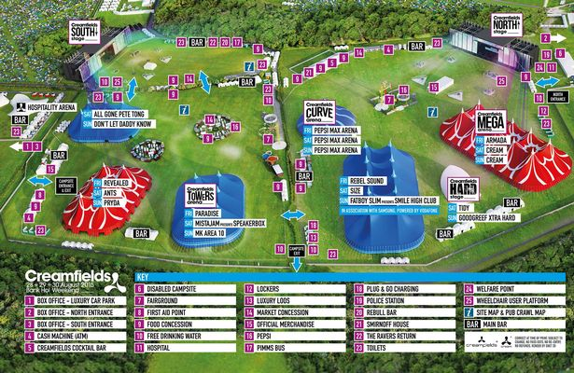

Image B: www.Creamfields.co.uk (2017) [online]
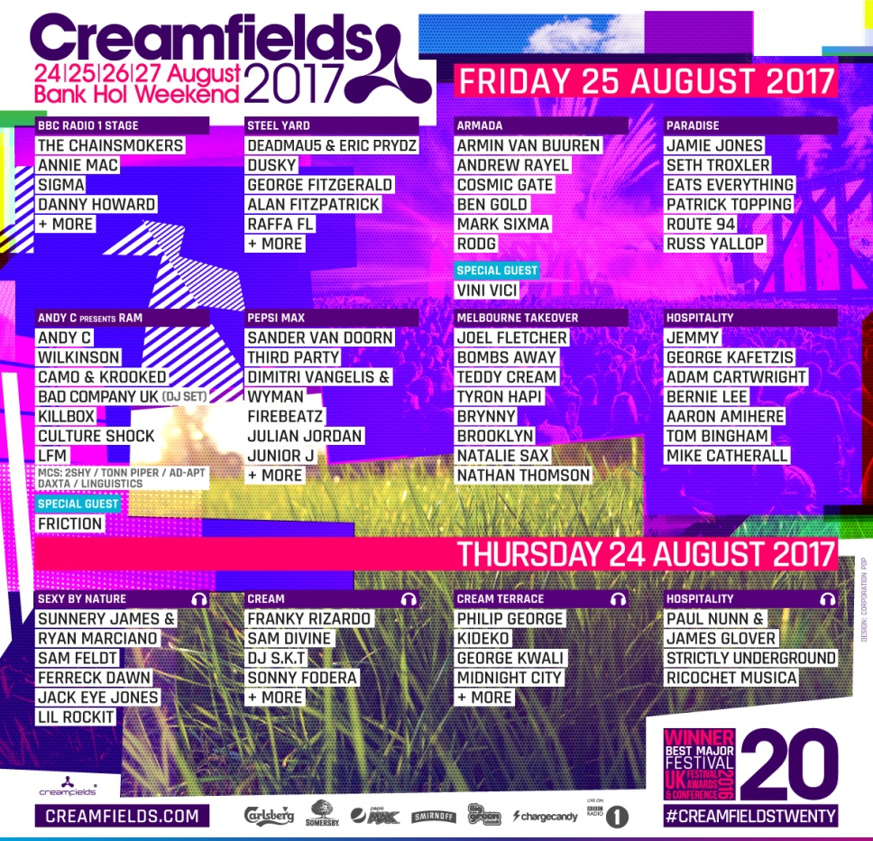

Image C: www.Creamfields.co.uk (2017) [online]
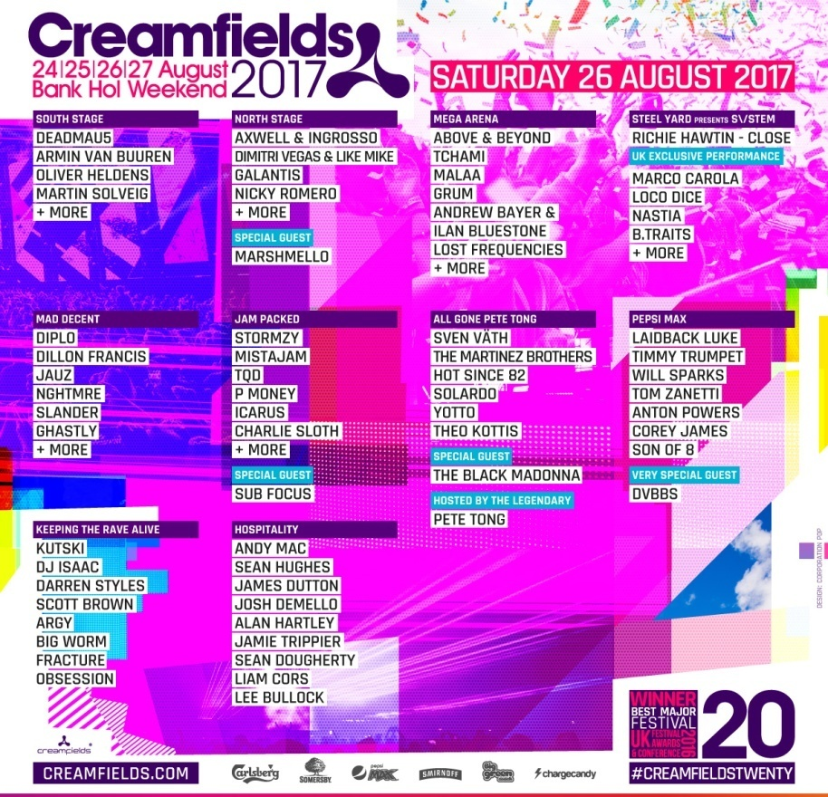

Image D: www.Creamfields.co.uk (2017) [online]
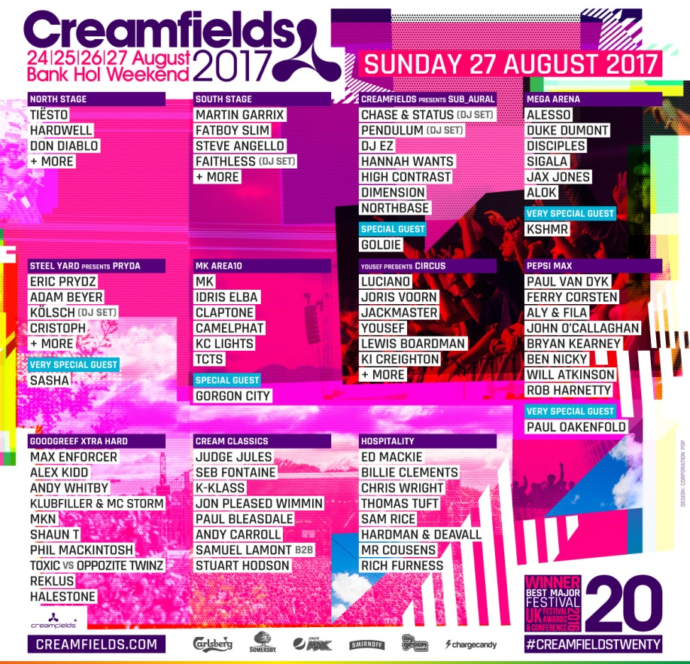

Checklist

What is the festival? | The review will contain information about the festival, where it is located, what music is played and who it attracts.
Details of tickets and how they advertise | Information will be shown on what tickets are available, how you can buy them and how they advertise to persuade people to buy their tickets.
Safety and security | Security measures will be talked about in the review. It will show what safety facilities the event has to make people feel safe
Customer needs and facilities | The review will include bad and good points of all the facilities in the event.

