Raheema Ashraf
2334327
5014
Changemakers creativity and value creation

Poster:
Care Link+ is a cutting-edge digital platform that helps older persons (65 and up) improve their social connectivity, access to health information, and daily well-being. The platform offers simpler video calling, virtual community gatherings, medication reminders, GP pre-appointment paperwork, and a safe communication environment for family members and carers. It aims to alleviate loneliness, enhance independence, and boost digital participation in UK communities. Social isolation and digital exclusion are serious public health issues in the United Kingdom. Over 1.7 million older people can go more than a week without speaking to anyone (Age UK, 2023). According to Holt-Lunstad (2015), loneliness raises mortality risk by 26%. Many older persons lack access to digital services required for contemporary healthcare; 4.7 million people over the age of 65 are digitally excluded (ONS, 2023). While NHS digital systems (GP online services, NHS App) are frequently used, older persons encounter challenges such as poor confidence, device inaccessibility, and a lack of training. There is a lack of a single, easily available platform that blends social support, digital health access, and communication amongst older individuals, carers, and specialists. Care Link+ closes this gap.
Beneficiaries include seniors living alone, people with poor mobility, and those at risk of loneliness and social exclusion.

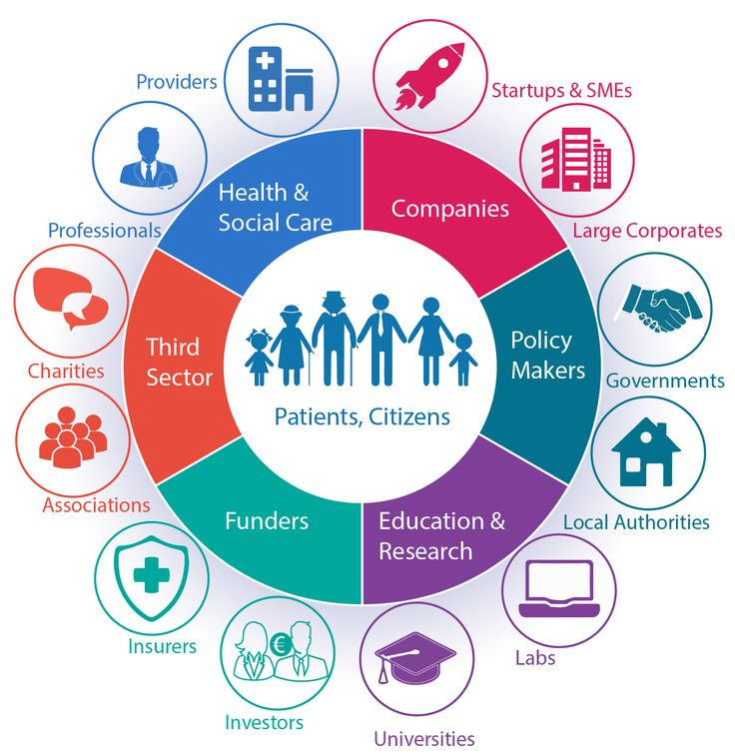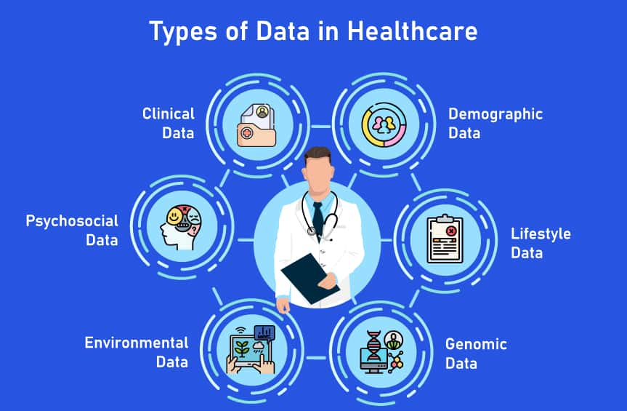
Secondary beneficiaries include family carers, community health teams, social prescribers, and GP surgeries.
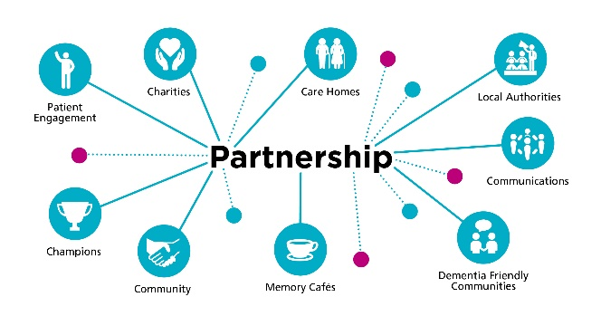
Impact on Health & Wellbeing: CareLink+ improves emotional wellbeing, reduces loneliness-related health risks (e.g. depression, cognitive decline), improves digital inclusion and autonomy, supports older adults to self-manage their health, and reduces GP appointments and emergency calls through improved communication. Overall, the invention benefits society by increasing equity, lowering inequality, and improving community support mechanisms.

Implementation
Locations include GP clinics, local community hubs, sheltered housing schemes, care homes, libraries, and digital inclusion centres. Who is involved: • Social prescribing link workers • NHS volunteers • Age UK digital coaches • Community nurses • Local digital champions.

Identify eligible older people through GP screening, community referrals, and social care evaluations. 2. Provide tablets (if necessary) with the CareLink+ app pre-installed, or assist with installation on existing devices. 3. Conduct in-person digital literacy sessions. 4. Weekly virtual check-ins to monitor overall well-being. 5. Ongoing support through a helpdesk staffed by digital champions.

The platform includes a simplified user interface, secure video calling, AI-assisted reminders, voice assistants, end-to-end encryption, and analytics dashboards for monitoring engagement. Technology increases independence in older individuals, minimises safety concerns, and improves communication with support networks.

Dissemination (Promotion strategy) CareLink+ will be promoted through various channels, including leaflets and posters in GP surgeries and pharmacies, local authority newsletters and websites, partnerships with Age UK and Alzheimer's Society, community roadshows and digital training events, social media campaigns for carers, presentations to Integrated Care Boards and NHS Trusts, and press releases to local media outlets.
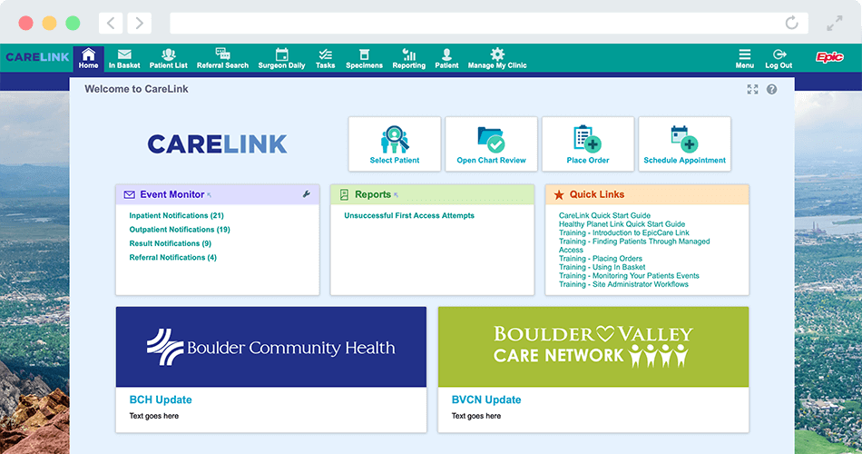



care Link+ is a complete, user-friendly digital solution for managing loneliness, digital exclusion, and communication difficulties in older individuals. It is consistent with national policy aims, promotes the common good, and provides verifiable benefits to individuals, communities, and the broader healthcare system. Adoption of CareLink+ can dramatically improve well-being, relieve demand on primary care, and promote healthier, more connected ageinAge UK (2023) The State of Loneliness. London: Age UK.
To unveil CareLink+, a digital program that helps older individuals reduce loneliness and improve digital access. The poster emphasises the need for the innovation, explains how it works, and shows how CareLink+ can improve wellness and increase ties between health and social care.
The purpose of this poster is to introduce CareLink+, an innovative digital engagement tool developed to combat loneliness and digital exclusion among older individuals in the United Kingdom. The poster's goal is to clearly highlight the initiative's necessity, outline its key characteristics, and show how CareLink+ can increase wellness, improve access to digital health resources, and strengthen communication among older individuals, carers, and healthcare professionals. The poster's visually appealing material aims to increase knowledge and support for the CareLink+ deployment in community health and social care settings.

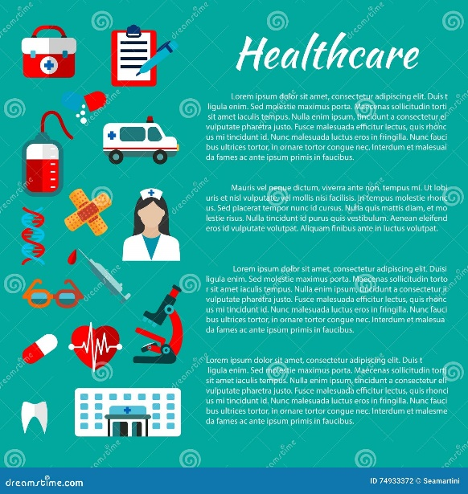

The purpose of this poster is to explain a unique health and social care solution in a clear, engaging, and understandable manner. The poster attempts to illustrate the innovation's essential components, purpose, and benefits, as well as how it meets an identified need in current UK health and social care provision. The poster's succinct images, evidence-based content, and persuasive language are intended to create awareness, generate support, and advocate the adoption of the proposed program among service users, professionals, and community stakeholders.
A simplified digital platform for elderly folks (65 and up).
• Offers video calls, wellness check-ins, reminders, and social groups.
• Promotes independence, confidence, and daily participation. 1.7 million older persons are chronically lonely (Age UK, 2023). Adults 65 and older have high levels of digital exclusion (ONS, 2023). Few technologies that combine communication, social interaction, and digital health access. Elderly individuals living alone or with limited mobility. Family carers and community health teams.

Reduces loneliness and improves mental health
• Encourages people to manage their own health
• Facilitates communication among people, caretakers, and professionals.
• Improves community cohesiveness and digital inclusion.

- Implementation:
Delivered through GP surgeries, community hubs, and local authorities.
- Supported by social prescribers, Age UK staff, digital champions.
- Training sessions, home visits, and ongoing helpline support.

Timeline
Months 1-2: Needs assessment
• Months 3-4: App development
• Month 5: Beta testing
• Months 6-7: Pilot rollout
• Months 8-9: Staff training
• Month 10: Launch
• Months 11-12: Evaluation and expansion.
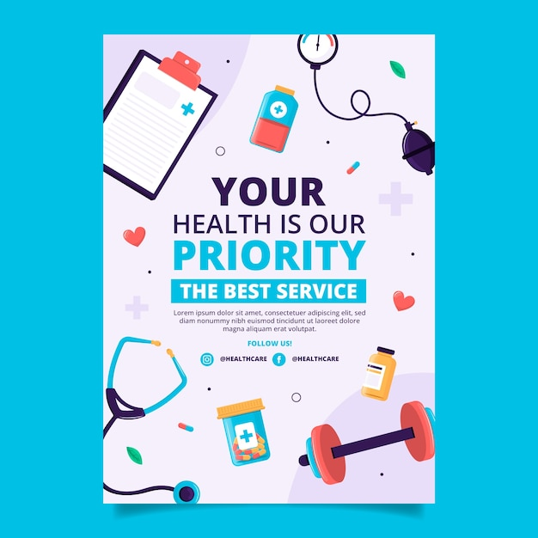

Dissemination
- GP and pharmacy posters
- Local authority newsletters
- Age UK partnerships
- Community workshops
- Social media campaigns
- ICB and NHS Trust presentations
Regulations include the UK GDPR, Data Protection Act 2018, Equality Act 2010 accessibility standards, NICE Evidence Standards, NHS DTAC compliance, and Safe Digital Safeguarding Protocol.

Pitch
Good afternoon, and thank you for taking the time to read about CareLink+, an innovative digital engagement tool created to address one of the most important and underappreciated public health issues affecting older individuals in the United Kingdom: social isolation mixed with digital exclusion. This presentation will highlight the problem's urgency, explain how CareLink+ provides a practical and evidence-based solution, and demonstrate how its implementation will greatly benefit older individuals' health and well-being while also assisting families, carers, and NHS services. I will also address legislation, regulations, and professional services that connect with CareLink+, as well as detail how the public can support and participate in the program.
Loneliness is currently regarded as a major public health concern. According to Age UK (2023), over 1.7 million older persons suffer from chronic loneliness, and many go days or weeks without making meaningful social contact. Loneliness is frequently linked to negative health outcomes, including depression, frailty, cognitive decline, and a 26% increased chance of death (Holt-Lunstad et al., 2015). At the same time, healthcare services in the UK are rapidly becoming digital, from the NHS App to remote GP appointments. However, older folks continue to be the most technologically excluded category. According to the Office for National Statistics (2023), over 4.7 million persons aged 65 and older lack basic computer skills, limiting their ability to arrange appointments, receive health information, and maintain social relationships. This exclusion leads to inequity and deepens the gap in health outcomes. Although there are already digital inclusion programs in place, none presently integrate social interaction, access to health resources, and carer communication in a single, user-friendly platform targeted to the needs of older persons. CareLink+ tackles both the emotional and practical issues that older individuals confront, making it a vital and necessary innovation. CareLink+ is a straightforward yet effective digital platform designed with older individuals, carers, and healthcare professionals in mind. The app is accessible via tablet or smartphone and offers features such as one-touch video calling and virtual community groups/social clubs. • Medication and appointment reminders • Wellbeing check-ins • Secure messaging between older individuals, caretakers, and professionals • Completing GP pre-consultation forms • Voice-assisted navigation for accessibility needs The design emphasises large icons, straightforward text, and simple layouts. Audio descriptions, colour-contrast choices, and streamlined menus all help to improve accessibility. The invention is based on behavioural research, which recognises that tiny digital interactions—such as daily check-ins or virtual conversations—can greatly boost well-being. CareLink+ is more than just technology; it is a comprehensive support tool that strengthens connections, increases independence, and lowers preventable health problems. The key beneficiaries are older persons over the age of 65 who are socially isolated, technologically excluded, or have long-term health concerns. Many people live alone or have mobility limitations that make in-person socialisation challenging. Secondary users consist of informal carers, community volunteers, social prescribers, and health professionals. Benefits include more daily social contact, improved mental wellbeing, improved digital skills and confidence, improved communication with caretakers, reduced social isolation and loneliness, medication adherence through reminders, and better preparation for GP appointments. CareLink+ can eliminate unnecessary GP consultations, prevent avoidable deterioration, and alleviate burden on community teams. CareLink+ will be deployed in partnership with health and social care organisations across the UK. The deployment involves using loneliness screening techniques to identify people at GP surgeries. • Social prescribers introducing the platform during wellness interventions. • Local governments offer digital inclusion workshops • Community partners include Age UK and other charities, while NHS volunteers assist with digital setup. The service will be offered via a combination of in-person digital coaching and continuous online support. NHS digital transformation grants, local authority innovation funds, and partnership grants with voluntary organisations are examples of funding opportunities. CareLink+ complies to essential legislation and regulatory frameworks: • Data Protection Act 2018 & UK GDPR: Ensures data protection, consent, and secure processing. • The NHS DTAC (Digital Technology Assessment Criteria) ensures safety, cybersecurity, and clinical risk management. • NICE Digital Health Technology Standards: Offers evidence-based assurance. • The Equality Act of 2010 ensures accessibility and nondiscriminatory design. • Safeguarding protocols: Professionals who use the system maintain a duty of care and monitor potential dangers. The involvement of social prescribers, community nurses, occupational therapists, and digital inclusion workers ensures that CareLink+ is consistent with professional practice and supports integrated care models. CareLink+ is heavily supported by the general public. Examples of community involvement include volunteering as a digital champion. • Attending local digital training events • Assisting elderly relatives or neighbours with digital access • Raising awareness of loneliness and digital exclusion • Participating in community engagement activities CareLink+ will be promoted through local and national networks, including NHS communication channels, charitable partnerships, social media campaigns, newsletters, and community roadshows. CareLink+ provides an effective, practical, and compassionate answer to the growing issue of loneliness and digital exclusion among older individuals. It corresponds with national policy objectives, promotes the common good, and improves the quality of life for some of society's most vulnerable people. We are not simply implementing a digital tool when we invest in CareLink+; we are also strengthening communities, modernising care, and encouraging healthier ageing for everybody.
The deployment of CareLink+ would involve a wide range of professional services. These include GPs and primary care teams, who refer patients and monitor their health. • Social prescribers promote community-based engagement and digital participation. • Adult social care services: finding adults who are lonely or vulnerable. • Community and voluntary organisations, such as Age UK. • Digital inclusion trainers/champions - who promote learning and confidence. • Healthcare technology teams are responsible for assuring patient safety, security, and accessibility. • Carers and family members use the platform to communicate and provide assistance. This multi-agency collaboration reflects the government's current focus for integrated, person-centred care in the NHS and social care sectors.
Volunteers can become digital champions; families can help elderly relatives use the site; and local groups can attend social events hosted by CareLink+. Public support also helps to normalise digital activity among older persons, eliminating stigma and increasing confidence. Promoting CareLink+ via social media, community events, GP surgeries, libraries, and local governments assures extensive visibility. By framing digital inclusion as a shared community goal, the campaign encourages people to see the broader social and economic benefits of assisting older folks.
CareLink+ is a relevant, significant solution that addresses some of the most important issues confronting older individuals in the UK.

