

Exploring Approaches to Digital Forensic Assessment and Cybersecurity Incident Analysis

By

Ayush Kumar

Lecturer: Dr. Nitheesh Kaliyamurthy

Report submitted as part of the requirements for the award of MSc Cyber Security and Digital Forensics

Jan 2024

Table of Contents
1. Digital Forensics: Insights into Trends, Challenges, and Exciting Career Prospects (Task 1) 1
1.1 Current State of the Field: 1
1.2 Intersection of Digital Forensics and Cybersecurity: 2
1.3 Emerging Trends: 3
1.3.1 AI and Machine Learning: 3
1.3.2 Blockchain Forensics: 3
1.3.3 IoT Forensics: 4
1.4 Key Challenges: 4
1.4.1 Encryption and Anonymity: 4
1.4.2 Data Volume and Velocity: 5
1.4.3 Skill Shortage: 5
1.5 National and International Job Market: 5
1.5.1 High Demand for Experts: 6
1.5.2 Global Opportunities: 6
1.5.3 Specialized Roles: 6
2. Navigating the Digital Forensics Toolkit: Commercial vs. Open-Source Tools (Task 2) 8
2.1 Introduction: 8
2.2 Current State of Digital Forensic Tools: 8
2.3 Evaluation of Open-Source Tools vs. Commercial Tools: 8
2.3.1. Commercial Tool: EnCase 8
2.3.2 Equivalent Open-Source Tool: Autopsy 9
2.3.3 Commercial Tool: FTK (Forensic Toolkit) 9
2.3.4 Equivalent Open-Source Tool: The Sleuth Kit 10
2.4 Coherence and Structure: 10
2.5 Conclusion: 11
2.6 Open-Source Tools: A Symphony of Collaboration 11
2.6.1 Budget Constraints and Community Backing 11
2.6.2 Diverse Needs of Digital Investigations 12
2.6.3 In Summary: 12
3. Digital Forensic Investigation (Task 3) 13
3.1 Social Media Investigation 13
3.1.1 Scenario Formation Steps: 13
3.1.2 My contribution 14
3.2 Analysing the newly acquired hard disk data for theme-related evidence 15
3.2.1 The analysis and investigation aspects considered: 15
3.2.2 My Contribution 16
3.2.3 Personal Reflection 17
3.2.4 Video link Presentation 17
4. Mobile Forensic Investigation (Task 4) 18
4.1 Role and Responsibilities: 18
4.2 Data Collected: 18
4.3 Investigative Process: 19
4.4 Conclusion: 21
4.5 Recommendations: 21
5. Conclusion 23
6. References 24
Appendix A 30
A.1 TEAM B: Data Collection Report 30
A.2 Newly Acquired HDD Group Report 39
Appendix C: Mobile Forensics Investigation 51

List of Figures
Figure 1:Concealed within an image is an encrypted file, skilfully embedded using Steg hide commands. 14
Figure 2: Root directories, files with each drive and storage capacity 17
Figure 3: Encrypted file hidden inside the image using steghide commands. 33
Figure 4:The above screenshot shows the encrypted files, using substitution encryption. 34
Figure 5:Call log from the victim’s phone and 37
Figure 6:Police report documents saved in a zip folder 37
Figure 7:The screenshots are proof of the PowerShell command. 40
Figure 8:Screenshot showing all four partitions 41
Figure 9:Screenshot showing root folders present in the HDD 41
Figure 10:Screenshot showing root folders present in the HDD 41
Figure 11:Screenshot showing each drive and storage capacity 41
Figure 12:Evidence of Credit card details recovered from the HDD. 42
Figure 13:Evidence of email accounts recovered. 42
Figure 14:Evidence of IP addresses. 43
Figure 15:Evidence of different URLs. 43
Figure 16:Evidence of Phone numbers recovered 44
Figure 17:Evidence of user contents, including images, audio, videos, document files, etc. 44
Figure 18:Evidence of unallocated spaces 47
Figure 19:Evidence Location of files with Metadata from the new image 47
Figure 20:chain of custody 52
Figure 21:Cellebrite forensics toolkit 53
Figure 22:Evidence of audio recordings 59
Figure 23:Recovered Data 61

List of Tables
Table 1:The following are files found in the new image of drive J. 47

1. Digital Forensics: Insights into Trends, Challenges, and Exciting Career Prospects (Task 1)

1.1 Current State of the Field:

Digital forensics is undergoing a transformative phase, evolving from a niche discipline into a critical component of cybersecurity, responding to the escalating frequency and sophistication of cybercrimes. This field involves the recovery, analysis, and preservation of electronic evidence, playing an indispensable role in investigations, incident response, and legal proceedings.
The current state of digital forensics is marked by remarkable growth and an increasing demand for professionals. Law enforcement agencies, governmental bodies, and private organizations heavily rely on digital forensics experts to investigate and mitigate cyber threats. This surge in demand is a direct response to the rising tide of cybercrimes, emphasizing the need for experts who can adeptly uncover and interpret digital evidence.
This growth is closely linked to technological advancements. Forensic tools and techniques have evolved significantly, enhancing the effectiveness of digital investigations. Specialized areas, such as cloud forensics, mobile forensics, and IoT device analysis, have emerged, empowering investigators to navigate complex digital environments and extract relevant evidence more effectively [1].
Cloud forensics, addressing incidents involving data stored in the cloud, provides a comprehensive approach to cybercrime investigations. Mobile forensics has gained prominence in an era where mobile devices are ubiquitous, reflecting the adaptability of digital forensics to the evolving technology landscape.
In addition to technological advancements, digital forensics has gained significant legal recognition. Digital evidence is widely accepted in legal proceedings, with courts globally acknowledging its importance in establishing the authenticity and integrity of electronic evidence. The field has adapted to legal standards, ensuring that forensic processes and methodologies align with the rigorous requirements of the judicial system [2].
In conclusion, the current landscape of digital forensics is characterized by unprecedented growth, driven by the increasing demand for expertise in investigating cybercrimes. Technological advancements have expanded the scope of digital forensics to encompass specialized areas, and legal recognition has elevated the field's importance in the judicial system. Digital forensics will remain at the forefront of efforts to combat cyber threats and ensure the integrity of electronic evidence as the digital landscape continues to evolve [3].

1.2 Intersection of Digital Forensics and Cybersecurity:

Digital forensics and cybersecurity function as close allies, working together to safeguard our digital realm from evolving cyber threats. Originally employed primarily for post-incident investigations, digital forensics has transformed into a proactive force within cybersecurity.
In the realm of proactive cyber defence, cybersecurity experts leverage digital forensics to retrospectively analyse historical data. This involves identifying vulnerabilities and comprehending the modus operandi of cyber-attacks. It transcends mere threat reaction; it involves fortifying defences and pre-emptively addressing potential threats before they materialize.
The collaboration becomes indispensable during incident response. Swiftly addressing a cyber incident requires understanding, containment, and recovery. Digital forensics plays a pivotal role by offering insights into cyber attackers' methods. This goes beyond mere detection, providing a nuanced understanding of attacker’s strategies [4]. This depth of understanding informs effective responses and fortifies defences against recurrent threats.
This collaboration extends into the realm of threat intelligence. Digital forensics assumes a key role in gathering threat intelligence, empowering organizations to proactively enhance their cybersecurity. By analysing data from prior incidents, forensic experts discern patterns, identify threat actors, and furnish valuable insights. This proactive approach enables organizations to predict and prevent potential threats before they escalate.
Deriving threat intelligence from digital forensics involves scrutinizing the tactics employed by threat actors. This detailed comprehension provides cybersecurity professionals with an intricate understanding of potential threats and vulnerabilities. This intelligence, rooted in the analysis of past incidents, facilitates adjustments to security strategies, ensuring resilience against new and evolving cyber threats [5].
In summary, the symbiotic relationship between digital forensics and cybersecurity is pivotal in addressing contemporary cyber threats. Digital forensics proactively engages in cyber defence, significantly contributes to incident response strategies, and plays a crucial role in shaping threat intelligence. As the cybersecurity landscape evolves, the ongoing collaboration between digital forensics and cybersecurity remains essential for effectively protecting our digital assets and responding to emerging threats.

1.3 Emerging Trends:

Digital forensics, the vanguard field investigating digital incidents and cybercrimes, is undergoing a transformative surge propelled by technological advancements. Let's delve into key emerging trends shaping the landscape.

1.3.1 AI and Machine Learning:
A standout trend is the infusion of artificial intelligence (AI) and machine learning (ML) into digital forensics, revolutionizing investigative methodologies. These technologies act as game-changers, enabling faster and more accurate analyses. By automating routine tasks, AI and ML empower forensic experts to focus on intricate aspects like anomaly detection, pattern recognition, and predicting potential cyber threats. Imagine a digital assistant not only handling repetitive tasks but also unravelling nuanced complexities within digital evidence [6].

1.3.2 Blockchain Forensics:
The ascent of blockchain technology introduces a frontier in digital forensics known as blockchain forensics. As our lives become intertwined with cryptocurrencies, expertise in this area becomes crucial. Blockchain forensics involves deciphering complex transactions, identifying illicit activities, and comprehending the movement of digital assets across decentralized networks. It's akin to being a digital detective in the realm of cryptocurrencies, tracing breadcrumbs in the blockchain to unveil the story behind digital crimes [7].

1.3.3 IoT Forensics:
The proliferation of Internet of Things (IoT) devices presents challenges and opportunities for digital forensics. Enter IoT forensics, a specialized field addressing incidents involving interconnected smart devices. Investigating these incidents demands unique skills and tools. Picture a crime scene with numerous devices, each holding a piece of the puzzle. IoT forensics involves extracting and scrutinizing data from this array of devices to ensure accurate interpretation of digital evidence. It's akin to solving a high-tech jigsaw puzzle, with forensic experts acting as modern-day detectives piecing it together [8].

In essence, digital forensics eagerly embraces the future by leveraging AI and ML for streamlined investigations. Blockchain forensics delves into the intricacies of cryptocurrency transactions, while IoT forensics unravels mysteries within interconnected smart devices. Digital forensics experts emerge as modern-day detectives, armed with the tools and knowledge to navigate the intricate digital landscapes of tomorrow's cybercrimes [8] [9].

1.4 Key Challenges:

In the ever-evolving realm of digital forensics, despite commendable progress, notable hurdles significantly impact the efficiency and effectiveness of investigations.

1.4.1 Encryption and Anonymity:
A significant challenge lies in the widespread use of encryption technologies that obscure user identities. This poses a formidable barrier for digital forensics, leaving investigators puzzled when attempting to access or decipher encrypted data. The complexity amplifies with the rise of anonymous communication channels, making it challenging to attribute specific actions to individuals. Picture it as solving a puzzle where some pieces are locked behind a code; it's not just about finding the pieces but deciphering the code to reveal the complete picture. Encryption and anonymity act as digital locks, necessitating digital forensics experts to navigate through these locks to unveil hidden insights [10] [11].

1.4.2 Data Volume and Velocity:
Another hurdle comes in the form of an overwhelming volume of daily-generated digital data. The vast amount of information from emails, social media, and online activities turns the task for digital forensics experts into finding a needle in a haystack. The challenge extends beyond volume to the speed at which data is generated – the velocity. Effectively analysing this massive data trove within reasonable time frames demands specialized tools and methodologies. In digital forensics, experts need to process, correlate, and interpret information with swiftness and precision [12] [13] [14].

1.4.3 Skill Shortage:
A critical challenge in digital forensics is the shortage of skilled professionals, as the demand exceeds the current supply. This notable skills gap becomes more critical as cyber threats grow in sophistication. Assembling a team for a complex mission, in this case, requires the right experts with the right skills. The shortage underscores the importance of training and education initiatives to bridge this gap. It's not merely about solving cases but also about preparing the next generation of digital detectives to adeptly navigate the challenges of tomorrow. In essence, the journey of digital forensics, while advancing, encounters hurdles such as encryption complexities, data deluge, and a shortage of skilled professionals. Overcoming these challenges is pivotal to ensuring that digital forensics remains a robust tool in the ongoing fight against cyber threats, presenting opportunities for continual growth and innovation in the dynamic realm of digital investigations [15] [16] [17].

1.5 National and International Job Market:

The job market for digital forensics professionals is thriving, reflecting their indispensable role in the realms of cybersecurity and law enforcement.

1.5.1 High Demand for Experts:
Digital forensics specialists are in high demand across various sectors, from law enforcement agencies to cybersecurity firms and private corporations. This demand is driven by the escalating frequency and complexity of cybercrimes. Organizations actively seek individuals with specialized skills in investigating digital incidents, emphasizing the pivotal role these professionals play in combating evolving cyber threats. Envision yourself as a sought-after detective in the digital realm, where your skills are vital for unravelling intricate cybercrime puzzles. The increasing sophistication of these crimes only heightens the value of expertise possessed by digital forensics specialists [18] [19].

1.5.2 Global Opportunities:
The job market for digital forensics professionals transcends borders. As cyber threats know no geographical boundaries, collaboration on a global scale becomes imperative. This provides opportunities for experts to contribute to international investigations, collaborate with cybersecurity teams worldwide, and engage in initiatives aimed at collectively combating cyber threats. Picture yourself as part of an international task force, where your skills are not confined to a specific region. The interconnected nature of cyber threats necessitates professionals who can operate on a global stage, placing digital forensics experts at the forefront of this global collaboration [20] [21].

1.5.3 Specialized Roles:
Within the digital forensics field, there is a growing demand for specialists in areas such as mobile forensics, cloud forensics, and incident response. Organizations are looking for professionals with expertise in extracting and analysing evidence from diverse digital environments. Specialization allows these experts to become proficient in niche areas, addressing challenges posed by mobile devices, cloud platforms, or responding to cyber incidents [22] [23].
In conclusion, the current landscape of digital forensics is marked by growth, technological advancements, and increased recognition. The collaboration between digital forensics and cybersecurity is crucial for proactive defence, incident response, and threat intelligence. Emerging trends, such as AI and machine learning, blockchain forensics, and IoT forensics, shape the field's future. Despite challenges like encryption, data volume, and skill shortages, the job market for digital forensics professionals remains robust nationally and internationally. In essence, being a digital forensics expert means not just solving today's puzzles but staying ahead of the curve in this dynamic and critical field [18].

2. Navigating the Digital Forensics Toolkit: Commercial vs. Open-Source Tools (Task 2)

2.1 Introduction:
The world of digital forensics is a complex realm, and the tools investigators employ play a pivotal role in unravelling electronic mysteries. In this comprehensive review, we delve into the current landscape of digital forensic tools, exploring their features and capabilities. Moreover, we embark on a journey to evaluate open-source tools in comparison to their commercial counterparts, all while drawing insights from reputable academic literature and industry reports [24].

2.2 Current State of Digital Forensic Tools:
Digital forensic tools have come a long way, evolving to meet the ever-growing challenges posed by cyber investigations. Among the stalwarts in this domain are commercial tools like EnCase and FTK (Forensic Toolkit). These tools are revered for their comprehensive features, offering a suite of functions for evidence collection, analysis, and reporting. They are known for their intuitive user interfaces, making them accessible to a broad spectrum of users.
The assessment of these tools often takes cues from academic literature. For instance, the work of Javed et al. (2022) emphasizes the critical aspects of accuracy, completeness, and speed in evaluating digital forensic tools. Adding a layer of industry standards, the NIST's program provides a benchmark for the performance of these tools [24] [25].

2.3 Evaluation of Open-Source Tools vs. Commercial Tools:
Here, we embark on a comparative journey, evaluating tools used in our digital forensics course and their open-source counterparts.

2.3.1. Commercial Tool: EnCase

Features and Capabilities:
EnCase stands as a powerhouse for evidence collection from diverse sources.
Its advanced analysis features are particularly valuable for intricate investigations.
Notably, EnCase extends its support to the contemporary data sources housed in cloud storage [26].

Academic Insights:
The research brings to light EnCase's reliability in the realm of file system analysis. Industry reports from cybersecurity conferences consistently feature EnCase as a leading player [27] [28].

2.3.2 Equivalent Open-Source Tool: Autopsy

Features and Capabilities:
Autopsy, an open-source alternative, boasts a user-friendly interface coupled with robust evidence analysis capabilities. Its open-source nature fosters community-driven development, ensuring continuous improvement. Autopsy shines in its support for various file systems, offering a well-rounded solution [29].

Analysis:
While Autopsy might lack some of the polished features found in EnCase, its accessibility and community support make it a compelling alternative, especially for those navigating tighter budget constraints [30].

2.3.3 Commercial Tool: FTK (Forensic Toolkit)

Features and Capabilities:
FTK prides itself on high-speed processing, ensuring efficient analysis of vast datasets.
The tool's advanced search and sorting functionalities elevate its analytical capabilities.
FTK boasts extensive file format support, a vital aspect in the multifaceted world of digital forensics [31].

Academic Insights:
Research by Alshammari et al. (2023) commends FTK's efficiency in handling large datasets, acknowledging its contribution to streamlined investigations [32].
NIST's reports add credibility, offering standardized testing methodologies and benchmarks for FTK's performance.

2.3.4 Equivalent Open-Source Tool: The Sleuth Kit

Features and Capabilities:
The Sleuth Kit, an open-source counterpart, operates through command-line utilities, presenting powerful forensic analysis tools. Its efficiency in handling large datasets is comparable to FTK, ensuring investigators have the necessary tools for intricate cases. Active community support adds a layer of reliability and continual improvement [33] [31].

Analysis:
While lacking the user-friendly interface that FTK boasts, The Sleuth Kit offers flexibility, especially for users comfortable with command-line operations. It stands as a testament to the collaborative power of open-source communities [34] [32].

2.4 Coherence and Structure:

This review is well-organized and easy to follow, providing a straightforward explanation of the status of digital forensic tools and their detailed features. The comparison between open-source and commercial tools is presented in a clear structure, offering valuable insights into the strengths and weaknesses of each option.

2.5 Conclusion:

As we conclude our exploration, it's clear that the world of digital forensics is complex. Both commercial and open-source tools have their places, and the decision between them depends on various factors. Factors such as budget constraints, personal preferences, and the specific needs of an investigation all play a role.
This review, filled with insights from academic literature and industry reports, serves as a guide for professionals navigating the intricate field of digital forensics. It reflects the ever-changing nature of this domain and offers guidance for those making decisions in the face of digital challenges. As the digital landscape continues to expand, the tools available to digital investigators will also evolve, shaping the future of this crucial field.
Exploring the digital landscape reveals the dynamic nature of digital forensics tools. Open-source alternatives, developed through collaboration and a commitment to accessibility, play a crucial role, providing a unique contribution to the field.

2.6 Open-Source Tools: A Symphony of Collaboration

Within the open-source realm, standout tools like Autopsy and The Sleuth Kit exemplify the potency of collective intelligence. Autopsy, with its user-friendly interface and robust analytical capabilities, epitomizes inclusivity. Its open-source nature encourages contributions from a diverse community, ensuring continual refinement.
Operating mainly through command-line utilities, The Sleuth Kit showcases the strength of a community-driven approach. Users proficient in command-line operations find a valuable ally in this tool, highlighting the flexibility inherent in open-source solutions [35].

2.6.1 Budget Constraints and Community Backing

Budget limitations often dictate the tools available to an investigator. Open-source tools shine in this aspect, providing robust solutions without the financial burden associated with commercial counterparts. The active communities surrounding these tools enhance their appeal, contributing to their evolution through continuous updates, bug fixes, and new features driven by community feedback [36].

2.6.2 Diverse Needs of Digital Investigations

In the realm of digital forensics, a one-size-fits-all approach falls short. Investigations span a spectrum, from straightforward cases to complex, multi-faceted scenarios. This diversity underscores the importance of a varied toolkit. Commercial tools like EnCase and FTK, boasting polished features and comprehensive support, prove invaluable for intricate investigations where time is of the essence and no compromises can be made. Conversely, open-source tools cater to a different niche. Aligned with the needs of those valuing accessibility, community collaboration, and budget considerations, their adaptability proves crucial in scenarios demanding a more flexible and customizable approach [37].

2.6.3 In Summary:

Traversing the digital forensic toolkit mirrors navigating a vast, ever-changing landscape. Commercial and open-source tools each bring unique strengths to the table. The former, with polished interfaces and comprehensive features, stand as pillars of efficiency. The latter, born from collaborative communities and driven by accessibility, embody the spirit of inclusivity.
For professionals in the field, the key lies in comprehending the nuances of each tool. Informed decision-making involves aligning a tool's capabilities with the unique demands of an investigation. The digital forensics toolkit, akin to a well-curated ensemble, equips investigators with the means to navigate the intricacies of the digital realm.
In conclusion, the journey endures. The evolution of digital forensics tools persists, shaped by technological advancements, community collaboration, and the ever-expanding landscape of cyber challenges. As professionals and enthusiasts embark on this journey, the toolkit at their disposal remains a critical companion, adapting to the diverse needs of the digital investigation frontier.

3. Digital Forensic Investigation (Task 3)

3.1 Social Media Investigation
Group report for social media investigation is attached as Appendix A.
In summary, I played a crucial role in the entire evolution of our cyberbullying scenario investigation, from its inception to the active initiation.

3.1.1 Scenario Formation Steps:
Scenario Outline:
1. Introduction of the Victim and Cyberbullying Attacks:
Begin’s by introducing the victim, detailing their background, online presence, and the initial encounters with cyberbullying. Clearly articulated the nature and severity of the attacks to establish a foundation for understanding the case [38] [39].

2. Description of Suspects and Diverse Personas:
Presented the suspects involved in the cyberbullying incidents, providing insights into their varied personalities and motivations. Explored different facets of their online personas to highlight the complexity of the case.

3. Overview of Attack Patterns Across Communication Channels:
Outlined the diverse methods employed by the suspects to carry out cyberbullying attacks. Included a comprehensive examination of communication channels such as social media, messaging apps, and email, emphasizing the evolving tactics used to harass the victim [40].

4. Victim's Attempts to Block and Report:
We have detailed the victim's proactive measures to defend against the cyberbullying, including attempts to block and report the perpetrators. Emphasized the resilience of the attacks, leading to ongoing distress for the victim despite their efforts to protect themselves.
5. Evidence Handover:
Provided the digital forensics team with a hard disk drive containing meticulously gathered evidence from the victim's device. Stressed the critical importance of relying solely on the presented evidence and avoiding any premature assumptions. Reminded the team to adhere strictly to the facts and data at hand during the forensic analysis to ensure an unbiased and accurate investigation.

3.1.2 My contribution
My contributions were diverse, involving the generation of initial chat logs through a range of tools. As the scenario unfolded, I took an active role in adapting and refining the generated chats to seamlessly align with the developing narrative. These adjustments were the product of collaborative discussions within our team, ensuring that the final content accurately mirrored the complexity of the evolving cyberbullying situation.

Furthermore, I played a pivotal position in implementing Steganography [41] [42] [43], offering guidance on encryption and decryption techniques, particularly in the context of images. Additionally, my involvement extended to the practical integration of real-time data capture, utilizing GPS information to enhance the investigation [44]. All these efforts were orchestrated with the shared goal of creating a comprehensive and dynamic digital forensic examination.
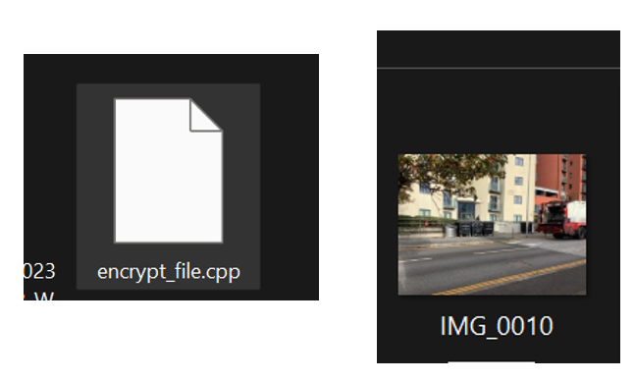
Figure 1:Concealed within an image is an encrypted file, skilfully embedded using Steg hide commands.

The adaptability demonstrated by our team in addressing the ever-evolving challenges within the simulated cyberbullying scenario underscores our unwavering commitment to a thorough and realistic investigative approach. This commitment is not just a claim but is evident in our proactive response to the complexities encountered throughout the investigation. Our collaborative efforts reflect a dedication to precision, ensuring that every facet of the cyberbullying scenario is meticulously examined and understood.

3.2 Analysing the newly acquired hard disk data for theme-related evidence

A detailed group report summarizing the HDD forensic analysis was prepared and is attached as Appendix B. This report encompassed findings, actions taken, and collected evidence.
In response to the potential corporate crime scenario involving Red Hot Passion, where confidential user information is at risk of being leaked, a comprehensive digital forensics investigation of the hard disk drive (HDD) was initiated. The team adopted a systematic approach to safeguard and analyse the HDD.

3.2.1 The analysis and investigation aspects considered:
1. Identification and Preservation of Evidence:
The affected HDD was identified, isolated. Forensic images of the entire HDD were created to ensure the integrity of the evidence [45].

2. Network Analysis:
Network analysis focused specifically on the HDD's activity, examining logs for suspicious patterns and tracing communication channels [46].

3. Database Forensics:
Database forensics centred on the HDD's file system and logs, aiming to identify any unauthorized access or modifications to stored data [47].
4. Endpoint Forensics:
Endpoint forensics concentrated on the HDD, involving scrutiny of system logs, file timestamps, and recovery of deleted files or traces of unauthorized access [48].

5. Email and Communication Analysis:
Analysis of email and communication data was limited to information stored on the HDD, with a focus on identifying evidence of potential insider threats [49].

6.Employee Investigation:
A thorough review of access logs on the HDD was conducted to identify individuals with access to sensitive information.

7. Legal Collaboration and Documentation:
Collaboration with legal advisors ensured adherence to relevant laws and regulations. Meticulous documentation of the chain of custody for the HDD and any extracted data was maintained [50].

8. Remediation and Reporting:
Remediation measures were implemented on the HDD to secure it, prevent further unauthorized access, and notify affected users if their data was present. The investigation prioritized maintaining the integrity of HDD data and adhering to legal standards, establishing a robust foundation for potential legal proceedings [51].

3.2.2 My Contribution
Captured the image of the HDD. Then, I employed PowerShell to assess partition integrity and used the DiskGenius tool to meticulously explore root directories and files, analysing storage capacities across drives. Notably, DiskGenius unveiled the presence of a malicious file on the HDD, impeding its normal operation. Furthermore, DiskGenius enabled me to inspect the written code of the malicious file. Subsequently, with Autopsy, I scrutinized unallocated space, deepening our insight into the digital landscape. This comprehensive approach facilitated a thorough examination of storage environments, significantly contributing to our understanding of potential security issues, maintaining the originality of the process. Storage environments, contributing significantly to our understanding of potential security issues, all while ensuring the originality of the process [52] [53].

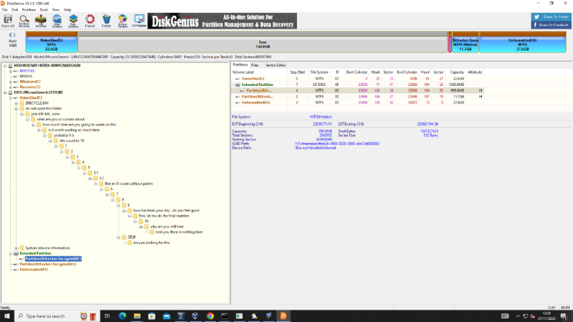

Figure 2: Root directories, files with each drive and storage capacity

3.2.3 Personal Reflection
Handling the Red Hot Passion corporate crime situation taught me a lot about balancing tech know-how and ethics. Being part of the response team showed how crucial it is to protect sensitive data and keep digital systems secure. Collaborating with different experts opened my eyes to the complexity of cyber threats. Digging into the personal side of the investigation, like understanding why some employees might be upset, highlighted how this affects real people. Following the rules and laws made sure we did things right. This experience stressed the need to keep learning in the fast-changing world of digital security and the power of teamwork in facing tough cybersecurity issues.

3.2.4 Video link Presentation
https://shorturl.at/bsx03

4. Mobile Forensic Investigation (Task 4)

Mobile forensics investigation group report is attached as Appendix C.

4.1 Role and Responsibilities:

In my capacity as the investigator, my primary responsibility revolves around ensuring the integrity and admissibility of evidence throughout the investigation. This critical objective is achieved through the rigorous maintenance of a comprehensive Chain of Custody for the suspect's mobile phone. The meticulous documentation of every handling instance is paramount, guaranteeing that the device remains unaltered from the moment of seizure to the conclusive stages of analysis. My role extends to coordinating seamlessly with the investigative team, fostering effective communication with the client, and overseeing the exhaustive examination of the mobile device through the utilization of Cellebrite tool kits. Upholding the highest standards of confidentiality, adhering to stringent legal protocols, and delivering an in-depth report to the client are at the forefront of my responsibilities [54].

4.2 Data Collected:
The utilization of Cellebrite tool kits for mobile forensics unearthed compelling findings:

a. 64 Images: These visual artifacts potentially offer insights into the TO's surroundings, activities, or social connections.

b. 23 Audio Recordings: A trove of potential evidence containing conversations or interactions that may be pertinent to the investigation.

c. 7 Video Files: Rich visual and auditory data providing additional layers of context to the TO's actions and communications.

4.3 Investigative Process:

1.Chain of Custody:
The establishment and meticulous maintenance of a transparent Chain of Custody form the bedrock of the investigative process. This involves a detailed and unbroken record of every individual who interacts with the suspect's mobile phone, ensuring the integrity and admissibility of the collected evidence [55].

2. Team Discussions:
Ongoing and collaborative discussions with the investigative team are essential for seamless coordination. These discussions facilitate the exchange of insights, ensure the security of the Chain of Custody, and address any emerging challenges throughout the investigation.

3. Initial Examination and Assessment:
The preliminary examination is a crucial step in assessing the condition of the suspect's mobile phone. This initial assessment ensures that the device remains unaltered and preserves its original state for subsequent phases of the investigation [56].

4.Storage and Backup:
Stringent measures are implemented to safeguard the collected evidence through secure storage. Creating backups is essential to prevent any inadvertent data loss or tampering, further reinforcing the integrity of the evidence collected [57].

5. Analysis and Examination:
Leveraging Cellebrite tool kits, a comprehensive analysis is conducted, encompassing both logical and physical dimensions. Messages, call logs, media files, and application data undergo meticulous scrutiny. Documentation of the methods employed during this phase, including any attempted brute-force attacks or social engineering tactics, is integral to providing transparency into the investigative process.

6. Documenting Methods of Analysis:
A meticulous documentation process is implemented, delineating the specific methods employed during the analysis. This includes a detailed account of any attempts at brute-force attacks or social engineering tactics used to access protected information. This documentation ensures transparency and aids in the admissibility of findings in potential legal proceedings.

7. Data Extraction and Identification:
Advanced techniques are applied to extract, analyse, and interpret the data stored on the mobile device. The identification of evidence directly related to the scenario remains a key objective during this phase, contributing to the overall narrative of the investigation [58].

8. Implications of Findings:
The implications of the findings are profound and far-reaching. Should the evidence corroborate suspicions, the initiation of potential legal actions against the TO may be warranted. Simultaneously, the organization may need to conduct a thorough reassessment and fortification of its internal security measures. Clear and transparent communication with the client becomes imperative, especially if suspicions are not substantiated. This ensures the restoration of confidence, maintaining a positive working environment within the company.

9. Personal Reflection:
This comprehensive investigative process, integrating a secure Chain of Custody, meticulous analysis methods documentation, and identification of evidence, illuminates the multifaceted nature of digital forensics. It underscores the delicate balance between legal adherence, technical expertise, and ethical considerations, ensuring a thorough and legally sound investigation. The implications of findings extend beyond the individual involved, carrying repercussions for organizational security and trust. This experience reinforces the critical role of a lead investigator in safeguarding corporate interests and maintaining transparency within the organization, solidifying the importance of a methodical and ethical approach in the realm of digital forensics. The journey through this investigation has further enhanced my understanding of the intricate nature of safeguarding digital evidence and its pivotal role in organizational integrity.

4.4 Conclusion:

The exhaustive investigation into the suspected data breach involving the Technical Officer (TO) in our client's AI self-driving car project has yielded substantial findings, meticulously extracted from the analysis of the suspect's mobile phone. The process, marked by a secure Chain of Custody, rigorous documentation, and advanced data analysis, has unveiled crucial insights into the TO's activities, potentially exposing the alleged unauthorized release of sensitive information.
The evidence, encompassing 64 images, 23 audio recordings, and 7 video files, establishes a solid foundation for further action. The repercussions of these findings are significant, potentially leading to legal consequences for the TO and necessitating a thorough review and fortification of the company's internal security measures.

4.5 Recommendations:

Legal Action: It is advised to seek legal counsel to evaluate the viability of pursuing legal action against the TO for potential breaches of confidentiality or unauthorized release of sensitive information, considering the gravity of the findings [59].

Internal Security Review: A comprehensive review of internal security measures is recommended, particularly focusing on access controls and data protection protocols. This proactive approach aims to address vulnerabilities and prevent similar incidents in the future [60].

Employee Training: Implementing robust training programs for employees on aspects of data privacy, confidentiality, and the consequences of unauthorized information release. This measure enhances awareness and acts as a deterrent against potential security breaches [61].

Regular Audits: Establishing a routine schedule for internal audits and reviews of security protocols can identify weaknesses or anomalies early on, enabling prompt corrective actions [62].

Enhanced Monitoring: Deploying advanced monitoring systems to track and analyse employee activities, especially those with access to sensitive information. This serves as a deterrent and provides real-time alerts for suspicious behaviour [63].

Continuous Improvement: Fostering a culture of continuous improvement in cybersecurity, ensuring regular updates to protocols and technologies to stay ahead of evolving threats.

This investigation not only offers actionable insights into the specific case but also underscores the broader significance of robust cybersecurity practices. The implementation of the above recommendations is pivotal for creating a more secure organizational environment, safeguarding sensitive information, and maintaining stakeholder trust.

5. Conclusion
To summarize, the simulated mobile forensic investigation into the suspicious activities of the Technical Officer (TO) within the self-driving car project has produced noteworthy outcomes. Our team conducted a comprehensive analysis of the TO's mobile phone, aiming to identify any potential unauthorized release of sensitive information to competitors.
The utilization of current digital forensics tools, both open-source and commercial, was a key aspect of our examination. The integration of digital forensics with cybersecurity played a pivotal role in ensuring the reliability and admissibility of the evidence, aligning with legal requirements.
Throughout the investigation, emerging trends in the field, such as advancements in mobile forensic tools and the increasing focus on data privacy, were observed. Overcoming challenges such as password protection on the TO's mobile phone and deciphering encrypted data showcased the complexities of the task.
The national and international job market for digital forensics professionals reflects a rising demand, particularly in addressing issues related to corporate espionage and data breaches.
The presented scenario necessitated a meticulous analysis of various data types, including documents, images, emails, videos, and text messages, while ensuring the anonymization of data to uphold ethical standards.
Our team successfully exchanged digital evidence with other teams via ChatGPT, adhering strictly to the stipulation against reciprocal exchanges. The analysis procedure involved breaking through password protection, analysing timestamps, and identifying evidence of unauthorized activities.
The final report documented the location of evidence, timestamps, total data size, and evidence of team discussions, offering a comprehensive picture of the TO's activities, including undisclosed trips and potential unauthorized data sharing with competitors.
In conclusion, the investigation showcased the prowess of digital forensics in uncovering crucial information crucial for legal proceedings. The team's commitment to diligence, ethical practices, and compliance with legal standards ensures the validity and reliability of the findings, presenting the client with a thorough report to support their case.

6. References

[1] | T. J. A. M. B. a. K. C. S.-S. Holt, Cybercrime and digital forensics: An introduction. Routledge, Routledge, 2022.
[2] | M. S. Y. A. A. A. J. J. M. R. A. S. M. a. H. H. Mazhar, “Forensic analysis on internet of things (IoT) device using machine-to-machine (M2M) framework,” Electronics, vol. 11, no. 7, p. 1126, 2022.
[3] | K. R. S. W. a. A. I. R. I. Ferguson, “PRECEPT: a framework for ethical digital forensics investigations,” Journal of intellectual capital, vol. 21, no. 2, 2020.
[4] | M. S. J. M. a. J. S. Syed Rizvi, “Application of Artificial Intelligence to Network Forensics: Survey, Challenges and Future Directions,” IEEE access, vol. 10, pp. 110362-110384.
[5] | Y. C. T. a. S. Chattopadhyay, “Identifying threats, cybercrime and digital forensic opportunities in Smart City Infrastructure via threat modeling,” Forensic Science International: Digital Investigation, vol. 45, p. 301540, 2023.
[6] | A. K. a. V. S. A. Yadav, “Open-source intelligence: a comprehensive review of the current state, applications and future perspectives in cyber security,” The Artificial intelligence review, vol. 56, no. 11, pp. 12407-12438, 2023.
[7] | P. S. A. a. R. R. Devi, “A Novel Blockchain Framework for Digital Forensics in Cloud Environment Using Multi-objective Krill Herd Cuckoo Search Optimization Algorithm,” Wireless personal communications, vol. 132, no. 2, pp. 1083-1098, 2023.
[8] | H. N. N. O. S. a. A. C. J.-P. A. Yaacoub, “Advanced digital forensics and anti-digital forensics for IoT systems: Techniques, limitations and recommendations,” Internet of Things, vol. 19, p. 100544, 2022.
[9] | I. M. A. S. R. J. K. T. Z. a. A. A. K. Kim, “Cybersecurity and Cyber Forensics for Smart Cities: A Comprehensive Literature Review and Survey,” Sensors (Basel, Switzerland), vol. 23, no. 7, pp. 3681-.
[10] | J. B. a. O. B. Popov, “Exploring Dark Web Crawlers: A Systematic Literature Review of Dark Web Crawlers and Their Implementation,” IEEE access, vol. 11, pp. 35914-35933.
[11] | A. A. a. E. Ojie, “Forensic analysis of open-source XMPP multi-client social networking apps on iOS devices,” Forensic Science International,” Digital Investigation, vol. 36, pp. 301122-, 2021.
[12] | O. E. a. S. Y. Yayilgan, “Criminal Network Community Detection in Social Media Forensic,” 2021.
[13] | P. a. K. V. Purnaye, “A comprehensive study of cloud forensics,” Archives of Computational Methods in Engineering, vol. 29, no. 1, pp. 33-46, 2022.
[14] | T. B. A. a. S.-S. K. Holt, Cybercrime and digital forensics: An introduction, Routledge, 2022.
[15] | R. N. H. M. P. C. a. M. S. G. Humphries, “Law enforcement educational challenges for mobile forensics,” Forensic Science International: Digital Investigation, vol. 38, pp. 301129-, 2021.
[16] | G. M. A. a. E. P. Davies, “Addressing the Skills Shortage in Cybersecurity,” in In International Conference on Cyber Warfare and Security, 2022.
[17] | M. Tampubolon, “Digital Face Forgery and the Role of Digital Forensics,” International Journal for the Semiotics of Law-Revue internationale de Sémiotique juridique, pp. 1-15, 6 Aug 2023.
[18] | E. M. C. P. a. N. G. S. F. Kelty, “Avoiding Burnout at the Digital Forensics Coalface: Targeted strategies for forensic agencies in the management of job-related stress,” Forensic Science International: Digital Investigation, vol. 38, pp. 301127-, 2021.
[19] | H. S. a. E. C. E. Ryser, “Structured decision making in investigations involving digital and multimedia evidence,” Forensic Science International: Digital Investigation, vol. 34, pp. 301015-, 2020.
[20] | Y. C. T. a. S. Chattopadhyay, “Identifying threats, cybercrime and digital forensic opportunities in Smart City Infrastructure via threat modeling,” Forensic Science International: Digital Investigation, vol. 45, pp. 301540-, 2023.
[21] | R. A. I. V. R. K. S. R. a. F. M. G. A. Al-Dhaqm, “Research Challenges and Opportunities in Drone Forensics Models,” Electronics (Basel), vol. 10, no. 13, pp. 1519-, 2021.
[22] | A. C. a. C. Iordan, “DIGITAL INVESTIGATIONS, FROM THE TRADITIONALIST PERIOD TO THE MODERN PERIOD,” Romanian Journal of Forensic Science (English ed.), vol. 24, no. 135, pp. 261-267, 2023.
[23] | A. C. a. C. Iordan, “PROFESSIONAL TRAINING OF DIGITAL INVESTIGATION EXPERTS AND SPECIALISTS IN THE CONTEXT OF CURRENT CHALLENGES,” Romanian Journal of Forensic Science (English ed.), vol. 23, no. 32, pp. 309-313, 2022.
[24] | W. A. M. A. Z. J. K. K. a. T. R. G. A. R. Javed, “A Comprehensive Survey on Computer Forensics: State-of-the-Art, Tools, Techniques, Challenges, and Future Directions,” IEEE access, vol. 10, pp. 11065-11089, 2022.
[25] | M. D. a. M. Juneja, “Steganography and Steganalysis (in digital forensics): a Cybersecurity guide,” Multimedia tools and applications, vol. 80, no. 4, pp. 5723-5771, 2021.
[26] | J. K. J. B. S. L. a. J. P. J. Yang, “CATCH: Cloud Data Acquisition through Comprehensive and Hybrid Approaches,” Forensic Science International: Digital Investigation, vol. 43, pp. 301442-, 2022.
[27] | Y.-A. D. a. I. Shawahna, “Digital Forensic Analysis of Vehicular Video Sensors: Dashcams as a Case,” Sensors (Basel, Switzerland), vol. 23, no. 17, pp. 7548-, 2023.
[28] | A. K. a. M. I. S. Tong Tan Pei, “The impact of forensic accounting tools in investigating white-collar crime,” E3S web of conferences, vol. 389, pp. 09034-, 2023.
[29] | M. A. a. M. E. C. S. Ferreira, “A Dataset of Photos and Videos for Digital Forensics Analysis Using Machine Learning Processing,” Data (Basel), vol. 6, no. 8, pp. 87-, 2021.
[30] | W. I. M. I. W. B. S. K. M. a. S. R. A. Menahil, “Forensic Analysis of Social Networking Applications on an Android Smartphone,” Wireless communications and mobile computin, pp. 1-36, 2021.
[31] | A. K. a. M. I. S. Tong Tan Pei, “The impact of forensic accounting tools in investigating white-collar crime,” E3S web of conferences, vol. 389, pp. 09034-, 2023.
[32] | A. Alshammari, “Detection and Investigation Model for the Hard Disk Drive Attacks using FTK Imager,” International journal of advanced computer science & applications, vol. 14, no. 7, 2023.
[33] | A. C. a. G. G. R. S. Paruchuri, “Gaslight revisited: Efficient and powerful fuzzing of digital forensics tools,” Computers & security, vol. 97, pp. 101986-7, 2020.
[34] | H.-P. D. S. M. a. F. F. J. Schneider, “Unifying Metadata-Based Storage Reconstruction and Carving with LAYR,” Forensic Science International: Digital Investigation, vol. 33, pp. 301006-, 2020.
[35] | J. B. F. &. R. O. Pluskal, “Netfox detective: A novel open-source network forensics analysis tool,” Forensic Science International: Digital Investigation, p. 301019.
[36] | F. B. a. S. O. T. Wu, “Digital forensic tools: Recent advances and enhancing the status quo,” Forensic Science International: Digital Investigation, vol. 34, pp. 300999-, 2020.
[37] | A. K. C. C. J. W. a. E. T. L. K. Cheung, “The age-based digital divide in an increasingly digital world: A focus group investigation during the COVID-19 pandemic,” Archives of gerontology and geriatrics, vol. 115, pp. 105225-105225.
[38] | S. T. J. V. A. M. N. a. D. R. Grigaliunas, “Digital evidence object model for situation awareness and decision making in digital forensics investigation,” IEEE Intelligent Systems, vol. 36, no. 5, pp. 39-48, 2020.
[39] | K. K. R. J. A. a. K. I. Subaramaniam, “Cyberbullying challenges on society: a review,” Journal of positive school psychology, vol. 6, no. 2, pp. 2174-2184, 2022.
[40] | M. N. F. C. V. a. C. F. López-Vizcaíno, “Early detection of cyberbullying on social media networks,” Future Generation Computer Systems, vol. 118, pp. 219-229, 2021.
[41] | S. a. A. S. Veena, “Forensic steganalysis for identification of steganography software tools using multiple format image.,” Int J Inf & Commun Technol ISSN, vol. 10, no. 3, pp. 188-197, December 2021.
[42] | J. a. C. Y. Park, “Design and implementation of automated steganography image-detection system for the kakaotalk instant messenger,” Computers, vol. 9, no. 4, p. 103, 2020.
[43] | A. Alhomoud, “Image Steganography in Spatial Domain: Current Status, Techniques, and Trends,” Intelligent Automation & Soft Computing, vol. 27, no. 1, 2021.
[44] | J.-P. Onnela, “Opportunities and challenges in the collection and analysis of digital phenotyping data,” Neuropsychopharmacology, vol. 46, no. 1, pp. 45-54, 2021.
[45] | A. Alshammari, “Detection and Investigation Model for the Hard Disk Drive Attacks Using FTK Imager,” International Journal of Advanced Computer Science and Applications, vol. 14, no. 7, 2023.
[46] | J. R. Y. W. J. a. L. Y. Shen, “Hard disk drive failure prediction for mobile edge computing based on an LSTM recurrent neural network,” Mobile Information Systems, pp. 1-12, 2021.
[47] | A. Al-Sabaawi, “"Digital Forensics for Infected Computer Disk and Memory: Acquire, Analyse, and Report,” in 2020 IEEE Asia-Pacific Conference on Computer Science and Data Engineering (CSDE), 2020.
[48] | A. G. M. a. P. E. Mishra, “A taxonomy of hypervisor forensic tools,” In Advances in Digital Forensics XVI: 16th IFIP WG 11.9 International Conference, pp. 181-199, January 2020.
[49] | E. A. A. H. R. M. a. I. A. Altulaihan, “Email Security Issues, Tools, and Techniques Used in Investigation,” Sustainability, vol. 15, no. 13, p. 10612, 2023.
[50] | C. a. V. K. Karagiannis, “Digital evidence and cloud forensics: contemporary legal challenges and the power of disposal,” Information, vol. 12, no. 5, p. 181, 2021.
[51] | G. C. N. C. D. D. G. I. R. a. W. T. Tully, “Quality standards for digital forensics: Learning from experience in England & Wales,” Forensic science international: digital investigation, vol. 32, p. 200905, 2020.
[52] | M. a. B. C. Funge-Smith, “Investigation and Analysis of Information Remaining on Used HDDs in Thailand,” in In 2023 8th International Conference on Business and Industrial Research (ICBIR) , 2023.
[53] | D. R. F. a. B. R. Helfer, “Post-mortem path correlation based on the NT Object Manager in Windows 1x systems.,” 2023.
[54] | J. S. M. a. L. D. Xi, “A concept for a comprehensive understanding of communication in mobile forensics,” in In Proceedings international conference on data analytics, Barcelona, 2021.
[55] | A. U. M. S. A. L. A. a. R. A. Khan, “MF-ledger: blockchain hyperledger sawtooth-enabled novel and secure multimedia chain of custody forensic investigation architecture,” IEEE Access, vol. 9, pp. 103637-103650, 2021.
[56] | S. A. R. R. A. I. V. R. K. a. K. S. A. Al-Dhaqm, “A Review of Mobile Forensic Investigation Process Models,” IEEE Access, vol. 8, pp. 173359-173375, 2020.
[57] | W. P. A. a. K. K. L. H. H. Lwin, “Comparative Analysis of Android Mobile Forensics Tools,” in IEEE Conference on Computer Applications(ICCA), Yangon, 2020.
[58] | A. S. R. a. G. Z. Fukami, “A new model for forensic data extraction from encrypted mobile devices. Forensic Science International,” Digital Investigation, vol. 38, p. 301169, 2021.
[59] | G. N. R. M. H. C. P. a. S. M. Humphries, “Law Enforcement educational challenges for mobile forensics,” Forensic science international: Digital investigation, vol. 38, p. 301129, 2021.
[60] | V. Fernando, “Cyber Forensics Tools: A Review on Mechanism and Emerging Challenges,” in 2021 11th IFIP International Conference on New Technologies, Mobility and Security (NTMS), Paris, 2021.
[61] | V. I. N. E. T. T. a. A. M. G. J. N. Uushona, “Network Forensics in a BYOD Environment,” 2021 3rd International Multidisciplinary Information Technology and Engineering Conference (IMITEC, pp. 1-5, 2021.
[62] | A. A.-D. e. al., “Digital Forensics Subdomains: The State of the Art and Future Directions,” IEEE Access, vol. 9, pp. 152476-152502, 2021.
[63] | P. A. D. a. S. T. Sharma, “Enhanced forensic process for improving mobile cloud traceability in cloud-based mobile applications,” Procedia Computer Science, vol. 167, pp. 907-917, 2020.
[64] | W. A. M. A. Z. J. K. K. a. T. R. G. A. R. Javed, “A Comprehensive Survey on Computer Forensics: State-of-the-Art, Tools, Techniques, Challenges, and Future Directions,” IEEE access, vol. 10, pp. 11065-11089, 2022.

Appendix A
Task 3

A.1 TEAM B: Data Collection Report
SELECTED THEME: SOCIAL MEDIA INVESTIGATIONS
DRAFTED SCENARIO: Cyberbullying
A high school student finds herself targeted by suspected cyberbullies on various social media platforms. The suspects assume different personalities, making it difficult for the victim to know who is behind the attack. These suspects employ various patterns of attack through SMS, call logs, WhatsApp chats, email accounts, social media, etc, to tarnish the victim’s reputation. The victim tries to evade the conversation by blocking the suspects and reporting to the appropriate authorities, but the suspects persist in the attacks, making the victim's online life a constant source of distress.
From the information gathered, the victim is not sure who is behind these attacks, as several accounts were used to converse with her. However, we believe that one of the suspects is behind this attack.
The other team has been handed a hard disk drive containing evidence from a victim's device. As a digital forensics team, they have been assigned the task of unravelling the mystery behind the cyberbullying, illicit activities, and harassment camp.
They are not to assume anything, but to prove their points based on the evidence at your disposal.

DATA COLLECTION
Since our scenario is based on cyberbullying, we generated data between a user(victim) and different suspects engaging her on different social media platforms like Facebook, Twitter which is now called 'X'., and WhatsApp messaging app. The data collected includes screenshots of the different social media platforms used between the victims of cyberbullying and suspects. Each suspect assumes different identities while some assume dual or multiple identities just to avoid been known.
We also collected evidence of a police report indicating a report of cyberbullying, and a document containing a call log to reveal who used a private number to harass the victim. Another important data collected was pictures of the victim's family being trailed by the suspect, these pictures contain timestamps, the date it was taken, and GPS locations where the images were taken by the suspects. The police will analyse the surveillance camera feed within that location and the suspect will be identified.

TEAM DISCUSSION
From our team discussions, we deliberated on how to generate the necessary data needed for this scenario. We wanted the data to be real data and that data from the internet, the essence of this was to relate the given tasks to how real-life evidence data will look like. Our team took it upon itself to recreate this scenario amongst ourselves. One person played the role of the victim, and 3 persons played the role of the suspects, one suspect had a dual identity acting as a friend and a bully on different accounts.
We achieve this by setting up different social media accounts for each user.
Roles played by each team member during the collection of data.
Number of team members: Our team was made up of 5 persons. (David, Ayush, Sravanthi, Jenish, Wei, and Talwinder)
Our team collaborated effectively on a multifaceted project, with each member contributing significantly to its success.
We wanted to create a more realistic case scenario, so we thought of ways to achieve this. We engaged collectively in open communication, fostering idea exchange and ensuring a cohesive approach to the project.
- Steghide Implementation (Jenish and Ayush):
Jenish and Ayush demonstrated technical expertise in concealing information using Steghide. Their collaboration successfully integrated Steghide, adding a layer of security through covert data embedding.
- Encryption and Decryption (Wei):
Wei's contribution to encryption and decryption files enhanced the project's security measures. His expertise in cryptographic techniques significantly strengthened the overall integrity of our solution.
- Planning and developing of Chats/Report writing
David played a major role in strategizing the flow and tone of the chats to suit the nature of the scenario. After developing the conversation flow, ChatGPT was used to generate these chats. After generating the chats, each member used an actual social media account with a fake name to start a conversation.
David is also responsible for compiling this report.
- Chatting Engagement
All team members participated in the chatting exercise.
Sravanthi participated by acting as the victim in the scenario on Facebook. She assumed the name Emmy James, and Jenish assumed the name Musta Seur on Facebook as the suspect.
Talwinder also participated by playing the role of the victim (Emmy James) on WhatsApp and Instagram. The suspects also tried to bully the victim on WhatsApp, Instagram and X(Twitter).

Total Size of HDD: 400GB
Total size of files in HDD: 38.7MB Each file contains timestamps and the necessary metadata.
Filesystem: exFAT
We chose the exFAT file system because of its ability to store huge files, a lot higher than the 4GB limit imposed by FAT32. It is Compatible with a lot of different devices and operating systems, and it can restore deleted files after unintentional deletion from the exFAT file system.

Data collected and Techniques employed.

We employ a steganography technique called “steghide” to hide a file inside another file. Steghide can support any file format.
Example: we have two files with the names “pictures.jpg, and lecture.txt”, with staghide, we can hide pictures.jpg in lecture.txt.
The following steps were used to achieve this result
We installed steghide in Kali virtual machine
-sudo apt install staghide -y
-ls
-image.jpg document.txt
-steghide embed -cf image.jpg -ef document.txt
-password (assign a password)
-ls
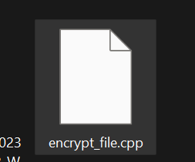
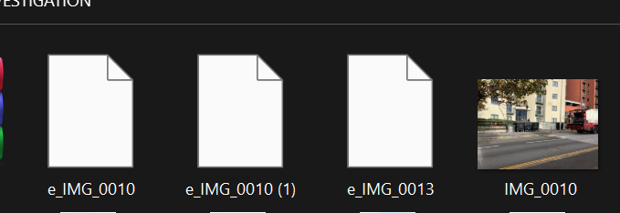
-document.txt
-ls
-xdg.open image.jpg
-steghide extract -sf
-ls (to view file)

Figure 3: Encrypted file hidden inside the image using steghide commands.

We employed some basic encryption techniques to encrypt some of the files from being visible on the HDD, the other team will have to research on what particular technique was used in the encryption before they try to decrypt it.
Substitution encryption is a method of encryption based on the principle of substitution. In this method, each byte of data is represented by two hexadecimal digits. Based on a cipher table, each of these hexadecimal digits is then substituted with another hexadecimal digit, resulting in an encrypted byte of data. The process of encrypting a file using substitution encryption involves the following steps:

Establish a cipher table where each hexadecimal digit is paired with another hexadecimal digit.
Read the file to be encrypted using C++ and substitute each byte of data according to the cipher table.
Write the encrypted data to a new file, resulting in an encrypted file.
To decrypt a file encrypted with this method, a decryption table is created based on the cipher table. The encrypted file is then read, decrypted using the decryption table, and written to a new file to obtain the decrypted file.
Here is an example:
an example cipher table:
0 -> 2 1 -> 8 2 -> 5 3 -> 0 4 -> b 5 -> d 6 -> f 7 -> 9 8 -> 6 9 -> c a -> 1 b -> 7 c -> 3 d -> 4 e -> a f -> e

an example decryption table:
2 -> 0 8 -> 1 5 -> 2 0 -> 3 b -> 4 d -> 5 f -> 6 9 -> 7 6 -> 8 c -> 9 1 -> a 7 -> b 3 -> c 4 -> d a -> e e -> f

The original data is 0x12, 0x2b, 0xfa. After encryption, the data becomes 0x85, 0x57, 0xe1. Upon decrypting, the original data of 0x12, 0x2b, 0xfa is retrieved.

Figure 4:The above screenshot shows the encrypted files, using substitution encryption.

Location of evidence
The screenshots below are files containing evidence of the scenario we created. Each file contains metadata.
There’s a total of 39 files
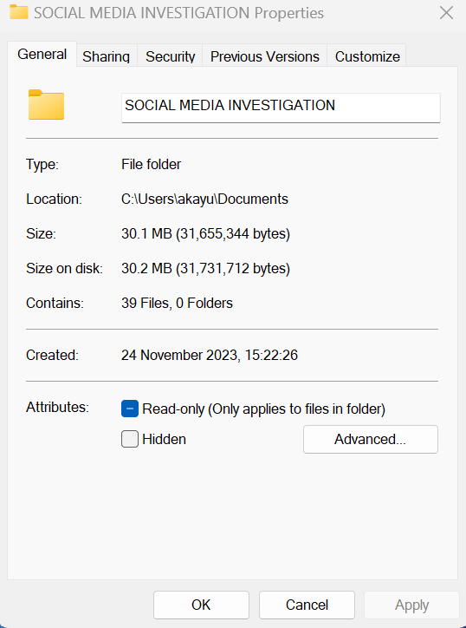
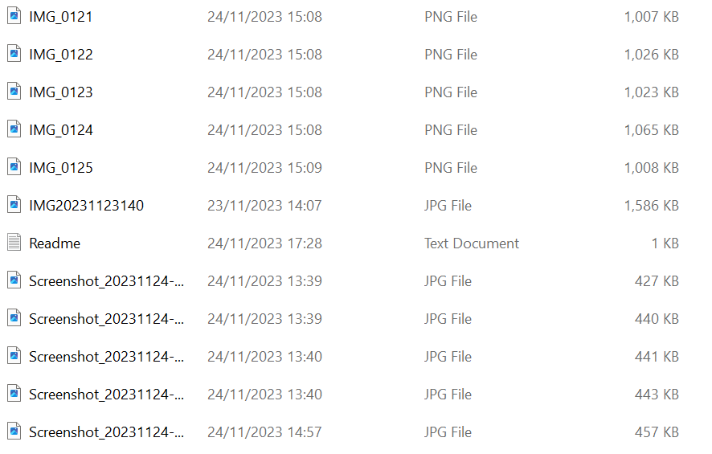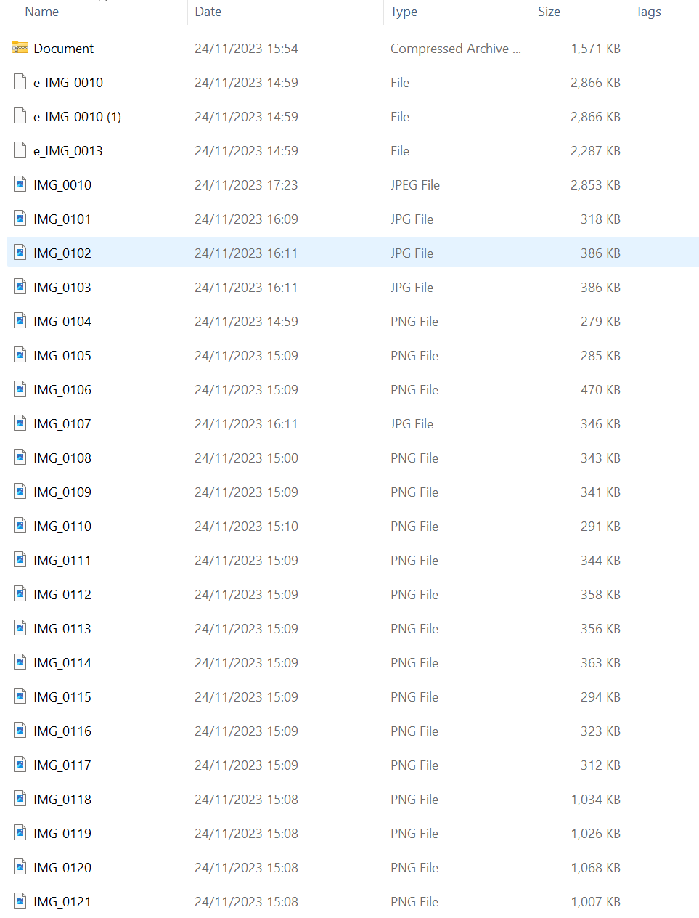
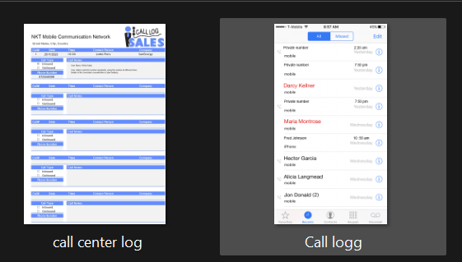

Figure 5:Call log from the victim’s phone and

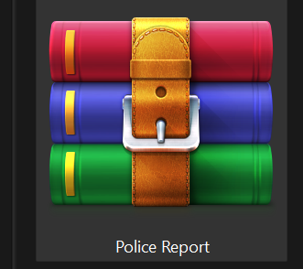

Figure 6:Police report documents saved in a zip folder

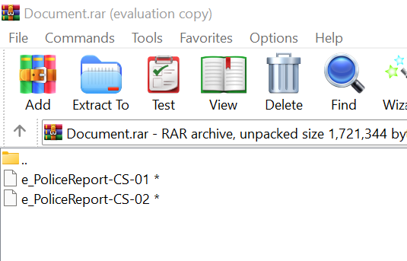
This is the police report documents inside the zip folder
This is the police report documents inside the zip folder

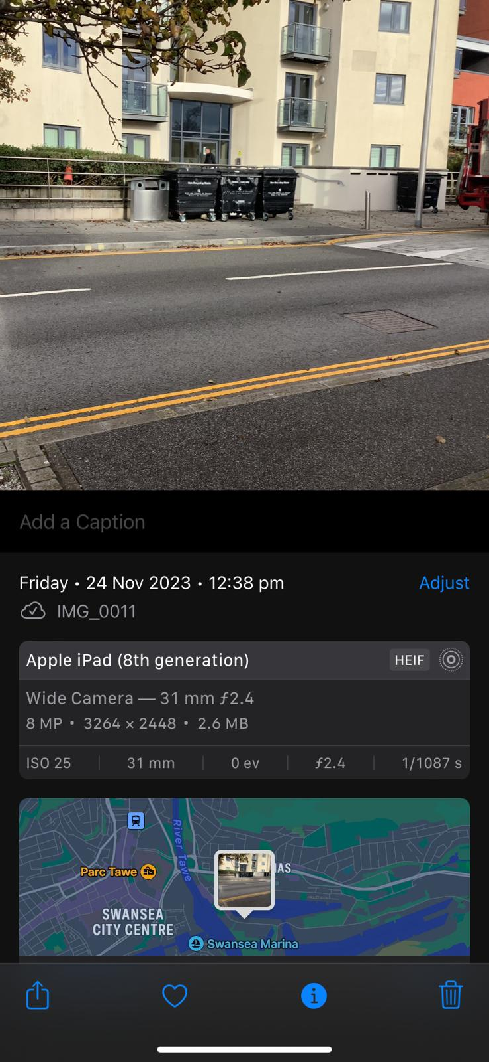
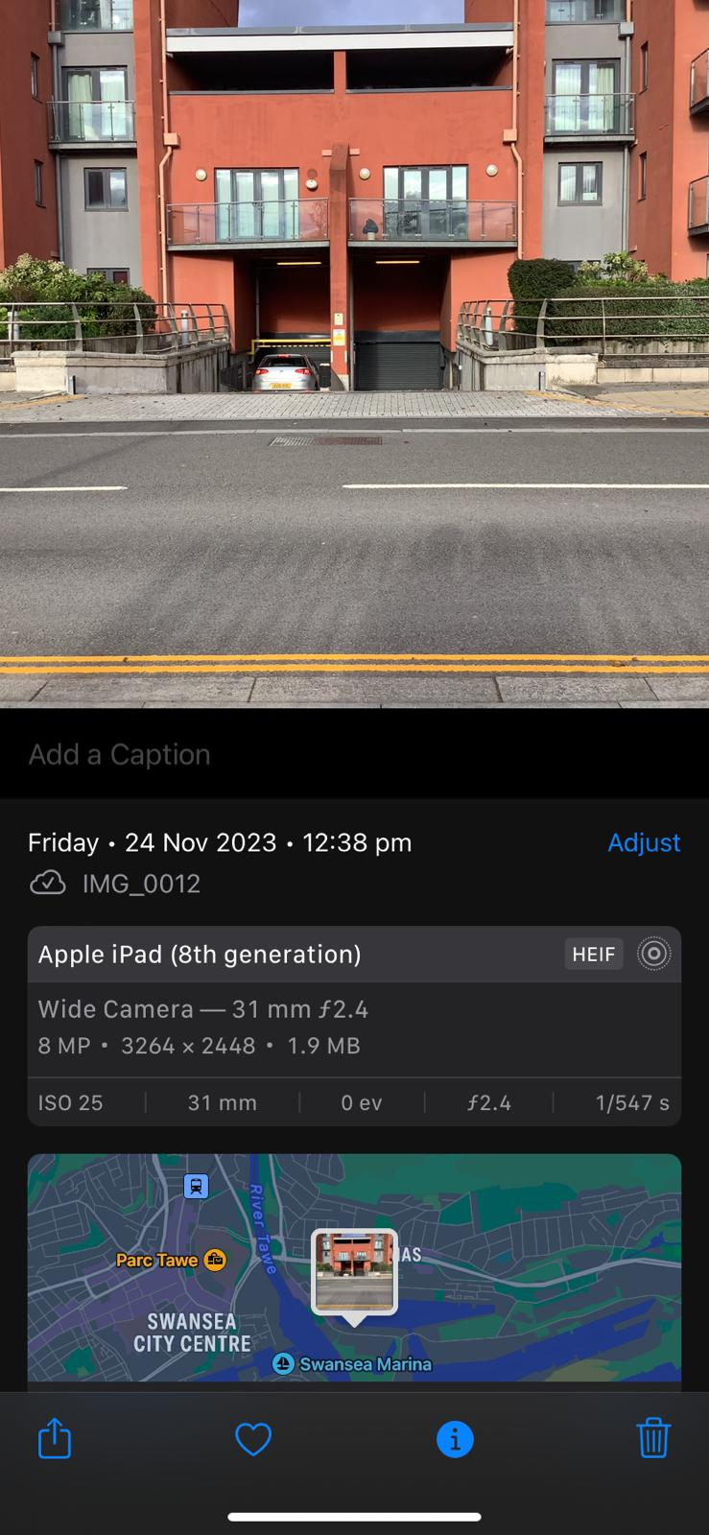
Images evidence captured with the location

TASK 3

A.2 Newly Acquired HDD Group Report
Scenario: corporate crime
An online dating company called Red Hot Passion has received veiled threats that confidential information such as (Payment information, Names, Addresses, Job positions, and Photographs) stored in database documentation and other communications via text messages emails, and videos could be leaked by unknown sources.
This information is more so sensitive due to the nature of the website which provides a platform for married members to engage in infidelity. This is an invasion of the user’s privacy who trusted that website would confidentially retain their information. A lot of the users of the website work in high positions of importance such as at Fortune 500 companies and in high-end managerial positions and could be under pressure of firing if this information was leaked as well as affecting the security of their marriages.
It is believed that several employees/employees of administration staff could have potentially had access to this sensitive information and have left the company recently. These employees could have potentially been disgruntled and could have had reasons to want to take revenge against the company due to previous payment disputes.

SIZE OF HDD: 250GB
DISKPART> detail disk

JMicron Generic SCSI Disk Device
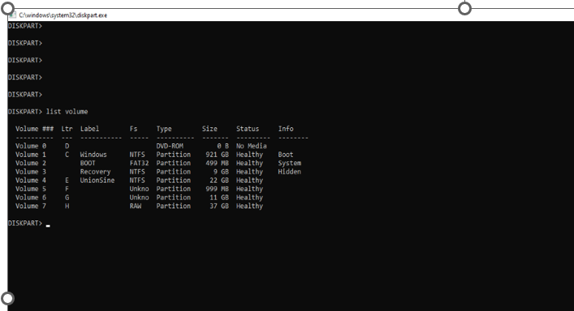

The HDD came with about 4 different partitions, lettered E, F, G, and H. Part. F and G have BitLocker password encryption without a password given.
We tried to disable the BitLocker using a PowerShell command “disable-BitLocker”, but it didn’t work. Except we use the system that was used to add the BitLocker on the HDD.

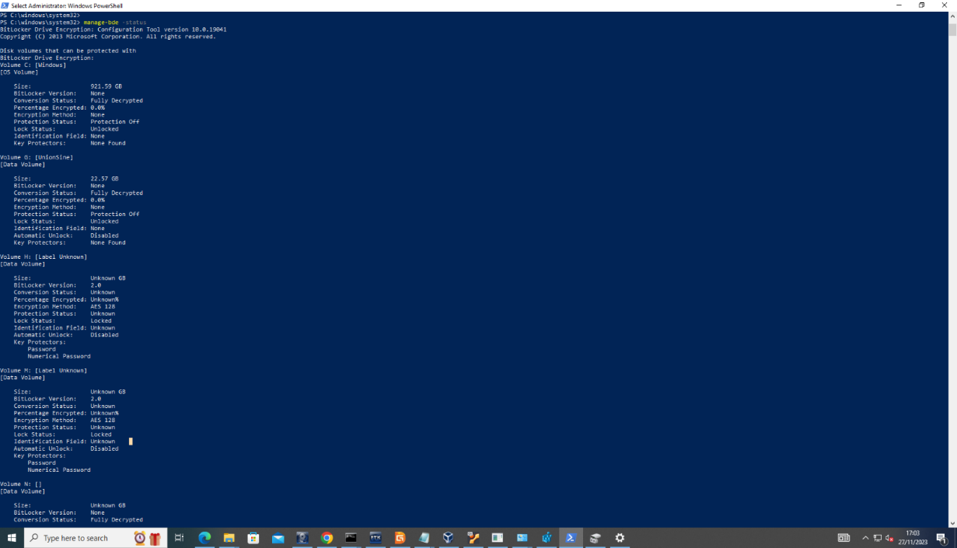

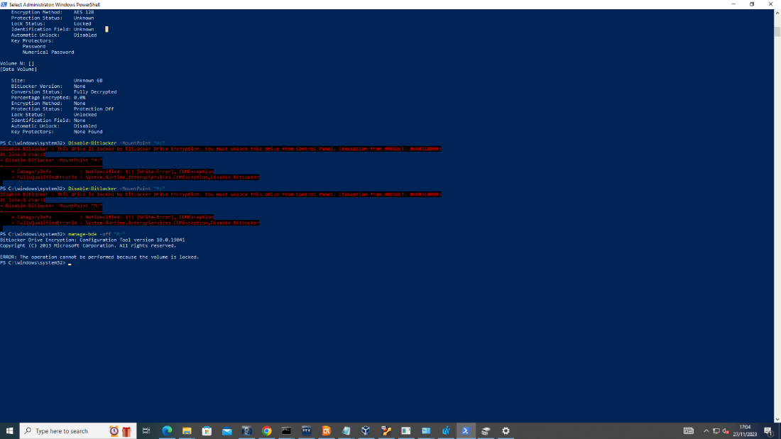
Figure 7:The screenshots are proof of the PowerShell command.

After several attempts to unlock the BitLocker drives, we reached out to Team A concerning the difficulties we encountered trying to unlock the BitLocker, we were informed that the BitLocker drives don’t contain any files and that we should ignore it.

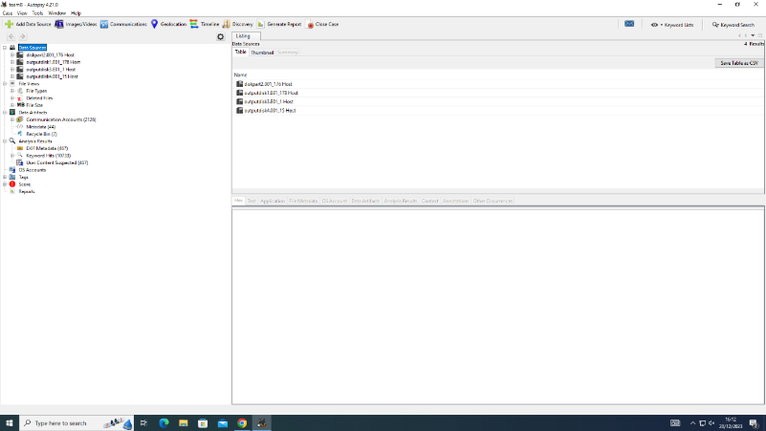
We took an Image of all visible partitions on the HDD using FTKImager, we tried to nalyse the image using the Autopsy tool, and we could recover previously stored and deleted files from the HDD. Below are screenshots of those files recovered.

Figure 8:Screenshot showing all four partitions

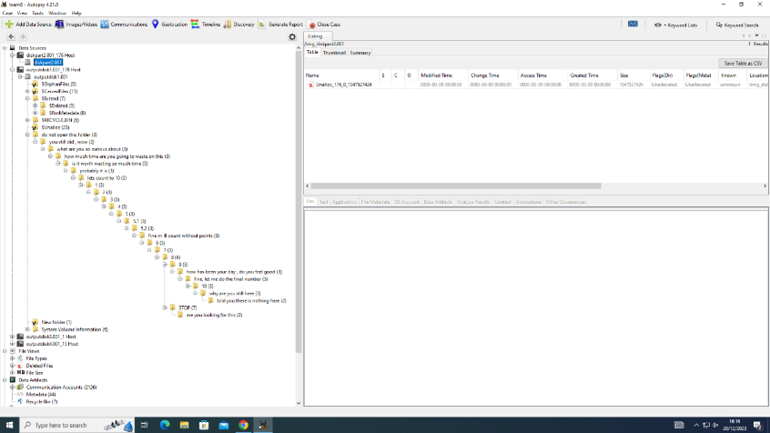
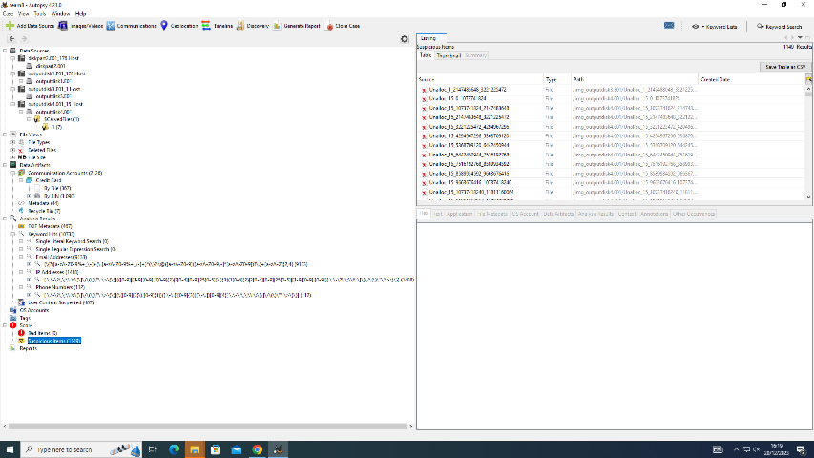
Figure 9:Screenshot showing root folders present in the HDD
Figure 10:Screenshot showing root folders present in the HDD
Figure 11:Screenshot showing each drive and storage capacity

Evidence of recovered files and folders found on the image taken of the HDD.
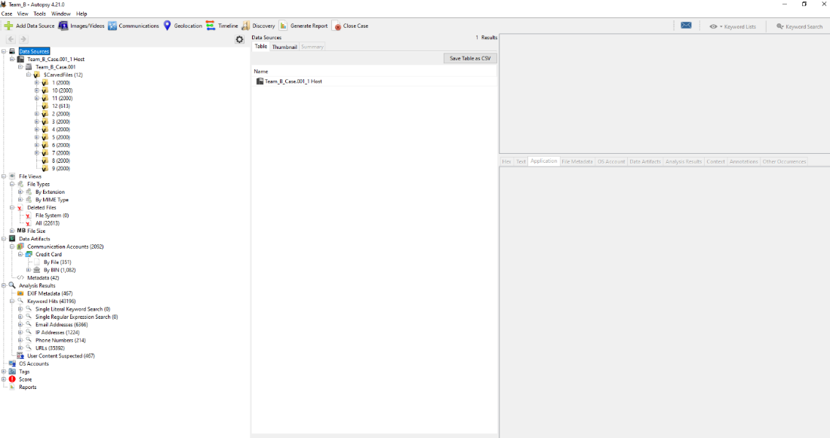

Figure 12:Evidence of Credit card details recovered from the HDD.

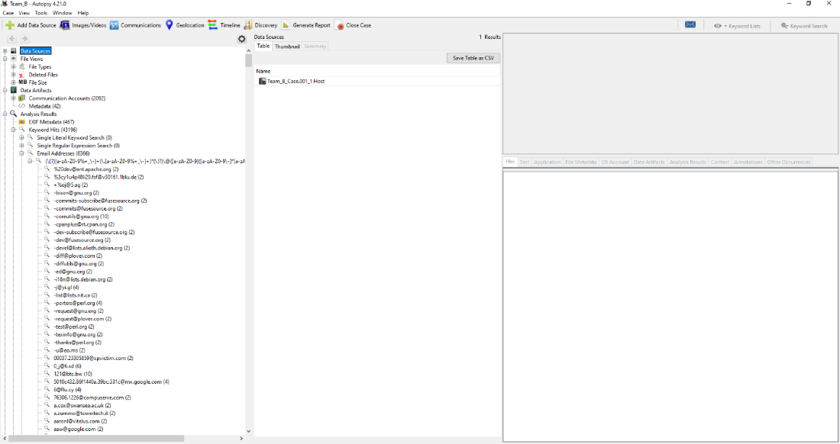

Figure 13:Evidence of email accounts recovered.

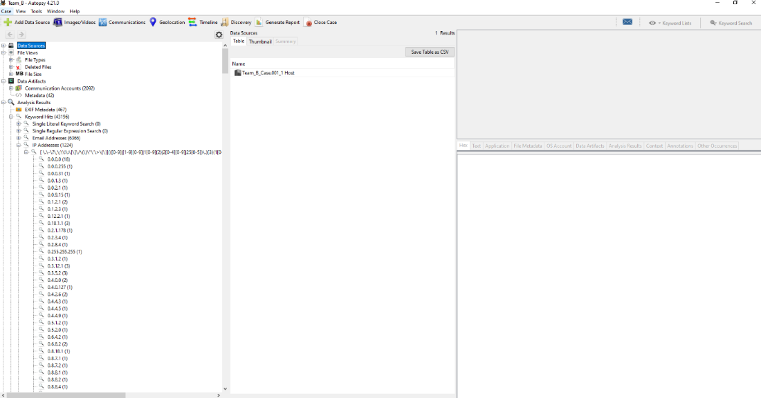

Figure 14:Evidence of IP addresses.

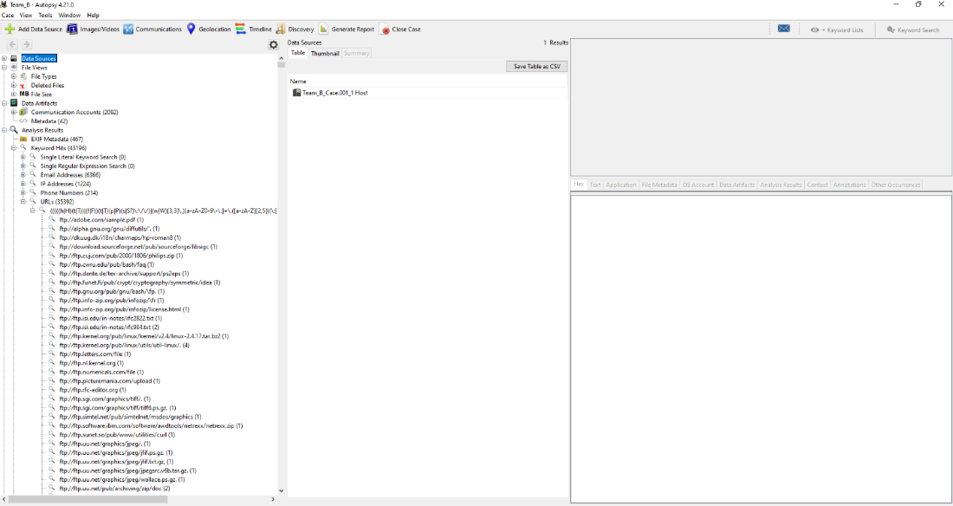

Figure 15:Evidence of different URLs.

Figure 16:Evidence of Phone numbers recovered

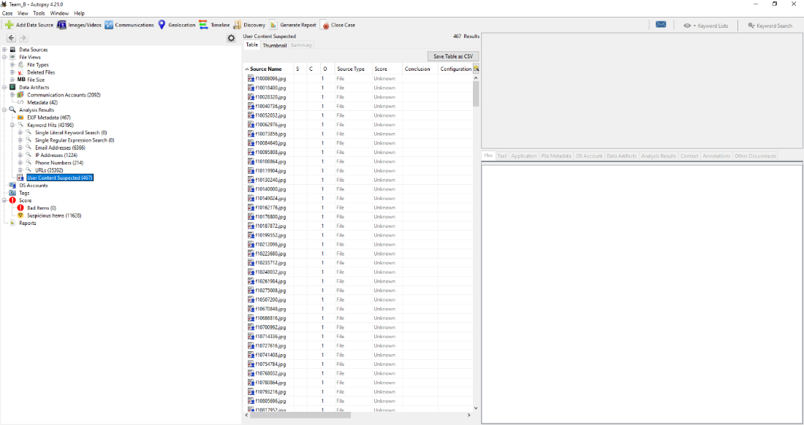

Figure 17:Evidence of user contents, including images, audio, videos, document files, etc.

After recovering all these files, we started analyzing the files one after another, and we noticed that the evidence didn’t corollate with the given scenario, so we had to reach out to the team to confirm if the files we recovered were the actual evidence they copied into the HDD, they confirm it wasn’t their files.
Team A informed us that there was a hidden drive partition on the HDD, and their actual evidence files are likely saved on that hidden drive partition.
After several attempts in trying to find the hidden partitions failed, we did some research and found a tool called VeraCrypt, this tool was used to encrypt the drive
This is the drives partitions that were visible before we used the VeraCrypt
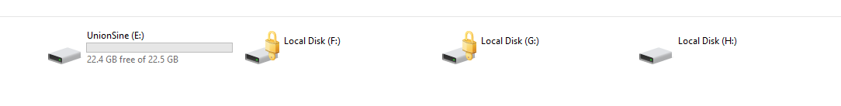
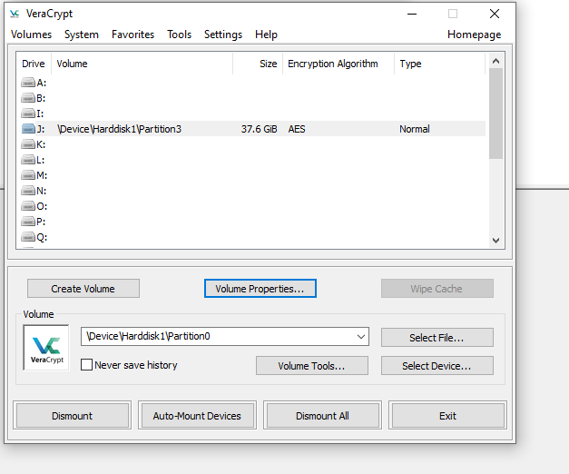

We used the VeraCrypt to dismount all drives in the HDD after which we mounted a new drive with a different drive letter, it requested for a password, which we collected from Team A.
The next shot below shows the new mounted drive, lettered “J”

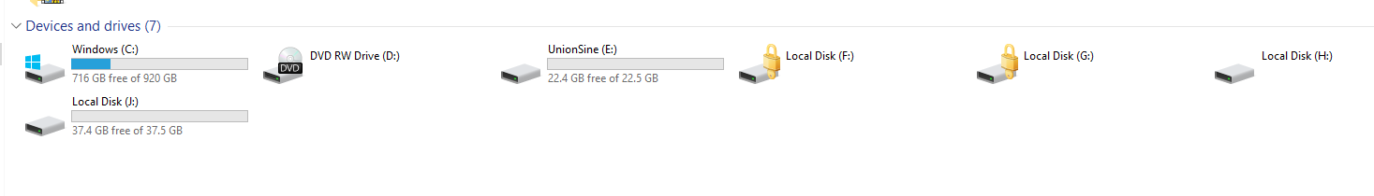
We now have five drives partitions. Drive J is the hidden drive which contains evidence files from Team A.

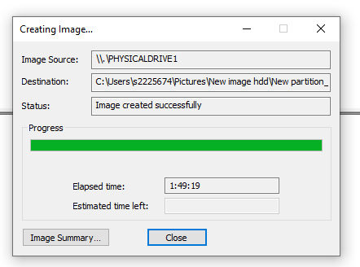
We took a new image of the un-hidden drive partition (drive J)

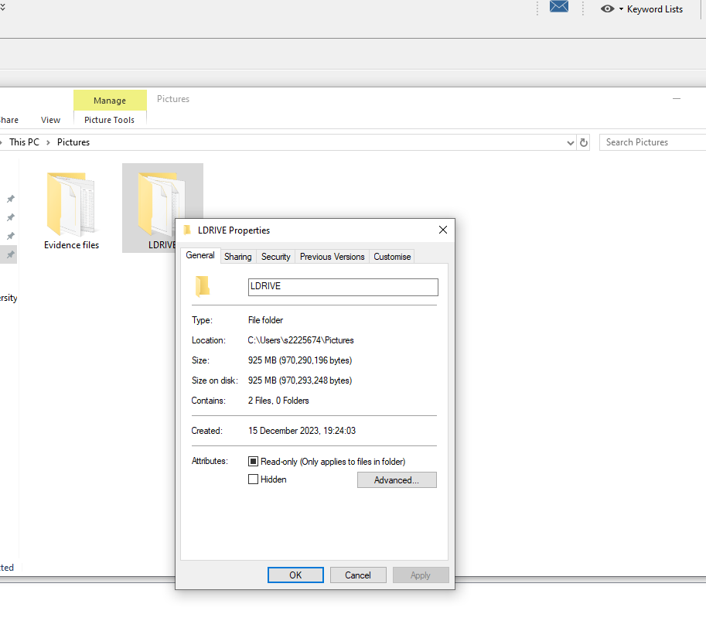
Size of Data: The total size of an image taken of Local disk J is 925MB

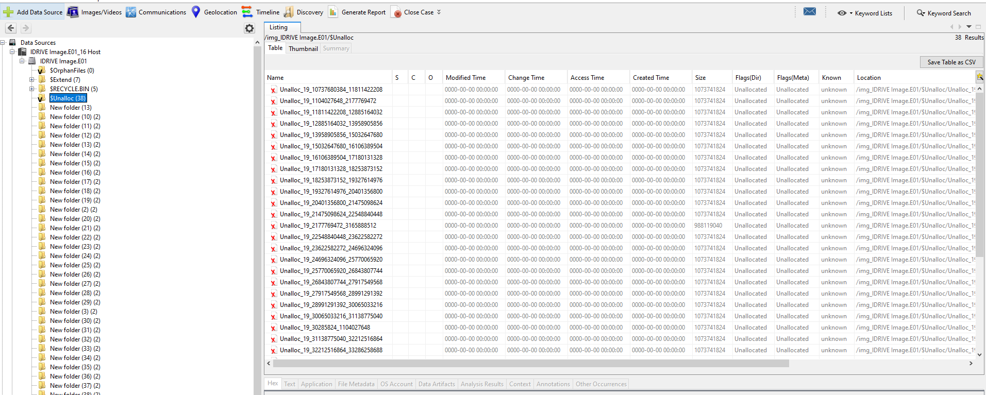
Figure 18:Evidence of unallocated spaces

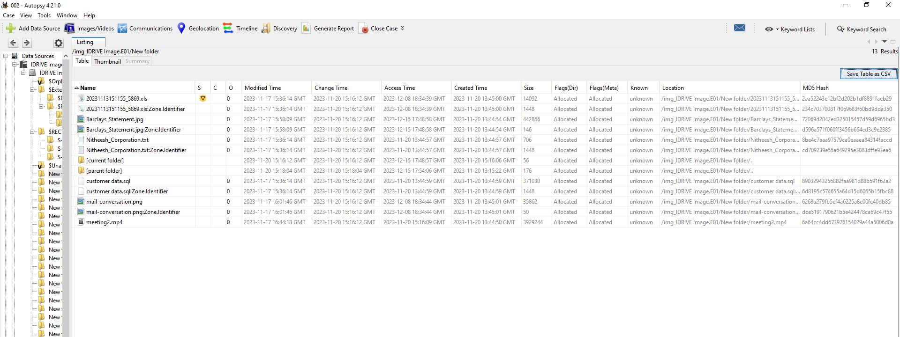
Figure 19:Evidence Location of files with Metadata from the new image

Evidence Title | Format | Extension
- 20231113151155_5869 | Excel sheet document | XLS
- Barclays_Statement | Image | jpeg
- customer data | Mysql Database | Sql
- mail-conversation | Image screenshot | Jpeg
- Nitheesh_Corporation | Notepad text file | txt
- meeting2 | Video | Mp4
Table 1:The following are files found in the new image of drive J.

ANALYSIS REPORT BASED ON EVIDENCE ANALYSED
- From the given scenario above, the customer database of a dating company (Red Hot Passion), with patronisers who are top executives at a 500 Fortune company was hacked and their user details were leaked, exposing names of different customers including top employees with managerial roles at (Nitheesh Corporation).

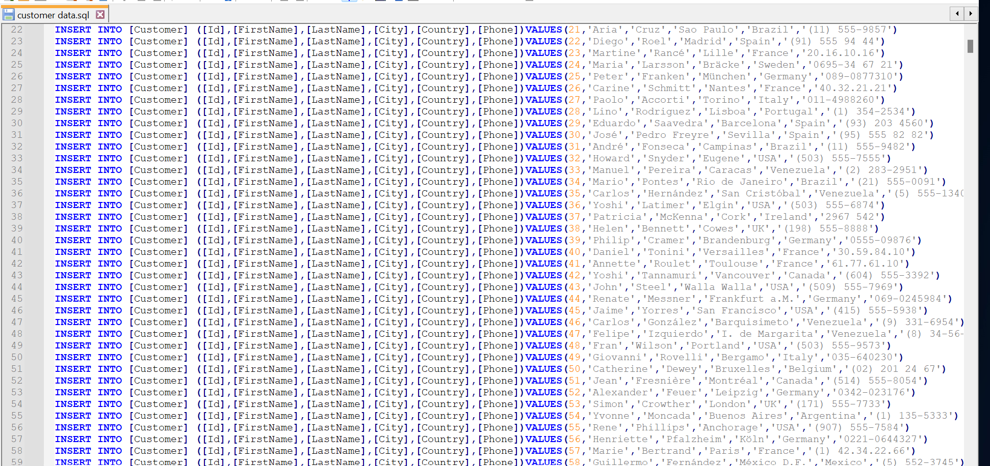

- A sender known as Josh sends a mail to Nitheesh's email (nithesh@gmail.com), but we can't tell who Josh is because there's no record of him in the database that was leaked, or why is he sending a mail to Nitheesh, asking him to verify his bank details. Nitheesh cooperation is possibly owned by Nitheesh. The sender of this email could be a hacker who is claiming the identity of someone very close to Nitheesh. He sends a verification form, for Nitheesh to verify his account details. But why?
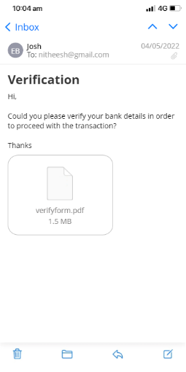

- Database containing confidential details and bank card details of employees' of Nitheesh's cooperation, possibly leaked by former staff of Nithesh corporation, who left the company due to issues. As administrative staff, these employees had access to almost every record and data of the cooperation, it is also possible that they leaked the bank card details of the employees.
The reason is they want to take revenge against the company due to previous payment disputes.
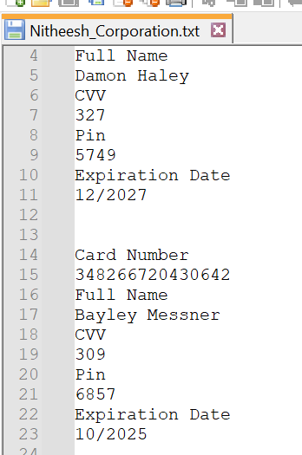
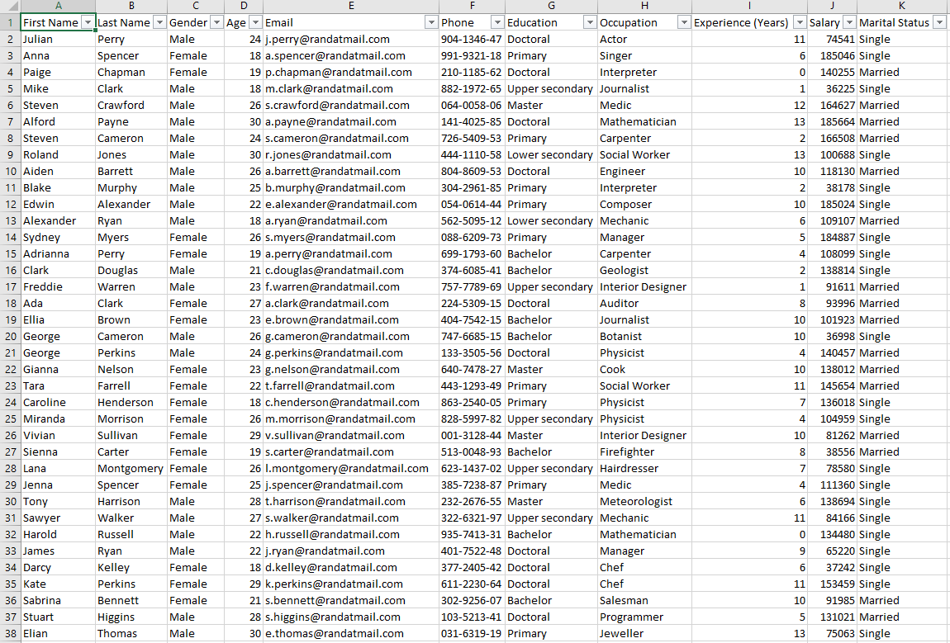


- An account statement having the name John Doe Lee, there's no record of John Doe among the list of either customer data of Red-Hot Passion or the database of Nitheesh Corporation. He may be the hacker, who was paid by the suspects who leaked confidential data of Nitheesh's cooperation. From his bank statement, there was a deposit of £540 into John Doe's account on 12 Jan. On 19 Jan. he paid £39 for transport to London.

Who are these culprits? we can't say for sure, but from the bank statement, John Doe made a card payment to London on 19 Jan. 2022. From the SQL database, about seven names appeared to live in London, I suspect that John could've possibly traveled to meet with these people. Those names have been highlighted below from the SQL file.
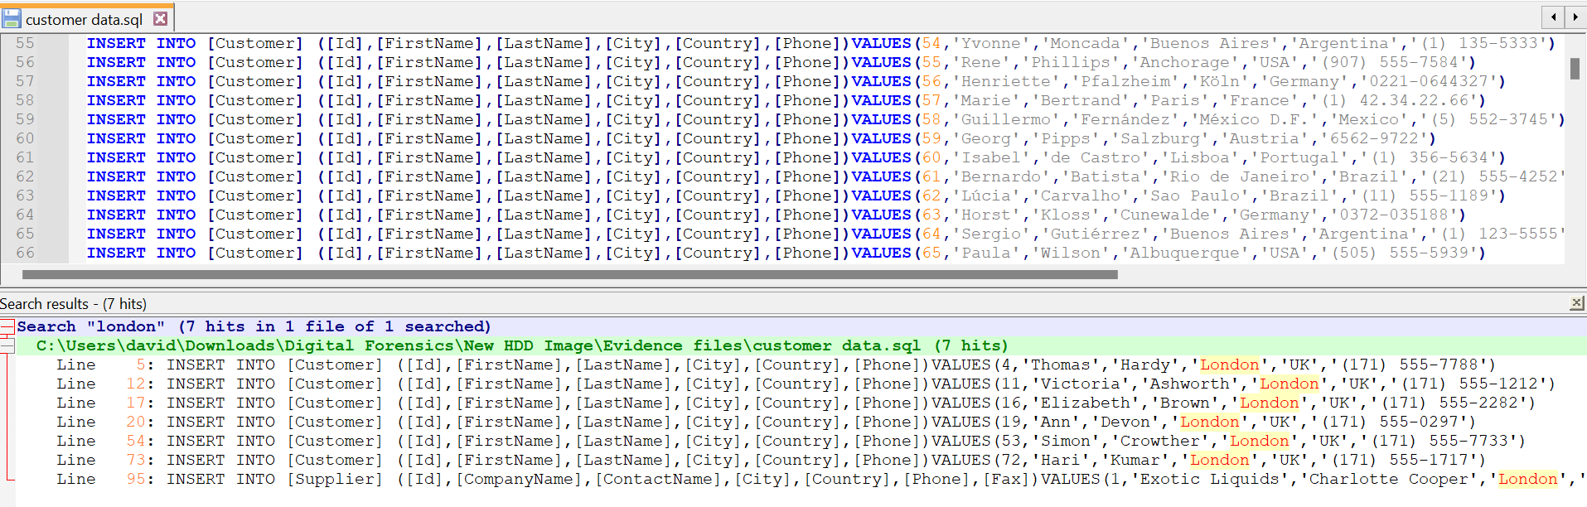

Challenges
Not able to ascertain the actual size of HDD and size data on the HDD, because it contained hidden partitions and unallocated spaces.
2. HDD contains 2 BitLocker encryption partitions, and no password was given.
3. The HDD Contains malware, that automatically displays multiple windows, which causes a disruption of operations on the PC.
4. In trying to recover hidden partitions using autopsy tools, the autopsy tools recovered previously deleted files on the HDD, these files amount to over 160GB. Below is a screenshot of the files recovered.

Video link: https://shorturl.at/bsx03

Appendix C: Mobile Forensics Investigation

Executive Summary
Background
Our client is a car manufacturing company working on a new model of AI self-driving cars.
They have competitors in several Countries, and they want to maintain the privacy of this project. However, they suspect that one of their technical officers might be selling the research data to their competitors.

Scope
The company wants us to investigate the veracity of the allegations by analyzing the suspect mobile phone. To achieve this, we will use Cellebrite tool kits to nalyse the phone. We will perform both logical and physical analysis of the phone.

1.3 Key Findings
From the analysis, we discovered over 64 images taken with the suspect's mobile phone camera, 23 audio recordings, and 7 video files. A summary of the evidence discovered is included in this report.

2. Case Information
2.1 Case Details
Case ID: MP-0140124
Date of Request:18/12/2023
Requesting Authority: Team B
Case Investigator: Team B
Device Information: ulefone
Manufacturer: China
Model: Note 14 (16)
Serial Number: S/N:3102SH1010027469
IMEI/MEID: IMEI-1:355617730545789

Methodology
Explain the methods and techniques used during the mobile forensics analysis, including tools, procedures, and any challenges encountered.
The mobile phone was handed to us by the company, and every authorization process was sorted by the company. We ensured to maintain a chain of custody after receiving it
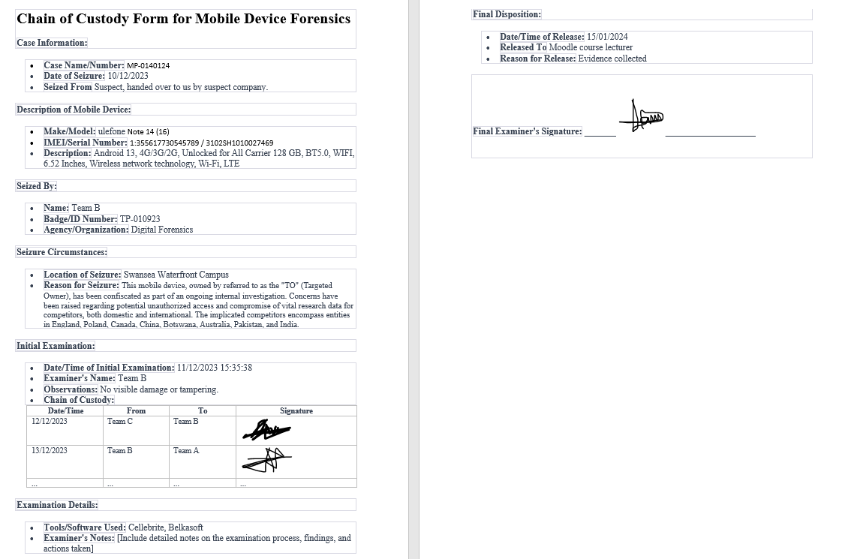

Figure 20:chain of custody

Data Acquisition
Device Identification
The phone was handed to us by the company where the suspect works, due to an ongoing investigation involving a breach of data. Every verification was done by the company before the phone was handed to us.

Data Extraction
We extracted a logical filesystem using the Cellebrite forensics toolkit. Due to the model of the phone, we could not perform a physical extraction.

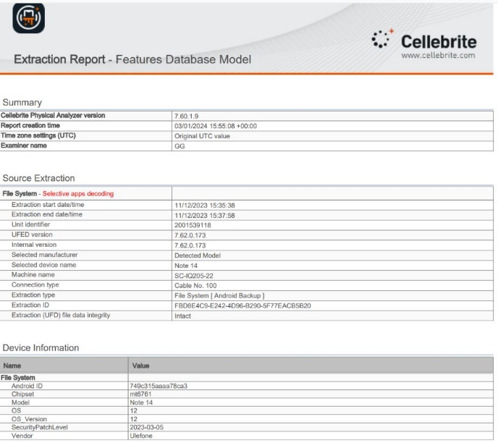

Figure 21:Cellebrite forensics toolkit
Data Preservation
Detail the steps taken to preserve the integrity of the evidence throughout the analysis.
To maintain data integrity, we set up a forensics lab in the Cisco lab, using virtual machines with operating systems installed on them. All digital extraction and analysis took place in this environment. Every piece of evidence collected and analysed was stored on OneDrive.

Data Analysis
Overview
We used the Cellebrite Physical analyser and Belkasoft forensics tool in analysing the data.
The analysed data contain images of different locations and places the suspect visited; we trailed his journey based on the position of images extracted from his device. We found audio recordings with details of events happening within the suspect. Some of the audio was not audible enough, but we were able to transcribe the audio to the best of our ability.
Below are screenshots of the evidence, with timestamps, location, and details about each piece of evidence discovered.
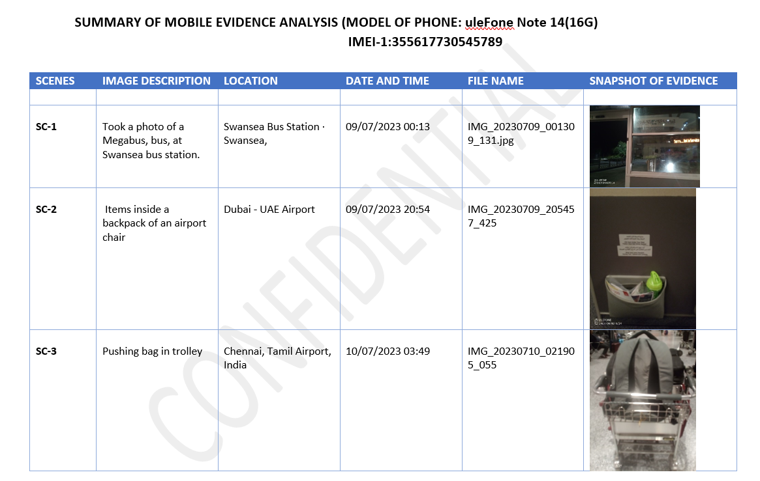
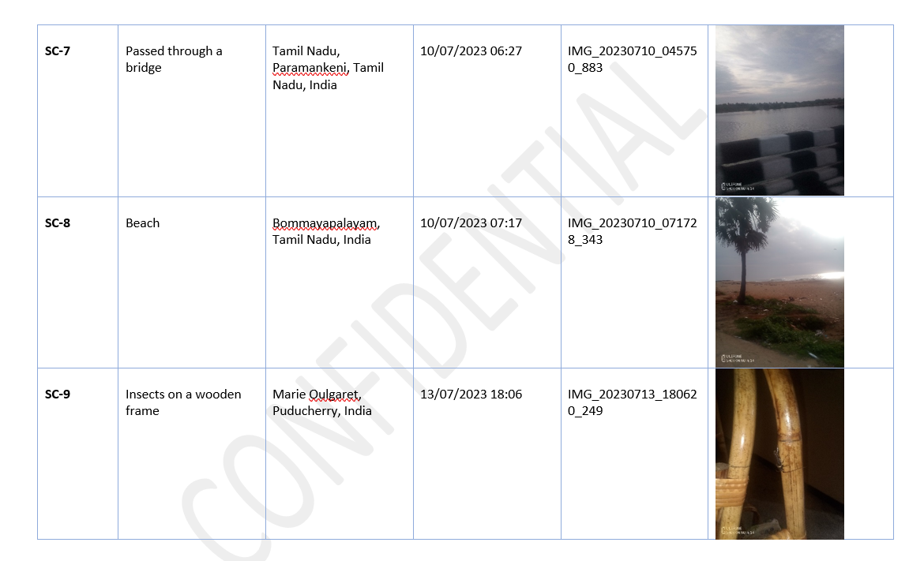
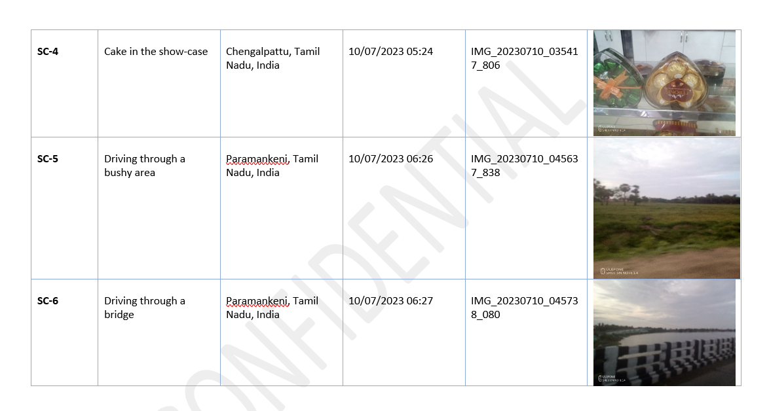

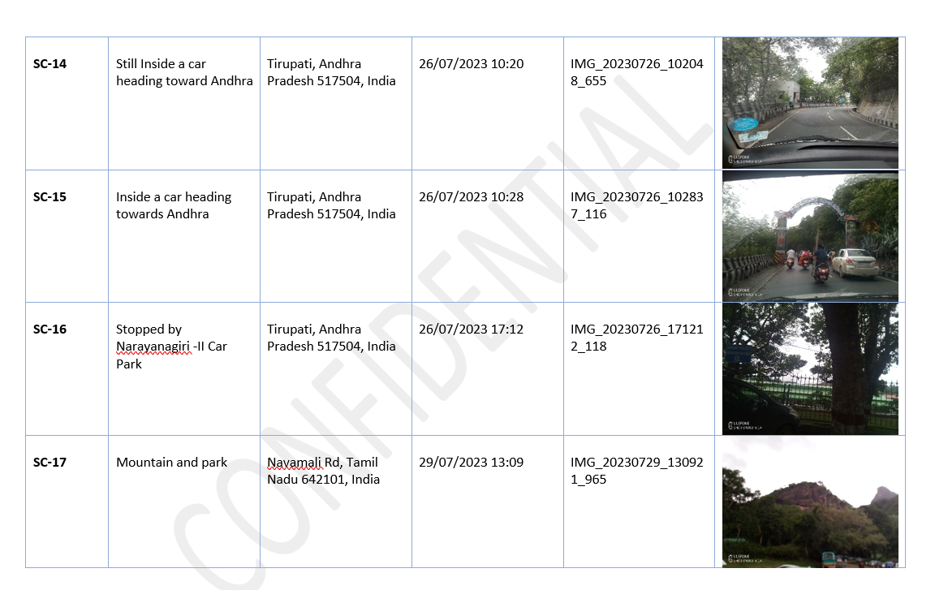
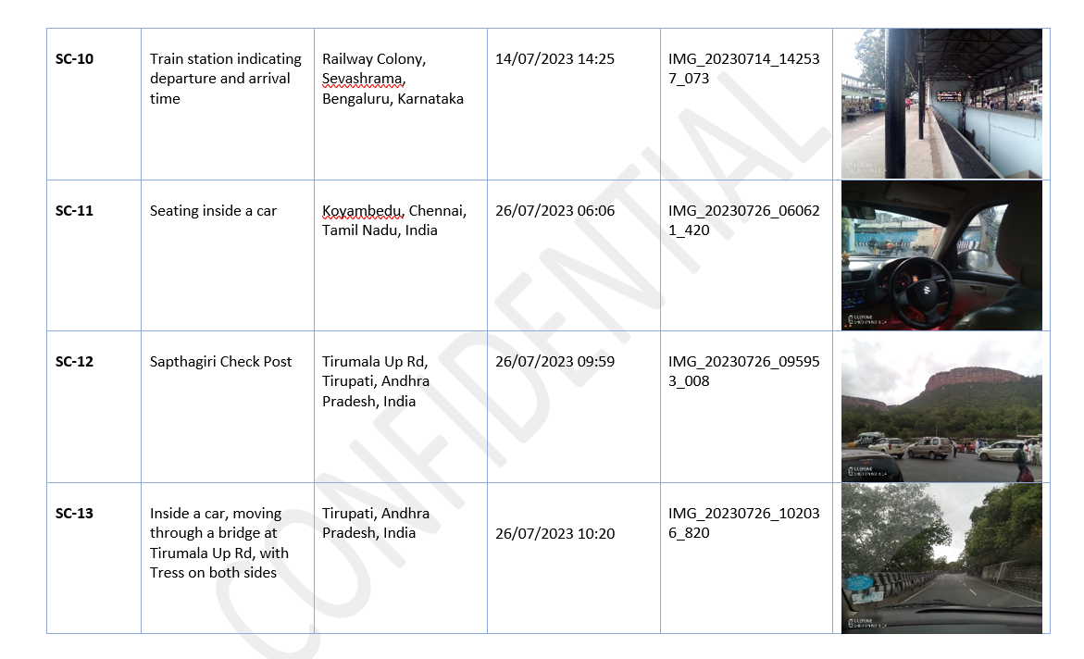

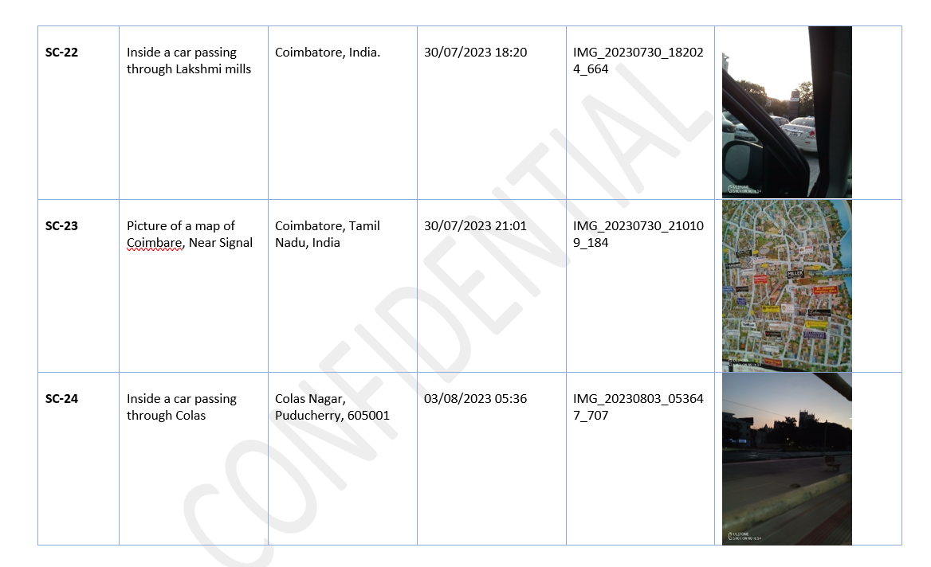
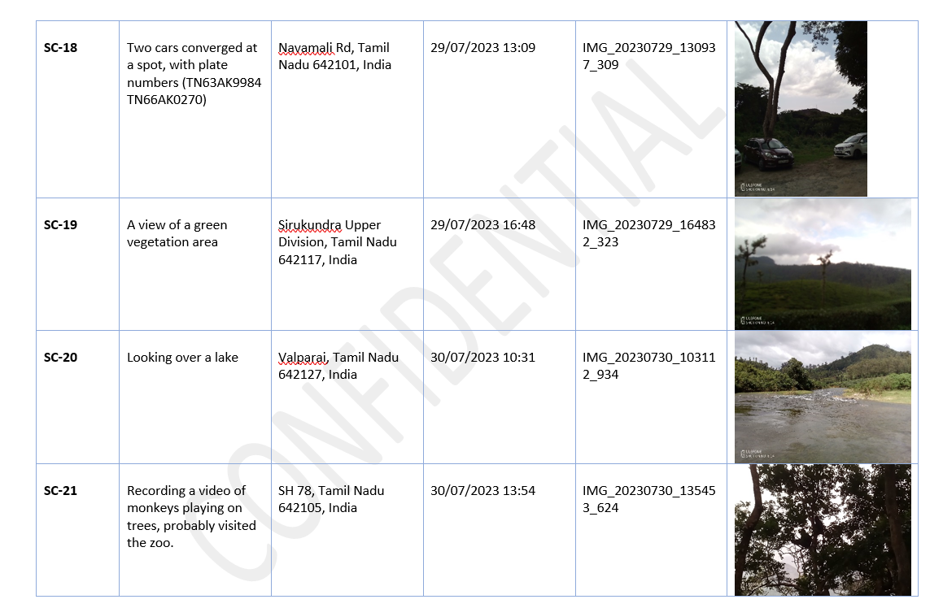

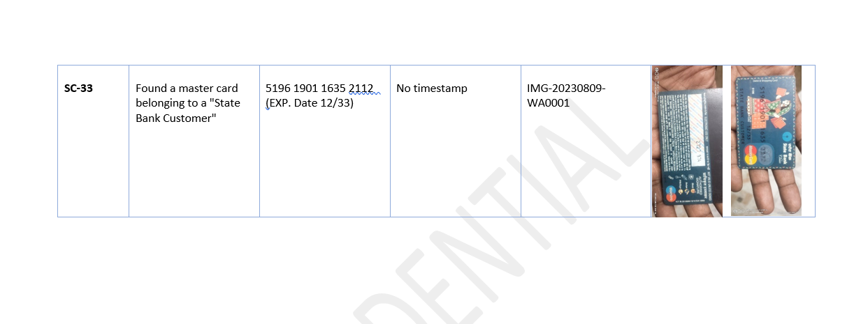
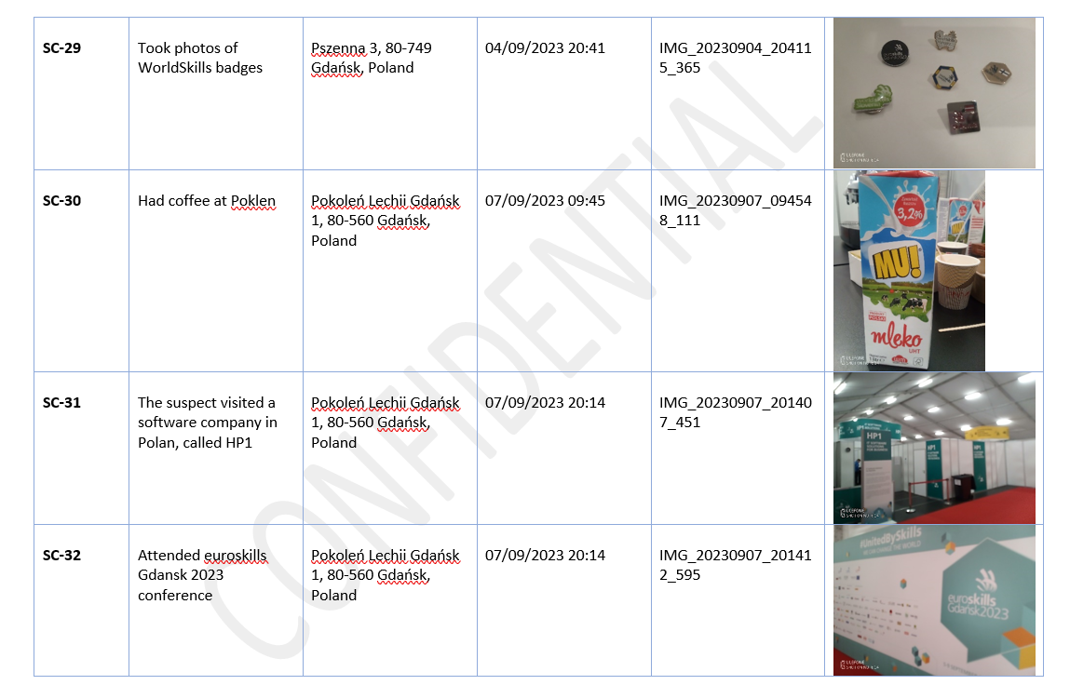
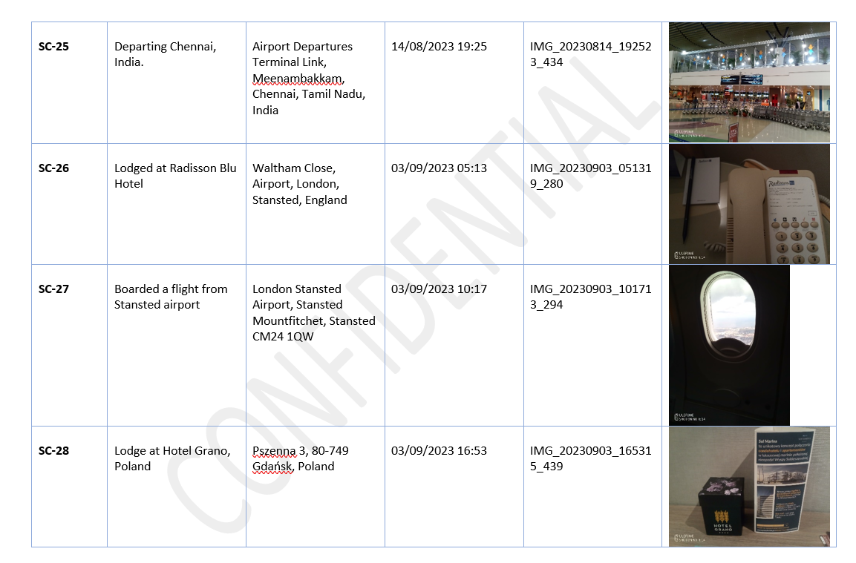
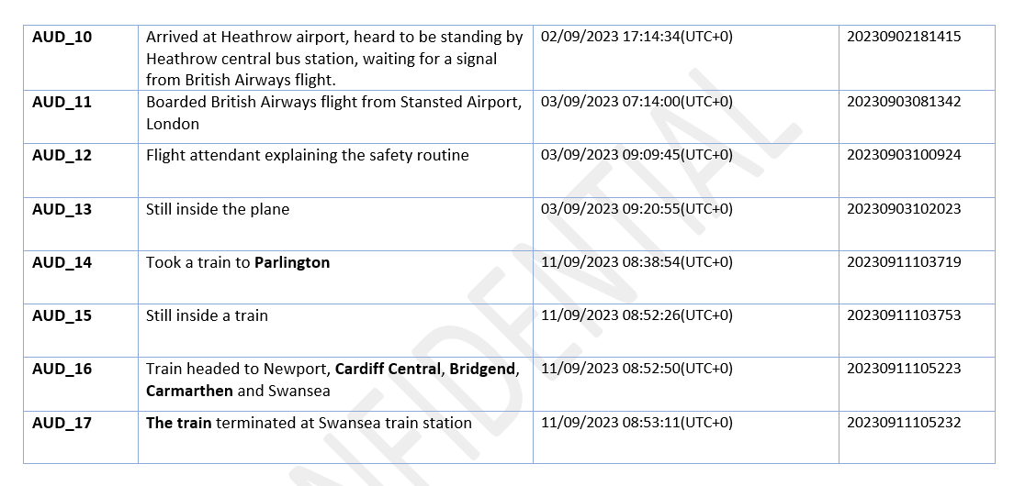
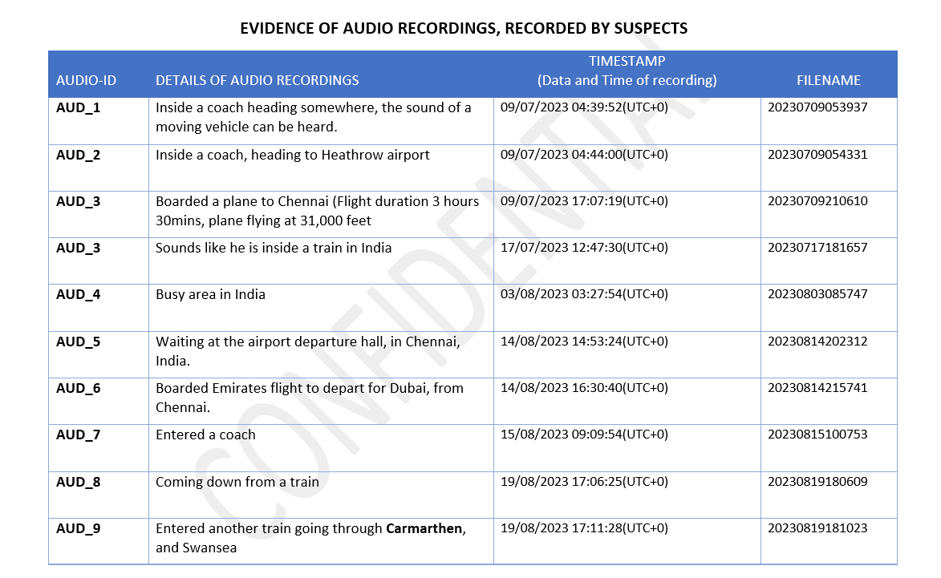
Figure 22:Evidence of audio recordings

SUMMARY OF ANALYSIS

The evidence provided contains a detailed analysis of the suspect's activities and locations throughout his journey.
The suspect embarked on two different trips.
- He began his first trip from Swansea to London, where he boarded a flight from Heathrow Airport, stopped at Dubai Airport, and took a reconnecting flight to Chennai, India, as indicated in Sc-1 and Sc-3.
- While in India, he met with an unknown person, as seen in SC-18, two vehicles are seen to converge in Navamali Road, Tamil, Nadu. One of the vehicles was probably used in transporting the suspect. The plate numbers of these vehicles have been captured for further investigation.
- He was in India for about 35 days starting from 10/07/2023 to 14/08/2023, Sc-1 to sc-25, AUD_1 to AUD_9.
- His first trip ended when he returned to Swansea on 19/08/2023.
His second trip started on 02/09/2023, as indicated in AUD_10.
- He arrived at Heathrow Airport and waited for a flight signal from British Airways.
- He was next spotted at the Radisson Blu Hotel, Stansted Airport, England on 03/09/2023,
Sc-26.
He boarded a flight that same day to Poland, at about 10:17, SC-27, AUD_11 to AUD_13.
- At about 16:53 of that same day, he lodged at Hotel Grano, Gdansk, Poland, Sc-28.
- While in Poland, he visited an IT company called HP1, located at Pokenlen Lechoo, Gdansk 1, Sc-31.
- He also attended euroskill Gdansk 2023 Conference, Sc-32. A payment card was also found in the suspect phone, but we can't confirm who the owner is, Sc-33.
- He returned to the UK on the 11/09/2023, AUD_14 to AUD_17.
- He spent about 8 days in Poland, and about 4 days in the UK.

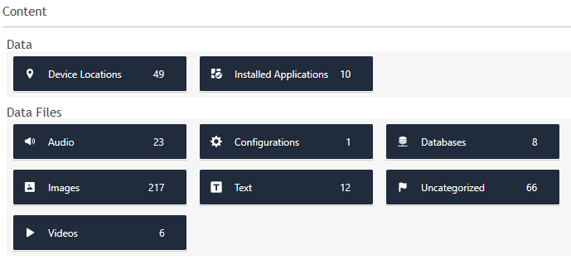

Figure 23:Recovered Data

Deleted Data
We didn't recover any deleted data.

6. Forensic Artifacts
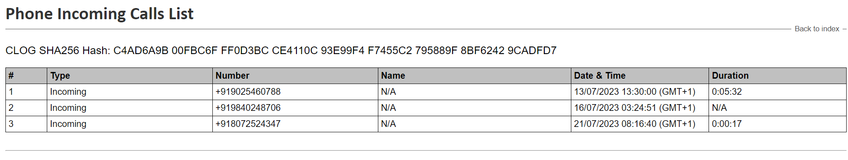
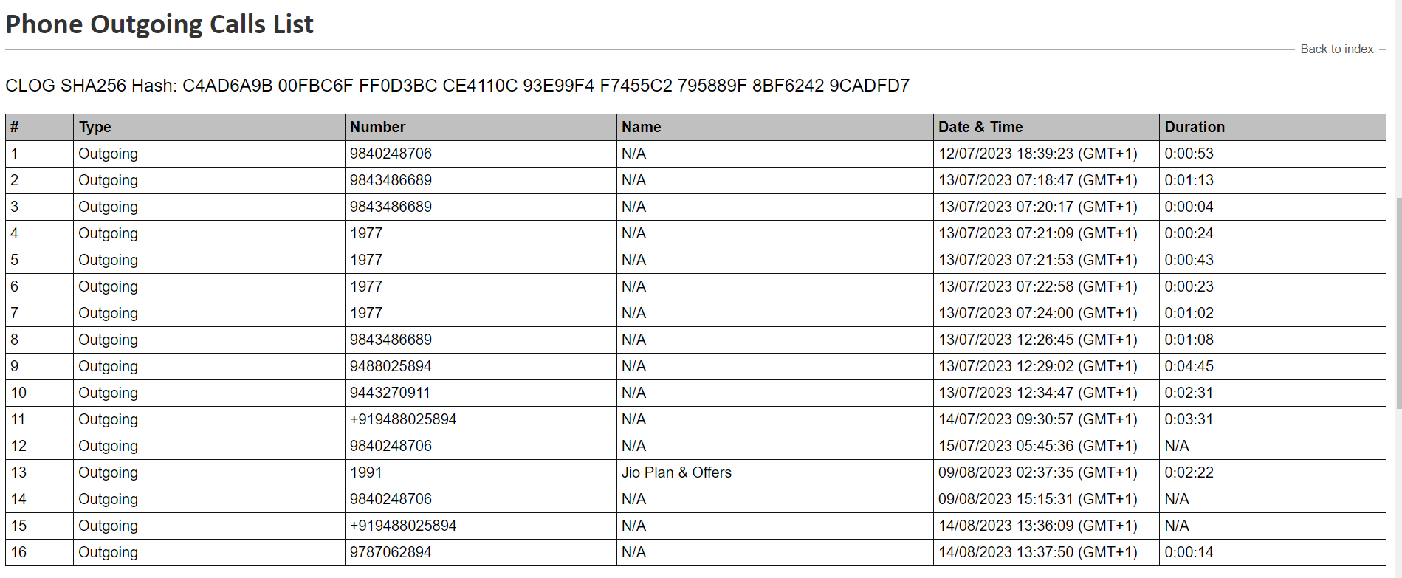
Artifacts Overview: Below is the file system structure of the mobile device and the data structure contained in the phone.
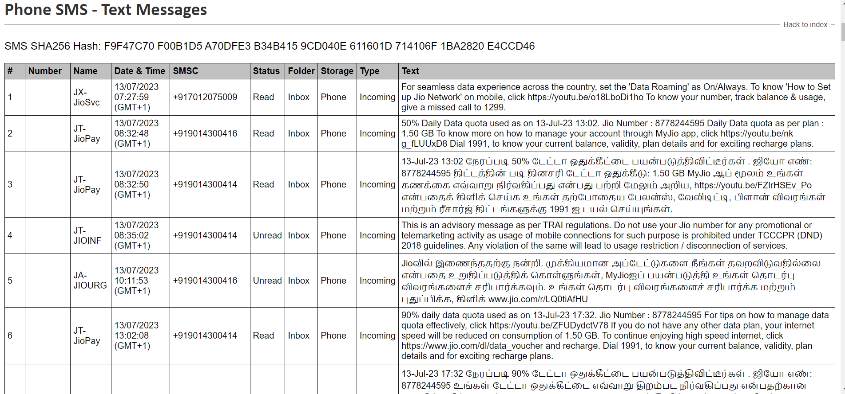
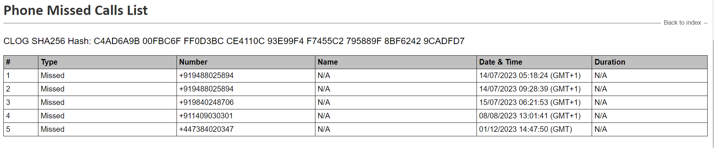

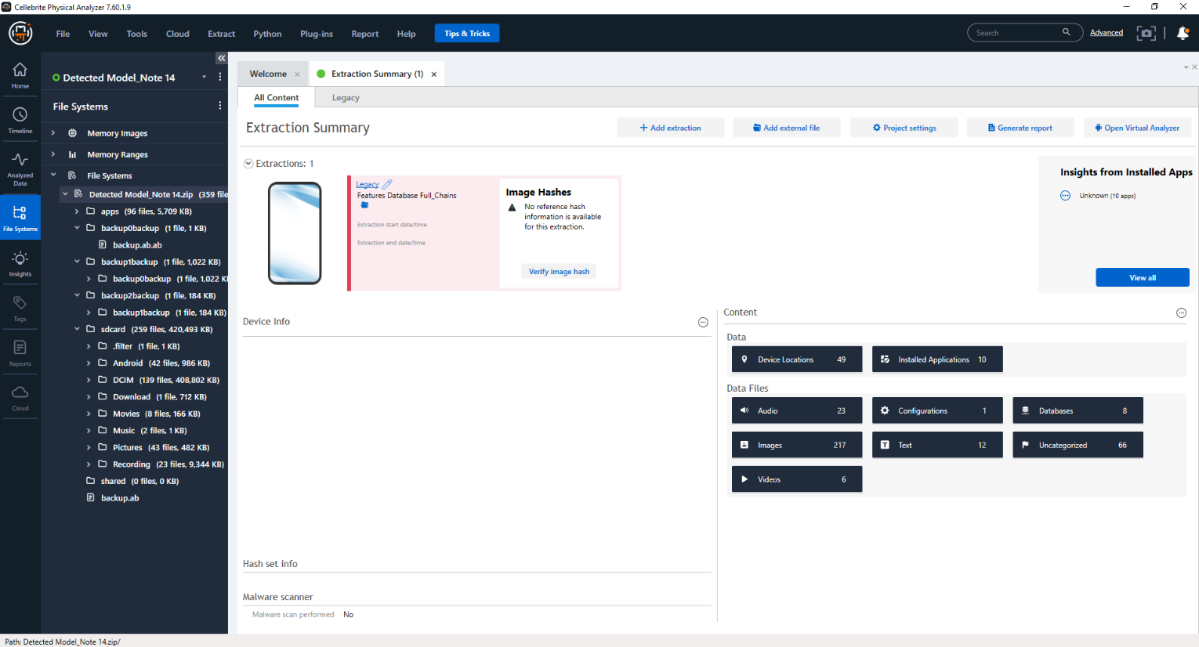
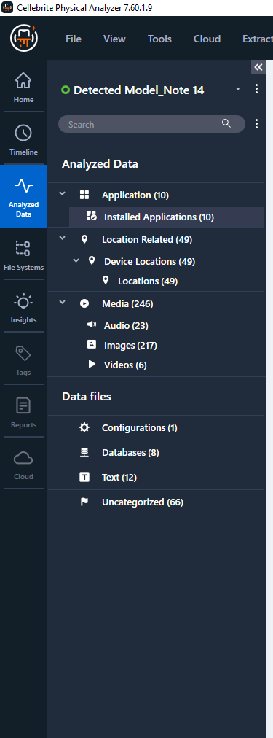

Notable Findings
From our analysis, we discovered that the suspects:
- Visited 4 different Countries, the United Kingdom, United Arab Emirates, India, and Poland.
- Spent more time in India than the other 3 Countries.
- Met with someone in India.
- Visited an IT company in Poland.
- Was careful not to leave any trace of the leaked research data on his mobile device.

7. Conclusions
From our analysis, we have been able to point out key convincing points to prove that the suspects visited some of the Countries. He visited 3 Countries from the list of suspected Countries (England, Poland, Canada, China, Botswana, Australia, Pakistan, and India).
This is proof that he compromised the research data of his company.

8. Recommendations
We recommend that further investigations be conducted to discover who he met with in India, based on the car plate numbers captured.
The IT company he visited should also be investigated to confirm this claim.

9. Limitations
Not enough evidence to establish a convincing case of stolen research data. There was no chat, text, or email of any conversation between the suspect and his accomplice.
Some features on the Cellebrite UFED and Physical analyser didn’t effectively. If we had more sophisticated proprietary forensic tools Magnet AXIOM, Oxygen Forensics Detective, and others.

Acknowledgments
The report is based on a group discussion. Each team member played a different role in ensuring the integrity of every evidence and analysis performed. Every fact and assumptions made were based on the team agreement.

