Introduction:
Teamwork or group work is a collaborative effort to achieve a specific goal or goals by
individuals in a group (Belbin, 2011). Group work or teamwork is an integral part of any
organization or in University courses. Every organization in the world tries to motivate their
employees to work in a group. To work efficiently effective communication is needed.
Communication means the interactions between people or among people of the organizations
where they communicate with others for their working purposes (Harvey, 2006). This study
will explore the overall communication process, the importance of effective communication
in an organization, the importance of group work or teamwork, and the effectiveness of
teamwork in an organization. Moreover, the study is intended to provide an understanding of
Shannon and weaver, Berlo, and schramm's model of effective communication
Student Name: Natasha Sushich
Student ID: 1921374
Module Title: Effective Team Working and Communication
Lecturer: Anita Nan

1. Introduction
This essay will discover total communication process, the pertinence of effective communication in the organization, the pertinence of teamwork, and the efficacy of teamwork. Teamwork is a constituent part in the organization but also in Universities as well. Any organization tries to inspire their employees to work in a group as a teamwork. To work properly effective communication is very important. Communication means the relationship among the people in the organization in the way how they communicate with the others.

2. Importance of Communication
To get better the productivity of the organization convenient communication between employees is necessary. To achieve the work, employees need to get different types of information from their colleagues. Poor communication composition it is the one of the main problems of fizzle in the organization. In these days every organization offering works to their employees. In these days every organization offering works to their employees, making a team or group with a group or team leader who pile up and managing the work with the group members which effective communication is necessary. They can also use different types of communication way at work.

3. Types of Communication
Employees achieve their awarded works individually or as a group. To resolve any type of problem, effective communication is very important and necessary.
- Verbal
- Non – Verbal
- Virtual Communication
- Written Communication
- Shannon and Weaver Communication
- Berlo's Model of Communication
- Schramm Communication Model
- Tuckman's Team Development (1965)
- Belbin Team Role Theory
Verbal Communication
- It is very common way of communication where we use words to speak with others. Verbal communication it is sharing information between 2 or more people using the words. It is the procedure of using talk to pass information to another people. At the workplace or University, you can use verbal communication to make presentations, sharing your ideas during meetings or breaks, make telephone phone calls or dealing in productive conversations with the people. The two main forms of verbal communication are: written and oral communication. We achieve verbal communication by face to face or using a mobile phone to make conversation or other devices where we can surrender our voice to other people.
Non – Verbal Communication
- Refers in way how we send information, to exchange messages, such as emotions, needs, intentions, attitudes, eye contact, facial expression, gestures, posture and thoughts without to use any words, verbal language. (Belbin 2011) It is called Body Language. Non-verbal communication means the way of communication without using any words but we can use verbal words to make the communication more noticeable.
Virtual Communication
- In these days, the world is based on modern technology. The improvement of technology made communication more easy. Nowadays we can communicate with the other people from any corner of the world. People can work from home by using these modern and improved technologies. People today are working in a group online, but sometimes they may have never met the other people face to face. Using technology communication is very easy now. To communicate virtually we can use, Video and Audio Conferencing.
The employees in any organization can achieve their work very effective using these technologies. Virtual communication reduces the cost of face to face communication and saves our time.
Written Communication
- Can be message by writing or text done between people. Is usually more formal and less effective than spoken communication.
Means express yourself obviously, using language with accuracy, developing a logical topic, note taking, writing the reports, editing and summarising. Written communication allows the reader to understand everything what is written.
Some of different type of written communications that are used inside for business operations include: Letters, Memos, Reports Emails, Text. Efficient written communication include next skills: Clarity, Concision and Tone.
Formal and Informal written communication are two different types of communication. Formal and Informal Communication are two inner communication.
Formal communication is less personal than informal communication. Formal communication is the communication with the other people who we do not know them very well. It is used to be written for professional or academic aim.
Informal communication is the communication with the people we know very well and we are more related and relaxed. Is used when we speak with someone close to us, writing speaking. Used to write personal emails, text messages and or in presentation. The key of informal communication it is more personal instead of formal communication.
Shannon and Weaver Communication
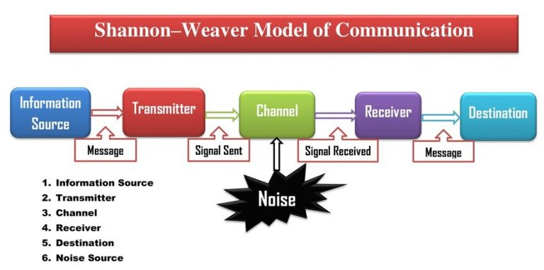

- This model is model one of the first and most important models of communication. The six conception in Shannon Weaver Model are: Sender (Information source), Encoder (Transmitter), Channel, Decoder (Receiver), Receiver (Destination) and Noise.
Sender (Information source)
Person where the information is created and sent. Sender send the message to the receiver, likewise the sender need to choose the channel which the message can be sent. Sender it is able to send the message in several ways, it may be oral (spoken words), or writing, via body language.
Encoder (Transmitter)
Sender who use the machine, transform idea into the signals, can be sent from sender to receiver. This model was created to understand communication via resources like, telephone, computers encode the words use the codes like radio waves or binary data.
Channel
Is the configuration which receive information from the sender and transmitter via decoder and receiver. To send message, different channels can be used by the sender, can be called Medium.
Decoder (Receiver)
Is the exactly opposite of encoder. Decoder is the machine which is used to transmute binary data or signals in to message or the receiver who will translate the message from the signals.
Receiver (Destination)
Is the ultimate point of the Shannon and Weaver model of the technical communication procedure. This is the model where the person finally get its message. The receiver give the feedback agreed to the message.
Noise
Noise cuts a message whilst it is on the way from the sender toward receiver. It is physical disturbance. When we sending message, it can be affected by anything which the receiver cannot get the same message of what it is sent by the sender.

Berlo's Model of Communication
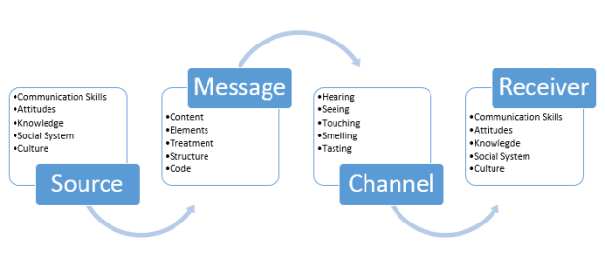Berlo model trust efficient communication to be held, receiver and source need to be in the same level. Then only communication can happen properly. Therefore, source and receiver will be alike. Berlo have four main components which describes communication. They are: S -Source, M-Message, C-Channel and R- Receiver.
S -Source
In another words this model is called the sender and it is one from to whom idea was appeared. This is the one who transfer all info to receiver after thoughtfully puts its idea into the words. There is some factors related to the sender the same as receiver.
M-Message
Individual when transmute ideas to the words, is created the message. This procedure is called also as Encoding. Message is the key of any communication. Can be in the form in, audio, text, voice, video and another media.
C-Channel
Is directed how the information run from sender to receiver. Technical machines can be used as a channel such as telephone, internet and other machines. In overall communication, the five meaning of a human being are the channel for the communication run and consequence the efficiency of the channel.
R- Receiver
When the message reach out the receiver, receiver tries to understand what the listener exactly want to transfer and then responds on this. This is also called as decoding.

Schramm Communication Model
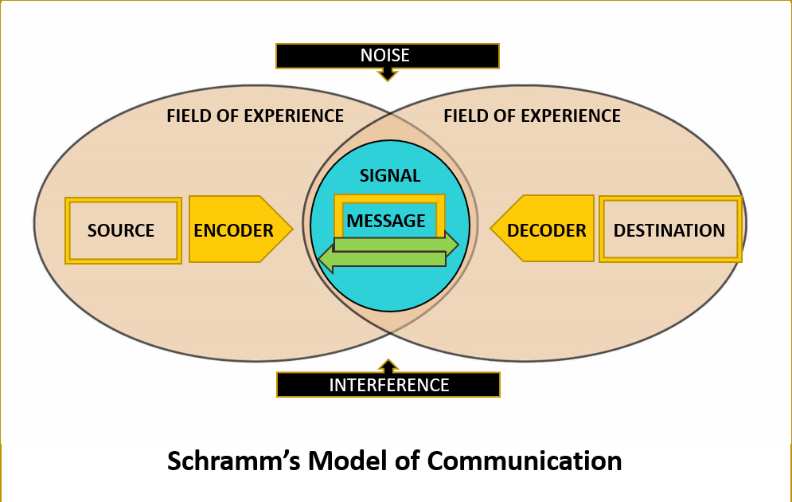
Schramm's model it is communication that have two method of function, where the sender send the messages in the format of text, audio or video, to the receiver. This mold have three sections.
Encoder
It is located in the initiator point where the senders sends their messages. The Encoder is a required department in the communication because transmute the message into the code which can be read by the network.
Decoder
Need to transmute the sender code in readable shape. If the receiver do not have any decoder, cannot read the sender message. Therefore the communication remains incomplete.
Message
Can hold verbal content, sign language, email, any text messages, and phone calls. Message can be formed in no verbal listing, also, behaving, gesture, body language, contact eye and many more other messages.

Tuckman's Team Development
Dr. Bruce Tuckman first published in 1965 his “Forming, Storming, Norming, Performing” model. Later he added a fifth stage in 1970, Adjourning. "Forming, Storming, Norming, Performing" theory it is an elegant, useful and helpful explanation of the team development and behaviour.
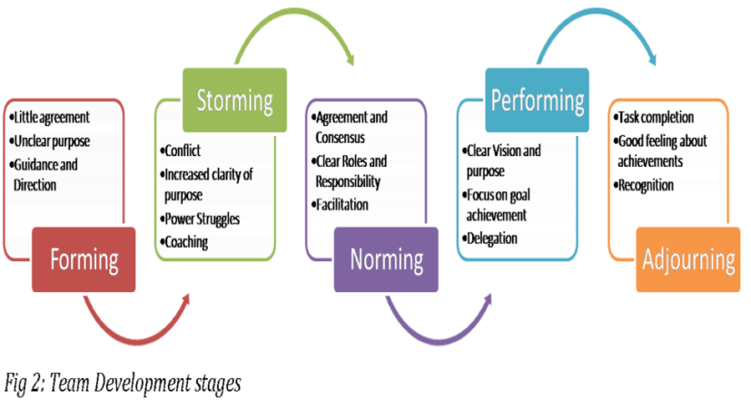

Belbin Team Role Theory
Dr Meredith Belbin designated the Team Role one of the nine groups of behaviour characteristics recognised by Belbin research like effective creature to facilitate team progress. Nine Belbin Team Roles: Resource Investigator, Team worker , Co-ordinator, Plant, Monitor Evaluator, Specialist, Shaper, Implementer and Completer Finisher.
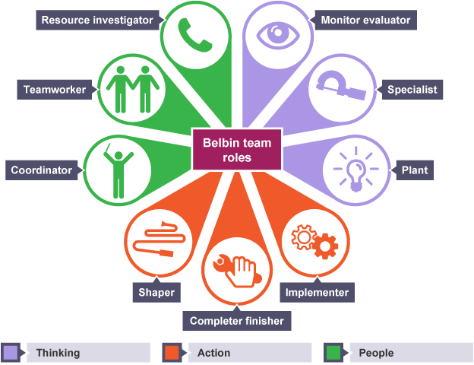

Advantages and Disadvantages of communication technology
Communication Technology is the electronic model utilized for communication between individuals or groups. Communication technology relieve communication who are not physically present. Communication has been and it is enormous part of our lives for decades. Letting us to connect with the people and share any information. Technology have improved in communication, making for us easier and faster than before.
They are telephones, telex, fax, radio, television, and video, more latest computer based technologies. The character of Technology in Communication are quick method of communication, available to people all over the world. It is common and easy to use.
Communication it is essential part of people lives and it can be better with technology. Technology have many advantages and can help communication to be more efficient and effective.
Advantages
Efficient and faster model throughout emergencies, capable to communicate from all around the world, from distance, letting Remote Communication, more Pervasive and free of Wires and Cables, excellent Approaching.

Technology have many profits, but there are some failures that can stop people to communicate effectively. There are disadvantages of technology on communication that can influence on people communication.
People probably use technology in methods that can violate privacy in ways that they support, and they are not capable to control how their information it is used.
Communication technology has changed in the past years. With the digitality of practically everything, it is almost impossible not to be continuously with the cell phone or computer.
Disadvantages of using Communication Technology are:
Privacy Issue, Making More Distractions and Lack of Conversation, Socially Inconvenient, harder to use for older people, cyber bullying, makes communication less personal and we are not always sure with who we communicating.
Poor communication at workplace is a failure that results lack of mutual understanding and respect that can happen between colleagues or managers. Can be improved with good communication, be consequent and constant, more collaboration and many more ways.
4. Conclusion
At the end of the study, it is very clear that teamwork it is very important for every organization. To make the group work efficient, effective communication is needed. The team is made with up of 3 people to work together to achieve their goals. Effective team can bring to increase their motivation and business productivity. People who are capable to build the skills and function to work with other people are able to achieve many things and to have transferable skills.

5. Reference
1. MUHAMMAD ALI (JULY 24, 2022) Advantages and Disadvantages of Technology on Communication Impact, Types, and Ways, Available at: https://topadvantagesof.com/ (Accessed: 2022).
2. M. Jones (February 2012) Communication of Technology: Advantages and Disadvantages, Available at: https://itstillworks.com (Accessed: 2022).
3. Elizabeth Smith (2019) What Are the Characteristics of Good Teamwork Habits, Available at: https://smallbusiness.chron.com (Accessed: 2022).

