BIS21865339 (Kieron Biscoe) 14/11/2024

Introduction To Web and Database Concepts – A1

Contents
Introduction 2
Requirements 3
Implementation (Pages) 4
Validation 5
Evaluation 6
References 7
Appendices (Put the Code here!!!) 8

Introduction
I was tasked in making a Website and Report on a topic of my choice which in the end I decided I would make a website about video games, the games I decided to do research for was the Mario Series, Sonic the Hedgehog Series, Pokémon Series and Kirby Series, I Chose these games in particular because I am very familiar with the series and can easily talk about them without problems in good detail.

Requirements
My Website is about Video games, in particular Mario, Sonic the hedgehog, Pokemon and Kirby. The website includes Characters from the game, Top selling games from the franchise and a bit of information about the games themselves e.g. what type of game it is, abilities, as well as an early game graphics and current game graphic pictures. The Age rating is for all ages but targets players who may be new and want to know more about these games but the website could also be useful for all other players who want to learn more about the game or wants to re learn after not playing for ages.

Implementation (Pages)
Home Page
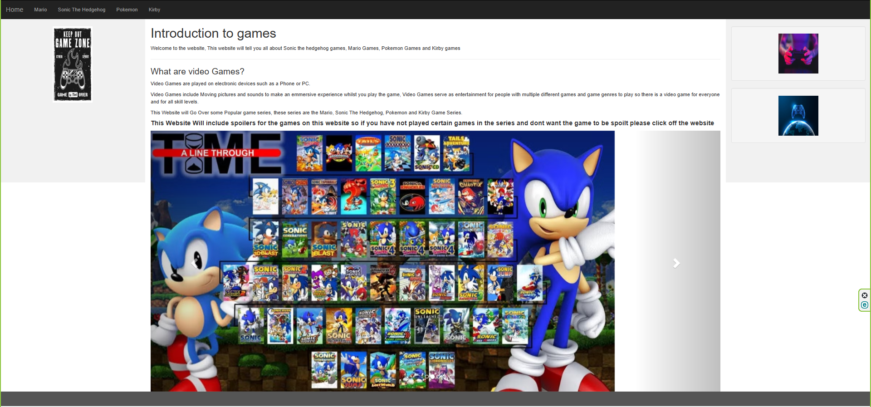
Mario Page [1]
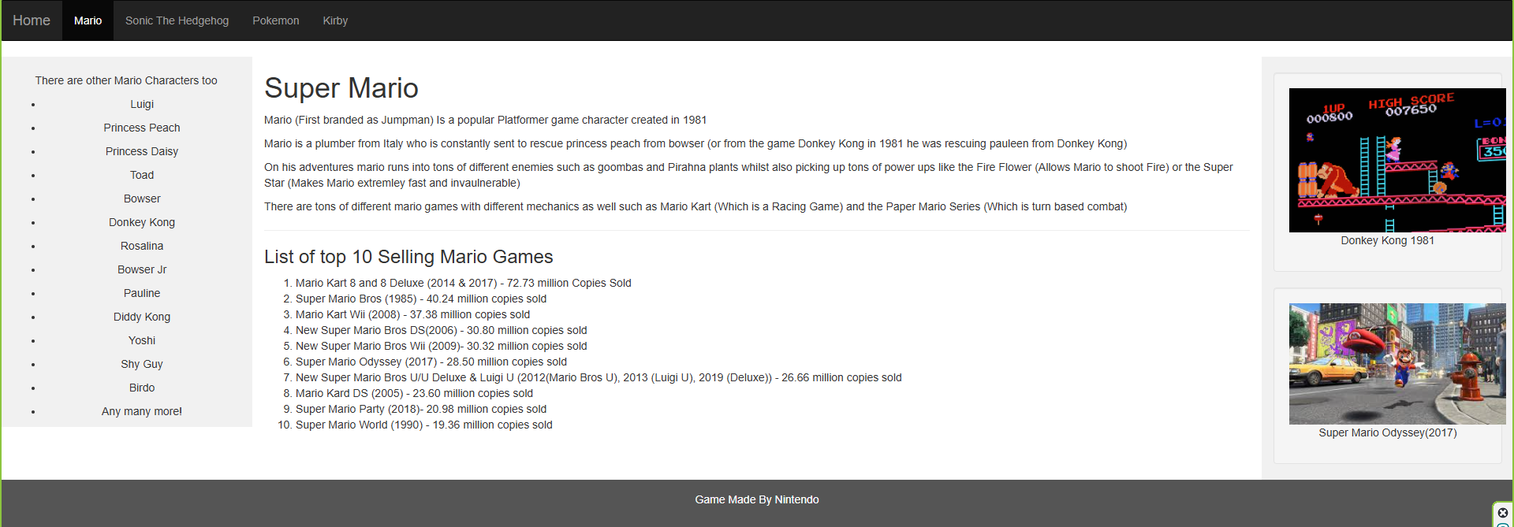
Sonic The Hedgehog Page [2]
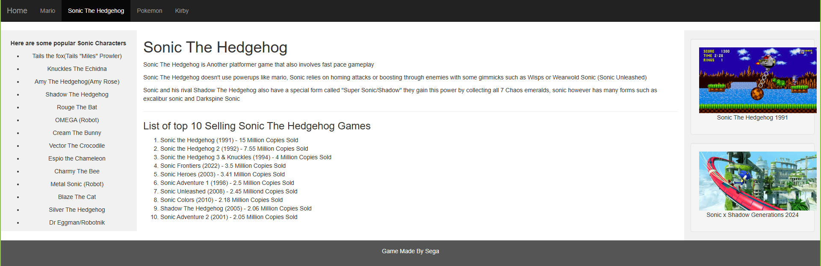
Pokemon Page [3]
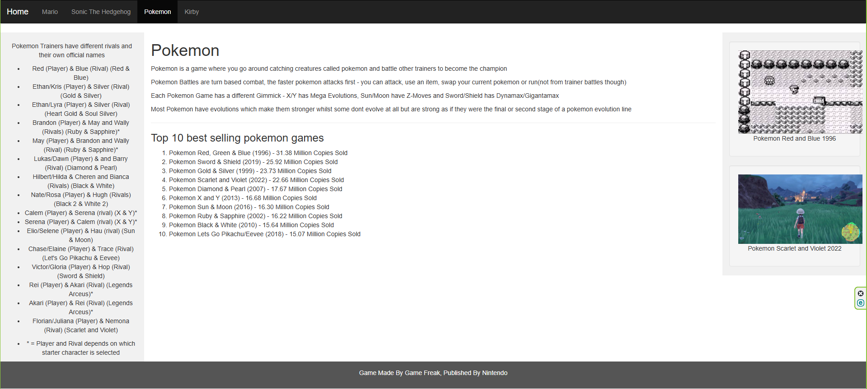
Kirby Page [4]
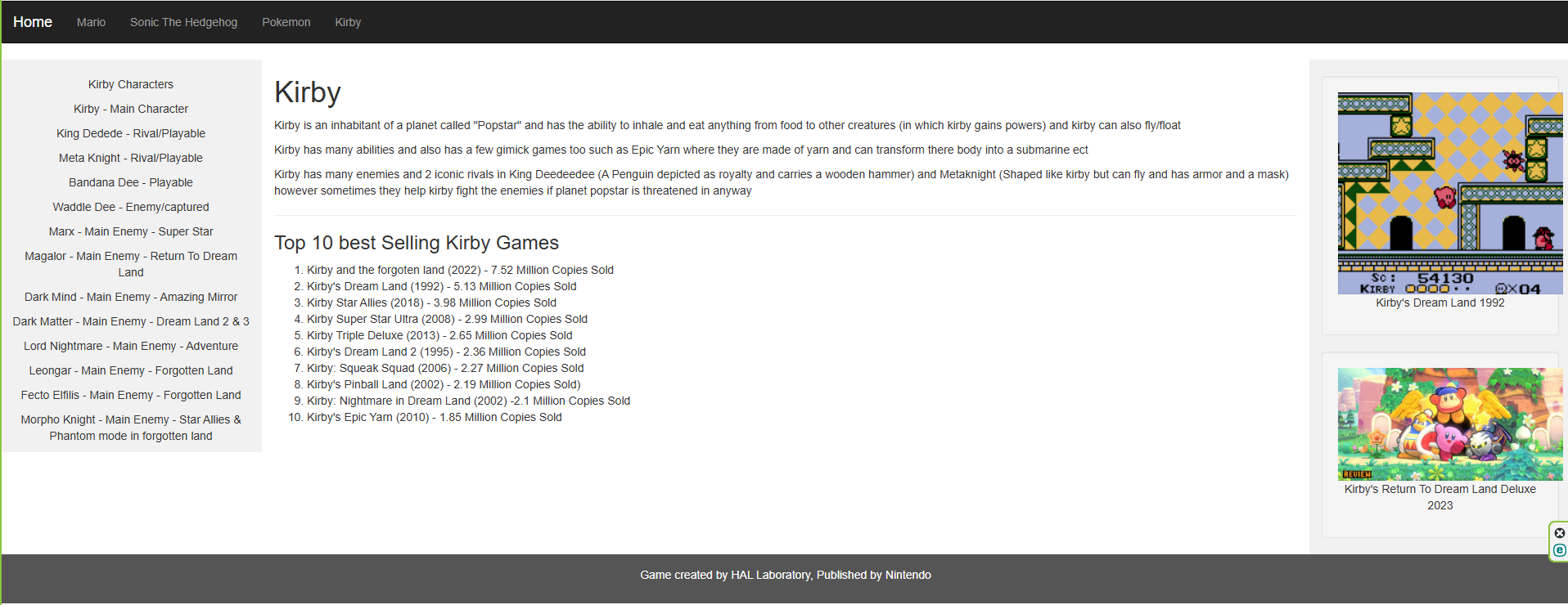

Validation
List of errors:
[5]
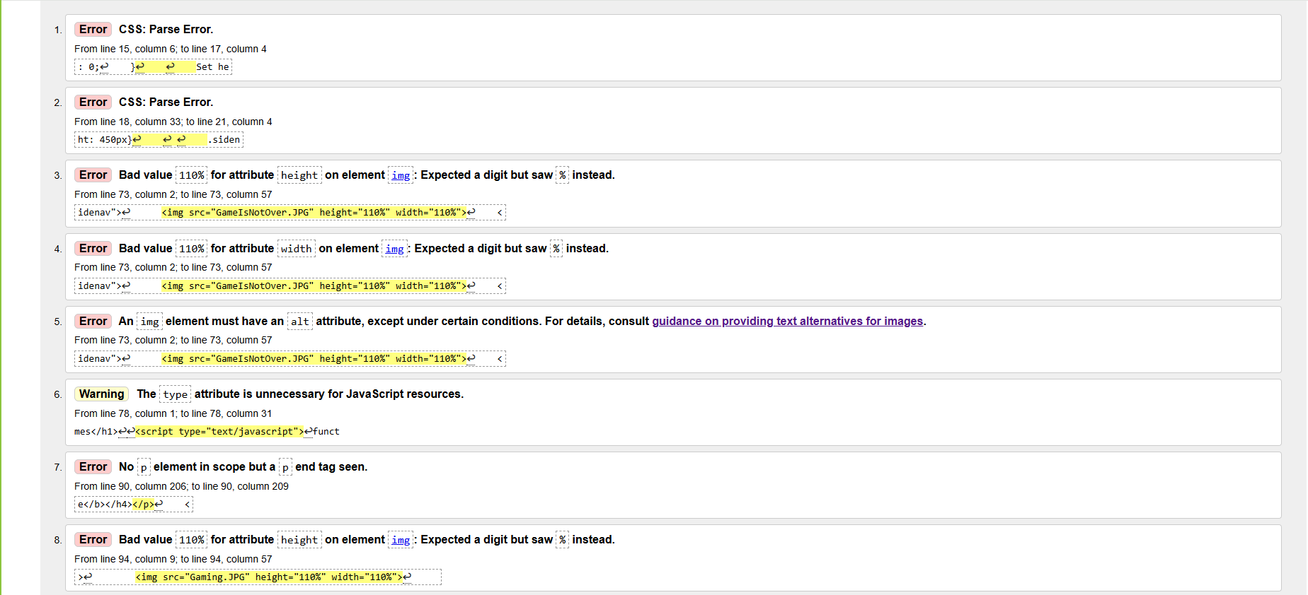
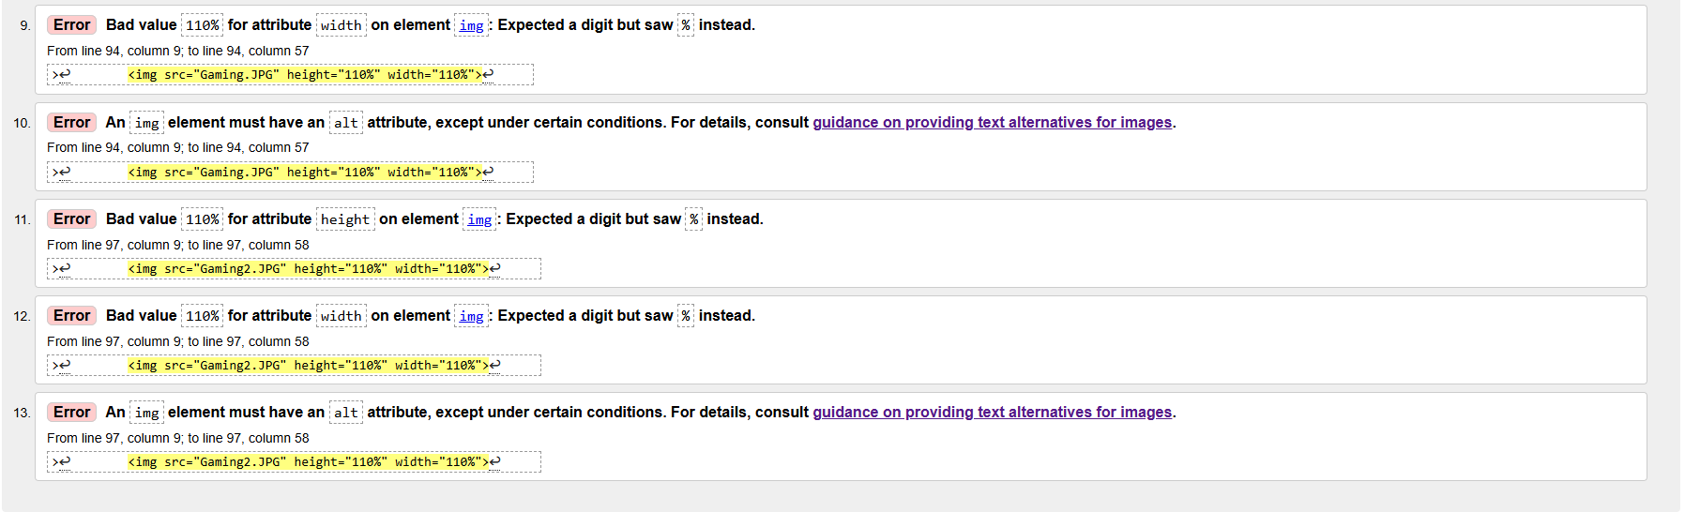
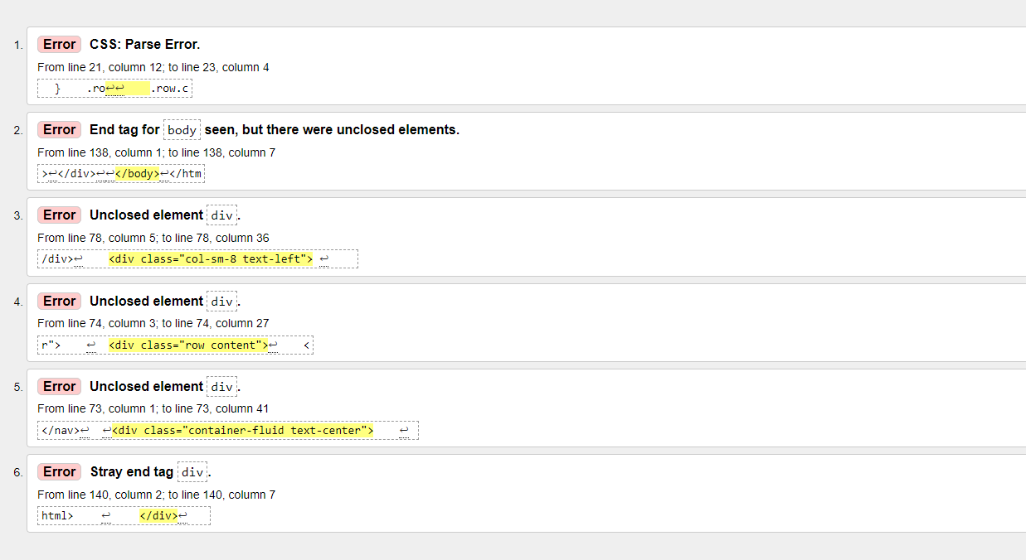
Solutions:
As you can see from the list there are 2 CSS: Parse Errors, I managed to fix this by Removing Unneeded text (Some text explaining some code) and it removed both Parse errors. There are quite a few errors for “Height expecting a digit but saw % instead”, to fix this all I had to do was remove the % mark for both width and height for the pictures. Some pictures also needed a “alt attribute” which is text describing the image, I added the alt attributes for all images and that fixed the errors. There was a type attribute with no java code for it, that has now been removed as it was not needed. The last error occurred because I was trying to use a Bold, Header and P but the P tag was not registering, I instead put the P tags above the text to create the space whilst the Bold and Header tag works for the text.
After Validating
The list above is a list of code I was unsure on how to solve in terms of the Div tags and body tags each tag has a closing and opening connected tag so I’m not sure how to fix those errors nor can I figure out this single Parse Error.

Evaluation
Website Usability, accessibility and search engine optimisation are all important when we analyse the quality of any website but, what do each of these terms actually mean? And what role does it have in web development?
[6]
Website Usability is the description of how easy and efficient it is for users to interact with the website and complete their goals, having good website usability impacts user experience, engagements and business outcomes which makes it important as improper website usability can make it so that more people will not use the website which impacts the business reputation.
Accessibility is ensuring disabled users can still use it regardless of physical/cognitive or situational limitations. Having an accessible website makes it compliance with legal standards and encourages an environment where all individuals feel welcomed and respected.
Search Engine Optimisation (SEO) means improving a website’s visibility in search engine results pages to attract more organic traffic. It involves optimizing various aspects to make it appealing to both users and search engines. SEO is crucial in enhancing the online presence of a business or individual making it essential for digital marketing strategies.

Usefulness
In terms of functionality I have made a navigation bar on the top of the page to easily access all of the pages, the web pages load very quickly making it easy to traverse the website, The website can be accessed on firefox, Chrome, Edge and Internet Explorer allowing users to access it from multiple different browsers allowing it to be accessible. In terms of usability I think it looks nice and presentable which also making it feel and look familiar and is very easy to use as there is only 1 navigation bar with text describing what the page is about. I could however make it adjust for mobile users as the web page doesn’t shrink when shrinking it on the webpage.

Search Engine Optimisation (SEO)
For SEO I have used Title tags which defines the title of the webpage, I have used Headers to make important text and titles bigger, the first 100 words include keywords such as “Video Games”, “Mario” ect which will allow it to appear when searched for and also describes what each page is about. Finally, I ensured that there was plenty of pictures as well as some alt text to make the page look nicer and to describe what you are seeing on the page.

Accessibility
Every website needs to be accessible to people who have disabilities with 4 main principles, the website has to be Perceivable which I have done as there is alt text describing images, operable ensuring all interactive images can be operated by a keyboard which I am unsure if that is possible on my website, Understandable which means using simple, clear and concise language which I feel like I have used on all pages on my website and finally, it needs to be robust which is used to ensure the content is compatible with assistive technologies such as screen readers ect, I used a screen reader [7] to see if it would read the text on the page which it did without problems, people who are colour blind shouldn’t have a problem reading it either as the website is in black and white, Finally I used axe DevTools to scan my HTML page and it found 0 problems so my website should be fully acceptable for use.

References
[1] “Top 10 best-selling Mario games” - https://nintendo.fandom.com/wiki/List_of_best-selling_Mario_games
[2] “Top 10 best-selling Sonic games” - https://www.reddit.com/r/SonicTheHedgehog/comments/163cxlr/mainline_sonic_games_by_sales/
[3] “Top 10 best-selling Pokemon games” - https://gamerant.com/the-highest-selling-pokemon-games-ranked/
[4] “Top 10 best-selling Kirby games” - https://nintendo.fandom.com/wiki/List_of_best-selling_Kirby_games
[5] HTML Validator - http://validator.w3.org/
[6] ChatGPT
[7] Screen Reader https://chromewebstore.google.com/detail/screen-reader/kgejglhpjiefppelpmljglcjbhoiplfn

Appendices (Put the Code here!!!)
Home Page
<!DOCTYPE html>
<html lang="en">
<head>
<title>Video Games</title>
<meta charset="utf-8">
<meta name="viewport" content="width=device-width, initial-scale=1">
<link rel="stylesheet" href="https://maxcdn.bootstrapcdn.com/bootstrap/3.4.1/css/bootstrap.min.css">
<script src="https://ajax.googleapis.com/ajax/libs/jquery/3.7.1/jquery.min.js"></script>
<script src="https://maxcdn.bootstrapcdn.com/bootstrap/3.4.1/js/bootstrap.min.js"></script>
<style>

.navbar {
margin-bottom: 0;
border-radius: 0;
}

.row.content {height: 450px}

.sidenav {
padding-top: 20px;
background-color: #f1f1f1;
height: 100%;}

footer {
background-color: #555;
color: white;
padding: 15px;
}

@media screen and (max-width: 767px) {
.sidenav {
height: auto;
padding: 15px;
}
.row.content {height:auto;}
}
</style>
</head>
<body>

<nav class="navbar navbar-inverse">
<div class="container-fluid">
<div class="navbar-header">
<button type="button" class="navbar-toggle" data-toggle="collapse" data-target="#myNavbar">
<span class="icon-bar"></span>
<span class="icon-bar"></span>
<span class="icon-bar"></span>
</button>
<a class="navbar-brand" href="Website.html">Home</a>
</div>
<div class="collapse navbar-collapse" id="myNavbar">
<ul class="nav navbar-nav">
<li><a href="Mario.html">Mario</a></li>
<li><a href="Sonic.html">Sonic The Hedgehog</a></li>
<li><a href="Pokemon.html">Pokemon</a></li>
<li><a href="Kirby.html">Kirby</a></li>
</ul>
<ul class="nav navbar-nav navbar-right">
</ul>
</div>
</div>
</nav>

<div class="container-fluid text-center">
<div class="row content">
<div class="col-sm-2 sidenav">
<div id="Picture1"><img src="GameIsNotOver.JPG" alt="Gaming Picture 1" height="210" width="110"></div>
</div>
<div class="col-sm-8 text-left">
<h1>Introduction to games</h1>

<p>Welcome to the website, This website will tell you all about Sonic the hedgehog games, Mario Games, Pokemon Games and Kirby games </p>
<hr>
<h3>What are video Games?</h3>
<p>Video Games are played on electronic devices such as a Phone or PC.</p>
<p>Video Games include Moving pictures and sounds to make an emmersive experience whilst you play the game, Video Games serve as entertainment for people with multiple different games and game genres to play so there is a video game for everyone and for all skill levels.</p>
<p>This Website will Go Over some Popular game series, these series are the Mario, Sonic The Hedgehog, Pokemon and Kirby Game Series.</p>
<h4><b>This Website Will include spoilers for the games on this website so if you have not played certain games in the series and dont want the game to be spoilt please click off the website</b></h4>
<p></p>
<p></p>
<p></p>
<p></p>
<p></p>
<p></p>
<p></p>
<!DOCTYPE html>
<html lang="en">
<head>
<title>Bootstrap Example</title>
<meta charset="utf-8">
<meta name="viewport" content="width=device-width, initial-scale=1">
<link rel="stylesheet" href="https://maxcdn.bootstrapcdn.com/bootstrap/3.4.1/css/bootstrap.min.css">
<script src="https://ajax.googleapis.com/ajax/libs/jquery/3.7.1/jquery.min.js"></script>
<script src="https://maxcdn.bootstrapcdn.com/bootstrap/3.4.1/js/bootstrap.min.js"></script>
</head>
<body>

<div class="container">
<div id="myCarousel" class="carousel slide" data-ride="carousel">
<!-- Indicators -->
<ol class="carousel-indicators">
<li data-target="#myCarousel" data-slide-to="0" class="active"></li>
<li data-target="#myCarousel" data-slide-to="1"></li>
<li data-target="#myCarousel" data-slide-to="2"></li>
<li data-target="#myCarousel" data-slide-to="3"></li>
</ol>

<!-- Wrapper for slides -->
<div class="carousel-inner">
<div class="item active">
<img src="MarioGames.png" alt="Super Mario" style="width:100%;">
</div>

<div class="item">
<img src="SonicGames.png" alt="Sonic The Hedgehog" style="width:100%;">
</div>

<div class="item">
<img src="PokemonGames.png" alt="Pokemon" style="width:100%;">
</div>

<div class="item">
<img src="KirbyGames.png" alt="Kirby" style="width:100%;">
</div>
</div>

<!-- Left and right controls -->
<a class="left carousel-control" href="#myCarousel" data-slide="prev">
<span class="glyphicon glyphicon-chevron-left"></span>
<span class="sr-only">Previous</span>
</a>
<a class="right carousel-control" href="#myCarousel" data-slide="next">
<span class="glyphicon glyphicon-chevron-right"></span>
<span class="sr-only">Next</span>
</a>
</div>
</div>

</body>
</html>
</div>
<div class="col-sm-2 sidenav">
<div class="well">
<div id="Picture2"><img src="Gaming.JPG" alt="Gaming Picture 2" height="110" width="110"></div>
</div>
<div class="well">
<div id="Picture3"><img src="Gaming2.JPG" alt="Gaming Picture 3" height="110" width="110"></div>
</div>
</div>
</div>
</div>

<footer class="container-fluid text-center">
<p></p>
</footer>

</body>
</html>
Mario Page
<!DOCTYPE html>
<html lang="en">
<head>
<title>Video Games - Mario</title>
<meta charset="utf-8">
<meta name="viewport" content="width=device-width, initial-scale=1">
<link rel="stylesheet" href="https://maxcdn.bootstrapcdn.com/bootstrap/3.4.1/css/bootstrap.min.css">
<script src="https://ajax.googleapis.com/ajax/libs/jquery/3.7.1/jquery.min.js"></script>
<script src="https://maxcdn.bootstrapcdn.com/bootstrap/3.4.1/js/bootstrap.min.js"></script>
<style>
Remove the navbar's default margin-bottom and rounded borders */
.navbar {
margin-bottom: 0;
border-radius: 0;
}

Set height of the grid so .sidenav can be 100% (adjust as needed) */
.row.content {height: 450px}

.sidenav {
padding-top: 20px;
background-color: #f1f1f1;
height: 100%;
}

/* Set black background color, white text and some padding */
footer {
background-color: #555;
color: white;
padding: 15px;
}

/* On small screens, set height to 'auto' for sidenav and grid */
@media screen and (max-width: 767px) {
.sidenav {
height: auto;
padding: 15px;
}
.row.content {height:auto;}
}
</style>
</head>
<body>

<nav class="navbar navbar-inverse">
<div class="container-fluid">
<div class="navbar-header">
<button type="button" class="navbar-toggle" data-toggle="collapse" data-target="#myNavbar">
<span class="icon-bar"></span>
<span class="icon-bar"></span>
<span class="icon-bar"></span>
</button>
<a class="navbar-brand" href="Website.html">Home</a>
</div>
<div class="collapse navbar-collapse" id="myNavbar">
<ul class="nav navbar-nav">
<li class="active"><a href="Mario.html">Mario</a></li>
<li><a href="Sonic.html">Sonic The Hedgehog</a></li>
<li><a href="Pokemon.html">Pokemon</a></li>
<li><a href="Kirby.html">Kirby</a></li>
</ul>
<ul class="nav navbar-nav navbar-right">
</ul>
</div>
</div>
</nav>

<div class="container-fluid text-center">
<div class="row content">
<div class="col-sm-2 sidenav">
<p>There are other Mario Characters too</p>
<ul>
<li>Luigi</li>
<p></p>
<li>Princess Peach</li>
<p></p>
<li>Princess Daisy</li>
<p></p>
<li>Toad</li>
<p></p>
<li>Bowser</li>
<p></p>
<li>Donkey Kong</li>
<p></p>
<li>Rosalina</li>
<p></p>
<li>Bowser Jr</li>
<p></p>
<li>Pauline</li>
<p></p>
<li>Diddy Kong</li>
<p></p>
<li>Yoshi</li>
<p></p>
<li>Shy Guy</li>
<p></p>
<li>Birdo</li>
<p></p>
<li>Any many more!</li>
</ul>
</div>
<div class="col-sm-8 text-left">
<h1>Super Mario</h1>
<p>Mario (First branded as Jumpman) Is a popular Platformer game character created in 1981</p>
<p>Mario is a plumber from Italy who is constantly sent to rescue princess peach from bowser (or from the game Donkey Kong in 1981 he was rescuing pauleen from Donkey Kong)</p>
<p>On his adventures mario runs into tons of different enemies such as goombas and Pirahna plants whilst also picking up tons of power ups like the Fire Flower (Allows Mario to shoot Fire) or the Super Star (Makes Mario extremley fast and invaulnerable)</p>
<p>There are tons of different mario games with different mechanics as well such as Mario Kart (Which is a Racing Game) and the Paper Mario Series (Which is turn based combat)</p>
<p></p>
<hr>
<h3>List of top 10 Selling Mario Games</h3>
<Ol>
<li>Mario Kart 8 and 8 Deluxe (2014 & 2017) - 72.73 million Copies Sold</li>
<li>Super Mario Bros (1985) - 40.24 million copies sold</li>
<li>Mario Kart Wii (2008) - 37.38 million copies sold</li>
<li>New Super Mario Bros DS(2006) - 30.80 million copies sold</li>
<li>New Super Mario Bros Wii (2009)- 30.32 million copies sold</li>
<li>Super Mario Odyssey (2017) - 28.50 million copies sold</li>
<li>New Super Mario Bros U/U Deluxe & Luigi U (2012(Mario Bros U), 2013 (Luigi U), 2019 (Deluxe)) - 26.66 million copies sold</li>
<li>Mario Kard DS (2005) - 23.60 million copies sold</li>
<li>Super Mario Party (2018)- 20.98 million copies sold</li>
<li> Super Mario World (1990) - 19.36 million copies sold</li>
</Ol>
</div>
<div class="col-sm-2 sidenav">
<div class="well">
<img src="DonkeyKong1981.JPG" height="110%" width="110%">
<p>Donkey Kong 1981</p>
</div>
<div class="well">
<img src="SuperMarioOdyssey2017.JPG" height="110%" width="110%">
<p>Super Mario Odyssey(2017)</p>
</div>
</div>
</div>
</div>

<footer class="container-fluid text-center">
<p>Game Made By Nintendo </p>
</footer>

</body>
</html>
Sonic Page
<!DOCTYPE html>
<html lang="en">
<head>
<title>Video Games - Sonic</title>
<meta charset="utf-8">
<meta name="viewport" content="width=device-width, initial-scale=1">
<link rel="stylesheet" href="https://maxcdn.bootstrapcdn.com/bootstrap/3.4.1/css/bootstrap.min.css">
<script src="https://ajax.googleapis.com/ajax/libs/jquery/3.7.1/jquery.min.js"></script>
<script src="https://maxcdn.bootstrapcdn.com/bootstrap/3.4.1/js/bootstrap.min.js"></script>
<style>
Remove the navbar's default margin-bottom and rounded borders */
.navbar {
margin-bottom: 0;
border-radius: 0;
}

Set height of the grid so .sidenav can be 100% (adjust as needed) */
.row.content {height: 450px}

.sidenav {
padding-top: 20px;
background-color: #f1f1f1;
height: 100%;
}

/* Set black background color, white text and some padding */
footer {
background-color: #555;
color: white;
padding: 15px;
}

/* On small screens, set height to 'auto' for sidenav and grid */
@media screen and (max-width: 767px) {
.sidenav {
height: auto;
padding: 15px;
}
.row.content {height:auto;}
}
</style>
</head>
<body>

<nav class="navbar navbar-inverse">
<div class="container-fluid">
<div class="navbar-header">
<button type="button" class="navbar-toggle" data-toggle="collapse" data-target="#myNavbar">
<span class="icon-bar"></span>
<span class="icon-bar"></span>
<span class="icon-bar"></span>
</button>
<a class="navbar-brand" href="Website.html">Home</a>
</div>
<div class="collapse navbar-collapse" id="myNavbar">
<ul class="nav navbar-nav">
<li><a href="Mario.html">Mario</a></li>
<li class="active"><a href="Sonic.html">Sonic The Hedgehog</a></li>
<li><a href="Pokemon.html">Pokemon</a></li>
<li><a href="Kirby.html">Kirby</a></li>
</ul>
<ul class="nav navbar-nav navbar-right">
</ul>
</div>
</div>
</nav>

<div class="container-fluid text-center">
<div class="row content">
<div class="col-sm-2 sidenav">
<p><b>Here are some popular Sonic Characters</b></p>
<ul>
<li>Tails the fox(Tails "Miles" Prowler)</li>
<p></p>
<li>Knuckles The Echidna</li>
<p></p>
<li>Amy The Hedgehog(Amy Rose)</li>
<p></p>
<li>Shadow The Hedgehog</li>
<p></p>
<li>Rouge The Bat</li>
<p></p>
<li>OMEGA (Robot)</li>
<p></p>
<li>Cream The Bunny</li>
<p></p>
<li>Vector The Crocodile</li>
<p></p>
<li>Espio the Chameleon</li>
<p></p>
<li>Charmy The Bee</li>
<p></p>
<li>Metal Sonic (Robot)</li>
<p></p>
<li>Blaze The Cat</li>
<p></p>
<li>Silver The Hedgehog</li>
<p></p>
<li>Dr Eggman/Robotnik</li>
<p></p>
</ul>
</div>
<div class="col-sm-8 text-left">
<h1>Sonic The Hedgehog</h1>
<p>Sonic The Hedgehog is Another platformer game that also involves fast pace gameplay</p>
<p>Sonic The Hedgehog doesn't use powerups like mario, Sonic relies on homing attacks or boosting through enemies with some gimmicks such as Wisps or Wearwold Sonic (Sonic Unleashed)</p>
<p>Sonic and his rival Shadow The Hedgehog also have a special form called "Super Sonic/Shadow" they gain this power by collecting all 7 Chaos emeralds, sonic however has many forms such as excalibur sonic and Darkspine Sonic</p>

<hr>
<h3>List of top 10 Selling Sonic The Hedgehog Games</h3>
<ol>
<li>Sonic the Hedgehog (1991) - 15 Million Copies Sold</li>
<li>Sonic the Hedgehog 2 (1992) - 7.55 Million Copies Sold</li>
<li>Sonic the Hedgehog 3 & Knuckles (1994) - 4 Million Copies Sold</li>
<li>Sonic Frontiers (2022) - 3.5 Million Copies Sold</li>
<li>Sonic Heroes (2003) - 3.41 Million Copies Sold</li>
<li>Sonic Adventure 1 (1998) - 2.5 Million Copies Sold</li>
<li>Sonic Unleashed (2008) - 2.45 Milliond Copies Sold</li>
<li>Sonic Colors (2010) - 2.18 Million Copies Sold</li>
<li>Shadow The Hedgehog (2005) - 2.06 Million Copies Sold</li>
<li>Sonic Adventure 2 (2001) - 2.05 Million Copies Sold</li>
</ol>
</div>
<div class="col-sm-2 sidenav">
<div class="well">
<img src="SonicClassic.JPG" height="110%" width="110%">
<p>Sonic The Hedgehog 1991</p>
</div>
<div class="well">
<img src="SonicPresent.JPG" height="110%" width="110%">
<p>Sonic x Shadow Generations 2024</p>
</div>
</div>
</div>
</div>

<footer class="container-fluid text-center">
<p>Game Made By Sega </p>
</footer>

</body>
</html>
Pokemon Page
<!DOCTYPE html>
<html lang="en">
<head>
<title>Video Games - Pokemon</title>
<meta charset="utf-8">
<meta name="viewport" content="width=device-width, initial-scale=1">
<link rel="stylesheet" href="https://maxcdn.bootstrapcdn.com/bootstrap/3.4.1/css/bootstrap.min.css">
<script src="https://ajax.googleapis.com/ajax/libs/jquery/3.7.1/jquery.min.js"></script>
<script src="https://maxcdn.bootstrapcdn.com/bootstrap/3.4.1/js/bootstrap.min.js"></script>
<style>
Remove the navbar's default margin-bottom and rounded borders */
.navbar {
margin-bottom: 0;
border-radius: 0;
}

Set height of the grid so .sidenav can be 100% (adjust as needed) */
.row.content {height: 450px}

.sidenav {
padding-top: 20px;
background-color: #f1f1f1;
height: 100%;
}

/* Set black background color, white text and some padding */
footer {
background-color: #555;
color: white;
padding: 15px;
}

/* On small screens, set height to 'auto' for sidenav and grid */
@media screen and (max-width: 767px) {
.sidenav {
height: auto;
padding: 15px;
}
.row.content {height:auto;}
}
</style>
</head>
<body>

<nav class="navbar navbar-inverse">
<div class="container-fluid">
<div class="navbar-header">
<button type="button" class="navbar-toggle" data-toggle="collapse" data-target="#myNavbar">
<span class="icon-bar"></span>
<span class="icon-bar"></span>
<span class="icon-bar"></span>
</button>
<a class="navbar-brand" href="Website.html">Home</a>
</div>
<div class="collapse navbar-collapse" id="myNavbar">
<ul class="nav navbar-nav">
<li><a href="Mario.html">Mario</a></li>
<li><a href="Sonic.html">Sonic The Hedgehog</a></li>
<li class ="active"><a href="Pokemon.html">Pokemon</a></li>
<li><a href="Kirby.html">Kirby</a></li>
</ul>
<ul class="nav navbar-nav navbar-right">
</ul>
</div>
</div>
</nav>

<div class="container-fluid text-center">
<div class="row content">
<div class="col-sm-2 sidenav">
<p>Pokemon Trainers have different rivals and their own official names
<ul>
<li> Red (Player) & Blue (Rival) (Red & Blue)</li>
<li> Ethan/Kris (Player) & Silver (Rival) (Gold & Silver)</li>
<li> Ethan/Lyra (Player) & Silver (Rival) (Heart Gold & Soul Silver)</li>
<li> Brandon (Player) & May and Wally (Rivals) (Ruby & Sapphire)*</li>
<li> May (Player) & Brandon and Wally (Rival) (Ruby & Sapphire)*</li>
<li> Lukas/Dawn (Player) & and Barry (Rival) (Diamond & Pearl)</li>
<li> Hilbert/Hilda & Cheren and Bianca (Rivals) (Black & White)</li>
<li> Nate/Rosa (Player) & Hugh (Rivals) (Black 2 & White 2)</li>
<li> Calem (Player) & Serena (rival) (X & Y)*</li>
<li> Serena (Player) & Calem (rival) (X & Y)*</li>
<li> Elio/Selene (Player) & Hau (rival) (Sun & Moon)</li>
<li>Chase/Elaine (Player) & Trace (Rival) (Let's Go Pikachu & Eevee)</li>
<li> Victor/Gloria (Player) & Hop (Rival) (Sword & Shield)</li>
<li> Rei (Player) & Akari (Rival) (Legends Arceus)*</li>
<li> Akari (Player) & Rei (Rival) (Legends Arceus)*</li>
<li> Florian/Juliana (Player) & Nemona (Rival) (Scarlet and Violet)</li>
<p></p>
<li> * = Player and Rival depends on which starter character is selected</li>
</ul>
</div>
<div class="col-sm-8 text-left">
<h1>Pokemon</h1>
<p>Pokemon is a game where you go around catching creatures called pokemon and battle other trainers to become the champion</p>
<p>Pokemon Battles are turn based combat, the faster pokemon attacks first - you can attack, use an item, swap your current pokemon or run(not from trainer battles though)</p>
<p>Each Pokemon Game has a different Gimmick - X/Y has Mega Evolutions, Sun/Moon have Z-Moves and Sword/Shield has Dynamax/Gigantamax</p>
<p>Most Pokemon have evolutions which make them stronger whilst some dont evolve at all but are strong as if they were the final or second stage of a pokemon evolution line</p>
<hr>
<h3>Top 10 best selling pokemon games</h3>
<ol>
<li>Pokemon Red, Green & Blue (1996) - 31.38 Million Copies Sold</li>
<li>Pokemon Sword & Shield (2019) - 25.92 Million Copies Sold</li>
<li>Pokemon Gold & Silver (1999) - 23.73 Million Copies Sold</li>
<li>Pokemon Scarlet and Violet (2022) - 22.66 Million Copies Sold</li>
<li>Pokemon Diamond & Pearl (2007) - 17.67 Million Copies Sold</li>
<li>Pokemon X and Y (2013) - 16.68 Million Copies Sold</li>
<li>Pokemon Sun & Moon (2016) - 16.30 Million Copies Sold</li>
<li>Pokemon Ruby & Sapphire (2002) - 16.22 Million Copies Sold</li>
<li>Pokemon Black & White (2010) - 15.64 Million Copies Sold</li>
<li>Pokemon Lets Go Pikachu/Eevee (2018) - 15.07 Million Copies Sold</li>
</ol>
</div>
<div class="col-sm-2 sidenav">
<div class="well">
<img src="Pokemon RedBlue.JPG" height="110%" width="110%">
<p>Pokemon Red and Blue 1996</p>
</div>
<div class="well">
<img src="Pokemon ScarletViolet.JPG" height="110%" width="110%">
<p>Pokemon Scarlet and Violet 2022</p>
</div>
</div>
</div>
</div>

<footer class="container-fluid text-center">
<p>Game Made By Game Freak, Published By Nintendo </p>
</footer>

</body>
</html>
Kirby Page
<!DOCTYPE html>
<html lang="en">
<head>
<title>Video Games - Kirby</title>
<meta charset="utf-8">
<meta name="viewport" content="width=device-width, initial-scale=1">
<link rel="stylesheet" href="https://maxcdn.bootstrapcdn.com/bootstrap/3.4.1/css/bootstrap.min.css">
<script src="https://ajax.googleapis.com/ajax/libs/jquery/3.7.1/jquery.min.js"></script>
<script src="https://maxcdn.bootstrapcdn.com/bootstrap/3.4.1/js/bootstrap.min.js"></script>
<style>
Remove the navbar's default margin-bottom and rounded borders */
.navbar {
margin-bottom: 0;
border-radius: 0;
}

Set height of the grid so .sidenav can be 100% (adjust as needed) */
.row.content {height: 450px}

.sidenav {
padding-top: 20px;
background-color: #f1f1f1;
height: 100%;
}

/* Set black background color, white text and some padding */
footer {
background-color: #555;
color: white;
padding: 15px;
}

/* On small screens, set height to 'auto' for sidenav and grid */
@media screen and (max-width: 767px) {
.sidenav {
height: auto;
padding: 15px;
}
.row.content {height:auto;}
}
</style>
</head>
<body>

<nav class="navbar navbar-inverse">
<div class="container-fluid">
<div class="navbar-header">
<button type="button" class="navbar-toggle" data-toggle="collapse" data-target="#myNavbar">
<span class="icon-bar"></span>
<span class="icon-bar"></span>
<span class="icon-bar"></span>
</button>
<a class="navbar-brand" href="Website.html">Home</a>
</div>
<div class="collapse navbar-collapse" id="myNavbar">
<ul class="nav navbar-nav">
<li><a href="Mario.html">Mario</a></li>
<li><a href="Sonic.html">Sonic The Hedgehog</a></li>
<li><a href="Pokemon.html">Pokemon</a></li>
<li class="Kirby.html"><a href="Kirby.html">Kirby</a></li>
</ul>
<ul class="nav navbar-nav navbar-right">
</ul>
</div>
</div>
</nav>

<div class="container-fluid text-center">
<div class="row content">
<div class="col-sm-2 sidenav">
<p>Kirby Characters</p>
<p></p>
<p>Kirby - Main Character</p>
<p></p>
<p>King Dedede - Rival/Playable</p>
<p></p>
<p>Meta Knight - Rival/Playable</p>
<p></p>
<p>Bandana Dee - Playable</p>
<p></p>
<p>Waddle Dee - Enemy/captured</p>
<p></p>
<p>Marx - Main Enemy - Super Star</p>
<p></p>
<p>Magalor - Main Enemy - Return To Dream Land</p>
<p></p>
<p>Dark Mind - Main Enemy - Amazing Mirror</p>
<p></p>
<p>Dark Matter - Main Enemy - Dream Land 2 & 3</p>
<p></p>
<p>Lord Nightmare - Main Enemy - Adventure</p>
<p></p>
<p>Leongar - Main Enemy - Forgotten Land</p>
<p></p>
<p>Fecto Elfilis - Main Enemy - Forgotten Land</p>
<p></p>
<p>Morpho Knight - Main Enemy - Star Allies & Phantom mode in forgotten land</p>

</div>
<div class="col-sm-8 text-left">
<h1>Kirby</h1>
<p>Kirby is an inhabitant of a planet called "Popstar" and has the ability to inhale and eat anything from food to other creatures (in which kirby gains powers) and kirby can also fly/float</p>
<p>Kirby has many abilities and also has a few gimick games too such as Epic Yarn where they are made of yarn and can transform there body into a submarine ect</p>
<p>Kirby has many enemies and 2 iconic rivals in King Deedeedee (A Penguin depicted as royalty and carries a wooden hammer) and Metaknight (Shaped like kirby but can fly and has armor and a mask) however sometimes they help kirby fight the enemies if planet popstar is threatened in anyway</p>
<hr>
<h3>Top 10 best Selling Kirby Games</h3>
<ol>
<li>Kirby and the forgoten land (2022) - 7.52 Million Copies Sold</li>
<li>Kirby's Dream Land (1992) - 5.13 Million Copies Sold</li>
<li>Kirby Star Allies (2018) - 3.98 Million Copies Sold</li>
<li>Kirby Super Star Ultra (2008) - 2.99 Million Copies Sold</li>
<li>Kirby Triple Deluxe (2013) - 2.65 Million Copies Sold</li>
<li>Kirby's Dream Land 2 (1995) - 2.36 Million Copies Sold</li>
<li>Kirby: Squeak Squad (2006) - 2.27 Million Copies Sold</li>
<li>Kirby's Pinball Land (2002) - 2.19 Million Copies Sold)</li>
<li>Kirby: Nightmare in Dream Land (2002) -2.1 Million Copies Sold</li>
<li>Kirby's Epic Yarn (2010) - 1.85 Million Copies Sold</li>
</ol>

</ol>
</div>
<div class="col-sm-2 sidenav">
<div class="well">
<img src="DreamLand.PNG" height="110%" width="110%">
<p>Kirby's Dream Land 1992</p>
</div>
<div class="well">
<img src="ReturnToDreamLand.JPEG" height="110%" width="110%">
<p>Kirby's Return To Dream Land Deluxe 2023</p>
</div>
</div>
</div>
</div>

<footer class="container-fluid text-center">
<p>Game created by HAL Laboratory, Published by Nintendo</p>
</footer>

</body>
</html>

