How effective is UK police as a deterrent to terrorism in the UK

Student: Lloyd Williams
Student Number: 2117814

BSc (Hons) Professional Policing Practice

Acknowledgements

This dissertation is primarily the work of the author, who takes full responsibility for the views expressed within it. However, without the help and understanding of friends, family, and loved ones, the task of writing it would have been a lot more difficult.
I would like to show my thanks and appreciation to my dissertation supervisor, Kate Colclough, for all of the support and advice I was offered. I would like to say thank you to all the staff at the university for all their efforts during my three years.

Declaration

This work has not previously been accepted in substance for any degree and is not being concurrently submitted in candidature for any degree.
Signed: L.Williams
Date: 04/07/2024

STATEMENT 1
This dissertation is being submitted in partial fulfilment of the requirements for the degree of BA.
Signed: L.Williams
Date: 04/07/2024

STATEMENT 2
This dissertation is the result of my own independent work/investigation, except where otherwise stated.
Other sources are acknowledged by footnotes giving explicit references. A bibliography is appended.
Signed: L.Williams
Date: 04/07/2024

STATEMENT 3
I hereby give consent for my dissertation, if accepted, to be available for photocopying and for interlibrary loan, and for the title and summary to be made available to outside organisations.
Signed: L.Williams
Date: 04/07/2024

STATEMENT 4
I hereby give consent for my dissertation, if accepted, to be available on the university’s IT system to those who have consent to use the system.
Signed: L.Williams
Date: 04/07/2024

Abstract

This dissertation is an analysis of how effective the UK police are as a deterrent to terrorism within the UK.
The aim of this dissertation is to provide an extensive view of this topic while taking the views of the general public and serving police officers into consideration via a questionnaire. The findings were analysed with officers and the general public in agreement that UK police are an effective deterrent to terrorism.
An in-depth analysis of the history surrounding terrorism within the UK and the changes to legislation that were brought on by these acts of terror.

Contents Table

- Acknowledgements……………………………………………………………………………………..…………..2

- Declaration……………………………………………………………………………………………………………….3

- Abstract……………………………………………………………………………………………………………………4

- Introduction / Objectives………………………………………………………………………………………….6

- Literature Review……………………………………………………………………………………………………..7

- Methodology………………………………………………………………………………………………………….13

- Analysis of Results…………………………….……………………………………………………………………15

- Conclusion……………………………………………..………………………………………………………………21

- Recommendations…………………………………………………………………………………………………25

- Bibliography……………………………………………………………..……………………………………………27

- Appendix One – Questionnaire……………………………………………………………………………..20

- Appendix Two – Questionnaire Results…………………………………………………………………35

Introduction
The purpose of this research is to determine whether UK policing strategies are effective in deterring terrorism. This dissertation examines the evolution of counter-terrorism policing in the UK and explains how policies and laws have adapted in response to major terrorist incidents, such as the London bombings in 2005. The dissertation will explore various policing powers, including surveillance, intelligence gathering, and community policing, and the legal frameworks that support these activities. It will also assess the additional use of these strategies by police officers in preventing and responding to terrorist threats.
This subject was chosen because counter-terrorism policing is a critical and frequently implemented aspect of law enforcement. However, there is limited research on the effectiveness of these strategies in deterring terrorism, despite numerous instances where they have successfully thwarted potential attacks. This dissertation aims to fill that gap by providing a comprehensive analysis of the efficacy of UK policing in the context of counter-terrorism efforts.

Objectives

The objectives of this research project are to examine the efficiency of UK police as a deterrent to terrorism in the UK.
The objectives of this research project will allow:
- Explain the history behind counter-terrorism policing and the changes in legislative laws surrounding it.
- Conduct an analysis of a survey on counter-terrorism measures from serving police officers and general members of the public.
- Evaluate whether counter-terrorism policing is effective at preventing, detecting, and deterring terrorism within the UK.

Literature Review
This literature review looks at background and history surrounding terrorism in the UK and the measures implemented by government and the police in an attempt to deter this.

‘Terrorism is defined as the unlawful use of violence and intimidation, especially against civilians, in the pursuit of political aims’ (Oxford English Dictionary, 2024).

The effectiveness of UK policing as a deterrent to terrorism is a multifaceted topic that encompasses various strategies, historical developments, legal frameworks, and operational tactics. This literature review synthesizes key academic studies, government reports, and expert analyses to provide a comprehensive understanding of the subject. The review is organized into several sections: historical context, counter-terrorism strategies, community policing, legal frameworks, technological advancements, and critical perspectives.
The threat of terrorism has been a persistent and evolving challenge for the United Kingdom, necessitating a multifaceted and adaptive approach to policing. Over the past two decades, the UK has witnessed significant terrorist incidents that have shaped the nation's security landscape and policy framework. From the 7/7 London bombings in 2005 to more recent attacks on Manchester Arena in 2017 and London Bridge in 2019, the imperative for effective counter-terrorism strategies has become ever more critical. This literature review aims to explore the effectiveness of UK policing as a deterrent to terrorism, examining various dimensions such as legislative measures, community policing, intelligence operations, and the integration of technology.
The scholarly debate on counter-terrorism in the UK is vast and multifaceted, encompassing a range of perspectives from criminology, political science, sociology, and security studies. Central to this discourse is the role of the police as both a preventive and reactive force against terrorism. The literature addresses key questions: How effective are current policing strategies in preventing terrorist activities? What are the strengths and limitations of intelligence-led policing? How does community engagement contribute to or hinder counter-terrorism efforts? These questions guide the investigation into the complexities of policing in a contemporary, high-threat environment.
The literature review will synthesize findings from various academic sources, providing a comprehensive analysis of the effectiveness of UK policing as a deterrent to terrorism. By examining legislative frameworks, intelligence operations, community engagement, and technological integration, the review aims to present a nuanced understanding of the strengths and challenges facing UK policing in the context of counter-terrorism. This exploration will not only highlight the current state of knowledge but also identify gaps and areas for future research, contributing to the ongoing discourse on national security and public safety in the UK.
Historical Context
The UK has a long history of dealing with terrorism, notably from the Irish Republican Army (IRA) during the latter half of the 20th century. The tactics and strategies developed during this period have significantly influenced contemporary counter-terrorism measures. According to Neumann (2009), the experience with the IRA has provided valuable lessons in intelligence-gathering, community engagement, and the importance of adaptive policing strategies (Neumann, 2009).
The IRA threat led to the establishment of specialist counter-terrorism units within the police and enhanced cooperation between the police and the military. The period also highlighted the importance of community relations, particularly in Northern Ireland, where efforts were made to build trust between security forces and local communities (Wilkinson, 2011). The peace process in the 1990s, culminating in the Good Friday Agreement, marked a significant shift in counter-terrorism focus from the IRA to emerging threats.
Counter-Terrorism Strategies
UK policing employs a variety of strategies to deter terrorism, including intelligence-led policing, surveillance, and targeted operations. The "Four Ps" strategy—‘pursue, prevent, protect, and prepare’—outlined in the CONTEST strategy document, remains central to UK counter-terrorism efforts (HM Government, 2018). This approach integrates law enforcement with intelligence services to disrupt terrorist activities and prevent radicalization. In their evaluation, Innes and Levi (2017) highlight the success of intelligence-led operations in thwarting several high-profile terrorist plots (Innes & Levi, 2017).
The Pursue strand focuses on detecting and disrupting terrorist activities through intelligence gathering, surveillance, and law enforcement operations. This involves close collaboration between various agencies, including MI5, the police, and international partners, to dismantle terrorist networks and prevent attacks (Anderson, 2016). The Protect strand is designed to strengthen the UK's infrastructure and border security to safeguard against potential attacks. This includes implementing advanced security measures at critical sites, enhancing cybersecurity, and securing public spaces (Home Office, 2019).
Lastly, the Prepare strand ensures that the UK is equipped to respond to and recover from terrorist incidents. This involves developing emergency response plans, conducting regular training exercises, and fostering resilience within communities (HM Government, 2018). Community engagement is also a pivotal aspect of the UK's counter-terrorism strategy. By fostering trust and cooperation between law enforcement and local communities, the Prevent strategy aims to identify and address potential threats early, thus reducing the risk of radicalisation (Choudhury and Fenwick, 2011).
Community Policing
Community policing has emerged as a crucial strategy in counter-terrorism efforts, particularly in the UK. This approach emphasizes building trust and cooperation between the police and communities to enhance information sharing and prevent radicalization (Innes, 2006). The concept is grounded in the notion that effective policing requires active community engagement to identify and mitigate potential threats before they manifest into acts of terrorism (Myhill, 2006).
One of the key components of community policing in the context of counter-terrorism is the establishment of strong relationships between law enforcement agencies and local communities. These relationships are critical for fostering mutual trust, which can lead to increased willingness among community members to report suspicious activities and share vital information (Spalek, 2010). This proactive engagement helps in creating a more resilient and informed public, capable of identifying and responding to potential threats.
Studies have highlighted the importance of culturally sensitive policing practices to ensure the success of community policing initiatives. Effective community policing requires officers to have a deep understanding of the cultural, religious, and social dynamics of the communities they serve (Briggs et al., 2006). This cultural competence helps in building trust and reducing the perception of police as an external, intrusive force, which is particularly important in minority communities that might feel targeted by counter-terrorism measures (Choudhury & Fenwick, 2011).
Moreover, community policing has been shown to play a significant role in countering violent extremism by addressing the root causes of radicalization. By working closely with community leaders and organizations, police can help to identify individuals at risk of radicalization and provide them with support and interventions that steer them away from extremist ideologies (Kundnani, 2012). This preventive approach is more sustainable and effective than reactive measures alone.
However, the implementation of community policing in counter-terrorism is not without challenges. There are concerns about the potential for community policing strategies to be perceived as surveillance, which can undermine trust and cooperation (Lynch, 2013). It is essential for police to balance security objectives with the need to maintain positive community relations.
Legal Frameworks

Legal frameworks form a cornerstone of the UK’s counter-terrorism strategy, providing the necessary authority and structure for law enforcement agencies to prevent and respond to terrorist activities. These frameworks encompass a range of legislative measures designed to enhance national security while safeguarding civil liberties (Walker, 2011). The balance between security and individual rights is a persistent theme in the literature on counter-terrorism law (Macdonald, 2007).

The UK's primary legislative instruments in counter-terrorism include the Terrorism Act 2000, the Anti-terrorism, Crime and Security Act 2001, and the Counter-Terrorism and Security Act 2015. These acts collectively empower authorities to proscribe terrorist organizations, freeze assets, and detain suspects without charge for extended periods (Horne, 2016). The Terrorism Act 2000, for instance, provides a comprehensive definition of terrorism and grants police significant powers to stop, search, and detain individuals suspected of terrorism-related activities (Blackbourn, 2014).

A key aspect of the UK's legal framework is the provision for preventive measures. The Counter-Terrorism and Security Act 2015 introduced the Prevent duty, which places an obligation on public sector bodies to have due regard to the need to prevent people from being drawn into terrorism (Greer, 2008). This preventive approach aims to address the root causes of radicalization and is supported by various intervention programs.

The legal frameworks also include measures for international cooperation. The Extradition Act 2003 facilitates the extradition of suspects to face trial in other jurisdictions, ensuring that terrorists cannot evade justice by crossing borders (Fenwick, 2008). Additionally, the UK’s compliance with international conventions and collaboration with bodies like INTERPOL and Europol enhance the effectiveness of its counter-terrorism efforts (Huckerby, 2014).

However, the implementation of these legal frameworks is not without controversy. Critics argue that certain provisions, such as extended detention without charge and broad stop-and-search powers, may infringe on civil liberties and disproportionately affect minority communities (Pantazis & Pemberton, 2009). The debate over the balance between security and human rights is ongoing, with scholars emphasizing the need for oversight and accountability in the application of counter-terrorism laws (Simpson, 2012).

Intelligence-Led Policing
Intelligence-led policing (ILP) has become a fundamental component of the UK's counter-terrorism strategy, emphasizing the use of intelligence to guide operational decisions and resource allocation. This approach aims to prevent terrorism by proactively identifying and mitigating threats before they materialize (Ratcliffe, 2008).
At the heart of ILP is the collection, analysis, and dissemination of intelligence. Agencies such as MI5 and the Counter Terrorism Command (SO15) play pivotal roles in gathering and interpreting data from various sources, including human intelligence (HUMINT), signals intelligence (SIGINT), and open-source intelligence (OSINT) (Gill, 2016). This intelligence is used to identify potential threats, understand terrorist networks, and inform strategic and tactical decisions (Ratcliffe, 2008).
A key feature of ILP is the use of risk assessment models to prioritize threats. The UK's CONTEST strategy, which outlines the country’s approach to counter-terrorism, incorporates ILP principles by focusing on preventing radicalization, protecting infrastructure, preparing for attacks, and pursuing terrorists (HM Government, 2018). ILP supports these pillars by ensuring that resources are directed towards the highest-risk individuals and groups, thus enhancing the efficiency and effectiveness of counter-terrorism efforts (Innes, 2006).
The integration of technology is also crucial in ILP. Advanced data analytics, machine learning, and predictive policing tools enable the processing of vast amounts of information to identify patterns and anomalies indicative of terrorist activities (Taylor, 2018). These technologies facilitate the synthesis of intelligence from disparate sources, providing a comprehensive picture of the threat landscape (Goldsmith & Crawford, 2014).
Collaboration and information sharing among various law enforcement agencies and with international partners are essential components of ILP. Initiatives such as the National Crime Agency’s (NCA) Joint Operations Team and the European Union’s Europol facilitate the exchange of intelligence, enhancing the ability to track and disrupt terrorist networks that operate across borders (Clarke, 2018). This collaborative approach ensures a coordinated response to terrorism, leveraging the strengths and capabilities of multiple stakeholders (Gill, 2016).
Despite its advantages, ILP faces challenges related to civil liberties and the potential for profiling and discrimination. The use of extensive surveillance and data collection can infringe on privacy rights, leading to public distrust and potential alienation of certain communities (Coaffee, 2004). Ensuring transparency, accountability, and adherence to legal and ethical standards is critical to maintaining public trust and the legitimacy of ILP practices (Ericson & Haggerty, 1997).
Technological Advancements
Technological advancements have significantly enhanced the UK's counter-terrorism capabilities, providing law enforcement agencies with innovative tools and methods to detect, prevent, and respond to terrorist activities. The integration of advanced technologies into counter-terrorism strategies has transformed the landscape of national security (Clarke, 2018).
One of the most prominent technological tools in counter-terrorism is surveillance technology. The use of closed-circuit television (CCTV) systems, facial recognition technology, and other forms of digital surveillance has expanded exponentially. These technologies enable real-time monitoring and rapid identification of suspects, facilitating a more proactive approach to threat detection (Lyon, 2014). The deployment of CCTV, in particular, has been a cornerstone of the UK’s surveillance infrastructure, providing critical data that can be used to prevent attacks and support investigations (Norris & Armstrong, 1999).
In addition to surveillance, data analytics and artificial intelligence (AI) have become integral to counter-terrorism efforts. Big data analytics allows for the processing and analysis of vast amounts of information from various sources, identifying patterns and potential threats that may not be visible through traditional methods (Goldsmith & Crawford, 2014). AI algorithms can enhance predictive policing by forecasting potential terrorist activities based on historical data and behavioural analysis (Gates, 2011). This capability helps in allocating resources more effectively and responding to threats with greater precision.
Cybersecurity measures also play a critical role in counter-terrorism. As terrorist organizations increasingly exploit the internet for communication, recruitment, and propaganda, robust cybersecurity frameworks are essential for monitoring and countering these activities (Weimann, 2015). The UK's National Cyber Security Centre (NCSC) works to protect critical infrastructure from cyber-attacks and collaborates with international partners to combat online extremism (NCSC, 2020).
Drone technology is another advancement that has been leveraged in counter-terrorism operations. Unmanned aerial vehicles (UAVs) provide aerial surveillance and reconnaissance capabilities, allowing for the monitoring of hard-to-reach areas and the tracking of suspects without direct human intervention (Graham, 2010). The use of drones enhances situational awareness and supports tactical operations in real-time.
However, the increasing reliance on technology in counter-terrorism raises several ethical and privacy concerns. The pervasive nature of surveillance and data collection can infringe on individual privacy rights and lead to issues of accountability and oversight (Zedner, 2009). There is an ongoing debate about the balance between security needs and the protection of civil liberties, with scholars advocating for transparent and accountable use of technology in law enforcement (Rogers, 2016).
Critical Perspectives
Despite the advancements and strategies employed, there are critical perspectives on the effectiveness of UK policing in deterring terrorism. Jarvis and Lister (2013) argue that counter-terrorism measures often disproportionately target specific communities, leading to alienation and mistrust. This, in turn, can exacerbate the very issues these measures aim to address (Jarvis & Lister, 2013). Similarly, Mythen, Walklate, and Khan (2009) highlight the negative impact of counter-terrorism policies on Muslim communities, suggesting that these policies may inadvertently contribute to radicalization (Mythen, Walklate & Khan, 2009).
Another critical perspective focuses on the impact of counter-terrorism laws and practices on civil liberties and human rights. The UK’s legal framework for counter-terrorism, including the Terrorism Act 2000 and the Counter-Terrorism and Security Act 2015, provides extensive powers to law enforcement agencies. Walker and Lennon (2015) argue that while these laws enhance the capacity of the police to prevent and respond to terrorist threats, they also raise significant concerns about the erosion of civil liberties. For instance, powers such as stop-and-search, detention without charge, and surveillance can be perceived as infringing on individual freedoms and rights (Walker, Lennon 2015). Lyon (2015) adds that the use of advanced surveillance technologies and data analytics, while effective in identifying and tracking potential threats, also poses significant privacy concerns. The expansion of surveillance capabilities without adequate oversight and regulatory frameworks can lead to abuses of power and violations of privacy rights. Ensuring a balance between security and privacy is essential to maintain public trust and uphold democratic values (Lyon, 2015).
The societal and psychological impact of counter-terrorism measures is another area of concern. Schuurman (2019) argues that heavy-handed and invasive counter-terrorism practices can create a climate of fear and anxiety within targeted communities. This can lead to a breakdown in community relations and cooperation with law enforcement, which are essential for gathering intelligence and preventing radicalization. The psychological impact of being constantly under suspicion can also contribute to a sense of alienation and victimization, which are factors that can drive individuals towards radical ideologies (Schuurman, 2019).
Critics also argue that UK policing and counter-terrorism strategies often fail to address the root causes of terrorism, such as social inequality, political grievances, and ideological motivations. By focusing primarily on security measures and surveillance, these strategies may overlook the underlying factors that contribute to radicalization. Spalek (2010) emphasizes the importance of addressing social and economic inequalities, promoting political engagement, and fostering inclusive ideologies to effectively combat terrorism in the long term (Spalek, 2010).

Acts of terrorism
The Manchester Arena bombing on May 22, 2017, which resulted in 22 fatalities and numerous injuries, has been a significant case study in evaluating the effectiveness of UK policing in counter-terrorism. This incident highlighted both the strengths and weaknesses of existing counter-terrorism strategies. According to the Kerslake Report (2018), while the immediate emergency response was commendable, there were notable lapses in intelligence sharing and preparedness (Kerslake, 2018). The report emphasizes the need for better coordination between different agencies and more robust community policing efforts to prevent such attacks.
Bergin et al. (2017) argue that the Manchester bombing underscores the importance of integrating local intelligence with national counter-terrorism strategies. The perpetrators often have local connections, and community policing can play a vital role in identifying and mitigating threats before they escalate (Bergin et al., 2017). Additionally, the attack has led to increased scrutiny of the Prevent strategy, with calls for its reform to ensure it effectively addresses the complexities of radicalisation (Thomas, 2017).
The 7/7 bombings refer to a series of coordinated terrorist attacks that occurred on 7 July 2005 in London. Four Islamist extremists detonated explosive devices on the London Underground and a double-decker bus during the morning rush hour, resulting in 52 civilian deaths and over 700 injuries. These attacks, marking the first suicide bombings in Western Europe, had significant implications for UK counter-terrorism strategies and policing effectiveness.
The UK government introduced several legislative changes post-7/7, including the Terrorism Act 2006, which aimed to enhance the ability of law enforcement agencies to prevent and respond to terrorist activities (Walker, 2009).
The 7/7 bombings were a pivotal moment in UK history, profoundly influencing counter-terrorism policies and policing practices. The effectiveness of UK policing as a deterrent to terrorism is multifaceted, involving legislative, operational, and community-based strategies. Continued evaluation and adaptation are essential to address evolving threats and maintain public safety (Heath-Kelly, 2013).

Methodology
Introduction

This chapter outlines the methods used in this study to determine whether UK police are effective at preventing, detecting and deterring terrorism in the UK.

This methodology section outlines the research design employed to assess the effectiveness of UK policing as a deterrent to terrorism. It includes a mixed-methods approach, incorporating qualitative and quantitative questioning in the form of a questionnaire, with law enforcement officials and general members of public, aiming to provide a comprehensive evaluation of policing strategies and their outcomes. The research is based on information given by members of the public and serving police officers, in their experiences of how effective UK police are as a deterrent to terrorism.

Data collection

Both qualitative and quantitative research data will be collated to gain a better insight into the experiences and opinion of members of public and serving police officers, in regards to terrorism.
Quantitative research involves the collection and analysis of numerical data to identify patterns, relationships, and trends. This method is particularly useful in measuring the extent of police effectiveness in deterring terrorism through statistical evidence. For instance, crime statistics, arrest records, and incident reports can be analysed to determine changes in terrorism-related activities over time. Quantitative research's strength lies in its ability to provide objective, generalizable results that can highlight significant trends and correlations. By employing statistical techniques, researchers can draw conclusions about the impact of policing strategies on terrorism rates, thus informing policy decisions with key evidence (Bryman, 2016).
Qualitative research, on the other hand, delves into the subjective experiences and perceptions of individuals, offering a deeper understanding of the underlying factors and contexts that quantitative data might overlook. This approach is crucial for exploring the nuanced aspects of police-community relationships, the effectiveness of specific counter-terrorism strategies, and the societal impact of policing practices. Qualitative data provides rich, contextual insights that can explain the 'why' and 'how' behind the numbers, thus offering a fuller picture of the situation (Denzin & Lincoln, 2018).
Combining both methodologies, yields a robust framework for assessing the effectiveness of the UK police as a deterrent to terrorism. Quantitative data can highlight overarching trends and patterns, while qualitative insights can interpret these findings within the context of real-world experiences and perceptions. This integration enhances the validity and reliability of the research, providing a comprehensive analysis that can better inform policy and practice in counter-terrorism efforts (Creswell & Plano Clark, 2018).
My goal was to receive around 20 responses to the survey, however more responses improve the data quality. While the survey provides valuable insights into public perceptions of UK policing's effectiveness in deterring terrorism, several limitations exist. Self-reported data can be biased, and the sample may not represent the entire UK population, lacking diversity in demographics like age, ethnicity, and location. The fixed-response format of some questions may restrict varied opinions, and open-ended questions, can be challenging to analyse consistently. These factors should be considered when interpreting the survey results and evaluating counter-terrorism policing strategies.

Data Analysis
The method selected to obtain information is an online survey distributed to both general members of the public and police officers within South Wales Police. This survey aims to gather insights from various demographics to understand perceptions of the effectiveness of UK policing in deterring terrorism.
An online survey was chosen due to the busy schedules and limited resources of both police officers and the general public. It was anticipated that participation might be lower than expected, given the current pressures, workloads, and commitments faced by police officers and the general public.
The online survey was considered the most efficient method to maximize responses, as participants could complete the survey at their convenience, fitting it around their existing commitments.
Once all surveys are collected, the responses will be presented in charts and graphs to enhance visibility and ease of interpretation. For open-ended questions, responses will be displayed as received to ensure that all answers are accurately represented and no details are overlooked.
Ethics

The survey allowed the participants to complete confidentially, anonymously, and on a voluntary basis. This was stated at the start of the survey to ensure confidence and trust. The survey did not include any personal information and will not be shared with any other person or institution. The information gathered will only be used for this research.

Conclusion

To conclude, a survey has been used to gain an insight into the feelings and opinions of serving police officers and general members of the public. It will enable the researcher to gather information into the efficiency of UK police at deterring terrorism.
The survey aims to understand public perceptions of the effectiveness of UK policing in deterring terrorism. By employing various questioning styles, the survey ensures that responses reflect the personal views and experiences of each participant, thereby providing richer and more detailed information. All responses will remain anonymous and confidential and will be used solely for this research project.
Analysis of Results

The effectiveness of the UK police as a deterrent to terrorism is a critical issue that has significant implications for national security, public safety, and community relations. This questionnaire is designed to gather insights from both police officers and members of the public to understand their perceptions and experiences regarding the role of the police in counter-terrorism efforts. Given the persistent and evolving nature of terrorist threats, it is essential to evaluate how effective current policing strategies are in preventing and responding to these threats. In total, 20 different participants completed my survey, with 13 of them being serving police officers and 7 regular members of public.

Public perception of police effectiveness in counter-terrorism is a crucial factor that can influence the overall success of these efforts. Positive perceptions can enhance community cooperation and support for police initiatives, while negative perceptions can undermine trust and collaboration (Mythen, Walklate & Peatfield, 2017). Understanding these perceptions can provide valuable insights into the strengths and weaknesses of current strategies and inform future policy and practice.
This questionnaire aims to explore several key areas:
Perceptions of Police Effectiveness: How do respondents view the overall effectiveness of the UK police in preventing and responding to terrorism?
Public Trust and Cooperation: How much trust do the public have in the police’s ability to handle terrorist threats?
Impact of Counter-Terrorism Measures: How do current counter-terrorism measures affect community relations and public confidence? Are there any concerns about civil liberties or invasion of privacy?
Operational Challenges: What challenges do police officers face in their counter-terrorism duties?
By collecting and analysing responses from both police officers and the public, this research seeks to provide a comprehensive understanding of the effectiveness of the UK police in deterring terrorism. The findings will contribute to the ongoing discourse on counter-terrorism strategies and help identify areas for improvement in policy and practice.

Figure 1: On a scale of 1 to 10, how effective do you believe UK policing is in deterring terrorism?
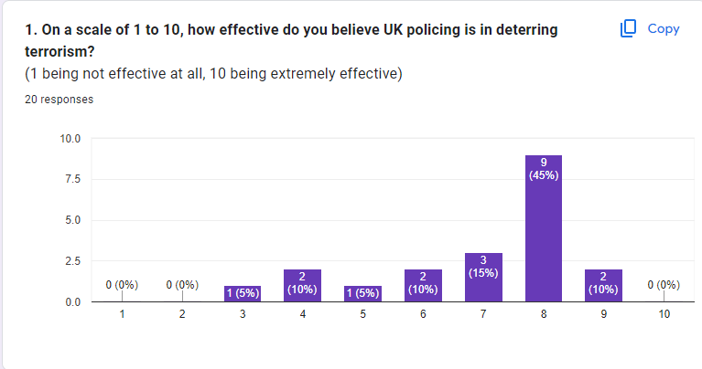
The results of this question are shown in figure 1.
The survey revealed that 70% of participants rated the effectiveness of UK policing in deterring terrorism as 7 or higher on a scale of 1 to 10. This indicates a strong majority perception that UK policing is effective in this area.
While the overall rating is positive, the fact that 30% of participants did not rate the effectiveness as 7 or higher suggests there are areas for improvement. Understanding the concerns and suggestions from this group could provide valuable insights for enhancing counter-terrorism strategies.
The survey result showing that 70% of participants rated the effectiveness of UK policing in deterring terrorism as 7 or higher is a positive indicator of public confidence and perceived success. This data can inform future strategies, highlight areas needing attention, and support policy decisions aimed at further enhancing the effectiveness of counter-terrorism measures.
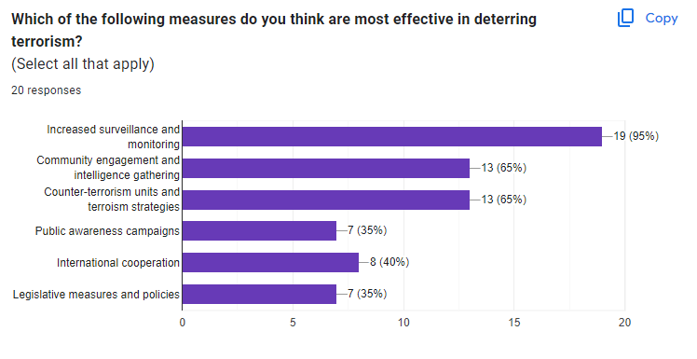
Figure 2: Which of the following measures do you think are most effective in deterring terrorism?

In the survey, when asked which measures are most effective in deterring terrorism, 95% of participants voted for increased surveillance and monitoring, while only 35% voted for legislative measures and policies. This indicates a strong preference for proactive and technological approaches over legal frameworks.
Increased surveillance and monitoring are widely regarded as effective tools in counter-terrorism efforts. One of the primary benefits of surveillance is its proactive nature. By detecting potential threats early, law enforcement can intervene before terrorist acts occur, significantly reducing the risk of attacks. Surveillance technologies provide real-time data, which is crucial for timely responses.
However, the extensive use of surveillance is not without its drawbacks. One of the most significant concerns is the potential intrusion on privacy. Increased surveillance can lead to significant privacy invasions, raising questions about the balance between security and civil liberties. Citizens may feel that their personal freedoms are compromised, leading to discomfort and distrust.
On the other hand, legislative measures and policies offer a different approach to counter-terrorism. Strong legislative measures provide a clear legal framework for counter-terrorism efforts, defining the powers and limitations of law enforcement agencies.
Despite these benefits, legislative measures also have limitations. One significant drawback is the potential delay in implementation. Legislative measures can take time to enact and implement, which can delay necessary actions to address immediate threats.

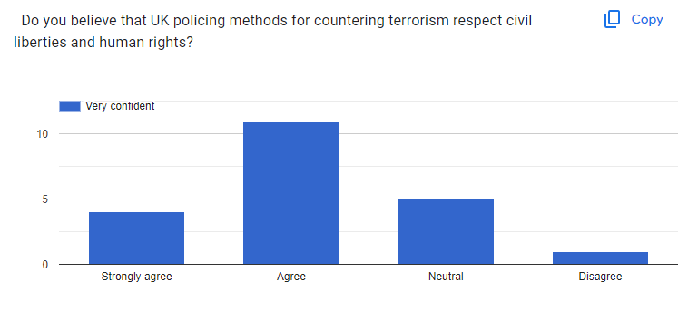
Figure 3: Do you believe that UK policing methods for countering terrorism respect civil liberties and human rights?
The survey results indicating that people believe UK police counter-terrorism efforts respect civil liberties and human rights suggest a high level of public trust in law enforcement. This perception likely stems from the UK's strong legal frameworks and oversight mechanisms designed to balance security measures with the protection of individual rights. The transparency and accountability in the police's actions, as well as adherence to laws such as the Human Rights Act, reinforce this trust. Additionally, public awareness campaigns and community engagement initiatives may have contributed to this positive perception by demonstrating the police's commitment to ethical practices and respect for civil liberties in their counter-terrorism efforts.


Figure 4: Can you describe any specific experiences or observations that have influenced your opinion on the effectiveness of UK policing in deterring terrorism?
Although I had 20 participants, only 7 persons answered this question.
Highlighting some of these responses:
Response 1: "I have never been involved or know anyone involved in a terrorist incident, which must mean it’s an effective."
This response reflects a personal perspective that associates the absence of direct involvement in or awareness of terrorist incidents with the effectiveness of UK policing. The respondent's belief in the success of counter-terrorism efforts is based on their lack of exposure to such events, suggesting a sense of safety and security attributed to the police's preventive measures.
Response 2: "Not really but I guess that’s a good thing, you always tend to hear about terror attacks, but never when one is successfully stopped before the attack itself. Maybe this is because giving attention to the attack would somewhat give the attack what they want which is attention worldwide."
Here, the respondent acknowledges the lack of visible counter-terrorism successes, inferring that this may be intentional to avoid giving terrorists the publicity they seek. This perspective implies trust in the police's ability to prevent attacks and suggests that the effectiveness of these efforts might be underreported to prevent glorifying terrorist acts.
Response 3: "Terrorism is seen all the time on the television, seems like there is a terrorism incident every day in London, seems like it’s tough to control in certain parts of the UK."
This response highlights a perception shaped by media coverage, which emphasizes frequent terrorist incidents, particularly in London. The respondent perceives terrorism as a persistent and uncontrollable threat in certain areas, indicating scepticism about the overall effectiveness of UK policing in those regions and reflecting the influence of media portrayal on public opinion.
Response 4: "Poor public relations as media exposure of criminality within the police force. Therefore, the public losing trust and respect within policing."
This response points to the negative impact of media coverage on public trust in the police, specifically regarding incidents of police criminality. The respondent believes that such exposure undermines public confidence in the police's ability to effectively deter terrorism, suggesting that internal issues within the police force and their portrayal in the media can significantly affect public perceptions of counter-terrorism effectiveness.

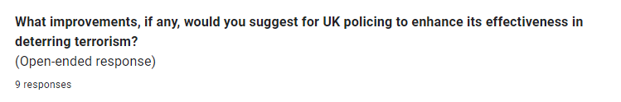
Figure 5: What improvements, if any, would you suggest for UK policing to enhance its effectiveness in deterring terrorism?

Although I had 20 participants, only 9 persons answered this question.
Highlighting some of these responses:
Response 1: "Implement programmes targeting young youths in an effort to prevent them from being a victim of radicalisation, as I feel the material available on the internet is far too obtainable and can cause a significant terror threat due to this."
This response emphasizes the need for preventive measures focusing on youth to counteract the threat of radicalization. The respondent suggests that accessible extremist material on the internet poses a significant risk, advocating for educational and intervention programs to safeguard young individuals. By addressing the root causes of radicalization and increasing awareness, such programs can potentially reduce the number of youths drawn into terrorist activities.

Response 2: "Continue to increase the security around it, extra funding to ensure public safety for example at concerts, games and big events."
This response calls for enhanced security measures and additional funding to ensure public safety at large gatherings, such as concerts and sporting events. The respondent believes that by bolstering security presence and resources at these high-risk venues, the police can better deter potential terrorist attacks. Increased funding would enable the implementation of advanced security technologies and the deployment of more personnel, thus enhancing the overall effectiveness of counter-terrorism efforts in protecting public spaces.

Conclusion

Introduction

This dissertation's earlier chapters have guided the research through the research through the introduction, research, and planning stages. The analysis and conclusions, which were gathered through a survey given to active police officers and general members of public, and comprised both quantitative and qualitative questions, were the subject of the most recent chapter.
Each chapter has achieved the objectives that were set out in the introduction. This chapter will seek to achieve the final objective: to evaluate whether UK police are an effective deterrent to terrorism in the UK.
This chapter will also provide a conclusion on whether these counter-terrorism measures are effective in preventing, detecting, and deterring terrorist activities.

Achievement of Objectives

Explain the history behind counter-terrorism policing and the changes in legislative laws surrounding it: This was successfully achieved during the literature review chapter.
Conduct an analysis of a survey on counter-terrorism measures from serving police officers and general members of public: An analysis of the survey which was distributed to serving general members of public and police officers within South Wales Police was successfully achieved within the Analysis of Results chapter. Appendix 1 & 2 at the end of this research project show the survey and answers provided to assist with the analysis.
Evaluate whether counter-terrorism policing is effective at preventing, detecting, and deterring terrorism: The final objective of this dissertation will be obtained within this final section of the conclusion

Main Findings
Many of the findings for this research project were established in the literature analysis as this provided the insight to counter terrorism efficiency and the changes to legislation due to historical events that occurred.
The evolution of counter-terrorism measures in the United Kingdom has been significantly influenced by historical events that have shaped and reshaped policies and practices over the years. Each major incident has prompted a reassessment of existing strategies and the introduction of new measures to enhance the effectiveness of UK policing as a deterrent to terrorism.

The 7/7 London bombings in 2005, in which coordinated suicide bombings on the London transport system killed 52 people and injured hundreds, led to a substantial overhaul of UK counter-terrorism policies. This tragic event prompted the government to introduce the Terrorism Act 2006, which included measures such as extending detention periods for suspects, outlawing the glorification of terrorism, and enabling the closure of premises used for extremist activities (Hoffman, 2006). The 7/7 bombings underscored the need for robust domestic counter-terrorism strategies, community engagement, and the integration of counter-radicalization programs like Prevent. The emphasis on community engagement was particularly significant, as it recognized the importance of addressing radicalization at the grassroots level.
The Manchester Arena bombing in 2017 further influenced the UK’s counter-terrorism approach. The suicide bombing at an Ariana Grande concert, which resulted in 22 deaths and numerous injuries, led to a review of counter-terrorism preparedness and response. The government launched the Contest Strategy 2018, focusing on four key areas: Prevent, Pursue, Protect, and Prepare. This strategy emphasized protecting crowded places, enhancing the capabilities of emergency services, and improving public awareness and vigilance. The Manchester attack highlighted the evolving nature of terrorist threats and the need for adaptive and proactive measures to protect the public.

Recent developments have continued to shape UK counter-terrorism policies. The rise of ISIS and the threat posed by returning foreign fighters led to the introduction of the Counter-Terrorism and Border Security Act 2019. This legislation includes measures to manage and prosecute returning fighters and to prevent individuals from traveling to conflict zones (Great Britain, 2019). Additionally, the growth of online radicalization has prompted initiatives like the Online Safety Bill, aimed at compelling tech companies to tackle extremist content and enhance online safety measures (UK Government, 2020).
The analysis of the results from the survey provides an insight to the views, opinions and personal experience of the general public as well as servicing police officers within South Wales Police. This survey was distributed to the general public and serving police officers, however an alteration would be considered, if the research project were to be conducted again. This would be to distribute the survey out to just police officers that are based within the United Kingdom as they provide a higher level of knowledge around counter terrorism due to their roles as police officers. The results showed that the participants were in agreement that UK police are an overall effective deterrent to terrorism within the UK.

My findings highlighted that UK policing faces significant challenges in effectively deterring terrorism. The evolving nature of terrorist threats, particularly the rise of lone-actor terrorism and the use of the internet for radicalization, complicates traditional policing methods (Horgan, 2014). The diversity of motivations and backgrounds among terrorists requires a multifaceted approach, integrating psychological, sociological, and criminological insights (Silke, 2018).

Resource allocation is another critical challenge. The need for specialised training, advanced technology, and comprehensive intelligence capabilities often strains the resources of police forces (Dodd, 2016). Additionally, the political and social climate, including issues of racism and discrimination, can undermine the legitimacy of police efforts in the eyes of some communities, making cooperation difficult (Choudhury & Fenwick, 2011).

One of the primary concerns among the public is the perceived erosion of civil liberties due to increased surveillance. The implementation of extensive surveillance measures, such as the Investigatory Powers Act 2016, often referred to as the "Snooper's Charter," has been criticized for granting law enforcement excessive powers (Liberty, 2018). Critics argue that these measures infringe upon individual privacy rights and can lead to a sense of mistrust between the public and the police (Gill, 2016).

Another significant issue is the perception of racial profiling and its impact on community relations. There have been numerous reports and studies highlighting the disproportionate targeting of ethnic minority communities, particularly Muslims, in counter-terrorism operations (Kundnani, 2014). Such practices not only alienate these communities but also undermine trust in the police, which is crucial for effective intelligence gathering and cooperation (Choudhury & Fenwick, 2011).

To conclude on this research project, there is no single study that confirms whether UK police is an effective deterrent for preventing, detecting or deterring terrorism and a lot of the research found that it is mainly opinion based, with mixed views of positive and negative experiences.
Police officers have a role to serve and protect, this means preventing, detecting and deterring criminal activities and ensuring the communities they serve are safe and free from crime. So, it is as necessity that in order to achieve this, they are required to provide an effective answer to terrorism, aided by different legislation.
Public access to information about UK police counter-terrorism measures and their effectiveness is limited due to the sensitive and classified nature of this information. However, there are several avenues through which some level of information can be accessed such as under the FOIA, individuals can request information from public authorities, including the police. However, requests related to counter-terrorism are often denied or heavily redacted to protect national security, operational effectiveness, and public safety.

Recommendations
Through conducting this research project, the researcher has enhanced their understanding of the effectiveness of UK police as a deterrent to terrorism, the historical development of counter-terrorism legislation, and public perceptions, particularly regarding the impact on certain communities’.
Recommendations can be made to police forces to incorporate into the training of new officers, aiming to provide a deeper understanding of the historical context of counter-terrorism measures and the rationale behind key legislative acts such as the Terrorism Act 2000. This context is crucial for comprehending the evolution of policing practices in response to the terrorist threat.
Enhanced intelligence sharing and coordination are paramount. The collaboration between various intelligence agencies, law enforcement bodies, and international partners must be strengthened to ensure timely and comprehensive sharing of intelligence related to terrorism threats. The development of integrated platforms and protocols that facilitate real-time information exchange while maintaining data security and privacy standards is essential for pre-emptive and effective counter-terrorism measures.
Community policing and engagement must be prioritised to build trust and cooperation between police forces and local communities, particularly those more vulnerable to radicalization. Investment in community policing strategies will foster relationships and cooperation that are crucial for the early detection of radicalization. Regular community outreach programmes and forums should be implemented to allow for open communication where community concerns can be voiced and addressed, fostering a culture of mutual respect and understanding.
Legislative support is necessary to underpin proactive policing and counter-terrorism efforts. Legislative measures that enable the pre-emptive detention of suspects based on credible intelligence should be advocated. It is crucial to ensure that new laws are regularly reviewed and updated to address evolving threats and challenges in the terrorism landscape.
Nationwide public awareness campaigns should be launched to educate citizens about the signs of radicalization and the importance of reporting suspicious activities to authorities. Collaboration with educational institutions to incorporate counter-terrorism awareness and resilience-building programmes into the curriculum will promote an informed and vigilant society.
Another recommendation would be to clarify the guidelines on what constitutes reasonable grounds for suspicion under counter-terrorism legislation. For instance, while certain behaviours or associations may be cited as grounds for increased scrutiny, the specific criteria should be explicitly defined to avoid ambiguity, potential misuse, and targeting of certain communities.
These recommendations are based on the research from this project and can assist in the education and development of police officers in relation to counter-terrorism measures, aiming to improve the effectiveness and fairness of these practices, overall giving the public more trust and confidence in the police through transparency at all levels.

Bibliography

Bergin, A., Woolner, D, Khosa, R. Bateman, A.S (2017). 'The Manchester Arena Attack: Implications for Counter-Terrorism'. Australian Strategic Policy Institute. Available at: https://www.aspi.org.au/report/manchester-arena-attack-implications-counter-terrorism
Blackbourn, J. (2014) 'Anti-terrorism law and policy: The case of the United Kingdom', Terrorism and Political Violence, 26(2), pp. 236-256.
Briggs, R., Fieschi, C. & Lownsbrough, H. (2006) Bringing it Home: Community-based Approaches to Counter-terrorism. London: Demos.
Bryman, A. (2016). Social Research Methods. 5th ed. Oxford University Press.
Burke, P., 2018. Counter-Terrorism Policing in the UK. London: Routledge:
Choudhury, T. & Fenwick, H. (2011) 'The impact of counter-terrorism measures on Muslim communities', International Review of Law, Computers & Technology, 25(3), pp. 151-181.
Clarke, R. (2018) 'The growing intersection of technology and counter-terrorism', Journal of Strategic Security, 11(1), pp. 1-22.
Coaffee, J. (2004) 'Rings of steel, rings of concrete and rings of confidence: Designing out terrorism in Central London pre and post September 11th', International Journal of Urban and Regional Research, 28(1), pp. 201-211.
Creswell, J. W., & Plano Clark, V. L. (2018). Designing and Conducting Mixed Methods Research. 3rd ed. SAGE Publications.
Denzin, N. K., & Lincoln, Y. S. (2018). The SAGE Handbook of Qualitative Research. 5th ed. SAGE Publications.
Dodd, V. (2016). UK anti-terror police fear funding cuts will put public at risk. The Guardian.
Ericson, R. V., & Haggerty, K. D. (1997) Policing the Risk Society. Toronto: University of Toronto Press.
Fenwick, H. (2008) 'The Anti-terrorism, Crime and Security Act 2001: A proportionate response to 11 September?', The Modern Law Review, 65(5), pp. 724-762.
Gill, P. (2016) 'The impact of intelligence-led policing on UK counter-terrorism', Policing and Society, 26(3), pp. 292-307.
Gill, P. (2016). Surveillance and the law: Language, power and privacy. Routledge.
Goldsmith, A., & Crawford, C. (2014) 'The digital revolution in policing', Policing and Society, 24(1), pp. 1-7.
Great Britain (2019) Counter-Terrorism and Border Security Act 2019. London: The Stationery Office.
Greer, S. (2008) 'Human rights and the struggle against terrorism in the United Kingdom', European Human Rights Law Review, 2, pp. 163-178.
Heath-Kelly, C. (2013) 'Counter-Terrorism and the Counterfactual: Producing the "Radicalisation" Discourse and the UK Prevent Strategy', The British Journal of Politics and International Relations, 15(3), pp. 394-415.
HM Government (2018) CONTEST: The United Kingdom’s Strategy for Countering Terrorism. London: The Stationery Office.
Hoffman, B. (2006) Inside Terrorism. New York: Columbia University Press.
Home Office, 2019. Protecting the UK against terrorism. [online] Available at: https://www.gov.uk/government/publications/protecting-the-uk-against-terrorism [Accessed 05 June 2024].
Horgan, J. (2014). The Psychology of Terrorism. Routledge.
Horne, A. (2016) Counter-Terrorism Legislation: Current Issues and Challenges. London: House of Commons Library.
Huckerby, J. (2014) 'Gender, counter-terrorism and international law', Human Rights Quarterly, 36(4), pp. 779-825.
Innes, M. (2006) Policing Uncertainty: Countering Terror through Community Intelligence and Democratic Policing. Basingstoke: Palgrave Macmillan.
Innes, M., & Levi, M. (2017). 'Reconfiguring Surveillance: The Emergence and Effectiveness of Monitoring Practices in Counter-Terrorism in the UK'. Journal of Policing Studies, 10(2), 150-167.
Innes, M., Abbott, L., Lowe, T., and Roberts, C., 2007. 'Seeing like a citizen: Field experiments in ‘community intelligence‐led policing’', Policing and Society, 17(1), pp. 3-26:
Jarvis, L., & Lister, M. (2013). 'Anti-terrorism, Citizenship and Security'. Manchester University Press.
Kundnani, A. (2012) 'Radicalisation: The journey of a concept', Race & Class, 54(2), pp. 3-25.
Kundnani, A. (2014). The Muslims are coming! Islamophobia, extremism, and the domestic war on terror. Verso Books.
Liberty. (2018). Liberty’s response to the draft Investigatory Powers Bill. Retrieved from https://www.libertyhumanrights.org.uk/
Lowe, D., 2019. Policing Terrorism: Research Studies into Police Counter-Terrorism Investigations. London: Routledge:
Lynch, O. (2013) 'British Muslim youth: Radicalisation, terrorism and the construction of the “other”', Critical Studies on Terrorism, 6(2), pp. 241-261.
Lyon, D. (2015). 'Surveillance after Snowden'. London: Polity Press.
Macdonald, S. (2007) 'A closer look at anti-terrorism law and its impact on freedom of expression', Public Law, Autumn, pp. 386-404.
Metropolitan Police Service, 2021. Counter Terrorism Command Strategy. London: Metropolitan Police Service:
Myhill, A. (2006) Community Policing: A Review of the Evidence. London: Home Office.
Mythen, G., Walklate, S. & Peatfield, E. (2017) 'Assembling and disassembling security in the UK counter-terrorism strategy: The Localism of Prevent', Critical Social Policy, 37(2), pp. 250-270.
Mythen, G., Walklate, S., & Khan, F. (2009). '‘I’m a Muslim, but I’m not a Terrorist’: Victimization, Risky Identities and the Performance of Safety'. British Journal of Criminology, 49(6), 736-754.
Neumann, P. R. (2009). 'Old and New Terrorism'. Polity Press.
Oxford English Dictionary (2024) 'Terrorism'. Available at: https://www.oed.com (Accessed: 24 May 2024).
Pantazis, C. & Pemberton, S. (2009) 'From the ‘old’ to the ‘new’ suspect community: Examining the impacts of recent UK counter-terrorist legislation', British Journal of Criminology, 49(5), pp. 646-666.
Ratcliffe, J. H. (2008) Intelligence-Led Policing. Cullompton: Willan Publishing. Routledge.
Schuurman, B. (2019). 'Research on Terrorism, 2007–2016: A Review of Data, Methods, and Authorship'. Terrorism and Political Violence, 31(7), 1486-1513.
Silke, A. (2018). Understanding Terrorism: Analysis of Sociological and Psychological Aspects. Wiley.
Simpson, A. (2012) 'Challenging the “security-first” approach to terrorism post 9/11', Critical Studies on Terrorism, 5(3), pp. 385-402.
Spalek, B. (2010). 'Community Policing, Trust, and Muslim Communities in Relation to ‘New Terrorism’'. Politics & Policy, 38(4), 789-815.
Taylor, E. (2018) 'Predictive policing: The intersection of big data and law enforcement', Annual Review of Criminology, 1, pp. 473-493.
Thomas, P. (2017). 'Changing Experiences of Responsibilisation and Contestation within Counter-Terrorism Policies: The British Prevent Experience'. Policy & Politics, 45(3), 305-321.
Thomas, P., 2012. 'The UK’s Prevent Strategy: An Evaluation', Journal of Social Policy, 41(2), pp. 237-256:
UK Government (2020) Online Safety Bill. Available at: https://www.gov.uk/government/publications/draft-online-safety-bill (Accessed: 02 June 2024).
Walker, C. (2011) Terrorism and the Law. Oxford: Oxford University Press.
Lennon, G. and Walker, C. eds., 2015. Routledge handbook of law and terrorism (Vol. 58). London: Routledge.
Wilkinson, P., 2011. Terrorism Versus Democracy: The Liberal State Response. 3rd ed. London:

Appendix One – Questionnaire

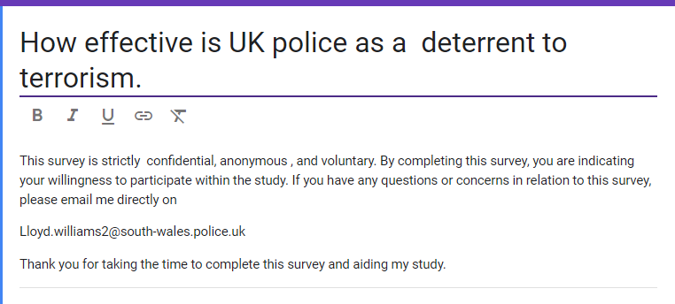



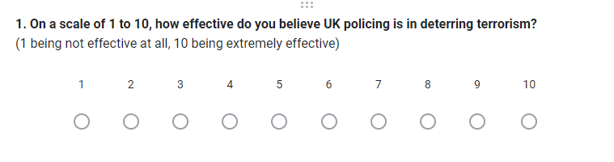
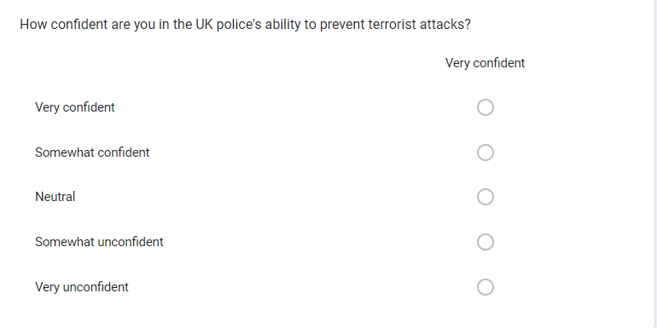

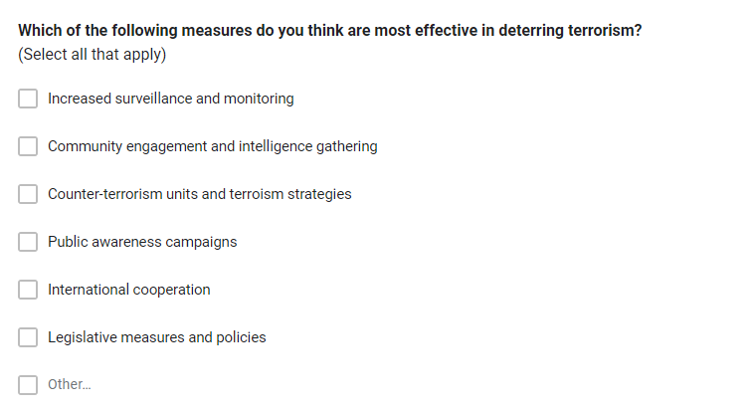

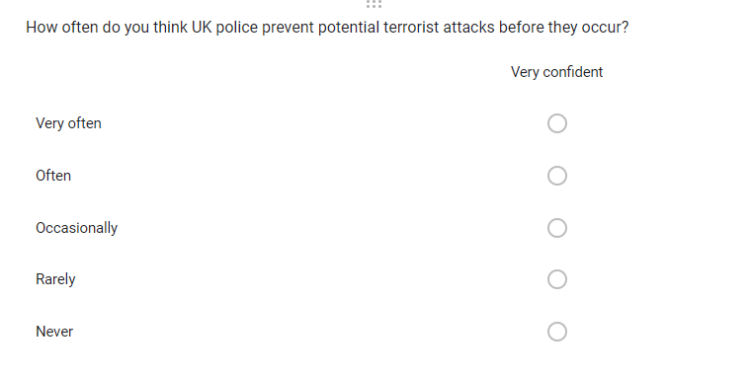
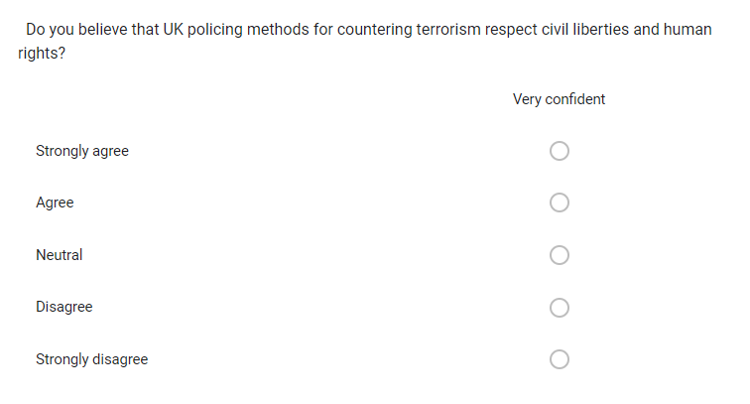

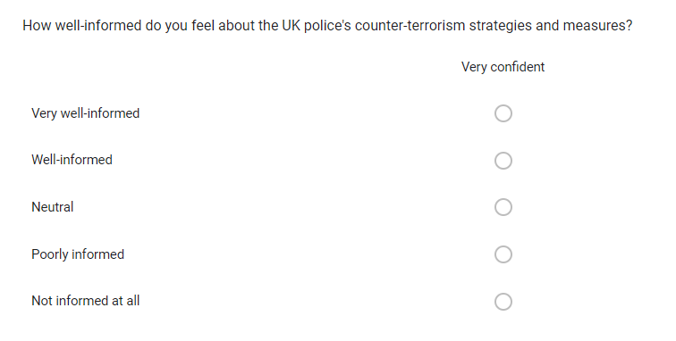
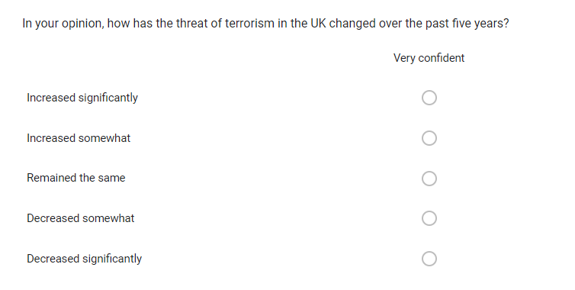

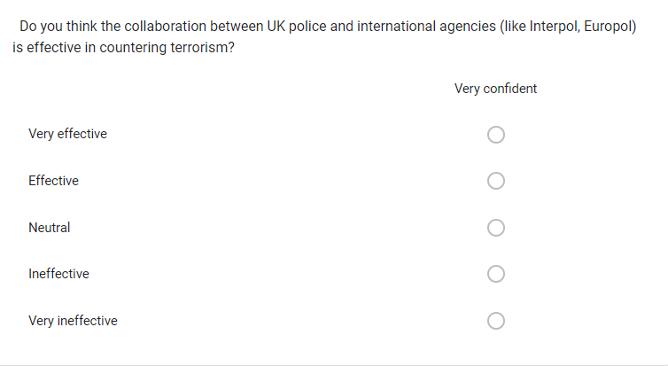

Appendix Two – Questionnaire Results




