Targed/Target 1 | Try to be more discerning in your choice of quotation to use or concept to raise from literature. Sometimes, the literature cited does not match the point you are trying to develop.  I have tried to implement this target and made sure that the literature links with the point I am making as this will enable a clear perspective.
Targed/Target 2 | Proof-read your work to ensure that all sentences are coherent.  I have proof-read my work several times before submitting to ensure it is clear, the punctuation is correct and to make sure I have included all themes. I have also asked family members to read it afterwards for clarity.
Targed/Target 3 | Ensure that you define any relevant terms.  I have made sure I have clearly explained any relevant terms which will make it clear for the reader.
Targed/Target 4 | Aim for clarity in your work.  I have tried not to over complicate my sentences to make sure they are clear.
A proposal for a School Community Project
The purpose of this essay is to compose a proposal for a community project for my Professional Teacher Experience (PTE) school. As stated by Welsh Government (2020), throughout a school's curriculum, it is essential to ensure learners have the opportunity to play a role within their community and broader society. Estyn (2018) state there are very few schools in Wales, where the teaching and learning experiences are excellent. Research from a case study shows teachers in the outstanding schools, provide pupils with innovative, creative and stimulating learning opportunities. This statement demonstrates the importance of making learning meaningful and stimulating for all learners to ensure progression is being made through all aspects of learning and development. Implementing a collaborative learning experience with members of the local community can have an extremely positive impact on the learner’s ambition and motivation (Estyn, 2019). The statements above have been put to attention as they are the driving force for the project proposal.
Throughout the proposal, the school will be named school A; this will ensure all information is kept private and confidential. School A is located in a small rural locality with ninety-two children altogether. Of the 92 pupils, 7.4% are currently eligible for Free School Meals (FSM), which is below the national average (Welsh Government, 2019). Nearly all pupils are of white British ethnicity and speak English as their first language, with very few children speaking Welsh at home (Estyn, 2015). The Pupil-Teacher Ratio (PTR) is 22.2; as a result of this high ratio, small schools often rely on parents, careers, volunteers and members of the community for support. The school is already involved with the community in many ways; for example, after school clubs, school trips, swimming lessons, school fayres, frequent parent engagement forums and “friends of the school”. Friends of the School are parents who are highly involved with the development, organisation and progress of the school. According to Head Teacher at School A, the whole school philosophy is centered on listening to the pupils’ voice, to promote engagement within their learning, to support and involve families and the community, to develop a resilient Welsh ethos and to guarantee all children are given the best opportunities' possible, to ensure they develop into the four purposes (Headteacher, 2019).
A project proposal is a structure which is used to determine the concept of the project, it includes the aims and objectives, procedures, how it will be accomplished and what must be achieved (Akalp, 2016). The project proposal is grounded upon meeting the requirements of School A’s School Development Plan (SDP). According to Welsh Government (2014), the SDP is a school's strategic plan which includes actions and priorities which need to be met every three years, this will ensure improvement and progression is being made at every level of the school will increase learners outcomes whilst raising standards of teaching and learning. Similarly, Estyn (2016 ) state to sustain high standards, it is vital for leaders and staff to define a clear vision and strategic direction for the school, this will support the progression of achieving the priorities. The report also expresses the importance of involving stakeholders within the community which will enable the school, teachers and learners to prosper.
The focus for the proposal is based on a whole school Entrepreneur Enterprise Project which involves rich learning opportunities, engagement with the local community and opportunities for the pupils to advance into the four purposes. Providing children with a community based enterprise project incorporates authentic learning; it helps pupils’ to establish relationships and develop as enterprising and creative contributors which will assist them to develop connections with the world of work and advance their ambitions (Welsh Government, 2020). On the subject of establishing positive relationships is a vital skill that all children will require throughout their whole lives, Joseph and Strain (2010) state building positive relationships with children is an fundamental duty and foundation component of excellent teaching.
In school A's SDP, there are six priorities that have been addressed to improve the school. The priority chosen for the focus of the project is priority six, “to ensure standards are raised in Literacy and Numeracy Skills”. This priority was chosen as the main focus is because raising standards in Numeracy and Literacy is a national mission across Wales (National Assembly for Wales, 2013). The Program for International Student Assessment (PISA) results undertaken in 2018 by children in Wales (Welsh Government , 2019). A conference led by the Education Minister, showed the average reading scores of learners in Wales was 483, which has not changed drastically since PISA 2006 where the score was 481. However, in mathematics, there has been an increase in the mean score compared which was 487 in comparison with PISA 2012 where the score was 468 (Williams, 2019). This demonstrates the importance of continuing to develop mathematical and literacy skills in an engaging, meaningful way, as well as being able to embed, sustain and improve learning (Welsh Government, 2019).
The Coronavirus Pandemic has impacted directly on all lives and demonstrates the importance of communities and what we can do to support and care for others. Therefore, the project ambition is for the teachers and children within school A to raise enough money through the Enterprise Fayre, to construct a communal garden area for the local community (see appendix 1). The garden would provide an opportunity and location to build a positive response for an exceptional situation; a place to show gratitude to the Key Workers who put their lives at risk for the community. In relation to meeting the child’s developmental needs. As the global issue has affected everybody - from very young children to parents, siblings, cousins, grandparents, great-grandparents, friends and neighbours. It is imperative for the community to promote community spirit and engagement. Utilising the inspiration shown by Key Workers and people such as Captain Tom Moore, who defines the importance of looking after each other and enhancing lives and learning. The project will only take place once the government announces it is safe to do so and the lockdown is lifted.
The Curriculum for Wales 2022 will be the drive and energy for the project. The four purposes must be the shared vision and ambition for every child and teacher, to fulfil this, practitioners must set high expectations throughout each task (Welsh Government, 2020). The project encourages real-life experiences, which is extremely useful as it develops life-long skills which the children will be able to use for their future. For example; budgeting, costing, communicating, socialising, planning, producing and organising. Vygotsky's (1978) theories emphasise the importance of social interaction in the development of cognition, as he believed the community plays a fundamental role in making learning meaningful (McLeod, 2018). Creating meaningful experiences is an encounter that passionately engages and drives a child to want to learn and understand, the experience can grasp their attention on many intellectual levels; emotionally, socially, sensory and physically (Barnes, 2015).

The cross-curricular responsibilities will be implemented throughout the Enterprise lessons together with the Areas of Learning and Experiences (AoLE); Mathematics, Literacy, Expressive Arts, Science and Technology, Humanities and Digital Competence Framework (DCF). A cross-curricular approach in the Curriculum for Wales 2022 is seen as fundamental; it explains the importance of educating using an inclusive approach which enables learners to develop life-long skills in comparison to planning for the skills and subjects individually (Welsh Government , 2020). Cross-curricular teaching not only enables teachers to educate variegated subjects, but to allow teachers and pupils to work cooperatively to discover a common vision for their working environment which meets all's requirements (Barnes, 2015). Conversely, Hayes (2010) disagrees, permitting children too much pupil choice, allows them to avoid areas of learning that they find challenging or dislike. As a result of giving children too much choice, this teaches children bad work habits and poor mindsets. Tonarely (2008) also states allowing children the opportunity to choice can sometimes cause disagreements as all children have different preferences and therefore, not all needs are put into account.

It is essential through every aspect of the project to ensure learning and learning opportunities are maximised, however, it is also crucial for the children to understand the purposeful nature of the project. Therefore, at the beginning of the enterprise week, it will be essential for the children of School A to attend a whole school assembly to initiate and establish the aims and purposes of the task. The assembly will discuss the lockdown and will permit the children to talk about what has occurred over the past few months. This discussion will cascade and continue in classes and smaller groups throughout the week. UNICEF (2020) state encouraging children to communicate and ask questions on the subject of the Coronavirus and how their lives have transformed will enable them to express their feelings, which is vital for promoting well-being. Discussion using the following questions as stimuli will be asked - "How many of you put a rainbow up in their house?", "How many of you clapped at 8 pm on a Thursday?", “How many of you saw Captain Tom Moore do his walk and celebrate his special birthday?” and “Did any of you count the teddies on your daily walk?”, This will establish the meaning of ‘thankfulness and gratitude’. Whilst discussing the pandemic educators must use age-appropriate vocabulary, ensuring all children regardless of age or ability understand and are engaged in the assembly.

The children will have a visual timetable in their classrooms of what their week will look like (see appendix 2). They will start their project by undertaking some digital research on a possible product idea that they can make and sell. This will be supported by the progression step 2 - Sourcing, searching and planning digital content of the DCF “I can develop strategies for finding specific information/media using different techniques and keywords (Welsh Government , 2020, p. 31). This task will be adapted to all ages and will enable them to research what has been useful in other schools or events, there will be visual templates for the children to follow while doing their research (see appendix 3).

Once the children in each year group have products ideas, they will them progress further into the Enterprise phase. Here are some examples of what each year group will be making. Nursery/ Reception will make clay flowerpots; Year one will create candles; Year two will become a bakery where they will make cakes and biscuits; Year three will create stationery, cards and bags; Year four will create soap; Year five will make jewellery and Year 6 will create cushions (see appendix 4). Reflecting back on my PTE I have created many of these creative products with a range of ages and abilities. Each activity had shown positive effects on the children’s attitude and engagement to learning, which was extremely rewarding for myself.

The children will then have the opportunity to meet individuals from the local community for support with their chosen product. Inviting members of the community into school is pursuing Vygotsky’s (1978) theory of the more knowledgeable other, as this enables the children to learn from someone else who has a better understanding and a higher ability of knowledge in comparison to themselves, this then assists them to progress their understanding and skills (McLeod, 2018). To show an example; employers from the bank (fund matching may well be possible if a parent works in the bank), managers from Tesco, small business owners (sewing, soap, bakers, jewellery, pottery, knitters, gardeners, bee keepers, farmers, care homeowners etc.), project managers and marketing directors. Meeting diverse entrepreneurs from the community will inspire and stimulate pupils’ range of ideas, optimism, designs, mindsets and products. In a case study, Estyn (2019), clarified there was excellent practice produced in a primary school where practitioners provided a variety of rich learning experiences by inviting members of the community into the school. The impact it had on the children’s attitude to learning was extremely positive as the study proved that pupils' felt motivated and enthusiastic about their learning. The case study demonstrated, by inviting members of the community into the school to share their experiences were very beneficial opportunities for the children, to extend their numeracy and literacy skills.

Towards the end of the Enterprise week the children will have the chance to sell their products to parents, careers and members of the community, and this will give the children a real sense of running their own school business. Akalp (2016) supports the importance of this stage, she states that enabling children to become involved in business enterprise ventures, allows them to develop invaluable life experience and develops practical life skills; organisation, money management, problem solving and communication.
Although the Enterprise week will finish, the development of the communal garden will continue to develop and progress. Pound (2006) includes an aspect of Owen’s (1815) theory of learning, he states learning outdoors is beneficial for all children, he believed that children should spend substantial amounts of time each day outdoors as it develops exploration and enquiry. This shows how beneficial a garden area would be to the children of School A. The area will embrace many memories and learning experiences for the future generation which will allow all children to learn in a natural and safe environment. To show an example, Welsh singing practice with members of the care home, growing and planting sessions with local farmers, collecting honey with bee keepers, decorating the community garden with the ‘yarn bombers’, learning new skills with local business owners, soup making from home grown vegetables, sewing with the elderly, educational workshops, science investigations and many more.

Reflecting on the progress, impact and aims at the end of a project is a crucial factor to consider. An undependable website named Continuing Professional Development (2014 ) states setting aims and objectives for a project will enable you to identify your destination which will also provide you with a clear route on how to get there. A goal-setting theory created by Locke and Latham (1990) supports this though as they understood, setting high goals, aims and objectives will indicate a positive attitude and enhanced well-being. The theory also explains providing a clear and engaging direction for staff and the pupils is crucial as it will support their understanding and engagement to the project’s purpose and aims.

The predominant aim for the project proposal is to ensure learning and development is at the heart of the project as this is about developing skills and understanding. The aim was taken from school A’s SDP to raise standards in mathematics and literacy skills. It is crucial to incorporate the four purposes, the three cross-curricular skills and aspects of the six AoLE’s. Throughout the enterprise project, the children will have the opportunity to develop these skills and many more through real-life experiences. Estyn (2019) state, the excellent practice has been perceived in schools where they have created real-life stimulating and meaningful experiences in comparison to following lesson schemes and plans, they did this by listening to the pupil's perspectives and engaging with the local community. The study showed that all teachers have observed that pupils show more interest in their work and, as a result, standards have been raised. They also observed that with pupils playing such a strong role in their education, the pleasure and determination to do their best was evident.
Another fundamental aim is to develop and maintain stronger links between the community and the primary school. Sanders and Harvey (2002) state there is a leading requirement for schools to engage with the community, local businesses and other schools within their local area. Doing this creates stimulating, approachable and encouraging learning environments for everyone. Within the article they explain, children do not have the appropriate support when it comes to educational resources as this is beyond the scope of the school. Therefore, this urges the importance to collaborate with outside communities to develop strong relationships to allow professionals and learners to benefit from these amenities. Epstein’s theory supports this, the theory of ‘Overlapping Spheres of Influence’ which is home, school and the community, identifies as the key factors which can construct or destruction a student success (Epstein et al. 2019). She explains the community as one of the primary environments in which children learn, however, all three spheres of influence must work collaboratively to ensure the academic success and socio-emotional well-being of all students is at the heart of the school. Epstein also states that the main reason why it is essential to create partnership and community links is to help all learners thrive in school and life to their full potential.
According to Welsh Government (2019) the budget per pupil in School A is £3885. As the scale of the school is small this results in less funding in comparison to bigger schools within the local area. Therefore, holding an Enterprise Project in this primary school may be an issue due to less available money. Each class will be allocated £50; as there are six classes the overall budget will be £300. There will also be stalls for the Enterprise day which will include hotdogs, squash, tea, coffee and sweet stalls; however, the school have been very fortunate as our local Tesco store has donated this as a thoughtful gesture. The total budget for the school will be £300. The children need to be aware of this from the start to understand that they need to raise £300 back before they create a profit. Once the children are aware of the cost, they will then be able to find the materials they need at the lowest possible prices in order to maximize production, this task will be essential to discuss throughout the mathematical costing lesson.
Arranging an Enterprise Project on a small rural school could initiate problems. Having less staff could make the project less effective, however, it is imperative to utilise all staff to its full capacity but also in incorporate parents, community members, volunteers and the friends of the school. However, Welsh Government (2018), clarify that the safeguarding of vulnerable groups is considered as paramount, therefore is it vital to remember that anybody who enters the school premises must have a Disclosure and Barring Service (DBS) check beforehand. A brief overview has been planned for the organisation of staff at School A; four fully qualified teacher will be placed separately into year Nursery/Reception, year 1/2, year 3 and 4, year 5 and 6. The two HLTA's will be placed into Reception/Nursery and years1/2 all of the volunteers and friends of the school will work with the different classes as appropriate.
According to EEF (2020), one of the significant transformations in education in the United Kingdom is the importance of understanding impact. This can be done on large and small scales by focusing on the influence of interventions, projects, teaching approaches and implementation of the school curriculum. Therefore, the impact of the project will be measured in several diverse methods. This will ensure enough information is gathered from different perspectives from the community, parents, teachers, children and myself.

Throughout the project, there will be a variety of short-term and long-term impact evaluations taken before, throughout and after. The children will take the responsibility to measure the impact they have had on the community and reach conclusions regarding the garden project. The first task will be based upon the What Matters Statement “statistics representation of data, probability models chance, and both support informed inferences and decisions” (Welsh Government, 2019, p. 2). The document states, the process of reasoning with data and statistics, improves analytical skills and critical thinking, these attributes are essential to allowing learners to make ethical and informed choices. The children will create a community 'check-in' survey, both electronically and paper depending on the skills of the individuals. The surveys will be given to members of the community before they attend the communal garden, during and after. Doing the survey will give the children and teachers a sense of whether it has had a positive effect on well-being in the community. This impact mission will allow children of all ages to create a survey which will be suitable to people of all ages and abilities within the community.

The children will also measure another aspect of the project, as they will become investigators, who will have the opportunity to develop their mathematical and DCF skills. It will be their duty to gather and then interrogate the data to monitor the number of people attending the communal garden. This will be done through a weekly mathematical mission, which will include, graphs, trips to the garden, and mean median and mode calculations. Giving children the duty to gather real-life data enables them to gain authority and confidence in their work (Welsh Government , 2020). This impact lesson will meet the Numeracy and Literacy requirements concerning the SDP, as it allows the pupils to learn in genuine environments which encourages them to practice their language skills in order to gather numerical data.

Impact will also be measured by teachers of School A. It will be the teachers' role to answer specific questions based on the influence of specific learning objectives. Hattie and Clarke (2019) state, the fundamental moderators to measure impact is feedback. The book explains that people need feedback to track progress concerning the aim. This data will then be analysed, which will enable me to measure the impact. Putting this into consideration, several questions will be given to the staff to gain feedback on the project. Who benefits from the project? What are the aims of the project, have the aims been met? What do you and others to do to make a difference? How has learning progressed? This data will then be analysed, which will enable me to measure the impact.

Finally, the long-term measurement of impact will be judged by the well-being of the community, engagement and learning outcomes. The well-being will be measured on a long-term visual basis, as will enable everyone to become involved and visit the community garden. Observation skills will be essential during this section as it is important to see members of the community express feelings of gratefulness and appreciation. Gratitude is believed to be one of the healthiest feelings that humans can practice, being grateful has many positive benefits for a child's social development as it allows them to have more self-control as they can become sensitive towards others and think about other people's perspectives (Wow Parenting, 2019).

Throughout the project proposal, it is important to identify strengths, weaknesses, opportunities and threats (SWOT), as a result of this a SWOT analysis has been undertaken to show these areas. Houben et al. (2017) state that active enterprise projects and businesses often incorporate appropriate interaction with the project's management of internal and external environmental factors and how this can influence the effectiveness of the project. Conversely, Queensland Government (2017 ) state that there are several limitations for using SWOT analysis. A SWOT analysis does not prioritise issues, it does not provide solutions or offer alternative decisions, it can generate too many ideas, and it can produce much information, and finally, not all of the information is useful.
The SWOT analysis contains several strengths and weaknesses within the project (see appendix 5). To show an example of the strengths; money handling and budgeting skills, social interaction with people within the community and organisational proficiencies. All of these skills are key for the learners to develop into the confident individuals of Wales (Welsh Government, 2020). However, although there are many strengths, there also lies some weaknesses. As school A is small, this results in less staff, space and money. All three factors could cause problems for the project, and these areas need to be considered throughout the planning process in order to make the project manageable and successful. Another aspect of the SWOT analysis incorporates opportunities and threats; an example of the opportunity the project brings is strengthening the relationship between the community and the school and to develop the four purposes. Again, although there are many positives that come along with the project, the threats are based on the size of the school and possible lack of parental engagement in relation to exposing their children to information about COVID-19.
For future development, there are several areas which could be progressed to enhance the enterprise project. To show an example, it is a possibility that other local schools can come and visit our communal garden. We could also join our enterprise projects with several schools in our local area which will result in one large enterprise fair. Finally, to invite small local businesses into the communal garden to sell their products to the community; for example; local eggs and natural honey. Inviting local businesses is seen as good practice according to Estyn (2017 ), many schools now keep chickens and animals to enrich the school curriculum, a school in Wales saw this opportunity as a way to expand the school's learning environment that allowed pupils to expand and progress their literacy and numeracy skills through more relevant, contextualised tasks.
To conclude, the enterprise project proposal is an effective way to raise standards in Numeracy and Literacy in a way that stimulates the children’s learning, develops the four purposes and produces authentic real-life learning. The enterprise project enables learners to develop many cross-curricular skills which are extremely useful for their future. As mentioned previously by Estyn (2014), in outstanding schools, standards have been raised from the children’s participating in business enterprise projects. The report states that enterprise projects have had a significant impact on developing a pupil's life, math's and literacy skills. Putting this into consideration, to meet the SDP target to raise standards in maths and literacy, implementing an enterprise project which engages with the local community and develops real-life learning will be extremally successful and valuable.
My aspiration is to bring a project like this to a Primary school as I feel it meets all the recommendations of the curriculum for Wales, involves members of the community and produces meaningful learning for everyone. Nevertheless, as the Coronavirus pandemic was an extremely real situation it is important as members of the community to remember the people who risked their lives and worked consistently during the outbreak and the people who sadly lost their lives. This community garden will be created to maintain the strong and resilient links established during pandemic even after normal life is continued.

References
Akalp, N (2016) Entrepreneur Europe. Available at: https://www.entrepreneur.com/article/276753 (Accessed 9 June 2016).

Barnes, J (2015) Cross-Curricular Learning 3-14. 3rd ed. London: Sage.

Continuing Professional Development (2014) How Setting Goals and Objectives for Projects Leads to Successful Outcomes. Available at: https://continuingprofessionaldevelopment.org/setting-goals-and-objectives-for-projects-leads-to-successful-outcomes/ (Accessed no date 2014).

EEF (2020) Education Endowment Foundation: Assessing and Monitoring Pupil Progress. Available at: https://educationendowmentfoundation.org.uk/tools/assessing-and-monitoring-pupil-progress/measuring-impact/ (Accessed 2020).

Epstein, J. et al. (2019) School, family, and community partnerships: Your handbook for action.. 4th ed. London: Corwin Press.

Estyn (2014) Business enterprise improving skills, Cardiff: Welsh Government.

Estyn (2015) A report on Hook C.P School, Cardiff: Welsh Government.

Estyn (2016) Leadership and Primary School Improvement. Available at: https://www.estyn.gov.wales/sites/www.estyn.gov.wales/files/documents/Leadership%20and%20primary%20school%20improvement%20(002)_0.pdf (Accessed September 2016).

Estyn (2018) Estyn: The Annual Report of Her Majesty’s Chief Inspector of Education and Training in Wales 2017-2018. Available at: https://www.estyn.gov.wales/sites/www.estyn.gov.wales/files/documents/ESTYN_Annual%20Report_Accessible_English__2018.pdf (Accessed September 2018).

Estyn (2017) A school farm that helps improve pupils’ numeracy and literacy skills, Cardiff: Welsh Government .

Estyn (2019) Local community visits provide opportunities to enrich children’s learning experiences. Available at: https://www.estyn.gov.wales/effective-practice/local-community-visits-provide-opportunities-enrich-childrens-learning (Accessed October 2019).

Estyn (2019) Using stimulating learning activties. Available at: https://www.estyn.gov.wales/effective-practice/using-stimulating-learning-activities (Accessed March 2019).

Hattie, J. and Clarke. S (2019) Visible Learning Feedback. London: Routledge.

Hayes, D (2010) The seductive charms of a cross-curricular approach. Education 3–13. no name, 38(4), pp. 381-387.

Headteacher (2019) Interviewed by Emily Wonnacott for School A project, 01 November.

Houben, G. et al. (2017) A knowledge-based SWOT-analysis system as an instrument for strategic planning in small and medium sized enterprises. Decision Support Systems, 26(2), pp. 125-135.

Joseph, G. and Strain. P (2010) Building Positive Relationships with Young Children, Colorado: Vanderbilt University .

Locke, E. A. and Latham. G (2006) New directions in goal-setting theory. Current directions in psychological science, 15(5), pp. 265-268.

McLeod, S (2018) Simple Psychology.
Available at: https://www.simplypsychology.org/vygotsky.html#social
(Accessed 2018).

National Assembly for Wales (2013) National Assembly for Wales Research Paper. Literacy and Numeracy in Wales.
Available at: https://www.assembly.wales/Research%20Documents/Literacy%20and%20Numeracy%20in%20Wales%20-%20Research%20paper-03062013-246762/13-039-English.pdf
(Accessed June 2013).

Queensland Government (2017) Benefits and limitations of SWOT analysis.
Available at: https://www.business.qld.gov.au/starting-business/planning/market-customer-research/swot-analysis/benefits-limitations
(Accessed 18 July 2017).

Sanders, M. and Harvey, A (2002) Beyond the school walls: A case study of principal leadership for school-community collaboration. Teachers college record, 104(7), pp. 1345-1368.

Tonarely, K (2008) Advantages and Disadvantages of Classroom Projects.
Available at: https://classroom.synonym.com/advantages-disadvantages-classroom-projects-7933801.html
(Accessed no date 2008).

Unicef (2020) 5 ways to help keep children learning during the COVID-19 pandemic.
Available at: https://www.unicef.org/coronavirus/5-tips-help-keep-children-learning-during-covid-19-pandemic (Accessed 30 April 2020).

Welsh Government (2018) Buisness Wales; The Disclosure and Barring Service (DBS) basic checks.
Available at: https://businesswales.gov.wales/news-and-blogs/news/disclosure-and-barring-service-dbs-basic-checks (Accessed 23 February 2018).

Welsh Government (2019) Achievement of 15 year olds (Program for International Student Assessment) PISA national report: 2018. Available at: https://gov.wales/achievement-15-year-olds-program-international-student-assessment-pisa-national-report-2018 (Accessed 3 December 2019).

Welsh Government (2019) Achievement of 15-Year Olds in Wales: PISA 2018 National Report. Available at: https://gov.wales/sites/default/files/statistics-and-research/2019-12/achievement-15-year-olds-program-international-student-assessment-pisa-national-report-2018_0.pdf (Accessed December 2019).

Welsh Government (2019) My Local School. Available at: http://mylocalschool.gov.wales/School/6682228?lang=en (Accessed no date 2019).

Welsh Government (2020) Curriculum for Wales Guidance. Available at: https://hwb.gov.wales/storage/afca43eb-5c50-4846-9c2d-0d56fbffba09/curriculum-for-wales-guidance-120320.pdf (Accessed January 2020).

Welsh Government (2020) Digital Competence Framework. Available at: https://hwb.gov.wales/curriculum-for-wales/cross-curricular-skills-frameworks/ (Accessed January 2020).

Welsh Government (2014) School Development Plan. Available at: https://gov.wales/sites/default/files/publications/2018-03/school-development-plans.pdf
(Accessed October 2014).

Welsh Government (2019) AREA OF LEARNING AND EXPERIENCE Mathematics and Numeracy. Available at: https://hwb.gov.wales/curriculum-for-wales/mathematics-and-numeracy/statements-of-what-matters/ (Accessed 28 Janurary 2020).

Williams, K (2019) Conference avaliable at: http://www.senedd.tv/Meeting/Archive/ae861b17-9e76-485e-8f4e-b2529b03b02c?startPos=4910&autostart=True#, Cardiff: Senedd.tv.

Wow Parenting (2019) Why is gratitude important for kids?.
Available at: https://wowparenting.com/blog/why-gratitude-is-important-for-kids/ (Accessed 15 February 2019).

Appendix 1 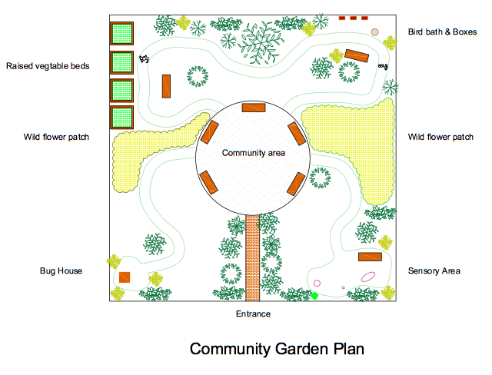

Appendix 2

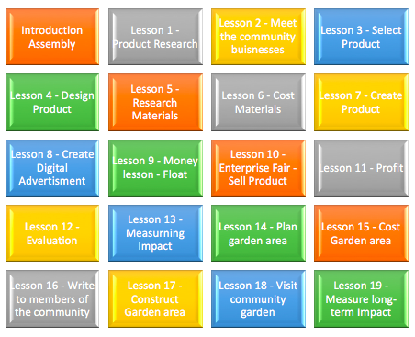

Appendix 3

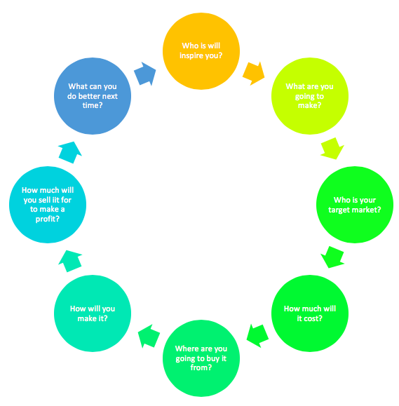


Appendix 4
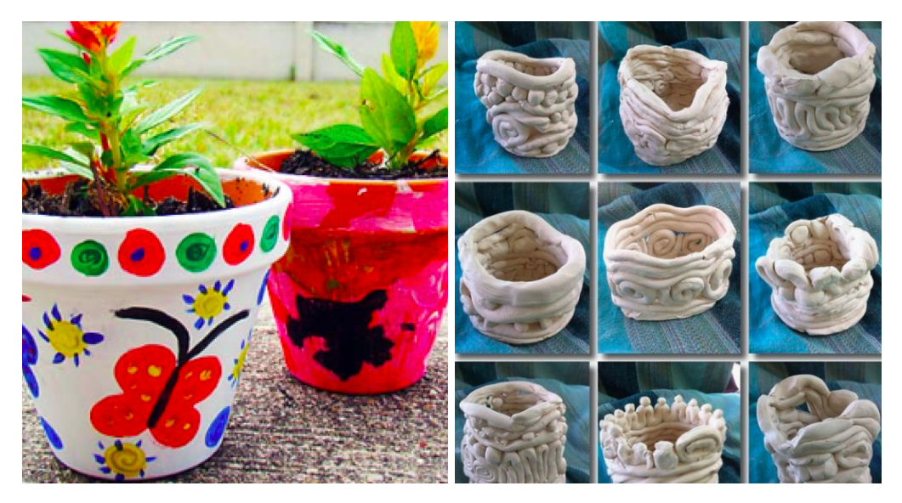

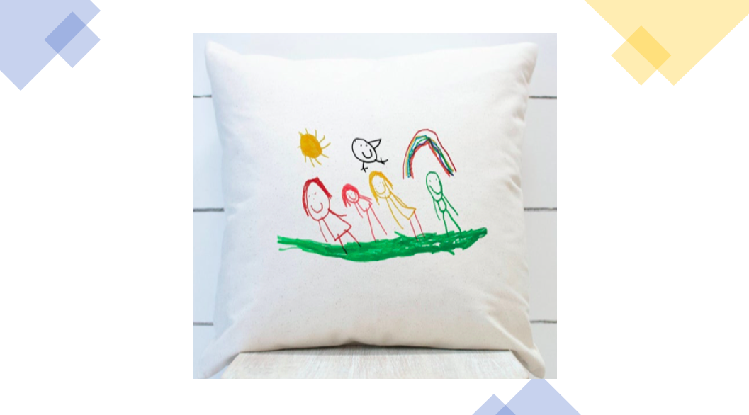

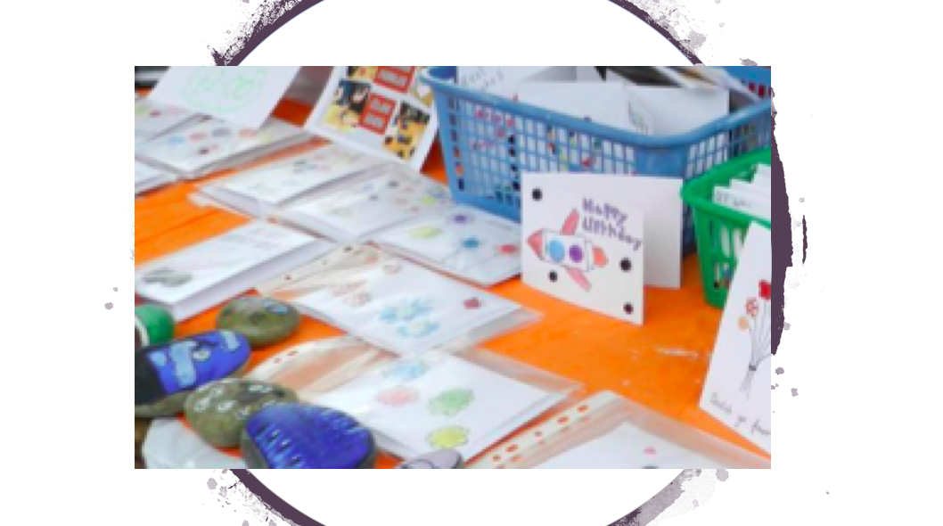


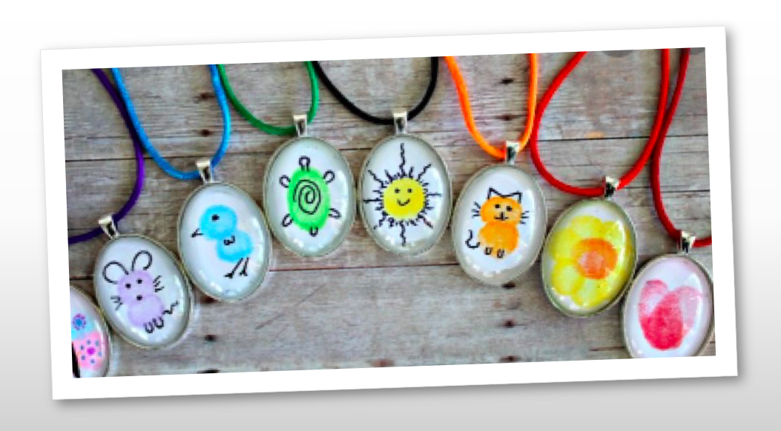

Appendix 5 – SWOT Analysis

 | HELPFUL | HARMFUL
INTERNAL  (within the school) | Strengths  - Developing the four purposes  - Real-life learning  - Purposeful experiences  - Meaningful learning  - The school is already a community school.  - Friends of the school (parents) are already very engaged.  - Meeting new people  - Engaging with possible career choices  - Understanding the requirements of running a business.  - Developing cross-curricular skills  - Social skills  - Communication skills  - Budgeting skills  - Money handling skills  - Organisational skills  - Other projects within the school have been very successful  - Positive Estyn reports | Weaknesses  - Staff  - Size of the school  - Budget  - Mixed classes  - Small number of children which could result in less money being raised.  - Advertisement could be a problem
EXTERNAL  (outside the school) | Opportunities  - Developing the four purposes  - Strengthening the relationships between the community and the school  - Close community area  - Show gratefulness and gratitude to the keyworkers in our local area  - Take time to discuss the COVID-19 pandemic as it affected everyone and is important to talk about the problems that have affected everyone.  - Engagement with the elderly.  - Inviting local businesses to the garden – milk, eggs, honey etc. | Threats  - Local area is very small  - Weather  - Parents might not want their children knowing about COVID-19.  - People might not want to visit  - Social distancing may still be in place

