
Davina Wyn Evans

Changemakers: Creativity and Value Creation

Content Page
Task 1 – Research Question………………………………………….Pg.1
Task 2 – Research Techniques………………………………………Pg.2
Task 3 – Presentation of Idea……………………………………….Pg. 3
Task 4 – Data Analysis………………………………………………….Pg. 4
References

Research question: How can HR professionals effectively utilize employee performance data to improve talent management strategies and drive organizational success?

Task 1 – Research Question
- Produce a written statement of a 1,000 words that considers the following:
  - A Research Question that has been formulated as a result of identifying an issue / problem that you would like to investigate that is appropriate to your programme of study. Within your summary you should express the Value that your research could create for the field being researched.
  - Your chosen Research Approach (deductive / inductive / abductive) (qualitative / quantitative / mixed methods).
  - Your Data Collection Method(s) (primary / secondary methods).
  - Your Sampling Method & Sample Size.

HR professionals are increasingly recognised for their role in using employee performance data to improve talent management strategies in the changing business landscape. Effective talent management places the right people in the right jobs and fosters continuous improvement and engagement. This study will examine how HR professionals may use performance data to improve talent management and organisational success (Betterworks, 2022).

Worth of Research:

This report gives HR professionals and organisations actionable insights into using performance data to improve personnel management. Data-driven insights can help HR professionals make better recruitment, development, and retention decisions. Using performance data to tailor people management techniques can boost employee engagement and happiness by helping HR personnel meet individual and group needs. Companies may improve productivity, innovation, and success by using data-informed human management practices. Such innovations not only promote internal growth but also help in establishing a competitive advantage, as businesses that embrace talent management are better positioned to attract and retain top staff. This competitive edge is vital in a market where skill is a basic differentiation. The efficient use of performance data creates a more dynamic and engaged workforce, allowing both individuals and the company to thrive (Maharajan et al., 2021; ResearchGate, 2020).

Approach to Research:

The research will employ an inductive and qualitative technique, which is suited for producing insights and establishing hypotheses specific to the context of talent management. An inductive technique, which involves collecting data and generating ideas rather than testing pre-existing theories, is excellent for this study since it allows for the identification of new patterns and themes that arise from the data. The open-ended nature of inductive research allows for the discovery of unanticipated insights that would not be clear using a deductive framework, making it especially beneficial for understanding how HR professionals may best use performance data. The inductive technique helps to generate context-specific theories applicable to talent management by concentrating on theory development based on data collecting. Qualitative methods augment this approach by diving farther into hard areas such as talent management. These methods, including in-depth interviews, enable for the collection of rich, detailed data about participants' experiences, perceptions, and behaviours, presenting a complete picture of their surroundings. Qualitative research also allows for a more nuanced understanding of the environments in which HR practitioners work, providing vital insights into the practical and contextual aspects of talent management. Furthermore, the flexibility inherent in qualitative approaches allows for the investigation of emergent themes and the adjustment of research focus as new insights occur. This adaptability keeps the study current and sensitive to the facts, resulting in more relevant and contextually grounded conclusions (ResearchGate, 2020; ResearchGate, 2019).

Data Collection Methods:

The research will use primary data collection methods, specifically in-depth interviews with HR professionals, to acquire qualitative insights into their experiences and practices when using performance data for talent management. These interviews will be semi-structured, allowing for freedom while ensuring that essential issues are covered, resulting in a complete knowledge of the subject. Primary data collection was used for this study since it has numerous main advantages. For starters, it gives direct insights by acquiring firsthand information from HR specialists, confirming that the data is legitimate and detailed, reflecting their real-world experiences and practices. Second, primary data is particularly relevant to the unique context of the research issue, guaranteeing that the conclusions are immediately applicable and topical to the topic at hand. Furthermore, the exploratory feature of semi-structured interviews, which allows for flexibility in responses, promotes the detection of new themes and patterns that may evolve throughout talks (ResearchGate, 2021; Abdullahi et al., 2022). Finally, in-depth interviews provide a complete grasp of the complexities and complexity involved in using performance data for talent management, allowing for a thorough analysis of the subject matter.

Sampling Method & Sample Size:
Researchers will select individuals using typical case samples. This method selects HR and talent management participants. For this research, a typical case sample is ideal because it shows HR practitioners' strategies and issues. This study uses a typical case sample for its benefits. It picks persons that reflect typical or average cases in the area, delivering insights that are valuable to most HR professionals and organisations. This strategy explores common habits and experiences to increase data relevance. Traditional case sampling allows researchers to discover and choose folks with intriguing data, speeding up data collecting. Insights from typical cases can be applied to similar situations, making them beneficial for a wider audience. This study will interview 5 HR specialists, which is enough to obtain varied viewpoints and allow for a deep dive into each participant's experiences and thoughts. Interviewing 5 professionals delivers a complete and broad perspective of the topic, even though a bigger sample size could yield more data. In doing research on how HR professionals may successfully exploit employee performance data to strengthen talent management strategies and promote organizational success, non-probability sampling is chosen due to numerous major aspects. First, targeting select groups or persons with adequate experience enables for concentrated insights into the actual applications of performance data in talent management, ensuring that the gathered data is extremely relevant and informative. Second, practical restraints such as time, budget, or access limitations often make random sampling unfeasible in many organizational settings. Non-probability sampling offers a more efficient and cost-effective way to obtain vital information. Finally, this technique is particularly excellent for pilot studies or exploratory research, as it helps find key aspects and concepts that may be further researched using more rigorous sample procedures in following studies (ResearchGate, 2021; ResearchGate, 2014). By adopting non-probability sampling, the research can generate meaningful and helpful data while overcoming practical obstacles.

This study addresses the research question, "How can HR professionals effectively utilise employee performance data to improve talent management strategies and drive organisational success?" to understand how employee performance data affects talent management and organisational success. Performance data use presents challenges and opportunities for HR professionals and organisations. The research will provide actionable insights. In-depth interviews with 6 HR professionals—Ms. Dila, Sarah, Cheong, Erica, Alisha, and Revathi—will be conducted via Microsoft Teams. Semi-structured interviews will allow for freedom while covering essential topics, ensuring a complete understanding of the subject.
Conclusion, this study seeks to understand how employee performance data affects talent management and organisational success. Performance data use presents challenges and opportunities for HR professionals and organisations. The research will provide actionable insights. This study asks, "How can HR professionals effectively utilise employee performance data to improve talent management strategies and drive organisational success?" to add to talent management and organisational success knowledge.

Task 2 – Research Techniques
- In no more than 300 words, select an appropriate research technique and conduct Primary and Secondary Research based on your chosen research approach from Task 1.

The SCAMPER methodology will be used as a divergent thinking tool to address the study's question. This technique will guide both primary and secondary research, using an inductive, qualitative methodology (Interaction Design Foundation, 2021; ScienceDirect, 2023; MasterClass, 2022; Asana, 2024).
Primary research involves conducting semi-structured interviews with five HR professionals using Microsoft Teams. Ms. Dila, Ms. Sarah, Mr. Cheong, Mrs. Erica, and Mrs. Alisha are among the professionals with a diverse background in performance management and human resource analytics. The key interview questions will focus on how employee performance data influences talent management initiatives, as well as the challenges associated with integrating this data.

To gain a deeper understanding, SCAMPER prompts will be used to generate follow-up questions. For example, Substitute will investigate alternative data sources, Combine will investigate integration with other HR measures, and Adapt will investigate adaptations for various positions (Scribbr, 2022; Dovetail, 2023).

Secondary Research:

The existing case studies, industry reports, and research papers on talent management and HR analytics will be reviewed. The project will use SCAMPER to investigate a variety of topics: Substitute will look at alternative talent management frameworks, Combine will look into integration with predictive analytics, and Adapt will look at how strategies are tailored across industries.

Furthermore, Modify will track the evolution of performance measures, Put to Another Use will discover new applications, Eliminate will streamline data collection processes, and Reverse will investigate the impact of inverting traditional performance management methods (Betterworks,2024).

By incorporating SCAMPER into both primary and secondary research, this inductive approach allows patterns and insights to emerge spontaneously from the data. The qualitative interviews and literature review will provide rich, contextual information, resulting in a thorough understanding of how to use performance data optimally in talent management.

This method aims to identify new solutions that improve organisational performance through better personnel management (ResearchGate, 2023; Indeed, 2022; OpenLearn, 2024; SlideShare, 2023).

Task 3 – Presentation on Ideas
- Produce a 3 minute video elevator pitch that presents your area of research to identified stakeholders and obtain feedback that should be reflected upon in no more than 200 words.

Link : Pitching slides
Video: Pitching video

Task 4 – Data Analysis
- In no more than 500 words create a conference poster that demonstrates the initial analysis of your findings and highlights key conclusions drawn from your research.

In an era where data-driven decision-making is becoming increasingly important, my research investigates how HR professionals can effectively use employee performance data to improve talent management strategies and drive organisational success. The study produced several significant findings by employing an inductive and qualitative approach, primarily through semi-structured interviews with HR professionals.

One key finding is that performance data significantly enhances HR decision-making processes. HR professionals can improve their recruitment, development, and retention decisions by analysing performance metrics. For example, performance data can be used to identify high-potential employees for leadership positions, increasing internal promotion rates and lowering turnover. Ms. Sarah, an HR Director at a technology company, uses performance data to develop potential leaders, which has resulted in a 20% increase in internal promotions. This approach not only lowers recruitment costs, but it also boosts employee morale and engagement.

Another important finding is that tailoring management strategies to performance data increases employee engagement and satisfaction. HR departments can create personalised development plans that are aligned with the career goals of their employees by addressing individual and group needs. Mrs. Alisha, an HR Business Partner at a consumer goods company, uses performance data to create personalised growth plans, which results in a 15% increase in employee engagement, demonstrating the benefits of data-driven management.

The study also discovered that using performance data improves overall organisational success by increasing productivity, innovation, and competitiveness. Organisations that effectively use performance data can improve workforce planning, allocate resources more efficiently, and foster a culture of continuous improvement. Mr. Cheong, an HR Analytics Specialist in financial services, used data analytics to improve workforce planning, resulting in a 10% decrease in operational costs, demonstrating the tangible benefits of data-driven HR policies.

Despite the benefits, the study identifies a number of practical challenges in using performance data, including data integration issues, complex analysis, and resistance to change. To address these challenges, the study recommends simplifying data use with accessible tools and clear metrics, incorporating frequent employee feedback for a comprehensive view of talent needs, and encouraging continuous learning among HR professionals to improve their ability to effectively use performance data.

The study emphasises the need for additional research in two key areas: increasing the sample size to include a broader range of industries, and conducting longitudinal studies to assess the long-term impact of data-driven talent management strategies on organisational outcomes.

To summarise, effectively using employee performance data allows HR professionals to improve decision-making, increase employee engagement, and drive organisational success. By addressing practical challenges and continuously improving data utilisation methods, organisations can create a more dynamic and engaged workforce that benefits both the organisation and its employees. These insights are invaluable for HR professionals looking to make the most of performance data in talent management. Ongoing research will strengthen the foundational practices required for effective talent management in today's workplace.

Transcript 1 : Ms. Dila, Senior HR Manager

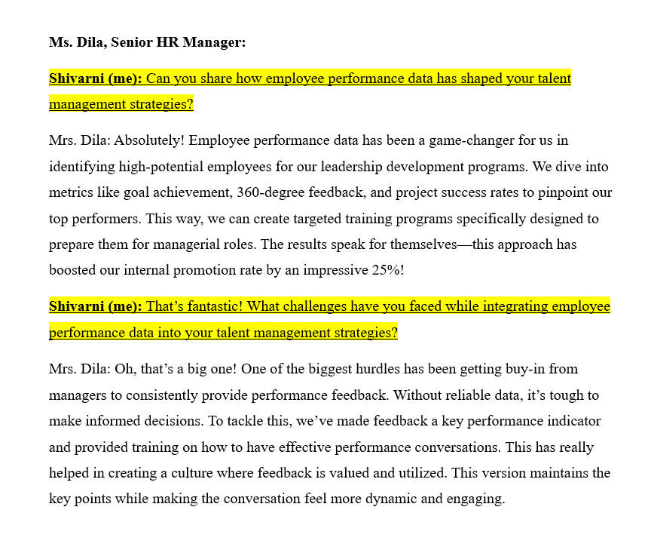

Transcript 2: Ms. Sarah, HR Director
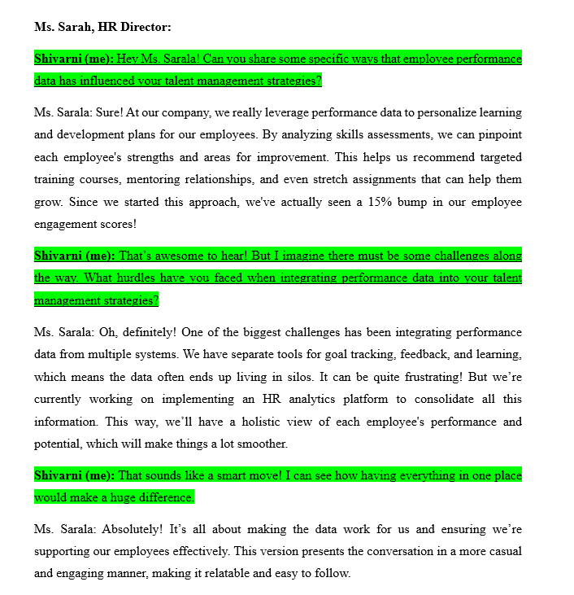

Transcript 3 : Mr. Cheong, HR Analytics Specialist:

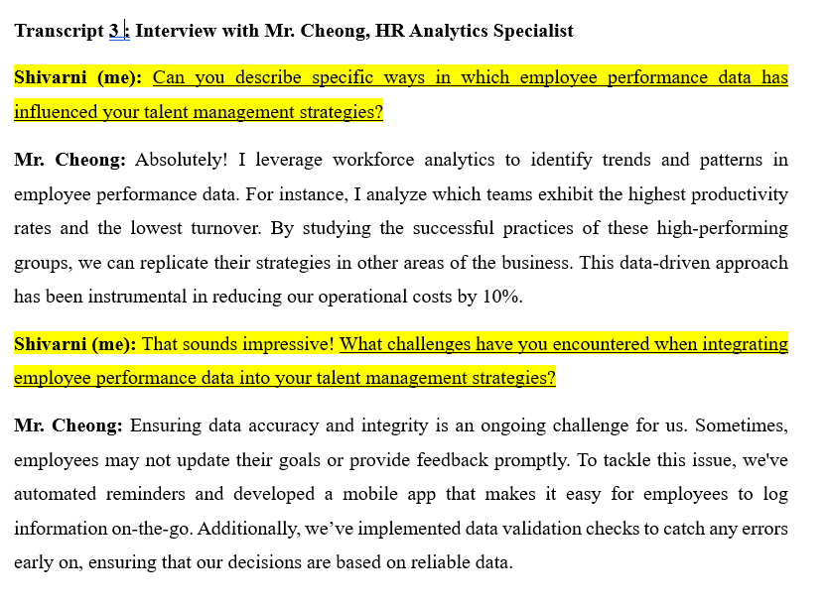

Transcript 4 : Mrs. Erica, Chief HR Officer

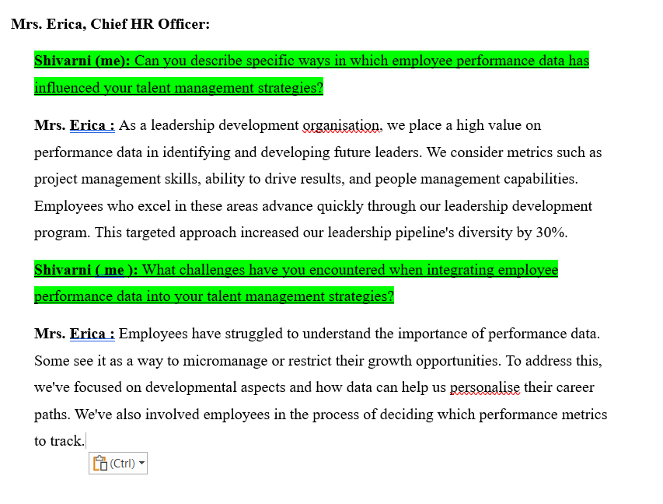

Transcript 5: Mrs. Alisha, HR Business Partner

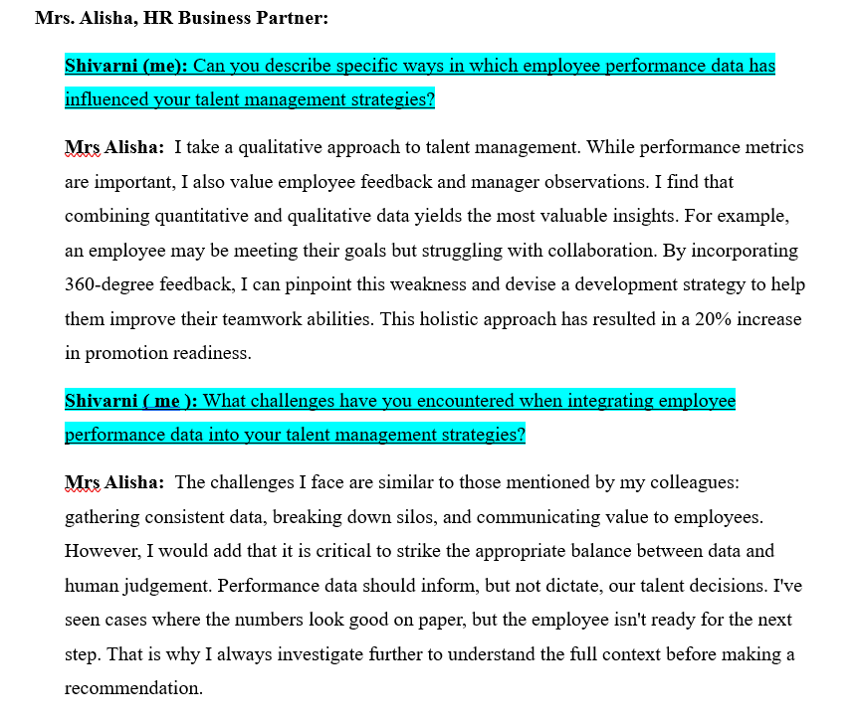

Poster :
link: Conference Poster

References
Abdullahi, et al. (2022). Talent management practices on employee performance: a mediating role of employee engagement in institutions of higher learning. ResearchGate. Retrieved from https://www.researchgate.net](https://www.researchgate.net
Asana. (2024). Convergent vs. Divergent Thinking: Finding Balance. Retrieved from Asana
Betterworks. (2022). Streamlining your workforce with talent management systems. Retrieved from https://www.betterworks.com/magazine/talent-management-system/
Dovetail. (2023). Semi-Structured Interview: Explanation, Examples, & How-To. Retrieved from Dovetail
Indeed. (2022). A guide to secondary research: methods, examples, benefits. Retrieved from Indeed
Interaction Design Foundation. (2022). What is Divergent Thinking?. Retrieved from Interaction Design Foundation
Maharajan, V. P., Hossain, M. A., Shekhar, S., Reddy, V., Sinha, S., & Chhajar, S. (2021). How to Use Data for Talent Management Decisions. LinkedIn. Retrieved from https://www.linkedin.com
MasterClass. (2022). Divergent Thinking: 5 Divergent Thinking Strategies. Retrieved from MasterClass
OpenLearn. (2021). The advantages and limitations of secondary data. Retrieved from OpenLearn
ResearchGate. (2014). Effectiveness of talent management strategies. ResearchGate. Retrieved from https://www.researchgate.net
ResearchGate. (2019). Impact of Talent Management Practices on Employee Performance. ResearchGate. Retrieved from https://www.researchgate.net
ResearchGate. (2020). Talent management practices on employee performance among academic staff of Malaysian private universities: Employee engagement as a mediator. ResearchGate. Retrieved from https://www.researchgate.net
ResearchGate. (2020). TALENT MANAGEMENT: A SYSTEMATIC REVIEW. ResearchGate. Retrieved from https://www.researchgate.net
ResearchGate. (2021). Best Practices in Talent Management and Their Impact on Employee Engagement and Employee Retention. ResearchGate. Retrieved from https://www.researchgate.net
ResearchGate. (2021). The impact of talent management on performance: Moderating effect of career management. ResearchGate. Retrieved from https://www.researchgate.net
ResearchGate. (2023). The role of talent management and HR generic strategies for talent retention. Retrieved from ResearchGate
ScienceDirect. (2023). Divergent Thinking - an overview. Retrieved from ScienceDirect
Scribbr. (2024). Semi-Structured Interview | Definition, Guide & Examples. Retrieved from Scribbr
SlideShare. (2022). Importance of Research in HRD. Retrieved from SlideShare

