
APPENDIX GA36d

LEVEL 7 ASSESSMENT SPECIFICATION

Student name: | Earnest Li | Student ID number: | 1715380
Programme: | DBA
Module: | Qualitative Research
Module code: | SBPD7002 | Contribution to Overall Module Assessment (%): | 40
Lecturer: | Dr. Stephanie Lee | Internal Verifier:
Assignment Title: | Evaluating current research | Word count (or equivalent):
Submission deadline: | November 4, 2018 | Return date of provisional marks & written feedback: | November 25, 2018
Submission method: | All written assessments, where practical and possible, must be submitted via Turnitin unless otherwise instructed by the Lecturer. (Please DO NOT put this assessment specification into Turnitin or it will match many similarities with other students’ submissions.)  Alternative submission method (if applicable):  Late submission of the assessment will result in a late penalty mark. Penalties for late submission: Up to one week late, maximum mark of 50%. Over one week late, 0%. Only the Extenuating Circumstances Panel may approve a change to submission dates.
Academic honesty / referencing: | Academic honesty is required. In the main body of your submission you must give credit to authors on whose research and ideas your work is based. Append to your submission a reference list that indicates the books, articles, etc. that you have used, cited or quoted in order to complete this assessment.

Module Learning Outcomes
(from module syllabus)
By the end of this module students should be able to:
- Critically consider the underpinnings of qualitative research principles and be able to recognise strengths and limitations of qualitative research techniques.
- Critically assess the contexts appropriate for qualitative research techniques, and be able to apply qualitative data collection and analysis techniques in order to address a research question.
- To generate a preliminary research proposal around some topic of interest that will culminate in a research presentation and paper.

TASK DESCRIPTION

Evaluating current research

- You will choose an article from a top journal in your field that uses a qualitative methodology.
- You should verify with the module leader that your chosen article is appropriate (this may be done verbally during classes).
- If your field has embraced qualitative methods and you have many articles to choose from, you should choose an article that employs a method that is of particular interest to you.
- If possible, choose an article that is related to your proposed research.
- Write a critical review of this article on qualitative research (2,500- 3,000 Words)

Note: Mixed mode of research methodology is NOT allowed. Only qualitative methods can be used.

You should include in your review:

- 1. The full citation
- 2. The philosophy and theoretical perspective being employed
- 3. The data collection method(s) used
- 4. A critique of the methods used

FORMATTING AND LAYOUT

Please note the following when completing your written assignment:
- Writing: Written in English in an appropriate business/academic style
- Focus: Focus only on the tasks set in the assignment.
- Formatting: Typed on A4 paper in Times New Roman or Arial font 12 with at 2 centimetre space at each edge, 1.5 spaced and pages numbered.
- Document format: Word
- Ensure the assignment specification (Page 1) is attached to your assignment and a bibliography using Harvard referencing throughout is also provided.
- Research: Research should use reliable and relevant sources of information e.g. academic books and journals that have been peer reviewed. The research should be extensive.

The use of a range of information sources is expected – academic books, peer reviewed journal articles, professional articles, press releases and newspaper articles, reliable statistics, company annual reports and other company information.

GUIDANCE FOR Students IN THE COMPLETION OF TASKS

NOTE: The guidance offered below is linked to the four generic assessment criteria overleaf.

- The philosophy and theoretical perspective being employed

You are required to identify and discuss the philosophy and theoretical perspective used in the qualitative research article. Elaborate using support from the literature.

- The data collection method(s) used

Comment and discuss the data collection used.

- A critique of the methods used

Critically analyse the methods used, i.e. analysing the pros and cons of methods. Suggest ways to improve or alternative methods.

- Strengths & limitations of Qualitative Research Article

Critically analyse the strengths and limitations of the article, e.g. in terms of methodology, design and results, backed up by evidence. Suggest ways to improve.

Student FEEDBACK FORM

This section details the extent to which the assessment criteria are demonstrated by you, which in turn determines your mark. The marks available for each category of skill are shown. Lecturers will use the space provided to comment on the achievement of the task(s), including those areas in which you have performed well and areas that would benefit from development/improvement.

Generic Assessment Criteria | Marks available | Marks  Awarded
1. The philosophy and theoretical perspective being employed  . | 10
2. The data collection method(s) used | 10
3. A critique of the methods used | 15
4. Strengths & limitations of Qualitative Research Article | 5

Assessment Mark (Assessment marks are subject to ratification at the Exam Board. These comments and marks are to give feedback on module work and are for guidance only until they are confirmed. ) | Late Submission Penalties (tick if appropriate) |  | %
 | Up to 1 week late (50% Max) |  | %
 | Over 1 week late (0%) |  | %

GENERIC ASSESSMENT CRITERIA

Level 7
In accordance with the Framework for Higher Education Qualifications, at the end of Level 7 students should be able to demonstrate: a systematic understanding of knowledge, and a critical awareness of current problems and/or new insights, much of which is at, or informed by, the forefront of their academic discipline or area of professional practice; a comprehensive understanding of techniques applicable to their own research or advanced scholarship; originality in the application of knowledge, together with a practical understanding of how established techniques of research and enquiry are used to create and interpret knowledge in the discipline; conceptual understanding that enables the student to evaluate critically current research and advanced scholarship in the discipline to evaluate methodologies and develop critiques of them and, where appropriate, to propose new hypotheses. They will be able to deal with complex issues both systematically and creatively, make sound judgements in the absence of complete data, and communicate their conclusions clearly to specialist and non-specialist audiences. They will demonstrate self-direction and originality in tackling and solving problems, and act autonomously in planning and implementing tasks at a professional or equivalent level to continue to advance their knowledge and understanding, and to develop new skills to a high level. They the qualities and transferable skills necessary for employment requiring the exercise of initiative and personal responsibility; decision-making in complex and unpredictable situations/professional environments; and the independent learning ability required for continuing professional development.

Level 7 | FAIL | FAIL | MARGINAL FAIL | SATISFACTORY  (Pass) | GOOD to VERY GOOD  (Merit) | EXCELLENT  (Distinction) | EXCEPTIONAL  (Distinction)
Category | 0-29% | 30-44% | 45-49% | 50-59% | 60-69% | 70-84% | 85-100%
The philosophy and theoretical perspective being employed  . | Little or no discussion of the philosophical and theoretical perspective being employed. | Poor discussion of the philosophical and theoretical perspective being employed. | Limited discussion of the philosophical and theoretical perspective being employed. | Reasonable amount of discussion of the philosophical and theoretical perspective being employed. | Good discussion of the philosophical and theoretical perspective being employed. | Excellent discussion of the philosophical and theoretical perspective being employed. | Outstanding discussion of the philosophical and theoretical perspective being employed.
The data collection method(s) used | Little or no discussion of the data collection methods used. | Poor discussion of the data collection methods used. | Limited discussion of the data collection methods used. | Reasonable amount of discussion of the data collection methods used. | Good discussion of the data collection methods used. | Excellent discussion of the data collection methods used. | Outstanding discussion of the data collection methods used.
A critique of the methods used | Wholly or almost wholly descriptive work. Little or no evaluation or critique. | Largely descriptive work, with superficial use of critical evaluation of research and methodologies. | Limited attempt at critical evaluation/ critique of current research and methodologies, tending towards description. | Some critical evaluation/ critique of current research and methodologies, though slightly underdeveloped in places. | Sound critical evaluation/ critique of current research and methodologies. | Excellent critical evaluation/ critique of current research and methodologies. | Exceptional critical evaluation/ critique of current research and methodologies.
Strengths & limitations of the Qualitative Research Article | Little or no analysis of the strengths & limitations of the Qualitative Research Article. | Poor discussion of the strengths & limitations of the Qualitative Research Article. | Limited discussion of the strengths & limitations of the Qualitative Research Article. | Reasonable amount of discussion of the strengths & limitations of the Qualitative Research Article. | Good discussion of the strengths & limitations of the Qualitative Research Article. | Excellent discussion of the strengths & limitations of the Qualitative Research Article. | Outstanding discussion of the strengths & limitations of the Qualitative Research Article.

Evaluating current research:

A qualitative analysis of charismatic leadership in creative teams

Introduction
This paper will evaluate the article “A qualitative analysis of charismatic leadership in creative teams” written by Murphy and Ensher (2008). It was published in the Leadership Quarterly that is an international journal social-science journal aiming to deepen our understanding of leadership as a phenomenon, the study approach, and the practical implications. According to Elsevier, the impactor of the Leadership Quarterly is 3.307, and the 5-year impact factor is 5.358. The evaluation is divided into four parts: philosophy and theoretical perspective, data collection method, critique the method, strengths and limitations of the article.

Philosophy and theoretical perspective being employed
According to the report published by Oxford Economics (2016), film and TV made a contribution to Chinese GDP of 254 billion yuan in 2016 representing 0.34% of the Chinese economy. 865,000 people were directly employed by the industry. Television director is the key person to lead and manage the creative and production team to produce products. Although little attention is given to study the leadership style of television directors, the researchers of the selected article try to study this topic.

Ontology
The purpose of conducting this research is adequately described. Considering the ontological position of the researchers, Murphy and Ensher believe that television directors play the role of “instant CEO”, and the study is a question of role relativism. Leadership can help to strengthen team effectiveness. The researchers focus on the charismatic leadership theory of Conger and Kanungo (1994) stating the six behavior factors of charismatic and transformational leadership: (1) strategic visioning and communication behavior, (2) sensitivity to the environment, (3) unconventional behavior, (4) taking personal risk, (5) sensitivity to organizational members’ need, and (6) deviation from the status quo.

How television directors facilitate the creative and production teams to work with a high level of creativity and great performance? The researchers believe that the leadership style of a television director associates with transformational leadership, empowering leadership, and leader-member exchange relationship. Besides, creativity and innovative behaviors include idea generation, structuring, and idea promotion. A television director is responsible to perform innovative behavior individually and with the support from team members. In the business world, organizations struggle to manage creativity not only to have greater performance, but also to retain their valuable talent. It explains why the researchers believe that television directors perform like “instant CEO”. The research aim is clearly defined.

In addition to the charismatic leadership, the grounded theory of the study linking other three factors: (1) leader and follower distance, (2) shared leadership, and (3) self-schema. In 1988, some researchers discussed the charismatic leadership with the perspectives of behavioral dimension, psychological characteristics, the institutionalization, contextual factors, maintenance factors, and the dark side of the charismatic leadership (Conger and Kanungo, 1988). Why the study of charismatic leadership is concerned by managers? It is because global competition makes many organization transformations happen. Employers demand greater performance and commitment from employees. In return, employees demand more job satisfaction and empowerment. A television director also demands the creative and production team members to perform better creativity and innovative behaviors. Team members of a director’s crew want to obtain more job satisfaction and empowerment to allow them to participate in decision-making process, and autonomy in the workplace.

Epistemology
Regarding the epistemological (emic) position, the researchers try to collect subjective pieces of evidence from participants of the study to lessen the distance between themselves and the subject being researched. Interviewers spend around an hour with each participant in an interactive approach. This qualitative approach is appropriate to answer the three research questions or propositions.

Axiology
From the axiological position, the researchers mention the value of the study is to elaborate the charismatic leadership with the field of the entertainment business and the TV industry. The researchers think the industry makes a contribution to the U.S. economy, however, there is so little research concerning this area. They also aware the issue of bias may happen when they interpret the information gathered from the participants. To avoid bias, the researchers arrange three interviewers to help to interpret the non-verbal aspects during the interview process. Moreover, they will take careful notes and tape-recording to ensure accuracy. Furthermore, researchers ask the interviewers to discuss immediately to check the consistency and clarity between interviewers’ interpretation.

Methodology
With regards to the methodological position, the researchers use in-person interviews that is a qualitative research technique to collect data. 21 television directors are invited to participate in the interviews. Interviewers will ask the director to answer 14 open-ended questions including his or her career history, developmental experiences, and past mentoring relationships. Apart from the open-ended questions, 6 questions about leadership are asked. These questions are based on the six behavioral factors stated by Conger-Kanungo model (Conger and Kanungo, 1994). The researchers try to collect the pieces of evidence to address three propositions:

- Television director plays the role of leadership, and acts as a manager.
- Charismatic leadership helps to study leadership in the creative production team.
- Leader’s philosophy and self-schema will affect charismatic leadership style.

To evaluate the study design, the context of this research is adequately described. In the selected article, the researchers do not use the term “research question”, and they use the term “proposition”. It is because the researchers did not find a single study of television directors as leaders. Under this circumstance, the researchers aim to explain the leadership style of television directors is a kind of charismatic leadership. The three propositions are relevant to the context described. From the second proposition, the study addresses the positive influence on creative production team under the charismatic leadership of television directors. The study also fills a gap in existing literature. It shows the researchers follow the appropriate steps to conduct the qualitative research: (1) set the propositions, (2) select relevant subjects, (3) collect relevant data, (4) analyze and interpretation of data, (5) conceptual and theoretical work, and (6) writing up findings.

Data collection methods used
Sampling
The sampling strategy is appropriate to the propositions of the study. Purposive sampling is applied to select 21 directors from 4 main networks in the United States. The researchers use three methods to invite participants. First, the researchers try to contact the directors through the association, Director Guild of America (DGA). Founded in 1936, the association is a labor organization representing the creative and economic rights of directors and members of the directorial team working in film, television, and so on (DGA, 2018). It is an appropriate source to recruit the participants. Second, the researchers go to invite the directors working at a specific situation comedy over for the past two seasons. Third, the researchers use “snowball” techniques to ask one director referring another one to participate in the study. In qualitative research, researchers prefer to use non-probability sampling that includes convenience sampling, snowball sampling, and quota sampling. Choice of sampling strategy is clear and justified. The researchers selected the directors to participate in the study with the requirements including the industry experience of the directors ranged from 10 to 40 years, nominated or won awards, and aged 28 to 72 years. With respect to gender, 7 of the participants are women, and 14 of them are men. It is unusual. The researchers explain why this happens, and they use the data of the DCG reporting 80% of 860 episodes of the TOP 40 prime-time drama and comedy series are directed by white men. Regarding the recruitment or research participants, the researchers can gain access to television directors who are the appropriate subjects.

The semi-structured interview is adopted. In the interviews with the directors, researchers on one hand prepare a list of six questions on the topic of the charismatic leadership style of television directors to be covered (Appendix A of the article). On the other hand, the interviews have a great deal of flexibility for the participants to reply or add information.

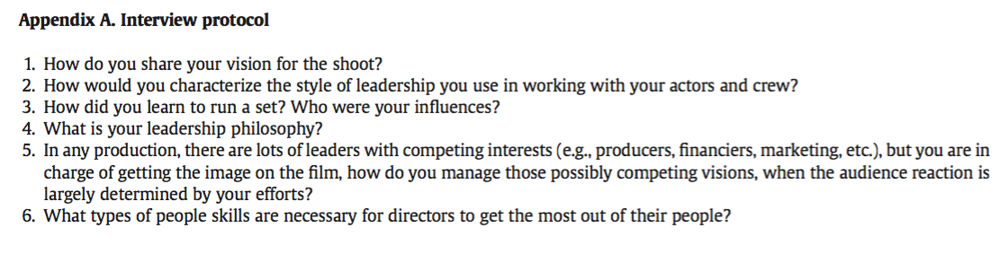

Critique of the methods used
Ethical issue
At the beginning of interviews, interviewers have disclosed the purpose of study with a statement, and asked the permission from the directors to share their stories. Consent procedures are used, and the research is explained to the participants. Nonetheless, the article does not mention whether the interviewers explain confidentiality and privacy or not. The ethical issues at the beginning of data collecting are inadequately discussed unless the privacy of each participant is respected and assured. At the end of interviews, the interviewers thank the participants, and provide the opportunity to feedback as well as recall any final thoughts. To a certain extent, the interviewers show their respects to the directors.

Data collection
The data collection procedures are clearly described in the article to a certain extent. During the process of interview, interviewers take notes and use tape recorder to record the answers of the participants. It is because the answer of each director is transcribed to an average 20 single-spaced-page document typing by an independent transcriptionist. All transcribed interviews are reviewed by the research team to check accuracy and consistency. However, the researchers have not described where to do data collection. Readers do not know whether privacy and confidentiality to be considered or not.

Data analysis
To a certain extent, the data analysis procedure is reliable. Five coders are trained to identify the six behavioral factors of charismatic leadership. Coders have to sign interrater agreements to ensure reliability and avoid bias. The researchers use the qualitative analysis technique of “pattern matching” to do content analysis and coding, and the coding goes through three stages:

Stage 1. Read the transcript of each interview at least two times.
Stage 2. Code the transcript in passages with the six factors, and no scale coding is used.

Stage 3. Additional coding such as the factor of leadership philosophy is counted.

From the above-mentioned procedure, it shows the researchers clearly process the raw data to arrive the stated results. All data are taken into account in the analysis. The researchers select the sample diction variables from the interview answers, and follow the steps to do coding and categorization to identify the emerging themes. Regarding data reporting, the researchers can avoid only disclosing positive results. From the relevant diction variables as shown in Appendix B of the article, positive results are shown: optimism (endorsing some person, group, concept, event), praise, satisfaction (positive affective states; joy), and inspiration (universal respect; attractive personal qualities). Negative results are also showed in the article: blame (evil), hardship (hostile actions), and denial collectives (negative contractions). From Appendix B, it shows the researchers give consideration to the words with the use of codes or labels with the bracket showing positive “(+)” and negative “(-)” meanings that help to explain the findings. For example, “satisfaction” is one of the sample diction variables. The researchers demonstrate the description of each diction variable with regards to the sample words. The description of “satisfaction” is the “terms associated with positive affective states, moments of undiminished joy, and moments of triumph”, and the sample words are “cheerful, passionate, happiness, smile, welcome, excited, fun, lucky, celebrating, pride, secure, relived”. Moreover, the researchers also identify the codes of “ambivalence” by reviewing the words with regards to the expressing hesitation or uncertainty. It shows the participant may lack commitment to the verbalization being made. Furthermore, to construct the variable of “optimism”, the researchers use the formula: [praise+satisfaction+inspiration]-[blame+hardship+denial]. It shows the findings of the research are valid, because the findings are drawn from the analysis of collected data rather than the researchers’ preconceptions to a certain extent.

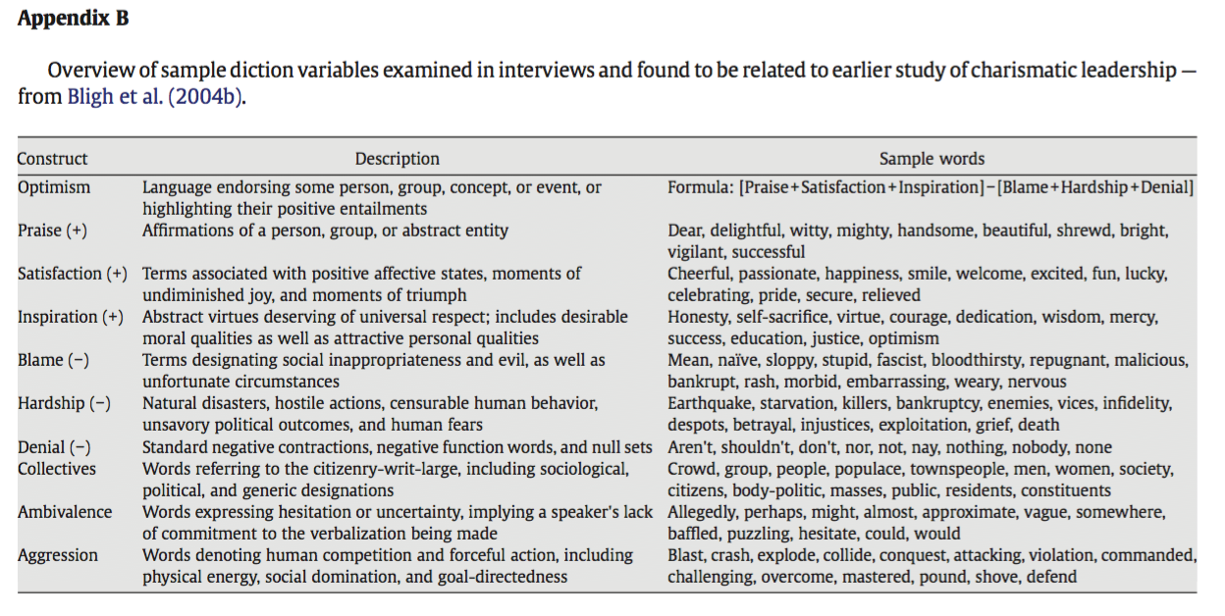

Strengths and limitations of the article
There is an adequate discussion of the study limitations. First, the researchers find the sample size is small to test a leader’s rhetoric corresponds, and leadership self-schema is not detailed enough to tell the differences of leadership distance. Because of the variation in the degree of charismatic demonstrated by the television directors, the authoritarian schema may use fewer behaviors to show the evidence to support the propositions of this study. Most of the participants may not aware of the type of leadership styles such as distance dimension, direct or indirect, individual group or larger group. The participants may not provide a clear description of their leadership behavior. Charismatic behaviors are complicated with the factors including shared or distributed leadership. Do the directors or the participants really know to use impression management to have positive influences on the creative and production team? Second, the researchers collect the data through the directors’ self-report of their behaviors. It needs to widen perspective from the perceptions of team members including crew and cast. The researchers suggest using the following test factors to improve the study: (1) satisfaction and turnover of crew, (2) overall industry reputation, (3) audience rating of the programs, and (4) industry nominations. The author agrees using these factors to explore the relationship between the leadership style of television directors and the workplace outcomes. Moreover, the researchers found that television directors may not consider the role of crisis. This area can be further developed to seek more pieces of evidence to support the propositions of the research. Unlike television directors, managers or leaders in the business world have to pay attention to handle the crisis to protect the organizations. Third, the researchers state the shortcoming of the in-person interviews. It is the weakness of the self-report questionnaire. The participants may tend to respond in a way to make them look like successful and caring leaders. Therefore, television directors may not provide reliable data.

The roles of researchers are described in the acknowledgements of the article. Readers can know five members from the Kravis Leadership Institute are responsible for qualitative coding, and the source of this research funding has come from Kravis Research Institute. It is suggested to describe the roles of researchers clearly in the section of methodology to strengthen the credibility of the article.
The findings are relevant to study the applicability of charismatic leadership theory for television directors. This study is important to explore the research area of charismatic leadership-innovative behavior link with the perspective of television directors. Researchers can extend the study in the creative industry in Hong Kong and China. From the observation of the author, the demand for television shows is increasing in China’s market. Many Hong Kong’s directors are recruited to produce TV drama and internet movie in different China’s cities. If producers and directors gain the knowledge of charismatic leadership, they can predict the team members’ creativity and innovative behavior of different sections. The effectiveness of the team performance can be strengthened, and it will help a better allocation of resources to produce the shows within budget. The issue of over-budget can be avoided, and the quality of production can be produced to meet the standard.

In short, the overall impression of the article is a high-quality paper to use qualitative analysis to study the leadership style of directors in the film and TV industry. The researchers can communicate the research gap, grounded theory, methodology, data analysis process, findings, discussion, and implication in a clear, straightforward, and appropriate language. Ethical issues are adequately considered. The recommendation is made for future study of this area.

Reference
Conger, J. A., & Kanungo, R. N. (1988). Charismatic leadership in organizations. Thousand Oaks, CA, Sage Publications.

Conger, J. A., & Kanungo, R. N. (1994). Charismatic leadership in organizations: Perceived behavioral attributes and their measurement. Journal of organizational behavior, Vol. 15 No. 5, pp. 439-452.

Directors Guild of America (2018). About the DGA. Available at: https://www.dga.org/The-Guild/History.aspx

Elsevier (2018) Journal: The Leadership Quarterly. Available at: https://www.journals.elsevier.com/the-leadership-quarterly

Murphy, S. E., & Ensher, E. A. (2008). A qualitative analysis of charismatic leadership in creative teams: The case of television directors. The Leadership Quarterly, 19(3), 335-352.

Oxford Economics (2016). The economic contribution of film and television in China in 2016.

