Data Handling and Business Intelligence

Student name: Ionut-Dragos Lisaru
Student ID: 2315590
Lecturer’s name: Xavier Matieni

Module code: LCBB5014

Table of Contents
Introduction 3
Data Understanding, Cleaning and Preparation 3
Descriptive Statistics and Summary Analysis 5
Trend Analysis and Data Visualisation 6
Statistical Analysis Using SPSS 8
Insights and Recommendations 11
References 13

Introduction
This report aims to examine the behaviour of viewers and films' popularity by using the Letterbox Movie Classification Dataset by applying data analytics to Microsoft Excel and IBM SPSS. The data is a set of 10,000 films with such variables (numerical variables) as average rating, runtime, watches, likes, fan count, and such categorical variables as genre and original language. These variables present a valuable clue to understanding the way the audiences interact with films, and that the perceived quality and popularity vary with the film characteristics. Data-driven decision-making in the modern media and entertainment business is essential to the content acquisition process, recommendation services, and targeting the audience (Nixon et al., 2024). The digital platforms are increasingly dependent on viewer engagement as an indicator of performance as well as business optimisation. The association between the film attributes and user response can help organisations in understanding how to improve user satisfaction, besides ensuring that their operations become efficient. The report takes a systematic analytical method. Data validation, descriptive statistics, and trend visualisation are done in Microsoft Excel, and inferential statistical analysis (as hypothesis testing, correlation, regression modelling) was done using SPSS. The hypotheses are to validate the dataset, characterise prominent features, discover patterns of ratings and participation, statistically test the differences between the results found, and draw actionable implications for the film and media industry.

Data Understanding, Cleaning and Preparation
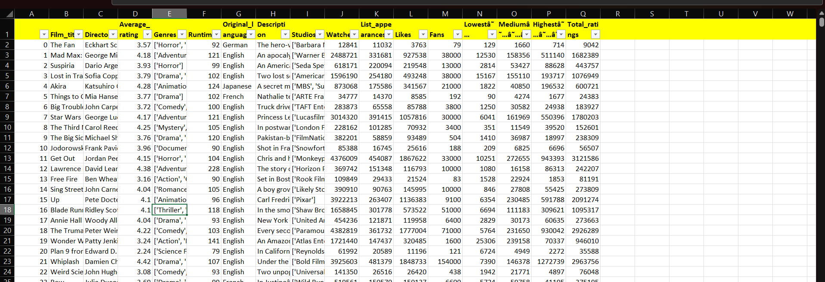
Snippet: 1
(Source: Self-Developed)
Primary data quality analysis was done in Microsoft Excel to check whether the data was appropriate to be analysed. This test established that there is a high degree of integrity in the dataset. The table had some extra letters that were not required, like the one with Lowest, as is seen in Snippet 1. Numerical variables expressing average rating, runtime, watches, likes, and the number of fans were full and did not have any misses or invalid values. As a result, there was no numerical imputation or deletion necessary, which minimised the chances of bias being added to the analysis.
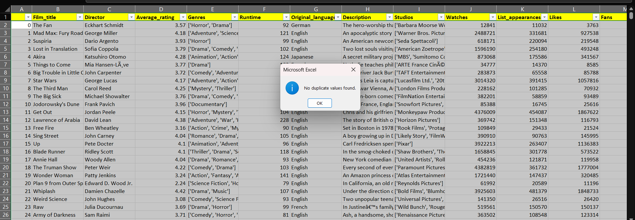
Snippet: 2
(Source: Self-Developed)
Structural problems of the data were also analysed. Duplicate identification was done in all the columns through the duplicate identification option of Excel, which can be seen in Snippet 2 and this ensured that there were no duplicate film records. This was done to make sure every observation was a distinct film. Categorical variables were checked against each other, especially the Original Language column. This variable was already in the right format and standardised, so no recoding or consolidation was needed.
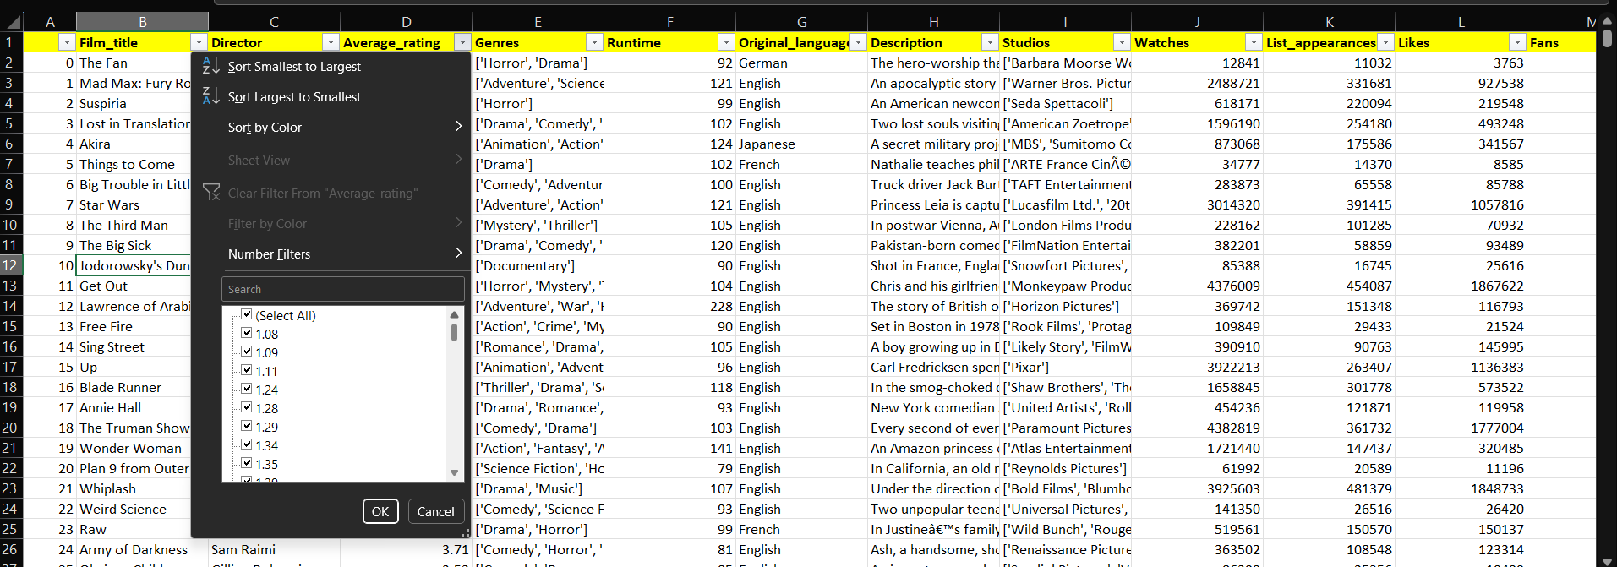
Snippet: 3
(Source: Self-Developed)
The preparation of data thus became validation-oriented and not a transformation one. Before analysis, variables were verified through proper types of data and level of measurement and therefore, numerical and categorical variables were considered as scale and nominal data, respectively. This validation-based method is consistent with the best practice of the Business Intelligence systems, where the correct insights require the correct and properly structured data (Maghsoudi and Nezafati, 2023). The data was thus considered to be in its complete analysis form to be analysed descriptively, trend-wise, as well as inferentially.

Descriptive Statistics and Summary Analysis
Microsoft Excel was utilised to summarise the important numerical properties of the Letterbox Movie Classification Dataset to conduct the descriptive statistical analysis. The sample is 10,000 films, which makes it possible to interpret the data statistically.
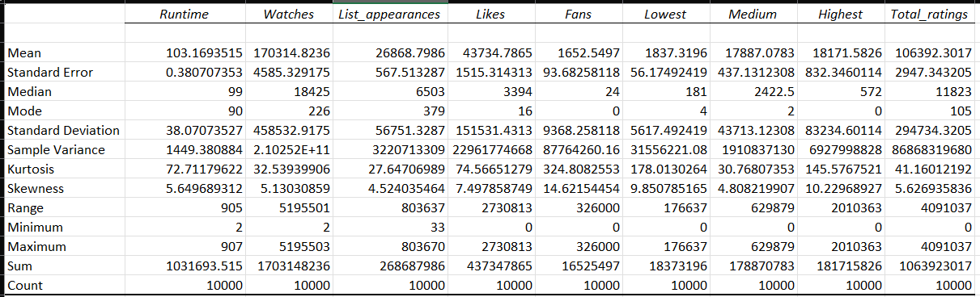
Table 1: Descriptive Statistics
(Source: Self-Developed)
The average length is around 103 minutes, the median is 99 minutes, and the mode is 90 minutes. It means that the majority of movies are of a typical feature length. Nonetheless, both the standard deviation (38.07 minutes) and the range (2 to 907 minutes) are rather large, indicating a high degree of variation in the length of the film. This indicates that we are talking of both the short-form productions and also exceptionally long films, as there is a wide range of content offered on digital film platforms. The variables of audience engagement have a high positive skewness and extreme dispersion. The median value is only 18,425 as opposed to the mean value of more than 170,000, which indicates a strong long-tail distribution. The same occurs with likes and the value of fans, with median values of (3,394 likes and 24 fans) being much less than the mean values.
Large skewness and kurtosis values in these variables affirm that there are few films that are engaged in by a small number of people. These long-tail effects have been well studied within the digital media environment and found to be consistent with the research of Heitmayer (2024), who also found that only a few high-profile titles receive audience attention. Conversely, measures associated with rating have relatively less variability. Although the total rating counts are quite diverse, audience ratings are more consistent than the engagement metrics. This difference supports this understanding by Sahu et al. (2022) that popularity and perceived quality are different directions of film success and cannot be regarded as synonymous variables in Business Intelligence systems. In general, the descriptive statistics offer an in-depth description of the film features and audience behaviour. This analysis provides a good foundation for further trend analysis and statistical testing by showing the common trends and outliers.

Trend Analysis and Data Visualisation
The initial analysis, trend analysis, was done in Microsoft Excel to determine the trends in film rating and viewership in the original languages and ratings.
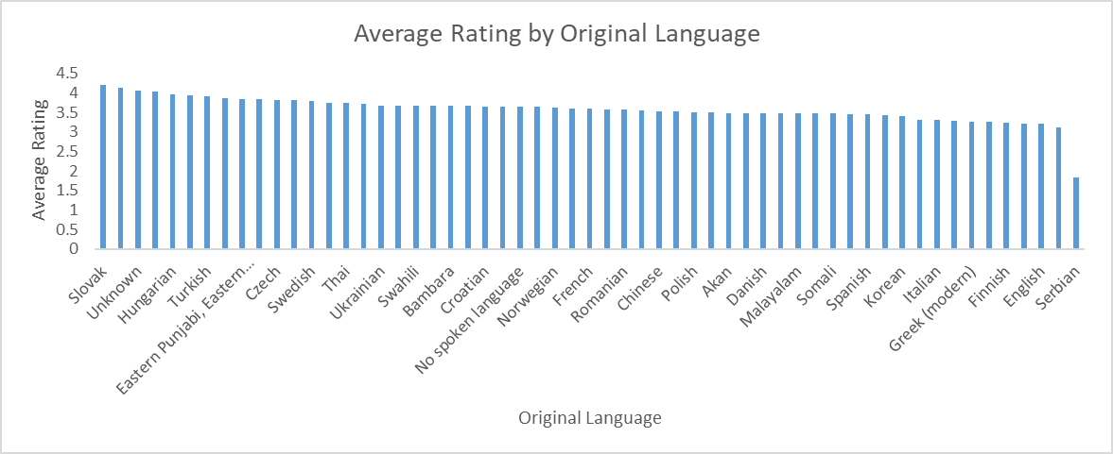
Chart 1: Average Rating by Original Language
(Source: Self-Developed)
The average rating analysis based on the original language used shows an evident difference among the linguistic groups. Some of the non-English languages use higher average ratings than the English-language films. Even though English films have a significant part of the dataset, they are located in the lower part of the rating distribution. This trend indicates self-selection, as the viewers who are willing to consume foreign-language movies might be more occupied or interested, leading to larger ratings. Other studies, e.g., Seetharaman (2025), previously established that niche and international content tend to have smaller audiences but more loyal ones, which results in higher quality scores perceived.
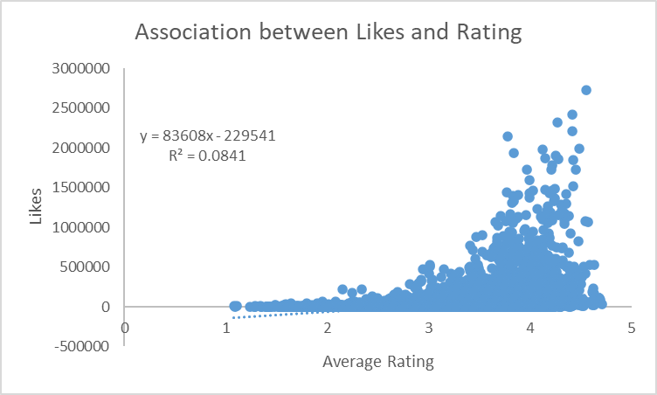
Chart 2: Association between Likes and Rating
(Source: Self-Developed)
Additional trend analysis was done to establish the relationship between the average rating and likes by utilising a scatter plot. The findings demonstrate that there is a positive relationship in that the movies that have higher ratings tend to be liked. Nonetheless, the correlation is also not very strong because there is a low coefficient of determination (R^2 = 0.0841). This shows that the mean rating accounts for only a very low percentage of the difference in the number of likes. Most strongly rated films get little attention, whereas other moderately rated films show high levels of visibility. This observation illustrates the difference between popularisation and audience approval, which conforms to the results of Dodds et al. (2023), one of the typical features of digital media platforms.
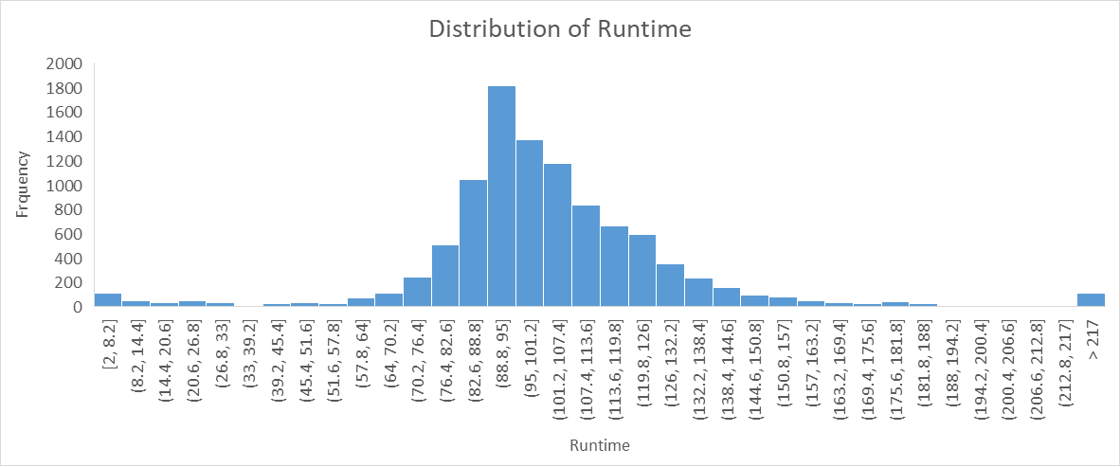
Chart 3: Distribution of Runtime
(Source: Self-Developed)
The histogram of run times depicts a distinct tendency of the films to fall between 80 and 120 minutes, which proves that the majority of productions are regarded as the most popular to watch, according to the conventional understanding of the term. The frequencies are sharply decreasing beyond this range, especially in the case of very long films. This indicates that there are indeed extreme run-times, but they are a minor percentage of the content and can be targeted to a niche market. In general, the trend analysis proves that there is a multidimensionality to film success. Greater ratings are not associated with greater participation, and the language has a significant part in influencing the evaluation of the audience (Berger, Moe and Schweidel, 2023). These observations can be used to emphasise the significance of the application of several metrics in measuring the performance of the content and offer a good reason as to why an inferential statistical test was used in SPSS.

Statistical Analysis Using SPSS
Formal testing of relationships and patterns identified during descriptive and trend analysis was performed using IBM SPSS Statistics to perform inferential statistical analysis. The use of SPSS was because it has strengths in testing hypotheses, correlating and conducting regression with the aim of modelling. They are popular methods used in applied data mining and Business Intelligence (Kafle, 2020).
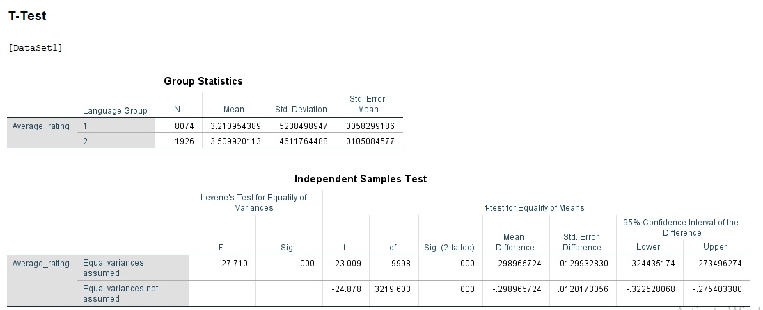
Table 2: T-Test
(Source: Self-Developed)

The independent samples t-test was conducted to test whether the difference in the average rating of the films between English and non-English language films is statistically significant. Movies were recoded into two categories, which were English (coded as 1) and non-English (coded as 2). All 10,000 observations were included in the analysis. The mean rating of English-language films (N = 8,074) is lower than that of the non-English films (N = 1,926) (mean rating equals 3.21 and 3.51, respectively). The unequal variances between the groups were statistically significant as the Levene test of equality of variances showed a value of F = 27.71, p<.001, The results of the t-test verify that the average rating of the rating is significantly different (t=−24.88, p<.001), which means that the null hypothesis should be rejected. This observation shows that originality in language is a significant variable used to determine the rating by the audience.
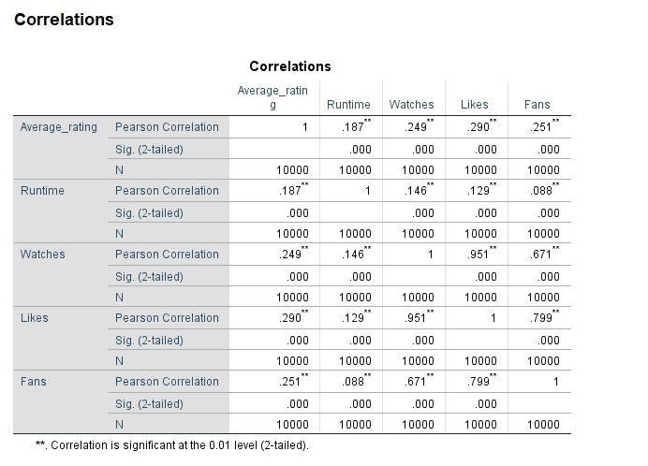
Table 3: Correlation
(Source: Self-Developed)
The relationships which existed among average rating, runtime and engagement measures were then analysed by Pearson correlation. Mean rating has weak, then moderate positive correlates with runtime (r =.187), watches (r =.249), likes (r =.290), and fans (r =.251), all significant at the.01 level. These findings indicate that more engaging movies and those with a slightly longer duration of running time are expected to have a slightly higher rating, but the correlation coefficients are weak. Engagement metrics, in turn, are highly correlated (in that case, watches and likes have a correlation of r =.951), which means that they represent strongly related measures of audience visibility and interaction.
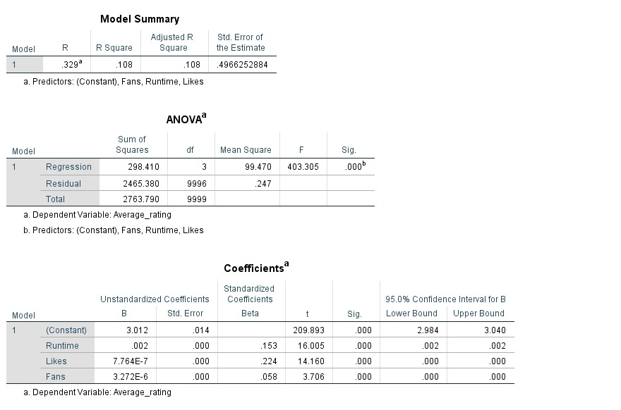
Table 4: Regression
(Source: Self-Developed)
The multiple linear regression analysis was done to test the hypothesis that runtime, likes, and fan counts predict the average rating. It is statistically significant (F(3, 9996) = 403.31, p <.001) and accounts for about 10.8 per cent of the variation in average rating (R^2 =.108). The strongest predictor was Likes (b =.224), then runtime (b =.153), and fan count (b =.058), which were all statistically significant. The model is not very powerful in explaining, but this is to be expected in datasets of behavioural data where the evaluation of the audience is conditioned upon many unobservable variables.

Insights and Recommendations
The analysis gives some key insights into the motivation of film success in the digital media. To begin with, popularity and perception of quality are two different dimensions. Although the metrics of engagement, including watches and likes, are highly correlated among themselves, they only account for a relatively low share of the difference in average ratings. This implies that high visibility is not always associated with high audience approval, further supporting the use of multi-metric evaluation systems. Second, the original language is also quite influential in developing the perception of the audience. The average rating of the non-English films is always greater than that of the English-language films, even though they do not attract as many audiences. This is an indication that International and foreign films attract a more discriminating and highly involved audience, and thus, perceived quality is high. This emphasises the importance of using rating-based metrics in addition to volume-based metrics in measuring content performance as per a Business Intelligence outlook.
Resting on these results, several data-driven recommendations are possible. Ratings, likes, and number of fans should be incorporated into the recommendation algorithms of media and not watch count, as the priority. Such areas of investment as international content and higher quality niche genres can increase the level of audience satisfaction, especially when these issues are accompanied by efficient subtitling and use of dedicated promotion tools (Sanchez-Mompean and Zanotti, 2025). It has been shown by runtime analysis that movies with their traditional duration ranges are more consistent, and runtime optimisation can be used during content planning. Operational efficiency-wise, content selection based on analytics will minimise the use of expensive but high-volume production with low approval of the audience (Mikalef et al., 2020). Despite the comprehensive nature of the dataset, in future studies, demographic variables may be included, review sentiment analysis may be included, or longitudinal engagement data may be included to enhance predictive accuracy and strategic value.

References
Berger, J., Moe, W.W. and Schweidel, D.A. (2023). What Holds Attention? Linguistic Drivers of Engagement. Journal of Marketing, 87(5), p.002224292311528. doi:https://doi.org/10.1177/00222429231152880.
Dodds, T., de Vreese, C., Helberger, N., Resendez, V. and Seipp, T. (2023). Popularity-driven Metrics: Audience Analytics and Shifting Opinion Power to Digital Platforms. Journalism Studies, 24(3), pp.1–19. doi:https://doi.org/10.1080/1461670x.2023.2167104.
Heitmayer, M. (2024). The Second Wave of Attention Economics. Attention as a Universal Symbolic Currency on Social Media and beyond. Interacting with Computers, [online] 37(1). doi:https://doi.org/10.1093/iwc/iwae035.
Kafle, S.C. (2020). (PDF) Correlation and Regression Analysis Using SPSS. [online] ResearchGate. Available at: https://www.researchgate.net/publication/343282545_Correlation_and_Regression_Analysis_Using_SPSS.
Maghsoudi, M. and Nezafati, N. (2023). Navigating the acceptance of implementing business intelligence in organizations: A system dynamics approach. Telematics and Informatics Reports, [online] 11, p.100070. doi:https://doi.org/10.1016/j.teler.2023.100070.
Mikalef, P., Boura, M., Lekakos, G. and Krogstie, J. (2020). The Role of Information Governance in Big Data Analytics Driven Innovation. Information & Management, [online] 57(7), p.103361. doi:https://doi.org/10.1016/j.im.2020.103361.
Nixon, L., Apostolidis, K., Apostolidis, E., Galanopoulos, D., Mezaris, V., Philipp, B. and Bocyte, R. (2024). AI and data-driven media analysis of TV content for optimised digital content marketing. Multimedia Systems, 30(1). doi:https://doi.org/10.1007/s00530-023-01195-7.
Sahu, S., Kumar, R., Pathan, M.S., Shafi, J., Kumar, Y. and Ijaz, M.F. (2022). Movie Popularity and Target Audience Prediction Using the Content-Based Recommender System. IEEE Access, 10, pp.42044–42060. doi:https://doi.org/10.1109/access.2022.3168161.
Sánchez-Mompeán, S. and Zanotti, S. (2025). Introduction. Riding the streaming wave: Broadening global access through audiovisual translation and media accessibility. The International Journal of Translation and Interpreting Research, 17(2), pp.1–15. doi:https://doi.org/10.12807/ti.117202.2025.a01.
Seetharaman, A. (2025). Evaluating the Effectiveness of Influencer Marketing in Niche Markets. Journal of Marketing & Social Research, [online] 2, pp.65–79. doi:https://doi.org/10.61336/jmsr/25-05-08.

