

Module Name: Psychology Health and Social Care
Module no:LCHS4010 _ LON
Student Name: Martha Deleon Joson

Student Id no :;2508286
Lecturer :Mr Brian Mashumba

Table of Contents
1,Introduction……………………………………………………………………………………….1
2. Theories of Lifespan Development …………………………………………………………..2
2.1 Attachment Theory……………………………………………………………………………2
2.2 Humanistic Theory……………………………………………………………………………3
3.Application Theories to Health and Social care ……………………………………………….4
3.1 Application to children and young people ………………………………………………..4
3,2 Impact of Health and wellbeing …………………………………………………………….5
4.Social and Biological Determinants of Human Behaviour....................................................6
4.1Biological Determinants ………………………………………………………………………6
4,2 Social Determinants…………………………………………………………………………7
5.Impact of social Media on Human Behaviour…………………………………………………8
5.1Positive impacts……………………………………………………………………………….8
5.2 Negative impact …………………………………………………………………………….9
5.3 the Impact of young children ……………………………………………………………10
6. Application to health and Social Care Practice ……………………………………………..11
7The Main body
8 Conclusion…………………………………………………………………………………………13
9 Reference list ………………………………………………………………………………….14
10 In- text citation…………………………………………………………………………………15

THE IMPACT OF SOCIAL MEDIA ON MENTAL HEALTH
INTRODUCTION
Social media has important part of everyday life particularly the young children and emotional changes. The young people increasingly used social media platform like Instagram , tiktok,Snaptchat and Facebook to communicate, to develop the relationship and their identities , while social media offers opportunities for learning , the social connection and emotional support ,the evidence suggested the excessive or negative to contribute the mental health, anxiety , depression, cyberbullying sleep disturbances and low self-esteem (Odgers ,2020) the impact in social media in mental health is complex , the experience can also promote wellbeing and social inclusion
Developmental theories provide valuable frameworks for understanding why adolescent, particularly vulnerable to physiological effects of social media . Erikson’s Psychosocial development ,this theory explains how identity formation during adolescence , the influenced by online interactions, Bowlby’s attachment theory the relationship shape of adolescents of emotional response and online behaviours this examines the behaviour ,and impact of social media on adolescent mental health . this essay will discuss the impact of social media. According to national statistic (2023)majority of young people in the United Kingdom used social media it important and influencing their emotional and social media offer of the benefits.

2 THEORIES OF LIFESPAN DEVELEOPMENT
- Attachment Theory was developed by John Bowlby ,who argued that children have an innate need to form close emotional relationship with caregivers . a secure attachment develops with caregivers Bowlby (1969) respond consistently and sensitively to a child needs this relationship can provide children with a sense of safety and help them develop confidence to explore their environment

Attachment is particularly important during early childhood because children depend on adult for emotional and physical security .research has found that secure attachment is associated with better emotional regulation and more positive
Emotional experiences while insecure attachment can be associated with difficulties in emotional regulation and coping (Cooke, Kochendorfer and Stuart- Parrigon 2019) therefore relevant
in contrast , inconsistent or inadequate care contribution to insecure attachment children who experience neglect ,separation or inconsistent responses may experience difficulties with trust , emotional regulation and relationship, Ainsworth et al. (1978) identified different patterns of attachment through research involving the strange situation, including secure and insecure patterns ,
however , attachment theory has limitation, it can be criticised for placing to much emphasise on the primary caregiver , children can formed attachment with several people including fathers , grandparents, sibling and other carers cultural differences
can also influence parenting attachments Behaviour the professional should use attachment theory as guide rather than learning the child to develop in their behaviour
- Humanistic potential approach focus on individuals’ potential personal growth ,choices and ability to achieve their goals Maslow(1943) developed the Hierarchy of needs , safety , love and belonging in love relationship with family friends and others Esteem involves feeling valued , respected and confident self-actualization refer to Achieving one ‘s potential Maslow Theory refers and can applied to children and young people example. The child who is hungry, tired or worried about their safety may find it difficult to concentrate or participate in activities .this theory is useful to encourage professional to consider the whole person rather than focusing only physical health ,

3.APPLICATION THEORIES TO HEALTH AND SOCIAL CARE
3.1 Application to children and young people both theories can applied when they working with children and young people attachment , theory helps professional understand the importance of the child and supportive relationship ,children needs adults who listen to them , Maslow’s Theory can also help professional identity unmet needs a child experiencing poverty , poor housing or lack of emotional support may have difficulty achieving their potential health and social care professional Can help by identifying needs providing their support and preparing families to relevant services
3,2 IMPACTS OF HEALTH AND WELLBEING
Developmental experiences can have an important influence on health and wellbeing . positive relationship can support emotional security, confidence and resilience .neglect the difficulties of the family and social disadvantage can increase vulnerability both theories support person centred approach this can improve wellbeing and help individuals participate more effectively in their own care
4.SOCIAL AND BIOLOGICAL DETERMINANTS OF HUMAN BEHAVIOUR
Human behaviour is influenced by both biological determinants include genetics , brain development , hormones , physical health and neurological factors these emotion and behaviour response the development and environment (Pinel and Barnes, 2018) the biological factors are not completed to determine the behaviour , social factors are highly important , this include family relationship education income , friends and culture in the community . the world health organization (2023) identifies social determinants people are born , grow , live work and age
4.1 Biological Determinants , genetics can influence characteristic such as temperament and Vulnerability to some health condition , brain development affects behaviour during childhood and adolescence , Hormonal changes during puberty can influence emotion and behaviour .
4.2 Social determinant include family relationship , socioeconomic circumstances , education housing and social support , poverty and poor housing can create the challenges for families Marmot et al.(2020)the health and inequalities I conditions the importance of social economic condition.
5.IMPACTS OF SOCIAL MEDIA ON HUMAN BEHAVIOR
Social media has become an important part of everyday life particularly for children and young people , it can influence communication , relationship identity and behaviour
5,1 Positive impact social media can provide opportunities for communication, education and social communication young people can maintain friendship ,communicate with family and access educational information communities can provide emotional support and allow individuals to share experience .
5.2 Negative impact there are potential risk, social media use can enterfre with sleep the physical activity and face to face relationship , the young people experiencing cyberbullying , online pressure and exposure or harmful content
5,3 impacts of young children and young people,Chidren and young people maybe particularly vulnerable because they are still developing emotional and socially, social media influence their identity and understand the relationship of Health and Social care.

6.APPLICATION TO HEALTH AND SOCIAL CARE PACTICE
Theories of development can support effective professional practice attachments ,theory encourage professional to build trusting and consistent relationship with children professional consider physical and emotional and social needs should use he co communication and observation and assessment to understand the individuals need

7 THE MAIN BODY
Social media has both positive and negative effects on mental health and development of adolescents young people use social media to communicate with friends and to develop their relationship and get the access and information these activities provide a sense of belonging and social support , particular the young people who may have experience of loneliness or social isolation, social media also provide opportunities for adolescents to share their experience to others have similar interest or difficulties . the benefits it depend on social media is used like problematic person , and expose to cyberbullying , unrealistic images , social comparison and pressure to gain approval from others in research has identified the association between social media use depression, anxiety and psychological distress among adolescents (Keles , Mc Crae and Grealish , (2020) and one of the positive effects of social media is to support social connection. Social networking platforms allow young people to communicate with friends even when they ar physically apart , this can be providing emotional support and help adolescents feel connected to their peers , online communities also particular valuable to young people who find difficult to established relationship to face to face ,(Odgers and Jensen, 2020)
Heath and social care professional have important role in promoting safe and healthy social media rather than telling to young people to stop using social media can provide education about the cyberbullying online communication , unrealistic habits and screen images the parents and carers also encourage them to communicate with young people important when they are sign of anxiety , depression , and social withdrawal , sleep difficulties or significant change behaviour

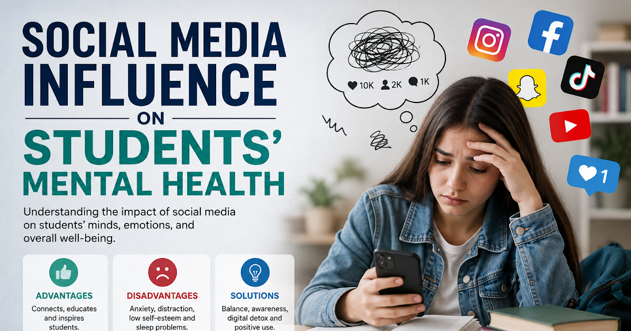

8 .CONCLUSION
In conclusion, lifespan development is influenced by biological , physiological and social factors, Bowlby’s attachment theory demonstrates the importance secure and supportive relationship during the childhood , Maslow Humanistic theoryis the importance of physical and emotional and social physiological needs both theory can applied effectively in health and social care particularly in when supporting children and young people to understand this theory provide appropriate support , biological and social determinants demonstrate the behaviour is influenced and circumstances such as genetic, family relationship education , and income environment social media is important and influence on modern behaviour, and support communication education and social connection also the young people expose to cyberbullying , the social comparison and harmful content the health and social care professionals should developmental theories along side person centred practice to support individuals health and well being

:
9.REFERENCE;
Bowlby ,J.(1988) A Secure base: Parent and child attachment and healty of himan development,
Marmot ,M.,Allen, Boyce , T.,Goldblatt P, and Morrison(2020) Health equity in England , institute of health. Equity

Maslow , A H.(1943)”A Theory of Human motivation; psychological Review.50(4)pp,-370-396
Odgers ,C.L(2020) adolescents mental health in digital age, Journal of child psychology and psychiatry.61(3)pp336-348
Pinel ,J,P,J and Barnes S.J.(2018) Biopsychology, Harlow :Pearson 10th edn
World Health organization(2023)

10.IN-TEXT CITATION
- (Bowlby J. 1969)
- Ainsworth et al.(1978)
- Maslow (1943)
- Pinel and Barnes (2018)
- Marmot et al, (2020
- Odgers and Jensen (2020)
- World Health organization (2023)

