Task 1 – Poster Template (Guidance Only)
Module: LCHS4003 – Introduction to Health and Social Care
Student Name: mariama dalanda jallow
Pharmacy service in the UK
Student Number: 2442841
Lecturer: MR mohamed Alieu
Submission Date: 17 November 2025

Introducing pharmacy in the UK
Pharmacy services in the UK range from giving medicines and advice to full clinical care and public health programs. Pharmacists are the main providers, supported by technicians and trained staff. Community pharmacies are the most accessible point for most of these service
A pharmacy is a health-care establishment where medicines are prepared, dispensed, and sold, and where people receive advice and services related to health and medications.Pharmacies are not just shops; they are health-care hubs that bridge the gap between doctors, hospitals, and patients.

Main function of pharmacy
Dispensing medicines
- Filling proscription from doctors dentist or other health care professionals
- Ensure correct dosage safety and patients understanding
2 over the counter advise
- Providing non prescription medicines and guidance for minor health problems like cold headaches or allergies
3 health and clinical service
- Offering vaccination (flu COVID-19 travel vaccines
- Monitoring chronic condition like diabetes or high blood pressure
- Giving lifestyle advice(smoking cessation weight management sexual health

Development of pharmacy service in the uk
- Traditional apothecaries (pre-19th century)
- Before modern pharmacy apothecaries preparedand sold medicines harbs and remedies
- Then often acted as both physicians and chemists advising patients on treatment.
- 19th -century pharmacy laws
- During the 1800s the UK introduced law to regulate medicines and pharmacists
- The pharmacy act 1868 was a key millstone; it required pharmacists to be registered and qualified ensuring safer preparations and dispensing of medicines

The functioning of pharmacy services under the NHD
1 how phamacy operate today
- Community pharmacies and contractual framework. Community pharmacies in England operate under the NHS community pharmacy contractual framework, which defines three tires of services: essential advance and national enhanced services.
- Electronic prescription service perscribers (eg) GP's can send prescriptions electronically to the patients chosen pharmacy. Then the pharmacies retrieve verify and dispense them
- Patient can self refer they can walk into a participating pharmacy or use a video in some cases without needing a GP referral.
- Pharmacies in the NHS do more than just dispense; they are increasingly clinical hub.
Through pharmacy first they manage common illnesses illnesses and can supply certain medicines reducing demand on GP's
Referrals NHS 111(and all other urgent care
Services) can refer patients into the pharmacy first Services if the patients condition fits one of the Seven path way

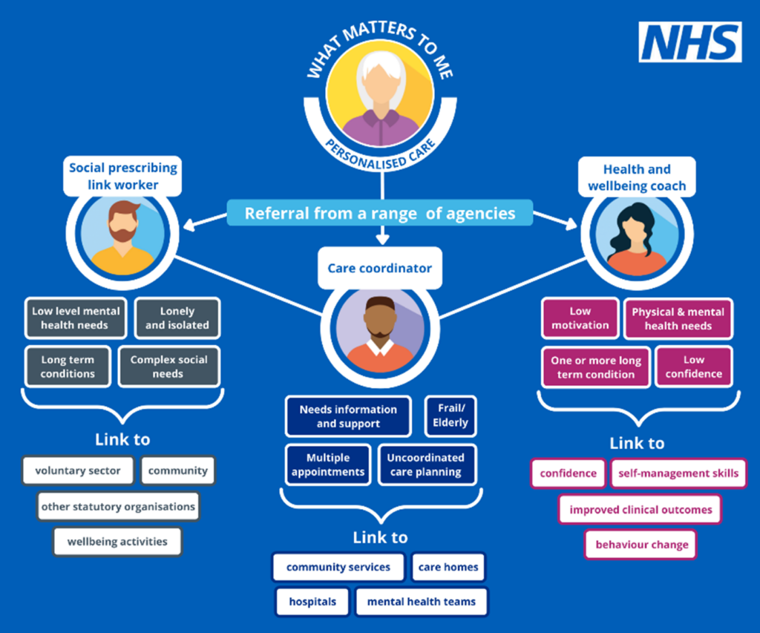

Challenges that pharmacy service are facing today
1 workforce shortages
Reduce capacity: with fewer pharmacists and pharmacy technicians, pharmacies struggle to maintain normal services such as dispensing clinical checks and consultation-based services(eg pharmacy first, vaccination
Longer waiting times; fewer staff available to complete checks prepare prescriptions or run service leads to slower workflows.
Reduce service availability; some pharmacies may reduce opening close or limit the clinical service they offer
How it affect phamacy staff
Increase workload: remaining staff must take on extra responsibilities leading to overload and multitasking under pressure

Stress and burnout; sustained understaffed contributes to fatigue, higher error risk and lower morale
Reduce development time; staff have less time for training, clinical development or new service implementation

Medical supply issues
How does this affect pharmacy
- Stock shortage; pharmacies may not be able to obtain certain medicines due to manufacturing problems global shortages or supply-chain disruption
- Administration burden; staff must spend time contacting wholesalers, sourcing alternatives or liaising with prescribes to amend prescriptions
- Financial pressure; some medicines may be reimbursed at rates that do not fully cover the inflated purchase price during shortage

How does this affect patients
- Longer waits for prescriptions; patients may experience delays in collecting medicines or getting advice
- Reduce access to service; not all pharmacies can offer such as pharmacy first vaccinations, blood pressure checks, or consultations if staff are stretched
- Risk of error; high pressure environment can increase the chance of dispensing mistake though pharmacies work hard to minimise this

How it affect patients
- Delays in accessing medicines; patients may need to return multiple times visit different pharmacies or wait for medicines to be sourced
- Forced changes in treatment; when alternative medicines are supplied, patients may need new prescriptions or experience different side effects
- Anxiety or confusion; especially for patients with long - term condition being unable to obtain regular medicine can cause worry and reduce treatment stability
How it affect pahrmacy staff
- Increase workload and frustration; staff must handle patient concerns, chase stocks,and arrange alternatives, which takes time away from clinical services
- Conflict management; staff often face patient dissatisfaction or worry when medicines aren't available increasing emotional strain
- More clinical decision making; pharmacists must work with GPs to recommend suitable alternatives, and ensure safe switching

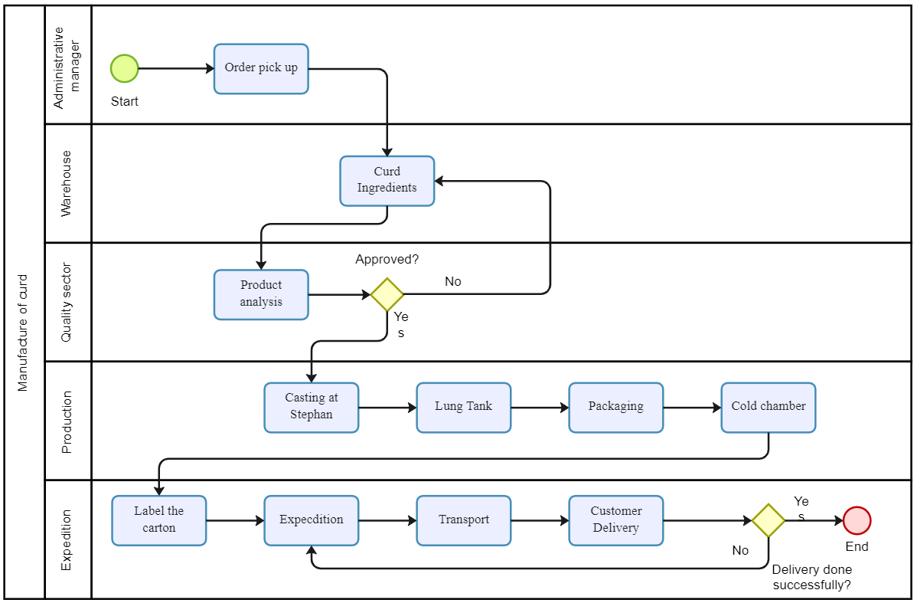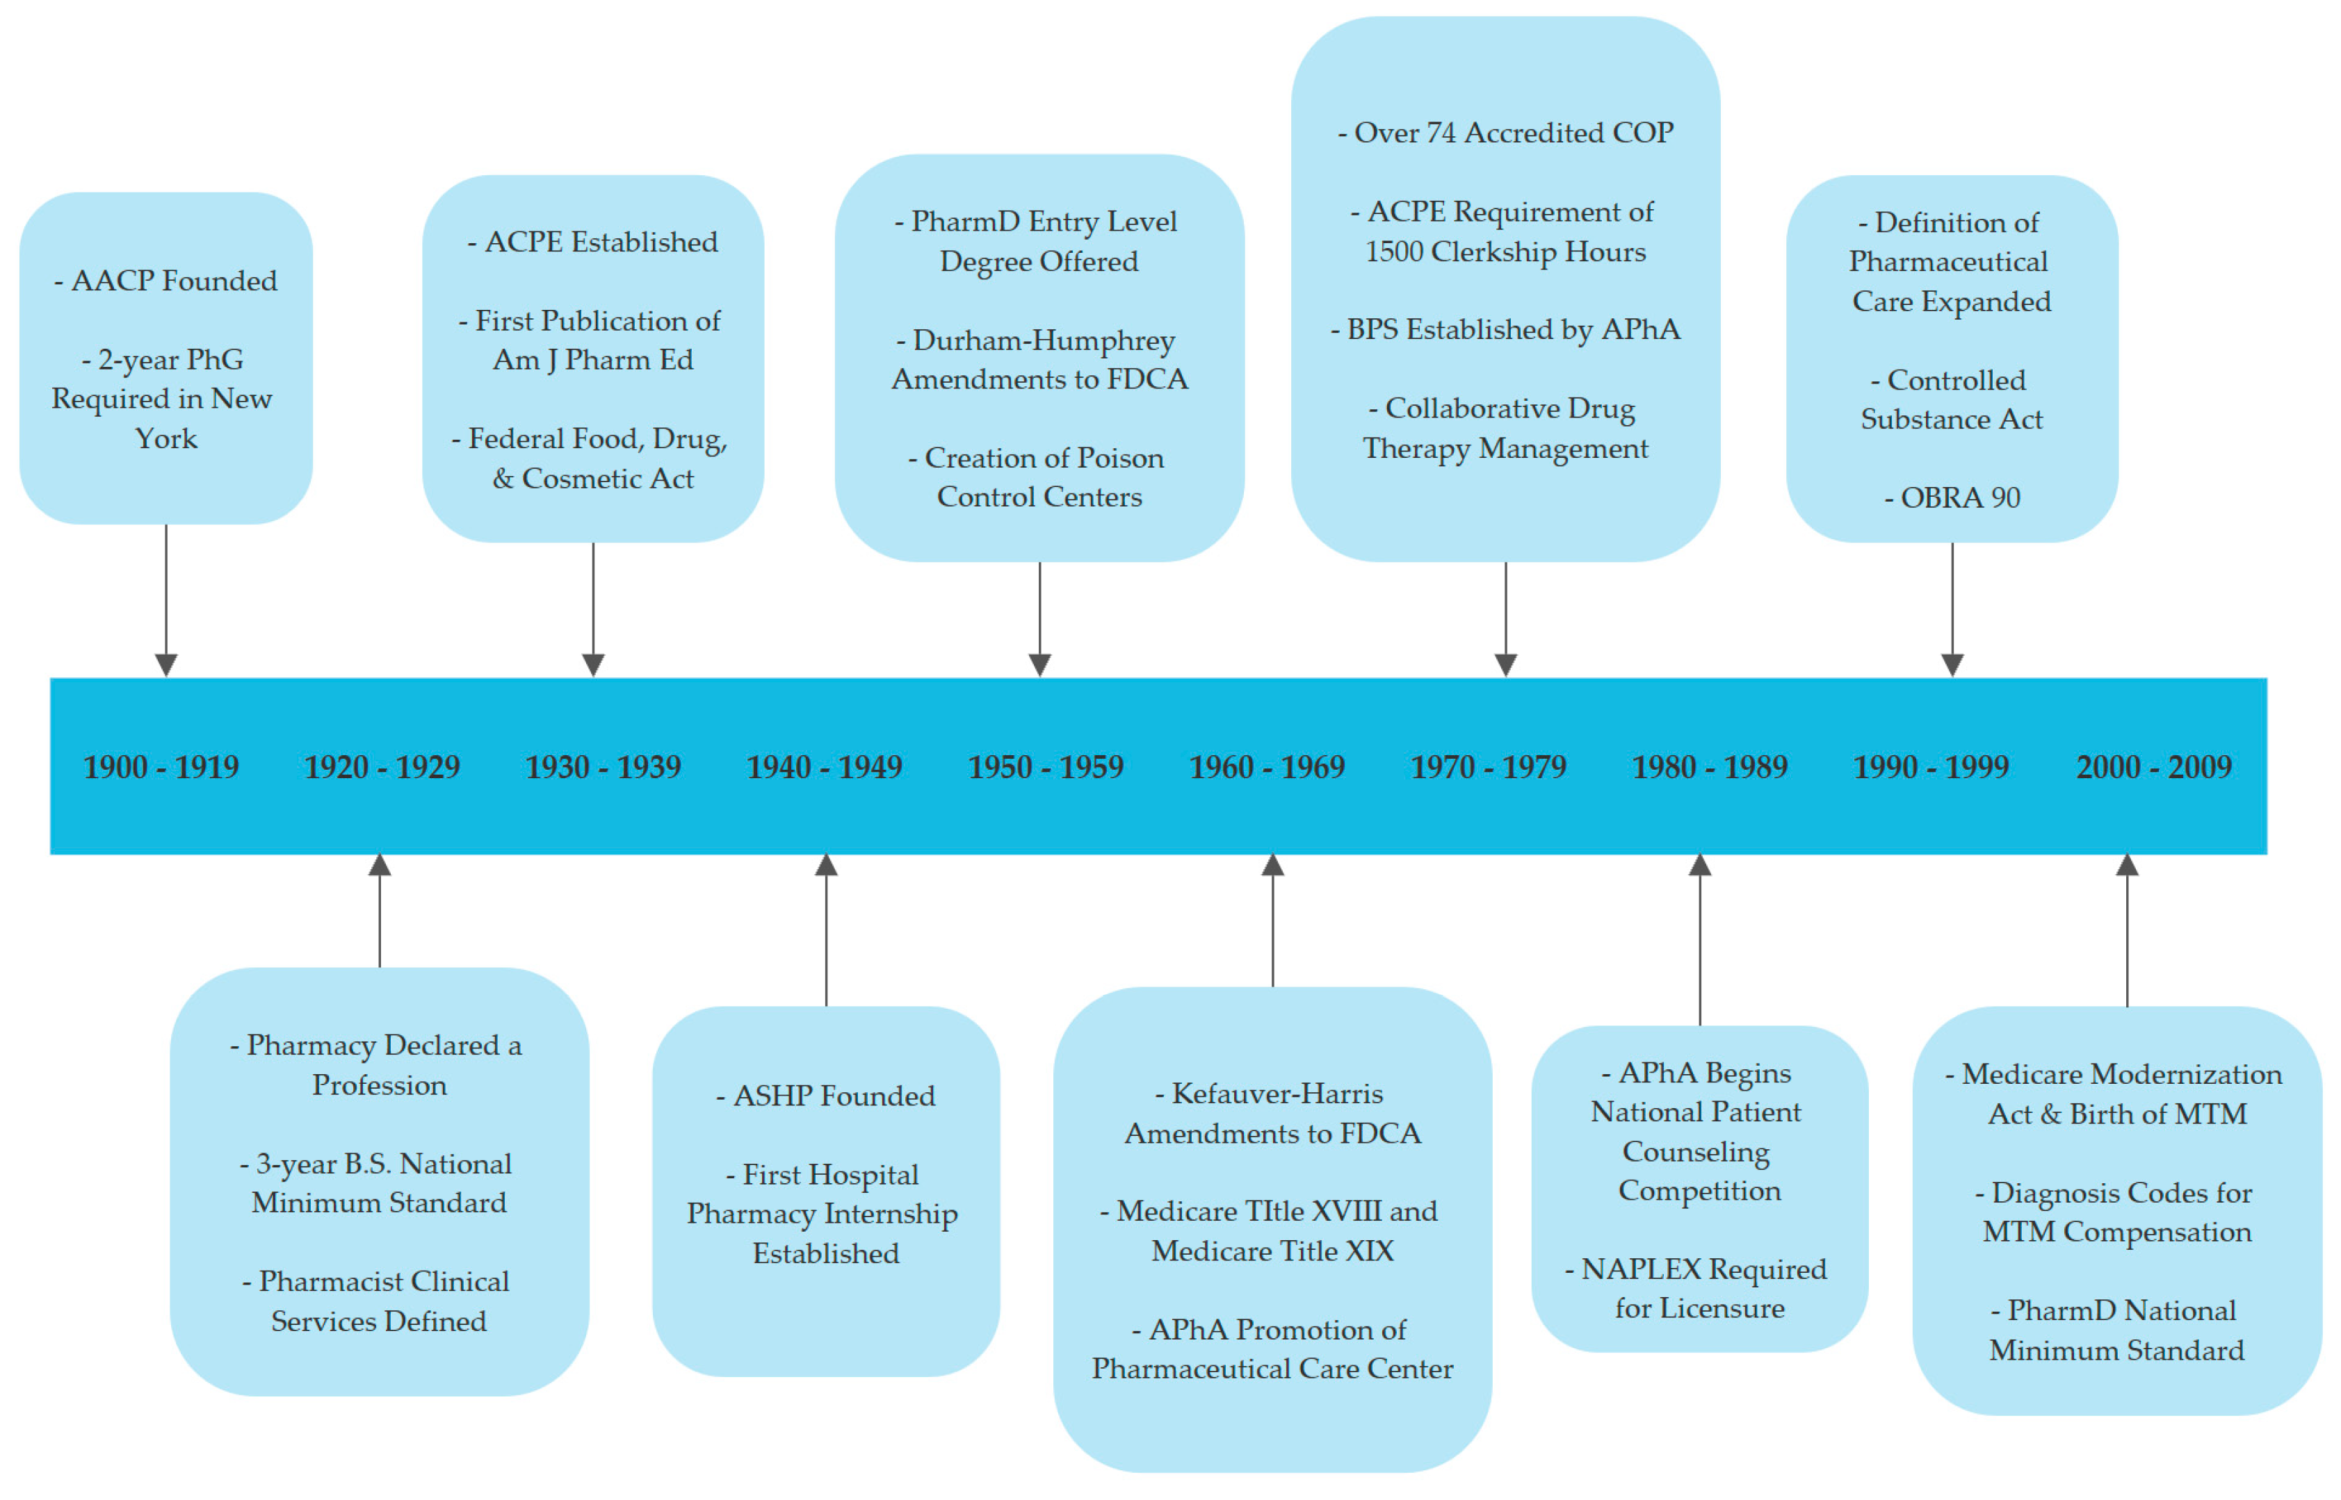
Department of Health and Social Care (DHSC) (2023) Community Pharmacy Contractual Framework: 5-year settlement update. London: DHSC.
General Pharmaceutical Council (GPhC) (2023) Annual report: The state of pharmacy regulation in Great Britain. London: GPhC.
NHS England (2024) Pharmacy First: National clinical pathways and service specification. Leeds: NHS England.
NHS England (2023) NHS Long Term Workforce Plan. Leeds: NHS England.
Pharmaceutical Journal (2023) ‘Ongoing medicines shortages in community pharmacy: causes and impact’, The Pharmaceutical Journal, 311(7974), pp. 1–6.
Royal Pharmaceutical Society (RPS) (2022) Workforce well being in pharmacy: National survey findings. London: RPS.

Types of pharmacy services

Dispensing=60% advice & support=10%

Clinical services=20% vaccination=10%

Task 2: Essay – The Origins and Structure of the National Health Service (NHS)
The National Health Service, known as the NHS, is one of the most important parts of life in the UK. It provides healthcare that is free when people use it, so that everyone can get medical help no matter how much money they have. In this essay, I will talk about where the NHS came from, what ideas shaped it, and how it works today. I will also look at some of the main challenges it faces now.
Before the NHS was created in 1948, health care in Britain was very different from what it is today. People often had to pay for treatment, and this meant that many working-class families could not afford to see a doctor. Hospitals were either run by charities or local councils, and the quality of care depended on where you lived or how much you earned (Baggott, 2015). During the Second World War, the government had to organize health services on a national level to treat soldiers and civilians, and this showed that a national system could work. This idea became even stronger after the Beveridge Report (1942), which called for changes to tackle poverty and poor health. It said that everyone should have access to health care as part of a new welfare system (Timmins, 2017).
The NHS was officially started on 5 July 1948, led by Aneurin Bevan, who was the Health Minister at the time. Bevan’s main goal was to make health care available for everyone, not just for those who could pay. The NHS was based on three key ideas: that it should meet everyone’s needs, that it should be free when people use it, and that care should be given based on need, not on income (Department of Health and Social Care, 2015). Many doctors did not like the idea at first because they thought they would lose control over their work. Bevan eventually convinced them by allowing them to keep some private practice alongside their NHS work (Klein, 2019). This was an important moment in British history because it meant that, for the first time, health became a public right rather than a privilege.
Today, the NHS is made up of four different systems in England, Scotland, Wales, and Northern Ireland. Each country manages its own NHS, but they all share the same core principles (Nuffield Trust, 2023). In England, the NHS is led by the Department of Health and Social Care and NHS England, which plan services and funding. There are also Integrated Care Systems (ICSs) that bring together hospitals, GPs, and community services to work as a team (Ham, 2022). The idea is to make care more joined-up so that patients get smoother support.
Even though the NHS is still loved by the public, it faces many problems today. The population is getting older, which means more people need long-term care. There are also staff shortages and long waiting lists for operations and GP appointments (King’s Fund, 2024). The COVID-19 pandemic made these problems worse by increasing pressure on hospitals and staff. Another big issue is that people’s health is not equal across the country — poorer areas often have worse health outcomes (Marmot, 2020). The government is now trying to improve things by focusing on prevention, digital health, and better coordination between services (NHS England, 2024).
In conclusion, the NHS was created after the war to give everyone in Britain equal access to health care. It was built on fairness, equality, and care for all. Although the NHS still follows those principles, it now faces huge challenges that make it harder to keep up with demand. Even so, it remains a symbol of national pride and one of the most important parts of British society. To protect it for the future, more investment, innovation, and staff support are needed so it can continue to serve everyone for generations to come.

Reference List (UWTSD Harvard Style)
- Baggott, R. (2015) Understanding Health Policy. 3rd ed. Bristol: Policy Press.
- Department of Health and Social Care (2015) The NHS Constitution for England. London: DHSC.
- Ham, C. (2022) ‘Integrated care systems and the future of NHS governance’, BMJ, 376, pp. 1–3.
- King’s Fund (2024) The NHS at 75: Priorities for the Future. Available at: https://www.kingsfund.org.uk (Accessed: 8 November 2025).
- Klein, R. (2019) The New Politics of the NHS: From Creation to Reinvention. 8th ed. London: CRC Press.
- Marmot, M. (2020) Health Equity in England: The Marmot Review 10 Years On. London: Institute of Health Equity.
- NHS England (2024) How the NHS is Structured. Available at: https://www.england.nhs.uk (Accessed: 8 November 2025).
- Nuffield Trust (2023) The Four Health Systems of the UK: How They Differ and What That Means. London: Nuffield Trust.
- Timmins, N. (2017) The Five Giants: A Biography of the Welfare State. London: HarperCollins.

