Task 3:

Safeguarding and working in complex situations – Case Study

‘Safeguarding means preventing and protecting children and adults at risk from abuse or neglect and educating those around them to recognise the signs and dangers’ – The Wales Safeguarding Procedures 2019.

For this safeguarding assignment, I will be critically reflecting on a mother (adult 1 and baby (child 1) fostering placement. Child 1 is now 6 months old. This analysis will include the parenting assessment, foster carer observations and consider all aspects of safeguarding for child 1. I will reference to Welsh legislation and polices/procedures in relation to the circumstances, including comparisons with England/EU laws and guidance. This will demonstrate an understanding of collaborative working, analysis in assessments and professional judgement in complex safeguarding situations. I will consider how this legislation supports my practice, alongside adhering to the Code of Professional Practice and framework guidance.

As supervising social worker, I have been working alongside foster carers supporting adult 1 and child 1 since April 2024. Due to risks identified, the local authority decided to seek foster carers to support a parenting assessment. This is becoming more common in fostering and provides opportunity to assess parenting skills and risk in a safe space. The local authority social worker will complete an assessment during this time, with a recommendation to court. For example, if mum and baby can safely remain together or if a separation/alternative care plan is in the best interests of the child. These assessments are child centred, with a large focus on safety, risk, well-being and meeting child 1’s basic holistic needs. My role within this is to support the foster carers and work closely with the local authority throughout their assessment. I provide advice, guidance and supervision to foster carers and support visits to adult 1 and child 1.

During this time, I help foster carers in completing detailed and informative logs that can be shared with the local authority and in court/legal proceedings. I attend care planning meetings and looked after child (LAC) reviews with the local authority and other professionals, including health. We work collaboratively to ensure effective support is provided to adult 1, child 1 and foster carers, contributing our observations throughout the assessment. I have a clear understanding how fundamental this multi-agency working is to contribute to an effective assessment. Furthermore, it supports working with other professionals, communication/sharing information and expertise, to resolve difficulties and professionally challenge in a respectful way. For example, in parent and child fostering, we have a ‘contract of expectations’, which can be amended as a working document, based on level of need. This includes supervision levels expected from foster carers and any independent time for adult 1 and child 1. When safeguarding concerns where highlighted, this supervision was increased after observations shared by foster carers and a meeting with the local authority.

Upon reflection, there are many positives of working collaboratively and following legislation. However, at times, this can cause difficulties to arise in practice. Such as, varying professional opinions/conclusions, different values/way of working. In my experience, I have found this to occur on occasion with the social and medical model. As I may view a circumstance more holistically, considering the variable social/economic factors influencing a person’s life. Whereas other professionals may have a different perspective. This contrast in professional judgement can cause conflicts to arise. However, when managed appropriately, it is helpful to view these differences as learning opportunities and reflective discussions. We endeavour to work in partnership, especially for assessment purposes, however, there are challenges social workers face with time restraints, resources, funding and high caseloads. Consequently, these timeframes and unrealistic workload expectations for practitioners, could create a sense of pressure, as discussed by Rodwell (2024), highlighting the need for a manageable caseload to prevent burnout.

Prior to coming into foster carer, the local authority completed a section 47 investigation, a safeguarding procedure embedded in the Children Act 1989. This is to assess risk of significant harm to a child/ren, holding strategy and core group meetings. In many cases, they will apply for an interim care order, before a final court hearing to ascertain the future care plan after completing assessments. Different outcomes could be a return home, full care order (remaining in care of the local authority/corporate parent) or a placement order for adoption. Social services became involved due to adult 1’s previous behaviours that caused concern and her own lived experiences of trauma and the care system. Including mental health and substance misuse, with concern of her ability to safely meet child 1’s needs. Foster carers were then part of the assessment process to support, guide and positively role model parenting skills.

The local authority social worker completes statutory visits alongside the assessment, whilst completing further risk assessments on family members and connected carers. Prior to this, I understand the process for protecting children at risk of harm, as guided by Wales Safeguarding Procedures (Welsh Government 2020), including reporting a child at risk (receiving a referral), responding, decision making and initial child protection procedures/conferences, planning assessment/intervention. In my practice, it is very helpful to utilize the Wales Safeguarding Procedures App. This is readily available to access and to refer to when needed. It highlights the procedures for children and adults safeguarding and guidance for practice. It remains child-centred throughout the safeguarding process focussing on the child’s wishes/feelings, experiences and promotes co-production to meet the individual needs of the child.

Adult 1 and child 1 were supported by a Welsh local authority; however, foster carers live in England. Adult 1 is a young, white British individual with Welsh heritage. Her hometown is an urban/town area of Wales and not a rural locality, therefore public transport and community amenities were accessible. In her current residing location, foster carers live in England, near North Wales. They live in a residential area, which is similar to adult 1’s hometown and has local services. Adult 1 does not drive; however, it is not a remote location, foster carers transport when needed or use public transport. Adult 1 is Welsh, although English speaking, and thus I ensured the fostering agency and local authority had offered the option of services in Welsh, as part of the requirements of the Welsh Language Measure/active offer. Although this was not needed, I remain mindful this must be considered to ensure a fair assessment and understanding of the process.

In Welsh practice, I continually consider the principles of the Social Services and Wellbeing (Wales) Act 2014. Part 3 of this act provides guidance on assessing the needs of individuals. In this case, I utilized this legislation for children’s safeguarding and parenting assessment, highlighting any risks or vulnerabilities, helping to determine the assessment recommendation and best interests of the child.

The Social Services and Wellbeing (Wales) Act 2024 was introduced to reform and simplify the law to build sustainable social services for Wales and aims to strengthen safeguarding. It emphasises the need to consider law, regulations and policies/procedures in relation to safeguarding children and/or adults. This legislation embeds the principles of the United Nations Convention on the Rights of the Child 1989 into its own laws for the people of Wales. The overarching duties of the Social Services and Wellbeing (Wales) Act 2024 include views, wishes and feelings of the individual and those with parenting responsibility. It focuses on safeguarding, well-being and health of individuals, whilst promoting partnership working between professionals. This way of working is encouraged throughout this assessment, although can be difficult at times as there remains issues with information sharing and inter-sectional working. This relies on practitioners thinking beyond their organisational boundaries, as discussed by Douglas and Barlow (2023). Although I am not directly completing the assessment, I am aware of the legislation referred to throughout this assessment, including Social Services and Well-being (Wales) Act 2014 part 7 – safeguarding. This aims to protect people from abuse, neglect or harm for adults and children, and the introduction of national independent safeguarding boards.

Throughout the assessment process, consideration would always be given to confidentiality. I comply to the data protection act 1989, ensuring information is only shared with necessary parties. For example, fostering logs being shared with solicitor for court purposes – some of these would be redacted to ensure only necessary details included and sensitive information edited when needed. Furthermore, I follow the Code of Professional Practice, ensuring I have a person-centred approach and listen to the voice/wishes of individuals and respect their rights. An example of this, is mum having her own solicitor for guidance and to seek legal advice when required throughout the assessment process.

The role of the foster carers and their observations is essential during this time. They will complete daily logs, shared with myself as supervising social worker, and I then forward to the local authority and legal team. Within this, foster carers are adhering to the expectations of their role and fostering regulations national minimum standards (standard 4: safeguarding children). My role is to supervise them, building confidence/diverse skillset, trauma-informed approach and ensuring standards of care are adhered to. Furthermore, we discuss training and development/learning plan and foster carers well-being needs. The fostering agency has expectations to work towards regulations within the Fostering Services: National Minimum Standards (2011). Alongside this, I work closely with child 1’s social worker, creating a collaborative approach (meetings, sharing reports/observations, regular communication/updates and reflective discussions) and being the linking connection between foster carers and local authority. Within this partnership working, I was able to apply analysis to foster carers observations, identifying risks, positive steps and adapting the action plan based on level of need. Throughout this assessment, I have provided my professional judgement and remained curious, ensuring we share these ideas and thoughts together to inform a coherent assessment.

Laws and legislation are needed in practice as we all have different values and beliefs as individuals/professionals. Following this statutory guidance helps create a foundation of procedures and expectations in our role, whilst remaining attuned to our own value-base. It also provides consistency in practice and support for individuals working with services, as professionals are following the same guidance. It is essential social workers have this knowledge of the law to ensure they understand the requirements in their role, legal frameworks and deliver high quality practice. This understanding of law will also ensure social workers provide care and support based on the needs of the individual, promote equal opportunities and effective safeguarding practice. This knowledge and awareness will help create a balance of providing a person-centred service, respecting the needs of individuals, whilst also remaining professionally curious and continually assessing risk, as discussed by Phillips et al (2022). This is a skill in social work practice and requires a thorough knowledge base in law, legislation, practice guidance and a commitment to continued professional development. We have a duty in our role to maintain this level of expertise to support delivering safe and competent practice, as stipulated in the Code of Professional Practice Section 6.

Tayor et al (2018) state that assessing risk can be complex and multifaceted. It requires social workers to provide a detailed and comprehensive analysis of assessment/observations, which often is used in court and for legal purposes. Chisnell et al (2019) identify the importance of understanding law, legislation and theoretical perspectives and utilizing this knowledge when assessing safeguarding. For example, in this situation, I have supported foster carers to analyse observations/assess risk. Child 1’s social worker provided a recommendation which will now go to court, including a very detailed assessment that focuses on factual information. Assessments must be objective and not based on opinion, ensuring the details are accurate and fair to the individual. Furthermore, understanding law and legislation, also provides us with a sense of security and protection as a professional.

We are working in challenging and emotionally charged situations with individuals, we have a high level of responsibility. Our professional judgement and decisions can be questioned at any time, by colleagues, individuals or in the legal process. By ensuring we follow statutory guidance/requirements, it ensures we are also safeguarding ourselves in our professional role, providing justification and evidence for our decisions.

Rights of Children and Young Persons (Wales) Measure 2011 imposes a duty upon the Welsh Ministers and the First Minister to consider the rights of children/young people in their decision making. For example, how their action plan adheres to the United Nations Convention on the Rights of the Child. In this parenting assessment, I am aware the social worker has had to thoroughly consider adult 1’s ability to safely meet child 1’s basic needs, including daily care and nurture. Within this, we all consider the assessment framework based on the needs of the child – please see below as an example. As supervising social worker, I support the foster carers closely in reviewing their fostering logs and sharing with the local authority on a weekly basis, throughout the duration of assessment. This is an important part of my role to ensure foster carers feel equipped to contribute to the level of expectations required, as discussed by Adams et al (2011). For the parenting assessment, a primary focus is on parenting capacity, however, all needs are taken into consideration to provide a holistic analysis.

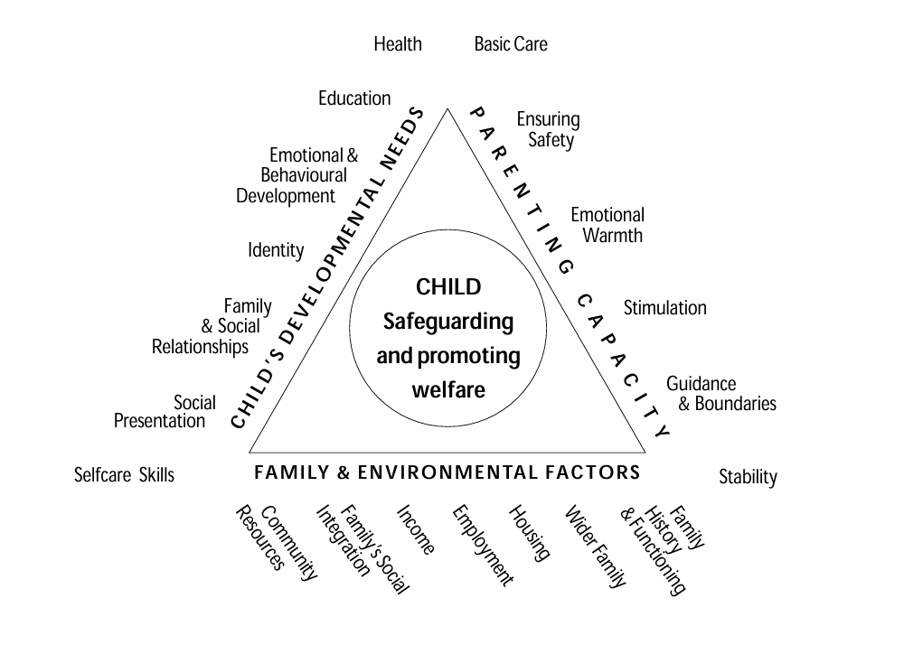

National Assembly for Wales: Home Office., (2001), Framework for the Assessment of Children in Need and their Families, London: The Stationary Office

When assessing risk, all professionals/individuals have a duty of care to safeguard and report concerns. Including social workers, teachers, health and all involved in a child’s life. It is essential all individuals understand their responsibility in keeping children and young people safe from harm (Wales Safeguarding Procedures Section 2 - Welsh Government 2020). It has often been seen as the role of the social worker, and it is an essential part of our job, however, all professionals in contact with a child must share any concerns or observations. This collaborative working will help keep children safe and promotes effective risk assessment/management. The importance of this partnership working for safeguarding children is highlighted in Elieen Munro’s child protection report, 2011. Furthermore, the number of professionals often involved in serious case reviews for children is identified by Cleaver et al (2020), providing critical and reflective analysis of the complexity of partnership working in safeguarding. Keeping children safe required caring and dedicated social workers, who can access supportive and experienced management and supervision to provide time for reflection and guidance.

Children are offered an advocate as part of their assessment process. As child 1 is only a young baby, they are not able to provide their wishes and feelings. Therefore, are solely reliant on professionals and adult caregivers to advocate for them and meet their needs. Older children may be considered as Gillick competent - able to provide consent/wishes under aged 16 in legal or medical purposes. However, young children can still be visited by a children’s guardian throughout the assessment/court process and in this case study, child 1 has had several visits throughout this time. The advocacy process includes, empowering, speaking up, safeguarding, enabling and supporting. This is also stipulated in the United Nations Convention on the Rights of the Child: Article 12, to respect the views of the child.

For this case study, I considered the local authorities’ policies and procedures, alongside Welsh law and legislation, to gather a deeper insight into children’s safeguarding processes for the area. This includes a Corporate Safeguarding Policy (reviewed February 2024) which relates to all children under the age of 18 and adults at risk over the age of 18. It stimulates guidance for safeguarding, alongside protection for their employees in their professional position of responsibility, such as potential allegations. This guidance states that all members of the local authority have a responsibility to adhere to the procedures and guidance in this policy to promote effective safeguarding of all staff (employee or volunteer) and service users. This council policy states the belief that every child and adult have the right to be safe and free from harm. It highlights safeguarding being a collaborative effort to promote welfare, positive well-being and reduce risk.

It was helpful in my analysis of this assessment process, to extend my knowledge of the local authorities specific safeguarding procedures, as every council may have different policies, which should be followed alongside the standardised Welsh laws and legislation. I was able to reflect and link this policy to the social workers approach to assessment and her professional judgement/analysis.

Professionals have a responsibility to ensure they have an up-to-date knowledge and understanding of legislation, law and safeguarding procedures. This will involve training and continued professional development to ensure a relevant and competent assessment is completed. For example, it would be valuable for social workers to have training in assessing risk and unconscious bias to support a reasonable and objective analysis. Having professional accountability and self-awareness is essential in safeguarding and effective risk assessing. Additionally, it is a requirement of the Code of Professional Practice and stated in the British Association of Social Workers code of ethics. We must be aware of our own value base, with an understanding of how this could impact our practice, ensuring our own beliefs do not overshadow professional judgement. Although we endeavour to be non-judgemental and anti-oppressive, it is natural our own feelings and lived experiences can influence our thought process. We uphold accountability by acknowledging this and helps provide a fair and transparent assessment, without own our personal bias. Adams et al (2011) state these assessments must be clear and evidence-based to ensure they meet ethical standards. According to Gershenson (2017), our own experiences and bias can influence decision-making, and we must be conscious of this in our professional practice and when assessing risk in an impartial capacity. Prysor (2023) suggests social workers need to demonstrate critical reflexivity when working with individuals, understanding our own sense of self and way of working, to empower others to make positive change.

In addition to legislation and law, I considered theoretical perspectives that could have been used in the assessment. For the context of this parenting assessment, I considered Maslow’s hierarchy of needs, as this links with the care needs for child 1.
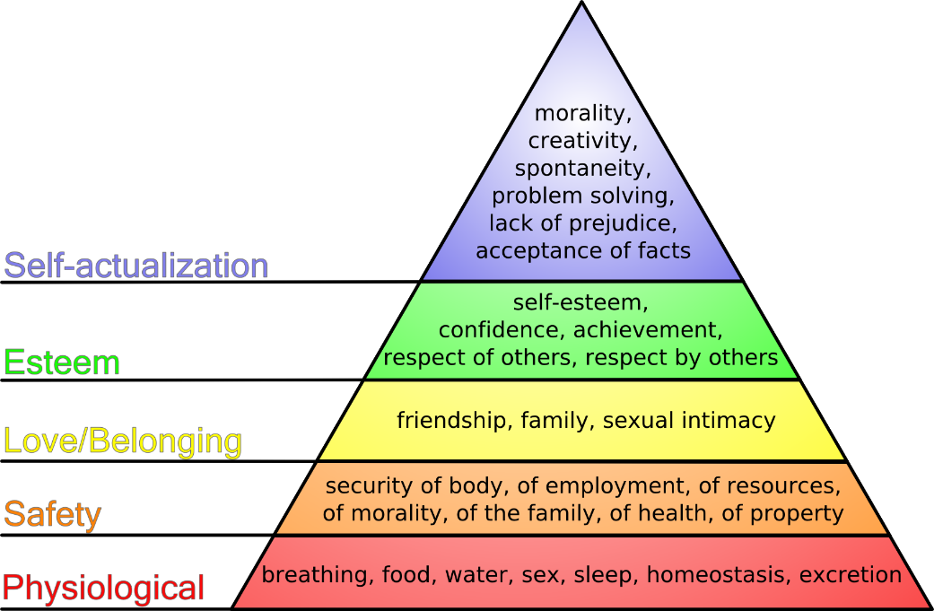

Carl Rogers (2020) devised the concept of a person-centred approach, and this is used in various helping/caring professionals, including social work. I endeavour to use this approach in my practice and ensure the individual is at the centre of my work. In this circumstance, it is considering both the needs of adult 1 and child 1, although with safeguarding child 1 and minimising risk being at the forefront of the assessment.
Another theory I would use if completing a safeguarding assessment would be the three-stage theory framework by Collingwood (2008). This is a tool in identifying what you already know about an individual and additional information to ascertain, theory to inform, followed by theory to intervene. For example, in this instance, a theory to inform/reason for social work intervention would be mental health, risk and attachment/loss. Theory to then support could include life story work and therapeutic work alongside a trauma informed approach. The final stage to this model would be for the social worker to consider their knowledge, skills and values/ethics, in relation to their work with the service user. I feel this could be incorporated into planning parenting sessions/visits to mum and identifying areas of focus and goals.

Within this safeguarding process, I would endeavour to deliver a strengths-based approach, Saleeby (1996), recognising the positives for the individual, alongside areas in need to strengthen. Having this approach is essential for individuals to feel empowered, as there is risk of feeling oppressed when assessing safeguarding/risk. It is part of the social workers role and professional skills, to balance this appropriately and sensitively, identifying factors that are working well, when possible, and not solely focussing on negatives, as this could appear oppressive and a barrier to change.
We often refer to power balance in social work, however, with decision making in our role, this can be difficult and unrealistic to create a complete fair balance of this. Therefore, we must strive to be approachable, kind and listen to individuals, to make them feel valued and their voice heard, using any professional authority in an empowering way for the individual. Law and legislation highlight the differences between power and duties. Considering this, it can be challenging when addressing safeguarding concerns with service users, even if we approach this in an empathic manner, as we will gather details to inform our assessment and ascertain an outcome. This can cause strain on professional relationships as social workers may deliver news that is difficult to hear and impacts the lives of individuals. I aim to build a foundation of trust with service users, and this helps when addressing sensitive topics or challenging their actions. This approach requires expertise, skill set, and emotional energy. Social workers/professionals should also be aware of their own needs to ensure they can effectively fulfil their role, safeguarding/risk manage and complete a high standard assessment. If we reach burnout, our ability to effectively manage this will impact our work with individuals and our ability to identify, reflect and analyse. For example, there have been times over the last few months, I recognised signs of compassion fatigue in my foster carers. I ensured I communicated regularly with them, and they felt supported to continue their role – being considered the ‘eye and ears’ in the assessment, whilst living in the home alongside adult 1 and child 1.

Additional legislation I would refer to during a safeguarding assessment, would be Equality Act 2010 – with anti-discriminatory practice being at the heart of social work, whilst recognising protected characteristics - age, disability, gender reassignment, marriage or civil partnership, pregnancy and maternity, race, religion or belief, sex, sexual orientation. Although working in Wales, there is UK law that underpins social worker practice, including the Human Rights Act 1989 and the United Nations Convention of the Rights of the Child (UNCRC). This is linked to all assessment work, supporting all individuals’ rights when working with services.

I follow this alongside Welsh legislation in my practice, helping to me think critically and reflectively in my safeguarding work for children. I am aware there is legislation that would apply for children’s safeguarding practice in England, such as the Children Act 1989, Children and Families Act 2014 and Every Child Matters Framework. As I work with foster carers and professionals in Wales and England, at times, this guidance could combine within assessments, depending on which local authority are supporting. Therefore, I strive to keep an updated knowledge for both geographical areas, although we remain a Welsh agency.

When assessing risk, it can be common to fall into using a procedural model. However, when possible, it would be valuable to use the exchange model, supporting the individual to recognise their strengths, internal/external resources and how to utilize this effectively to make positive changes. When considering this for parent and child, this model could be demonstrated in visits from the social worker, to support mum in identifying her skillset and what is working well for her at present, ways she is safely meeting child 1’s needs and highlight areas of concern, in an honest and open discussion.

There is not a standardised/mandatory format in completing parenting assessments, although social workers will often have had specific training for the purpose of this work. Professionals completing parenting assessments often now use ‘Parent Assess’ - a new assessment framework in the UK, albeit this is not set guidance. Many local authorities in England and Wales have now chosen Parent Assess as their preferred assessment tool, including independent social workers. It embeds relevant law and provides a structured, strength-based format whilst obtaining a detailed assessment. It also provides a clear summary of the main outcomes that can be shared with the parent(s), helping with clear understanding and avoiding confusion of a lengthy report and professional/legal terminology.

The assessment framework used by the local authority, appeared to be detailed and contain a thorough and factual report that was appropriate to be used in the court of law. In this case study, the recommended outcome was negative, with it being suggested as not safe for adult 1 and child 1 to remain together independently. After 3-4 months of assessing, the information gathered provided an evidence base for this decision. An example of this is not being able to meet child 1’s basic needs, such as, forgetting to give milk feeds and change nappies and needing continuous prompting for care tasks. This is a very sensitive situation, and the recommendation was delivered in an empathic way, whilst being clear and transparent in the reasoning and the process now moving forward. For example, adult 1’s opportunity to contest and seek legal advice. This experience has enabled me to support assessing risk and safeguarding over several weeks, with many reflections and moments of professional curiosity. I have been actively involved in meetings to review progress and plan appropriately to ensure child 1 is safe. At times, this was emotionally challenging as I was aware of the risks and agreeable with the outcome from the local authority, although felt empathy and compassion to adult 1.

After the assessment decision was shared with adult 1, the child’s social worker and I had a meeting to discuss moving forward and the need to be vigilant in the aftermath of delivering this news. For example, depending on how adult 1 processed this difficult outcome, how this could influence her actions and possible increased risk to child 1. We discussed an action plan with foster carers, and they were aware who to contact in an emergency/out of hours – the agency and emergency duty team. Foster carers are now primary care givers to child 1, whilst adult 1 has moved out of the household into a residential setting, whilst we await the final court hearing. With no connected carers, the local authority is seeking a placement order for adoption, due to the child 1’s young age. This will be dependent on the judge’s decision if they are agreeable with the social workers assessment.

Word count: 4352

