Summer Gomes
P150401
Critical Review (ADFM6001)

Ideal Job Descriptions
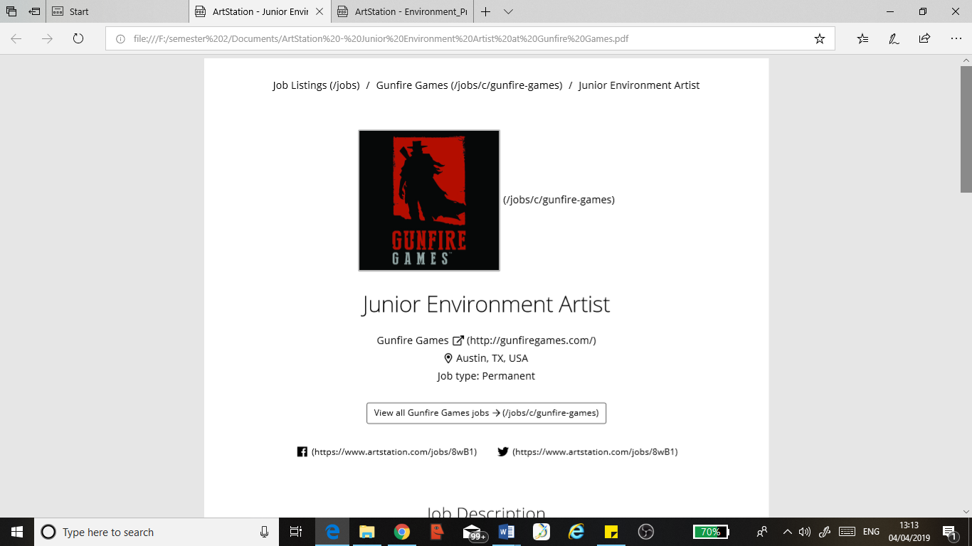
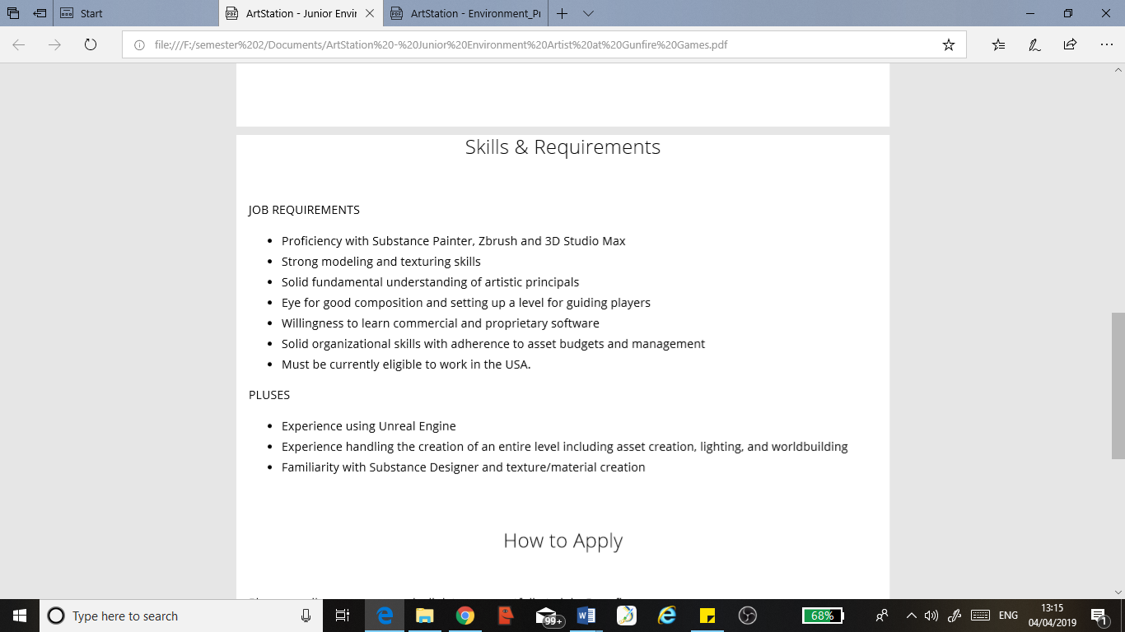
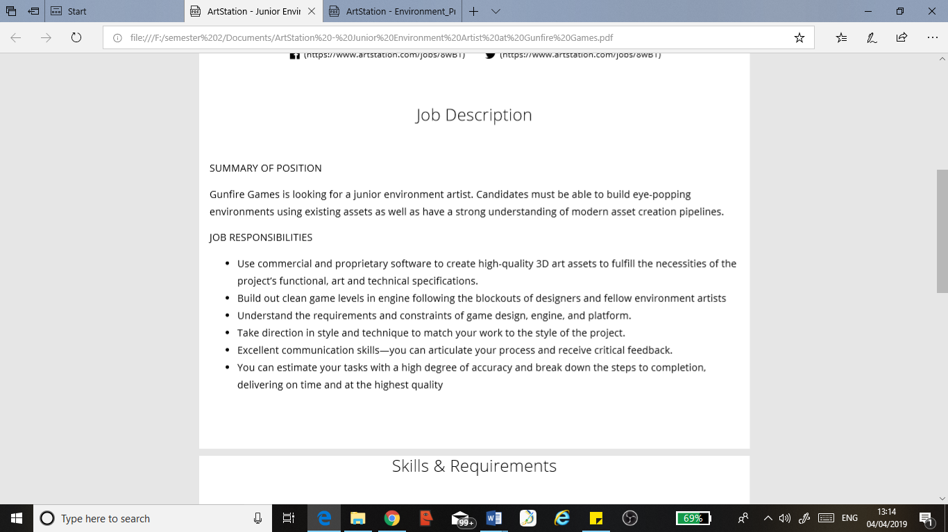

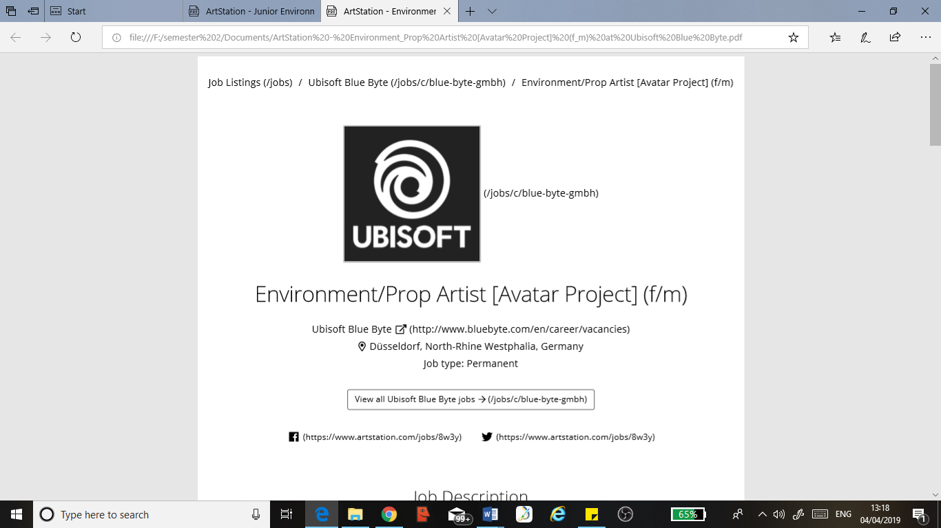
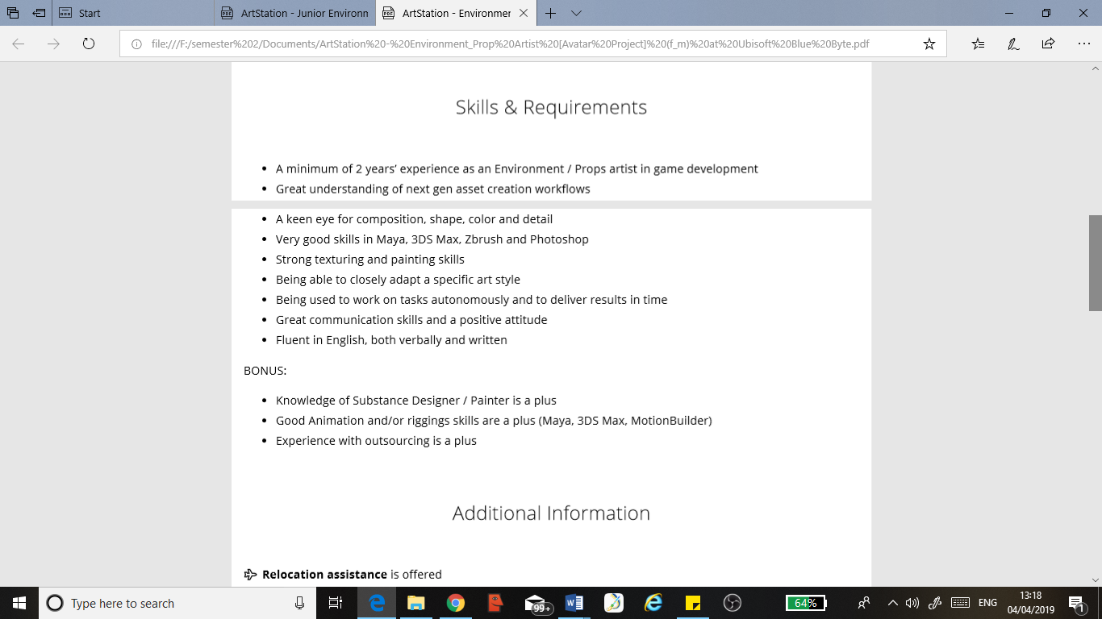
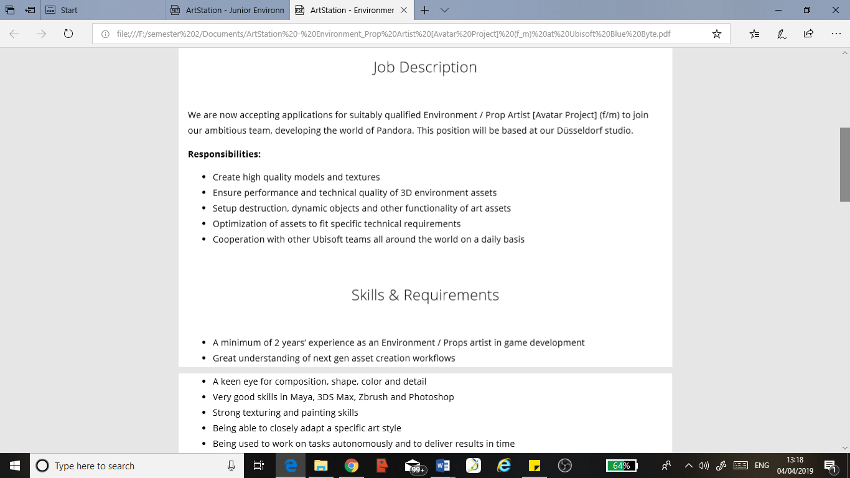

Self-Reflective Report

Time Management
I am fully capable of efficiently managing my time during projects and planning for issues and contingencies during production. This course has taught me the value of using Gantt charts properly; creating and using a Gantt chart correctly is imperative to good time management as it allows me to keep a visual record of deadlines and the related tasks needed to reach them.
I’ve learned that creating an effective Gantt chart is about finding a balance between your work/life schedule /, overloading almost always led to me failing to complete every task I had set myself. I managed to use these lessons I’d learned to improve the way I manage my time and my projects more effectively. In my third year I especially found that as well as creating a Gantt chart, it helped if I created a separate workflow plan. Below is an example of how I set out my plan:
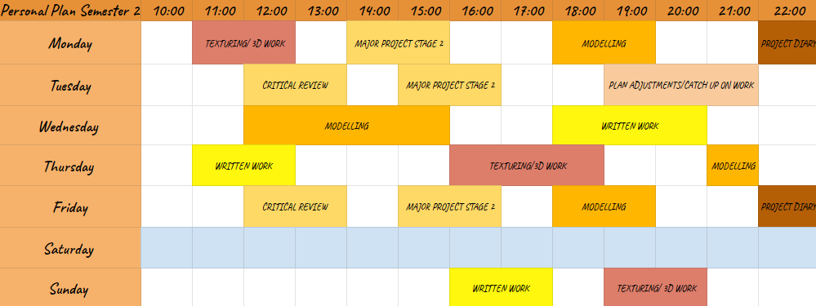
I use these tables to share my time between, research, practical work and written/report work. I have found these to be extremely helpful in gaining perspective of my workload and the timescale I am working with.
I realise that I haven’t perfected managing my time, but I am constantly striving to improve this as I understand the value of budgeting time during a project and meeting deadlines. One other thing that greatly helps me manage my time is prioritising tasks. It is most important to prioritise the areas that are vital to the functionality of the experience.

Research
This course has helped me to improve my researching skills, I have learned to improve the way I approach research for my projects to get the most out of the information I need. Although I focus on visual creativity and am artistically driven, I have learned that it is important to explore sources outside of game design and the typical visual arts.
The course has taught me that research is as important as the creation process; the information gained from extensive research can greatly influence the creative direction of a project. I learned this lesson early on in my time on this course, but it can be clearly demonstrated when reflecting on my work during my third year. Instead of looking at reference images and nothing else, I looked into the 80’s and the culture that made that era so iconic. I started with general references but expanded my research by looking into other creative industries such as interior design and ended up finding a design movement that became a major influence on the art style of our game.
As well as direction from lecturers, I learned that this it is vital to share and gain research from peers as well as online communities. It is usually more affective to ask other individuals instead of spending days looking for a solution that is hindering the progression of a certain task.
I know that I can greatly improve my approach because there have been times when I overlooked the importance of extensive research and instead got carried away with the creation process. An example of this mistake would be a project in my second year, a group of a set out to create a board game but a lot of focus was spent on the visual side of the game and creating characters and environment. I overlooked a lot of aspects of research that were required to understand the process of creating a well-designed board game, from a gameplay perspective.

Documenting Practices
I know that documenting my practices is extremely important, as it allows me to continuously reflect on my approach and productivity. For practical work I use OBS recorder to capture my work processes. I sometimes used the footage to recognise patterns and find ways for improvement for completing a certain task, or action; this is especially helpful when 3-D modelling assets or characters.
Using OBS is always useful as it allows me to keep an archive of my creative work and refer to processes that I may not use all the time; so, it provides constant access to helpful reminders. I can also use the footage to demonstrate my workflow and it adds further context when demonstrating projects to lecturers or people not involved in the team or project.
Throughout the course I've kept several project diaries and realised the importance of documenting my practice; I’ve found that regularly adding entries to a project diary helps me further understand the processes I go through because I analyse and evaluate as I progress. This has been very valuable because it has allowed me to reflect on past projects and recognise my strengths and weaknesses and therefore adapt my methods of production to make the most of my time.
I found that regular reviews with lectures have been another effective way of documenting my practice as the reviews allow me to get perspective of the direction and pace of my work. The reviews have made me more capable of answering and reporting to a higher authority, that can provide extra insight to my project.

Collaboration and Teamwork
I am comfortable and capable of working as part of a production team to achieve a collective goal. I have strong communication skills that are necessary to succeed when working with large groups. Using management websites such as Trello and Team Gantt have allowed me to remain in constant connection with team members throughout several projects. Trello allowed us to share ideas and work, which resulted in our team members bouncing ideas off each other and feeding into each other's creativity; this is vital as an artist because it creates a constant flow of creativity for inspiration and therefore boots morale throughout the project.
I have also learned the value of regular group meetings and recording minutes. I found the team meetings have greatly improved certain aspects of production in some projects; using team meetings allowed me to identify potential problems and bottlenecks in production and we used them to find solutions to these problems to maintain a constant workflow.
I can work with the team to create an effective production pipeline, assign roles and tasks and set deadlines. The course has taught me how important it is to create and understand an effective production pipeline and plan and to plan for contingencies to avoid problems such as bottlenecks and “feature creep”.
I realise that I have not perfected the full use of production pipelines and at times I have overlooked some aspects of this as part of the team; those mistakes have only reinforced how important it is to communicate and plan with your team, which is something I am always aiming to improve.

Report Writing
I am confident when it comes to writing reports and reflecting on projects and my approach to my practices. I have found that recording notes or thoughts throughout the project is very useful when it comes to the report stage.
I use these notes to find a rhythm in my writing. I've discovered that I am most comfortable free writing my report first; I handwrite a rough draft first whilst keeping a record of any references or sources used. Handwriting reports helps me connect more with the process and the work produced. I feel that handwriting is more organic to me and it feels easier to analyse and recognise the methods that are used; this makes the writing flow more naturally. 6
I then use my first free writing draft to type out a refined version of my findings and to ensure that I format my document correctly to create a clear and concise report.

Maya
I am confident in my skills using Maya for polygon modelling amongst other processes. In my first year of university we were introduced to Maya and ZBrush and I instantly found that I had a natural intuitive understanding of Maya.
In my second year I solely used Maya to model to robotic characters, I felt that Maya offered tools that allowed me to create models that resembled organic creatures yet had a strong “man-made” element to them. Whilst modelling these two enemy types I discovered a lot more about the software- as it pushed me to experiment more with settings and tools. I feel that Maya has given me a strong understanding and appreciation for polygon modelling.
I'm also confident in UV unwrapping. I enjoy the UV process and the problem-solving that is required when I'm unwrapping a model and creating clean logical UV layouts. I believe that there is still a lot of room for improvement and I am constantly striving to improve my skills in Maya.
The software has given me a strong appreciation for optimising models for games; I'm always aware of the poly-count of my models and I strive to find ways to reduce it where possible and necessary. An area that I would like to improve would be my retopology skills, I possess a good understanding of the process and am capable of it retopologising a model in the day. But I would like to be a lot more efficient at this skill, as it plays a vital role in model optimisation.
I would also like to improve my rigging and animation skills; this is a skill set that I vastly overlooked in my time during university. I possess basic skills and knowledge of skinning and rigging but have almost no knowledge of the animation process. I feel that this would be highly valuable as it would allow me to create more engaging environments and props.

Zbrush
I possess a strong understanding of ZBrush and can confidently use my skills to sculpt models of various detail. My skills using the software have greatly improved since my first year on the course; during my first year I had a natural preference to Maya but always had a desire to learn and improve my skills in ZBrush.
In my final year of the course I found a renewed passion for sculpting in Zbrush and I've tried to continue to improve my skills in software; I have found that it is a lot more comfortable for organic modelling as the tools are more adaptable and intuitive for organic processes.
Even though I now have a greater understanding of the processes involved when sculpting in Zbrush, I know that I still have a lot to learn and my skills need constant development if I want to use the software to its full potential. I've also realised the importance of importing exporting models between different modelling software: I’ve learned that a model can be completed using various tools from separate programs and that this can benefit the outcome and sometimes cuts down on production time. In retrospect this knowledge would've been extremely valuable in past projects.

Artistic Principles and Using Them to Guide Players
My background in Fine Art and Photography allowed me to begin the course with a good understanding and appreciation of the fundamentals of design. I have a strong knowledge of colour and light theory, as well as a great appreciation and understanding of visual composition.
All these creative skills were transferable when starting the course and they helped me to understand the fundamentals of game design- from the artistic principles required for good visual design, to using the skills to guide players through game world.
I've learned that it isn't just great artwork that creates a good game experience for gamers, it all starts with great fundamental design; from gameplay to game flow. And after these aspects of design are solidified, they can be reinforced visually and creatively.
Good game design leads/guides a player through a level and this can be done with the effective use of colour and light theory to highlight the intended path that the player is supposed to take. This principle can be adapted to be more blatant or subtler by incorporating ideas of using signs, textures or even audio to guide players. These are skills that I have experimented with in projects such as “Project Eve”, I made decals to create obvious prompts in certain parts of the experience but also used audio design to prompt and influence the player at times.

Unreal Engine
I possess a fair understanding of Unreal Engine and the basics of navigation and tools within the software. This is not something that I focused a lot of attention on during my years on the course; in the second year we were prompted to choose areas to specialise in and using Unreal Engine for visual scripting didn't appeal to me at the time.
Although I don't possess extensive knowledge of Unreal Engine, I'm still skilled enough to set up scenes and dioramas within the engine. This includes been able to create a white box environment to convey the general feeling or flow of the game. I'm also confidently capable of importing assets into the engine, setting up models, using texture maps to create materials and applying them to assets.
I also have a good understanding of using lighting and rendering within the engine to create the most effective, visually compelling scenes. Regarding using Unreal Engine, I've learned the importance of using naming conventions and how they can effectively cut down time in post-production. The use of naming conventions is a practice that should be used throughout the entire production process as it provides clarity throughout the project and it makes all files easily identifiable and accessible to all members of the production team.

Substance Painter
I have a strong understanding of Substance Painter and consider texturing to be one of my strongest skills. Throughout my time on the course I've continuously developed my skills using Substance Painter. I have become familiar with using other software such as Adobe Photoshop and Substance Designer to create custom decals, alphas and materials to use in projects.
Instead of hand painting every detail -as I often did when I first started using substance painter- I've made more use of tools such as procedurals, alphas, grunges and smart masks. Experimenting with different tools has resulted in some interesting visual outcomes throughout projects.
I have learned to cut production time by using existing materials, smart materials and just experimenting with the technical parameters of certain tools to achieve an affect that is desirable. I realise that using the software’s in-built tools and materials is less of a shortcut but rather more of a cost-effective way of making the most of production time when necessary.

Game Designer
My education in Creative Computer Games Design further solidified my understanding and knowledge of design. It has pushed me to better myself and become more proactive in self-development and further learning. I understand research practices to a deeper extent and recognise the importance of continuously improving my own learning. It has allowed me to improve my critical thinking and analysis skills, which are extremely valuable in all creative industries.
Education
Gower College Swansea
2013–2015
A-levels
Art and Design
Photography
2015–2016
Diploma
Fine Art

University of Wales Trinity Saint David
2016–2019
BA/HONS
Creative Computer Games Design

I am a creative artist with the ability to adapt to multiple art styles, who is always ready to learn new things and I can work towards a collective idea. I'm proficient in working within large teams, but also enjoy self-directed projects.
Professional practice
Graphics: 2-D Drawing/Concepting, Digital Drawing, Low and High Poly Modelling, Texture Mapping, Light Theory, Colour Theory, Character Design, Environment Design, Prop Design, 3D Character Modelling3D Prop Modelling, 3D Environment Modelling, Rigging and Skinning, Design Iteration, Storyboarding, Photography, Visual Composition, Fine Art, Generalist 3D modelling, GDD Creation & Compilation
Technical Skills
Software: Maya, ZBrush, Unreal Engine, Substance Painter, Substance Designer, Sculptris, Adobe Photoshop, Adobe Illustrator, Adobe Premiere Pro, Mud Box
General Artist
I have a long educational history in Art and Design. This provided me with a strong foundation and knowledge of the various elements of design and the fundamental rules of art. I understand the purpose of design, how to avoid designing without direction or purpose.
Photographer
My experience and education in Photography provided me with a strong understanding and appreciation for composition, lighting as well as cinematography. The skills are transferable in all artforms of the creative industry.

Skill Experience
Summer Gomes CV
“I strive to create compelling work that evokes emotion and passion. I believe that the recipe for a job well done must have a large amount of passion, fun-loving dedication and hard work”

