Content Page
Part 1 Study timetable – pages 1-4
Part 2 AI activity – Pages 5-9
Part 3 Poster and reference list – pages 10-11
Part 4 Link to oral presentation also shared with lecture team – page 12

Basic Acknowledgement format of AI tool use
I acknowledge the use of Microsoft 365 copilot ( https://copilot.microsoft.com/?msockid=31cedb1415cc63a70abfcd6b14ed629a ) on the 31/08/2026

Time | Monday | Tuesday | Wednesday | Thursday | Friday | Saturday | Sunday
00:00 - 00:59
01:00 - 01:59
02:00 - 02:59
03:00 - 03:59
04:00 - 04:59
05:00 - 05:59 |  |  |  |  | Wake up  Skin routine  Brush teeth
06:00 - 06:59 |  | Wake up  Skin routine  Brush teeth | Wake up  Skin routine  Brush teeth | Wake up  Skin routine  Brush teeth | Change into gym clothes  Breakfast  Drive to the gym
07:00 - 07:59 |  | Change into day clothes  Makeup and style hair  Breakfast | Change into day clothes  Makeup and style hair | Change into day clothes  Makeup and style hair | Arrive at the gym  Follow gym plan
08:00 - 08:59 | Wake up  Skin routine  Brush teeth | Pack bag  Drive to work  Arrive at work | Pack bag  Drive to work  Arrive at work | Pack bag  Drive to work  Arrive at work | Continue to follow gym plan  Drive home
09:00 - 09:59 | Shower and wash hair  Change into day clothes | Start 1st class | Start 1st class | Start 1st class | Shower and wash hair  Change into day clothes | Wake up  Skin routine  Brush teeth | Wake up  Skin routine  Brush teeth
10:00 - 10:59 | Dry hair and style  Breakfast | Start 2nd class | Start 2nd class | Start 2nd class | Dry hair and style  Makeup Watch TV | Shower  Change into day clothes  Breakfast | change into day clothes  Walk to coffee shop
11:00 - 11:59 | study | Snack break  Start 3rd class | Snack break  Start 3rd class | Snack break  Start 3rd class | Continue watching TV  Snack | Clean dishes | Arrive at coffee shop
12:00 - 12:59 | Study | Start 4th class | Start 4th class | Start 4th class | Drive to aunties house  Arrive at aunties house | Pack bag | Breakfast
13:00 - 13:59 | Lunch | Lunch | Lunch | Lunch | Lunch with auntie | Lunch  Drive to partner’s football game | Walk to partner's house
14:00 - 14:59 | Study | Start 5th class | Start 5th class | Start 5th class | Lunch with auntie | Watch football game | Arrive at partner’s house  Watch TV
15:00 - 15:59 | Study  Snack  Pack bag | Tidy classroom  Drive home | Tidy classroom  Drive home | Tidy classroom  Drive home | Drive home  Arrive home  Study | Watch football game | Watch TV  Snack
16:00 - 16:59 | Drive to friend's house  Drive to university | Arrive home  Study | Arrive home  Study | Arrive home  Study | Study | Drive to partner's house | Change clothes  Pack bag  Drive to choice of outing
17:00 - 17:59 | Arrive at university  Start lecture | Study | Study | Study | Study | Arrive at partner's house | Arrive to choice of outing
18:00 - 18:59 | Break | Dinner  Change clothes | Change clothes  Drive to dance class | Study | Dinner | Dinner | Dinner
19:00 - 19:59 | Lecture | Drive to choice of outing to meet friends | Arrive at dance class | Dinner | Wash the dishes  Change into pyjamas | Unpack clothes | Drive home
20:00 - 20:59 | Drive to choice of dinner  Drive to friend’s house | Time with friends | Drive home  Arrive home  Dinner | Shower  Change into pyjamas  Skin routine  Brush teeth | Watch TV  Word search | Change into pyjamas  Watch TV | Arrive home  Unpack bag
21:00 - 21:59 | Drive home  Arrive home  Unpack bag | Time with friends  Drive home | Shower and wash hair  Skin routine  Brush teeth | Watch TV | Skin routine  Brush teeth | Watch TV | Shower  Change into pyjamas  Skin routine  Brush teeth
22:00 - 22:59 | Change into pyjamas  Skin routine  Brush teeth | Arrive home  Shower  Change into pyjamas  Skin routine  Brush teeth |  |  |  | Watch TV  Skin routine Brush teeth
23:00 - 23:59

549 words

Part 2 – Using AI
Initial prompts
- How can I improve time management
- How can I improve my organisation skills
- How can I improve my focus

- Time blocking — Assign specific blocks of time to specific tasks. This prevents your day from being hijacked by randomness and gives your brain a clear “mode” to operate in.

- Weekly workflow reset

Once a week, spend 10–15 minutes: Reviewing what has been completed
- Cleaning up files and tabs
- Planning the next week
- Re-prioritising tasks

This prevents chaos from accumulating.

switching — the biggest enemy of organisation.

Organisation becomes automatic instead of effortful.

- Focus sprints

Short, intense work blocks (25–50 minutes) followed by 5–10 minutes of rest. Why it works: your brain loves boundaries. This is the fastest way to build consistent concentration

- Distraction-proofing

Remove friction before you start:
- Silence notifications
- Put your phone in another room
- Close irrelevant tabs
- Use “Do Not Disturb” mode
Focus is easier when there is nothing pulling at you.
Context batching
Group similar tasks together:
- All emails at once
- All admin tasks at once
- All creative work in one block
This prevents your brain from switching gears — the biggest focus killer.
Refined prompts
- As a student how can I use time blocking when studying?
- Can you provide more information based on the Pomodoro method including references for the sources you used to find this information.
- I am a first-year student in university, and I would like information based on the distraction proofing technique. This should include references from the sources you used to find this information and the output to be bullet points.

Academic writing on two chosen study technique supported by Ai and other research (300 words)
To begin with this piece of writing will examine two study techniques that can support students academically to achieve their goals. The two study techniques are the Pomodoro method (Gupta, 2026) and the Eisenhower Matrix method (Houdmont, 2019).
Firstly, the Pomodoro technique is a time management technique that helps students improve their studying skills. The pomodoro approach increases productivity by using the 25 minutes focused work, followed by brief breaks. This method is known to reduce stress, encourage focus and is easily adaptable to students’ day to day work schedules. Gupta (2026) states that this technique aims to work with the brain, not against it. Using this method has multiple advantages, the biggest one being that it lowers the chances of boredom and burnout. This is because the method creates a balance between effort and regular breaks. Even though this method started with a basic timer, it has gained popularity and helped students develop more structured routines while studying (Kaplan, 2026). People who suffer with ADHD or people who have trouble focusing will also benefit from this specific approach as they may feel overwhelmed, lack motivation, or be easily distracted. Additionally, by making their time more manageable and reasonable this method will help them reduce delays within their study times (Birmingham City University, 2025).
Secondly, the Eisenhower matrix technique is a technique student’s use for assessing and prioritising their tasks for studying based on their level of Importance and urgency. This technique is split into 4 equal parts; do, decide, delegate and delete (Houdmont, 2019). The first part of the method is used if the task is urgent, a crisis or a deadline. The second part of the method is for tasks that are important but not urgent, a task that can be scheduled for the future but does not need to be done immediately. In the third part tasks are considered as urgent but are not important, so they can be delegated to someone else to pick them up. Finally the fourth part, tasks in this part are not important or urgent, tasks can typically be eliminated entirely (Columbia University 2024). According to Heinrich (2026), by incorporating the Eisenhower matrix method into student's routines, they can spend more time achieving their goals and less time responding to opposing needs. Overtime this method can eventually improve decision making and can create long term impact for students studying.
In conclusion, both techniques are useful for time management when it comes to studying. The pomodoro technique encourages students to stay focused and reduce distractions. Meanwhile the Eisenhower matrix technique allows students to organise their study schedule and prepare their work. Overall, when used together, these techniques can provide simple and practical ways for students to make use of their study time and achieve their academic goals.

Reference list
Gupta, S. (2022). What is the pomodoro technique? Verywell Mind. Available at: https://www.verywellmind.com/pomodoro-technique-history-steps-benefits-and-drawbacks-6892111 [Accessed 25 Sept. 2026].
Houdmont, T. (2019). The eisenhower matrix: A practical prioritisation technique | insight | box UK. [online] www.boxuk.com. Available at: https://www.boxuk.com/insight/the-eisenhower-matrix-a-practical-prioritisation-technique/ [Accessed 25 Sept. 2026].
uk (2026). What is the pomodoro technique? A simple guide to improving focus and productivity. [online] Kaplan.co.uk. Available at: https://kaplan.co.uk/blog/learning/pomodoro-technique [Accessed 25 Sept. 2026].
Birmingham City University (2025). The pomodoro technique – work your way to an A, one pomodoro session at a time. [online] Birmingham City University. Available at: https://www.bcu.ac.uk/exams-and-revision/time-management-tips/pomodoro-technique [Accessed 25 Sept. 2026].
Columbia University (2024). The Eisenhower Matrix. [online] Columbia.edu. Available at: https://sps.columbia.edu/sites/default/files/2023-08/Eisenhower%20Matrix.pdf [Accessed 25 Sept. 2026].
Heinrich, A. (2026). How to prioritize tasks effectively using the Eisenhower Matrix. [online] Harvard Business School. Available at: https://online.hbs.edu/blog/post/how-to-prioritize-tasks [Accessed 25 Sept. 2026].

Reflection 400 words
Reflection n using Microsoft 365 copilot for academic
This reflection includes my perspective on Microsoft 365 copilot and my experience using it to support the information given on academic studies. It examines what was successful, the difficulties that occurred, the advantages and disadvantages of using artificial intelligence (AI) and how I can use it in the future.
When using Microsoft 365 copilot, one thing I noticed was how quickly it provided answers to my questions. The fast responses made it easier for me to complete my task and find more information without having to spend a long time searching for answers myself. Although, I learned that even though copilot provides answers quickly, I still need to take time and check the information carefully to make sure it is correct and relevant to my work. I also learned that copilot is easy to access for everyone and can be used whenever I need support with my work, which is useful for when I am working individually or studying at home. I can use copilot rather than existing programs like word, PowerPoint and excel without having to switch betweeen different websites.
One limitation I noticed while using copilot was that it did not provide many references for the information it gave me. It only included a few sources, which meant I had to do some additional research of my own to find more reliable and detailed references. This showed me that although copilot can be useful for quickly finding information, it can also make me spend more time searching for sources to use for my references. Another limitation is that copilot’s answers can sometimes not sully match to what I’m looking for, meaning I must adjust my questions in order for copilot to provide more relevant information.
I learned that Copilot could help generate ideas, summarise information and gather sources to support the information, I found this particularly helpful when I did not know where to start. However, I also learned that copilot should not be relied on completely. Copilot gave me sources including Wikipedia, this is an example of unreliable information. This is why I used mostly my own research. Using copilot has shown me that using technology can support my learning, but it needs to be used alongside my own effort and critical thinking. Overall, I believe that Microsoft 365 Copilot can help me in multiple ways when used responsibly and accurately.

Part 3
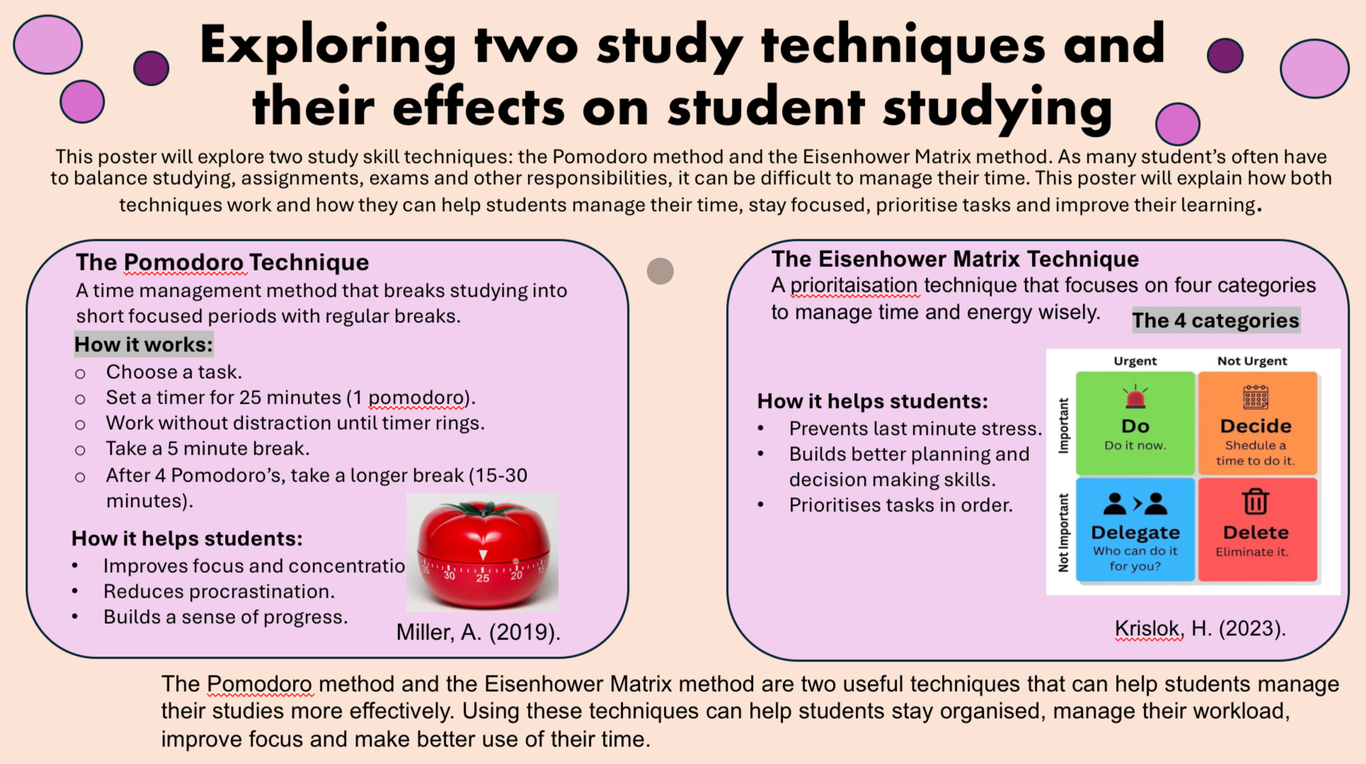

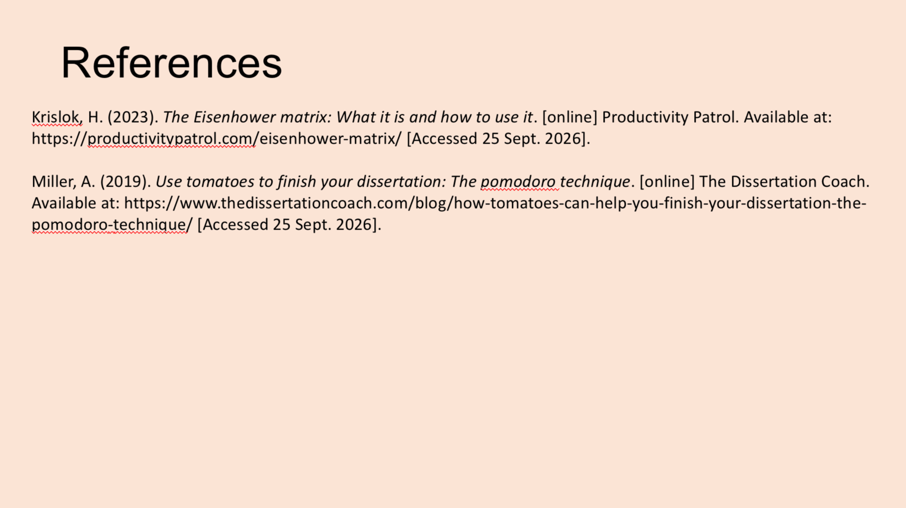
Part 4
A PowerPoint presentation/ voiceover of poster.

https://1drv.ms/p/c/3192b571b7f65704/IQAF-Ep6XD43Sowkcg_fwjcTAcKDpdTOhy2vuyJ4cvf9IMw

