Dr. Nik Whitehead
Experimental Data Analysis
Data Analysis and Visualisation
Runa Bibi
1702463

Table of Contents

Introduction 2
Method 2
Hypothesis 3
Results 3
Outliers 5
External Factors 7
References 8

Introduction
The data I will be analysing consists of two sets of 40 kicks of two rugby balls, one with helium and one with air. A rugby club wish to discover whether the ball with helium will travel further. The same player kicked both balls alternatively each time on a windless day on their club’s training ground. The dataset it shown below in metres.
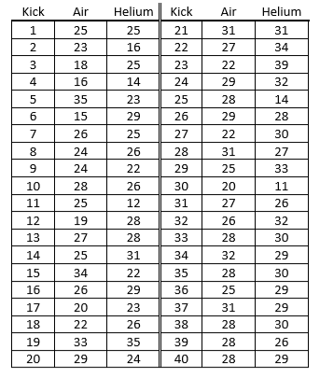

Method
To determine whether the helium ball does indeed go further, I will conduct a paired t-test. This type of test is used to compare two observations in two samples where one can be paired with the other [1]. In this case, the kicks of the helium ball are being compared to the kicks of the air ball. This test will help discover whether there is a statistically significant difference between the helium and air ball, meaning the null hypotheses can be rejected [2]. This means we can accept the alternative hypothesis that the helium ball does travel further.

Hypothesis
H0: There is no difference in the mean kick distance of the helium and air balls
H1: The helium ball travelled further than the air ball
The significance level I will be testing this against is p = 0.10

Results
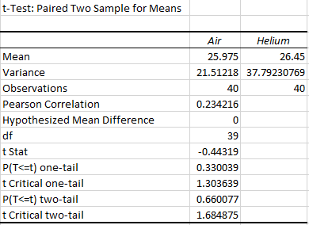
There is not a statistically significant difference between air and helium, so we therefore cannot reject null hypothesis H0. We also cannot accept the alternative hypothesis H1 as the chance of this being random is over 5% and so is unreliable [3].
The next test of the hypothesis has been tested to a significance level of p = 0.01.
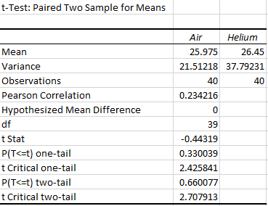
These results show that there is also no statistically significant difference between helium and air, so we cannot reject the null hypothesis H0. As the significance level is 0.01 we can accept the alternative hypothesis.
The following test has been tested to a significant level of p = 0.02.
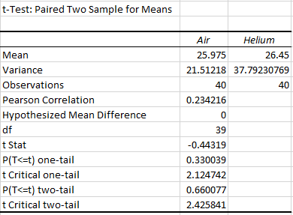
This test shows that there is no statistically significant difference between helium and air. So, we again cannot reject null hypothesis H0. As the significance level is 0.02 we can accept the alternative hypothesis.
As we can accept the alternative hypothesis for p = 0.01 and p = 0.02 and not for p = 0.10, we can see the results are mixed. This may be because we are comparing to a lower significant level, so we are saying that there is a 1% and 2% chance that the difference can be brought down to chance [4].

Outliers
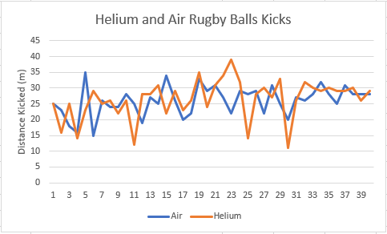
From this graph, you can see that there are certain outliers in the data which may have affected the results [5]. From kick 23 to 25, the distance travelled by the helium ball dropped significantly from 39m to 14m. It then increases again dramatically then slowly builds until 30 when it drops again. As the balls were kicked alternatively, it is interesting how they almost share a similar pattern. According to the test I ran in Excel to find any outliers [6], for Air 15m and 16m are the only outliers. However, for Helium 11m, 12m, 14m, 16m and 39m are all found to be outliers. These results are shown below.
Air | Outlier? | Helium | Outlier?
25 | FALSE | 25 | FALSE
23 | FALSE | 16 | TRUE
18 | FALSE | 25 | FALSE
16 | TRUE | 14 | TRUE
35 | FALSE | 23 | FALSE
15 | TRUE | 29 | FALSE
26 | FALSE | 25 | FALSE
24 | FALSE | 26 | FALSE
24 | FALSE | 22 | FALSE
28 | FALSE | 26 | FALSE
25 | FALSE | 12 | TRUE
19 | FALSE | 28 | FALSE
27 | FALSE | 28 | FALSE
25 | FALSE | 31 | FALSE
34 | FALSE | 22 | FALSE
26 | FALSE | 29 | FALSE
20 | FALSE | 23 | FALSE
22 | FALSE | 26 | FALSE
33 | FALSE | 35 | FALSE
29 | FALSE | 24 | FALSE
31 | FALSE | 31 | FALSE
27 | FALSE | 34 | FALSE
22 | FALSE | 39 | TRUE
29 | FALSE | 32 | FALSE
28 | FALSE | 14 | TRUE
29 | FALSE | 28 | FALSE
22 | FALSE | 30 | FALSE
31 | FALSE | 27 | FALSE
25 | FALSE | 33 | FALSE
20 | FALSE | 11 | TRUE
27 | FALSE | 26 | FALSE
26 | FALSE | 32 | FALSE
28 | FALSE | 30 | FALSE
32 | FALSE | 29 | FALSE
28 | FALSE | 30 | FALSE
25 | FALSE | 29 | FALSE
31 | FALSE | 29 | FALSE
28 | FALSE | 30 | FALSE
28 | FALSE | 26 | FALSE
28 | FALSE | 29 | FALSE

As the outliers are sporadic in the data, they cannot necessarily be blamed on any external factors. However, if we were to remove the outliers the mean for Air changes from 25.975m to 26.526m and for Helium changes from 26.45m to 28m. This may have an effect on the overall t-test.

External Factors
Some other factors that may affect the results could be the skill level of the player. If they are someone who is a good player and consistently kick well in games, then the ball may travel a far distance regardless of whether it is filled with helium or air. Another factor to consider is whether the player gets tired as the kicks go on. If that were the case, the further it goes on the lower the distance would become. However, it is shown this is not the case but if this experiment were to be repeated, breaks could be scheduled between each kick in order to get the most reliable data for each kick. It is also not known whether the ball is measured where it first lands or if it bounces or rolls and is measured then. If it measured after movement then the data may not be accurate so wherever the ball lands first should be marked, and the distance should be measured then. As this is a bar wager, the player who kicks the ball may be biased and want the helium ball to go far or not depending on what they bet on. In order to keep it unbiased, a player from a different club could possibly kick the balls without knowing the stakes.

References

[1] | R. Shier, "Statistics: 1.1 Paired t-tests," 2004. [Online]. Available: http://www.statstutor.ac.uk/resources/uploaded/paired-t-test.pdf. [Accessed 4 April 2018].
[2] | StatPac, "Statistical Significance," [Online]. Available: https://www.statpac.com/surveys/statistical-significance.htm. [Accessed 4 April 2018].
[3] | Laerd Statistics, "Hypothesis Testing," [Online]. Available: https://statistics.laerd.com/statistical-guides/hypothesis-testing-3.php. [Accessed 4 April 2018].
[4] | M. Marusteri and V. Bacarea, "Comparing groups for statistical differences: how to choose the right statistical test?," Biochema Medica, vol. 20, no. 1, pp. 15-32, 2010.
[5] | Socratic, "How does an outlier affect the mean of a data set?," 22 June 2017. [Online]. Available: https://socratic.org/questions/how-does-an-outlier-affect-the-mean-of-a-data-set. [Accessed 5 April 2018].
[6] | J. T. Michael, "How to Use the Outliers Function in Excel," [Online]. Available: https://www.techwalla.com/articles/how-to-use-the-outliers-function-in-excel. [Accessed 5 April 2018].

