Contents
I. Introduction to computer forensics 2
II. Uk Law 2
III. Ethical conduct and proffesional standards 2
IV. Requirements of specialist forensic tools 2
A. Open source 2
B. Closed Source 2
C. Free Software 3
D. Common features of toolset 3
E. Evidence file types 3
V. FTK 3
VI. Autopsy 4
VII. OSForensics 4
VIII. Kali Linux and CAINE 4
IX. Capturing forensic data 6
A. Live data acquisition 6
B. Offline data acquisition 6
X. Case study 7
XI. Gathering the data 10
Appendix 13
XII. Bibliography 17

Synthesize a solution to a potential real life scenario

Brian Morris
Computer Forensics
Univeristy of Wales Trinity St Davids Swansea
1809130@student.UWTSD.ac.uk

Abstract— Abstract—This document outlines computer forensics its place within law including standards and codes of practice. It covers the availability of computer forensics both open source and closed source software. The use of write blockers during a forensic copy from a computer. The document also outlines processes to follow when performing a live capture

Introduction to computer forensics
Forensics or the scientific process for the collection, analysis and presentation of collected evidence, this can be equally applied to information systems including computers mobile phones tablets databases hard drives flash drives etc. A more formalized definition [1]“It is the discipline that combines the elements of law and computer science to collect and analyze data from computer systems, networks, wireless communications, and storage devices in a way that is admissible as evidence in a court of law.”

Uk Law

The Crown Prosecution Service identify two closely linked by distinct ranges of criminal activity when computerized systems are used to perform a criminal act. [2]
Cyber-dependant crimes where the crime can be committed only through the use of information communication technology. Where the device is both the tool used to commit the crime and the target of the act.
Cyber-enabled crimes where criminal activity can extend its range through the use of computers, networks or other forms of ICT
In the event that a suspected criminal act has been committed the following law can be applied for information systems to be lawfully seized for subsequent forensic examination. Section 19 and 20 of PACE or the Police and Criminal Evidence Act of 1984 . [3]
An officer may seize anything on the premises they have reasonable grounds to believe the equipment was obtained or used in the commissions of an offence and it is necessary to seize in order to prevent it being concealed lost damaged or destroyed. Also an officer me seize additional items that they have reasonable grounds to believe are related to the offence and seizure will prevent the evidence being concealed lost altered or destroyed .
Section 20 of the PACE act specifically extends the powers of the act for information systems:-
Every power of seizure which is conferred by an enactment to which this section applies on a constable who has entered premises in the exercise of a power conferred by an enactment shall be construed as including a power to require any information stored in any electronic form contained in a computer and accessible from the premises to be produced in a form in which it can be taken away and in which it is visible and legible or from which it can readily be produced in a visible and legible form.

Ethical conduct and proffesional standards
[4]An accredited forensic lab would typically be required to meet ISO/IEC 17025, first issued in 1999 by ISO and IEC now on iteration 17025:2017 [5]. It has become an important standard for testing and calibration laboratories globally. The standard was developed with the goal of promoting confidence in the performance of laboratories, showing that they are competent and that they provide valid and unbiased, valid results with a minimal margin or error.
It ensures entities operating within ISO/IEC 17205 are able capable of keeping a record of the state, mode and physical condition of any seized device and any potentially relevant information; Including labelling the components of the device and taking photographs ( screen, computer front and back, and the area around the device to be seized) and/or sketching the device’s connections and surrounding area where relevant. Whilst maintaining a contemporaneous audit log of actions of the evidence.

Requirements of specialist forensic tools

To be confident in data presented as evidence by an expert witness the integrity of the data must not be in question. To this end tools used should not in any way alter source data or cause the source data to be question. Based on the assignment the scope of the tools are limited to the assessment of data gathering from hard drives and volatile storage. If the tools are also able to gather information off mobile devices these will not be explored to any meaningful depth

Open source
Open source software is software that has published is source code for public scrutiny. End users are able to examine and make changes to the software to meet their own needs. The perception is the use of open source software poses a risk as there is no-one individual who owns or supports the software. However, there are many companies that have been created to provide support for specific open source solutions. The ability to amend and fix open source software has led to open source software becoming some of the most widely used and popular software in a forensic specialists’ tool set.

Closed Source
Closed source software is generally published by an organization that doesn’t want to expose its propriety source code. Primarily this is for commercial reasons as the organization would sell this software as part of its solution.
From a consumer perspective this provides a level or reassurance that the software is backed by dedicated support teams and the software is produced with a level of liability resting with the software publisher.

Free Software
Free software not to be confused with Open Source software, is often published by commercial software publishers either as a time limited version of the full retail or enterprise version or may be limited to a subset of the tools available to the full commercial product. In many cases the free software may be more than adequate to meet the needs of small scale use case.

Common features of toolset
Not all software suites provide the same level of functionality and a forensic specialist may find they prefer to use a particular tool for particular tasks. Examining the features of FTK, Encase, Autopsy and OSForensics the following features appear to be available. Although not all suites are able to offer all the functionality and to varying degrees of competence.

Multiple file system support
Preview of file types
Copy of data for evidence
Internet history
Import existing images
Annotate evidence
Converting to Vmware image
GUI
eMail evidence trail
Sort file by type
Mon email comms trails
Search by path
Process driven support
Customizable
User friendly
64bit support
Run from thumb drive
Open source
Non x86 systems
Built in reporting
Decryption tools
Automation of data gathering
Auto update of tools
Protects memory
Captures memory
Multiple file system support
Works on remote computers
Write protection

Evidence file types
Dependant on the toolset used image files captured as evidence can be stored in a variety of formats. The format capture method provides a number of benefits and draw backs dependant on the type used e.g. raw fully uncompressed data destination file will occupy the same physical space as the source material however evidence files can be considerably smaller. Some common evidence based image file formats are as follows:-

raw (Single raw file (dd))
aff (Advanced Forensic Format)
afd (AFF Multiple File)
afm (AFF with external metadata)
afflib (All AFFLIB image formats (including beta ones))
ewf (Expert Witness format (encase))
split raw (Split raw files) via affuse
affuse - mount 001 image/split images to view single raw file and metadata
split ewf (Split E01 files) via mount_ewf.py
mount_ewf.py - mount E01 image/split images to view single raw file and metadata
ewfmount - mount E01 images/split images to view single raw file and metadata

FTK
The Forensic Tool Kit published by AccessData has released a subset of the tool set as FTK Imager. This software is freely distributed and can be used without charge however the software remains closed source.
The primary use of FTK Imager is to permit an investigator to acquire and image data off storage media at a bit level. This ensures that data which has not been sufficiently scrubbed from the source media can be captured and reported upon. It should be noted that FTK imager does not guarantee data is not written back to the source drive and the use of a write blocking solution be employed to prevent the source data being over written.
There is a fairly comprehensive list of options when acquiring data using FTK:-
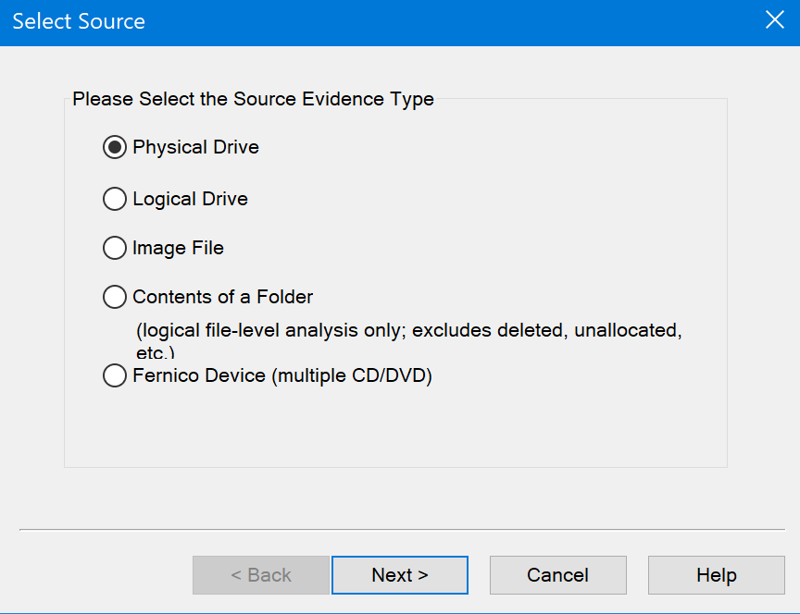
Figure 1
Typically when investigating a workstation the whole drive would be captured however where this is not practical or not required specific partitions/logical drives can be captured individually.
The use of an Image file would traditionally be associated with an ISO or other format used to store data on a CD/DVD however the image file support extends to VHD and VMDK files. This type of image support would prove invaluable when investigating changes to virtual machines running on a workstation or on servers in data centres.
Capturing the contents of a folder limits the use of the tool to a logical file level analysis this omits hidden or purposely obfuscated data from the capture.
An end user would not typically have access to a Fernico device [6]. An appliance used to archive data across multiple DVDs or Blue Ray disks. However, if data does need to be retrieved from such an archival solution FTK imager does extend to this as well.
With the image captured it can then be stored as an ARW file type and utilized either by FTK or other tools.

Autopsy
The sleuth kit [7] is a collection of command line tools and libraries that allows for analysis of disk images. This software is used in many open source and commercial forensic tools. Autopsy is a graphical user interface that extends the sleuth kit functionality. Autopsy is available on both Linux and Widows platforms. Its interface is similar to Windows Explorer to assist end users in navigating the application. A wizard driven process is used to guide new users capturing and analysing data. With the results can be find and examined in depth from a simple tree structure.
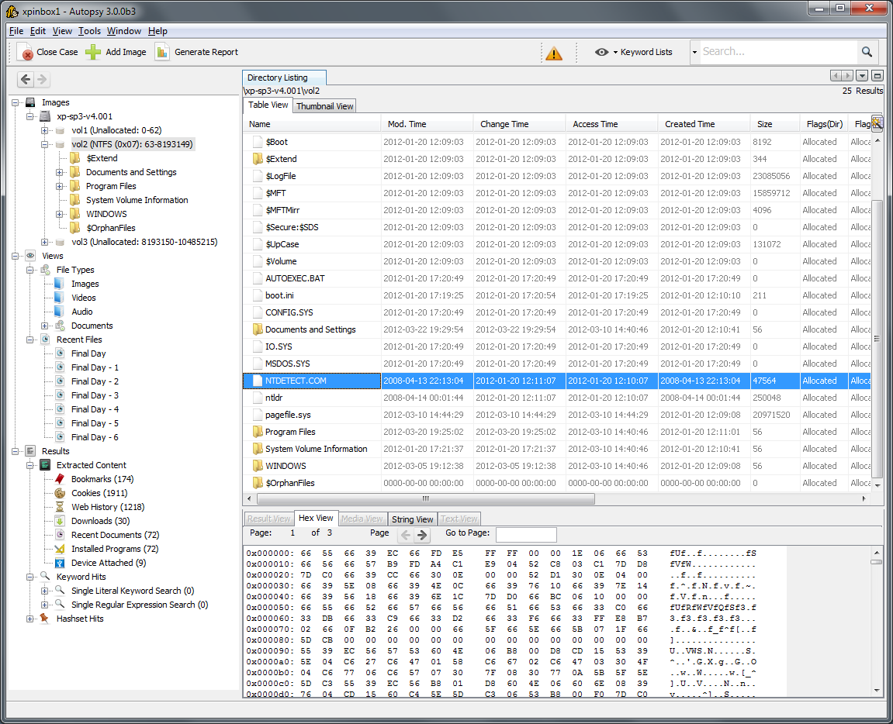
Figure 2 [8]

OSForensics

OSForesnics is commercial offering from Passmark Software is billed by the manufacture as a complete suite for forensic investigation [9]. For an inexperienced or untrained first responder there are a wizards to guide the user to achieve a fully automated capture and reporting process gather digital evidence securely.
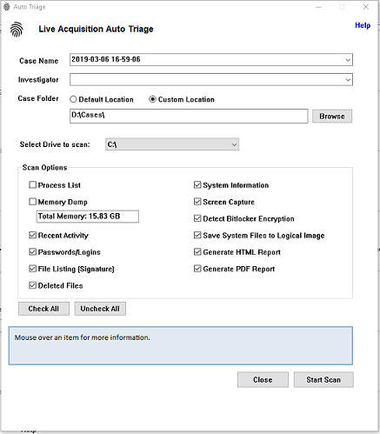
Figure 3 [10]
OSForensics can also be configured to run either from a usb thumb drive or from a WinPE boot disk this solutions is useful if a live capture isn’t possible if the suspect machine is running an unsupported operating system

Kali Linux and CAINE
Kali Linux and CAINE are not a specific forensic solutions they are a collection of open source tools that have been bundled together within a Linux distributions to assist Cyber security and Computer forensic specialists in their tasks. Kali [11] was developed by Mati Aharoniu and Devon Kearns of Offensive Security and is a successor to the BackTRack penetration testing platform it is more focused on penetration and ethical hacking but contains many of the same tools CAINE contains. CAINE (Computer Aided Investigative Environment) aims to provide a collection of user friendly tools within a graphical user interface that can assist an investigator during the phases of an investigator. [12]

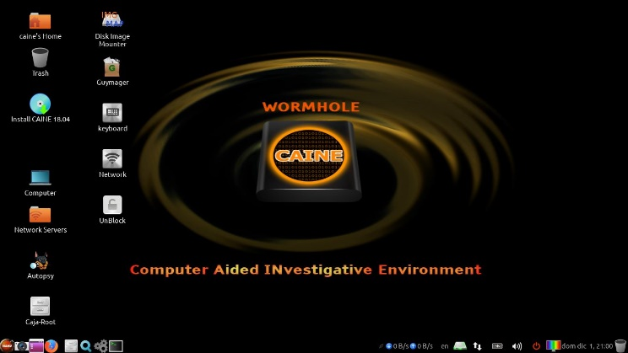

Figure 4. [12]

Below is a table of some of the software available to aid in forensic investigations
Product | Publisher/Maintainer | License Type | Cost
FTK imager | Access Data | Closed Source | Free to use
OSForensics | PassMark Software | Closed source | $995
Autopsy | Brian Carrier | Open Source | Free to use and modify
Kali Linux | Offensive Secuirty | Open Source | Free to use and modify
CAINE | Nanni Bassetti | Open Source | Free to use and modify
Figure 5

Capturing forensic data
Edmond Locard a pioneer of physical forensics , formulated that an overriding principal to forensic data capture is to handle the original data a little as possible [16] as a forensic investigator being called to a scene is expected to capture and secure digital evidence without modifying the footprint of the source system sufficiently to be submitted as valid evidence

Collecting information quickly ensures that data loss particularly of volatile information is minimized RFC 3227 guidelines [15]suggest evidence is captured in the following order:-
Volatile data consisting of CPU memory registers level 1 and level 2 cache to capture recent or resident instructions being performed by the processor. Routing tables and Address Resolution Protocol caches to capture recent network sessions that whilst inactive may not have been completely severed. The process table to identify current active processes on the system. Kernel statistics and modules to understand what the background operating system process were being performed. Main memory to capture data that is still resident in the system either in an active process or in an orphaned process. Temporary files, files created by the operating system or an application during its normal working process. File slack from partially written to hard drive clusters. Free space from unused portions of the drive or areas of the drive that have been identified as being available to writing to. The complete file system itself including swap files or partitions and hibernation files. The system registry which contains most of the system and application configuration details. System state backups of the device if available to compare and possibly create a timeline of activity. Internet traces either from the local device or from proxy/firewall or internet service provider logs.

Live data acquisition

Being mindful of the above order, a live capture of data that is capturing evidence at the primary scene as soon as possible without interfering with the running state of the system to preserver as much evidence as possible, but also include the recoding of active users , processes, network connections and open files. A benefit of capturing live information is the opportunity to access files that are protected by either partial or full disk encryption as the decryption keys are likely to be resident in main memory.
There are many reasons why a live data acquisition is necessary including: -
The system may be contained in infrastructure where it is impractical to remove for example a cloud hosted virtual machine.
The removal of the device or service may have a detrimental risk to others for example if the service was a social care or financial system.
Where its believed changing the state of the system may cause further evidence to be lost either inadvertently or as an avoidance tactic by a suspect eg anti-forensic countermeasures are suspected to be employed.
The removal of the live system is simply not necessary as the use of remote live acquisition tools are able to gather sufficient evidence.

Offline data acquisition
Data acquisitions from offline media are still at risk of being written to, its possible to use software or hardware devices to intercept write command to mitigate against the risk. A hard drive hardware write blocker (Fig 1, Fig 2) connected between the forensic examination PC and the source data is one example where, the write blocker intercepts write instructions to prevent modifying the source information. Some of the devices also have additional feature including the ability to read data from the hardware protected areas or device configuration overlays. The HPA or DCO can be used to store firmware instructions or drive utilities etc so isn’t normally accessed by the operating systems [17]. However a sufficiently skilled individual can extend this HPA area to store data.
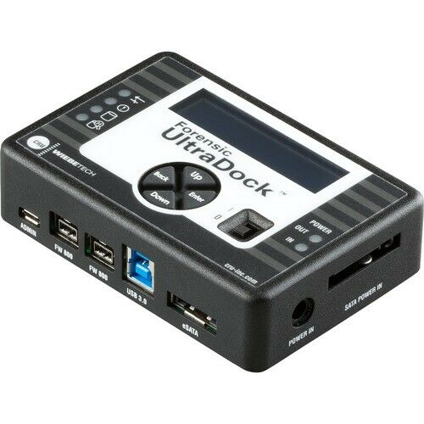
Figure 6 [18]

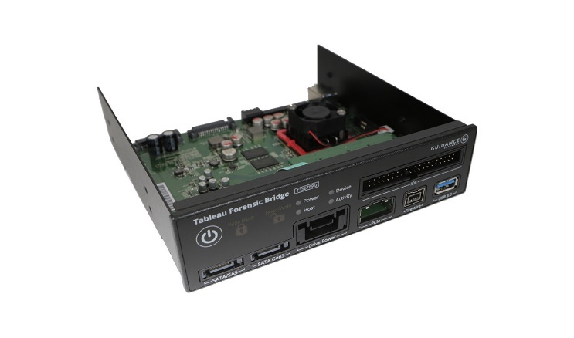
Figure 7 [19]

Case study
If the location of the data was at the crime scene and if a forensics specialist is first to the scene, they should identify any individuals at the scene and areas where evidence may reside. The wellbeing of the forensic specialist should be paramount and threats that remain on site such as other individuals or suspicious items should be dealt with as appropriate. Dependant on the location a suitable authorized representative should accompany the specialist to the scene. The specialist should then explain to the representative what actions will be taken. The representative may be able to offer more information that can be of assistance to the capture of the data. During this period the forensic specialist should also maintain a log of their actions. [13]

Guidance from the Association of Chief of Police Officers ACPO [14] and ENISA the European Union Agency For Network And Information Security [15] prior to an investigation the forensic specialist should ensure their response kit is prepared with the relevant items including but not limited to the following:-

A property registers. Gloves to protect against contamination at the scene. Exhibit labels (tie-on and adhesive). Labels and tape to mark and identify component parts of the system, including leads and sockets. Tools such as screw drivers (flathead and crosshead (the author would also suggest torx if working on servers)), small pliers, wire cutters for removal of cable ties. A range of packaging and evidential bags fit for the purpose of securing and sealing heavy items such as computers and smaller items such as PDAs and mobile phone handsets. Cable ties for securing cables. Flat pack assembly boxes - consider using original packaging if available and secure evidence bags including antistatic bags. A camera to record details of the scene including the state of the equipment at the time of seizure or a pencil and paper to record the above information as a sketch if a camera is not available. A digital clock to be put into the pictures so the time stamp is visible not just as meta data. Sanitized storage devices capable of storing a forensic duplicate. A torch. Mobile telephone for obtaining advice, but do not use in the proximity of computer equipment. A forensic laptop to be used during data acquisition, additional devices to capture data from firewire storage devices etc including a write protection device, a network hub to capture network traffic including the required cables to use the equipment. A clear understanding of the process of how to capture the data depending on the state of the computer. A check list of the possible relevant legal issues to consider at the scene and relevant contacts for getting legal advice

The investigator should review any statements in relation to the equipment that may provide useful such as known passwords or what additional media is to be examined. The examiner will also need to confirm they have the relevant consent to examine the system and data, including any warrants for device searches and service providers.

Finally upon receipt of the equipment the forensic investigator should ensure that any chain of custody documentation has been updated recording receipt of the equipment to verify the evidence has been stored, handled and transported in accordance with evidence handling guidelines. See appendix for a sample chain of custody form

- Traditional advice was to turn the device off however whole disk encryption systems and loss of vital active processes has changed the methodology. As the laptop was in standby mode the investigator should try and perform a live capture of the device erring on the side of caution and gathering as much volatile information off the system as practical in the order detailed in RFC 3227 [15].
- Time and date stamped photos of the device in its current state should be documented as evidence. Be aware that the media used to store the images during the examination is now part of evidence and should be treated accordingly.
- Once the device is powered up images of the screen should be taken.
- It is assumed for the sake of this case study the either no password was set on login or the password was known.
- As the device is a windows based system the investigator should start task manager to identify what process are currently running. The investigator should also take photos of the screens as writing data out to a file my overwrite evidence.

- Start an elevated command console and run the following netstat commands.
Netstat -ab to display all connections and listening ports plus the executable involved with creating the or listening on the port.

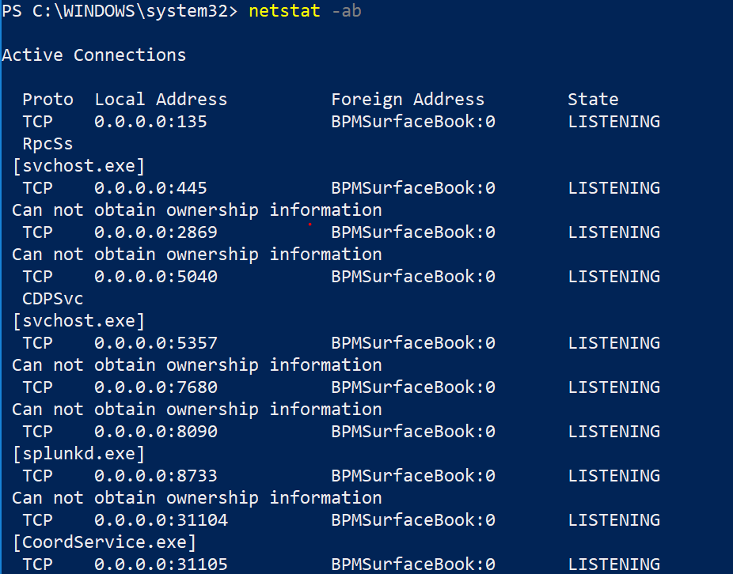
Example output of 'netstat-ab'

Netstat –esp to display the ethernet statistics overall with a breakdown of protocols. i.e volume of data sent or received using a specific service (file sharing web browsing etc)

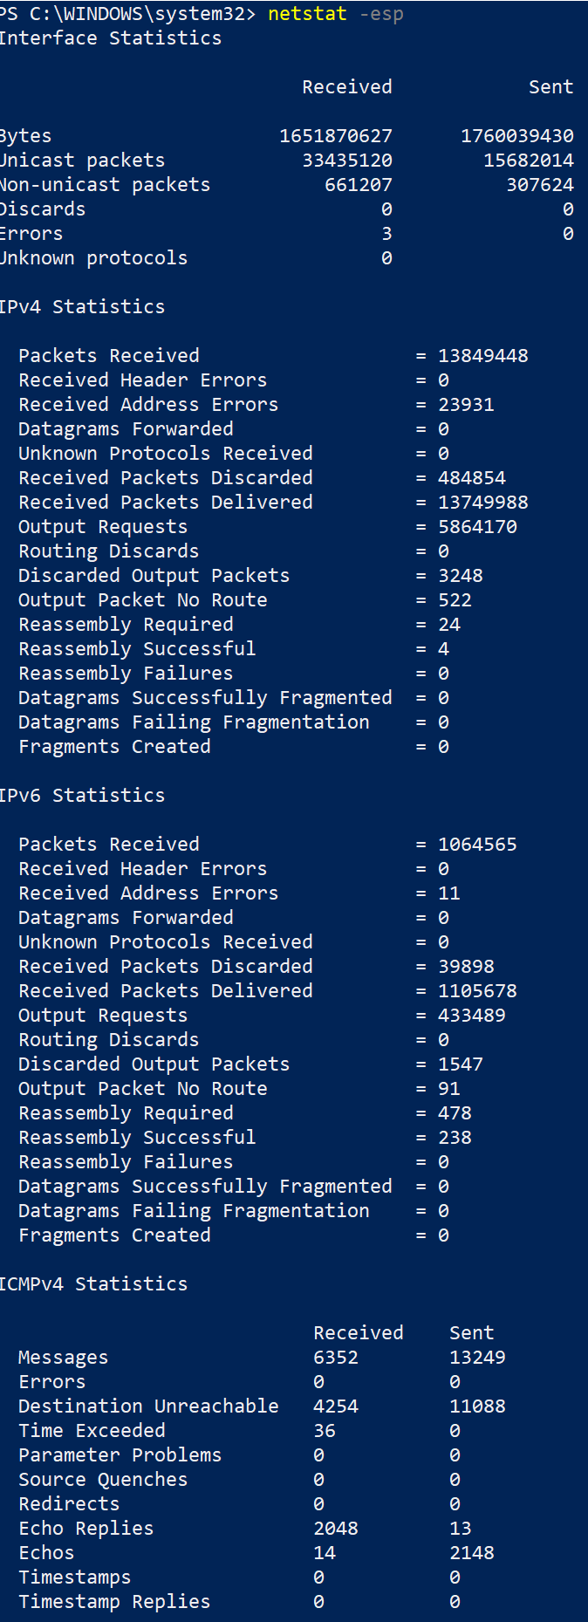

Example output of 'netstat -es'
Netstat -r will display a routing table of network connections. In the event that the defence may say the network was ‘hijacked’

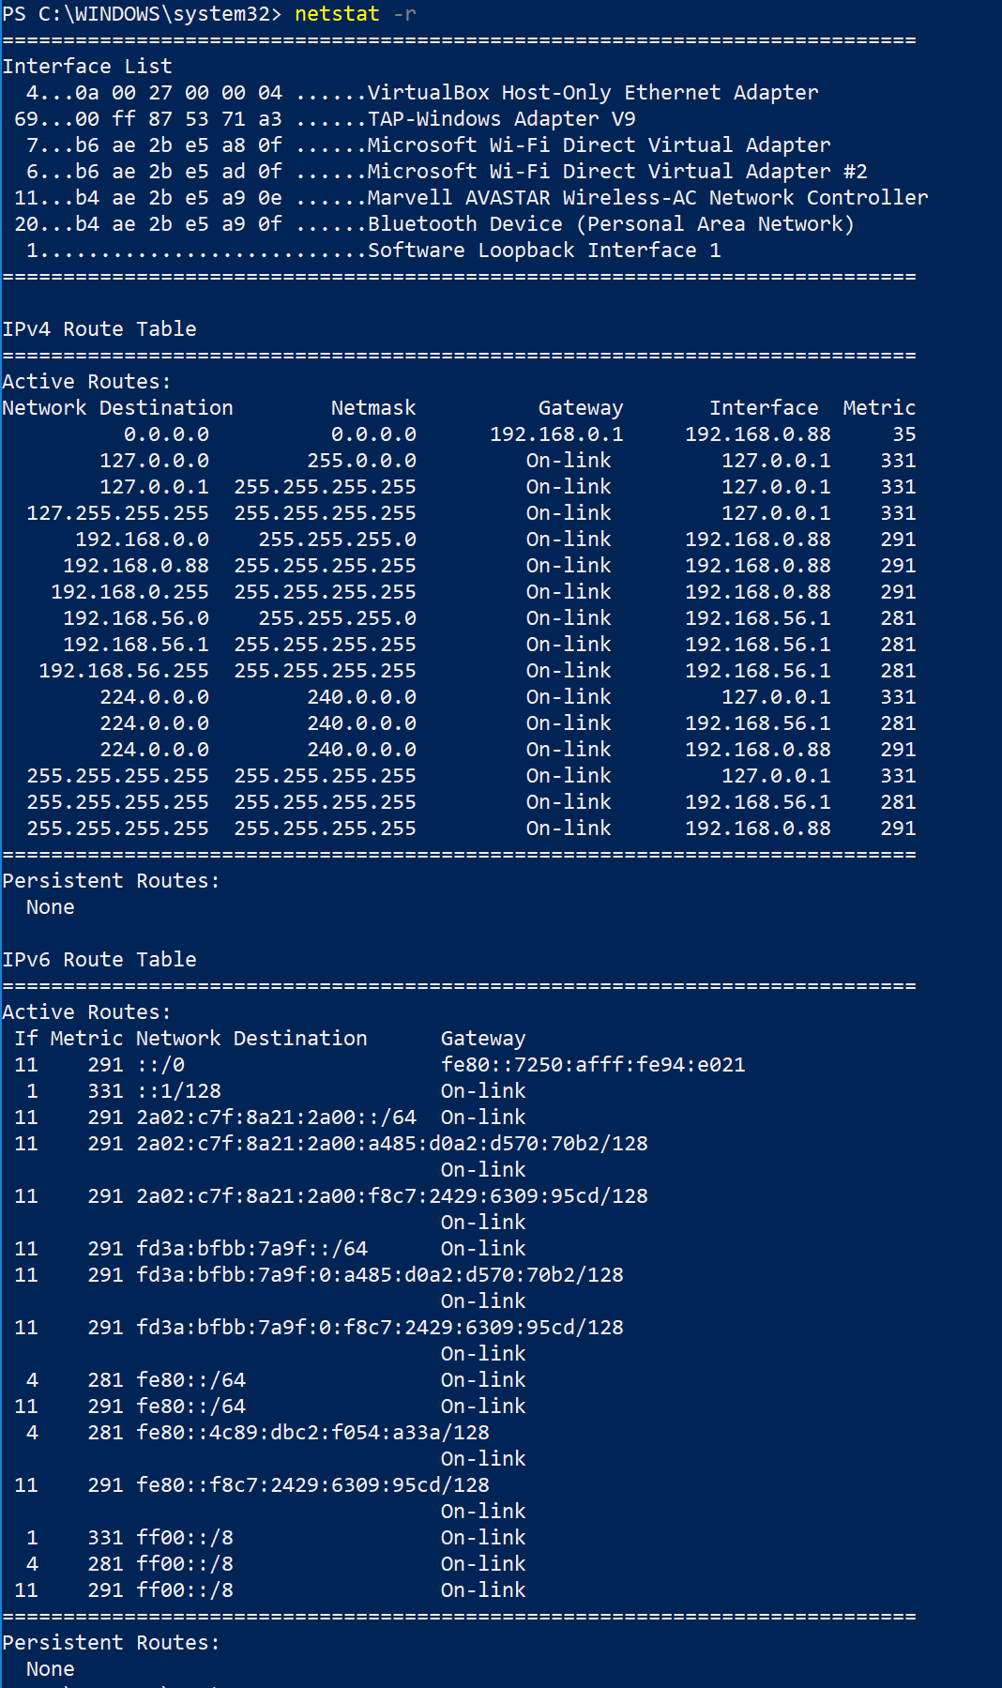
Example output of ‘netstat -r'

Document each screen by taking a photo a screen grab is not acceptable in this instance.

- Within the elevated command prompt run the following.
Net Session – The command unlike Netstat shows more meaning full connection data such as someone logging into the system. [17].

Again capture output using a timestamped photo.
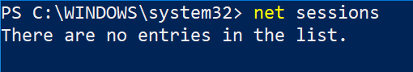
Example output of 'net-sessions'
- Continuing within the cmd console run the following :-
‘Openfiles’ – This command will report back any files or folders that are shared and are open plus who has them open.

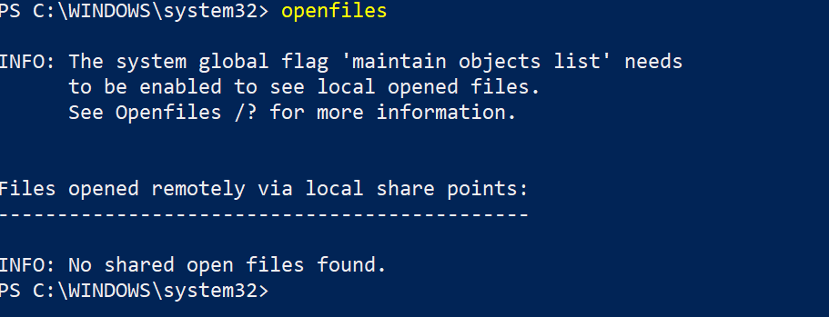

- To capture the remining live system information it would by best to run live capture software from a USB stick and capture the output to sanitized storage.

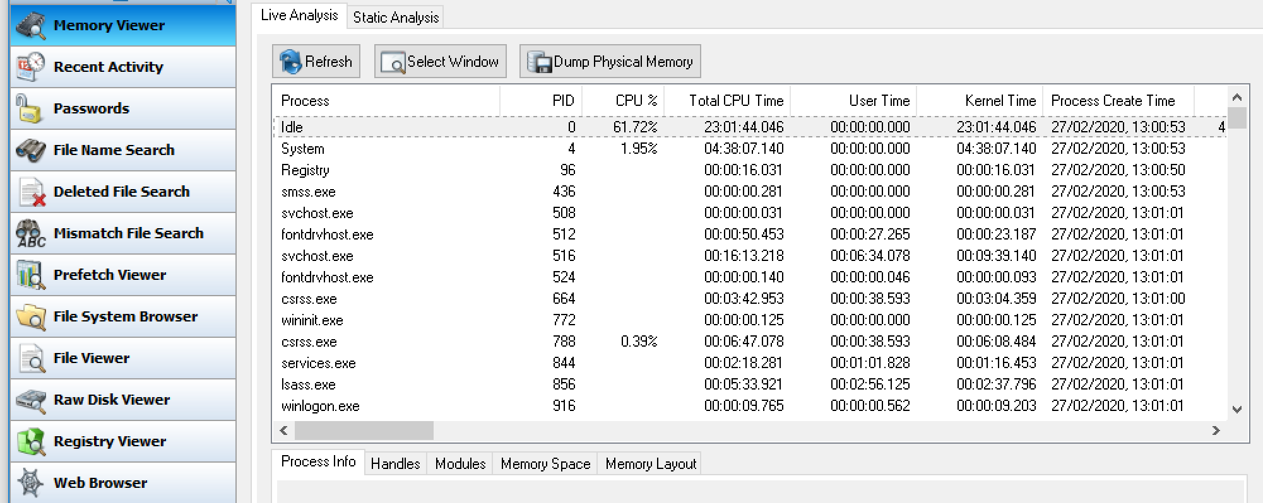

- Whilst the system is still accessible an investigator should take the opportunity to perform a live forensic capture of the drive.

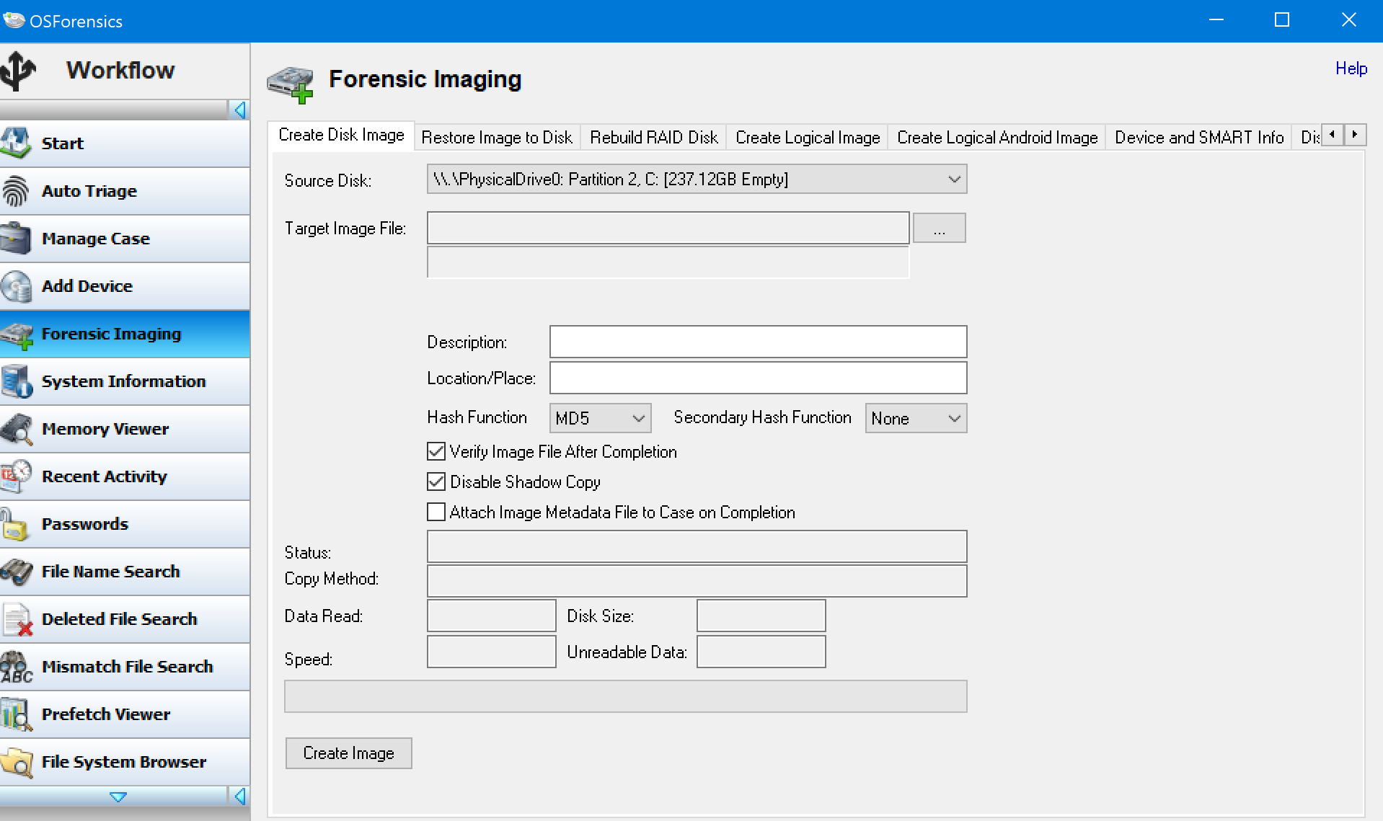

Provided the suitable decryption key has been captured as part of the capture process then a full forensic image will be possible. If not, a bit for bit copy will be problematic when trying to examine at a later date. In this case study instance it is assumed the use of whole drive encryption is not used.

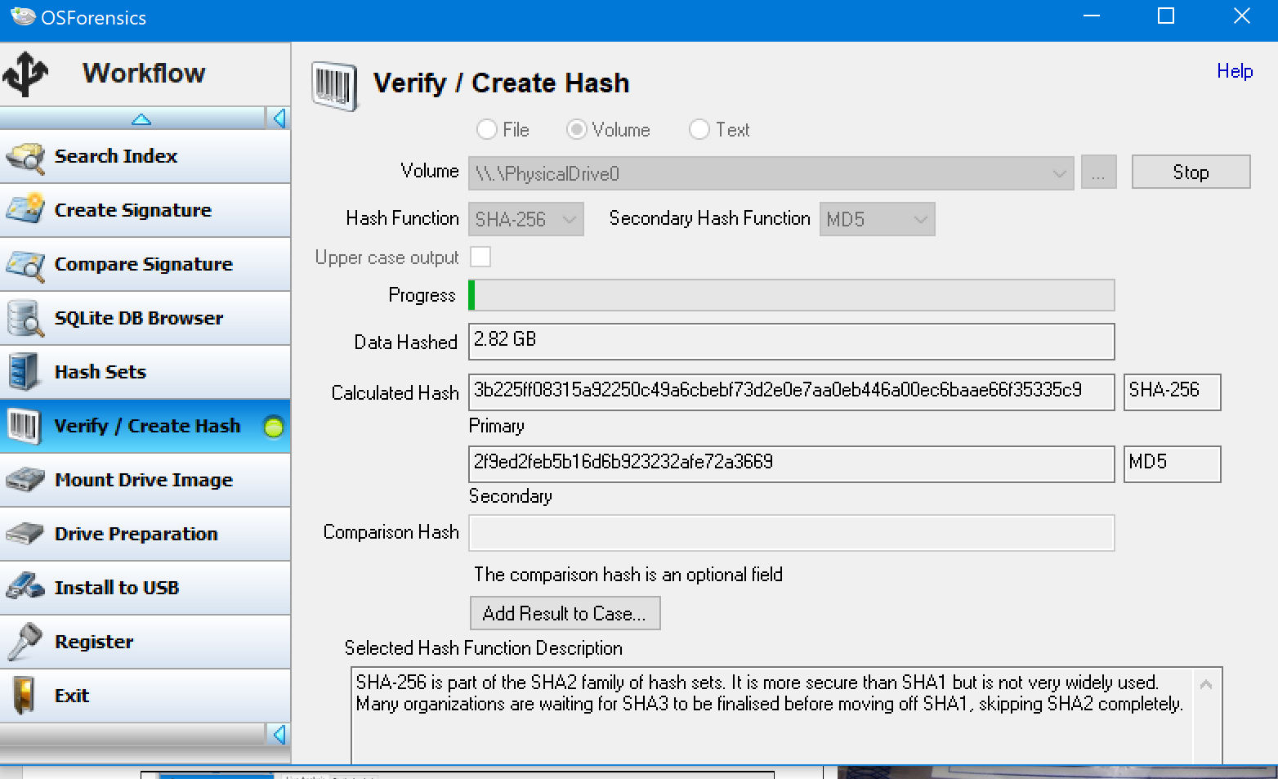

Once all live capture events have been complete then to power down the PC. AOPC [19] ENISA [18] and Chuck Eastman [21] recommend simply pulling the power from the device to interrupt normal operations or which may have some anti forensic operations occurring on the device that could impact data capture. Do not turn the unit off at the wall socket or press the power button on the unit. In the case of a laptop with a removable battery, remove the battery.

- Once the live data capture has been completed and the hash values of the data calculated and compared to the source data the investigator must return the source drive back to secure evidence storage to continue examining the captured data.

- If hardware is to be removed from the scene individual components should be tagged as evidence and a chain of custody log be updated. Tagged electronic items should be sealed in anti-static bags and transported in in secured boxes with sufficient packing materials. Items of evidence should be clearly labelled as to be not confused with similar items which could lead to evidence being lost.

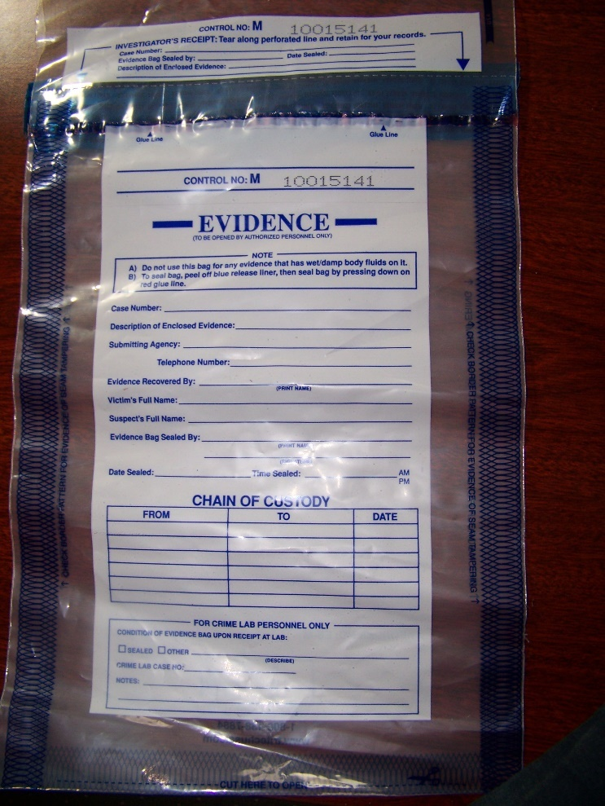
Figure 8 [20]
Evidence should be supervised to prevent further loss of data or potentially malicious acts to compromise the data. The adherence to the chain of evidence document is vital as improper processes can be used to call into question the validity of the evidence.

Gathering the data
As there are a number of solutions that can be used some software can be more useful than other when trying to achive the required results. For example While FTK imager would have possibly been used in capturing the source data when it came to do any analysis it was a poor working experience only able to perform some basic tasks like viewing file types on the drive. OSForesics built in tools for password cracking make it relatively easy for a novice forensic specialist when attempting to bypass office document protection. Autopsy with is tree structure was able to navigate and was able to view files natively within the interface where OSForensics struggled.

- When examining the captured data compare the hash values of the data prior to examination each time to ensure the source information has not changed. Either accidentally or maliciously. Record in the events in an examination log if the examination software does not maintain its own log.

The forensic tools test Autopsy and OSForensics keep a track of the overall process by creating a Case in which a log of activity is maintained.

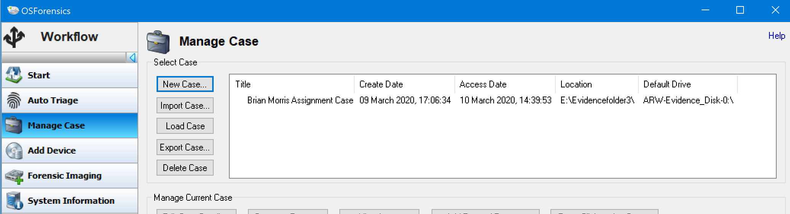
OSForensics Case management
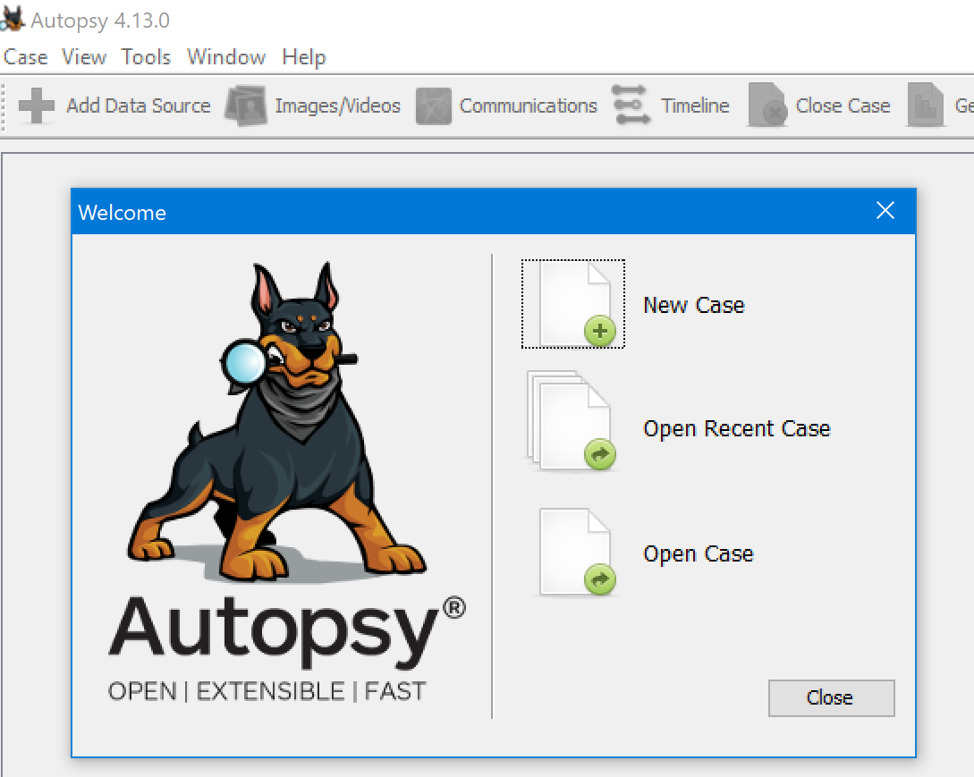
Autopsy Case management

Once a case has been created the forensic images can be loaded ready for examination.
Autopsy will process the image as a background task enumerating details of the image as the process progresses

- The forensic investigator role can be broken down to three main tasks. Find evidence , Preserve Evidence and Prepare evidence. Using the forensic image and the appropriate tools an investigator will document and record file names, creation dates / times, the last modified time of all relevant files.

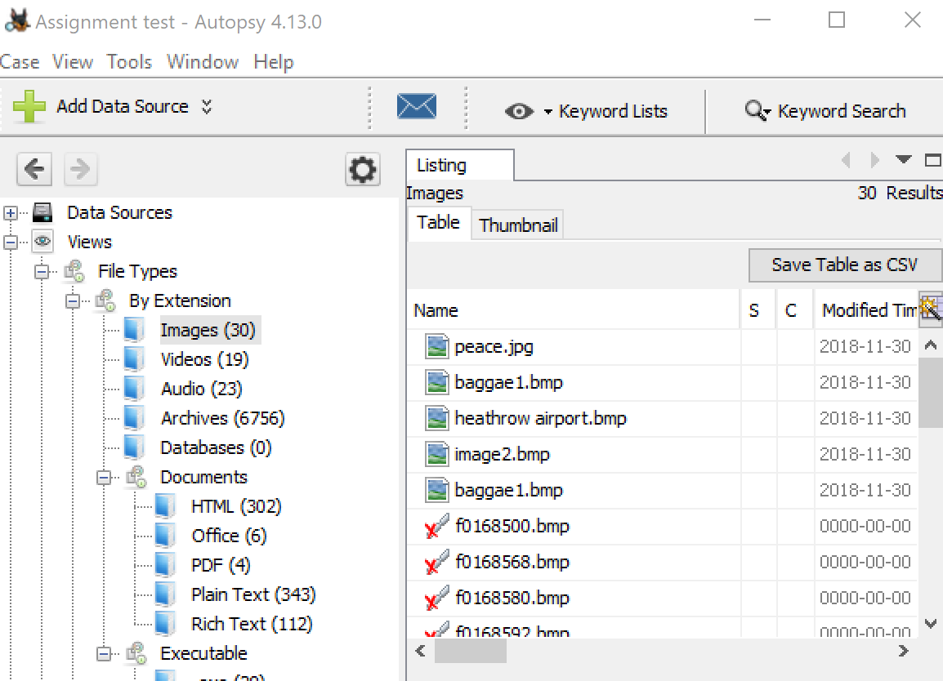
Autopsy examining image for specific file types
Separate reports for file type information can be created as required. Below is an example of video files. This can be extended to common office documents, images and media files as required
Example of Autopsy file type CSV report

Carved/Deleted file CSV report OSForensics

Emails stored collectively may be stored in a compound file type like an PST or OST single email messages may be stored in a msg file. Other file types for email exist using a general search for file types its possible to search for these file types.

- An investigation may require information to presented in a timely manner that can assist the client in reacting to get a positive outcome from an investigation.
Data that may be directly relevant to an investigation may be highlighted in a forensic report as time may be a factor during the investigation however the details should not be used as a method of judgement against the suspect.
The source files for the image didn’t include any Windows folders or user folders or the program files directories. This may be to aid in the exercise however this made capture of emails and relevant system and application information problematic
Invoice for the time and materials spent gathering the evidence should be provided. Password cracking should include CPU time, more complex passwords may require dedicated resources and more time in the future utilising cloud hosted GPU systems so it’s a good practice to record high compute activities.
The secure storage of evidence could incur additional costs especially as more clients have more equipment that needs examination so secure space comes at a premium. Some secure storage services also charge for deposit and retrieval of securely stored equipment. In this instance it is assumed the evidence is stored in an wholly owned facility. The due date should provide 28 day to the client to pay

Table of figures

Figure 1 3
Figure 2 [8] 4
Figure 3 [10] 4
Figure 4. [12] 4
Figure 5 5
Figure 6 [18] 6
Figure 7 [19] 6
Figure 8 [20] 10
Figure 9 [21] 15

Appendix

Supporting report generated from Autopsy. The evidence files have been removed from the report to ensure the supporting attachment and submission stay below the 100mb limit for a submission. Without it the file was over 3GB in size.

Below is a sample chain of evidence example provided by NIST.

Anywhere Police Department
EVIDENCE CHAIN OF CUSTODY TRACKING FORM

Case Number: ________________________ Offense: ______________________________
Submitting Officer: (Name/ID#) _______________________________________________
Victim: ______________________________________________________________________
Suspect: _____________________________________________________________________
Date/Time Seized: __________________Location of Seizure: ______________________

Description of Evidence
Item # | Quantity | Description of Item (Model, Serial #, Condition, Marks, Scratches)

Chain of Custody
Item # | Date/Time | Released by  (Signature & ID#) | Received by  (Signature & ID#) | Comments/Location

APD_Form_#PE003_v.1 (12/2012) Page 1 of 2 pages (See back)

EVIDENCE CHAIN-OF-CUSTODY TRACKING FORM
(Continued)

Chain of Custody
Item # | Date/Time | Released by  (Signature & ID#) | Received by  (Signature & ID#) | Comments/Location

Final Disposal Authority
Authorization for Disposal
Item(s) #: __________ on this document pertaining to (suspect): ____________________________________________
is(are) no longer needed as evidence and is/are authorized for disposal by (check appropriate disposal method)
☐ Return to Owner ☐ Auction/Destroy/Divert
Name & ID# of Authorizing Officer: ____________________________ Signature: ______________________Date: _______________

Witness to Destruction of Evidence
Item(s) #: __________ on this document were destroyed by Evidence Custodian ___________________________ID#:______
in my presence on (date) __________________________.
Name & ID# of Witness to destruction: ________________________ Signature: ______________________Date: _______________

Release to Lawful Owner
Item(s) #: __________ on this document was/were released by Evidence Custodian ________________________ID#:_________ to
Name _____________________________________________________________________________
Address: ________________________________________________ City: ____________________State: _______ Zip Code: __________
Telephone Number: (_____) ___________________________________
Under penalty of law, I certify that I am the lawful owner of the above item(s).
Signature: _______________________________________________________ Date: __________________________
Copy of Government-issued photo identification is attached. ☐ Yes ☐ No
This Evidence Chain-of-Custody form is to be retained as a permanent record by the Anywhere Police Department.

APD_Form_#PE003_v.1 (12/2012) Page 2 of 2 pages (See front)
Figure 9 [21]

Bibliography

[1] | US-Cert Department of homeland security, 7 3 2020. [Online]. Available: https://www.us-cert.gov/sites/default/files/publications/forensics.pdf.
[2] | The Crown Prosecution Service, "Cybercrime - Prosecution Guidance," [Online]. Available: https://www.cps.gov.uk/legal-guidance/cybercrime-prosecution-guidance. [Accessed 7 3 2020].
[3] | The National Archives, "Police and Criminal Evidence Act 1984," [Online]. Available: http://www.legislation.gov.uk/ukpga/1984/60/section/19. [Accessed 7 3 2020].
[4] | UK Gov, "Digital forensic services: codes of practice for forensic service providers," [Online]. Available: https://www.gov.uk/government/publications/digital-forensic-services-codes-of-practice-for-forensic-service-providers. [Accessed 7 3 2020].
[5] | ISO.org, "ISO/IEC 17025:2017," ISO.org, [Online]. Available: https://www.iso.org/standard/66912.html. [Accessed 7 3 2020].
[6] | "Total Archive," Fernico, [Online]. Available: http://www.fernico.com/FAR.aspx. [Accessed 11 Feb 2020].
[7] | "Open Source Digital Forensics," [Online]. Available: https://sleuthkit.org/. [Accessed 9 March 2020`].
[8] | sleuthkit.org, "Intuative," sleuthkit.org, [Online]. Available: https://sleuthkit.org/autopsy/intuitive.php. [Accessed 9 March 2020].
[9] | Passmark Software, "Digital investigation for a new era," [Online]. Available: https://www.osforensics.com/osforensics.html. [Accessed 9 March 2020].
[10] | Passmark Software, "Auto Triage," Passmark Software, [Online]. Available: https://www.osforensics.com/faqs-and-tutorials/auto-triage.html. [Accessed 9 March 2020].
[11] | Kali.org, "Kali Linux Community and Support Policy," [Online]. Available: https://www.kali.org/community/. [Accessed 9 March 2020].
[12] | "CAINE," [Online]. Available: https://www.caine-live.net/. [Accessed 9 2 2020].
[13] | E. U. A. f. N. a. I. a. S. &. P. Anderson, "Electronic evidence- a basic guide for First Responders," European Union Agency for Netork and Information and Security, Heraklion, 2014.
[14] | Association of Chief Police Officers, "Good Practice Guide for Computer-Based Electronic Evidence Offical Release version 4," [Online]. Available: https://www.7safe.com/docs/default-source/default-document-library/acpo_guidelines_computer_evidence_v4_web.pdf. [Accessed 4 March 2020].
[15] | D. B. &. T. Killalea, "Guidelines for Evidence Collection and Archiving," ietf.org, [Online]. Available: https://tools.ietf.org/html/rfc3227. [Accessed 7 3 2020].
[16] | C. Easttom, "Forensic Methodologies," in System Foresnsics, Investigation an Response, Burlington, Jones & Bartlett Learning, LLC an Ascend Learning Company, 2019, pp. 60-61.
[17] | M. R. Gupta, H. M. D and R. M. K, "Hidden Disk Areas: HPA and DCO," International Journal of Digital Evidence, vol. 5, no. 1, p. 8, 2006.
[18] | "NEW DataPort 31350-3109-0000 Forensic UltraDock FUDv5.5 Drive Dock v5.5," [Online]. Available: https://www.ebay.co.uk/i/283727378765?chn=ps&norover=1&mkevt=1&mkrid=710-134428-41853-0&mkcid=2&itemid=283727378765&targetid=878927679025&device=c&mktype=pla&googleloc=9045398&poi=&campaignid=9441269196&mkgroupid=99850131590&rlsatarget=aud-629407027665:pl. [Accessed 9 March 2020].
[19] | "Tableau Forensic Universal Bridge," [Online]. Available: https://www.guidancesoftware.com/tableau/hardware//t356789iu. [Accessed 9 March 2020].
[20] | European Union for Network and Information Security, "Forensic Analysis Web =server anlysis Handbook, Document for techers," December 2016. [Online]. Available: https://www.enisa.europa.eu/topics/trainings-for-cybersecurity-specialists/online-training-material/documents/2016-resources/exe3_forensic_analysis_iii-handbook. [Accessed 9 March 2020].
[21] | NIST.gov, "Sample-chain-of-custody-form," [Online]. Available: https://www.nist.gov/system/files/documents/2017/04/28/Sample-Chain-of-Custody-Form.docx. [Accessed 14 March 2020].

