Cover page

Executive Summary

Table of Contents
Executive Summary I
1.0 Introduction 1
1.1 About the Company 1
1.2 Project Justification 1
1.3 Aim of the Project and Objectives 2
2.0 Environment Analysis 4
2.1 PESTLE Analysis 5
2.2 SWOT Analysis 8
3.0 Research Methodology 11
3.1 Secondary Research 11
3.1.1 Complex Adaptive System and New Leadership Theory 12
3.1.2 Employee Reward 13
4.0 Finding and Analysis 16
4.1 Leadership for Netflix in 21st century 16
4.2 Total Reward Management 17
5.0 Conclusion 19
6.0 Recommendations 20
7.0 References 21
Appendix I - Labour Force Survey sampling variability (95% confidence intervals) 36
Appendix II - Generation in the Workplace 37
Appendix III - Characteristics Elaboration of Transformational Leadership 39

Table 1 - Factors that Affect the Human Resource Management
Table 2 - Top 5 priorities by generation
Table 3 - SWOT analysis of Netflix
Figure 1 - Percentage of Revenue Growth and expenditure growth
Figure 2 - Shares of Netflix in 2020

1.0 Introduction

1.1 About the Company
Netflix is designed to offer streaming service, involves a wide range of films, TV programmes and documentaries etc., which enabling people to watch in everywhere and every time (Netflix, 2020). According to record by Rivera (2019), Netflix has been guided by its mission and vision that to becoming one of the leading companies in the Internet entertainment age. As the streaming media giants, Netflix always being performance remarkable, the company stock more than tripled in 2013 alone and its subscriber in the U.S. has increased to approximate 29 million (McCord, 2014), besides, Netflix also ranks first in telecom subscriber satisfaction, which gains 79 scores on an ASCI’s 100-point system (Berk, 2019).

1.2 Project Justification
The 4th industrial revolution has marked a significant turn point that people enter knowledge-based economy era (Uhl-Bien et al., 2007; Tiwari, 2015), megatrends are reshaping the human capital trends (CIPD, 2014; Volini et al., 2019), work quantity and behaviour (Bain, 2016; WEF, 2018). Changes driven by megatrends (Beaston, 2019) lead organisations are facing increasingly complex and uncertain context and turned the standard understanding of human resource management (Retief et al., 2016). Globalisation, for instance, causing labour-intensive manufactures are gradually losing its market which is decreased from 55% in 2015 to 43% in 2017 (Lund et al., 2019), while cultivating high-tech talents becoming the crucial task in the contemporary enterprise as the growing importance of knowledge and intangible assets (Lee et al., 2017).

Traditionally, the relationship between employees and employers were explained as industrial relations which full of unequal and inhuman (Ayling and Suff, 2019), and organisations are treated as a machine, employees were expected to work like a clockwork without any deviation (Jackson, 2003; Stacey, 2004). However, nowadays, Guest (2007) and Brotherton (2020) pointed out, it is necessary for organisations to reconstruct the ‘psychological contract’ between employees and employers, as well as should reconsider the organisation as a complex adaptive system with more complicate interactive states (Uhl-Bien, 2007).

Magnificent human resource management could promote the cohesion and engagement between employees (Redman & Wilkinson, 2013; Gifford, 2016), as well as enabling the management of organisations more effective so that support organisations to enhance the enterprise performance (King, 2008; Sarache & Naranjo, 2016), heighten the core-competitiveness (Dociu, 2018). In addition, problems appeared in the Netflix also has indicated the necessity for the company to improve the human resource management process (Flint et al., 2018; Mail Online., 2018; Glassdoor, 2020).

1.3 Aim of the Project and Objectives
Consequently, the aim of the project is to focus on the improvement of Netflix’s human resource management process through conduct micro- & macro-environment analysis to identify the situation facing Netflix and problems within the organisation. Specifically, the changing characteristics of macro environment will be summarised through the research of environmental change in the 21st century, after that, studying the corresponding field literature review and evaluating the pros and cons of different theoretical frameworks. Meanwhile, investigating recent situations through new searches related to Netflix, a large company review website - Glassdoor, for instance, as well as comments about Netflix on authoritative new websites and magazines. Eventually, the practical approaches that improving the human resource management process of Netflix would be provided end of the report through combine with trends in the external environment and real situation analysis of Netflix.

2.0 Environment Analysis
Business environment analysis could be likened as a process of gathering information to identify the general and operating circumstance of enterprise so as to support enterprises’ strategic decision (Proctor, 2000; Ward et al., 2007).

Basically, environment analysis can be divided into macro- and the micro-aspect. Detailed analysis of the macro-environment or the overall environment facing an enterprise is PESTLE analysis (Elarn Ltd, 2015; Bastain et al., 2020), which could support managers and strategists to identifies the current position and future direction of development (Dobbs, 2019). Regarding the micro-level, SWOT model might be an appropriate tool for organisations to evaluate the strengths and weaknesses of business so as to respond to the opportunities and threatens (Farran, 2013; Lim, 2018).

An environmental analysis can help enterprises to recognise the trend of macro-environment change, and then consider the improvement or reform of strategic plan according to the advantages and disadvantages within their organisation (Edgaro et al., 2016). However, part of the micro environment survey will rely on primary research data, the lack of primary research may lead to the analysis is not deep enough to organise the real situation. Besides, the information generated by environmental analysis can not be determined to be fully effective, and might even lead to further strategy-making confusion due to information overload. Therefore, environment analysis for different tools still needs to be used with caution.

2.1 PESTLE Analysis
There are considerable unpredictable changes in the 21st century, thus it is called VUCA in which short for volatility, uncertainty, complexity and ambiguity. According to Clark (2013) & Bonciu (2017; 2019), the characteristics of the 4th industrial revolution can be summarised as globalisation, interrelatedness and interdependencies. Hinton (2018) further review and discuss that the technologies of the 4th industrial revolution will strengthen, transform and replace the majority of the economies and societies in the next 50 years. Besides, owing to the development of globalisation, the 21st century has entry knowledge era that the labour-intense manufacture is gradually losing its market with the rise of the intangible assets (Uhl-Bien et al., 2007; Lund et al., 2017; Kaltenegger et al., 2017). Therefore, the framework affecting the human resource management will be listed below through PESTLE analysis, and the detailed elaboration following.
Table 1 - Factors that Affect the Human Resource Management
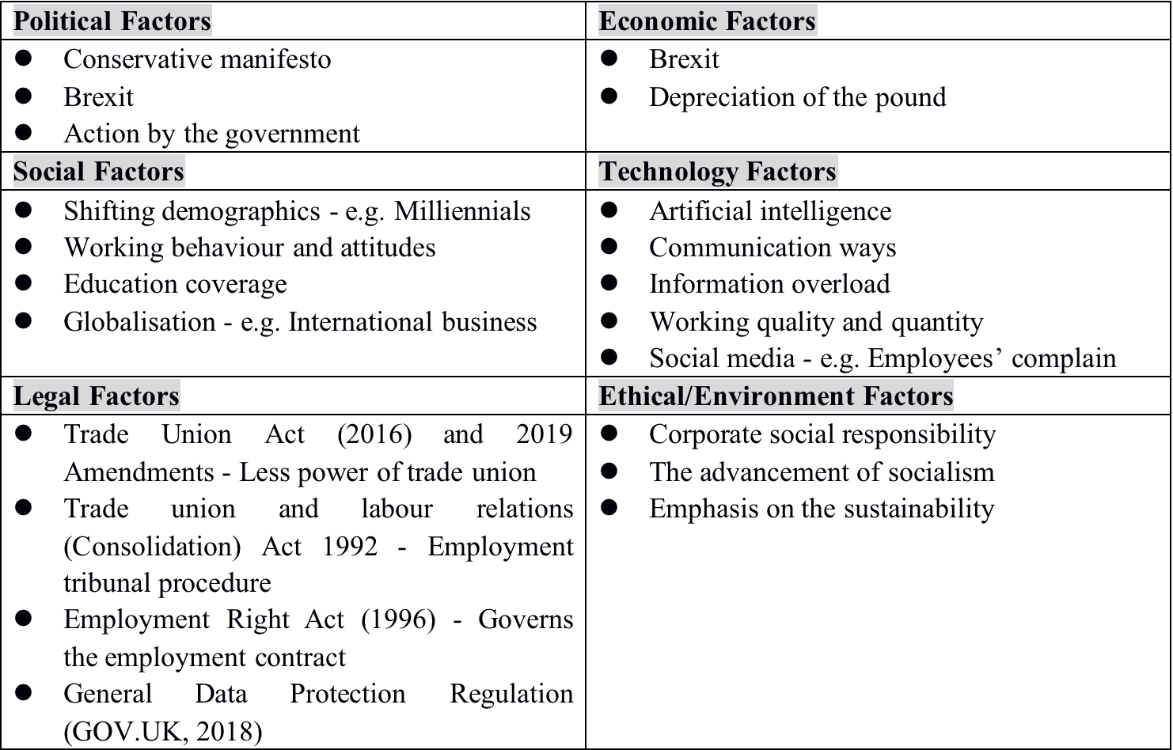
The rise of technology has changed the majority of social trends. Nowadays, technology is an essential part of life and work, organisations are leveraging the benefits provided by digital tools to improve the learning and development strategies (Brynjolfsson & McAfee, 2014; Green, 2017). Amazon, for instance, which large online retailers are now considering the use of drones for distribution; Uber is investigating driverless cars and transportation through automatic chopper (Hern, 2015; Souza, 2016). Investment in digital learning technology development was reported to exceed $7 billion in 2016 alone (Meetari, 2017). Gartner (2016) highlighted that the boundary between the digital world and the real world would become increasingly ambiguity since the development of virtual network usability. As for workplaces, technology enabling employers to monitor and command closer and thus greatly promote productivity (Hall, 2010; Medcof, 2017; Martinez et al., 2018), besides, technologies can connect employees from offices around the world and share ideas in minutes (Schwab, 2016; Green, 2017), which facilitates people’s communication as well as results in the overload of information (Bullock & Colvin, 2015; Nimrod, 2018; Black & Farrish, 2019; Tams et al., 2020).

However, there are drawbacks of technology. Research by Bain (2016) finds that employees are widely suffering from the syndrome of ‘always on’ in which causing the mental problems of lack of sleep, depression and stress (Lewis, 2012; Gross, 2014; Churchill, 2019). According to Qualtrics survey (2019) illustrated that there are exceed half of the employees being disturbed by work/life balance issues which count for 52%. CIPD (2019) further review and discuss overwork is most common among professionals and managers.

The trend of demographic changes in the workplace can be roughly summed up as the ageing of the workforce, the spread of education and growth in the proportion of female employees. Increasing older workers in the workplace, along with the growth of younger generations, have required the contemporary organisation to across generation collaboration and communication. Miranda & Allen (2017) support this notion that the growing graduates and ageing of the workforce have fundamentally transformed the composition of the working population. ONS (2020) points out that the number of workers aged over 50 had increased by 258,000 by 2020, meanwhile, the more young generation are pouring into the workplace (Ruth & Dionne, 2012), indicating that people of different ages in the workplace need to work together (Gye, 2011; Ashworth, 2016). However, conflicts might easily occur in the workplace owing to the different characteristics of generations (refer to Appendix II for the detail information), which also poses a challenge for management within organisations (Underwood, 2007; Penna, 2008; Delcampo et al., 2011; Kane, 2011; Bown-Wilson, 2012). Likewise, different generations are driven by different factors as shown in table 2, To name a few, the table provides information that the primary incentive for all generations is financial reward. And secondly, the differences between the baby boomers and Gen Y is the term of non-financial incentive, specifically, baby boomers expect work content to be interesting, while Gen Y is more attracted by clear and customised individual and professional developments (Terjesen et al., 2007; Wong et al., 2008; De Hauw & De Vos, 2010).
Table 2 - Top 5 priorities by generation
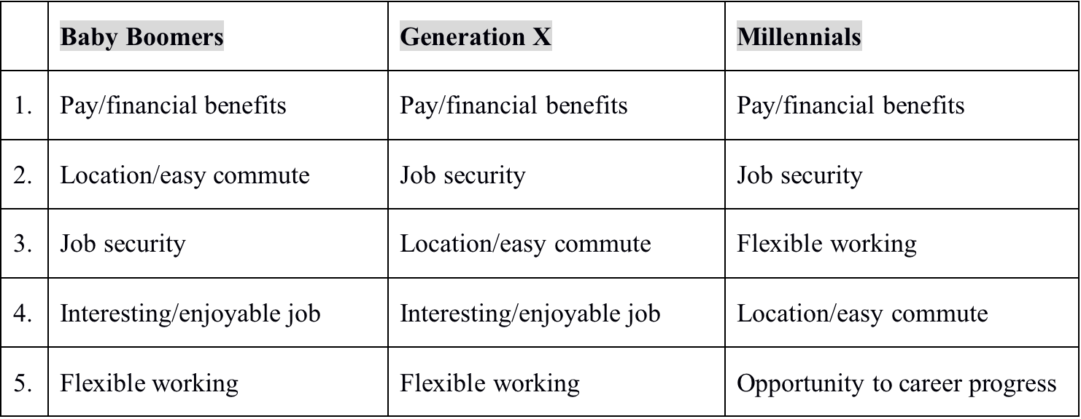
Source: Great Place to Work, 2016

As for the political, economic, legal factors, are more affected by changes in national condition. Brexit, for instance, would lower the exchange rate of pound and thus increase the cost of British companies paying salaries in foreign currency (CIPD, 2017; Moore, 2017; McGrattan & Waddle, 2020). In addition, organisations in the UK are required to be responsible for the data and information of customers and employees under the influence of the General Data Protection Regulation (GOV.UK, 2018).

2.2 SWOT Analysis
Table 3 - SWOT analysis of Netflix
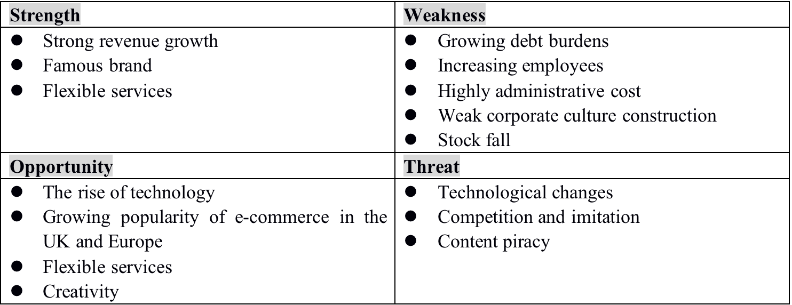
Regarding the business strategy, as the table 3 shown, the advantage of Netflix lies in its strong brand and popularity, which can bring sustained revenue growth for the company, meanwhile, Netflix also has its own high-quality original series. The House of Cards, for instance, scores 8.9/10 in IMDb ratings (IMDb, 2020). However, precisely owing to a large volume of the original programme that led Netflix facing a series of troubles. Reported by Trainer (2019), Netflix has invested considerably in original content that its shares fell to 11% on July 18, 2019, which means that Netflix has been a failure in its strategy or gain competitiveness with the high-quality original programme, in the other word, the growth rate of Netflix is not enough to compensate for its increasing cost consumption (refers to the figure 1). Further, rising costs will force Netflix to raise its prices and thus might lead to a loss of subscribers.
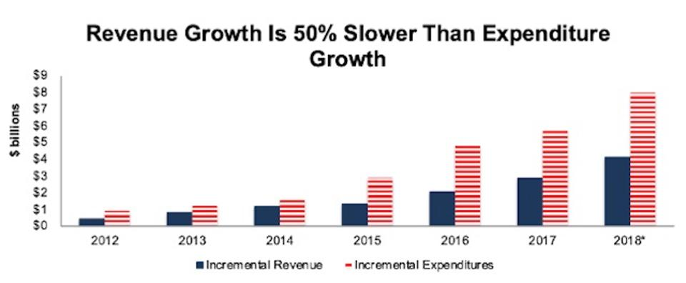
Figure 1 - Percentage of Revenue Growth and Expenditure Growth
Sources: New Constructs, LLC and company filings, 2019

Nevertheless, the appearance of the coronavirus recently enabled Netflix to take advantage of its flexible service to gain stock growth. According to figure 2, the share price of Netflix rose 16% in the first three months of 2020, most of the increase since mid-March in which due to the government almost cancellation of all entertainment activities in COVID-19 (Swartz, 2020).

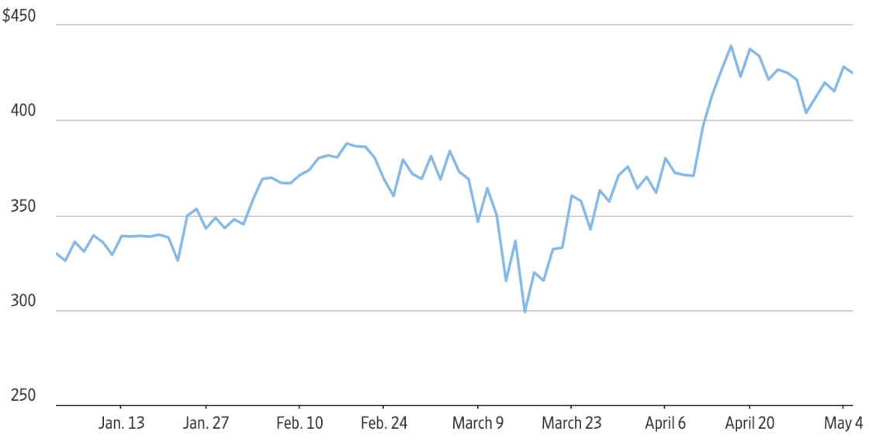
Figure 2 - Shares of Netflix in 2020
Source: Dow Jones Market Data, 2020

In terms of the organisation level, there are three issues caused by corporate culture construction. Firstly, the ‘fear culture’ that Netflix has been advocating has lead to the rigidity of employee relations within the organisation (Wharton Magazine, 2019). Employees are at risk of being dismissed at uncertain times as a result of ‘The Keeper Test’ (Netflix, 2020), which greatly increases their sense of insecurity during the working and the continued deterioration of the organisation climate (Flint et al., 2018; Mail Online., 2018; Glassdoor, 2020). Research supported by Wall Street Journal (2018) indicates that there are 70 employees states that they are surfer from the test pressures and it is difficult to re-trust the organisational environment. Additionally, ‘The Keeper Test’ has once again added to the debt burden of Netflix (Thompson, 2019). Denning (2018) support this notion that the test requires the organisation to invest considerable expenditures and energy to operate. The final issue comes from the high freedom culture of Netflix (Netflix, 2019), that is, motivating employees through flexibility as well as results in employees being unable to navigate in a highly liberal culture as lack of direction. Many employees report they can not feel guided and supported since the culture that encourages them to make decisions independently (Tapper, 2018; Glassdoor, 2020).

3.0 Research Methodology
Generally, research methodology could be divided into primary research and secondary research. Primary research refers to collect information through self-developed methods (McCorklin, 2018), secondary research can be defined as search information via previous studies (Bradley, 2010). Fischer et al. (2010) and Kumar (2014) demonstrate that primary research could provide emerging and creditable information for analysis, while with comparing the secondary research, primary research requires higher budget and time.

However, owing to the Netflix headquarters is in the US, and the report is written in the UK, which means it is not realistic to conduct primary research in Netflix headquarters. Therefore, the main source of information data and the theoretical framework of the report mainly comes from secondary research.

3.1 Secondary Research
The literature review will mainly focus on finding the present trends of the 21st century and the theoretical framework put forward by different scholars in the corresponding field. And include measures (both positive and negative examples) taken by some similar enterprises in response to a similar scenario. Hence, this section generalises the search direction of the literature review into employee reward investment and leadership research in the 21st century.

3.1.1 Complex Adaptive System and New Leadership Theory
Uhl-Bien et al. (2007) pointed out that employers should consider the organisation as a complex adaptive system (CAS) rather than a machine. McDaniel (2008) support this notion that the possible reason why organisational performance is difficult to improve is that organisation are always viewed as machines, which result in the pattern managers treat organisation is also consistent with the pattern that they treat machines. Research and discussion by successive scholars (Wardrop, 1992; Capra, 1996; Leventhal & Warglien, 1999; Chu, Strand & Fjelland, 2003; Beinhochocker, 2006; Maguire et al., 2006) described the characteristics of CAS as ‘a) Diverse agents that learn; b) That interact with each other in nonlinear ways; c) Self-organised; d) Have emergent properties; e) Co-evolve with the environment’.

Under this premise, Taylor & Van Every (2000, P.40) highlighted that to exploit CAS features rather than overcome them (Levy, 1992; Goodwin, 1994; Carley & Lee, 1998; Carley & Hill, 2001). Mckelvey & Boisot (2003) also suggest that organisation should increase their complexity to the same level as the external environment, rather than simply rationalising the organisational structure (also can refer to the Law of Requisite Variety developed by Ashby in 1960). Therefore, new managerial tasks have been proposed.

Meanwhile, according to Chakhoyan (2017) described in ‘Is the era of management over?’, 21st century has entered the post-management era in which the command strategy will no longer be feasible as well as the hierarchical management pattern. The transformation of leadership could be categorised as follows:

Table 4 - Mindset Shifts for Organisation Transformation
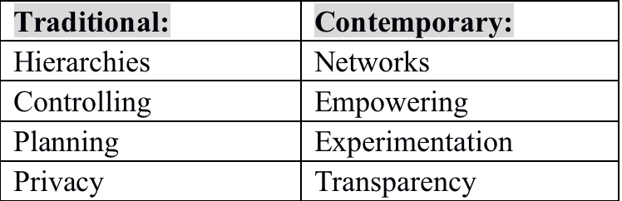

Hence, there are two leadership theory could be matched to CAS. The concept of transformational leadership (TL) was originally introduced by Burn in 1978 which aims to transform followers within the organisation into leaders so as to motivate higher performance. Avolio et al. (1991) illustrated four essential elements of TL, i.e., ‘idealised influence, inspirational motivation, intellectual stimulation and individual consideration’ (refer to Appendix III for more detailed). Meanwhile, Bass & Avolio (1990) further review and define the TL as attracting and motivating follower (employees) via ethics and values. TL could effectively improve employee performance and innovation capability while setting a development direction/goal for employee (Janssen, 2002; Jaussi & Dionne, 2003; Eisenbeiss et al., 2008; Pradhan & Jena, 2019).

Nevertheless, according to Yukl & Howell (1999) and Bass & Steidlmeier (1999), TL has strict requirements on the quality of leaders, which demands that leaders should be ethic, moral and authentic, or they might become to the ‘pseudo-transformational leaders’. Researched by Christie et al. (2011) finds that ‘pseudo-transformational leaders’ are self-interested and has a negative impact on employees’ innovation thinking, which might eventually lead to the damage of organisational performance (Conger ＆ Kanungo, 1998; Dasborough ＆ Ashkanasy, 2002).

Therefore, in order to make up for the shortcoming of transformational leadership, there is another leadership could be referred by organisations called intent-based leadership (IBL), and then organisations might consider both approaches to complement each other as appropriate to form a leadership that appropriate for Netflix.

IBL was developed by Marquet in 2015, which made employees feel empowered and psychological safety by providing an environment that enabling employees to voice. Similarity with the TL, IBL also has the objective that turns followers into leaders. (Fernandez et al., 2017; Marquet, 2018). Baer & Oldham (2006) and Newenham (2013) and Yoshida et al. (2014) demonstrates that providing an expression space for employees also means creating a psychological comfort zone and space for employees because the atmosphere established by IBL enabling employee aware it is acceptable to challenges authority and propose new propose without any hesitation (Buckingham, 2015; Marquet, 2016; 2018; Larkin, 2017). However, Premuzic (2017) and Reynolds (2019) also highlight that diversity brought by IBL might lead to the disorder and confusion within the organisation, thus increasing the workload of managers and reducing the organisational productivity.

3.1.2 Employee Reward and Total Reward
The traditional employee relations can be described as the economic perspective, that is, the relationship between employers and employee be regarded as financial transactions. According to Wilkinson & Johnstone (2016) and Antoni et al. (2017), in the past, the purpose of the award is to maintain and stimulate employees to satisfy the demand of the employers/organisations. While with the rise of the post-management era, the command management style has been almost eliminated, and the requirements for employees’ rewards no longer stays on financial rewards, rather more emphasis the non-financial rewards, such as flexible work/life arrangements (Chakhoyan, 2017; Marriott et al., 2019; Okros, 2019; Shields et al., 2020). Dan Pink (2009) also found that it is low effective for organisations to award employees with bonus and compensations, he proposed the ‘autonomy, mastery and purpose’ would be the future organisation climate, and the employee reward strategies should be implemented in combination with intrinsic and extrinsic motivation. Plus, many scholars (Kane, 2011; Helyer and Lee, 2012; Ayling and Miller, 2019) report that different generations of employees working together and present their own characteristics, indicating that contemporary labour market has become extremely complex and diverse, and also post challenges for employers in the employee rewards management (Anantatmula & Shrivastav, 2012; Stuart, 2015; Sakdiyakorn & Wattanacharoensil, 2018).

The rise of the ‘total’ reward concept was caused by changes in employee relations. Compared with traditional employee rewards, total rewards cover a wider range of content, including financial rewards and non-financial rewards (Cotton, 2019). Heneman (2004) provided a framework of total reward content i.e., compensation, benefits, personal & professional development and working environment construction. Each element should not be implemented independently seems to be the consensus reached by scholars (Dibben, 2011; Korsh, 2019; Cotton, 2019), since it might lead to excessive stress and mental health problems if there are only financial rewards, and the issues of only use non-financial reward might be considered by employees as a way to cut corners in order to avoid paying normal salary (Heneman, 2004). Besides, according to Marriott (2019), the implementation of the total reward strategy is highly dependent on the line manager, hence, the strategy might be a failure without the support of line managers.

4.0 Finding and Analysis

4.1 Leadership for Netflix in 21st century
As evaluated previously, Netflix could utilise the beneficial factors of two leadership theory to develop a new leadership that could respond to the external environment changing while enhancing the human resource management process. Specifically, utilising the bench-marking role of TL to offer orientation for employees so that to solve the chaos caused by high freedom culture and the disorder caused by the excessive diversity involved in IBL characteristics. Specifically, leaders could link the self-concept of employees to the development goal of organisation to increase their self-identity and ethics (Avolio & Gardner, 2005; Bass & Riggio, 2006; Snowden＆Boone, 2007; Hartnell & Walumbua, 2011). Regarding IBL, Netflix could use its characteristic that encourages employee voice to create a positive atmosphere for the organisation and decrease the anxious emotion among employees. Besides, IBL is effective for the organisation to capture information about trends in the external environment (Sarkar, 2016; Marquet, 2018; Carig, 2019; Maelrieussec, 2019), as well as help Netflix to ease the employee relationship rigidity caused by ‘fear culture’.

In conclusion, leadership for Netflix use in the 21st century should be based on the IBL style of creating the psychological comfort zone for employees and the TL to provide a benchmark with employees, so that can guide Netflix to move forward in an orderly and flexible way.

4.2 Total Reward Management
As described, there are wider formations of reward as pay no longer the only motivator for employees. Reported by Clark (2019) illustrates that the pay level of Netflix is 25% to 50% higher than competitors, the entry-level coordinator is paid in six - figures and the vice president earns at least $1 million. Given that Netflix has provided employees with satisfy pay level and has a heavy debt burden, it is appropriate to consider emphasising non-financial rewards into employee reward strategies. Therefore, the total reward management could be divided into three aspects.

Primary, offering personal and professional development, particularly more customised career development and training. Career development and training not only can enhance the individual’s ability but also enabling employees to contribute themselves into the organisation, gain specific skills to add value to the enterprise and might even create the competitiveness that competitors cannot imitate. It should be noted, however, that the acquisition of some skills makes it easy for employees to transform to other organisations, and thus does not creates practical strategic value to Netflix (Brown, 2014; Armstrong, 2017).

On the other hand, enhance the work environment. According to Heneman (2004), job design also is an important part of the total reward strategy, and job design can be divided into physical and psychological characteristics. Hence, based on the categorisation, Netflix can make improvements to the office environment, such as providing a more visually pleasing office, in addition, in terms of the psychology, Netflix could setting more challenges business working objectives and content for employees to improve employee motivation. The final one is to achieve the work/life balance. More flexible schedules, for instance, enabling effectively improve employee satisfaction to the organisation, thereby increasing productivity, while the biggest negative influence of flexible arrangement is might lead to employee absenteeism happened (Ahmad & Hashim, 2013; De Menezes et al., 2016; Patrick et al., 2018).

5.0 Conclusion and Recommendations
The 21st century is unpredictable since its characteristics that volatility, uncertainty, complexity and ambiguity.

Based on analysis, recommendations can be summarised as:
- Conducting new leadership that combine with transformational leadership theory and intent-based leadership theory
- Providing employees with space to voice
- Establishing a psychological comfort zoom for employees
- Enhancing the employee rewards strategies, non-financial reward particularly
- Offering customised career development and training
- Creating a comfortable office environment
- Improving the working content
- Using a flexible schedule

6.0 References
Ahmad, A., Idris, M. & Hashim, M. (2013) A Study of Flexible Working Hours and Motivation. Asian Social Science, 9(3), pp.208-215.

Anantatmula, V. & Shrivastav, B. (2012) Evolution of project teams for Generation Y workforce. International Journal of Managing Projects in Business, 5(1), pp.9–26.

Antoni, C., Baeten, X., Perkins, S., Shaw, J. and Vartiainen, M. (2017) Reward Management. Journal of Personnel Psychology, 16(2), pp.57-60.

Armstrong, M. & Taylor, S. (2017) Armstrong’s handbook of human resource management practice 14th ed., London: Kogan Page.

Ashworth, M. (2006) Preserving knowledge legacies: workforce aging, turnover and human resource issues in the US electric power industry. The International Journal of Human Resource Management, 17(9), pp.1659–1688.

Avolio, B., Waldman, D., & Yammarino, F. (1991) Leading in the 1990’s: The four I’s of transformational leadership. Journal of European Industrial Training, 15(4), pp. 9–16.

Ayling, L. and Suff, R. (2019) Employee relations: an introduction. [online] Available at: https://www.cipd.co.uk/knowledge/fundamentals/relations/employees/factsheet#6057 [Accessed 12 April 2020].

Bain, R. (2016) Any Time, Any Place, Anywhere (Part 2) | CIPD. [online] CIPD. Available at: https://www.cipd.co.uk/news-views/changing-work-views/future-work/thought-pieces/any-time-any-place-anywhere-2 [Accessed 24 April 2020].

Bass, B.M. (1985) Leadership and Performance Beyond Expectations, Free Press, New York, NY.

Bass, B., & Avolio, B. (1990) Developing transformational leadership: 1992 and beyond. Journal of European Industrial Training, 14(5), 21.

Bass, B., & Steidlmeier, P. (1999). Ethics, character, and transformational leadership behavior. The Leadership Quarterly, 10(2), 81-217.

Bastain, P., Shojaei, P., Hatam, N., Salehi, A. and Pourmohammadi, K. (2020) A comprehensive environmental scanning and strategic analysis of Iranian Public Hospitals: a prospective approach. BMC Research Notes, 13(1), pp.1–8.

Beaston, M. (2019) Megatrends: Flexible Working. [online] Available at: https://www.cipd.co.uk/Images/megatrends-report-flexible-working-1_tcm18-52769.pdf [Accessed 9 April 2020].

Beinhocker, E.D. (2006) The origin of wealth evolution, complexity, and the radical remaking of economics. Boston, MA: Harvard Business School Press.

Berk, N. (2019) Video Streaming And Netflix Rise To First Place In Customer Satisfaction For Telecommunications. [online] Forbes. Available at: https://www.forbes.com/sites/nancyberk/2019/05/21/video-streaming-and-netflix-rise-to-first-place-in-customer-satisfaction-for-telecommunications/#5886d33b438e [Accessed 14 April 2020].

Black, H. & Farrish, J. (2019) The dark side of technology: examining the impact of technology overload on salespeople. The Journal of Business & Industrial Marketing, 34(2), pp.317–337.

Bonciu, F. (2017) Evaluation of the impact of the 4th industrial revolution on the labor market. Romanian Economic and Business Review, 12(2), pp.7–16.

Bonciu, F. (2019) Impact of the 4th Industrial Revolution on the World Order. Romanian Journal of European Affairs, 19(2), pp.51–62.

Bradley, N. (2010) Marketing research: tools & techniques 2nd ed., Oxford: Oxford University Press.

Brotherton, C., Boiral, O. & Talbot, D. (2020) Building trust in the fabric of sustainability ratings: An impression management perspective. Journal of Cleaner Production, 260, pp.Journal of Cleaner Production, 01 July 2020, Vol.260.

Brown, D. (2014) The Future of Reward Management: From Total Reward Strategies to Smart Rewards. Compensation & Benefits Review, 46(3), pp.147–151.

Brynjolfsson, E., & McAfee, A. (2014) The second machine age: Work, progress, and prosperity in a time of brilliant technologies. New York, NY: W. W. Norton.

Buckingham, M. (2015) What Great Managers Do. [online] Harvard Business Review. Available at: https://hbr.org/2005/03/what-great-managers-do [Accessed 7 May 2020].

Bullock, A. & ; Colvin, A. (2015) Communication Technology Integration into Social Work Practice. Advances in Social Work, 16(1), pp.1–14.

Burns, J. M. (1978) Leadership. New York: Harper & Row.

Carley, K., & Lee, J. S. (1998) Dynamic organizations: Organizational adaptation in a changing environment. Advances in Strategic Management: A Research Annual, 15, 269−297.

Carley, K., & Hill, V. (2001) Structural change and learning within organizations. In A. Lomi & E. R. Larsen (Eds.), Dynamics of organizational societies (pp. 63−92). Cambridge, MA: AAAI/MIT Press.

Capra, F. (1996) The web of life: A new scientific understanding of living systems. New York: Anchor Books Doubieday.

Chakhoyan, A. (2017) Is the era of management over? [online] World Economic Forum. Available at: https://www.weforum.org/agenda/2017/12/is-management-era-over/ [Accessed 1 May 2020].

Christie, A., Barling, J. & Turner, N. (2011) Pseudo-Transformational Leadership: Model Specification and Outcomes1. Journal of Applied Social Psychology, 41(12), pp.2943-2984.

Chu, D., Strand, R., & Fjelland, R. (2003) Theories of complexity: Common denominators of complex systems. Complexity, 8(3), 19-30.

Churchill, F. (2019) ‘Always On’ Employees Are More Engaged But Also More Stressed. [online] People Management. Available at: https://www.peoplemanagement.co.uk/news/articles/always-on-employees-more-engaged-but-more-stressed [Accessed 21 April 2020].

CIPD. (2014) HR Megatrends | Reports | CIPD. [online] Available at: https://www.cipd.co.uk/knowledge/work/trends/megatrends [Accessed 22 March 2020].

CIPD. (2017) Brexit And The Labour Market: Submission To The House Of Lords Select Committee On Economic Affairs. [online] Available at: https://www.cipd.co.uk/Images/cipd-response-house-of-lords-economic-affairs-committee_tcm18-20895.pdf [Accessed 4 May 2020].

CIPD. (2019) UK Working Lives - The CIPD Job Quality Index: June 2019. [online] Available at: https://www.cipd.co.uk/Images/uk-working-lives-summary-2019-v1_tcm18-58584.pdf [Accessed 20 April 2020].

Clarke, N. (2013) Model of complexity leadership development. Human Resource Development International, 16(2), pp.135–150.

Conger, J. A., & Kanungo, R. N. (1998) Charismatic leadership in organizations. Thousand Oaks, CA: Sage.

Copeland, M. (2014) The Emerging Significance of Values Based Leadership: A Literature Review. International Journal of Leadership Studies, 8(2), pp.105-135.

Cotton, C. (2019) Reward & Pay | Factsheets | CIPD. [online] CIPD. Available at: https://www.cipd.co.uk/knowledge/fundamentals/people/pay/reward-factsheet [Accessed 22 April 2020].

Dasborough, M. T., & Ashkanasy, N. M. (2002) Emotion and attribution of intentionality in leader–member relations. Leadership Quarterly, 13, 615– 634.

De Hauw, S. & De Vos, A. (2010) Millienniais’ Career Perspective and Psychological Contract Expectations: Does the Recession Lead to Lowered Expectations? Journal of Business and Psychology, 25(2), pp.293–302.

De Menezes, L.M. & Kelliher, C. (2016) Flexible Working, Individual Performance, and Employee Attitudes: Comparing Formal and Informal Arrangements. 56(6), pp.1051-1070.

Dibben, P., Klerch, G. and Wood, G. (2011) Employment relations: A critical and international approach. | Pauline Dibben, Gilton Klerck and Geoffrey Wood., London: Chartered Institute of Personnel and Development.

Dociu, M. (2018) The importance of human resources in project management. Knowledge Horizons. Economics, 10(3), pp.8–14.

Dobbs, Ben. (2019) Making the best of PESTLE. Modern English Teacher, 28(2), pp.77–79.

Edgardo B., Henning, H. and Jhony M. (2016) Relationship between the business environment and business strategy types: Evidence in Peruvian companies. Universidad y Empresa, 19(32), pp.61–86.

Eisenbeiss, S. A., Van Knippenberg, D., Boerner, S. (2008) Transformational leadership and team innovation: Integrating team climate principles. Journal of Applied Psychology, 93(6), 1438-1446.

Eisner, S. (2005) Managing Generation Y. S.A.M. Advanced Management Journal, 70(4), pp.4–15.

Fernandez-Salvador, C. et al. (2017) From nuclear submarines to graduate medical education: applying David Marquets intent-based leadership model. Military Medical Research, 4(1), p.31.

Hart, K. (2006) Generations in the workplace: finding common ground. Medical Laboratory Observer, 38(10), pp.26–7.

Elearn Ltd. (2005) Business environment, Oxford: Pergamon Flexible Learning.

Esposito, M. & Tse, T. (2018) DRIVE: The Five Megatrends that Underpin the Future Business, Social, and Economic Landscapes. Thunderbird International Business Review, 60(1), pp.121–129.

Farran, H. (2013) The SWOT Analysis. Guident, 6(4), pp.22–23.

Fischer, E. & Parmentier, M.A. (2010) Doing Qualitative Research With Archival Data: Making Secondary Data a Primary Resource. Advances in Consumer Research, 37, p.798.

Flint, S. and Ramachandran, S. (2018) At Netflix, Radical Transparency and Blunt Firings Unsettle the Ranks. [online] WSJ. Available at: https://www.wsj.com/articles/at-netflix-radical-transparency-and-blunt-firings-unsettle-the-ranks-1540497174 [Accessed 25 April 2020].

Gifford, J. (2016). Could do better? Assessing what works in performance management. London: Chartered Institute of Personnel and Development. Available at: https://www.cipd.co.uk/Images/could-do-better_2016-assessing-what-works-in-performance-management_tcm18-16874.pdf [Accessed 24 April. 2019].

Glassdoor.co.uk. (2020) [online] Available at: https://www.glassdoor.co.uk/Reviews/Netflix-culture-of-fear-Reviews-EI_IE11891.0,7_KH8,23.htm [Accessed 25 April 2020].

Goodwin, B. (1994) How the leopard changed its spots: The evolution of complexity. New York: Charles Scribner's Sons.

GOV.UK. (2018) Guide to the General Data Protection Regulation. [online] Available at: https://www.gov.uk/government/publications/guide-to-the-general-data-protection-regulation [Accessed 24 April 2020].

Green, M. (2017) The Future Of Technology And Learning. [online] Cipd.co.uk. Available at: https://www.cipd.co.uk/Images/the-future-of-technology-and-learning_2017_tcm18-29348.pdf [Accessed 21 April 2020].

Gross, M. (2014) Chronic stress means we’re always on the hunt. Current Biology, 24(10), pp.R405–R408.

Gye, H. (2011) A Well-Earned Rest! Britain's Oldest Shop Worker Retires Aged 96 After Holding Down A Job Continuously Since The Age Of 14. [online] Mail Online. Available at: https://www.dailymail.co.uk/news/article-2059411/Syd-Prior-retire-Britains-oldest-shop-worker-retires-aged-96.html [Accessed 21 April 2020].

Helyer, R. and Lee, D. (2012) The twenty‐first century multiple generation workforce. Education + Training, 54(7), pp.565-578.

Hern, A. (2015) Are driverless cars the future of Uber? [online] The Guardian. Available at: https://www.theguardian.com/technology/2015/feb/03/are&#8208;driverless&#8208;cars&#8208;the&#8208;future&#8208;of&#8208;uber [Accessed 21 April 2020].

Hinton, S. (2018) Council Post: How The Fourth Industrial Revolution Is Impacting The Future Of Work. [online] Forbes. Available at: https://www.forbes.com/sites/theyec/2018/10/19/how-the-fourth-industrial-revolution-is-impacting-the-future-of-work/#7a61e5fa65a7 [Accessed 19 April 2020].

IMDb. (2020) House Of Cards (TV Series 2013–2018) - Imdb. [online] Available at: https://www.imdb.com/title/tt1856010/?ref_=nv_sr_1 [Accessed 4 May 2020].

Jackson, M. C. (2003) Systems-thinking: Creative holism for managers. Chichester: Wiley.

Janssen, O. (2002) Transformationeel leiderschap en innovatief werkgedrag van medewerkers: Een kwestie van benaderbaarheid van de leider. Gedrag and Organisatie, 15(5), 275–293.

Jaussi, K. S., Dionne, S. D. (2003) Leading for creativity: The role of unconventional leader behavior. The Leadership Quarterly, 14(4–5), 475-498.

Kaltenegger, O., Loschel, A. & Pothen, F. (2017) The effect of globalisation on energy footprints: Disentangling the links of global value chains. Energy Economics, 68(S1), pp.148–168.

Kane, S. (2011) The Common Characteristics Of Millenial Professionals. [online] thebalancecareers. Available at: http://legalcareers.about.com/od/ practicetips/a/GenerationY.htm [Accessed 27 April 2020].

Kendrick, J.S. (2011) Transformational Leadership. Professional Safety, 56(11), p.14.

Kenneth, H., Ranida, H., John, C. & Dawn, C. (2015) Resource loss from technology overload and its impact on work-family conflict: Can leaders help? Computers in Human Behavior, 50, pp.411–417.

King, A. (2008) Employee Advisory Resource roundtable - From people to profit: Driving the link from health to wealth, London, UK, 14 May, 2008. Strategic HR Review, 7(6), pp.57,57A.

Korsh, J. and Gilmartin, M. (2019) Total Rewards. Deloitte.

Kumar, R. (2014) Research methodology: a step-by-step guide for beginners Fourth., Los Angeles: SAGE.

Larkin, N. (2017) Why you should encourage your employees to be themselves | CV-Library. [online] Recruitment Insight. Available at: https://www.cv-library.co.uk/recruitment-insight/why-you-should-encourage-your-employees-to-be-themselves/ [Accessed 6 Mar. 2020].

Lee, Y.-D., Lin, C.-C. & Huang, C.-F. (2017) An overview of contemporary international human resource management studies. Library Hi Tech, 35(4), pp.490–508.

Levinthal, D. A., & Warglien, M. (1999) Landscape design: Designing for local action in complex worlds. Organization Science, 10(3), 342-357.

Levy, S. (1992) Artificial life: The quest for new creation. New York: Random House.

Lewis, R. (2012) Always On. Best's Review, 113(3), p.74.

Lichtenstein, B., Plowman, D. (2009) The leadership of emergence: A complex systems leadership theory of emergence at successive organizational levels. Leadership Quarterly, 20, 617–630.

Lim S. (2018) Business Strategy Selection Using SWOT Analysis with ANP and Fuzzy TOPSIS for Improving Competitive Advantage. Pertanika Journal of Social Sciences & Humanities, 26(2), pp.1143–1159.

Loomis, J. (2000) Generation X. RoughNotes, (143), pp.52-54.

Lund, S., Manyika, J., Woetzel, J., Bughin, J., Krishnan, M., Seong, J. and Muir, M .(2019) Globalization In Transaction: The Future Of Trade And Value Chains. Chicago: McKinsey Global Institute.

Maguire, S., McKelvey, B., Mirabeau, L, & Oztas, N. (2006) Complexity science and organization studies. In S. R. Clegg, C. Hardy, T. B. Lawrence, & W. R. Nord (Eds.), The SAGE handbook of organization studies (2nd ed., pp. 165-214), Thousand Oaks, CA: SAGE Publications Inc.

Mail Online. (2018) Netflix employees reveal the company’s ‘culture of fear’. [online] Available at: https://www.dailymail.co.uk/news/article-6318259/Netflix-employees-reveal-companys-culture-fear.html [Accessed 25 April 2020].

Marquet, D.L. (2015) Turn the Ship Around! A true story of turning followers into leaders. Great Britain: Portfolio Penguin.

Marquet, D. (2016) Brief summary of Turn the Ship Around – A true story of turning Followers into Leaders. [online] Srinathramakrishnan.files.wordpress.com. Available at: https://srinathramakrishnan.files.wordpress.com/2016/10/brief-summary-of-turn-the-ship-around.pdf [Accessed 6 April 2020].

Marquet, D. (2018) How intent-based leadership could help UK companies. [online] People Management. Available at: https://www.peoplemanagement.co.uk/voices/comment/intent-based-leadership-could-help-uk-companies [Accessed 1 May 2020].

Marriott, L., Perkins, S. and Cotton, C. (2019) Reward Management: Focus On Pay. [online] CIPD. Available at: https://www.cipd.co.uk/Images/reward-management-report-2019-2_tcm18-68009.pdf [Accessed 2 May 2020].

Martinez-Bejar, R. & Brandle, G. (2018) Contemporary technology management practices for facilitating social regulation and surveillance. Technology in Society, 54, pp.139–148.

McCord, P. (2014) How Netflix Reinvented HR. Harvard Business Review, 92(1,2), pp.70–76.

McCrocklin, S. (2018) Primary Vs. Secondary Research - Geopoll. [online] GeoPoll. Available at: https://www.geopoll.com/blog/primary-vs-secondary-research/ [Accessed 8 May 2020].

McDaniel, R. (2008) Management Strategies for Complex Adaptive Systems: Sensemaking, Learning, and Improvisation. Performance Improvement Quarterly, 20(2), pp.21-41.

McGrattan, E. and Waddle, A. (2020) The Impact of Brexit on Foreign Investment and Production. American Economic Journal: Macroeconomics, 12(1), pp.76-103.

Meetari. (2017) The 2016 Global Learning Technology Investment Patterns. [online] Available at: http://www.metaari.com/assets/Metaari_s-Analysis-of-the-2016-Global-Learning-TechnologyInvestment-Pat25875.pdf [Accessed 25 April 2020].

Medcof, J.W. (2017) Leadership development: Towards a more systematic approach in technology management. Journal of High Technology Management Research, 28(2), pp.167–178.

Miranda, G. & Allen, P. (2017) Strategies for Leading a Multi-Generational Organization. i-Manager's Journal on Management, 12(2), pp.14 - 25.

Moore, C. (2017) The impact of Brexit uncertainty on schemes. Professional Pensions, pp.26–27.

Netflix. (2020) Netflix United Kingdom - Watch TV Programmes Online, Watch Films Online. [online] Available at: https://www.netflix.com/gb/ [Accessed 13 April 2020].

Newenham, P. (2013) Five ways to create a culture of innovation in the workplace. [online] The Irish Times. Available at: https://www.irishtimes.com/business/five-ways-to-create-a-culture-of-innovation-in-the-workplace-1.1557801 [Accessed 6 May 2020].

Nimrod, G. (2018) Technostress: measuring a new threat to well-being in later life. Aging & Mental Health, 22(8), pp.1086–1093.

Office for National Statistics (ONS). (2020) Older workers in the labour market 2011. [online] Available at: www.ons.gov.uk/ons/dcp171776_234491.pdf [Accessed 21 April 2020].

Okros, A. (2019) Harnessing the Potential of Digital Post-Millennials in the Future Workplace. Springer.

Patrick, H.A. & Ugargol, J.D. (2018) The Relationship of Workplace Flexibility to Employee Engagement among Information Technology Employees in India. South Asian Journal of Human Resource Management, 5(1), pp.40–55.

Pink, D. (2009) The Puzzle Of Motivation. [online] TED. Available at: https://www.ted.com/talks/dan_pink_the_puzzle_of_motivation [Accessed 27 April 2020].

Premuzic, T. (2017) Does Diversity Actually Increase Creativity? [online] Harvard Business Review. Available at: https://hbr.org/2017/06/does-diversity-actually-increase-creativity [Accessed 7 Mar. 2020].

Price, D. (2020) 7 Reasons To Avoid Subscribing To Netflix. [online] MakeUseOf. Available at: https://www.makeuseof.com/tag/reasons-avoid-subscribing-netflix/ [Accessed 5 May 2020].

Pradhan, S., & Jena, L. (2019) Does Meaningful Work Explains the Relationship Between Transformational Leadership and Innovative Work Behaviour? Vikalpa: The Journal for Decision Makers, 44(1), 30-40.

Proctor, T. (2000) Chapter seven: Analysing the business environment. Strategic Marketing, pp.121–144.

Redman, T. & Wilkinson, A. (2013) Contemporary human resource management: text and cases 4th ed., Harlow: Financial Times Prentice Hall.

Retief, F., Bond, A., Pope, J., Morrison, A. & King, N. (2016) Global megatrends and their implications for environmental assessment practice. Environmental Impact Assessment Review, 61(C), pp.52–60.

Rivera, A. (2019) Netflix’s Mission Statement & Vision Statement: A Strategic Analysis. [online] Rancord Society. Available at: https://www.rancord.org/netflix-corporate-vision-statement-mission-statement-strategic-analysis [Accessed 14 April 2020].

Ruth, H. & Dionne, L. (2012) The Twenty-First Century Multiple Generation Workforce: Overlaps and Differences but Also Challenges and Benefits. Education & Training, 54(7), pp.565–578.

Sakdiyakorn, M. & Wattanacharoensil, W. (2018) Generational Diversity in the Workplace: A Systematic Review in the Hospitality Context. Cornell Hospitality Quarterly, 59(2), pp.135-159.

Sarache-Castro, W. & Naranjo-Valencia, J. (2016) Impact of human resource management on performance in competitive priorities. International Journal of Operations & Production Management, 36(2), pp.114–134.

Sarkar, A. (2016) We live in a VUCA World: the importance of responsible leadership. Development and Learning in Organizations, 30(3), pp.9–12.

Schwab, K. (2016) The Fourth Industrial Revolution: What It Means And How To Respond. [online] World Economic Forum. Available at: https://www.weforum.org/agenda/2016/01/the-fourth-industrial-revolution-what-it-means-and-how-to-respond/ [Accessed 24 April 2020].

Shields, J., Rooney, J., Brown, M. and Kaine, S. (2020) Managing Employee Performance And Reward. London: Cambridge University Press.

Souza, D. (2016) Technology Never Sleeps I CIPD. [online] CIPD. Available at: https://www.cipd.co.uk/news-views/changing-work-views/future-work/thought-pieces/technology-never-sleeps [Accessed 21 April 2020].

Stacey, R. D. (2004) Strategic Management and Organisational Dynamics: The Challenge of Complexity. 4 ed. Harlow: Pearson Education Limited.

Stuart, R. (2015) Developing The Next Generation. [online] CIPD. Available at: https://www.cipd.co.uk/Images/developing-next-generation_tcm18-10268.pdf [Accessed 28 April 2020].

Swartz, J. (2020) Netflix May Have Edge On Competition As Coronavirus Keeps People Looking For New Shows. [online] MarketWatch. Available at: https://www.marketwatch.com/story/netflix-in-the-age-of-covid-19-streaming-pioneer-may-have-new-edge-on-competition-2020-04-07 [Accessed 6 May 2020].

Tams, S., Ahuja, M., Thatcher, J. & Grover, V. (2020) Worker stress in the age of mobile technology: The combined effects of perceived interruption overload and worker control. Journal of Strategic Information Systems, March 2020, Vol.29(1).

Tapper, J. (2018) Netflix Boss Apologises To Staff After Executive Sacked Over N-Word. [online] the Guardian. Available at: https://www.theguardian.com/media/2018/jun/22/netflix-chief-of-communications-leaving-after-reports-of-using-n-word [Accessed 8 May 2020].

Terjesen, S., Vinnicombe, S. and Freeman, C. (2007) Attracting Generation Y graduates. Career Development International, 12(6), pp.504-522.

Tiwari, B. (2015) Building and branding talent hub: an outlook. Industrial and Commercial Training, 47(4), pp.208–213.

Tourish, D. (2019) Is Complexity Leadership Theory Complex Enough? A critical appraisal, some modifications and suggestions for further research. Organization Studies, 40(2), pp.219–238.

Trainer, D. (2019) Netflix’S Original Content Strategy Is Failing. [online] Forbes. Available at: https://www.forbes.com/sites/greatspeculations/2019/07/19/netflixs-original-content-strategy-is-failing/#e9364536075e [Accessed 5 May 2020].

Uhl-Bien, M., Marion, R. & McKelvey, B. (2007) Complexity Leadership Theory: Shifting leadership from the industrial age to the knowledge era. The Leadership Quarterly, 18(4), pp. 298-318.

Volini, E., Schwartz, J., Roy, I., Hauptmann, M., Durme, Y. and Denny, B. (2019) 2019 Deloitte Global Human Capital Trends. [online] Deloitte. Available at: https://www2.deloitte.com/content/dam/Deloitte/ro/Documents/HC_Trends_2019_C_TT-FFF-06291_ro_2019_General_Document_en.pdf?nc=1&utm_campaign=HC_Trends_2019_C_TT-FFF-06291_ro_2019_General_Email_en&utm_medium=email&utm_source=Eloqua&_ga=2.247472903.1420582091.1587078374-2011052262.1575908505 [Accessed 16 April 2020].

Waldrop, M. M. (1992) Complexity: The emerging science at the edge of order and chaos. New York: Touchstone by Simon and Schuster Inc.

Ward, P., McCreery, J. & Anand, G. (2007) Business strategies and manufacturing decisions. International Journal of Operations & Production Management, 27(9), pp.951–973.

Wilkinson, A. and Johnstone, S. (2016) Encyclopedia Of Human Resource Management. Edward Elgar Publishing Limited.

Wong, M., Gardiner, E., Lang, W. and Coulon, L. (2008) Generational differences in personality and motivation. Journal of Managerial Psychology, 23(8), pp.878-890.

Yoshida, D.T. (2014) Does servant leadership foster creativity and innovation? A multi-level mediation study of identification and prototypicality. Journal of Business Research, 67(7), pp.1395-1404.

Yu, H. and Miller, P. (2003) The generation gap and cultural influence - a Taiwan empirical investigation. Cross Cultural Management, pp.23–41.

Yukl, G. A. (1999) An evaluation of conceptual weaknesses in transformational and charismatic leadership theories. The Leadership Quarterly, 10(2), 285–305.

Appendix I - Labour Force Survey sampling variability (95% confidence intervals)
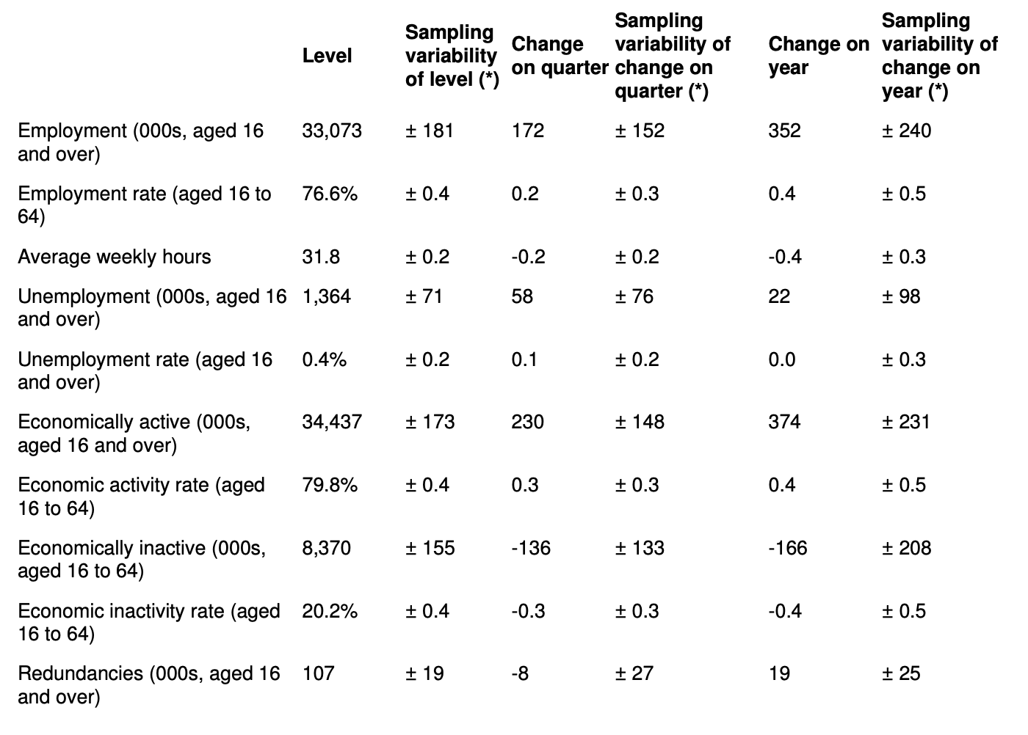
Source: Office for National Statistics - Labour Force Survey, 2020

Appendix II - Generation in the Workplace
Veterans | Born between 1939 and 1947 (Also known as traditionalists)
Baby Boomers | Born between 1948 and 1963
Generation X | Born between 1964 and 1978
Generation Y | Born between 1979 and 1999 (Also known as Millennials)
Generation Z | Born after 2000 (Often grouped with Generation Y)

Veterans:
- Respect for rules and authority (Eisner, 2005)
- Loyal and self-sacrificing (Lowe, Levitt, and Wilson, 2008)
- Tends to ‘do what is right’ (Eisner, 2005)

Baby boom:
- Remains loyal to an organization (Hart, 2006)
- Idealistic, optimistic, and driven (Loomis, 2000)
- Diligent (Yu and Miller, 2003)
- Tends to micro-manage others (Eisner, 2005)
- Advocates change and expansion (Eisner, 2005)

Gen X:
- Is comfortable with change and diversity, but rarely remains loyal to a company (Hart, 2006)
- Independent and self-sufficient (Hart, 2006)
- Search for more challenging work and better pay (Loomis, 2000)
- Sceptical of authority (Hart, 2006)
- Bends the rules to get things done (Eisner, 2005)

Gen Y:
- Tech-Savvy (Lowe, Levitt, and Wilson, 2008)
- Achievement-Oriented
- Attention-Craving
- Self-centred
- Favors inclusive management (Lowe, Levitt, and Wilson, 2008)

Appendix III - Characteristics Elaboration of Transformational Leadership
(Kendrick, 2001)
- Idealised influence is founded on trust. An individual must exhibit high moral and ethical standards. These are the foundations that begin the bond between leaders and followers.
- Inspirational motivation is the ability to help followers see clearly what is the right thing to do. It creates the drive for shared goals and visions. There may be frequent challenges to the status quo and development of clear mind maps of what the future state looks like.
- Intellectual stimulation also challenges the follower to question basic assumptions and to generate a more creative solution to problems. ‘This is the way we've always done it’ is definitely not in the vocabulary. Through the transformational leader's vision, the followers can connect the dots and see the big picture. This releases them from staid conventions.
- Individual consideration treats each follower as a unique contributor and provides coaching, mentoring, feedback and growth opportunities. This is not a cookie-cutter approach or a one-sizefits-all solution. Once given individual attention and allowed to grow, many followers far exceed what was generally recognised as outstanding performance.

. a) Shifting global economic power; b) Demographic shifts; c) Accelerating urbanisation; d) Rise of technology; e) Climate change and resources scarcity
The employee retention depends on the managers’ will, and the assessment criteria are that the manager asks if he/she is willing to try to retain the employee.

