Essay Title:
Write a critique of an experience in a built world. What evidence from this critique can be used to show how this experience transforms actual world phenomenon for the audience/participant?
Student Number: 1404928
BA Course Title: Illustration
Word count: 2,190
Tutor’s name: Scott Smith

Write a critique of an experience in a built world. What evidence from this critique can be used to show how this experience transforms actual world phenomenon for the audience/participant?

Stephen King’s first published novel, Carrie, is a captivating exploration of teenage life. It is characteristically a horror novel about the paranormal, focusing on the human aspect of the characters, especially the character of Carrie White. James Smythe, writing for The Guardian, describes this well:
“Carrie ended up being quite a zeitgeisty novel: published in the same rough timeframe as ‘Rosemary’s Baby’ and ‘The Exorcist’… The public were beginning to fall in love with the weirder, more human side of the paranormal…” (Smythe, 2012)
Although Carrie is often categorised as a horror novel, likely due to the high body count and intense gore, the reader may feel as though the novel is less of a revenge horror and more of a tragedy.
Carrie as a novel explores several instances of actual world phenomenon, due to the tragically human nature of the story. Carrie suffers at the hands of her schoolmates and her own mother. Actual world phenomenon is transformed for the reader in numerous ways throughout this novel, through Stephen King’s writing style and through his characterisation and use of realistic scenarios and character tropes. King makes the reader feel at home in his novel, as if they are a part of the story themselves, instead of simply watching from afar.

Carrie White is a normal teenage girl. She is portrayed as unremarkable in appearance, lonely and ostracised by her schoolmates. She portrays an average teenager that we may relate to, or have met. In the novel, she is described by Stephen King as “a frog among swans” (King, 1974: 4). This novel revolves much around the appearances of the characters, the women especially, as their first appearances are often descriptions of their breast sizes. Carrie feels like the outcast, though she does admit that if she made an effort she could be pretty too. However, it is made clear that this would not save Carrie. “…Carrie’s desperate effort to become like her peers fails… because of the bottomless conservatism and bigotry of high school society.” (Strengell, 2005: 161) The novel begins immediately with Carrie showering in her school changing room, before the other girls realise she’s started her period.
Carrie, directed by Brian De Palma in 1976, opens with a scene of the girls in the changing room. It is filmed in slow motion and the girls are all naked, which emphasises that they are beautifully unafraid of their bodies. Carrie however, is not changing with the other girls and it still standing in the shower alone. This scene is the first time that we see the cruelty Carrie is haunted with. This is the first point in which Stephen King will make a reader feel sympathy for Carrie:
“A tampon suddenly struck her chest… Then the laughter, disgusted, contemptuous, horrified, seemed to rise and bloom into something jagged and ugly, and the girls were bombarding her with tampons and sanitary napkins…” (King, 1974: 7)
The way this scene is described is crude, and the reader may feel disgusted by it. They don’t want Carrie to be hurt because she is described as small and childlike. King establishes this feeling early on in the chapter, and this may evoke emotion in the reader to such an extent that they wish they were part of the novel, so they could end the conflict as though it was reality.

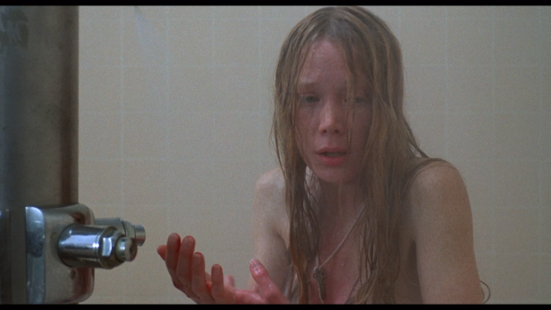

De Palma, B. (1976) [Film still] Carrie in the shower

Paul Gilbert writes about compassion, and explains that:
“…compassion [is viewed] as central to liberating our minds from the power of destructive emotions, such as fear, anger, envy, and vengeance.” (Gilbert, 2005)
In relation to this, it is correct to assume that had Carrie been shown compassion by her schoolmates, she may have been able to rid herself of negative feelings and become the person she wished she could be. Her mother is not compassionate towards her either, which is even more detrimental, as a young teenage girl may feel lost without the help of her mother. She suffers from all of the negative emotions mentioned by Gilbert at one point in the novel and a reader’s reaction to show her the compassion she desperately needs.
Carrie revolves around Carrie’s struggle in coming to terms with herself, dealing with her transition into womanhood, and she remains alone, literally and figuratively, throughout a majority of the novel. King writes Carrie White incredibly well, by portraying her as a relatable character, which in turn would make the reader more affected by later events in the novel. A review written for the New York Times explains, “King does more than tell a story… he gets into Carrie’s mind…” (New York Times, 2018) She is an innocent girl who is driven to her final straw by her classmates who bully her viciously, and by her mother who believes she is the Devil. We see from Carrie’s thoughts that she believes what her mother tells her, which adds to her trauma.
Her mother, Margaret White, is incredibly religious and bordering on insanity. She believes Carrie is dirty, and is abusive towards her. This religious extremism causes Carrie to be shielded from many life experiences, as she is not taught basic life experiences. Maturity is a sign of evil in Margaret’s eyes, as she believes the Devil has taken hold of her daughter. Harold Bloom writes, “Carrie and her mother must destroy each other in order to put an end to this intolerable relationship.” (Bloom 2007: 49) This may add to a reader’s experience as Margaret’s character might remind them of someone they have come in contact with in their day to day lives possibly reminding them of toxic family relationships.
In relation to this, the novel ends in a disaster as Bloom predicts as almost no one survives Carrie’s onslaught, including Margaret. Margaret White is responsible for most of Carrie’s grief in the novel, and is a catalyst for several traumatic events. The novel would never have ended well for Carrie, Margaret would have still killed her due to her own motives and selfishness about her need to have the perfect daughter, despite what may have happened earlier in the novel.
One of Carrie White’s issues are her telekinetic powers. This seems bizarre, as Carrie’s powers are not the main focus of her story and it is treated as another struggle in her daily life. King manages to avoid characterising Carrie as a cliché, by giving her a power that acts as a hindrance rather than a blessing. Characters that fall under this cliché are usually referred to as a Mary Sue - a character that is superior to others and could be considered perfect. They may also possess a power that is beyond their reality. (Sparkpress, 2017)
During the end of the novel, Carrie’s telekinesis becomes a main plot device and she loses her control. If Stephen King had not built Carrie as a victim, and caused the readers to sympathise with her, this scene would have been different for the audience’s experience. At first glance, the novel seems to be about revenge but in many ways the story is about a girl who is bullied into fear and submission. Carrie is not a vengeful character as King writes her as a victim. This is seen when she is eventually driven to revenge, and she is broken down to a point where she feels she must destroy everything, shown in the infamous prom scene.
The overall atmosphere of the prom is one of happiness and growth for Carrie. She is voted to be prom queen, along with prom king Tommy Ross. The reader is led to believe that Carrie will prevail and that the novel will end well. Because the reader has witnessed her past traumatic events, they will want nothing more than for her to be happy. This scene is a turning point for her character in more than one way, as all of her sadness and anger comes out in a tirade and her powers run rampant. Harold Bloom explains that during this scene, “We are shown the childish vindictiveness of the teenage conspirators who have set this scene of defilement up.” (Bloom, 2007: 47) in reference to the teenagers who set up the bucket of pig’s blood above the stage.
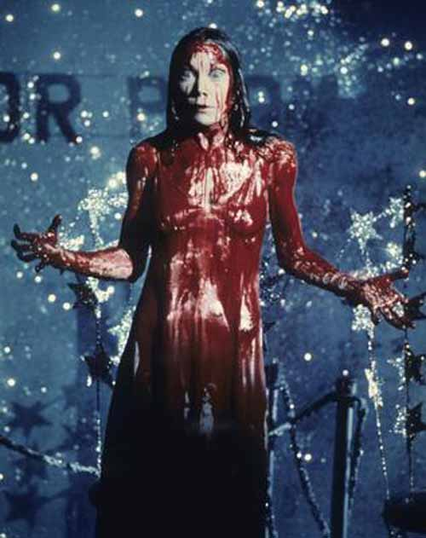

De Palma, B. (1976) [Film still] Carrie at the prom

When Carrie is doused in blood, the scene slows down. The reader will experience everything in great detail and this is mirrored in the 1976 movie adaption of the novel, through director Brian De Palma’s use of split screen effects. The split screen is used to reflect Carrie’s madness and hysteria. This scene masterfully uses close up shots of Carrie’s eyes, with fast paced shots of her head turning as she locks the gymnasium doors. It reflects the novel well, and captures the exact feeling a reader would grasp from Carrie’s lack of control.
Blood symbolism is also important in this scene as blood is typically known as a bad omen, the colour red signifying anger and danger. It is a constant in Carrie’s life – the novel begins with her starting her period, and the novel ends with her drenched in blood. Carrie is angry and dangerous. Her pale face is now covered in streaks of bright red, and her sharp blue eyes pierce look colder. Instead of being portrayed as pathetic she is now something to be afraid of, even for the reader. In contrast to her appearance at the start of the novel and the film, Carrie now stands with her arms spread and her back straight. During the start of the novel, she slouches and lets her hair cover her face. She becomes powerful in the final scenes of the novel, and the split screen effects in the film mirror this. This scene could influence a reader’s experience as it relates to someone gaining confidence in real life and mirrors the experience of many people who find their confidence following a certain event.
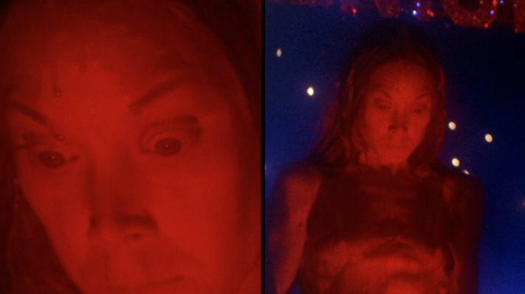

De Palma, B. (1976) [Film still] Split screen – Carrie at the prom

Stephen King’s style of writing adds to the audience experience throughout the novel. Carrie is an epistolary novel. These novels will use articles and letters littered throughout the story, in order to build a more three dimensional plot. (Curran, 2018) We see this throughout the prom scene, as the action is interrupted with articles documenting the tragedy. “A disaster of major proportions has struck the town of Chamberlain, Maine tonight. A fire… at Ewen High School…” (King 1974: 196) This is an experience for the reader, as the use of newspaper clippings and reports from fictional books further detailing Carrie White’s tragic story, place her experience in a three dimensional world. The use of these documents connects to our real world experiences of tragedies, like the reader is watching the news or reading a newspaper.
Stephen King’s writing style impacts the audience experience, as he uses dialogue and text to inform the reader about the intricacies of a scene. He often writes with bracketed dialogue during scenes of great tension, and these act as a way of showing what the characters are feeling and how they are reacting to certain stimuli. These dialogues engage a reader and give them even further insight into the minds of the characters, and how they are engaging with their surroundings. These are very prevalent during the climax of the novel.
“She began to drag herself across the parking lot, going nowhere. (momma i’m sorry it all went wrong o momma o please o please i hurt so bad momma what do i do)” (King, 1974: 219)
These sections are grammatically incorrect, lacking in punctuation and represent a singular train of thought that may be revisited once, or several times during a particular scene. The novel without these dialogues would generally not have the same impact as the reader, although they would still feel somewhat connected to a scene or event, would not get to feel exactly how the characters felt in that moment. This is often something King does within his writing, he allows the reader to be the character and experience everything in a first-hand perspective in order to make the scene more realistic.
To conclude, Stephen King transforms the reader’s view of actual world phenomenon through his writing style, plot devices, and his characterisation. Creating a sympathetic main character causes a reader to feel connected to her, as they relate her to people they may have known in reality, possibly even themselves. The events of the novel are close to real life events and King’s use of articles and interviews add to this element of realism and three dimensionality. Using these literary devices, the reader realises the connection between Carrie White’s story in Chamberlain and their own lives, making connections between characters and people they know, or areas in their neighbourhoods. Stephen King succeeds in creating a highly believable plot that, despite the heavy supernatural elements, still rings true in the real world. Carrie’s troubled home life, and her struggles at school, may mirror a reader’s own experience or educate them. Carrie is incredibly well written and translates well into our reality allowing a reader to experience actual world issues through fiction, and are given a chance to become emotionally invested in a story, through King’s exceptional storytelling abilities.

Bibliography
Bloom, H. (2007) Blooms Modern Critical Views: Stephen King (ed.) United States of America: Infobase Publishing (p. 47, 49)
Carrie, (1976), Brian De Palma [DVD], United States: United Artists.
Curran, L (2018) Letters, letter writing and epistolary novels, Available at: https://www.bl.uk/restoration-18th-century-literature/articles/letters-letter-writing-and-epistolary-novels (Accessed: 19th November 2018)
De Palma, B. (1976) Carrie at the prom, [Film still] Available at: https://www.altfg.com/film/carrie-brian-de-palma/ (Accessed: 19th November 2018)
De Palma, B. (1976) Split Screen – Carrie at the prom, [Film still] Available at: http://www.criticalcommons.org/Members/brettservice/clips/carrie_clip3.mp4/view (Accessed: 19th November 2018)
De Palma, B. (1976), Carrie in the shower, [Film still] Available at: https://diaboliquemagazine.com/getting-carried-away-female-sexuality/ (Accessed: 19th November 2018)
Gilbert, P. (2005) Compassion: Conceptualisations, Research, and use in Psychotherapy (ed.) United States of America, Canada: Routledge
King, S. (1974) Carrie, Great Britain: New English Library
Smythe, J. (2012) Rereading Stephen King: week one – Carrie, Available at: https://www.theguardian.com/books/2012/may/24/rereading-stephen-king-carrie (Accessed: 19th November 2018)
Sparkpress (2017) What is a Mary Sue? Available at: https://gosparkpress.com/what-is-a-mary-sue/ (Accessed: 25th November 2018)
Strengell, H. (2005) Dissecting Stephen King: From the Gothic to Literary Naturalism, United States of America: The University of Wisconsin Press (p.161)
The Editors of Encyclopaedia Britannica (1998) Epistolary Novel, Available at: https://www.britannica.com/art/epistolary-novel (Accessed: 19th November 2018)
The New York Times (2018) Notes From The Book Review Archives, Available at: https://www.nytimes.com/2018/06/01/books/review/stephen-king-carrie.html (Accessed: 19th November 2018)

