School of Hospitality & Tourism Management BA International Hotel Management
Module Handbook Autumn Term 2024
BMIH5007
Financial Management for the Hotel Industry LEVEL 5
Saima Jabeen 2241265
Tutor Tristan Hawkins
18/10/2024

How to Acknowledge your use of AI
This guidance is for students and staff to support the integration of AI tools in assessment.
Every assessment specification identifies the allowable use of AI in that assessment. You should be able to see a version of the following table:
RESEARCH | For this assessment, you can use Generative AI to support you in research, including searching for bibliography, using tools to summarize, compare and interrogate materials. | Yes ☐  No ☐
STRUCTURE | For this assessment, you can use Generative AI to support you in structuring your submission, including creating a draft argument structure, identifying parts and headings, etc. | Yes ☐  No ☐
PROOFREADING | For this assessment, you can use Generative AI to check your own text/creation for grammatical and syntactical mistakes, including rephrasing of your own work within specific standards. | Yes ☐  No ☐
WRITING | For this assessment, you can use Generative AI to create text for submission. | Yes ☐  No ☐
CREATIVE | For this assessment, you can use Generative AI to create creative materials, such as images. | Yes ☐  No ☐
PROGRAMING | For this assessment, you can use Generative AI to create and check code. | Yes ☐  No ☐
NONE | For this assessment, you are not allowed to use any type of Generative AI support. This includes research support, structure support, writing/proofreading support and creative support. | Yes ☐  No ☐

Table of Contents
Introduction 3
Total Revenue Analysis: Shangri-La Hotels and Premier Inn 3
Comparative Analysis of Revenue Strategies 5
Market Position: Shangri-La Hotels and Premier Inn 6
Shangri-La Hotels 6
Premier Inn 7
Growth Potential: Shangri-La Hotels and Premier Inn 8
Financial Commitment to CSR (Corporate Social Responsibility) 9
Shangri-La Hotels 9
Premier Inn 10
Comparative Analysis: Shangri-La Hotels vs. Premier Inn 11
Recommendations and Conclusion 12
References 14

Introduction
Shangri-La Hotels and Premier Inn Hotels are the main players in the global hospitality industry and while each of them has its defined niche in the market. Shangri-La Group is a luxury hotel and travel company based in Asia with hotels and resorts in Europe, Middle East, North America and Asia to fulfill consumers’ desire of luxury travel (Alhemeiri et al., 2023). While, Premier Inn is a U.K. based, economy hotel brand targeting the value-conscious travelers who prefer clean and comfortable accommodations usually in areas that are easy to get. In this report, these two hotel chains will be compared based on the viewpoint of the financial management plans, including the total income, current market status, growth possibility as well as commitment to CSR. Hence, by looking at these observations it is possible to evaluate various business models and financial strategies that operate in the sphere of hospitality.

Total Revenue Analysis: Shangri-La Hotels and Premier Inn

Shangri-La Hotels
Shangri-La Hotels, being a luxurious hotel franchise company, obtains its major revenue from luxurious services including, lodging services, F&B services, and banquet and conference services. According to its annual report for 2023, the Shangri-la group’s total revenues stood at 7.7 billion where the company has identified the significant recovery from prevalent challenges such as the COVID-19 pandemic challenges (Shangri-La, 2023). This is a 47% yearly growth; boosted by the revival of high-end travel and the reintegration of borders in Asia and Middle East especially because they are key markets for Shangri –La. Moreover, Shangri-La Asia Ltd (69: HKG) has even recorded a 52-week high stand at HKD 6.27 this year proving that the company has solid financial wise and has recovered from the market downturn (Financial Times, 2024) (Figure 1).
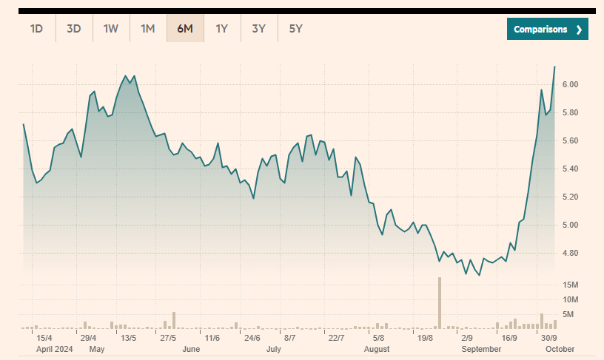
Figure 1 Shangri-La Asia Ltd
Source: (Financial Times, 2024)

Shangri-La’s emphasis on high-value customers drives its revenue strategy, which centers on offering premium experiences that command higher prices. This business approach enables Shangri-La to focus on the premium consumers who will be willing to pay a premium in a luxurious facility. Consequently, the company receives more revenue per guest even if a lot of money is spent on operations. For instance, in 2023, According to Shangri-La the RevPAR had a drastic rise of 69%, this is attributed to the uptake of luxury travel after the effect of the pandemic (Shangri-La, 2023). The latest revenue we have for Shangri-La Hotel PCL is $2.308 billion. It records an average of $1.391 billion of revenues from fiscal years 2019-2023 with a median of $1.201 billion. The highest values in the revenue were registered in December, 2019 being $2.550 million and the lowest one registered in December 202, being $355.9 million. Revenue has been reduced in the fiscal year 2019 nearly 6.9%, in the fiscal year 2020 due to the pandemic 74.0%, improved slightly in the fiscal year 2021 46.3% but has registered a tremendous uptake in 2022 to $1.201 billion and a relatively stable growth in 2023 (Figure 2) (Finbox, 2024).
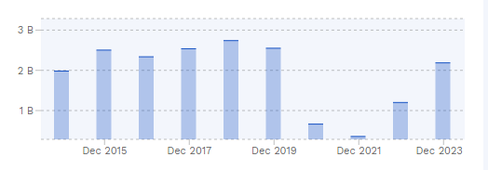
Figure Revenue of Shangri-La for last 5 years. 2
(Finbox, 2024)

Premier Inn
On the other hand, Premier Inn which is under the company known as Whitbread is in the inexpensive kind of hotel services. It earned total revenues of £2.6b within the year ending on 31st December 2022 by mostly gaining from enhanced domestic travel and business environment across the UK (Whitbread.co, 2022). Primarily, Premier Inn has been experiencing steady improvement of the company’s revenue from high demand of hotel rooms at relatively cheap rates. This is in contrast to further augmenting services such as F&B, which Premier Inn avoids so as to keep cash flowing regularly, if guest occupancy rates are constant. This increase is because its RevPAR went up by 8.8% in the same time period which has striven to target price sensitive traveler’s (Whitbread.co, 2023).
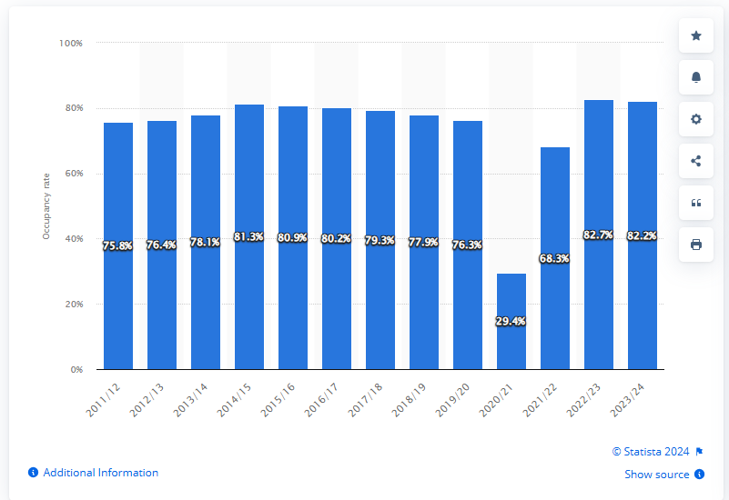
Figure 3 Premier Inn hotel room occupancy rates in the UK and Ireland 2011-2024
Source: (Statista, 2024)
On the other hand, the primary target of Premier Inn is cost-sensitive consumer, and stressing high room turnover and low rates leapfrog over luxurious amenities (Gursoy, Buttle and Bowie, 2022). Therefore, the net operating income model depends on the ability to hit high occupancy rates and does not rely on absolute revenue generators such as F&B. This places Premier Inn to be capable of generating consistent revenue through the year even in the hard economic times of reduced premium travels. Constant costs characteristic of organizations such as Premier Inn are, low when compared with variable costs hence allowing it to better control on its expenses during inflationary periods since most of its focuses on a limited operations compared to other full-service hotels. (Anand, 2023).

Economic Theory: Supply and Demand Analysis
In the given segments, there are some fundamental differences in the supply and demand relationship in the service industry. This is because the services in organizations such as Shangri-La are viewed as an inelastic commodity among the rich hence changes in prices do not affect them much. Shangri-La’s emphasis on high-value customers drives its revenue strategy, which centers on offering premium experiences that command higher prices (Shangri-La, 2023). Other determining periods include global trends in tourism, area and the disposable income of the target rich clientèle. As for those economy franchises, such as Premier Inn, the demand for the commodity is not viable due to the increased price sensitivity of frugal consumers. The least change in price is powerfully followed by a change in the demand. One segment relies on high room turnover, low costs and superior operational efficiency to support revenue in the face of rapidly dropping prices.

Market Position: Shangri-La Hotels and Premier Inn

Shangri-La Hotels
Shangri-La Hotels functions under a renowned worldwide luxury brand, precisely catering to high-net-worth (HNW) customers, corporate managers, and prosperous business and leisure travelers (Tam et al., 2022). The brand is associated with the elegance and richness in terms of business conducted in some of the strategic places in Asia, Middle East, and Europe. Originally from Asia, Shangri-La has sought to take advantage of the fast-growing demand for luxury travel and luxury accommodation, especially China and Southeast Asia (bin Mustaffa, 2021).
Shangri-La has a very positive brand image as leaders in luxury hotel business, with a focus on friendly personalized services, luxurious amenities and services, exclusive and differentiating location differentiated between business and leisure travelers (Huimin, 2024). Promoting culturally-themed products has been useful to the group since it has worked to set the Shangri-La brand as a luxury hotel chain that guarantees cultural interactions.

Factor | Details
Market Segment | Luxury segment in the hospitality industry
Competitors | Ritz-Carlton, Four Seasons, Mandarin Oriental
Geographical Focus | Predominantly Asia, with strong presence in China
Customer Base | Large, loyal customer base
Opportunities | High demand from high-net-worth tourists in Asia
Loyalty Program | Golden Circle program enhances customer retention through incentives
Strengths | Strong brand, loyal customers, and growth potential in Asia
Vulnerabilities | High dependency on the Asian market, susceptible to regional fluctuations
Figure 4 (Wang, Hu and Zhang, 2020).

Premier Inn
Considering the Premier Inn, the strategic location through which Premier Inn conduct its business makes it the biggest low-cost hotel in the UK main market customer’s base cuts across families, business people, tourists, and any one in need of cheap but quality hotel (Setia, Ronald and Amelia, 2021). The strength of the brand is clear, it is positioning itself as a low-cost provider of clean and simple rooms. The company operates within a broad network of business premises. Premier Inn’s marketing activity had assisted to increase customer volumes from 4.2 million in 2018 to 5.9 million in 2022 (Stephenson, 2023) as shown in figure below.
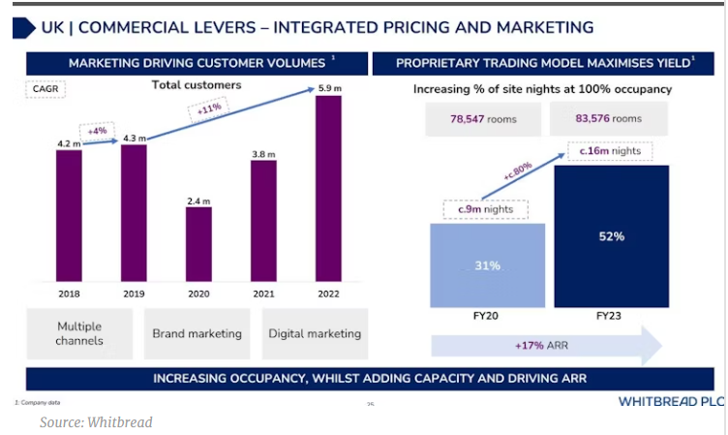
Figure 5 Premier Inn brand Marketing
Source: (Stephenson, 2023)
It is noteworthy that the proportion of market share of Premier Inn in the sector of budget hotels is vast, and the brand has been vigilant in the UK (Bharwani and Mathews, 2021). Essentially, while Premier Inn leads the UK‘s economy hotel segment having 93% brand awareness, these customers are largely brand loyal. Over four in ten hotel customers in the UK are customers of Premier Inn and about a third of these customers are willing to stay in the brand again which supports the notion that Premier Inn is good at keeping customers coming back (Statista, 2022). On the other hand, Shangri-La is aimed at the upper end clients especially the high-end marketers with products that include luxury accommodation. In as much as Premier Inn is established in providing value for money for the lower end market, Shangri-La on the other hand understands its core competency to be the delivery of luxury to upscale consumers.
One of the major strategic accomplishments of the company has been to target local consumers, especially in turbulent economic times when demand for holidays is high, but consumers are constrained by tight budgets. While currently being by far the most popular chain in the United Kingdom, opinions about Premier Inn’s international operation are quite reserved (George, 2021).
Hotel Group | Market Share | Customer Demographics | Brand Perception
Shangri-La Hotels | Significant in Asia | Affluent travelers, business executives | Leader in luxury, known for opulent experiences
Premier Inn | Dominant in UK budget market | Budget-conscious travelers, families, business | Value-for-money, reliable, and affordable
Figure 6 (Page and Connell 2020)

Growth Potential: Shangri-La Hotels and Premier Inn

Shangri-La Hotels
Shangri-La Hotels is a high-end Chinese resort company that depends on attracting the high-end tourists who are interested in experiencing the luxury services (Qian, 2018). Gaining the essence or the taste of off the track the company plans to offer uniqueness to the guests for providing them the memorable stay. According to the data obtained from its annual report, Shangri-La has generated a total of $2.7 billion for the year 2022, with focus on its luxury products and services.
To achieve this, the firm’s growth strategy that needs to be implemented is to pursue the expansion strategy into new luxury locations throughout Asia and the middle East as well as consolidating the markets that the firm has already established. As the firm’s expansion strategy for the next five years, Shangri-La targets to launch 20 new hotels; it will also invest $150 million in renewable energy consistent with sustainability concepts and principles (Zhang, 2020) as shown in figure 4. The business is also likely to gain from a return to luxury travels once COVID is behind us and analytics show an increase in demand by 10-15% every annum (Kataya, 2021).
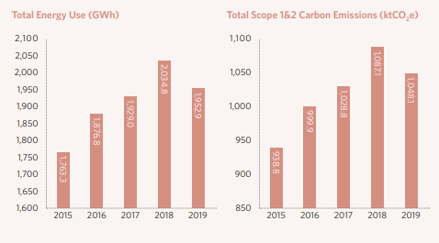
Figure 7 Shangri-La Sustainability
Source: (Sustainability Report, 2019)
Also, sustainability policies at Shangri-La thus conform to consumers’ trends regarding environmentally sensitive tourism hence encouraging environmental conscious clients to visit Shangri-La. Still, there are risks in Shangri-La, including macro-level issues including economic and political instabilities in its core markets since more than 40% of the group’s revenues are generated from the areas (bin Mustaffa, 2021). In the same way, issues of market competitiveness, especially with famous brands such as the Four Seasons is a threat to its expansion prospects in Europe and North America.

Premier Inn
Premier Inn on the other hand competes with the low end or economy market of the hospitality industry serving the common man, families, transient or short-term business travelers. As at the year ended 2022, Premier Inn went on to achieve a brand revenue of £1.9bn from its network of sub £100 hotels (Ahmad, 2024). The target development plan of Premier Inn is to increase its outlets in United Kingdom and to incur in international market like Germany. The upward expansion from 45 to 60 by the end of 2026 dovetails a twin strategy of focusing on the core feeder market and conducting a search for opportunities in bigger European economies (Molla, 2020). This year, Premier Inn has been experiencing a consistent increase of a domestic demand in UK that has made its occupancy rate of impressive 75% in 2023 asserting greater demand in the budget segment it offers (Pandi and Spanaki, 2024). In the same way, the hotel chain’s Word of Mouth (WOM) Exposure score, which asks if customers have talked regarding a brand with friends and family in the past two weeks, grew from 10% in January 2022 to 13% in June 2023 (YouGov, 2023) as shown in figure 5.

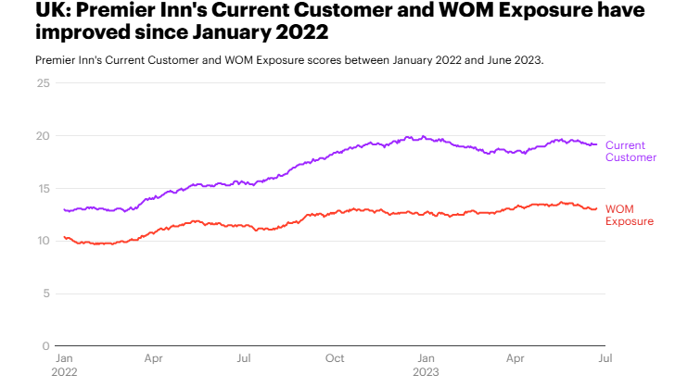
Figure 8UK: Premier Inn's Current Customer and WOM Exposure have improved since January 2022
Source: (yougov, 2023)
That’s why the key advantage of spotlight increasing operational costs, such as energy or staff wages remains one of the significant risks for Price Premier Inn in case of its further growth. Question also arises of competitive threats from other hotel chains either currently or in the future that might threaten the market position of the hotel chain including Travelodge and Ibis (Callwood, 2022).
Lastly, both, Shangri-La Hotels and Premier Inn possess a clear plethora of organic growth opportunities but their operating models are quite distinct. Shangri-La aims at the luxurious and green hospitality operations in the Asia-Pacific, whereas Premier Inn aims to accommodate affordable customers across the UK and the rest of the world. These differences in market positioning underscore the issues of dynamics and constant development as the key Preserving growth under competitive conditions

Financial Commitment to CSR (Corporate Social Responsibility)

Shangri-La Hotels
Shangri-La Hotels has one of the most remarkable corporate social responsibility strategies in its company through the SPE program. Financially, the company has been building stable capital expenditure for environmental conservation and combating climate change as well as advocacy for sustainable business. For instance, the annual report of Shangri-La in year 2020 shows that the company spends 2% of operating profit to environmental issues including efficient energy management technology & water, waste treatment, renewable energy purchasing, and so on. It reports that a large portion of the funding is allocated towards renewables and sustainable food procurement, when the latter means eating food that is sourced locally or from farm to consumers minimizing impacts of food supply chains (Maltese, 2020). As shown in figure 6.

Figure 9 Shangrila Suplier Code of Conduct
Source: (Mark Basaloga, 2016)
Shangri-La also embraces environmental sustainability by supporting the Sanctuary Program whose main goal is to protect species in jeopardy in areas of the company’s operations. According to Zhou et al. (2023) in 2021 the company spend about $10 of million in biodiversity as a way of managing ecosystems so that the impacts that the company has on its environment will be negligible. The application of the GRI guidelines helps to guarantee the high level of report transparency and communicate Shangri-La’s CSR activities (Koseoglu et al., 2021). The GRI framework ensures that the company links CSR strategies with the United Nations Sustainable Development Goals hence benchmarking the company on sustainability and accountability globally (Guix and Font, 2020).

Premier Inn
Unlike most players in the industry who have CSR strategies that integrate charitable donations to the needy and sponsorship of arts and cultural events, Premier Inn as part of the Whitbread Group, endeavors to be energy efficient, reduce carbon emission and support the community through the Force for Good strategy. The company has sought to invest a significant amount of money into improving sustainability mainly in carbon and energy. In its 2022 Annual Report, Whitbread outlined Premier Inn invest £40 million in energy efficient structures, for instance, retrofitting buildings with enhanced LED lights and smart HVAC systems as well as extending the use of renewable energy sources to make the chain less carbon intensive (Jones and Comfort, 2021). Energy storage’s long-term goal is to support the company’s vision to be a net zero carbon company by 2050 hence the investment makes sense in the fight against climate change (Sinha and Fukey, 2020).
As for environment activities, Premier Inn gave much attention to social responsibilities for running the company through the ‘Apprenticeship scheme’ that provides employment opportunity to the youths in the context of the hospitality sector. In the past five years, this program has received £10 million to train young people from disadvantaged backgrounds for employment (Bahl, 2023). It not only solves employment issues but also strives for the betterment of the community strong and highly skilled workforce. Moreover, through its responsible sourcing policy, all of Premier Inn’s hotels have put measures in place on how they can reduce wastage and recycle. It had minimized its use of plastic bag by 35% and in 2020 it made a record of landfill waste sent to landfill was only 2% and overall waste managed sustainably was 98% (Sinha and Fukey, 2020).

Comparative Analysis: Shangri-La Hotels vs. Premier Inn
It can be noted that Shangri-La Hotels and Resorts have a broader corporate mandate toward environmental conservation such as nature conservation and climate change, and food and water sustainability. Hence, these include $10 million spent on biodiversity and 2% of the operating profit funneled to the environment or sustainability (Sinha and Fukey, 2020).
Whereas, in Premier Inn’s supply chain management, more focus has been laid down to energy efficiency & carbon minimization in its operation. In increasing their commitment to the limitation of carbon emissions they have pledged £40 million to renewable energy and energy-saving technologies to reach net zero by 2050 (Ahmad, 2024). Premier Inn especially accompany the concept with short- and long-term initiatives directly linked to its carbon cutback strategy, while Shangri-La falls under the protecting and conserving the environment goals.
The latest example is the Apprenticeship Scheme that involved up to 10 million Pounds dedicated to employing youth, and is a vivid example more of Premier Inn’s commitment to develop the community and included youth into it (Morrison, 2022). This particular programing well reflects the Premier Inn’s Force for Good vision as it is illustrated to be very much committed to enhancing the living standards of people within this emerging communities through employment and other related training.
Comparing the two companies CSR reporting system, it is clear that while Premier Inn does not adhere to the GRI on its reporting system, Shangri-La does. The GRI standards offer a framework of structured and internationally accepted guidance with how to report environmental, social and governance activities more transparent and accountable (Gutterman, 2021). Although Premier Inn has published its CSR activities through the annual reports of Whitbread, applying similar international reporting frameworks such as GRI for reporting will help the company improve report comparability and thus strengthen the stakeholders’ assurance.
CSR Area | Shangri-La Hotels | Premier Inn
Environmental Initiatives | Sustainable food sourcing, energy conservation | Carbon reduction, renewable energy investment
Social Commitment | Local community projects, education programs | Youth employment programs, charity partnerships
Governance | Alignment with GRI and SDGs | Emphasis on transparency by Whitbread Group
Figure 10 CSR activities Source: (Roblek, Milenkovska and Milojica, 2016)

Recommendations and Conclusion
Diversify Revenue Streams
Shangri-La could discover further sources of revenue, such as launching mid-range hotel brands to decrease dependance upon luxury markets, making it less susceptible to financial downturns in premium segments. Premier Inn could upsurge its food and beverage offerings to diversify beyond room revenue (Sadhale, 2023).
Strengthen CSR and Sustainability
The two firms need to improve their sustainability plans. This way, Shangri-La can make more investments in sustainable measures in all of its luxurious facilities while Premier Inn can continue to compress the degree of its operating costs with the help of green solutions (Emmanuel, Hilda and Adenubi, 2024).
Leverage Digitalization
Shangri-La need to improve its digital involvement to appeal and attract tech-savvy high-net-worth travelers, while Premier Inn need to continue leveraging technology to streamline booking procedures and improve customer experiences at a lower operational cost (Ning, 2021).
In conclusion, it is revealed that Shangri-La Hotels has built up a quite different financial management system to Premier Inn according to their different market segment. Shangri-La is concentrated on the luxury segment and has a clear and aggressive expansion strategy in Asia and the Middle East markets which are seen to experience high growth over the coming years. The internalization of CSR appears in both companies’ focus on customer satisfaction and technology, but the amounts dedicated to this sector are various since the priority depends on the nature of operations. Shangri-La is more sensitive to regional changes due to its luxury segment while Premier Inn is ready to continue its growth in the budget segment with the help of digitalization and cost control.

References
Anand, N., (2023). The" New Normal" in Hotels: Study on Challenges and opportunities in post covid world.
Bahl, A... (2023). . Making Sense of Social Involvement with Disadvantaged Apprentices: Narrative Patterns of Actors in a Profit-Oriented Company. Morality as Organizational Practice: Negotiating, Performing, and Navigating Moral Standards in Contexts of Work. p.105.
Bharwani, S. and Mathews, D... (2021). Techno-business strategies for enhancing guest experience in luxury hotels: a managerial perspective. Worldwide Hospitality and Tourism Themes. 13(2), pp.168-185.
bin Mustaffa, A... (2021). . SOUTHEAST ASIA-CHINA TRADE AND ECONOMIC RELATIONS: IMPACT ON PROSPERITY AND SECURITY. The Journal of Defence and Security, 15(2), pp.11-I.
Callwood, R.,. (2022). Tourism Marketing Strategies to Sustain Small Resorts in the British Virgin Islands. Walden University.
Chen, X.,. (2022). Location Strategies of Multinational Hotel Groups in China: An Application of Game Theory (Doctoral dissertation, University of Plymouth).
Chon, K. and Schuckert, M. (2020). Hospitality in Asia: The Dawn of a New Paradigm. In The Routledge Companion to International Hospitality Management Routledge. (pp. 133-141).
Financial Times . (2024). Shangri-La Asia Ltd, 69:HKG summary - FT.com. Markets.ft.com. https://markets.ft.com/data/equities/tearsheet/summary?s=69:HKG
George, R.,. (2021a). Tourism and Hospitality Marketing Principles. In Marketing Tourism and Hospitality: Concepts and Cases Cham: Springer International Publishing. (pp. 3-31).
George, R.,. (2021b). Tourism and Hospitality Marketing Principles. In Marketing Tourism and Hospitality: Concepts and Cases Cham: Springer International Publishing. (pp. 3-31).
Guix, M. and Font, X.,. (2020). The Materiality Balanced Scorecard: A framework for stakeholder-led integration of sustainable hospitality management and reporting. International Journal of Hospitality Management,. 91, p.102634.
Huimin, C.,. (2024). Research on the Application of Customer Value Theory in Luxury Hotel Customer Relationship Management: A Case Study of JW Marriott Hotel Shenzhen, China. Tourism Management and Technology Economy,. 7(2), pp.41-50.
Jones, P. and Comfort, D.,. (2021). Modern slavery statements and leading UK hotel companies. Athens Journal of Tourism,. 8(3), pp.147-162.
Kataya, A.,. (2021). . Current Trends and Issues of Luxury Tourism. Empirical Research on Supply and Demand Effects of Covid-19 Pandemic. Annals of the University Dunarea de Jos of Galati: Fascicle: I, Economics & Applied Informatics,. 27(2).
Kulakhmetova, G., Aktymbayeva, A., Assipova, Z., Baoleer, B. and Koshkimbayeva, U. (2022). . Current Problems In The Tourism And Hotel Industry Taking The World’s Tourist Cities As An Example. GeoJournal of Tourism and Geosites,. 43(3), pp.841-849.
Maltese, D.,. (2020). . Ecotourism development in Shangri-La, Yunnan province, China: the case of Tiger Leaping Gorge (Master’s thesis, Norwegian University of Life Sciences, Ås).
Pandi, S. and Spanaki, M.Z.,. (2024). . The influence of Social Media Platforms on Casual Dining Restaurants in the Thessaloniki Region: The Management Perspectives.
Setia, L.C., Ronald, R. and Amelia, A.,. (2021). . Analysis of the Effect of Service Quality Dimensions on Customer Loyalty through Perceived Value, Image, Consumption Emotion and Customer Satisfaction on Shangri-La Hotel Customers in Surabaya. Jurnal Nusantara Aplikasi Manajemen Bisnis,. 6(2), pp.307-320.
Shangri-la. (2023). Shangri-La Group. Www.shangri-La.com. https://www.shangri-la.com/group/media/media_post?post=Shangri-La%20Group%20Releases%202023%20Full%20Year%20Results
Sinha, M. and Fukey, L.N.,. (2020). Circular Economy: Assessing a Progress of Resources Efficient Practices in Hotel Industry. In Circular Economy for the Management of Operations CRC Press. (pp. 89-117).
Spanaki, M.Z.,. (2024). Management of new procedures’ implementations risks in the hotel industry: A case study from Crete, Greece.
Statista. (2024). Premier Inn hotel occupancy rates 2011-2020. Statista. https://www.statista.com/statistics/739831/premier-inn-hotel-occupancy-rates/
Stephenson, J. (2023, April 25). Premier Inn owner hails brand marketing a “powerful tool.” Marketing Week. https://www.marketingweek.com/premier-inn-marketing-powerful-tool/
Tam, S.S., Fong, L.H.N. and Law, R.,. (2022). Management response to online review: The case of Hong Kong luxury hotels. In Information and Communication Technologies in Tourism 2022: Proceedings of the ENTER 2022 eTourism Conference, January 11–14, 2022 Springer International Publishing. (pp. 123-133).
Ternes, B.,. (2020). Exploiting Shangri-La: Assessing the Tibetan Plateau’s Natural Resources and the Work of Karl Wittfogel. Rev. Eur. Stud.,. 12, p.1.
Whitbread.co. (2023). Q1 FY24 Trading Update. https://cdn.whitbread.co.uk/media/2023/06/RNS-Q1-FY24-FINAL.pdf
whitbread.co. (2022). PREMIER INN Annual Report and Accounts 2021/22. https://cdn.whitbread.co.uk/media/2022/05/Whitbread_AR21-1.pdf
Zhang, J.,. (2020). Tourism and environmental subjectivities in the Anthropocene: observations from Niru Village, Southwest China. In Anthropocene Ecologies . Routledge. (pp. 67-81).
Alhemeiri, N., Ali, N., Alawlaqi, M., Almarzooqi, Y., Alshowab, A. and Nobanee, H.,. (2023). Financial analysis of Shangri-La Hotel.
Chathoth, P., Altinay, L. and Okumus, F.,. (2020). . Strategic Management for Hospitality and Tourism. Strategic Management in the International Hospitality and Tourism Industry; Routledge: London, UK,. 18, pp.33-52.
Emmanuel, A.U., Hilda, O.O. and Adenubi, A.,. (2024). The Application of Eco-Aesthetic Principles into the Design Proposal of Hotels.
Gursoy, D., Buttle, F. and Bowie, D.,. (2022). Hospitality marketing: Principles and practices. Routledge.
Ning, Y.,. (2021). December. Research on the Development Path of Wuhan International Brand Hotel Based on the Interpretive Structure Model Method. In Proceedings of the 2021 4th International Conference on E-Business, Information Management and Computer Science. (pp. 435-443).
Page, S.J. and Connell, J.,. (2020). . Tourism accommodation and hospitality services. In Tourism Routledge. (pp. 216-241).
Roblek, V., Milenkovska, V. and Milojica, V.,. (2016). The impact of corporate sustainability in achieving business goals in hotel industry. In Faculty of Tourism and Hospitality Management in Opatija. Biennial International Congress. Tourism & Hospitality Industry (p. 388). University of Rijeka, Faculty of Tourism & Hospitality Management.
Sadhale, M.V. (2023). . A study of customer engagement as a business strategy with reference to five star hotels in pune city (Doctoral dissertation, Tilak Maharashtra Vidyapeeth).
Sinha, M. and Fukey, L.N.,. (2020). Circular Economy: Assessing a Progress of Resources Efficient Practices in Hotel Industry. In Circular Economy for the Management of Operations CRC Press. (pp. 89-117).
Statista. (2022). Premier Inn Brand Profile UK 2022. Statista. https://www.statista.com/forecasts/1335699/premier-inn-hotels-brand-profile-in-the-uk
Wang, C., Hu, R. and Zhang, T.C.,. (2020). Corporate social responsibility in international hotel chains and its effects on local employees: Scale development and empirical testing in China. International Journal of Hospitality Management,. 90, p.102598.
Ahmad, A.A.,. (2024). Corporate Governance and Its Determinants: A Study on Shangri-La Hotel (Malaysia) Berhad. Available at SSRN 4694743.
Gutterman, A.,. (2021). . Sustainability Reporting Frameworks. Sustainability Reporting Frameworks and Instruments,. pp.1-15.
Koseoglu, M.A., Uyar, A., Kilic, M., Kuzey, C. and Karaman, A.S. (2021). Exploring the connections among CSR performance, reporting, and external assurance: Evidence from the hospitality and tourism industry. International Journal of Hospitality Management,. 94, p.102819.
Mark Basaloga. (2016, November 20). Corporate Social Responsibility in Shangri La Hotels&Resorts. YouTube. https://www.youtube.com/watch?v=et8-VjWUjQE
Molla, N.,. (2020). Benefits of tourism to regional airports and businesses: Case Tampere City and Tampere-Pirkkala Airport.
Morrison,. (2022). Hospitality and travel marketing. Routledge.
Qian, J.,. (2018). . Use of language strategies for hotel website evaluation in China.
Sinha, M. and Fukey, L.N. (2020). . Circular Economy: Assessing a Progress of Resources Efficient Practices in Hotel Industry. In Circular Economy for the Management of Operations CRC Press. (pp. 89-117).
Zhou, Z., Cheng, F., Wang, J. and Yi, B. (2023). . A Study on the Impact of Roads on Grassland Degradation in Shangri-La City. Sustainability,. 15(10), p.7747.
Finbox, 2024, Revenue for Shangri La Hotel PCL, https://finbox.com/SET:SHANG/explorer/total_rev/#:~:text=Shangri%20La%20Hotel%20PCL's%20operated,December%202021%20of%20355.9%20million., [Accessed on 11-October-2024]
Annual_Report_. (2023). https://sitecore-cd.shangri-la.com/-/media/Project/Shangri-La-Group/Investor/Files/Public-Disclosures/Latest-Top-Publications/2023_Annual_Report_E.pdf.
Whitbread PLC Annual Report and Accounts. (2024). Building Building advantage on our. https://cdn.whitbread.co.uk/media/2024/05/Whitbread-PLC-Annual-Report-and-Accounts-2023_Single_pages-1.pdf

Appendix: 1 Finnacial Sttament for Premier Inn (Whitbread PLC Annual Report and Accounts, 2023)
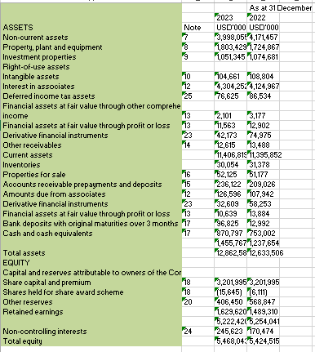
Whitbread 2023
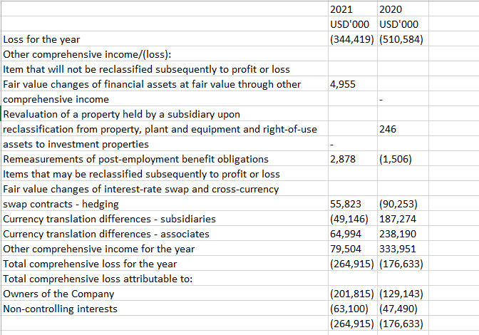

Appendix 2: Financial Statements of Premier Inn and Shangri-La for 2020
Shangri-La
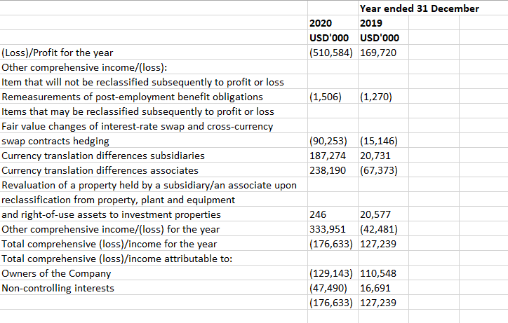
Whitbread 2020
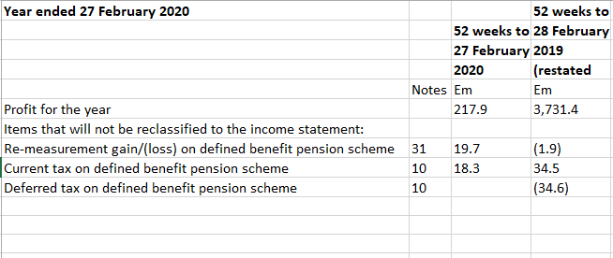

Appendix 3: Financial Statements of Premier Inn and Shangri-La for 2019
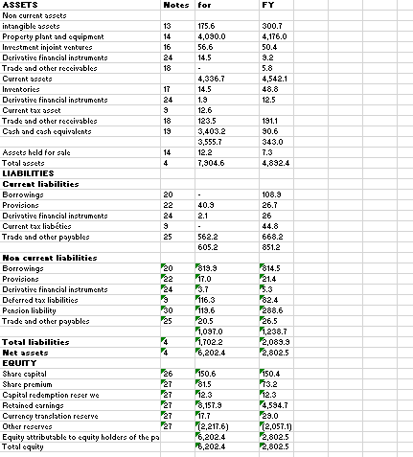
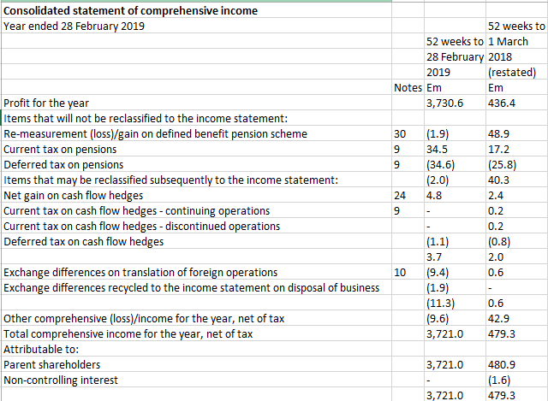

Shangri-La’s income statement for the year 2019
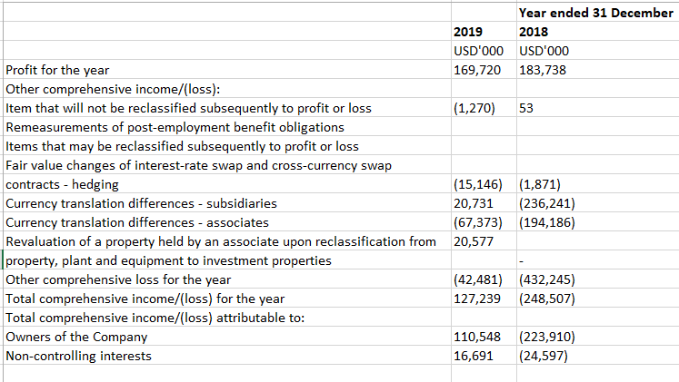

Appendix 4: Financial Statements of Premier Inn and Shangri-La for 2021
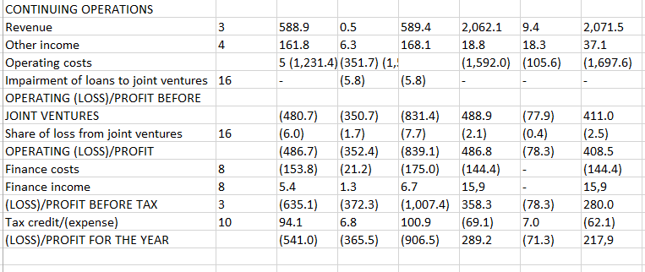
Shangrila 2021


