Skills DEVElopment in the workplace
Introduction:
Welcome to my own Reflection Journal on Skills Development in the Workplace! I'm starting an amazing journey of personal and professional development as a student in this course. This notebook will serve as a record of my experiences as I negotiate the complexities of developing critical workplace competencies.
I'm enthusiastic to gain a variety of skills via this course that will help me in my job. The ability to clearly communicate ideas and interact with coworkers and clients will be a key focus of mine, both verbally and in writing. I look forward to developing the skills of cooperation and teamwork, appreciating the importance of many viewpoints, and using the talents of others to accomplish common objectives.
I'll be focusing on developing my critical thinking and problem-solving abilities. I'm excited to learn how to tackle difficult problems, conduct in-depth analysis of circumstances, and come to wise judgements. This training will also teach me about successful leadership, developing my capacity to uplift and encourage others towards group achievement.
Additionally, keeping a journal will encourage introspection. I'll have a better grasp of my advantages, weaknesses, and special skills that I bring to the office. I intend to find areas for improvement, accept criticism, and consistently improve my professional development journey by regularly reflecting.
I'm eager to develop talents that go beyond the workplace as I start this learning journey. I'm keen to improve my capacity for change-handling, resilience, and flexibility. I will flourish in my current position and be better equipped for challenges and opportunities in the future if I cultivate these qualities.
Join me as I reflect on my experiences, learnings, and development during the Skills Development in the Workplace course. Let's realize our full potential and pave the way to success together.

UNIT 1 - How Innovation Changes the World

I've always been interested by innovation. It never fails to astound me how far humans are willing to go in order to push the envelope and find innovative solutions to problems that already exist. I have personally experienced how innovation has radically altered the world, changed many facets of our lives, and shaped the future throughout my life.
The subject of communication is one area where I have witnessed the enormous effects of innovation. Landline phones were the main form of communication when I was a child. Long-distance calls were pricey and only used on exceptional occasions, and I can still clearly recall having to wait patiently in queue to use the phone. However, the introduction of mobile phones and the ensuing technological advances have made communication rapid and available to practically everyone. Today, we have instantaneous access to people from all over the world, and information is freely shared, empowering people and promoting global connectivity. (Zagorsky, 2019)
Healthcare provides yet another outstanding illustration of how innovation has the capacity to revolutionize an industry. The way we identify, treat, and prevent diseases has undergone a radical change because to medical developments. I can remember a period when medical procedures were intrusive and fraught with danger. However, patient outcomes have dramatically improved as a result of the introduction of minimally invasive procedures and robotic-assisted surgeries (Unknown, UCL, 2022). Additionally, the development of telemedicine and wearable technology has improved access to healthcare services, especially for people living in remote places. In addition to extending and improving lives, innovation has also improved healthcare by emphasizing the needs of all patients.
Our interactions with our surroundings have changed as a result of innovation. Scientists and engineers have been working on sustainable solutions as a result of worries about climate change and the depletion of natural resources. Our reliance on fossil fuels has decreased as a result of the widespread use of renewable energy technology like solar panels and wind turbines. An increasingly popular alternative to conventional cars that is cleaner and more environmentally friendly are electric vehicles. These solutions show how innovation can help solve global problems and reflect our shared commitment to a more sustainable future (Unknown, European Environment Agency, 2016).
After considering these developments, I see that innovation is not limited to the fields of science and technology. It includes a way of thinking and the readiness to question convention and consider novel ideas. It calls for imagination, tenacity, and the readiness to fail forward. Innovation serves as a catalyst for development, allowing us to solve complicated issues, enhance lives, and make the world a better place for coming generations.
I experience enthusiasm and optimism as I consider the future. There are still fresh ideas emerging, and innovation is continuing at a rapid pace. The important thing is that we approach innovation responsibly and ethically. We must be aware of the potential effects of new technologies and solutions on society as we adopt them, ensuring that everyone may benefit and that no one is left behind.
In conclusion, innovation has undeniably made significant changes to the globe. Its impact is visible throughout many industries, from improving communication and healthcare to tackling environmental issues. Personally, seeing these developments has motivated me to adopt an innovative mindset, to continually inquire and research, and to make a positive difference in the world in my own unique way. Innovation is the key to creating a better future, and I am thrilled to take part in this continual process of advancement and exploration.

UNIT 2 - Samuel L. Jackson: A Change Maker's Influence on My Life

Introduction: I will discuss Samuel L. Jackson's enormous influence on my life in this reflective journal. He is a change-maker and a powerful person. Samuel L. Jackson has affected and changed my perspective in many ways through his motivational journey, dedication to social concerns, and love for his profession. This reflection blog tries to document the life lessons I've learned, my personal development, and how Samuel L. Jackson's work has influenced me.
I consider Samuel L. Jackson's profound impact on my life today. He has motivated me via his extraordinary talent, unwavering determination, and passion to having a positive impact on the world as an actor, activist, and philanthropist.
I have learned the value of tenacity and the pursuit of one's goals from Samuel L. Jackson's path as a change maker (Unknown, n.d.). His tale of overcoming obstacles and persevering in the face of difficulty has given me hope for my own potential. I am inspired to pursue my passions with all of my heart and to seize any chance that comes my way after seeing his great success and the difference he has made in the entertainment business.
Samuel L. Jackson's dedication to philanthropy and social problems has also struck a deep chord with me. I've learned the value of utilizing one's influence to uplift and empower others from his involvement in a variety of humanitarian causes, notably in the areas of education and children's welfare. His charitable endeavors have motivated me to look for ways that I may improve society, no matter how modest or significant my contribution could be.
Samuel L. Jackson's support of diversity and inclusion has had a significant influence on my worldview and social interactions. He has emphasized the value of accepting and enjoying our differences via his words and deeds. His writings have inspired me to be more accepting, understanding, and compassionate of people from different backgrounds. Samuel L. Jackson's dedication to equality and representation served as my inspiration. I now make an effort to foster inclusive environments and confront preconceptions in my contacts with others.
Samuel L. Jackson's commitment to his profession has also taught me the importance of perseverance, self-discipline, and hard work. He has inspired me to strive for perfection in all of my endeavors because of his dedication to developing his acting abilities and giving outstanding performances. Success, I've discovered, requires tenacious effort, a hunger for information, and a willingness to push myself beyond of my comfort zone.
To sum up, Samuel L. Jackson's path as a change agent has had a significant impact on and inspired me in many areas of my life. His fortitude, philanthropy, support of diversity, and commitment to his profession have permanently altered my outlook. His example serves as a reminder to me of the value of following my passions, making a positive impact on the world, accepting diversity, and pursuing ongoing improvement. My own journey will continue to be influenced by and inspired by Samuel L. Jackson as I try to make a difference and bring about real change in the world.

Participation:
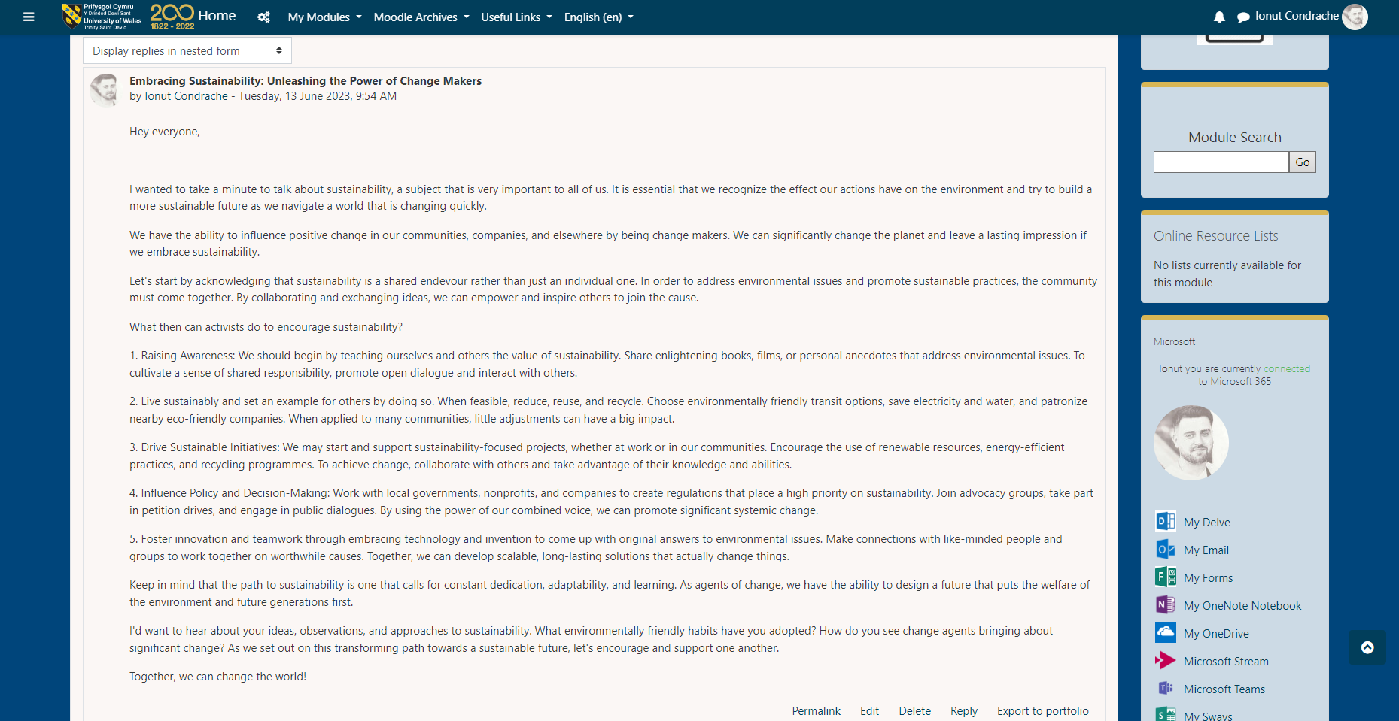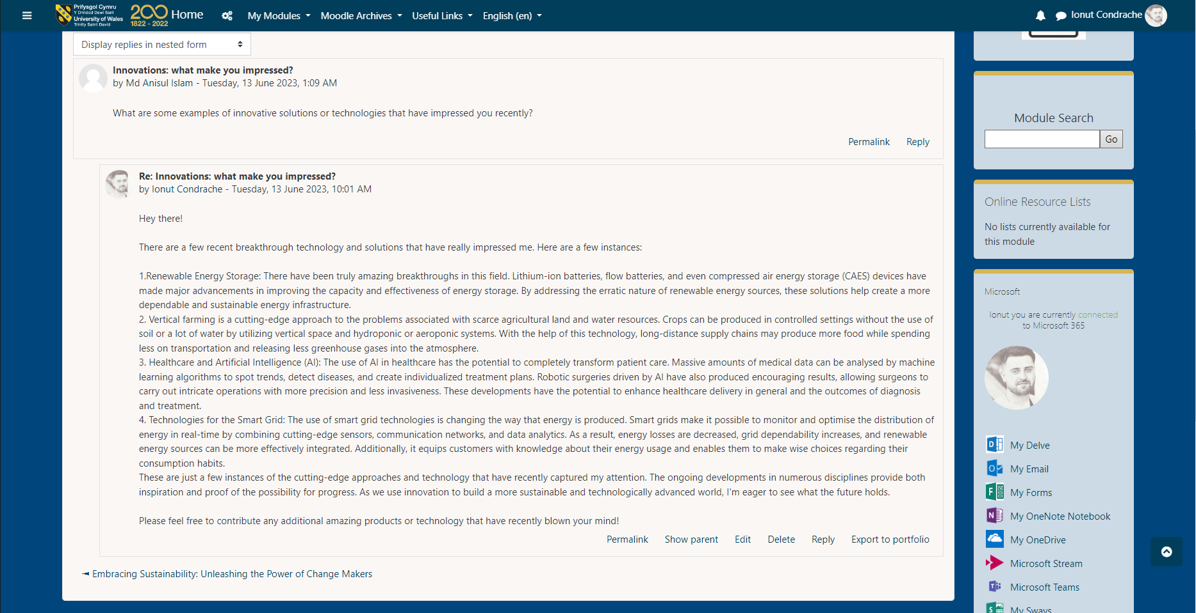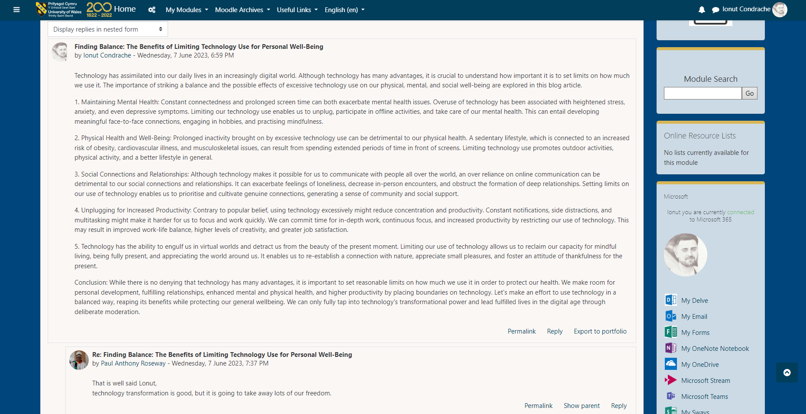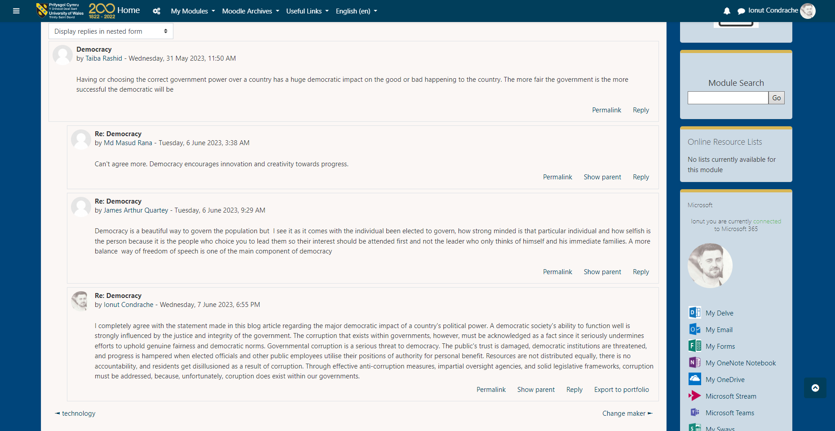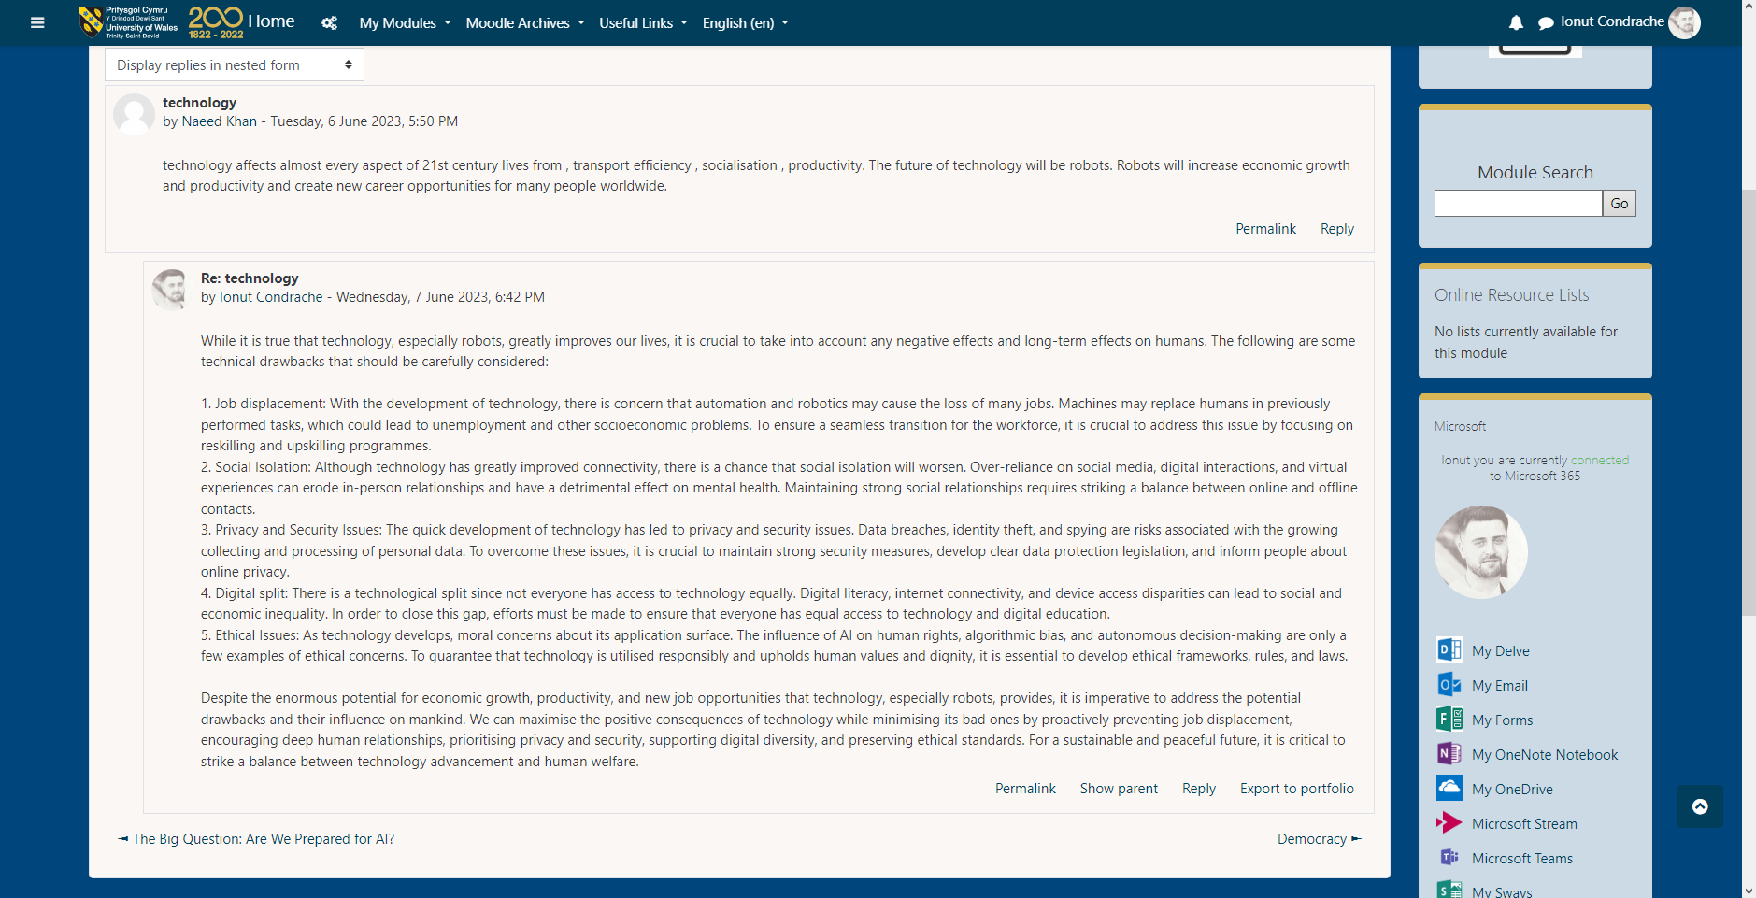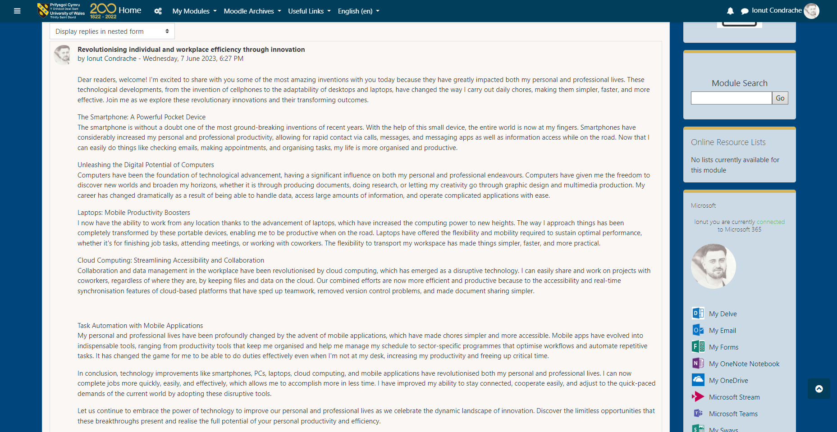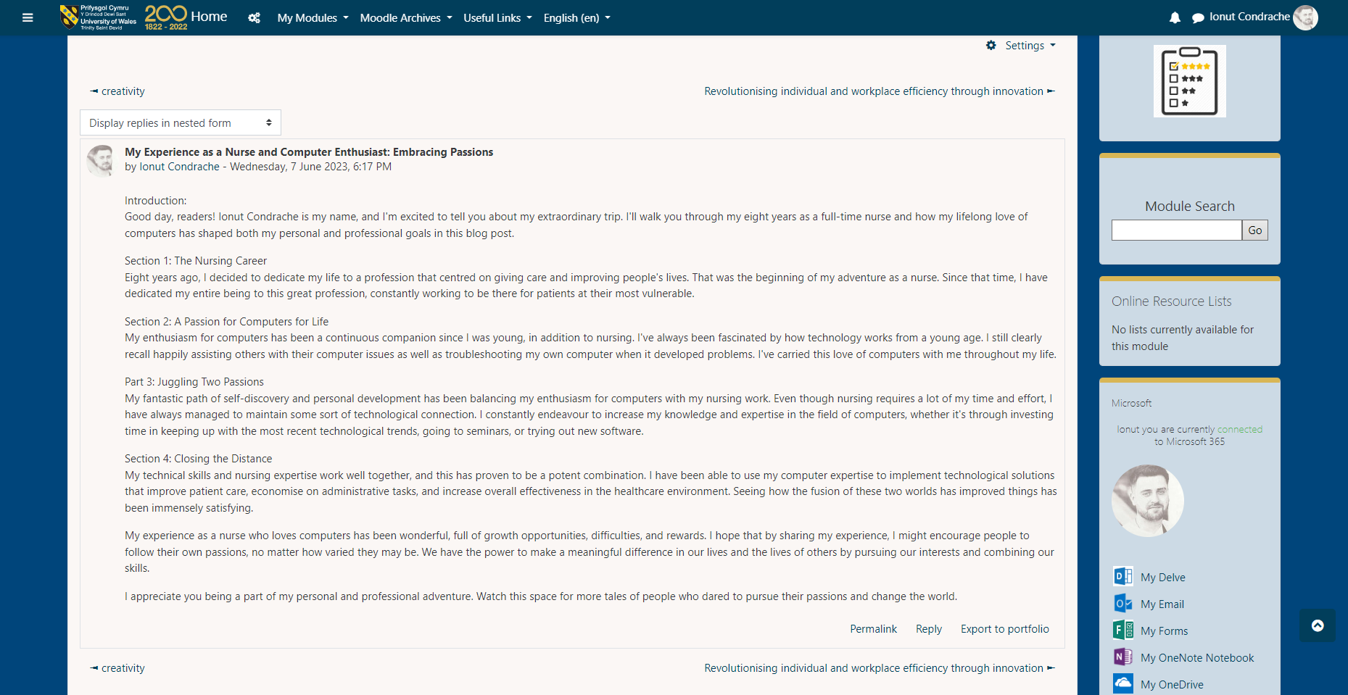

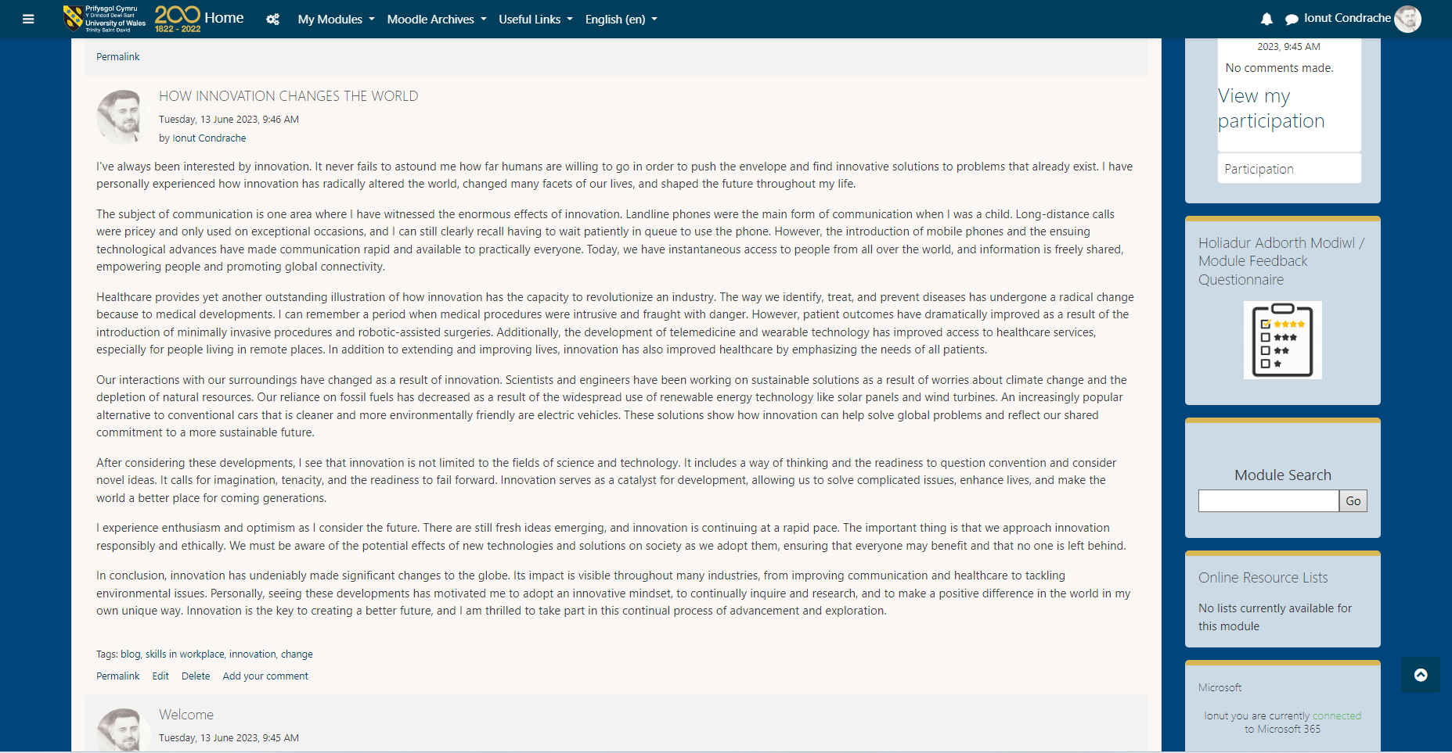

References:
https://theconversation.com/rise-and-fall-of-the-landline-143-years-of-telephones-becoming-more-accessible-and-smart-113295
https://www.ucl.ac.uk/news/2022/may/robotic-surgery-safer-and-improves-patient-recovery-time
https://www.eea.europa.eu/highlights/renewables-increasingly-curbing-reliance-on
https://www.looktothestars.org/celebrity/samuel-l-jackson

UNIT 3 -

UNIT 4 -

