  Component One: Student journal | Student No: | Jean Bankamina 2118397
 | Module Title: | Operating Hotel Facilities
 | Module Code: | BMIH4006
 | Lecturer: | Laurence Blake
Hotel operations are various and complex ( Hollander, 2022). From room booking , check in/ check out guest, to meeting the guest need so many activities have to be done by different staff from various departments of the hotel. A major part of the success of hotel depends on housekeeping department. The housekeeping team operate the general maintenance of the hotel. They work to bring comfort and cosiness of guestroom. Because the room seems to be the main place where guests live during their stay in the hotel. So the environment must be clean, safe and well maintained. For example Hilton establishes “Hilton CleanStay”, the purpose is to upgrade the cleaning process to the ultimate. As for Premier Inn, their cleaning method is “Clean Protect”. That method call for high hygiene standards which is developed in collaboration with Diversey, which is a company producing cleaning and hygiene products for the healthcare and hospitality industries (Premier Inn).” In order to maintain a high standards in cleanliness. Premier Inn recruits 9,000 housekeeping members to handle the daily operations in their various hotels, the reason is to make the hotel premises safe and clean.
Furthermore hoteliers look for qualified housekeeping staff with key skills such as time managing skill, attention to detail, organizational skill ( Hollander, 2022). In one hand time managing skill is essential in room cleaning, indeed housekeeping employees have to handle room depending on check in and check of guests. When previous guest left the room must be properly cleaned before a new one comes in. The new guest must not stay long waiting for the room. In the other hand it is compulsory for housekeeping staff to know how to clean, dust and polish, those elements are considered as hard skills. Every member of the team well qualified will be able to deliver a great quality of service (Castro-Casal, Vila-Vázquez, and Pardo-Gayoso, 2019). It is necessary for housekeeping staff to develop a sense of service, be capable of understanding the guest needs. It is important to point out that hospitality is part of service sector(Castro-Casal, Vila-Vázquez, and Pardo-Gayoso, 2019). What is the difference between hospitality and service? According to De Tarso (2022)“ the difference between service and hospitality : service is how you get the product from a to b hospitality is how you make a human being feel”. Indeed hotel staffing and service levels are the top concern of hoteliers. How to recruit the qualified team who can deliver the best services to their guests, as far as all departments are concerned especially housekeeping department. For example Hilton adapts a flexible housekeeping policy, this means the activities of the housekeeping team are planned according to guests request. Hilton strategy is to prove to guest their capacity to adjust their daily operations. How can housekeeping team perform excellently in order to wow the guests. Nowadays customer request personalised experiences.
In the other hand an unclean and untidy room can affect hotel reputation and revenue (Patrick, 2022), indeed guests appreciate lodging in clean space. So to retain guests housekeeping staff have to maintain a sound and fresh environment. Their daily tasks are focused on overall upkeep of the hotel by providing clean living spaces. Therefore to achieve their daily goals housekeeping staff need to be dynamic in planning their tasks. Indeed rooms must be clean before guest arrival. Also for a well-run hotel, communication is a key element to enhance teamwork and to interact with the guests in a great way that will attract more customers. When employees communicate effectively there is less misunderstanding , mistakes and conflicts. Therefore unqualified staff can damage hotel reputation, so it is important to keep the training the staff and build their commitment to the brand. The importance of the training is to avoid housekeeping issues such as unprofessional behaviour, poor work performance which can impact the hotel revenue. The main goal of hoteliers is the satisfaction of guests so they can be loyal to the hotel brand. The hospitality industry being extremely competitive, guest loyalty is needed for the growth of the hotel.

Word Count | 680

Component Two: Scenario
Problem | Why did it happen? | What are you going to do? | How will you prevent this from happening in the future? | What measures would you introduce to improve team effectiveness?
Complaint of a guest : an unclean room at arrival | The room attendant did not clean the guest room properly | Apologise, transfer the guest to a better room  Then call for an urgent meeting with the housekeeping team of the floor | Check the room before guest arrival | Train the team
Dust in the room | The room attendant have a lot of room to clean | Act promptly to handle the complaint | Schedule the cleaning process | Make the cleaning standards of the hotel be known
Dirtiness in the bathroom | Hair in the bathroom | Address the issues with the team of the floor | Put instruction on how the room should be cleaned | Constantly remind the process of the cleaning of the room
Dirty linen | Stain on the linen | Planning and organising the team | Develop a partnership with a cleaning company like Diversey | Enforce a high quality customer service by promoting high standards of hygiene and safety.
Disorganised room | The room is not tidy | Appoint a mentor for verification before check in | Fix a daily routine of preparing the room before guest arrival | Create the policy of a cosy environment

Component Three: Presentation



Training Notes: Today is a wonderful meeting day for us to meet collaborate in other to bring out our best. We have few days for training to enlighten our day to day operations. We will work on how to deliver a top clean guest room.
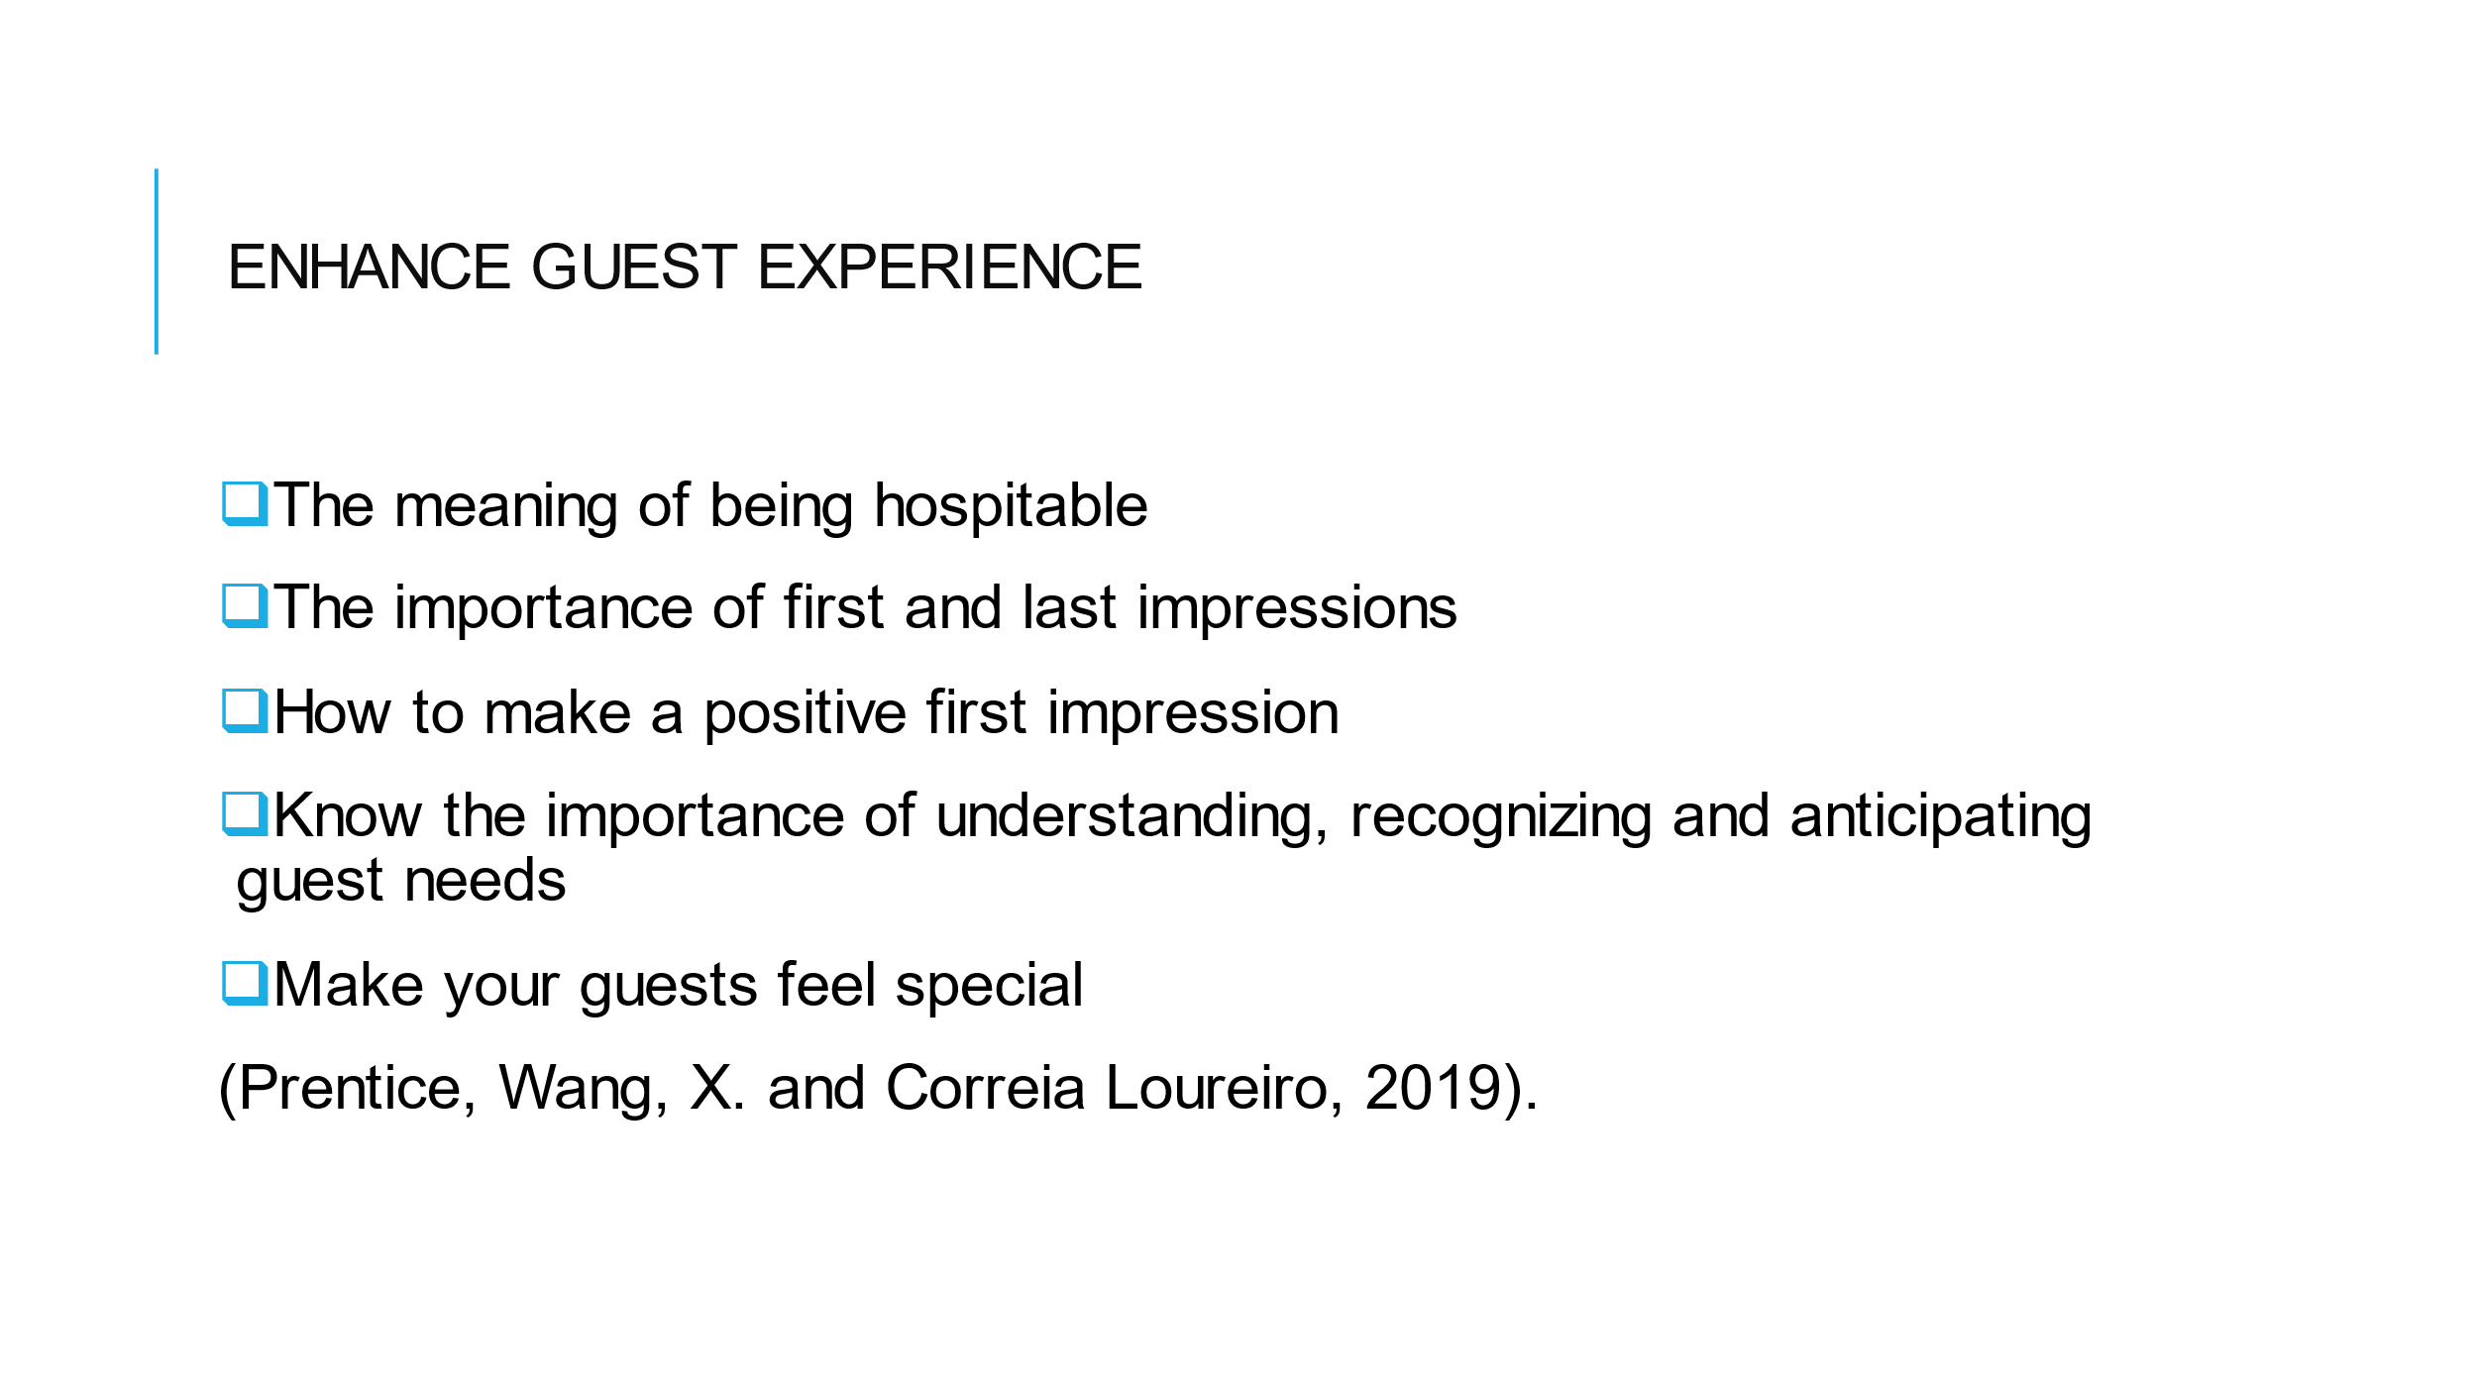

Training Notes: we are working in the sector of service which is hospitality. We are in a very competitive field, so to attract and retain customers we have to enhance guest experience. Guest experience relate to the importance of first and last impressions. Our mission is to wow our guests.
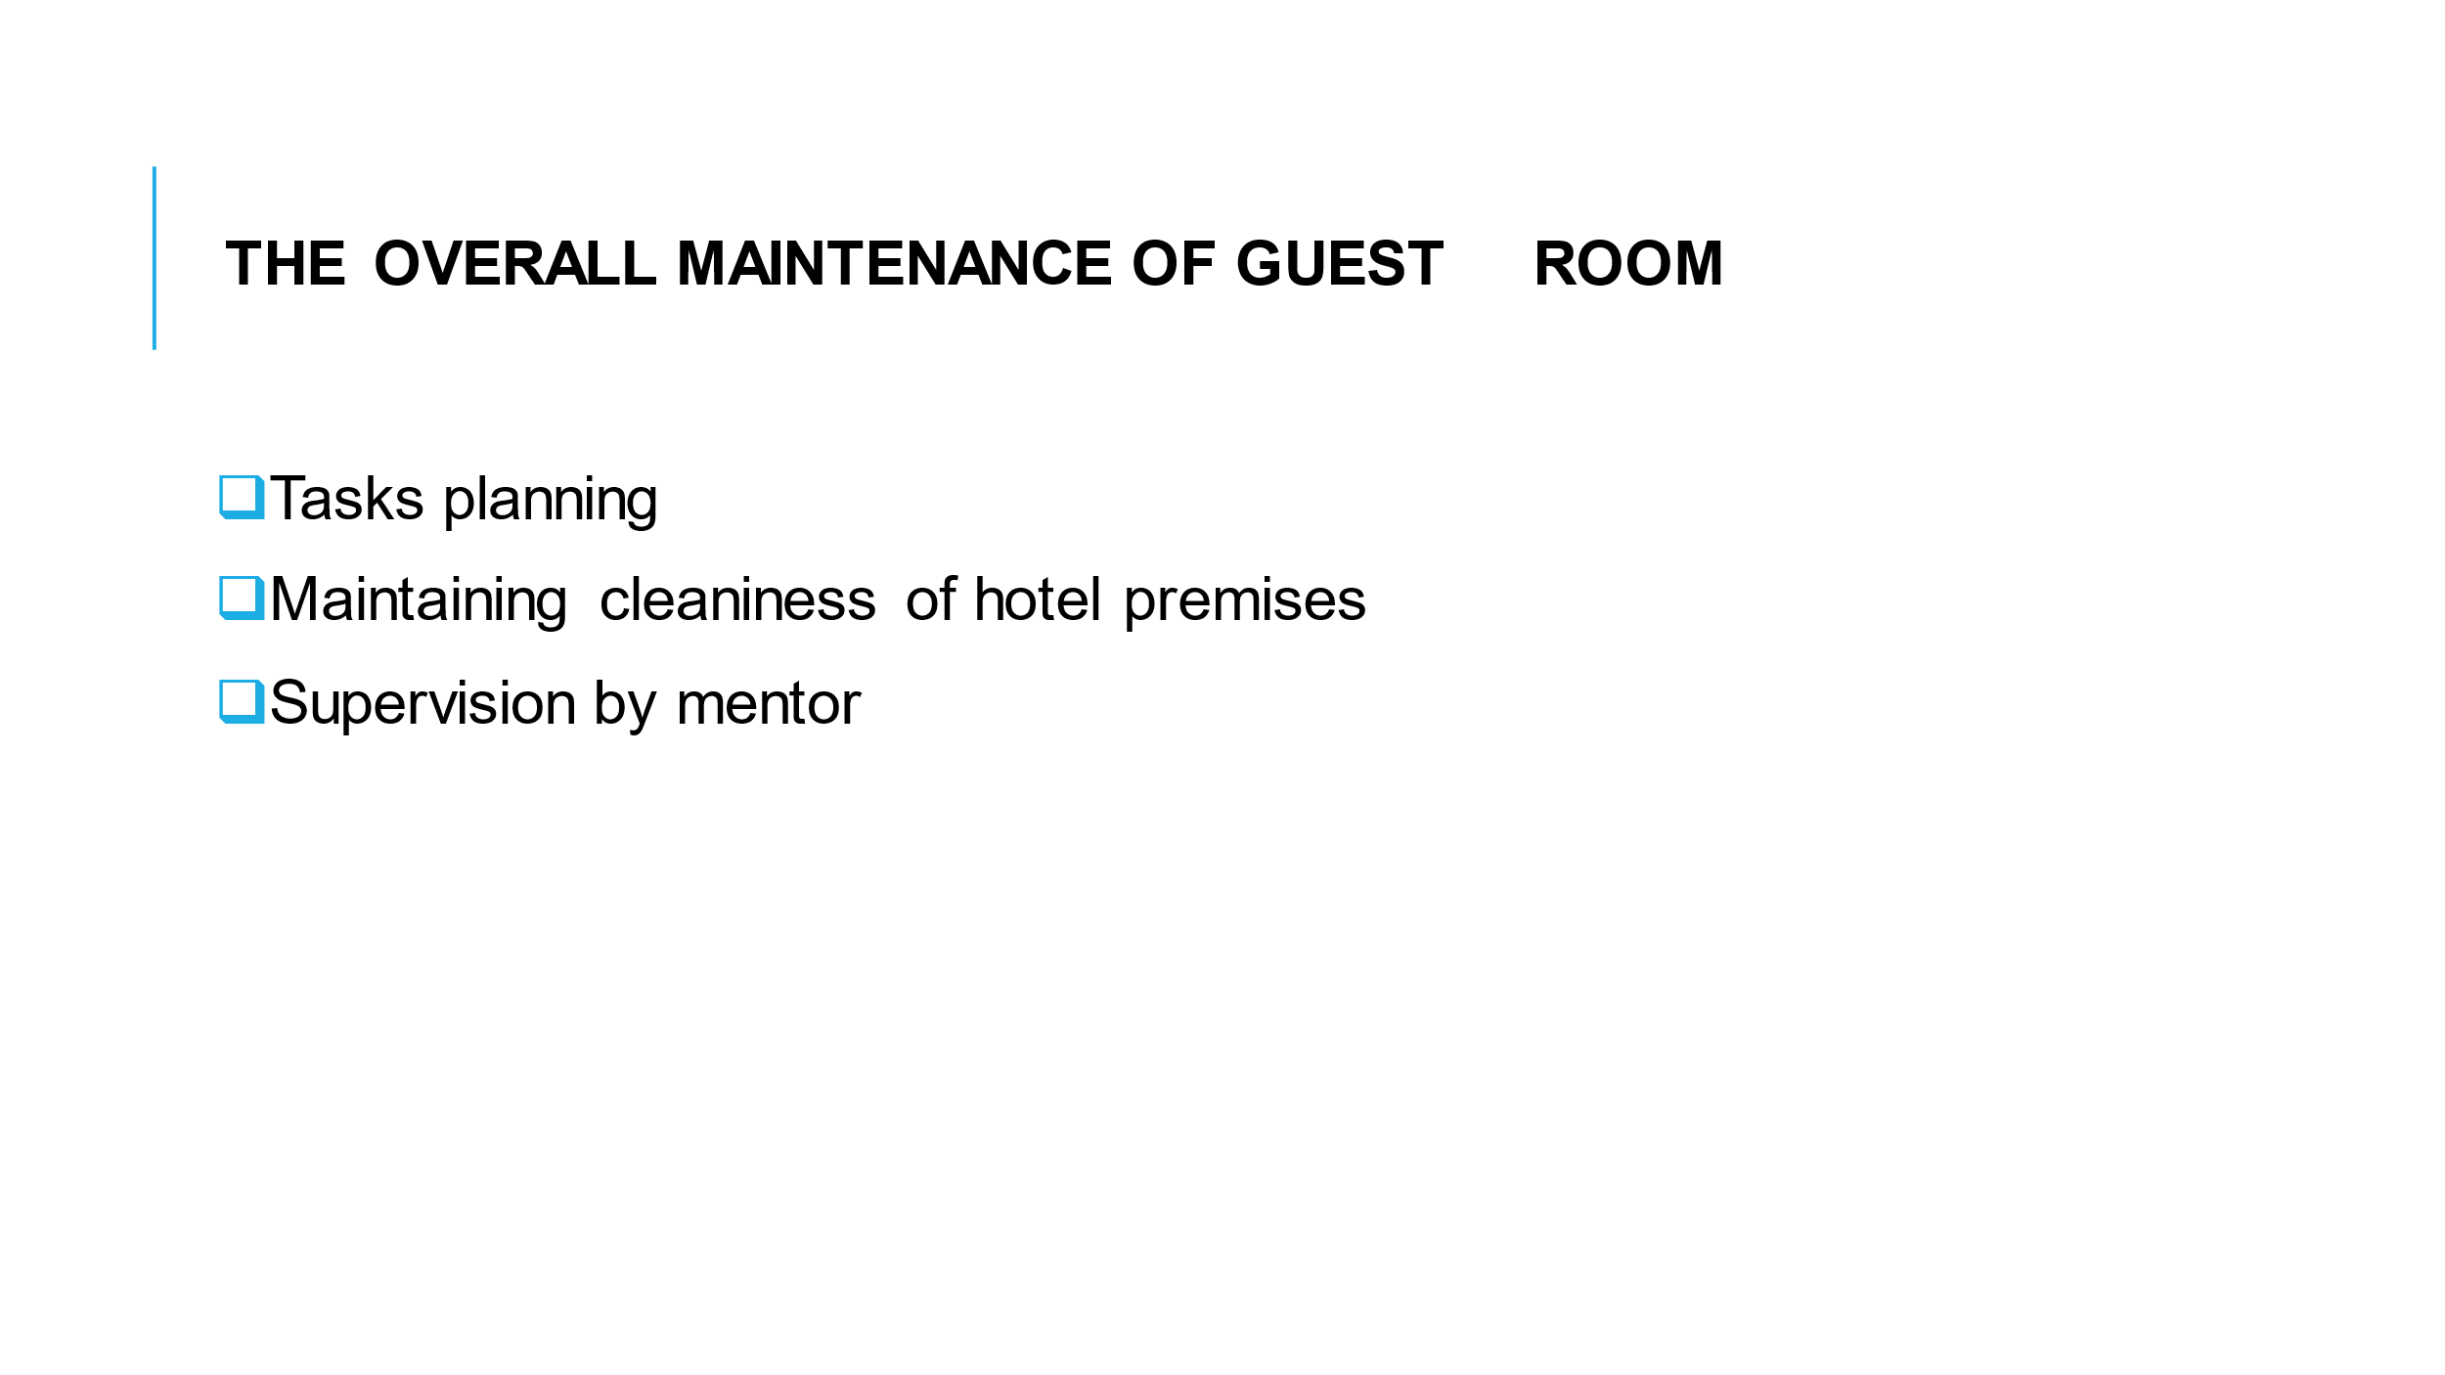

Training Notes: The guests can only be impressed by the quality of services and the cleanliness of our premises. Our duty is to be attentive to details while handling our daily tasks.
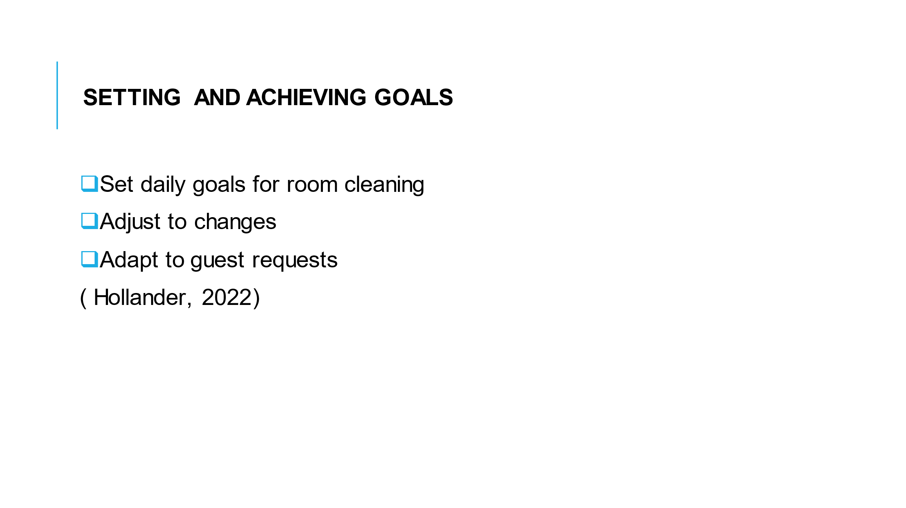

Training Notes: bear in mind to always set goals and put effort to achieve them.
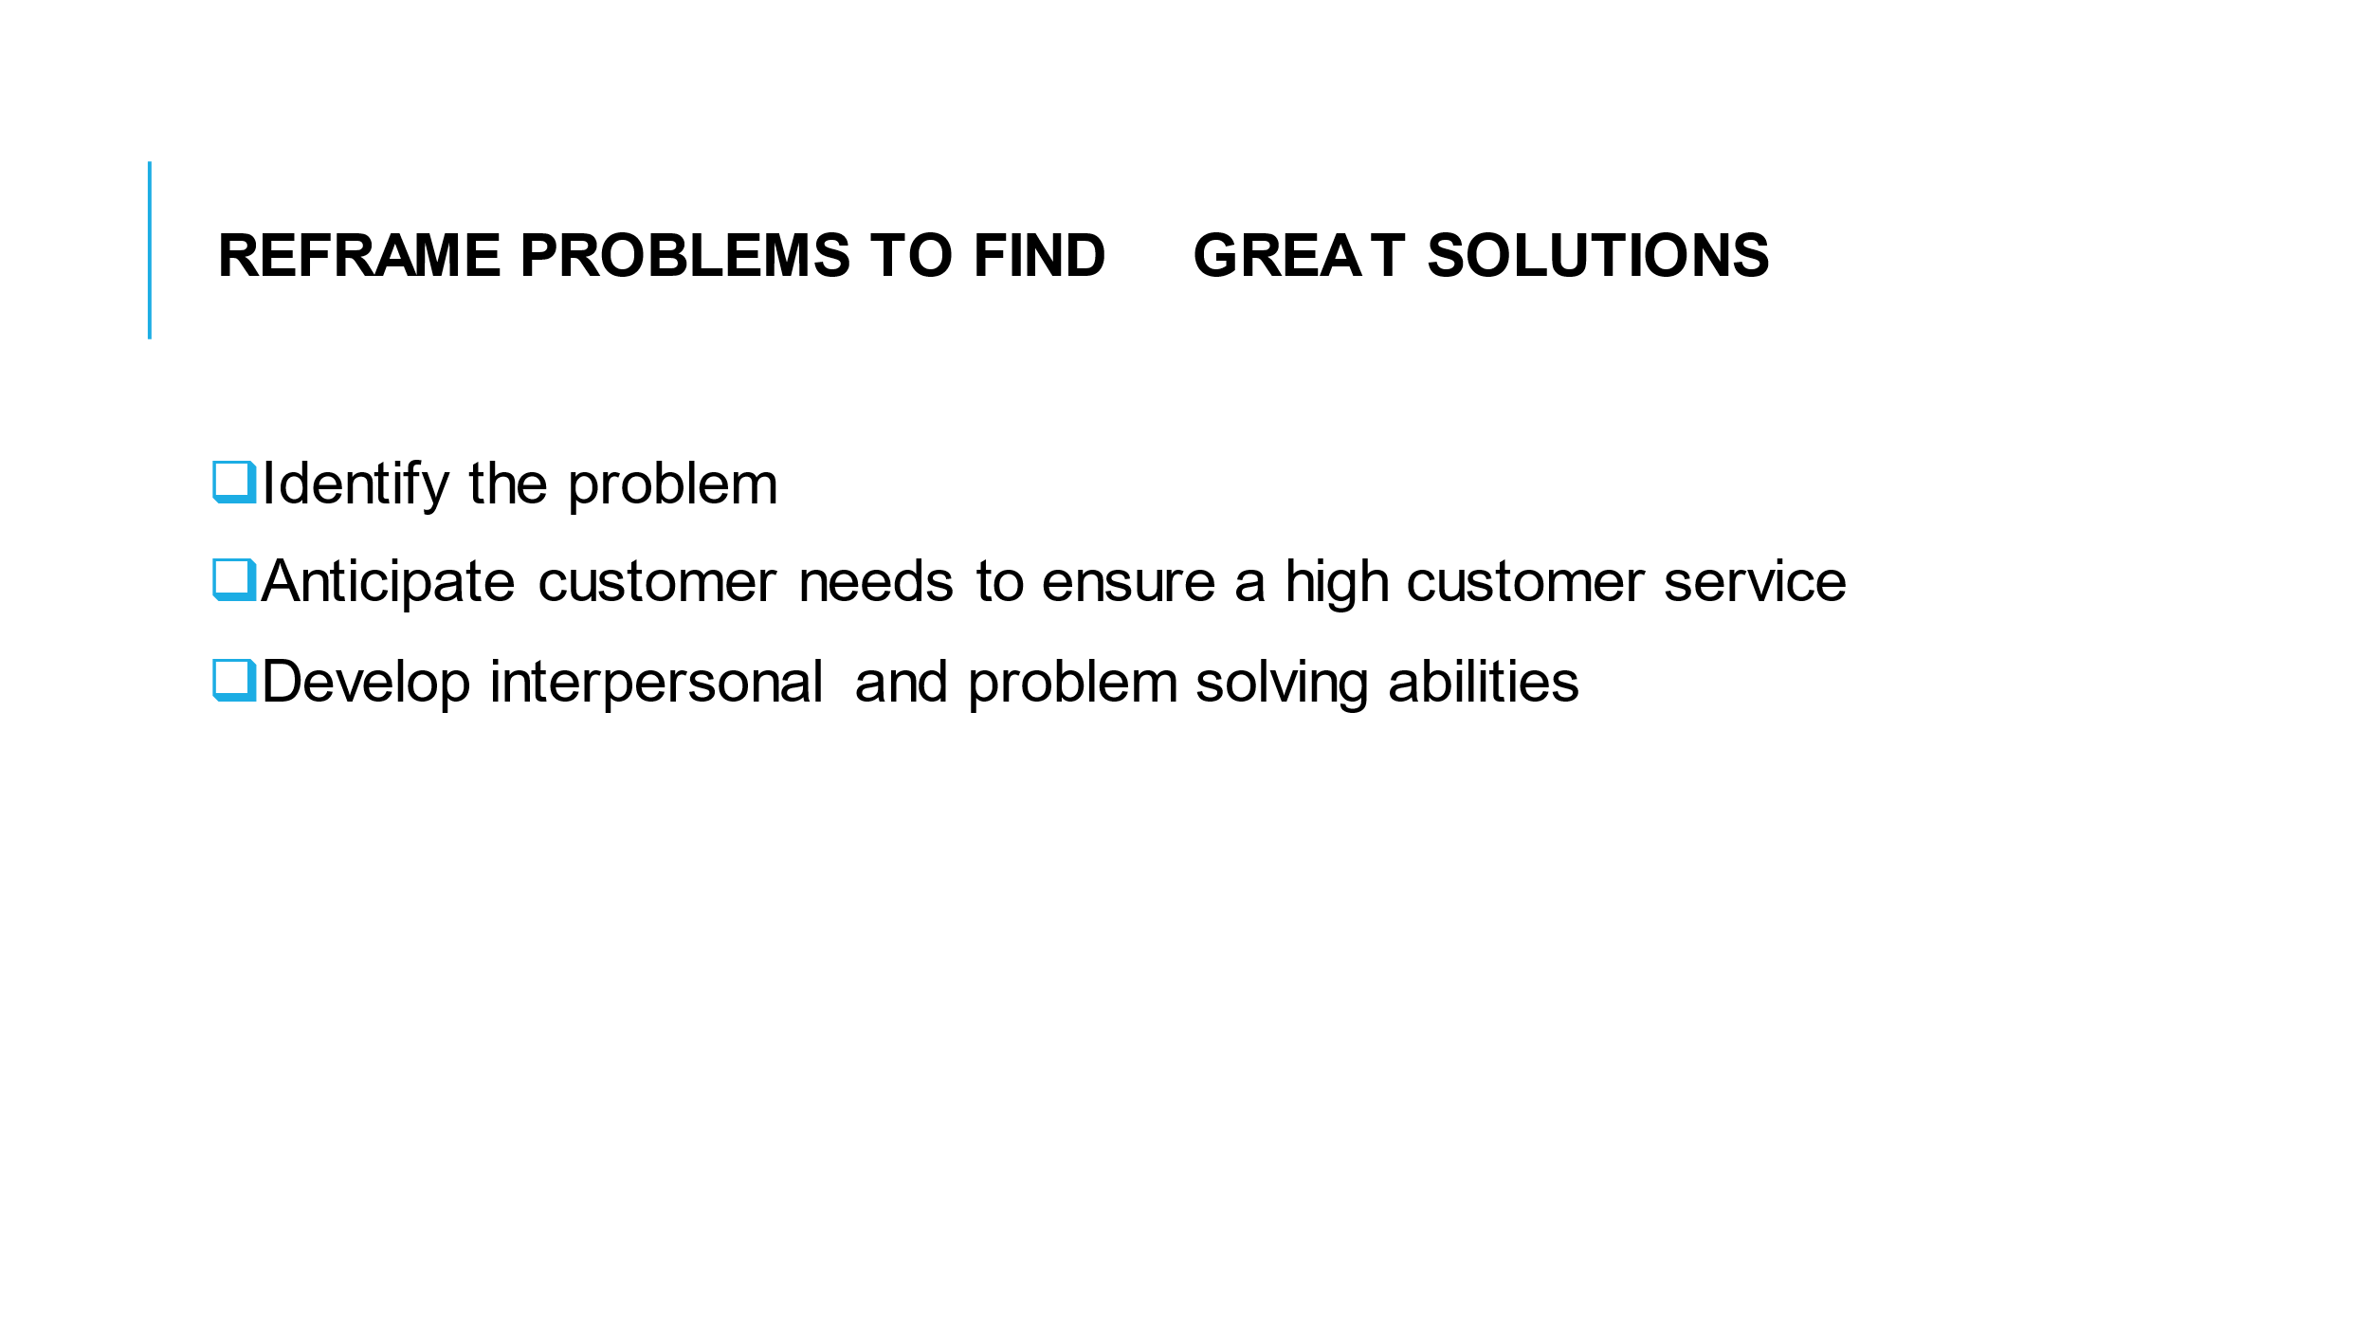

Training Notes: when guest complains, be quick to apologise, identify the problem and sort it out as soon as possible. We must always satisfy the guest. It is necessary to develop problem-solving skills.

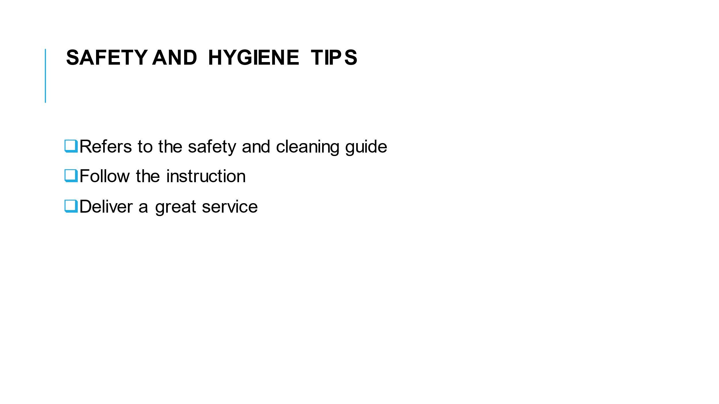

Training Notes: Be safe and take into consideration safety and hygiene recommendations. We are the ambassador of the brand, then our responsibility is to promote top hygiene and safety standards.
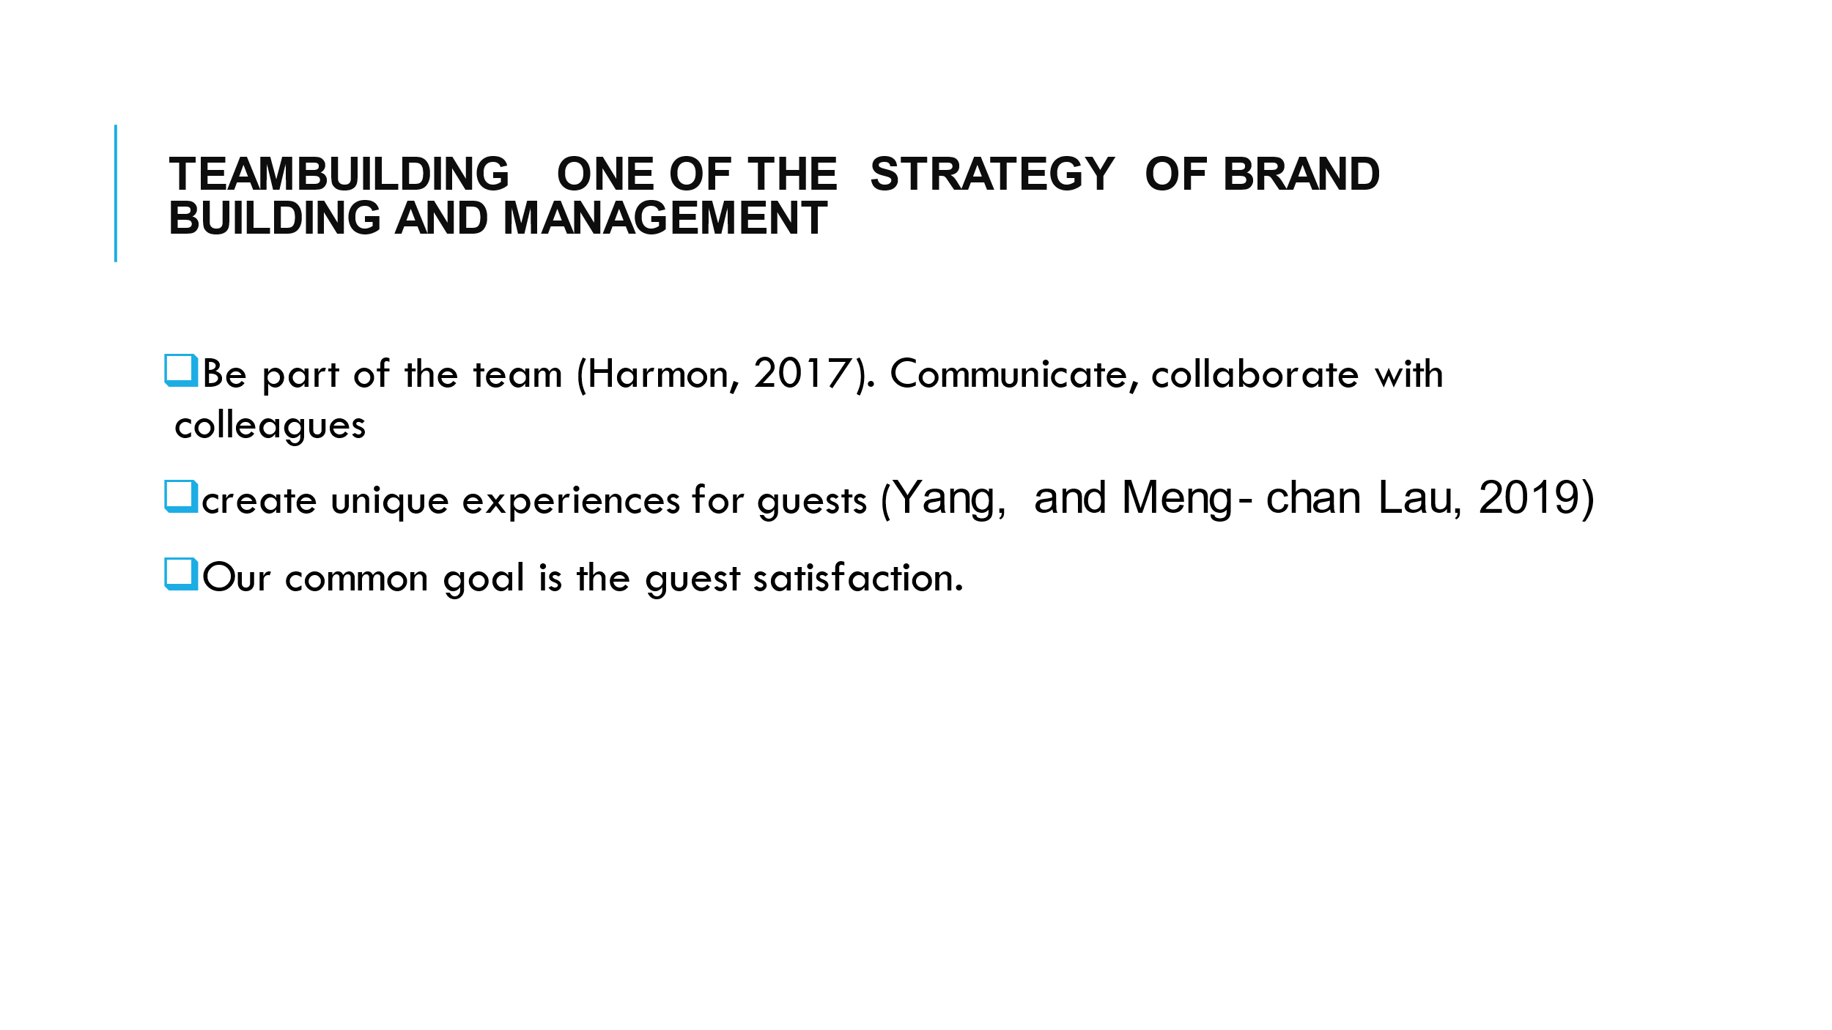

Training Notes: Our relationship with each other matters, it reflects on customer overall satisfaction. Effective communication and interaction are key elements to the process of building our team.
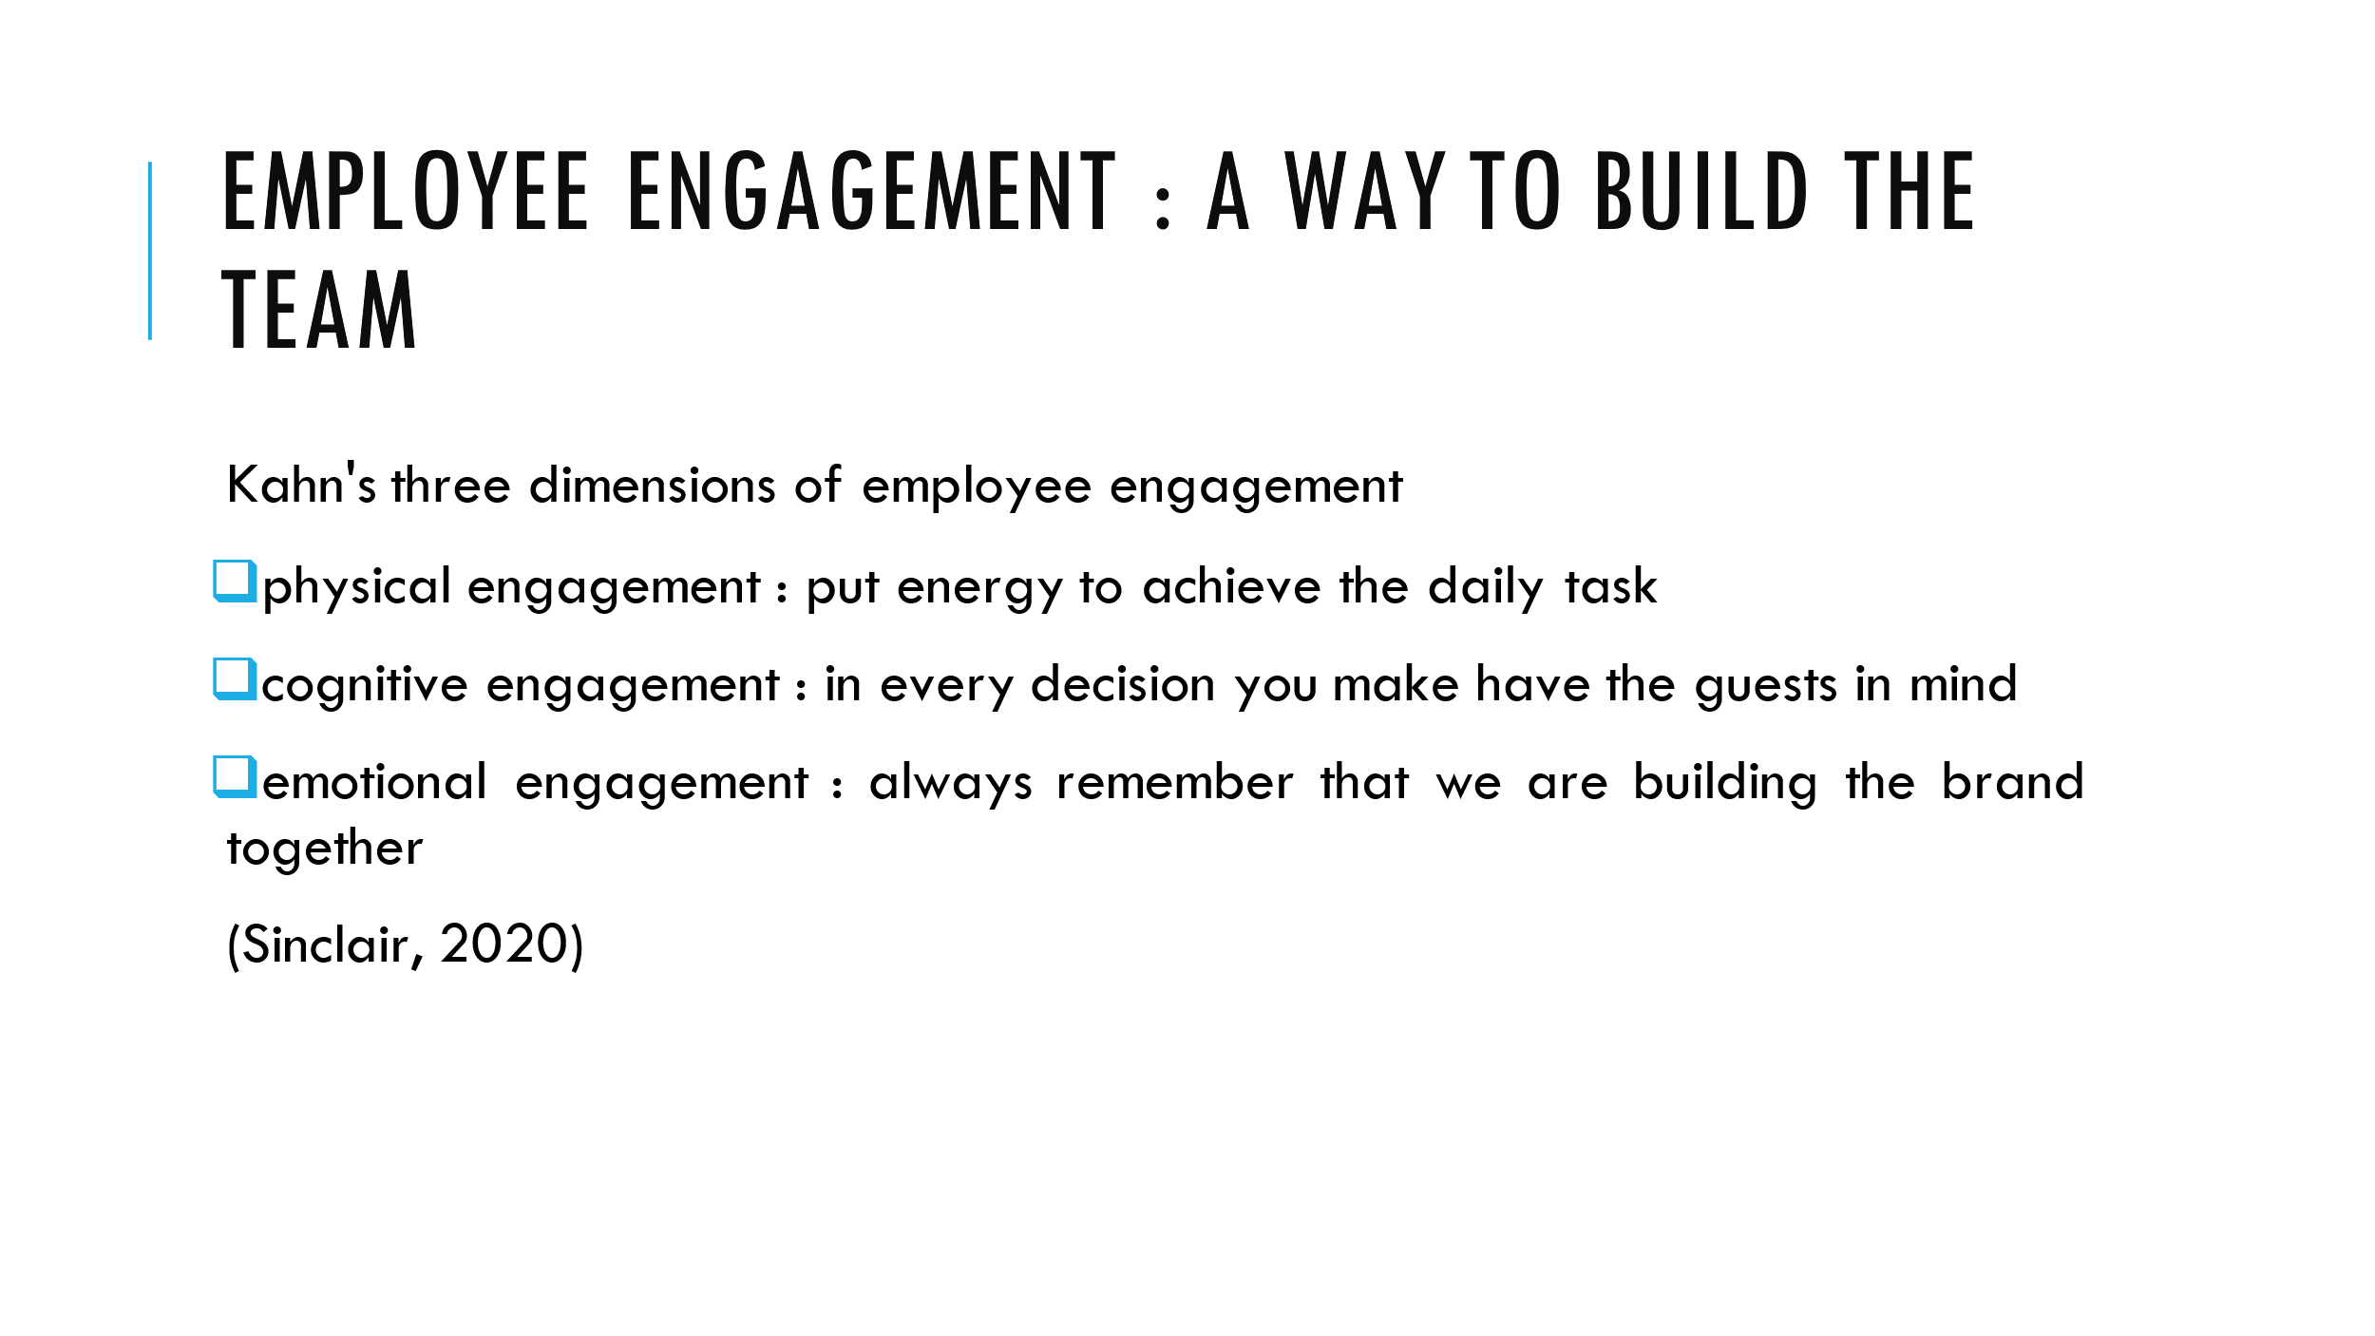

Training Notes: let’s have a look at the employee engagement developed by Kahn
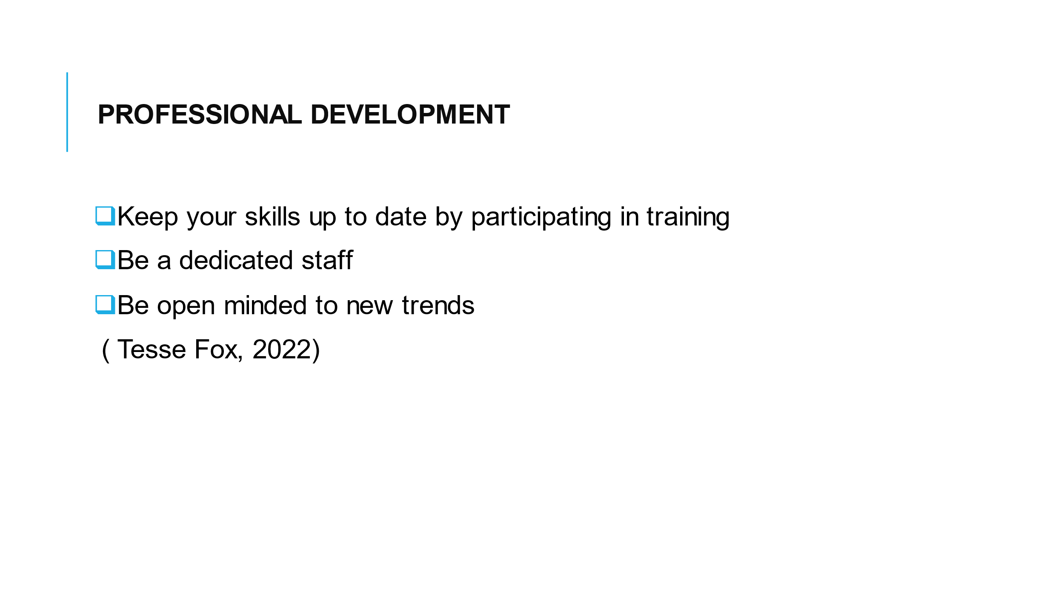

Training Notes: we are encourage to be our better version at workplace. Self and professional development we helps us to be steady in learning continually.
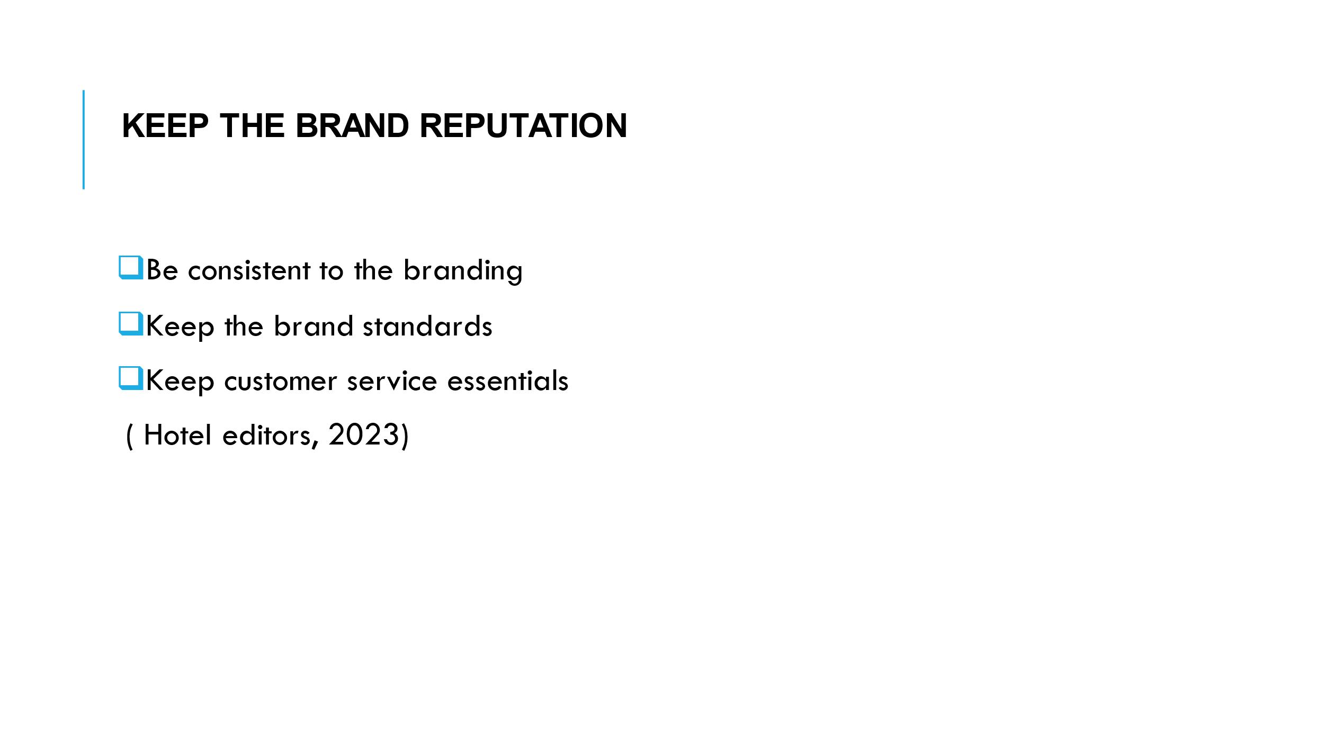

Training Notes: to succeed we need to maintain the brand reputation, guest are loyal to great brand. Keep our standards high and be focus on delivering excellent guestrooms.

References
Component one
- De Tarso, P. ( 2022). The secret power of hospitality. TEDx talks Available at (530) The Secret Power of Hospitality | Paulo De Tarso | TEDxSoho - YouTube

- Hollander, J. (2022). Hotel housekeeping duties: a day in the life. Available at Hotel Housekeeping Duties: A Day in the Life (hoteltechreport.com) ( accessed 1st March 2023).

- mews ( 2017). The future of hotel housekeeping technology. [blog]. Available at https://www.mews.com/en/blog/future-hotel-housekeeping (accessed 1st March 2023).

- Patrick, L (2022). Cleanliness is Everything: Excellence as a Housekeeping Manager Available at Cleanliness is Everything: Excellence as a Housekeeping Manager - hosco. (accessed 4th March 2023)

- Premier Inn Clean Protect available at CleanProtect - our enhanced cleanliness commitment | Premier Inn (accessed 2nd march 2023)

Component two
- Castro-Casal, C. Vila-Vázquez, G. and Pardo-Gayoso, A. (2019). "Sustaining Affective Commitment and Extra-Role Service among Hospitality Employees: Interactive Effect of Empowerment and Service Training" Sustainability 11, no. 15: 4092. Available at https://doi.org/10.3390/su11154092 ( accessed 20th February 2023).

- Hollander, J. (2022). Hotel housekeeping duties: a day in the life. Available at Hotel Housekeeping Duties: A Day in the Life (hoteltechreport.com) ( accessed 1st March 2023).

- Pappas, N. and Bregoli, I. (2016) Global dynamics in travel, tourism and hospitality. Hershey. Business Science Reference.

- Tesse Fox, J (2022). Housekeeping takes training shift. Available at https://www.hotelmanagement.net/housekeeping/how-management-companies-are-training-housekeepers (accessed 5th March 2023).

Component three
- Harmon, M. (2017). The soul of a hotel. TEDx talks Available at (530) The Soul of a Hotel | Mark Harmon | TEDxWilmingtonSalon - YouTube (accessed 10th February 2023).

- Hollander, J. (2023) The Ultimate Guide to Hotel Operations. Available at The Ultimate Guide to Hotel Operations (2023) (hoteltechreport.com) (accessed 10th February 2023)

- HOTELS Editors ( January 13. 2023). How eroding customer satisfaction impacts hotel profits. Available at How eroding customer satisfaction impacts hotel profits - HOTELSMag.com (accessed 5th March 2023).

- Prentice, C. Wang, X. and Correia Loureiro, SM (2019). The influence of brand experience and service quality on customer engagement. Journal of Retailing and Consumer Services. Available at https://www.semanticscholar.org/paper/The-influence-of-brand-experience-and-service-on-Prentice-Wang (accessed 25th FebruarY)

- Radison Hotel group (2021). Radisson Academy - The umbrella for all training and development initiatives within RHG. Available at https://hospitality-on.com/en/hospitality-schools/radisson-academy-umbrella-all-training-and-development-initiatives-within-rhg (accessed 8th March 2023).

- Radley, B. (2018). How William Kahn Revolutionized Employee Engagement at Work. [blog]. Available at https://blog.workday.com/en-us/2018/how-william-kahn-revolutionized-employee-engagement-work.html ( accessed 5th March 2023).

- Sinclair, S; (2020). Kahn's 3 Dimensions of Employee Engagement: Still Good to Go in 2021? [blog]. Available at https://www.talkfreely.com/blog/dimensions-of-employee-engagement (accessed 5th March 2023).

- Tesse Fox, J (2022). Housekeeping takes training shift. Available at https://www.hotelmanagement.net/housekeeping/how-management-companies-are-training-housekeepers (accessed 5th March 2023).

- Yang, FX. and Meng- chan Lau, V. (2019). Evil customers, an angel boss and coopetitive coworkers: Burnout of frontline employees. International journal of hospitality management. Available at Evil customers, an angel boss and coopetitive coworkers: Burnout of frontline employees - ScienceDirect ( accessed 25th February 2023)

