September 2012
Building a Simple Web Service
Distributed Enterprise Applications
Stephen Hole, Tim Bashford

Simple Web Service
Distributed Enterprise Applications

Introduction
This tutorial is meant to illustrate the ease with which a Web Service can be constructed.

Creating the Service
Create a new Visual Studio 2010 Web Site named MoneyConverter. The service needs to provide functions for the following:
- Converting Dollars To Euros
- Converting Euros To Dollars
The new project should use the:
- ASP.NET Web Service Template
- HTTP as location (http://localhost/MoneyConverter)
- C# as the language

Create a new ASP.NET Web Service Application in Visual C# utilising .net Framework 3.5. Name the Project “MoneyConverter”.
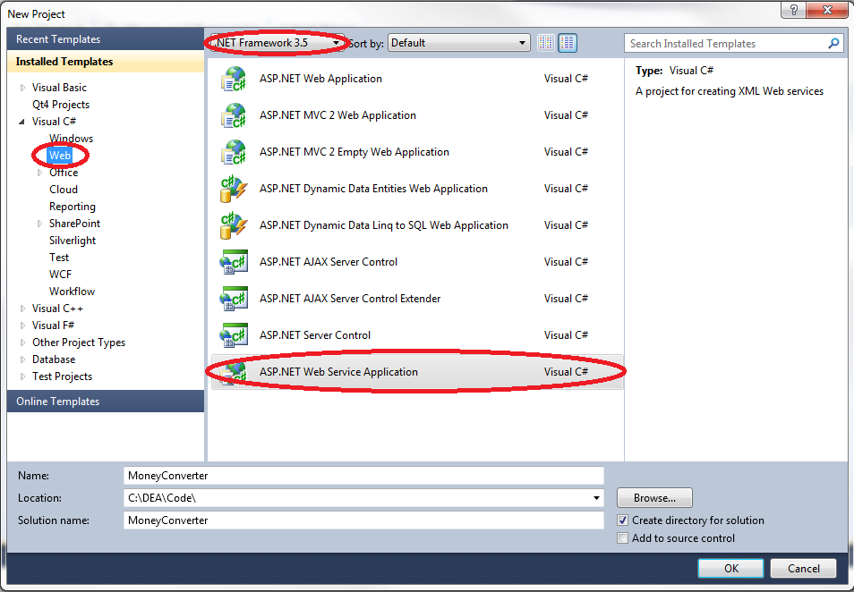

When the ASP.NET Web Service template opens, the Solution Explorer should look similar to Figure 2.
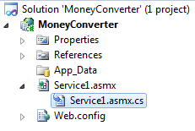

The default code created is shown below.
Please note that there is a Hello World WebMethod created as a template for guidance on how to create programmer defined WebMethods.
using System;
using System.Collections.Generic;
using System.Linq;
using System.Web;
using System.Web.Services;

namespace MoneyConverter
{
/// <summary>
/// Summary description for Service1
/// </summary>
[WebService(Namespace = "http://tempuri.org/")]
[WebServiceBinding(ConformsTo = WsiProfiles.BasicProfile1_1)]
[System.ComponentModel.ToolboxItem(false)]
// To allow this Web Service to be called from script, using ASP.NET AJAX, uncomment the following line.
// [System.Web.Script.Services.ScriptService]
public class Service1 : System.Web.Services.WebService
{

[WebMethod]
public string HelloWorld()
{
return "Hello World";
}
}
}

In the Solution Explorer rename Service1.asmx to MoneyConverter.asmx.
In the Code Window rename the Class from Service1 to Converter.
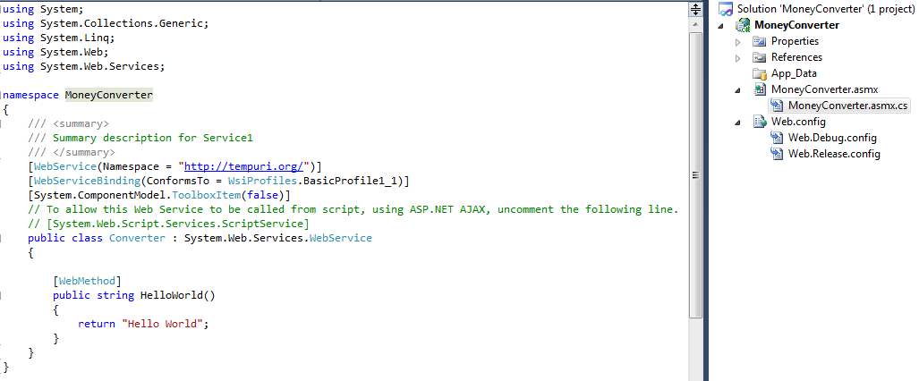
Change the tag code in MoneyConverter.asmx to reflect the change in class name (Open With > Web Service Editor).

Default MoneyConverter.asmx code
<%@ WebService Language="C#" CodeBehind="Service1.asmx.cs" Class="Service1.Service1" %>

MoneyConverter.asmx code after change in class name
<%@ WebService Language="C#" CodeBehind="MoneyConverter.asmx.cs" Class="MoneyConverter. Converter" %>

You can test the Web Service by running your project. This is ok if you want a simple test but you will need to run without debugging.

When the service runs it will open a web interface in the default web browser.
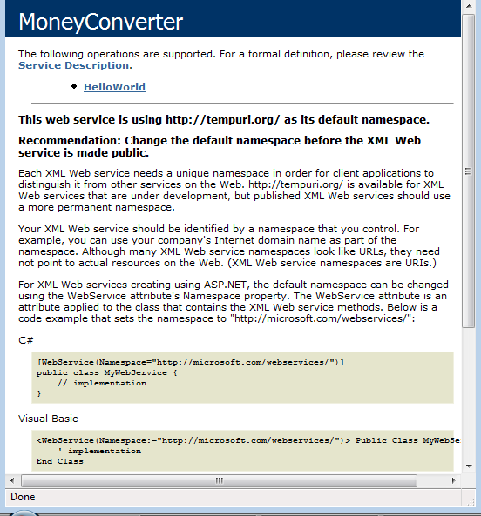

Click HelloWorld and then the Invoke button. The result will be another browser window with the XML generated by the service.
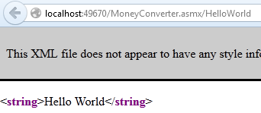

It is time to remove the HelloWorld WebMethod and build our MoneyConversion WebMethods.
- Insert a Description attribute into the WebService tag
- Delete the HelloWorld WebMethod
- Add the EuroToDollar WebMethod
- Add the DollarToEuro WebMethod
- Add the Function GetEuroToDollarConversionRate
- Run the service a note the XML returned.
using System;
using System.Collections.Generic;
using System.Linq;
using System.Web;
using System.Web.Services;

namespace MoneyConverter
{
/// <summary>
/// Summary description for Service1
/// </summary>
[WebService(Namespace = "http://tempuri.org/", Description = "A web service for converting currencies")]
[WebServiceBinding(ConformsTo = WsiProfiles.BasicProfile1_1)]
[System.ComponentModel.ToolboxItem(false)]
// To allow this Web Service to be called from script, using ASP.NET AJAX, uncomment the following line.
// [System.Web.Script.Services.ScriptService]
public class Converter : System.Web.Services.WebService
{

private float GetEuroToDollarConversionRate()
{
return 1.3f;
}

[WebMethod(Description = "Convert from Dollar to Euro currency")]
public float DollarToEuro(float amount)
{
return amount / GetEuroToDollarConversionRate();
}

[WebMethod(Description = "Convert from Euro to Dollar currency")]
public float EuroToDollar(float amount)
{
return amount * GetEuroToDollarConversionRate();
}
}
}

Run the service.
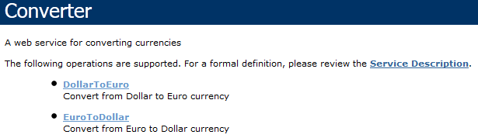
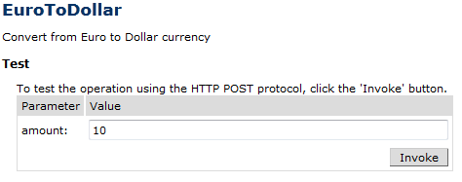

<float>13</float>

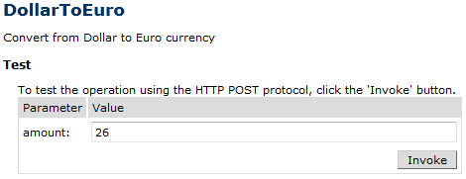
<float>20</float>

Creating the Client

Add a Windows form project (MoneyConverterClient) to the Solution.
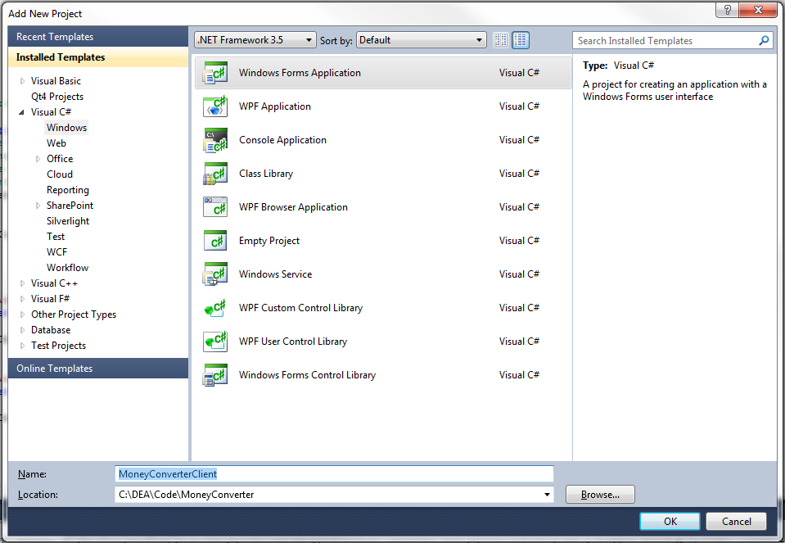

Add the following controls:
- Two Labels
- Two TextBoxes
- Two Buttons
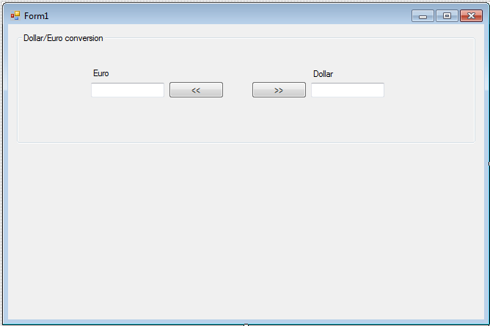
In the Solution Explorer select the Windows Project :
- Add a Service Reference to the MoneyConverter Web Service
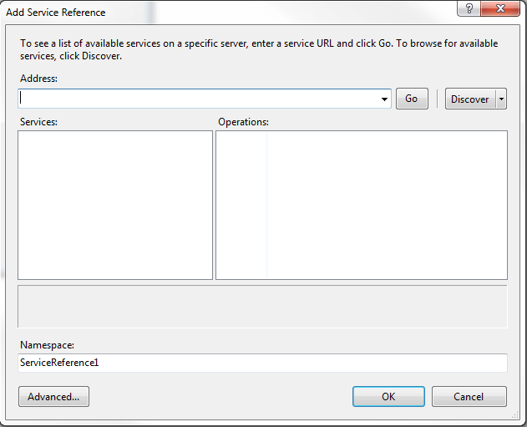

- Click Discover, the MoneyConverter service should be discovered from within the solution.
- Name the reference “MoneyConverterReference”.
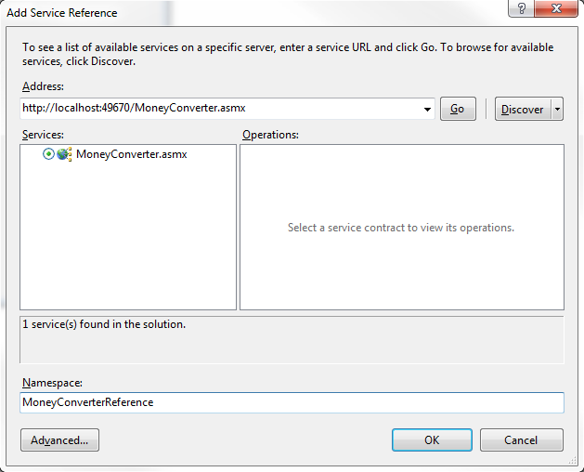
Add the following code behind the Buttons
using System;
using System.Collections.Generic;
using System.ComponentModel;
using System.Data;
using System.Drawing;
using System.Linq;
using System.Text;
using System.Windows.Forms;

namespace MoneyConverterClient
{
public partial class Form1 : Form
{
public Form1()
{
InitializeComponent();
}

private void buttonDollarToEuro_Click(object sender, EventArgs e)
{
MoneyConverterReference.ConverterSoap conv = new MoneyConverterReference.ConverterSoapClient();
float res = conv.DollarToEuro(float.Parse(textBoxDollarToEuro.Text));
textBoxEuroToDollar.Text = res.ToString();
}

private void buttonEuroToDollar_Click(object sender, EventArgs e)
{
MoneyConverterReference.ConverterSoap conv = new MoneyConverterReference.ConverterSoapClient();
float res = conv.EuroToDollar(float.Parse(textBoxEuroToDollar.Text));
textBoxDollarToEuro.Text = res.ToString();
}
}
}

Set the Client Application as the Start Up Project
Run the Client Application
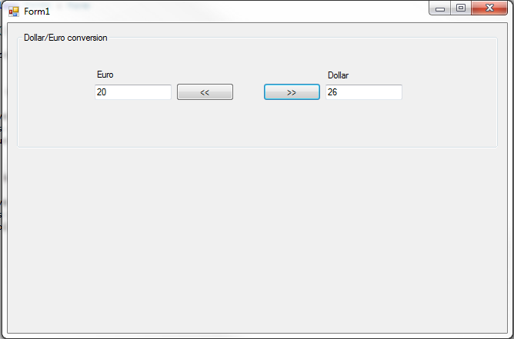

Exercise

- Modify your web service to include conversion between Pounds and Euros by adding PoundToEuro and EuroToPound Web Methods. Take the conversion rate as 1.25.
- Modify your C# client to accommodate these changes, adding new text boxes, labels and buttons.
- Add the necessary code to access the PoundToEuro and EuroToPound Web Methods from the client, allowing conversion between Pounds and Euros in addition to Dollars and Euros. To access changes made to your Web Service, you will need to rebuild the service then update the service reference.


