Introduction to Research

Research Topic: How to Prevent Colon Cancer
BMHP5005
Musammat Khaleda Begum
1714938
Lecturer: Tayo Korede
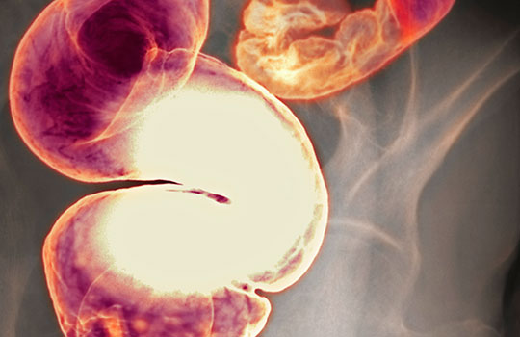

Table of Contents
1.0 Introduction/Background 3
1.1 Rationale of this research 3
2.0 Methodology 3
3.0 Ethical practice 4
4.0 Literature Review 5
5.0 Findings and discussion 8
6.0 Conclusion and recommendations 10
7.0 References 11

1.0 Introduction/Background
Colon cancer or bowel cancer is one of the leading cause of death because of cancer in the UK. The death rate because of this disease is increasing day by day. In the UK there is more than 268000 patient who has colon cancer. In this disease, an individual cell is affected by cancer. This is a very deadly disease in which individual cells grow abnormally which can invade other parts of the body as well. This cancer can invade the body of any people but the people whose age is over 50 is in the risk of having the diseases more than others. Because of these reason preventing this diseases is important as the treatment is very expensive and in most of the cases, people know about this diseases in the last stage when there will be no chance for the individual to prevent that disease. For that people needs to take initiative so that it can be prevented. This research aims to understand how someone can stay away from the risk of colon cancer. This will include the methods which will be used, ethical consideration, literature review of colon cancer and the findings. This will also include recommendations on how to prevent cancer.

1.1 Rationale of this research
In the UK there is more than 268000 patient who has colon cancer and it is the second leading cause of cancer death in the UK. Most of the people who have this disease are over 50. The number of people who are affected by it is increasing in the 21st century and 94% of the new case is among the people who are over 50 (Cuevas, 2017). The cost of treating colon cancer is high and people realise in the last or critical stage where the doctors have nothing to do. The modern lifestyle is a major cause of diseases. The number of a colon cancer patient is increasing in industrialised countries. This has become very deadly and there are ways by following which an individual can reduce the risk of this disease. These are the reason for which this research topic is been chosen as “prevention is better than cure”.

2.0 Methodology
The choice of an appropriate research method is important to achieve the objectives of the research. Here, all the data will be collected from secondary sources like journal articles, websites, and books. The work will be based on literature review and for that its methodology includes only the search and review process. For doing this task at first the researcher search in Google about the article which was done before about this matter. From that, some of the peer-reviewed articles were chosen for the task. Another important criterion for the task was the journal in which the article published. For this, a high rated journal has been chosen.
For reviewing the chosen journal article, the researcher read it. Based on the summary literature review for this research has been written. This also tries to find out the area which the researcher did not cover where further research can be done. These are methods that were used for this research.

3.0 Ethical practice
A researcher must have to make sure that ethical factors are considered while conducting research. Research ethics is important for various reasons. It helps the researcher to find out the aim of the research to expand knowledge. If a researcher does not follow ethical conduct while conducting research then it can be assumed that the researcher manipulates data to find the results. This will raise the question of the effectiveness of the research outcome. This is also required to make sure that collaborative work has been done which is required to find out the objective of the research effectively. The audience trust over the research outcome is very important because if the people do not trust the outcome of the research then the objectives of conducting the research will not be achieved.
To maintain ethical conduct of the research there are things about which the researcher needs to think. “Honesty and integrity” is among the most important ethical consideration of a researcher. A researcher must have to make sure the integrity of the research outcome. Objectivity is another ethical factor that needs to be ensured by the researcher. The researcher should have the aim to reduce bias. Carefulness is another important criterion of ethical consideration which can help the researcher to find a valid result. Confidentiality and responsible publication also need to be considered by the researcher. This is the ethical consideration which a researcher must have to be considered.

4.0 Literature Review
According to Chang and Kopestz (2015) colon cancer is among the deadliest types of cancer which can be prevented by taking the proper measure. This type of cancer begins in the cell and affect other parts of the body from there. It mostly affected the cell which produces and realises “mucus and other types of fluid”. There are different causes of colon cancer and if people try to avoid those causes then it will help the people to avoid having this disease. The authors put many emphases on the prevention of cancer than cure.
Cuevas (2017) tries to found out the reason for colon cancer. There are the different factor which the author found out about the cause of colon cancer and genetics is among the most important reason for which an individual may have colon cancer. Family history of the individual inherited syndromes, the racial background also related to the genetics of the people which can be determinant of these types of cancer. Perhaps lifestyle is the important reason for which an individual affected by these types of cancer. Diet, inactive lifestyle, smoking, and alcohol are some of the factors of an individual lifestyle that can cause colon cancer.
Loehrer (2015) and Kritchevsky (2010) found out that “Fruits, vegetables, and fibre” intake can help an individual to prevent colon cancer. The fruits which are high in fibre are effective in case of preventing colon cancer. The study of Loehree found out if an individual include fruit in the diet then it will lower the risk of the individual by 40%-50%. This is great because most of the people of the world have access to fruit and for that this can be an effective and easy solution to prevent colon cancer. Different result shows different results as some of the research found out that fruits have little to do to prevent colon cancer. But these two researchers were sure that diet has a significant impact on reducing the risk of colon cancer.
According to Norat, Lukanova, Ferrari and Riboli (2012) “read meat, fat and carbohydrates” consumption increase the risk of having colon cancer among the men who eat meat 5 times or more in a weak compared to the men who eat less. From this, it can be easily understood that red meat needs to be avoided to prevent colon cancer. But Bostick et al., (2014) found out that red meat does not have much influence on having colon cancer rather fat has a huge impact on colon cancer. According to the author people who have red meat can prevent other types of disease but fat needs to be avoided. Most of the study found out that the intake of red meat has increased the risk of colon cancer and for that, it needs to be avoided.

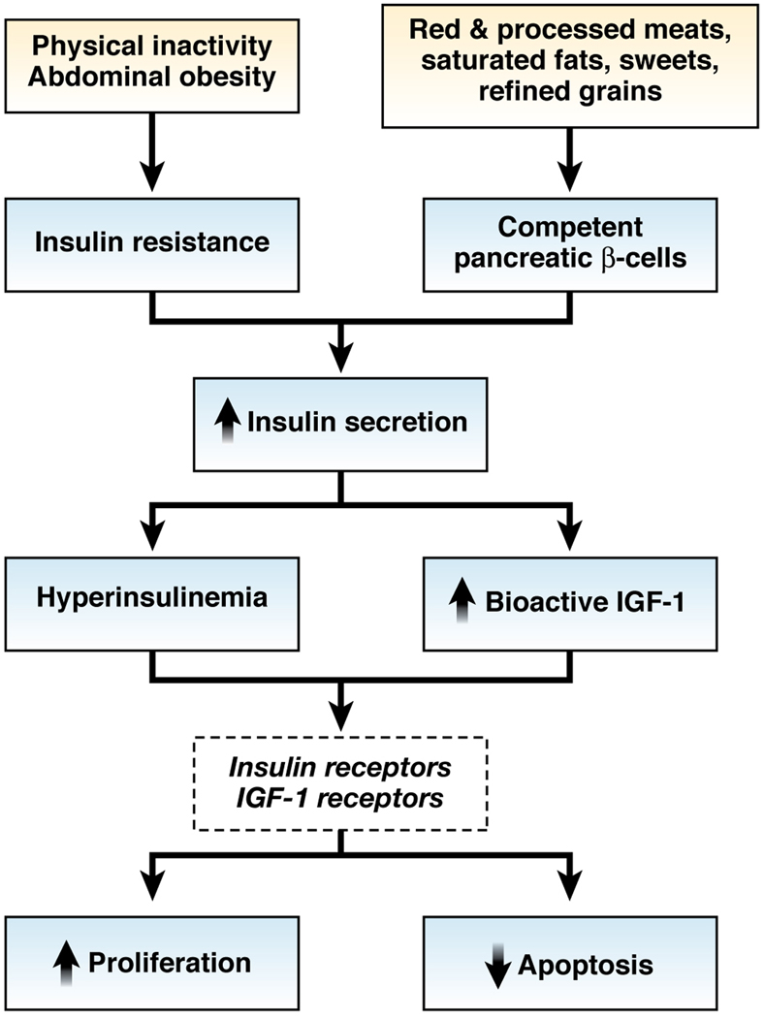
Figure: “Inflammatory mechanism relating to diet”
Source: Bostick et al., (2014)
Wu (2012) found out that calcium and vitamin D has a huge impact on lowering the risk of colon cancer. Calcium creates “bile acids and ionised fatty acids” which form insoluble soaps in the colon lumen which helps to reduce the colon cancer. The author suggests that people need to intake food which is high in calcium. According to Cho (2016), calcium and vitamin D intake in a large number can reduce the risk of colon cancer by 22%. Most of the studies which are been conducted about this found out a positive relationship between calcium and vitamin D to prevent colon cancer. Most of the authors also suggest increasing the consumption of the product which are high calcium and vitamin D.
According to Giovannucci (2013), vitamin B intake can be an effective option to reduce the risk of colon cancer. Vitamin B is an effective element of “one-carbon metabolism” and its affect DNA synthesis, methylation and repair which lessen the risk of cancer. Based on this the author advised taking vitamin B particularly B6 to protect an individual from the risk of cancer among the men. Sanjoaquin et al., (2018) also found out the results of a similar type while researching the effectiveness of Vitamin to prevent colon cancer. The author found out that Vitamin B directly or in association with other vitamin helps an individual to prevent the risk of colon camper. The people who do have this vitamin the diet is in danger of colon cancer.
Voronov and Apte (2015) found out dietary micronutrients like “selenium, beta carotene and vitamin A, C and E” can help an individual to lessen the risk of colon cancer. These elements have antioxidant properties which are effective in term of preventing the risk of colon cancer. Among these selenium has the strongest relationship to prevent colon cancer. Most of the studies found out these effective relationships. The study of the author also found out that selenium can reduce colon cancer risk by 50%.
Prasad (2014) found out that the dietary pattern of an individual has a significant impact on the risk of colon cancer. The diet pattern which is consists of a large amount of red meat, carbohydrate, and fat will increase the risk of colon cancer among the individual. Other research along with support this claim of Prasad and indicated that if people decrease the amount of meat and fat consumption then it will decrease the risk of having colon cancer significantly.
According to Lynch (2013) lifestyle of an individual has a great impact on the risk of colon cancer. The people who consume less alcohol will be at lesser risk than the people who will consume more alcohol. This result was also found out by Giovannucci (2011) and the author suggests that people must have to reduce alcohol consumption to reduce the risk of colon cancer. Tobacco consumption increased the risk of having colon cancer. Most of the studies including the study which was conducted by Liao, Ma, Liu, and Fu (2019) found out a similar result that tobacco consumption can increase the risk of colon cancer.
Another factor that is related to lifestyle is body mass and fat and this has an effective relationship with colon cancer. The people with a BMI matrix of more than 29 are in danger of having this disease. The people who are in idea BMI has less chance to affect by this. Most of the studies concerning body mass and fat found an effective relationship with the high risk of colon cancer. Loehrer (2015) stated that the level of exercise and active lifestyle has an effective impact on the risk of the disease. The people who have a high level of physical activity are less risk of having this disease than the people who are less active. The authors suggest that an individual needs to reduce alcohol and tobacco consumption and increase the level of physical activity to reduce the risk of colon cancer. Decreasing body mass can also help the individual to reduce colon cancer risk.

5.0 Findings and discussion
Colon cancer affects the cell of an individual and later other parts of the body. Literature research shows that there are ways by following which an individual can reduce the risk of colon cancer. The Diet and lifestyle of an individual have a huge impact on this. This part of the research will analyse how to reduce the risk of colon cancer based on literature research.
- The most important cause of colon cancer is the diet which the individual intake and the lifestyle of the individual. Genetics of an individual has also a huge impact on the risk of having colon cancer (Cuevas, 2017). If an individual can ensure a balanced diet and a healthy lifestyle then it will help the individual to reduce the risk of having this disease. Before knowing how to prevent diseases it is essential to know the cause.
- A balanced diet is one of the most effective solutions to prevent the risk of colon cancer. If an individual has the ability or willingness to take a balanced diet then it will help the individual to prevent colon cancer. Fruit and vegetable loaded with fibre can help an individual to lessen the risk of colon cancer by 40%-50% (Loehrer, 2015). For that, an individual must have to increase the consumption of fresh earthy food to prevent colon cancer. There are results of this subject but most of the researchers found out similar results.
- The consumption of red meat and carbohydrate needs to be reduced to prevent this disease. The people who eat red meat five times a weak area in the danger of having this disease (Norat, Lukanova, Ferrari, and Riboli, 2012). For that, the consumption of red meat needs to be less than normal and try to eat not more than 3 times in a week. The consumption of carbohydrates also needs to be decreased to in order to fight against the disease. Most of the study found out that over-consumption of red meat and carbohydrate put individual in the risk of colon cancer.
- Increasing the intake of calcium can be an effective prevention process of colon cancer. Calcium intake binds “bile acids and ionised acids” which work as a prevention process of these diseases (Wu, 2012). The people who consume more calcium contained food are at less risk of having this disease. For that, to prevent this disease people must have to increase the consumption of this food component. The dietary pattern of the people also needs to be changed to make sure that it is effective to decrease the chance of having colon cancer (Prasad, 2014). The dietary pattern which includes more meat, fat, and carbohydrate can increase the risk of this cancer, and for that, this item needs to be reduced from the diet and ensure a balanced diet.
- Different types of Vitamin like B6, D, C, E, and A are effective in reducing the risk of colon cancer. Vitamin B6 helps to create “one-carbon metabolism” which helps to reduce cancer risk (Giovannucci, 2013). Some researchers did not found any effective relationship between vitamin D and colon cancer but most of the research found an effective relationship and for that, an individual to prevent colon cancer must have increased the consumption of these vitamins. This will also help to prevent other diseases as well.
- Lifestyle change is another effective way to prevent colon cancer. Alcohol consumption increased the risk of colon cancer. The study suggests that people who intake 2 or more drinks in a day are at high risk of having this disease and for that alcohol consumption by an individual needs to be reduced (Lynch, 2013). This will also help the individual to prevent other types of diseases as well. To reduce the risk of colon cancer one must have given up smoking. The people who smoke regularly have a high risk of having this disease because smoking weakens the cell of the individual. For that, cancer can easily penetrate the protective shield of the individual. So, to prevent colon cancer an individual must have to give up smoking.
- Body mass and fat of individual has a significant impact on an individual risk to have this disease. Most of the study found out that people whose BMI is more than 29 are in great danger of having this disease. People need to reduce BMI and keep it at the ideal level to prevent the risk of colon cancer. People who have high BMI have more fat in the body and this another important cause of colon cancer (Liao, Ma, Liu and Fu, 2019). High level of physical activity is required to prevent this disease. People who are not active can store more fat in the body which will increase the chance of having this disease. For that, to prevent this disease people need to introduce more exercise and activities to their normal routine.

6.0 Conclusion and recommendations
In the UK, colon cancer affected people is increasing day by day. Because of this prevention of this disease is important and people need to know about the process of prevention. This research is based on secondary literature review. To prevent colon cancer one must have to have a balanced diet and a healthy lifestyle. The consumption of fruits and vegetables need to be increased. Red meat and fat consumption need to be reduced as this can increase the risk of colon cancer. Consumption of vitamin B6, calcium, A, E, and C can also help an individual to reduce the risk of this researcher. Alcohol and smoking need to give up and the level of physical activity needs to be increased. Here, are some recommendations to stay away from colon cancer:
- A balanced diet loaded with fruits and vegetables needs to ensure.
- Increasing consumption of food which contains calcium, vitamin B6, A, E, and C will also help to reduce the risk of colon cancer.
- People need to give up alcohol consumption and smoking to prevent this disease.
- Increasing physical activity levels can also help to fight against colon cancer.

7.0 References
Bostick, R., Potter, J., Kushi, L., Sellers, T., Steinmetz, K., McKenzie, D., Gapstur, S. and Folsom, A. (2014). Sugar, meat, and fat intake, and non-dietary risk factors for colon cancer incidence in Iowa women (United States). Cancer Causes & Control, 5(1), pp.38-52.
Chang, G. and Kopetz, S. (2015). Coordination of care in colon cancer. Cancer, 121(18), pp.3201-3202.
Cho, E. (2016). Dietary Fiber Intake and Risk of Colorectal Cancer: A Pooled Analysis of Prospective Cohort Studies. Obstetrics & Gynecology, 107(3), p.737.
COSTLEY, C., ELLIOT, G. and GIBBS, P. (2010). Doing Work Based Research: Approaches to Enquiry for Insider-researchers. London: SAGE.
Cuevas, R., 2017. CHARACTERIZATION OF COLON CANCER. CIRUGIA PARAGUAYA, 41(1), pp.8-13.
Fletcher, A. (2016). Applying critical realism in qualitative research: methodology meets method. International Journal of Social Research Methodology, 20(2), pp.181-194.
FLICK, U. (2011). Introducing Research Methodology: A Beginner’s Guide to Doing a Research Project. London: SAGE.
Giovannucci, E. (2011). Alcohol, One-Carbon Metabolism, and Colorectal Cancer: Recent Insights from Molecular Studies. The Journal of Nutrition, 134(9), pp.2475S-2481S.
Giovannucci, E. (2013). Epidemiologic Studies of Folate and Colorectal Neoplasia: a Review. The Journal of Nutrition, 132(8), pp.2350S-2355S.
Kritchevsky, D. (2010). Epidemiology of fibre, resistant starch and colorectal cancer. European Journal of Cancer Prevention, 4(5), pp.345-352.
Liao, D., Ma, L., Liu, J. and Fu, P. (2019). Cigarette smoking as a risk factor for diabetic nephropathy: A systematic review and meta-analysis of prospective cohort studies. PLOS ONE, 14(2), p.e0210213.
Loehrer, P. (2015). Dietary Fiber Intake and Risk of Colorectal Cancer: A Pooled Analysis of Prospective Cohort Studies. Yearbook of Oncology, 2007, pp.13-14.
Lynch, P. (2013). Colorectal Cancer Survival by Location and Microsatellite Status. Diseases of the Colon & Rectum, 56(8), pp.935-936.
Norat, T., Lukanova, A., Ferrari, P. and Riboli, E. (2012). Meat consumption and colorectal cancer risk: Dose-response meta-analysis of epidemiological studies. International Journal of Cancer, 98(2), pp.241-256.
Prasad, A. (2014). Novel diet-related mouse model of colon cancer parallels human colon cancer. World Journal of Gastrointestinal Oncology, 6(7), p.225.
Sanjoaquin, M., Allen, N., Couto, E., Roddam, A. and Key, T. (2018). Folate intake and colorectal cancer risk: A meta-analytical approach. International Journal of Cancer, 113(5), pp.825-828.
Voronov, E. and Apte, R. (2015). IL-1 in Colon Inflammation, Colon Carcinogenesis and Invasiveness of Colon Cancer. Cancer Microenvironment, 8(3), pp.187-200.
Wu, K. (2012). Calcium Intake and Risk of Colon Cancer in Women and Men. CancerSpectrum Knowledge Environment, 94(6), pp.437-446.

