Training Programme

Client Profile

To create a training programme, the first step of this process was to have a face-to-face consultation with the client (O’Brien 1997). During this consultation, a PAR-Q was filled out by the client along with a health questionnaire (see figures 1 and 2). This allows for any health conditions to be made aware of before the client partakes in any physical activity, it also allows personal trainers to look at the client’s overall health and fitness levels and their current lifestyle before designing them a suitable programme (ACSM 2022).

The client that this programme was designed for is a 22-year-old female. She already has quite an active lifestyle, her hobbies include going for walks and going out on the weekends. The client has a desk job and works from 8:30-17:00 on weekdays. She already went to the gym 3 times a week before this programme, the client said that she wasn’t sure what she was doing in the gym and that she would usually pick random weight machines that were free at the time she was in the gym. Her working hours made this difficult for her, as when she would go to the gym after work it would often be peak time and extremely busy. The client believed that because she was picking random exercises this was why she wasn’t seeing any results, this was the main area she wanted help in. During the consultation, the client gave a description of her lifestyle to give a better picture for when she was able to train. The client lives by herself and has no children, this meant she has more free time to engage in activities, as her main commitment is her work. The client previously took part in sport such as hockey, dance, and netball which she said she used to enjoy but fell out of as she became older. The client listed her likes and dislikes in the gym, this ensured that the programme was more enjoyable for her. The client’s likes included weights, resistance training, treadmill intervals and incline walking. Her dislikes included running and CrossFit. After the client had listed her training likes and dislikes, she then explained that her goals were to lose weight, build muscle and to tone up. She explained that she wanted set days to go to the gym that targeted a specific muscle group/area, for example glutes and hamstrings or chest and triceps. The conclusion of the PAR-Q was that the client was regularly active, but her fitness levels were low. After filling out the PAR-Q, the client then filled out a health questionnaire, her general health is good, but she did mention that she suffers with asthma. As the client had been sitting down for a while, it was a good time to take her resting heart rate and blood pressure. The results for resting heart rate were 75, which is classed as average for the clients age and gender (see figure 3). The clients blood pressure was 124/90 which is classed as prehypertension (see figure 4). The client also allowed for her weight and height to be measured, which enabled for her BMI to be worked out. The clients BMI measured 27.8, this is classed as overweight (see figure 5).

Programme Overview – Table 1

Weekday | Week 1 | Week 2 | Week 3 | Week 4 | Week 5 | Week 6 | Week 7 | Week 8
Monday | Lower Body session | Lower Body session | Lower Body session | Lower Body session | Lower Body session | Lower Body session | Lower Body session | Lower Body session
Tuesday | Rest | Rest | Rest | Rest | Rest | Rest | Rest | Rest
Wednesday | Upper Body session | Upper Body session | Upper Body session | Upper Body session | Upper Body session | Upper Body session | Upper Body session | Upper Body session
Thursday | Rest | Rest | Rest | Rest | Rest | Rest | Rest | Rest
Friday | Full Body session | Full Body session | Full Body session | Full Body session | Full Body session | Full Body session | Full Body session | Full Body session
Saturday | Rest | Rest | Rest | Rest | Rest | Rest | Rest | Rest
Sunday | Rest | Rest | Rest | Rest | Rest | Rest | Rest | Rest
Table 2

Lower Body Exercises Session 1 | Sets and Reps
Leg Press (Glute) | 3 sets 8-10 reps
Bridge with weight | 3 sets 8-10 reps
Lunges | 3 sets 8-10 reps
Leg Extensions | 3 sets 8-10 reps
Hamstring Curl | 3 sets 8-10 reps

Table 3

Upper Body Session 1 | Sets and Reps
Lat Pulldown | 3 sets 8-10 reps
Seated Row | 3 sets 8-10 reps
Shoulder Press (machine) | 3 sets 8-10 reps
Chest Press (machine) | 3 sets 8-10 reps
Close Grip Pulldown | 3 sets 8-10 reps

Table 4

Full Body Session 1 | Sets and Reps
Lat Pulldown | 3 sets 8-10 reps
Leg Press | 3 sets 8-10 reps
Shoulder Press (machine) | 3 sets 8-10 reps
Leg Extension | 3 sets 8-10 reps
Seated Row | 3 sets 8-10 reps

Table 5
Warm-Up (30 seconds each) | Bodyweight Exercises (2 sets, 8-10 reps or 60 seconds) | Cool-Down (60 seconds each)
5-minute Incline Treadmill Walk | Mountain Climbers | 5-minute Cross Trainer
Arm Circles Clockwise | Bird Dog | Overhead Tricep Stretch
Arm Circles Anti-Clockwise | Kneeling Push-Ups | Cross Body Shoulder Stretch
Calf raises | Plank | Abdominal Static Stretch
Torso Twist |  | Hip Flexor Stretch
Hamstring Sweep |  | Hamstring Stretch
Knee to Chest Walk
Bodyweight Squat
Cat Cow Pose
Heel Kicks
Chest Expansions

Programme Rationale

When designing this programme, it was considered that the client was a beginner when it came to resistance training. Therefore, even though she wasn’t active on days separate from her training days, it was decided that this was enough for her to achieve her goals. This conclusion was made as individuals who don’t regularly or properly train will gain muscle mass from doing fewer sessions than those who do. This is because they have higher levels of protein synthesis than those who regularly train, meaning that because they don’t train regularly, they don’t have to push as hard as those who regularly train to increase their muscle mass (Cartwright 2005). There are also rest days between each session, as beginners are likely to experience delayed muscle onset soreness, this would make it difficult to do back-to-back days of training and would leave the muscles with a lack of rest, this could negatively interfere with results (Shepherd 2006). Whilst designing the programme, it was decided that it would be best to include a warm-up. In the warm-up, a five-minute incline treadmill walk was included. As the client expressed her dislike for running and mentioned that she suffers from asthma, it was concluded that an incline walk would be better suited to her than intervals, since she expressed that she likes both in her training. It is important to warmup before exercising as it increases blood flow to the muscles and creates a flexible muscle rather than a stiff one (Aaberg 2006). This should increase the clients RPE and creates a better foundation for the client to carry out the weights session and prevents her from any injuries that may occur, especially as a beginner as form may be a difficulty to maintain (Fradkin 2009). In the warm-up, a series of dynamic stretches were included. It is important that stretches included in a warm-up are dynamic, as this enhances the individuals’ range of motion to carry out further exercise (Behm 2011). An example of the dynamic stretches that were included in the warm-up are chest expansions and hamstring sweep. In the warm-up, there are exercises included to increase blood flow to majority of the muscle groups, including upper body, lower body, and the core. This is because even though all sessions aren’t full body sessions, the core muscles are used in most exercises in resistance training as good posture and control is needed (Aaberg 2007). The bodyweight exercises were included in each session and included all these muscle groups; this was taken into consideration when designing the warm-up. The first session of the week for the client is a lower body session, each exercise included 3 sets and 8-10 repetitions. Even though beginners can get away with minimal sets and repetitions for muscle growth, as this client had been going to the gym prior to this programme, it was thought to include more sets to build muscle rather than possibly maintain the current muscle growth (Cartwright 2005). The repetitions started at 8-10 for the client, as her goals were to build muscle, this number of repetitions lays in the zone for hypertrophy and causes stress to the muscle fibres, creating muscle growth (Damas 2016). The lower body session included five total exercises in this order, leg press, leg extension, bridge with weight, lunges and then leg curl. The reason for the exercises being in this order as compound movements should be done first; this is due to them using multiple joints and needing more strength than single muscle movements and they won’t be carried out as effectively if the individual is fatigued (Heaney 2009). As the client only has one lower body session, it was important to include most of the muscle groups within this area, so that they are being worked regularly enough to build muscle (Cartwright 2005). Similar muscle groups were put together to increase stress in the muscle (Russell et al, 2010). An example of this would be two glute-based exercises after one another, a lunge which works the glutes, hamstrings, and the quadriceps, followed by leg extension which works the quadriceps and hamstring curl which works the hamstrings: causing stress in all the major muscle groups.
The next sessions designed for the client was an upper body session, this session had all the same principles applied as the lower body session when it was being designed. Once again, it started off with the compound movements. The first exercise is lat pulldown followed by seated row, shoulder press, chest press and finally close grip pulldown. In this session, it was decided that the client would benefit from fully using machine weights. This conclusion was made as they teach form and reduce the risk of injury, which is a good starting point until the individual feels comfortable moving onto free weights (Youth Sport Trust, 2001). The final session of the week is a full body work out, this was thought to be time efficient and what the client had asked for. She had stated that she didn’t feel strong enough to do a full body session, but would like to start trying, therefore this was considered when looking at the exercises that were put into this session. Once again, just like the sessions before there are five exercises, the reason for each session containing this number of exercises is so that the client can focus on the exercises and use more intensity, using quality of the exercises for muscle growth over the quantity of exercises (Otuska et al, 2022). All the exercises in the full body workout consist of both exercises from the upper and lower body workout. This allows the client to consistently do each exercise regularly, which will improve her results as she will be training the same muscle groups twice each week (O’brien 2003). The exercises included in the full body workout are lat pulldown, leg press, shoulder press, leg extension and seated row. As you can see, the exercises are alternating between upper body and lower body. This allows for the muscle group to recover between exercises, which will improve performance of the exercises and therefore the results (Aaberg 2006). As mentioned earlier, each session also consisted of bodyweight exercises, this was to strengthen the client’s core (Selby and Herdman, 1999). The bodyweight portion of the session included two sets and 8-10 repetitions or 60 seconds for those the client had to hold. This is because the muscle groups would already be fatigued, this not only strengthened the core but caused further stress to the muscle. It has been found that the muscle needs at least 40 seconds of stress applied to create tears in the muscle for muscle growth, which a beginner may not be creating in the rep range of 8-10, as they haven’t mastered slow and controlled movement yet (Freitas et al, 2017). Finally, each session consisted of a cool down. This allows for the heart rate and blood pressure to make a gradual recovery; it also reduces the build-up of lactic acid along with creating a sense of relaxation for the client after the session (Van Hooren and Peake (2018). The cool down consisted of five minutes on the cross trainer to bring the RPE down to a moderate level, so that the clients heart rate starts coming back down to its normal range. After the cross trainer, the client was given five static stretches to do over a five-minute period. Using Static stretches consistently has been found to reduce a risk of injury after resistance training sessions (Norris 2007). As all the sessions included the upper body, lower body, and the core, it was thought that the cool down should include both upper and lower body.

Reflection

Throughout the period I was training my client, I found the overall programme was well suited to her. However, in the bodyweight section of the programme, the client found it difficult to do kneeling push-ups, especially after the upper body session. We tried a few different exercises instead of the kneeling push-ups and found that wall push-ups were better suited to her. I also moved some exercises round, such as changing leg extensions to one of the last exercises, as it is a single muscle movement. I also moved the close grip pulldown to be done after the lat pulldown, as these movements work the same group of muscles. During the first lower body session, the client found the lunges too easy. I wanted to be sure that she was able to carry out the foundational movement before adding any weight to it, as this could’ve caused injury. Therefore, I modified this exercise by adding weight within the client’s comfort zone. The same applied for the bridge with weight, the client found it easy to hold for 30 seconds and so we increased this time until her glutes felt fatigued from holding the weight up. To maintain progressive overload, I explained the rep ranges to the client and what each rep range benefits in relation to her goals. I explained that as the weight she is using on the machines starts to feel easier, she should increase the rep range and/or increase the weight that she is using. Along with this, I explained that form is an important factor in this and that is the reason I started her off on machine weights along with preventing the risk of injury. To ensure my client was using the correct weight, we started off with a weight that she was comfortable with for the maximum number of reps that she was able to do, ideally within the range of 8-12 (for progressive overload see figures 6,7,8,9,10 and 11). I ensured that the movements were slow and controlled and that she had a minimum of 60 seconds rest between sets. I then asked her on a scale of 1-10, 1 being easy and 10 being extremely hard how the weight was for her on each exercise in the first session to work out what weight she should be using. I found my client appeared to enjoy the sessions we had together and that she was very enthusiastic in taking part, she displayed a lot of interest in the programme and was asking questions about long-term results and wanted a better understanding of resistance training/the exercises provided as a whole. Unfortunately, the client did have some life changes throughout the 8-week programme which meant a lack of communication from their side did occur, this meant that the number of sessions we had together were limited. I carried on communicating with the client to arrange sessions which she was unfortunately unable to attend. Therefore, I told her that I was confident I had shown her the exercises thoroughly and explained the programme to her for her to have a good understanding. I told the client to do each session once a week, as she has a gym membership at home. I found it difficult to see how effective the programme was for the client over the 8 weeks as we had limited sessions together. I also found it difficult to receive feedback from the client due to her busy lifestyle. Although I did have limited sessions with the client, I found that having this experience boosted my confidence in communicating with individuals I haven’t encountered before. It also helped my conversational skills along with my professionalism linked together, as I needed to maintain a professional relationship with my client. My knowledge also benefitted from this experience, as I am a practical learner, and this helped me gain some on-the-job experience.

Appendix

Figure 1 -

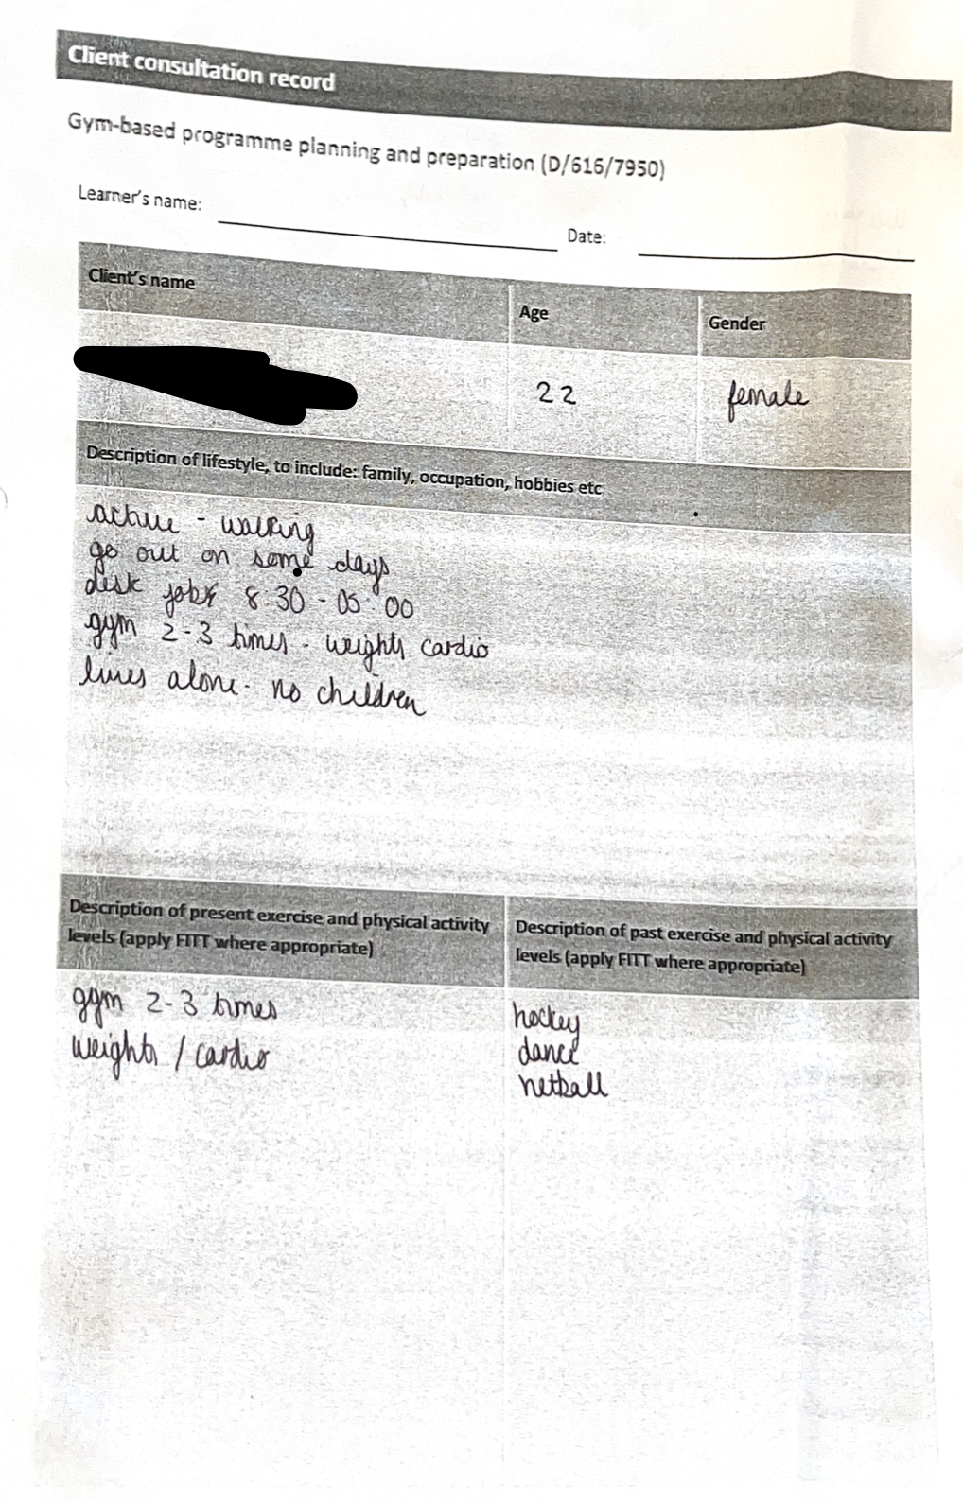

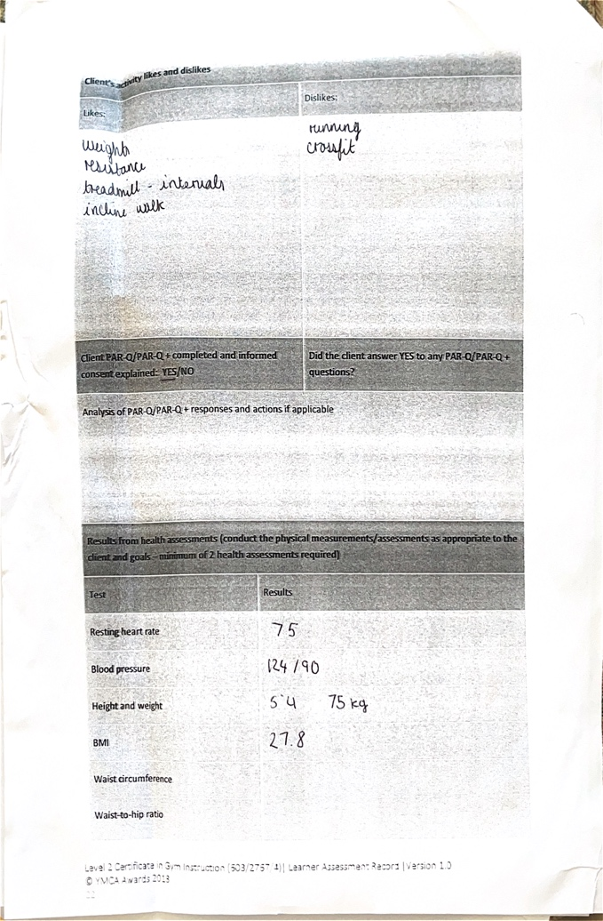

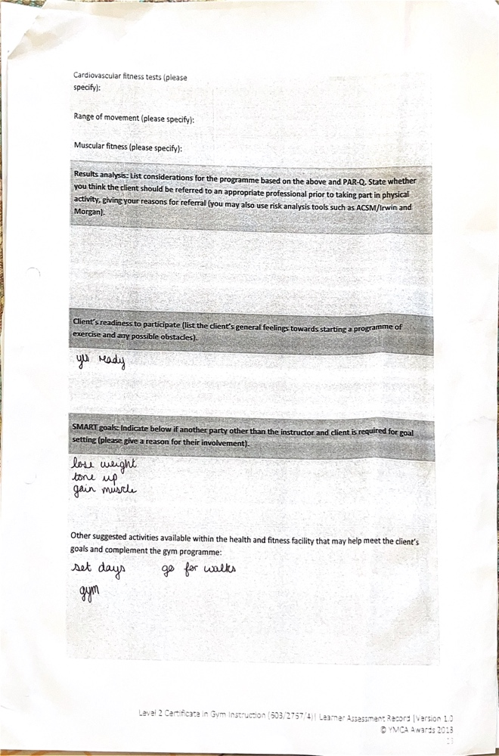

Figure 2 –

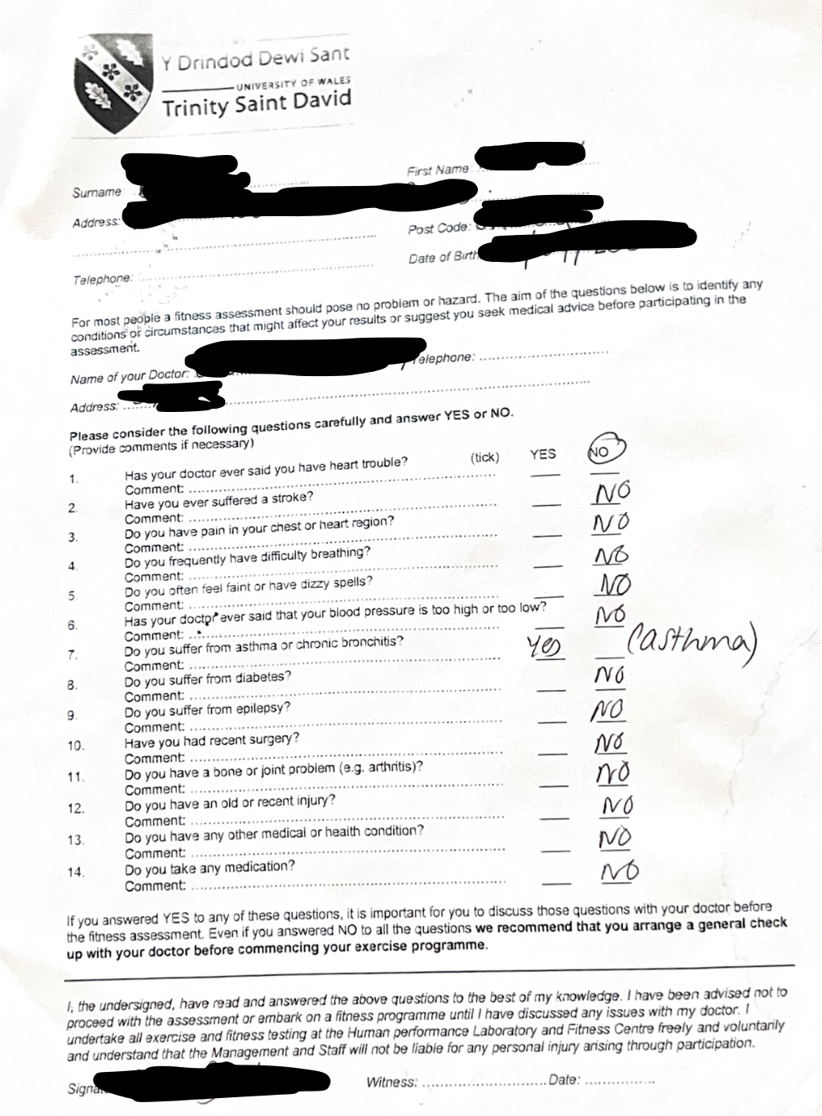

Figure 3 –

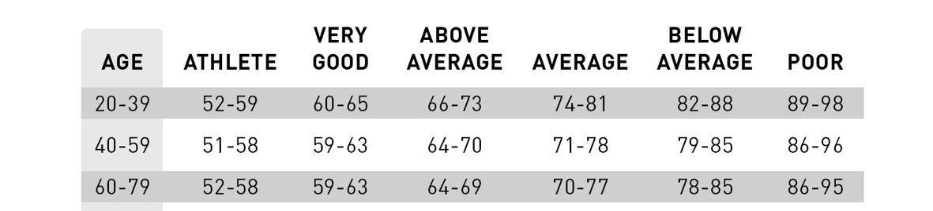

Figure 4 –
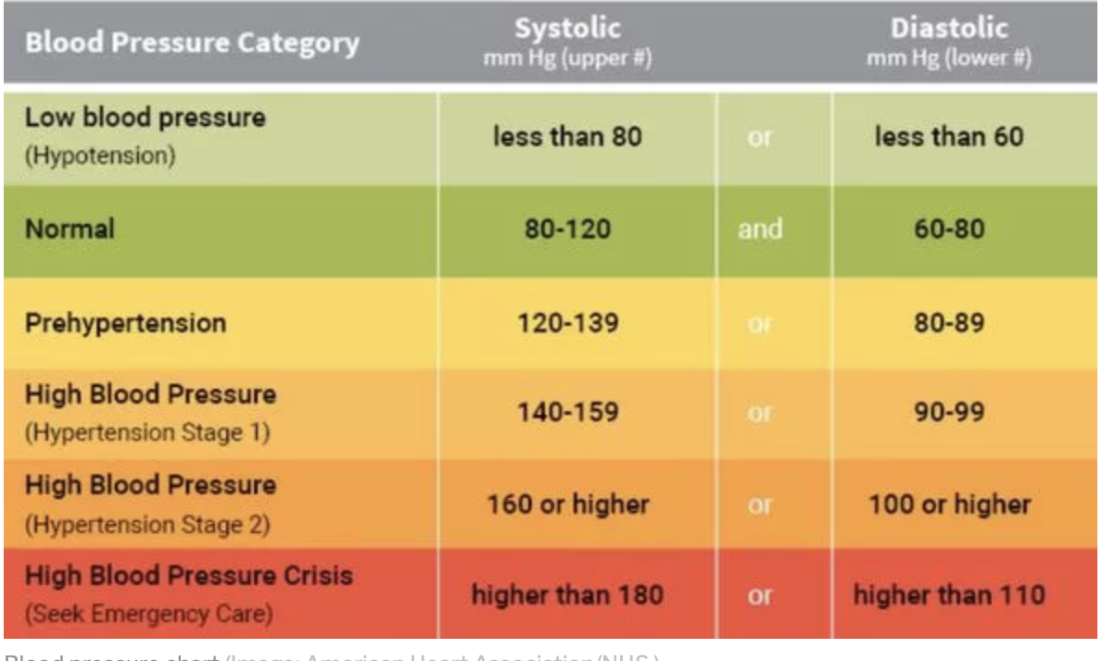

Figure 5 -

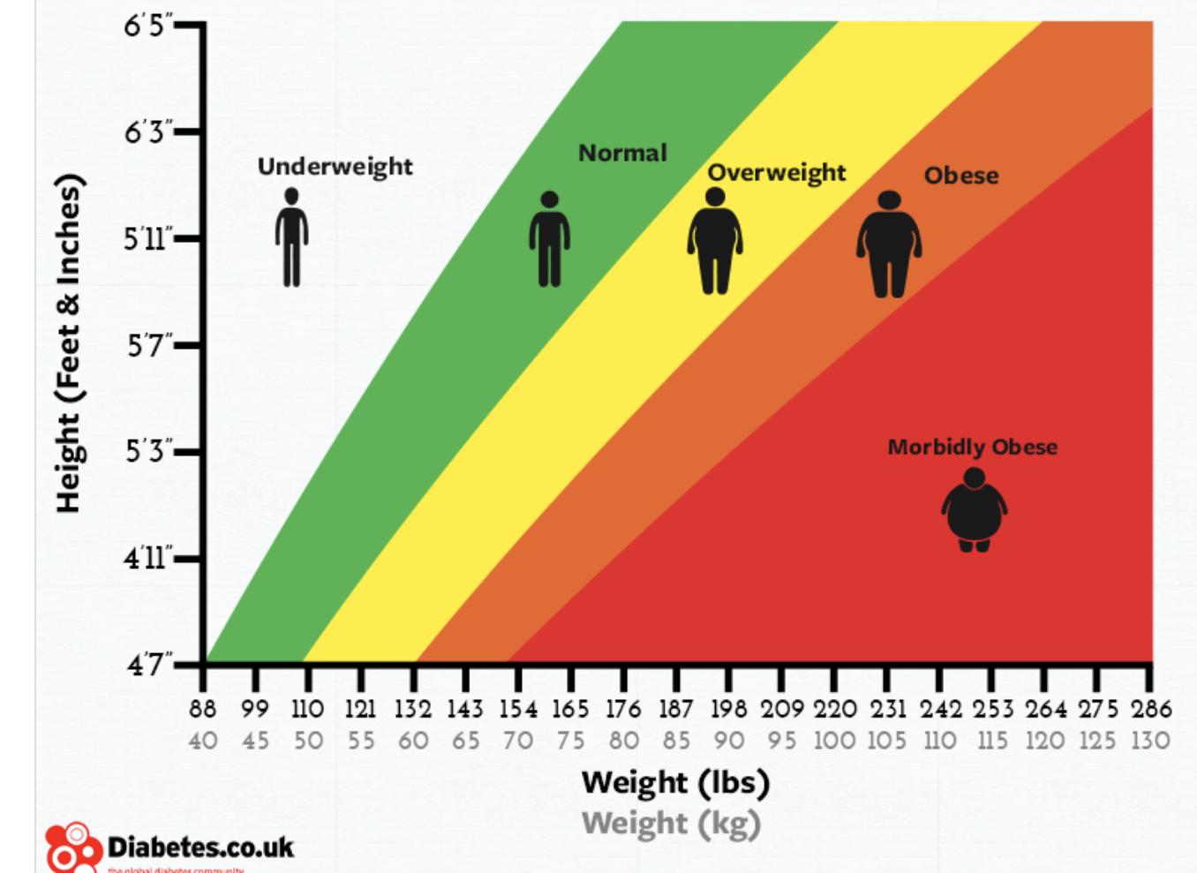

Figure 6 –

Exercise | Duration | Level/Speed | RPE | Alternatives
Treadmill | 5 minutes | Week 1 – Incline 5/Speed 3  Week 2 – Incline 6/Speed 3.5  Week 3- Incline 8/Speed 4  Week 4- Incline 9/ Speed 4.2  Week 5- Incline 10/Speed 4.5  Week 6 – Incline 11/Speed 4.8  Week 7- Incline 12/Speed 4.8  Week 8- Incline 12/Speed 5.0 | 4-6 | Shuttle Runs
30 seconds each-  -Arm circles clockwise  -Arm circles anti-clockwise  -Calf raises  -Torso twist  -Hamstring sweep  -Knee to chest walk  -Bodyweight squat  -Cat cow pose  -Heel kicks  -Chest expansions |  |  | 6-8

Figure 7 –

Exercise | Resistance | Reps | Sets | Rest | RPE | Alternatives
Leg Press (Glutes) | Week 1 – 20  Week 2- 25  Week 3 – 30  Week 4 – 35  Week 5 – 40  Week 6 – 45  Week 7 – 50  Week 8 – 55 | Week 1-5: 8-10  Week 6-8: 8-12 | 3 | 60 seconds | Weeks 1-3: 7  Weeks 4-6: 8  Weeks 7-8: 9/10 | Squat
Bridge with weight | Week 1 -8  Week 2 – 10  Week 3 – 10  Week 4- 12  Week 5 – 12  Week 6 – 14  Week 7 – 14  Week 8 - 16 | Weeks 1-5: 8-10  Weeks 6-8: 8-12 | 3 | 60 seconds | Weeks 1-3: 7  Weeks 4-6: 8  Weeks7-8: 9/10 | Hip Thrust
Lunges with weight | Week 1 – 6  Week 2 – 8  Week 3 – 8  Week 4 – 10  Week 5 – 10  Week 6 – 12  Week 7 – 12  Week 8 - 14 | Weeks 1-5: 8-10  Weeks 6-8: 8-12 | 3 | 60 seconds | Weeks 1-3: 7  Weeks 4-6: 8  Weeks7-8: 9/10 | Bulgarian Split Squat
Leg Extension | Week 1 – 15  Week 2 – 15  Week 3 – 17.5  Week 4 – 17.5  Week 5 – 20  Week 6- 20  Week 7 – 25  Week 8 – 27.5 | Weeks 1-5: 8-10  Weeks 6-8: 8-12 | 3 | 60 seconds | Weeks 1-3: 7  Weeks 4-6: 8  Weeks7-8: 9/10 | Elevated Goblet Squat
Hamstring Curl | Week 1 – 20  Week 2 – 20  Week 4 – 25  Week 5 – 25  Week 6 – 27.5  Week 7 – 30  Week 8 – 32.5 | Weeks 1-5: 8-10  Weeks 6-8: 8-12 | 3 | 60 seconds | Weeks 1-3: 7  Weeks 4-6: 8  Weeks7-8: 9/10 | Kettlebell Swing

Figure 8 –

Exercise | Resistance | Reps | Sets | Rest | RPE | Alternative
Lat Pulldown | Week 1 – 15  Week 2 – 15  Week 3 – 20  Week 4 – 20  Week 5 – 25  Week 6 – 25  Week 7 – 30  Week 8 - 35 | Weeks 1-5: 8-10  Weeks 6-8: 8-12 | 3 | 60 seconds | Weeks 1-3: 7  Weeks 4-6: 8  Weeks7-8: 9/10 | Lateral Raise
Close Grip Pulldown | Week 1 – 10  Week 2 – 10  Week 3 – 15  Week 4 – 15  Week 5 – 20  Week 6 – 20  Week 7 – 25  Week 8 - 25 | Weeks 1-5: 8-10  Weeks 6-8: 8-12 | 3 | 60 seconds | Weeks 1-3: 7  Weeks 4-6: 8  Weeks7-8: 9/10 | Cable Pulldowns
Shoulder Press (machine) | Week 1 – 10  Week 2 – 10  Week 3 – 15  Week 4 – 15  Week 5 – 20  Week 6 – 20  Week 7 – 25  Week 8 - 25 | Weeks 1-5: 8-10  Weeks 6-8: 8-12 | 3 | 60 seconds | Weeks 1-3: 7  Weeks 4-6: 8  Weeks7-8: 9/10 | Dumbbell Shoulder Press
Chest Press (machine) | Week 1 – 5  Week 2 – 10  Week 3 – 10  Week 4- 15  Week 5 – 20  Week 6 – 20  Week 7 – 25  Week 8 -25 | Weeks 1-5: 8-10  Weeks 6-8: 8-12 | 3 | 60 seconds | Weeks 1-3: 7  Weeks 4-6: 8  Weeks7-8: 9/10 | Bench Press
Seated Row | Week 1 – 15  Week 2 – 15  Week 3 – 20  Week 4- 20  Week 5 – 25  Week 6 – 25  Week 7 – 30  Week 8- 30 | Weeks 1-5: 8-10  Weeks 6-8: 8-12 | 3 | 60 seconds | Weeks 1-3: 7  Weeks 4-6: 8  Weeks7-8: 9/10 | Barbell Row

Figure 9 –

Exercise | Resistance | Reps | Sets | Rest | RPE | Alternatives
Lat Pulldown | Week 1 – 15  Week 2 – 15  Week 3 – 20  Week 4 – 20  Week 5 – 25  Week 6 – 25  Week 7 – 30  Week 8 - 35 | Weeks 1-5: 8-10  Weeks 6-8: 8-12 | 3 | 60 seconds | Weeks 1-3: 7  Weeks 4-6: 8  Weeks7-8: 9/10 | Lateral Raise
Leg Press (Glute) | Week 1 – 20  Week 2- 25  Week 3 – 30  Week 4 – 35  Week 5 – 40  Week 6 – 45  Week 7 – 50  Week 8 – 55 | Weeks 1-5: 8-10  Weeks 6-8: 8-12 | 3 | 60 seconds | Weeks 1-3: 7  Weeks 4-6: 8  Weeks7-8: 9/10 | Squat
Shoulder Press (machine) | Week 1 – 10  Week 2 – 10  Week 3 – 15  Week 4 – 15  Week 5 – 20  Week 6 – 20  Week 7 – 25  Week 8 - 25 | Weeks 1-5: 8-10  Weeks 6-8: 8-12 | 3 | 60 seconds | Weeks 1-5: 8-10  Weeks 6-8: 8-12 | Dumbbell Shoulder Press
Leg Extension | Week 1 – 15  Week 2 – 15  Week 3 – 17.5  Week 4 – 17.5  Week 5 – 20  Week 6- 20  Week 7 – 25  Week 8 – 27.5 | Weeks 1-5: 8-10  Weeks 6-8: 8-12 | 3 | 60 seconds | Weeks 1-5: 8-10  Weeks 6-8: 8-12 | Elevated Goblet Squat
Seated Row | Week 1 – 15  Week 2 – 15  Week 3 – 20  Week 4- 20  Week 5 – 25  Week 6 – 25  Week 7 – 30  Week 8- 30 | Weeks 1-5: 8-10  Weeks 6-8: 8-12 | 3 | 60 seconds | Weeks 1-5: 8-10  Weeks 6-8: 8-12 | Barbell Row

Figure 10 –

Exercise | Resistance | Time/Reps | Sets | Rest | RPE | Alternatives
Mountain Climbers |  | 60 seconds | 2 | 30 seconds | Weeks 1-3: 6  Weeks 4-6: 7  Weeks7-8: 8/9
Bird Dog |  | 60 seconds | 2 | 30 seconds | Weeks 1-3: 6  Weeks 4-6: 7  Weeks7-8: 8/9
Wall push-Up |  | 60 seconds | 2 | 30 seconds | Weeks 1-3: 6  Weeks 4-6: 7  Weeks7-8: 8/9
Plank |  | 60 seconds | 2 | 30 seconds | Weeks 1-3: 6  Weeks 4-6: 7  Weeks7-8: 8/9

Figure 11 –

Exercise | Duration | Level/Speed | RPE | Alternatives
Cross-Trainer | 5 minutes |  | Down to 3 | Shuttle Runs
-Overhead Tricep Stretch  -Cross Body Shoulder Stretch  -Abdominal Static Stretch  -Hip Flexor Stretch  -Hamstring Stretch | 60 seconds each | Week 1 – 50  Week 2 – 50  Week 3- 50  Week 4- 50  Week 5- 50  Week 6 – 50  Week 7- 50  Week 8- 50 | Down to 3

References

Aaberg (2007). Resistance Training Instruction. Second Edition. United States of America. Human Kinetics.

Aaberg, (2006). Muscle Mechanics. United States of America. Human Kinetics.

ACSM (2022). Resources for the Personal Trainer. 6th Edition. Philadelphia. Wolters Kluwer.

BEHM, PLEWE, S., GRAGE, P., RABBANI, A., TAGHI BEIGI, H., BYRNE, J. M., & BUTTON, D. C. (2011). Relative static stretch-induced impairments and dynamic stretch-induced enhancements are similar in young and middle-aged men. Applied Physiology, Nutrition, and Metabolism, 36(6), 790–797. https://doi.org/10.1139/h11-107

Cartwright (2005). Fundamentals of Athletic Training. Second Edition. United States of America. Human Kinetics.

Damas, Phillips, S. ., Libardi, C. ., Vechin, F. ., Lixanao, M. ., Jannig, P. R., Costa, L. ., Bacurau, A. ., Snijders, T., Parise, G., Tricoli, V., Roschel, H., & Ugrinowitsch, C. (2016). Resistance training-induced changes in integrated myofibrillar protein synthesis are related to hypertrophy only after attenuation of muscle damage. The Journal of Physiology, 594(18), 5209–5222. https://doi.org/10.1113/JP272472

Diabetes.co.uk (2022). Body Mass Index (BMI) Calculator. Available at: https://www.diabetes.co.uk/bmi.html [Last accessed: 20/04/2023]

Fradkin. (2009). Injury Prevention and Performance Enhancement: The Science of Warm-up. Healthy Learning.

Freitas et al (2017). Role of metabolic stress for enhancing muscle adaptations: Practical applications. Available at: https://www.ncbi.nlm.nih.gov/pmc/articles/PMC5489423/ [Last accessed: 18/04/2023]

Heaney (2009). Exploring Sport and Fitness. United States of America. Routledge

Meserve (2021). What is a good resting heart rate by age and gender? Available at: https://www.whoop.com/thelocker/resting-heart-rate-by-age-and-gender/ [Last accessed: 20/04/2023]

Norris. (2007). The complete guide to stretching (3rd ed.). A. & C. Black.

Otuska et al (2022). Effects of resistance training intensity on muscle quality/quantity in Middle Aged/older people: a randomised controlled trial. Available at: https://onlinelibrary.wiley.com/doi/full/10.1002/jcsm.12941 [Last accessed: 18/04/2022]

Russell et al (2010). Mechanical stress-induced sarcomere assembly for cardiac muscle growth in length and width. Available at: https://www.sciencedirect.com/science/article/abs/pii/S0022282810000775 [Last accessed: 18/04/2023]

Selby and Herdman (1999). Pilates Creating the body you want. United Kingdom. Gaia Books Ltd.

Shepherd (2006). The Complete Guide to Sports Training. London. A&C Black.

Teri S. O’Brien (1997). The Personal Trainer’s handbook. United States of America. Human Kinetics.

Teri S. O’Brien (2003). The Personal Trainer’s Handbook. Second Edition. United States of America. Human Kinetics.

Toua (2021). Blood Pressure chart: what is a healthy range? Available at: https://www.express.co.uk/life-style/health/1454979/blood-pressure-chart-healthy-range-signs-too-high-symptoms-EVG [Last accessed: 20/04/2023]

Van Hooren, B., Peake, J.M. Do We Need a Cool-Down After Exercise? A Narrative Review of the Psychophysiological Effects and the Effects on Performance, Injuries and the Long-Term Adaptive Response. Sports Med 48, 1575–1595 (2018). https://doi.org/10.1007/s40279-018-0916-2

Youth Sport Trust (2001). The Young Athletes Handbook. United States of America. Human Kinetics.

