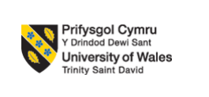
Programme: Master of Business Administration
Module: Marketing Management
Module code: LCMB7024

Assignment Title: Marketing Environment Analysis and Strategic Growth for Tata Steel's Transition to a Low-Carbon Business Model

Student Name: Sajan hareshbhai vekariya
Student ID: 2529464
Total Words: 2602

Table of Contents
Task 1: Marketing Environment Analysis 3
1.1 Natural Environment 3
1.2 Two External Marketing Environment Actor: Political and Legal Environment 6
1.2.1 Actor 1: Political Environment 6
1.2.2 Actor 2: Legal Environment 7
Task 2: Strategic Growth and Competitive Positioning 8
2.1 Ansoff Matrix Overview 8
2.2 Recommended Growth Strategy: Product Development 8
2.3 Competitive Advantage 10
2.4 Risks and Limitations 11
Task 3: Critical Reflection on AI Usage 11
3.1 Tool Disclosure 11
3.2 Critical Evaluation of AI Output 12
3.3 Contribution Analysis 12
3.4 Ethical and Professional Reflection 12
4. Conclusion 13
Reference List 14
Appendices 18
Appendix 1: Application of PESTLE analysis 18
Appendix 2: Screen Clippings of AI Tool Used 19

Task 1: Marketing Environment Analysis

1.1 Natural Environment
Natural environment has emerged as one of the major external influences in decision making for marketing. As defined by Kotler et al., (2024), the natural environment includes natural resources, climate and ecological concerns that affect organisations' ability to create and deliver customer value.
It has been noted that there has been a great environmental challenge faced by the steel industry, as the old-fashioned blast steel making uses a lot of fossil fuel energy and produces about 7 to 9% of the world's CO₂ emissions (Rathore, 2025). Some of the industries that are facing challenges with decarbonisation include the steel industry, which depends highly on coal technologies and requires a lot of investments to change (IEA, 2023). In a similar manner, Mission Possible Partnership (2026) argued that a large-scale technology effort, renewable energy investments, and collaboration of many sectors will be required to achieve the aim of net-zero steel production.
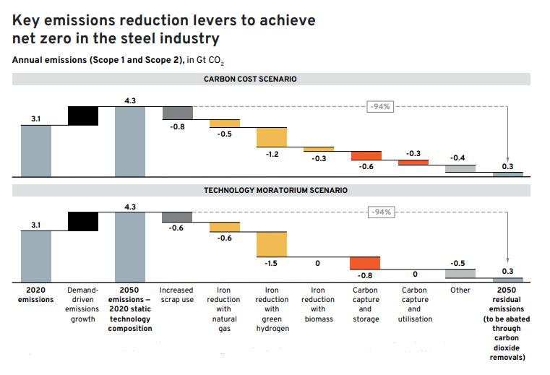
Figure 1: Reduction Levers for Net-zero Emissions
(Source: Mission Possible Partnership, 2026)
The opportunities available are huge in light of the evolving natural environment as well. As highlighted by Tolettini (2025), industrial clients belonging to industries such as the automotive, construction and renewable energy industries are increasingly getting attracted to low-carbon steel in their ESG initiatives. As an investor, it has also become necessary to look at the climate performance of the business in terms of its long-term viability. Although all this will add to the sustainability of Tata Steel, it can distinguish the brand as well. For instance, Bataille et al. (2025) argue that in such a case, if green steel is adopted early enough in the market, there is a competitive advantage in the long run since customer and investor expectations are continuously evolving. However, as stated by IEA (2023), the high capital investment and dependency on renewable energy infrastructure will slow down the profitability of the project.
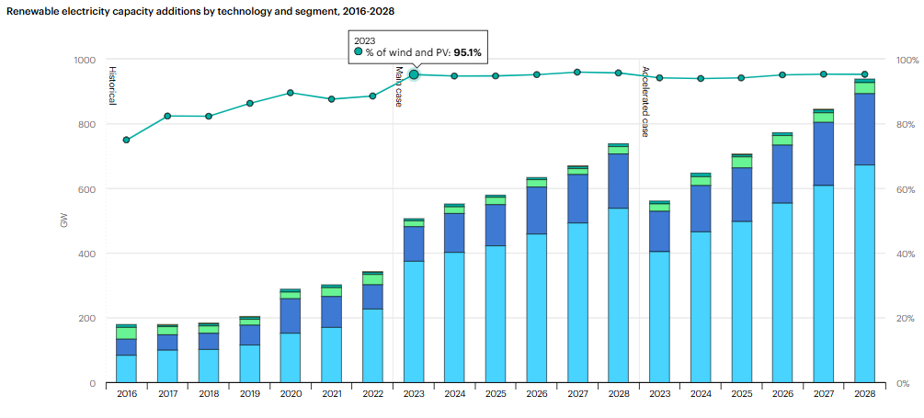
Figure 2: Renewable Energy Infrastructure
(Source: IEA, 2023)
It can be stated that the company has experienced all the environmental issues to a great extent and has played a key role in shaping the direction of growth accordingly. Climate change and greenhouse gas emissions stand as material business risks related to the climate that affect value creation as well as stakeholder relationships in the long run. In response, Tata Steel has invested substantially in technologies that will help manufacture low-carbon steel products. The company has restated its commitment to achieving the goal of becoming Net Zero by 2045, and it is still working on initiatives like carbon capture technology, circular economy (Tata steel, 2026), and hydrogen-based steel manufacturing. Among some of the interesting developments is the 100% scrap-based Electric Arc Furnace (EAF) in Ludhiana that works on 50% renewable energy and produces steel with carbon footprints of less than 0.3 tonnes of CO₂ per tonne of crude steel, much less than the carbon footprint in the blast furnace process (Tata steel, 2026).
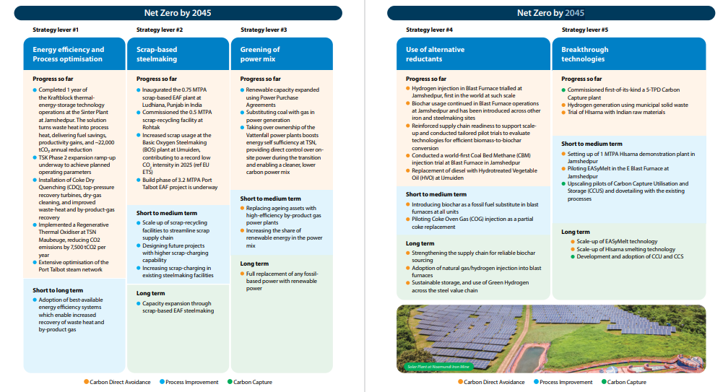
Figure 3: Net-zero by 2045
(Source: Tata steel, 2026)
In addition, Tata Steel is focusing on achieving decarbonised steel manufacturing process in the Netherlands using low carbon technology while setting up EAF plants in the UK for decarbonisation (Tata steel, 2026). In this way, the natural environment is a great market opportunity for Tata Steel as well as a great strategic challenge for which the firm needs constant technological investments and good positioning through communication.

1.2 Two External Marketing Environment Actor: Political and Legal Environment
The political and legal environment is one of the important determinants that will influence Tata Steel's mission towards decarbonising its steel-making processes (Refer to appendix 1).

1.2.1 Actor 1: Political Environment
One of the regulatory measures is the European Union's Carbon Border Adjustment Mechanism (CBAM), which will introduce additional carbon charges on imports of steel that are heavily embedded with carbon. The steel industry is among the industrial sectors that will come under CBAM, hence making the cost of producing steel and exporting it to those markets more expensive due to the cost of compliance with the regulations (Vriz et al., 2026). Consequently, Tata Steel has accelerated investments in technologies for decarbonisation, reporting lifecycle emissions, and manufacturing low-carbon steel to facilitate its entry into the markets (Tata Steel, 2023). However, the intention of India to become net zero emitter by 2070 and developing policies for green steel is the driving factor for local companies to reduce emissions through technological innovations (The Times of India, 2025).
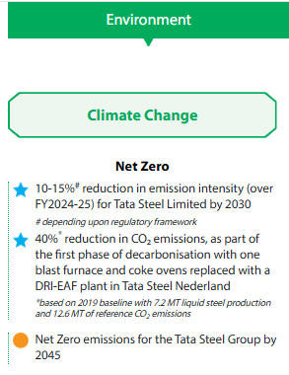
Figure 4: Net Zero Policies of Tata Steel
(Source: Tatasteel, 2024)
From a political context, the level of regulatory uncertainty that exists in the global market, the existence of varied carbon standards and the resultant cost of compliance complicates things and limits the finances of the firms (Samuel, 2025). The governments across the world are increasingly imposing stricter regulations on climate change while at the same time implementing carbon pricing and mandatory emissions disclosures and net-zero commitments, thus compelling the steel manufacturers to integrate sustainability into their strategies and promotional activities (Tata Steel, 2022). There would be large financial investments that would have to be made to change the conventional blast furnace process, and changes in environmental laws might affect its profitability in the short run.

1.2.2 Actor 2: Legal Environment
The support from the government has also shown Tata Steel's steps toward achieving a low-carbon transformation. The Indian Government has offered incentives to produce green steel, development and innovation, using of renewable energy sources and resource-efficient technologies for emission reductions in the steel sector (Reuters, 2025). Tata Steel has supported these initiatives through implementing internal carbon pricing in the investment process, expanding recycling of its steel and utilising hydrogen and electric arc furnace (EAF) technology as part of its climate change strategy (Tata Steel, 2022).
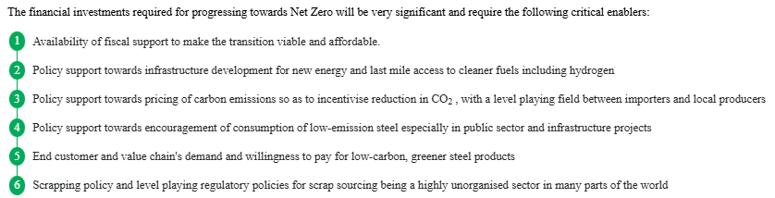
Figure 5: Financial Investment on Net Zero Approach
(Source: Tata Steel, 2022)
In consideration of legal landscapes, the implementation of the policy could be delayed because of lack of adequate infrastructural capacity and inconsistency of policy execution (Wang et al., 2025). However, most significantly, governmental policies create competitive advantage through prioritising sustainability, while marketing success of Tata Steel depends upon the balance of these three factors (The economic times, 2025). For Tata Steel, these developments focus on demonstrating both regulatory obligations and prospects to distinguish its products in environmentally conscious markets in an increasing manner (Tatasteel.com, 2023).

Task 2: Strategic Growth and Competitive Positioning

2.1 Ansoff Matrix Overview
The Ansoff Matrix is one of the major frameworks for the identification of growth opportunities, including market penetration, market development, product development and diversification of the market. Demirci and Erkip (2024) have mentioned that market penetration is one of the primary processes of increasing sales, as it can offer an introduction to the new consumer market using the existing products. The development of new product lines, on the other hand, requires the improvement of the new products or introducing new products. The diversification of the product further requires the development of new products in new markets (Kotler et al., 2024). Based on the analysis of the organisational environment, product development is the most suitable approach for Tata Steel, leveraging the existing consumer demand in the markets. This would further require the supply of green steel for the existing consumer base, including the automotive, packaging, and construction partners.

2.2 Recommended Growth Strategy: Product Development
The product development strategy for Tata Steel is recommended due to the capacity of the organisation for designing and marketing the low-carbon steel products among its existing customers, which can help in carbon footprint reduction during operations. The strategy proposed for the long run development of the organising must include the utilisation of the technologies for the carbon emissions reduction and steel recycling. Jovičević-Klug and Rohwerder, (2023) have mentioned that the renewable electricity sources and the utilisation of the energy efficient manufacturing can be effective for the development of the steel products with a high strength and better quality.
The report from Tata Steel (2026), has already mentioned that the company is committed towards the carbon footprint reduction and maintains the recommendations from the Task Force on Climate-related Financial Disclosures (TCFD) with a dedicated team of climate action and having the Executive Director and Chief Financial Officer as one of the members of the TCFD. Tata Steel, being one of the major suppliers of multiple industries in India, including automobile manufacturing, construction, infrastructural projects, engineering and durable consumer goods, is under high pressure regarding the maintenance of quality and sustainability at the same time. Bangaraju, Aneja and Mishra, (2022) have further highlighted the increasing investment of India in infrastructure. This also highlights the necessity of renewable energy and sustainable manufacturing through carbon emissions reduction in the supply chain process. The formal circular steel economy in India was previously initiated by Tata Steel to develop lower-carbon variants of steel products in scrap-based Electric Arc Furnace (EAF) plants (Tata Steel, 2026B). Investment towards these plants can further help in lower emissions in the domestic infrastructure.
The procedure of the new and sustainable product line must focus on the STP line of the production where the initial step requires the segmentation of the Indian market based on industrial type, environmental conditions, purchasing behaviour, and product usage. The primary sectors that are being identified as potential products include automobile firms, infrastructure firms for the development of green buildings, and renewable energy manufacturers. The company have already developed high-strength steel grades with>600 MPa for automotive applications for vehicle curb weight reduction (Tata Steel, 2026). Therefore, the primary target is the OEMs and large infrastructure developers who are facing challenges related to green procurement. These organisations, with their high potential to value lower carbon emissions and the maintenance of the lifecycle efficiency requires the environmental certification (Sathiyan et al., 2022). Therefore, rather than offering a single product design for all the sectors in the Indian market, it is essential to design as per the market requirement.

2.3 Competitive Advantage
The activity of the competitors represents the urgency of green steel in the Indian market. For example, JSW Steel is integrating sustainable materials as one of its growth strategies through the development of a low-carbon steel solution, including the certification of emissions reduction and the book-and-claim method (JSW Infrastructure, 2026). Similarly, SAIL have also increased its efforts and investment in the reduction of polluting production generation during the development of iron and steel. From the perspective of Porter’s differentiation strategy, the competitive advantage for Tata Steel is in low-cost production with effective differentiation and lower carbon intensity. The competitive positioning of the organisation needs to be maintained as the high tech based and high consumer focused organisation.
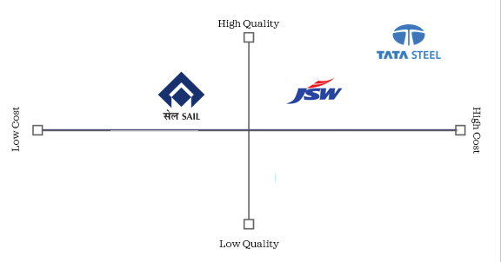
Figure 6: Competitive Positioning of Tata Steel
(Source: Self-generated, information derived from JSW Infrastructure (2026), Tata Steel (2026)
Anderson, Lopez and Parker (2022) have further mentioned that the Digital B2B aggregation platform and the Direct B2C retail can help any organisation in effective channel strategy development. Currently, the key green products of Tata Steel, including Tata TISCON Fe550D or Tata Pravesh, are leveraging the B2C digital platform to become one of the market leaders and enhance brand value for the retail channels. However, competition might arise from Eco-friendly flat steel coils provided by JSW Steel or Heavy structural steel developed by SAIL. To mitigate these challenges, the company must implement the Focused Differentiation strategy to outperform the competitors in both price and quality.

2.4 Risks and Limitations
The proposed strategy has several risks that can have a direct impact on the production of low-carbon steel. One of the primary challenges is the requirement for the considerable capital investment in renewable energy resources including the recycling facilities, electric arc, and other technologies that are effective in the carbon capture (Bahman et al., 2023). This, in the long run, can have a direct impact on the escalation of cost at before understanding sufficient customer demand and the range that can be established for premium pricing.
The primary limitation of the strategy is in market acceptance due to the high price sensitivity among Indian consumers (Bhutto et al., 2022). Without any regulatory, economic, or operational advantage there can be a limitation of the pay extra charges for low-carbon steel. Competitiveness in the recent market has increased with JSW Steel producing and the investments of SAIL in lower-emission technology. To mitigate these challenges, the company first needs to do effective market research and have a proper understanding of the market demand.

Task 3: Critical Reflection on AI Usage

3.1 Tool Disclosure
The creation of the present report has been facilitated using Artificial Intelligence (AI) in a reasonable and responsible manner. As evident from the screen shots shown in the Appendix 1, ChatGPT has been mainly utilised to generate the structure of the report along with the headings and ideas for the Marketing Environment and Growth Strategy Discussion. The only reason for using Grammarly has been to detect and correct all the error related to grammar, spelling and sentence structure of the report.

3.2 Critical Evaluation of AI Output
The assistance received from ChatGPT for the structure of the report and drafting some parts of it was done with careful analysis of the results obtained and their further use in the report. All data about sustainability initiatives of Tata Steel, environmental regulations and corporate decisions of Tata Steel have been verified with Tata Steel's most recent Integrated Report, Sustainability Report, peer-reviewed journal articles, Reuters and Government of India documents and reports of the Carbon Border Adjustment Mechanism (CBAM) from the European Commission. Some of the AI-generated statements turned out to be rather wide or not detailed enough in terms of supporting data. These issues were solved by replacing such statements with up-to-date referenced data and adding academic marketing theories to the analysis.

3.3 Contribution Analysis
AI contributed most prominently to this report in a supportive capacity during its writing process. ChatGPT assisted in preparing an outline for the report, offering ideas about how to structure it with logical headings, to improve sentence structure and grammar. Additionally, ideas on how to discuss the marketing environment and growth strategies have been suggested through ChatGPT. However, the content of the substance was not altered in any way from that of the author himself. Marketing frameworks, assessment of the external environment, evaluation of the evidence and strategic recommendations using the Ansoff Matrix were researched and formulated independently from each other. Arguments used in the report are original and created through research and synthesis of academic literature, company and industry sources.

3.4 Ethical and Professional Reflection
The report has been written based on the principles of academic integrity, honesty, and responsible use of the AI in writing. The AI was only used as a supplement and not as a replacement for independent critical thinking throughout the process of idea generation, structuring and language editing. If the content was created by the AI, then it has been detected, verified, and edited extensively to make sure that it is accurate and original. In case of marketing analysis, the unethical use of AI can lead to creation of inaccurate information or biased information, which can influence marketing plans and can lead to wrong decisions. Therefore, responsible AI focuses on utilising the human judgement, thorough verification of the source, and transparent acknowledgement for the purpose of upholding the ethical standards along with maintaining professional credibility.

4. Conclusion
In general, it can be concluded that the company of Tata Steel operates in an ever-changing environment that is influenced by sustainability, technology and regulation. The use of product development and carbon-low technologies can provide the company with a competitive advantage as well as fulfil the expectations of stakeholders and sustain growth accordingly.

Reference List
Internal Readings:
Kotler, P., Armstrong, G., Harris, L.C. and He, H. (2024). Principles of marketing. 19th edn. Harlow: Pearson.
Additional References:
Anderson, E.G., Lopez, J. and Parker, G.G., (2022). Leveraging value creation to drive the growth of B2B platforms. Production and Operations Management, 31(12), pp.4501-4514. https://papers.ssrn.com/sol3/Delivery.cfm?abstractid=3975711
Bahman, N., Al-Khalifa, M., Al Baharna, S., Abdulmohsen, Z. and Khan, E., (2023). Review of carbon capture and storage technologies in selected industries: potentials and challenges. Reviews in Environmental Science and Bio/Technology, 22(2), pp.451-470. https://www.researchgate.net/profile/Nahed-Bahman-2/publication/368901289_Review_of_carbon_capture_and_storage_technologies_in_selected_industries_potentials_and_challenges/links/66ffdcbc553d245f9e4a1826/Review-of-carbon-capture-and-storage-technologies-in-selected-industries-potentials-and-challenges.pdf
Bangaraju, T., Aneja, P. and Mishra, B., (2022, October). Transport Infrastructure Investment: A Comparative Analysis between China, Russia and India. In IOP Conference Series: Earth and Environmental Science (Vol. 1084, No. 1, p. 012065). IOP Publishing. https://iopscience.iop.org/article/10.1088/1755-1315/1084/1/012065/pdf
Bataille, C., Pai, S., Stiebert, S., Mishra, M., Patil, G. and Francis, L., (2025). Meeting climate targets will lead to major steel production technology shifts and preserve jobs. Available at SSRN 5278075. https://papers.ssrn.com/sol3/Delivery.cfm?abstractid=5278075
Bhutto, M.H., Tariq, B., Azhar, S., Ahmed, K., Khuwaja, F.M. and Han, H., (2022). Predicting consumer purchase intention toward hybrid vehicles: testing the moderating role of price sensitivity. European Business Review, 34(1), pp.62-84. https://jyx.jyu.fi/bitstreams/77db37f7-3eee-4fcc-a3c6-129a22fd3d4f/download
Demirci, E.Z. and Erkip, N., (2024). Integrating efforts for product development and market penetration. European Journal of Operational Research, 312(3), pp.927-937. https://repository.bilkent.edu.tr/bitstreams/143a57d9-a837-4675-987b-39712808f235/download
IEA (2023). Electricity – Renewables 2023 – analysis. International Energy Agency. Available at: https://www.iea.org/reports/renewables-2023/electricity. (Accessed: 23 July 2026).
Jovičević-Klug, P. and Rohwerder, M., (2023). Sustainable new technology for the improvement of metallic materials for future energy applications. Coatings, 13(11), p.1822. https://www.mdpi.com/2079-6412/13/11/1822
JSW Infrastructure (2026) Integrated report 2021-22 sustainable growth for a better everyday, Sustainable Growth for a Better Everyday. Available at: https://www.jswinfrastructure.in/wp-content/uploads/2025/11/JSW-Infrastructure-AR-2021-22.pdf (Accessed: 23 July 2026).
Mission Possible Partnership (2026). Steel | materials - Mission Possible Partnership. Available at: https://missionpossiblepartnership.org/steel-materials/. (Accessed: 23 July 2026).
Rathore, D., (2025). Toward green steel: Role of pilot-scale carbon capture and utilisation technologies. Energy for Sustainable Development, 89, p.101866. https://www.sciencedirect.com/science/article/pii/S0973082625002169
Reuters (2025). India’s steel ministry seeks $1.7 Bln from budget to help mills cut emissions, sources say. Reuters. [online] 16 Jan. Available at: https://www.reuters.com/world/india/indias-steel-ministry-seeks-17-bln-budget-help-mills-cut-emissions-sources-say-2025-01-16/ (Accessed: 23 July 2026).
Samuel, S.A., (2025). Carbon pricing mechanisms for reducing greenhouse gas emissions and encouraging sustainable industrial practices. World J. Adv. Res. Rev, 25(2), pp.1-24. https://www.researchgate.net/profile/Adebayo-Solarin-2/publication/388763454_Corresponding_author_Solarin_Adebayo_Samuel_Carbon_pricing_mechanisms_for_reducing_greenhouse_gas_emissions_and_encouraging_sustainable_industrial_practices/links/67a51d2d645ef274a4731cbd/Corresponding-author-Solarin-Adebayo-Samuel-Carbon-pricing-mechanisms-for-reducing-greenhouse-gas-emissions-and-encouraging-sustainable-industrial-practices.pdf
Sathiyan, S.P., Pratap, C.B., Stonier, A.A., Peter, G., Sherine, A., Praghash, K. and Ganji, V., (2022). Comprehensive assessment of electric vehicle development, deployment, and policy initiatives to reduce GHG emissions: opportunities and challenges. IEEE Access, 10, pp.53614-53639. https://ieeexplore.ieee.org/iel7/6287639/6514899/09775727.pdf
Tata Steel (2022). Sustainability report. [online] Tata Steel. Available at: https://www.tatasteelnederland.com/en/sustainability/report (Accessed: 23 July 2026).
Tata steel (2026). Integrated Report/Annual Report | Tata Steel. Available at: https://www.tatasteel.com/investors/integrated-reportannual-report/. (Accessed: 23 July 2026).
Tata steel. (2026). Tata Steel | Climate action. Tata Steel. Available at: https://www.tatasteel.com/sustainability/environment/climate-action/ (Accessed: 23 July 2026).
Tata steel. (2026B). Tata Steel Inaugurates its first Scrap-based Electric Arc Furnace in India. Available at: Tata Steel. https://www.tatasteel.com/newsroom/press-releases/india/2026/tata-steel-inaugurates-its-first-scrap-based-electric-arc-furnace-in-india/ (Accessed: 23 July 2026).
Tatasteel (2023). Tata steel | climate action. [online] www.tatasteel.com. Available at: https://www.tatasteel.com/sustainability/environment/climate-action/ (Accessed: 23 July 2026).
Tatasteel.com (2023). Tata steel annual report 2023-2024 - Climate Change Report. [online] Tatasteel.com. Available at: https://www.tatasteel.com/investors/integrated-report-2023-24/climate-change-report.html (Accessed: 23 July 2026).
The economic times (2025). Tata steel says monitoring EU, UK policy developments to prioritise, optimise decarbonisation capex. [online] The economic times. Available at: https://economictimes.indiatimes.com/industry/indl-goods/svs/steel/tata-steel-says-monitoring-eu-uk-policy-developments-to-prioritise-optimise-decarbonisation-capex/articleshow/125276299.cms (Accessed: 23 July 2026).
The Times of India (2025). Cbam impact: Carbon cost hits indian steel and aluminium exports from Jan 1, here’s what GTRI report says. [online] The Times of India. Available at: https://timesofindia.indiatimes.com/business/india-business/cbam-impact-carbon-cost-hits-indian-steel-and-aluminium-exports-from-jan-1-heres-what-gtri-report-says/articleshow/126275986.cms (Accessed: 23 July 2026).
Tolettini, L., (2025). SUSTAINABILITY STRATEGIES AND DIGITAL TECHNOLOGIES IN THE STEEL SECTOR. A CASE STUDY. https://www.research.unipd.it/bitstream/11577/3557103/2/Tesi_Laura_Tolettini.pdf
Vriz, G.L., Cojoianu, T., Fischer, C. and Taschini, L., (2026). Early signs that the EU carbon border adjustment mechanism is reshaping EU–India steel trade. Nature Climate Change, 16(6), pp.737-741. https://www.nature.com/articles/s41558-026-02607-y.pdf
Wang, S., Li, Y., Cui, Y., Yu, J., Zhou, C., Ametefe, D.S., John, D. and Darboe, T., (2025). Integrating renewable energy into building energy systems: a systematic review of strategies, barriers, and policy interfaces. Discover Sustainability, 6(1), pp.1-22. https://link.springer.com/content/pdf/10.1007/s43621-025-01966-4.pdf

Appendices

Appendix 1: Application of PESTLE analysis
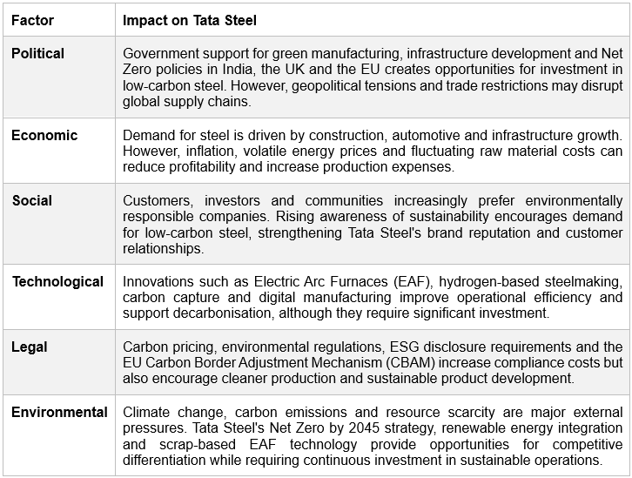

Appendix 2: Screen Clippings of AI Tool Used


