How primary research influence the development of websites?

As part of this assessment we are asked to design and distribute a questionnaire to conduct market research for the business plan we are developing. We designed the questionnaire to help us identify our potential customers and what they will be looking for in such business as ours.
Indian garden ltd is the business we are creating the business plan for, we will be specialising in Indian vegan food, we have a mobile catering van which will be attending food event all around the country, we also have services such as cooking classes, cooking exhibitions and workshops.
By analysis the questionnaires, I will be able to identify the core demographic of our potential customers.

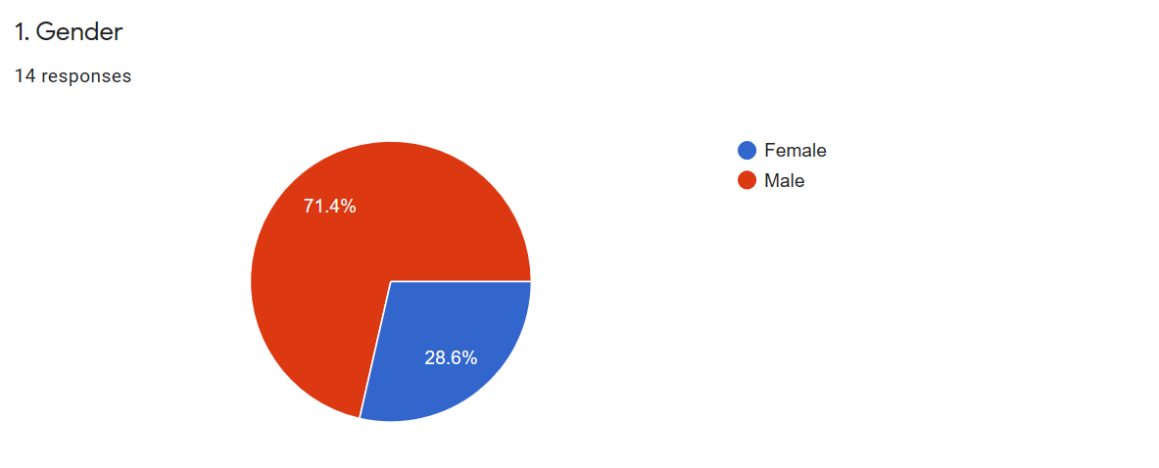

In our questionnaire we asked dependence their gender, and 71.4% where male and 28.6% where female, this will help design the website as our website should be designed to appeal to the male market, but not forgetting the female market, we will target the male market, by creating campaigns that target them, so we will be holding vegan classic car events, and for the women vegan cooking classes and workshops.

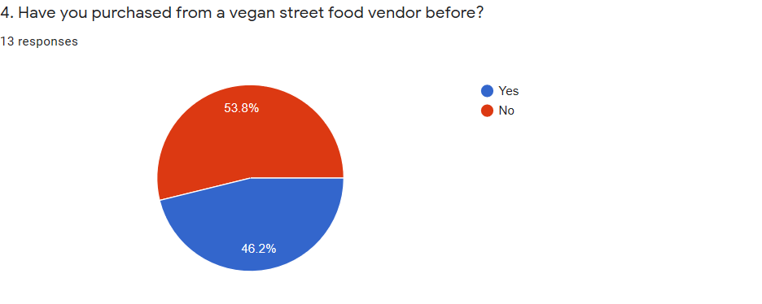A questionnaire was given to 13 people in our classroom, 53.8% said they never tried vegan street food and 46.2% said they have, this is nearly a 50/50 split this show the demand for our vegan street food is getting big quick. When marketing our product and services on our website we will need to educate the meat eater on vegan foods and the benefits to the environment as this will help us grow our vegan market share, also the trend in the vegan market looking forward is growing year on year. We will come up with innovative market strategies to grow our numbers for example targeting the people who have tried vegan food to bring somebody who hasn’t by offering voucher for them to bring a second person, these vouchers can be in the form of e-voucher that can be access from our website.
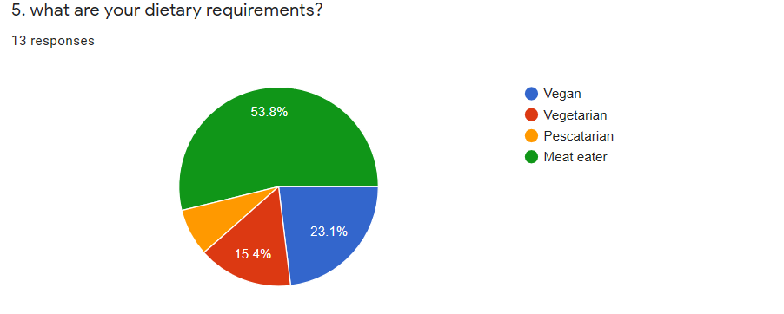We have identified most of our audience as meat eaters, we will be defiantly designing our website with this in mind, we will try to educate people through our website maybe have a recipe page on our web site showing people vegan alterative to meat. We will be a part of the vegan and vegetarian society’s, their logo will be displayed on our website to say we are approved, these society advertises to our chosen target markets, and this will be a great benefit to our business. Vegetarian, vegan and street food are all keyword in my SOE settings.
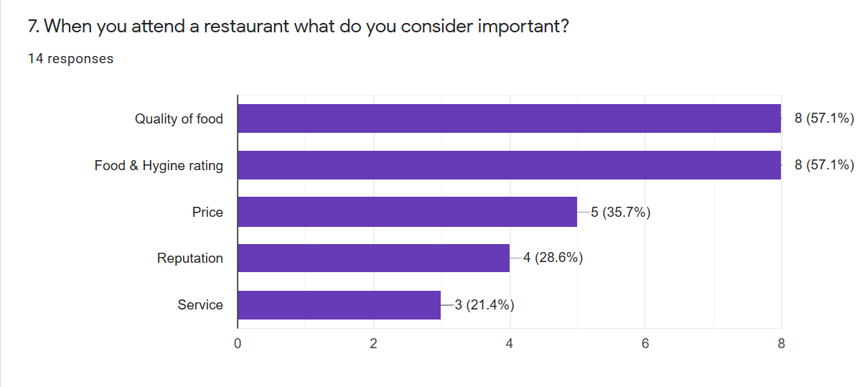
In joint place we have food rating and quality of food, this is why we need to insure we have a 5* rating which will be visible on our website and also a place where customers can leave a review as we are confident with the food so this will show in our review page that the quality of our food is exceptional. we will advertise that we use local produce, this will also be mentioned in our website, words like 5* rating and quality food will be used as key words.

Website analysis
This is a website created for our Indian vegan street food business (INDIAN GARDEN LTD). Within this write up we will explore the reasons why we created our website pages in this way and included the information we did.

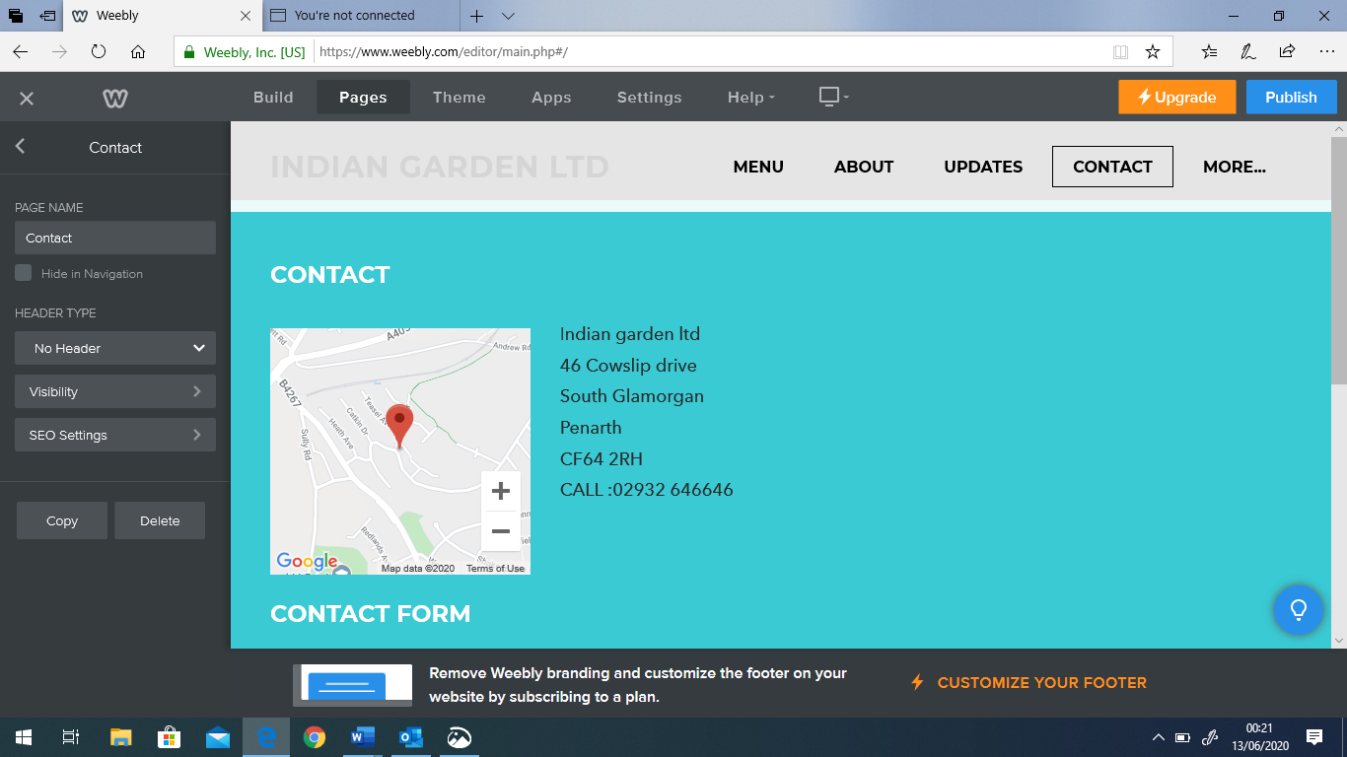
For the contact page I felt it is important to have a map with our location as Google rank website which have map and location in a higher in the search ranking, this is very important for our SEO strategy. The use of our address is important as this also help our rankings on search engines as this will be used in our keywords. Along with our contact number. The layout we used is very clear and precise as it is not confusing and not jammed with information, this gives a more professional effect. The colours we used are neutral and refreshing this gives a relax and confident look and is appealing to our audience, making them feel more welcomed.
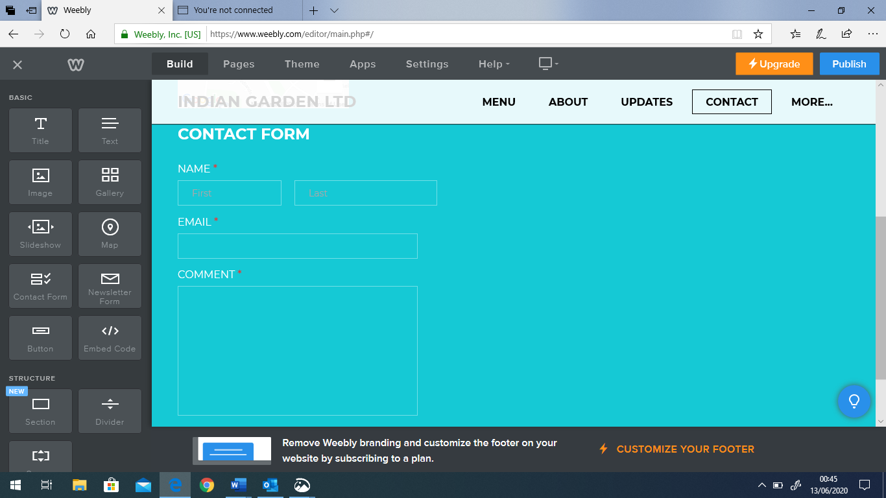
We have also added a contact form where people could include their email address, we did this for many reasons, firstly so people can contact us regarding booking and inquires and new business. This is very important tool in getting leads and more business. Secondly and more importantly if customer allow us, we can use their email addresses to target them in future marketing campaigns. This will be great way of building our marketing database. We must follow GDPR guidelines to capture this information, so we will have to have a tick box where users can allow us to obtain their information for marketing purposes and promotions.

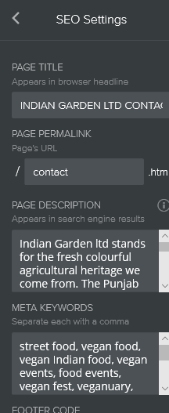
page description
Indian Garden ltd stands for the fresh colourful agricultural heritage we come from. The Punjab which is a region in India which is known as the garden of India, it has a wide array of fruit vegetables and grains and therefore it is famous for is vegan food dishes. It’s a big part of many cultures in India to eat a vegan diet and this is a way of life for many people. There are a wide range of tasty Indian vegan street food dishes which we want to show case and introduce to the UK street food scene, while doing this we want to keep it authentic and do many famous vegan street food dishes from as many locations as possible. Therefore, we felt it best to be on a mobile food van so we can share our passion for our food across the UK working many food and wellbeing events to promote and sell our products.
Keywords
street food, vegan food, vegan Indian food, vegan events, food events, vegan fest, Veganuary, vegan cooking experience, Punjabi vegan food, healthy eating, wellbeing events, Cardiff, Bristol, Swansea, London

1817040lr@gmail.com
Password: Myakaur2010

