

WORKING FROM HOME

PATRICIA FAKROGHA
1606024
RESEARCHING AND ANALYSING DATA
MUSHFIQUR RAHMAN
Executive Summary
The primary purpose of this study is to examine two sides of an argument, but related, working from home vs Working in the office. Secondary purposes are to assess the advantages and disadvantages of the argument ad the benefits to the person and the business.

One of the most important conclusions is that working from home has its perks and downfalls. Even though is saves money in terms of commuting, traffic is avoided and gives you freedom and flexibility, while others believe that it is a distraction and find it difficult to maintain professionalism. In my opinion, it is better to keep the two separated and find the right balance that works for me.

Table of Contents
Executive Summary
- Introduction
  - Aims and Objectives
  - Research Questions
  - Background
- Literature Review
- Methodology
  - Data
- Findings and Analysis
  - Analysis
  - Advantages and Disadvantages
- Conclusion and Limitations
References
Appendix

- Introduction
A company’s technology development process is achieved by both in- house research and development through external sources (Croisier,1998), also through distributed sources (Chesbrough, 2003; Changi, 2004; Grand strand et al, 1997). For at least 20 years there has been people working from home. This could range from a career choice that is popular now for example, people running their own business online, or people that decide to take on their organisations workload from the comfort of their home with a company tech equipment. Most people prefer this way of working as they find it more comfortable and more flexible with their lifestyle.

However, some argue that working from home does not give you the experience of working in a professional setting. With this majority of companies require workers that would work in the office.

We can already see there are advantages and disadvantages of both sides, in this report we look at a number if articles that would assist in discussing the advantages and disadvantages of working from home vs working from the office.

  - Aims and Objectives
The aim of this report is to examine two sides of an argument, working from home vs working from the office, and show evidence for both views.

  - Research Questions
- Is working from home more productive than in the office?
- What will be the future impact of working from home?
- What is the impact of working from the office?

  - Background
“The concept of work-life balance is a fleeting idea for a Bombshell. Instead, a focus on work-life success where time and energy shifts based on the rotating demands of each area of life is far more realistic” (Hurdle,2017). Knowing how to balance out work and personal life makes working anywhere a lot easier.

This report examines the findings of thorough research to find out whether working
from home is feasible or not.

To gather and make a fair conclusion on this subject, I have undertaken 50 surveys to
understand each person’s preferences. My research has data from the questionnaire
survey that was given to all employed workers, self-employed and non-workers to
balance out a fair conclusion.

- Literature Review
The articles reviewed gives an understanding of what working from have can add or even take away from a person. They talk about the benefits or working from home and gives points on the society today and how technology has really made an impact on the work life.

In one of the articles it gives ten benefits of working from home, with surveyed results;
- Environmentally Friendly: 23%
- More Time with family: 29%
- Less Stressful environment: 38%
- Quieter atmosphere: 43%
- Eliminate long commute: 44%
- Less distractions: 44%
- More productive: 45%
- Avoid Traffic: 47%
- Save gas: 55%
- Work/home balance: 60%
The article listed all these out in a way that readers are able to understand why the survey was done with backed up evidence.

- Methodology
  - Data
The data for this research are from questionnaire surveys. It was conducted through a selection of different participants in a work environment. The survey consisted of three quantitative questions. After surveys were collected appreciation and thank you notes were sent out for their participation.

Data percentage can b seen in Appendix Table 1

- Findings and Analysis
  - Analysis
The questionnaire surveys have revealed that 55% would work from home. This is now a popular trend in today’s modern world. With the increased development and wide use of the internet, people are now choosing to work from home. The mail online released an article saying that “People who work from home are more productive because they avoid distracting ‘office chat’ and try harder out of fear of looking lazy” (Allen, 2017). Working from home relieves an employee from stress they get daily from the organisation that they work for, this s regardless of health conditions, weather, family circumstances and other happenings in their life (Salary.com,2015).

According to Work Without Walls survey, they list out a percentage of benefits attached to working from home:
- Less stressful environment: 38%
- Quiet Atmosphere: 43%
- No longer commute: 44%
- No distractions: 44%
- More productive work: 45%
- Saving money: 55%
- Home/ work balance: 60%
With this survey from Forbes (2015), it stills enhances the lack of control and inability to see results of not working from the office can affect the productivity of those employees that work from home in a negative way of not having the experience of working in a professional setting.
  - Advantages and Disadvantages
In this report, there has been an argument of whether working from home is more effective than working from the office. This section would list out the advantages and disadvantages by working from home.
Advantages
- Saves time and Money
- Working from home brings monetary value
- Saves Valuable resources
- Can work flexible hours
- Less commuting
- Able to spend more time with family
Disadvantages
- Can hamper team harmony
- Can tamper with office professionalism skills
- Separates people from an office environment
- It would be a challenge to manage your time correctly and effectively
- It requires self- discipline
- Less professional experience

- Conclusion and Limitations
In conclusion, this report has examined the argument of whether working at home is more productive tan working from the office. The argument includes, but not limited to;

Working from home generally improves employee satisfaction with their lives and workplace. For example, it lessens the number of absences due to health conditions or other reasons such as family troubles or emergencies. Working from home, reduces any distractions and more productive work is produced. The biggest example is the saving of money on transport and it minimizes workplace discrimination.

It is important to consider the working atmosphere. For example, you avoid any office chats or any pressure to get work done as fast as possible. It is quiet and you are able to focus on the work without any interruption. Working from home you have the luxury of designing your office to suit you and easier to get around and reach for files and documents.

A flexible working arrangement. Working from home you have the final say over how, where, or when you work. You benefit from an element of freedom to determine any working arrangement that goes with your lifestyle. The benefits of having a flexible work- time focus mainly on improving a better work- life balance, while also looking after health and well- being.

Based on all the arguments it can be said that working from home in the modern times we are living in stands a better chance of productive and effective work being done.

References
Allen, V (2017) People who work from home are MORE productive because they avoid distracting ‘office char’ and try harder out of fear of looking lazy. [online] Available: http://www.dailymail.co.uk/sciencetech/article-4945486/People-work-home-productive
Accessed: 12th December 2017

Bailey, S (2012) Does working from home work. [online] Available: https://www.forbes.com/sites/Sebastianbailey/2012/09/19/does-working-from-home-work Accessed: 10th January 2018

Barton, E (2017) Working from home may actually hurt your career. [online] Available: http://www.bbc.com/capital/story/20170418-how-working-from-home-ruins-everything
Accessed: 7th January 2018

Boag, P (2013) The benefits and challenges of remote working. [online] Available: https://boagworld.com/digital-strategy/remote-working-2/
Accessed: 8th January 2018

Chang,Y.-C. (2004), Benefits of co-operation on innovation performance: evidence from integrated circuits and biotechnology firms in Taiwan and the UK, R&D Management, Vol. 33 (4) 425-437

Chest rough, H. (2003), Open innovation: The new imperative for creating and profiting from Technology, Harvard Business School Press, Cambridge

Christie, S (2017) Seven Reasons why home working is the future. [online] Available: https://www.telegraph.co.uk/Business/2017/07/24/seven-reasons-home-working-is-the-future
Accessed: 10th January 2018

Crosier,B. (1998). The governance of external research: empirical test of some transaction-cost related factors, R&D Management, Vol. 28(4) 289-298

Forbes Magazine (2015) Top 10 Benefits of working from home ( Survey Results)

Grandstrand, O., Patel, P. And Pavitt, K. (1997), Multi technology corporations: why they have ‘distributed’ rather than ‘distinctive core’ competencies, California Management Review. Vol39(4) 17-29

O’Mahony, H (2017) Why Now’s the time to embrace flexible working. [online] Available: https://jobs.guardian.com/article/why-now-s-the-time-to-embrace-flexible-working/
Accessed: 12th December 2017

Salary.com (2015) 5 Reasons to Let Employees work from home

Appendix
Table 1: Data Collection Percentage
Agree | 55%
Disagree | 5%
Neither Agree nor Disagree | 40%

Picture 2: Survey Questionnaire
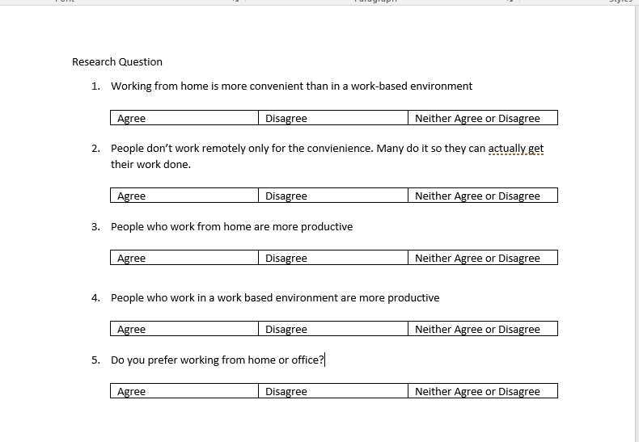
Picture 3: Research Question answers


