

University of Wales
Name: Mir Saleha Begum
Student ID: 1810254
Module Title: Problem Solving and Decision Making
Assignment Title: A Written Report on Problem of Favouritism at Workplace and its Solution.
Module Lecturer: Afzal Munna

Contents Page number

1.0 Introduction ……………………………………………………… …. 3
2.0 Favouritism and its causes. …………………………………………. 3
2.1 Disadvantages of favouritism. …………………………………….. 4
2.2 Overcoming favouritism ………………………………………….… 5
2.3 My experience of favouritism at workplace …………………….... 6
3.0 Problem solving and its steps. …………………………………….. 6
4.0 Decision making, its types and process. …………………………. 7
4.1 Types of decision making ………………………………………...... 7
4.2 Decision making process …………………………………………. 7
4.3 Factors affecting decision making …………………………………. 7
4.4 Analysis which are essential for good decision making. ……… 8
5.0 Ishikawa/ Fishbone analysis ……………………………………….. 11
6.0 Proposed solutions ………………………………………………….. 12
7.0 Evaluation of the proposed solutions …………………………….. 13
8.0 Implementation of the plan for the proposed solution ………….. 13
9.0 Monitor and review of the implementing plan ………………….. 14
10.0 Conclusion ………………………………………………………… 15
References ……………………………………………………………… 16

A Written Report on Problem of Favouritism at Workplace and it’s Solution
1.0 Introduction
In a basic sense, favouritism is favouring an individual not in view of his/her performance and capacities, yet rather as a result of individual preferences. Favouritism can take type of recruiting based on contact or personal connection, honouring, rewarding, promoting, or offering granting contracts. In the following study, I will discuss about various aspects of favouritism including my own experience with the problem, and present an action plan to manage the issue, detailing what has been done and how the circumstance was settled.
2.0 Favouritism and its causes
The term favouritism can be defined as giving someone in particular or gathering exceptional treatment to the detriment and weakness of others. Equivalent chance, equity, and reasonableness are disregarded when favouritism is utilized in any determination procedure (John Bright 2019). Causes of favouritism has described below.
Desire: Desire influence people support one individual over another. It may not really be a craving for the person concerning love or friendship. It could be on the grounds that the individual can offer a type of bit of advantage in the field of business or social status.
Self-regard/ Pride: Self-regard or pride some time makes people blind to understand the goodness for everybody concerned. They accept any choice they make, regardless of what points they base their choices on, will be correct.
Authority and Power: Self-admiring individuals additionally prefer to apply authority at the time they usually in places of obligation and power. In some cases these people like to use their capacity by choosing somebody for a situation for no other explanation than they have the ability to do it.
Connection/attachment: Everybody in life is closely related to specific individuals, excitements, wants, propensities, and methods for getting things done. They incline toward these despite the fact that occasionally clearly they will mess up themselves or others.
Reliance: Individuals who are reliant on others due to incapacity or some imperfection in their character normally incline toward those people who demonstrate an ability to take into account their wants, despite the fact that these wants may not be to their greatest advantage.
Jealousy: Jealousy can create two inverse consequences for a person where favouritism is related.
Expectations: At the point when people think someone in particular will act in their own eventual benefits or support themselves over others at the time of picking individuals for exercises and tasks, they will be slanted to support them. So expectations can also be sometime responsible for favouritism at workplace.
Greed: Greed might be the motivation behind why people support individuals who offer limits and benefits within the workplace.
Bigotry, Prejudice, Racism, and Discrimination: It is shocking that people exhibit these demeanours in their cooperation with individuals who don't have similar perspectives, religion, skin shading, sex, body shape, race, or nation of inception. These instances of bias and prejudice are not clear until clashes emerge.
Lust/Desire: When people from two different genders want themselves, they are bound to treat them well and incline toward their organization to other people.
Pity: There are also situations like when people within the organisation go through difficult situations and they feel frustrated about them. The management people in general treat them with more thoughtfulness and support them with regards to magnanimous activities, gifts, and awards.
Selfishness and Self-intrigue: Grownup people frequently settle on choices dependent on their selfishness and self-interest with the goal that they get the most advantage out of a circumstance or movement.
2.1 Disadvantages of favouritism
Disadvantages of favouritism have explained below.
Dishonesty: Favouritism creates dishonesty in light of the fact that, when someone show inclination for one individual over another.
Prejudice: Favouritism when based on preference creates the hostility between individuals isolated by their convictions and frames of mind. Individuals of different sorts, types, and gatherings will in general partner with those with like convictions adding to the issue of separation.
Misery/Hopelessness: People who experience the ill effects of the favouritism by their colleagues, trailed by being disregarded for advancements and different focal points at work, may reach the resolution that they are not deserving of the adoration or kinship of others.
Envy: Envy is another disadvantage, for example when individuals select companions, it isn't on the grounds that they detest another person and really treat them in a bad way; it is on the grounds that somewhere deep down forces them towards the individuals who they select as their dear companions. This is the reason, much of the time, the individuals who are the casualties of dislike and envy can't comprehend what the issue is.
Absence of Self-regard: Absence of confidence can likewise be the consequence of intentional or oblivious favouritism.
Depression/Loneliness: Sometime favouritism can reverse on individuals and creates dejection or depression afterwards.
No Commitment or Loyalty: People that have representatives working for them and demonstrate favouritism when giving advancements, pay rises, or different advantages loses the dedication of staffs who are normally left off the rundown of recipients.
No Self-regard: When favouritism is utilized as an approach to decide anything to do with one's associations with others, sense of pride is lost by the individuals who are chosen, the individuals who are not chosen, and by the individual who is choosing.
2.2 Overcoming favouritism
According to Sreeradha D Basu (2013), there are the following ways to overcome favouritism practice at the workplace which is discussed below.
- It is important to analyse the situation if somebody is a victim of favouritism. Analysing the situation can bring out a clear picture to employees within the workplace that why and how the favouritism is happening.
- It is important to maintain a positive attitude after knowing that favouritism practice is happening within the workplace because it will help the employees to move on as the people who are responsible for favouritism are powerful within the organisation.
- It is important to avoid gossip because tattling about the circumstance with other employees within the organisation won't help in any capacity. All it will do is make the circumstance increasingly tense and negative.
- It is very important to speak up about the situation because a great deal of times some employees might be playing favourites, yet the organisation may not know about it. At that point the employees can take the issue up with the HR or even the higher management.
- Finally it is important to search for alternatives to deal with the problem because if the situation isn’t improving and nobody is tuning in, then employees have to proceed onward. Proceeding onward is very important and eventually it will find a solution for the problem.

2.3 My experience of favouritism at workplace
The problems that I have identified at my workplace are discussed below.
I am in retail and working in Sainsbury’s from few years. When I started, the store has hired eight individuals on staff who were altogether contracted simultaneously and trained together also having same capacity levels and abilities. This has brought about one individual from this gathering accepting propelled duties at an early time, although she was not more than equipped for taking care of them. She was not performing well but she was continuing the duties and responsibilities. Later we have learnt that she was a good friend of the store manager.
Then there came some situation when I had to move from Manchester to London for my study purposes and after coming here I started working with Sainsbury’s again. After joining my store I have realised that 80% of the employees there are from African origin. The store manager and the area manager are also African British. So I understood that they are favouring people from African origin.
I have also noticed that somebody is more than once the beneficiary of different advantages or rewards at workplace when these people don’t even know what their jobs and also don’t have the capacity to communicate properly at the workplace.
I have also noticed that our store manager is especially open to the proposals and thoughts of a specific worker, this could be an indication of partiality – particularly if the recommendations are bad. Lot of us assume that the store manager and the worker are having an affair.
3.0 Problem solving and its steps
Favouritism is a problem for any organisation and it is important to know and understand the mechanism of problem solving. problems are at the focal point of what we do at work each day. A key piece of each manager's job is discovering approaches to understand them (Henry Kaiser 2019).
The seven-strides for a compelling problem solving procedure have given below.
- Recognize the issues
- Comprehend everybody's inclinations
- List the potential choices
- Assess the choices
- Select a choice
- Document the agreement
- Concede to possibilities, monitoring, and evaluation

4.0 Decision making, its types and process
Decision making can be defined as the manner of thinking of choosing a legitimate decision from the accessible choices. When attempting to settle on a decent decision, an individual need to weight the positives and negatives of every choice while considering other options. For powerful basic decision making, an individual need to have the option to figure the result of every choice well in advance, and also figure out which decision is the best for that specific circumstance (Brockmann et al 2002). In the more extensive procedure of critical thinking, basic decision making includes picking between potential solutions for an issue. Choices can be made through either an instinctive or contemplated process or a mix of the two (Skills you need 2011).
4.1 Types of decision making
There are various types of decision making such as
- Standard and Basic Decision Making
- Individual and Organizational Decision Making
- Individual and Group Decision Making
- Strategy and Operating Decision Making
- Programmed and Non-Programmed Decision Making
- Planned and Unplanned Decision Making
- Tactical and Strategic Decision Making and Organizational
- Departmental and Interdepartmental Decisions Making
4.2 Decision making process
It is very important to know and understand the decision making process. The process has described below.
- At first it’s important to identify the problem for the decision
- Gather related data regarding the problem
- Identifying the options to create decision
- Weighing the proof
- Choosing among options
- Taking action
- Reviewing the decision and its results
4.3 Factors affecting decision making
The most common and important factors that influence decision making are explained below.
Personal factors: Personal Demographics like age, sexual orientation, organizes in life cycle, instruction, profession, financial position are some of the important factors that influence decision making. There are some other factors like a person’s way of life, dispositions, self-idea, and worry about status, esteem frameworks, convictions and so forth.
Cultural factors: Cultural factors are simply a combination of components like religion, customs, taboos, language, and training, childhood, set up example of social conduct, values and so on which influence decision making.
Social factors: Basically social factors involve family, companions, peer gatherings, close associates and affectionate associations. These people have the high believability and impact.
Information: Information for decision making ought to be real, dependable, and satisfactory and must be accessible within a given time. Information overload makes perplexity and slow down the decision making process.
Psychological factors: Factors like motivation and employees perceptions are very important factors. There are some other factors like selective consideration, deformation and maintenance. Learning Process is also an important factor as individuals do change their convictions, beliefs, likes and abhorrence which occur through learning.
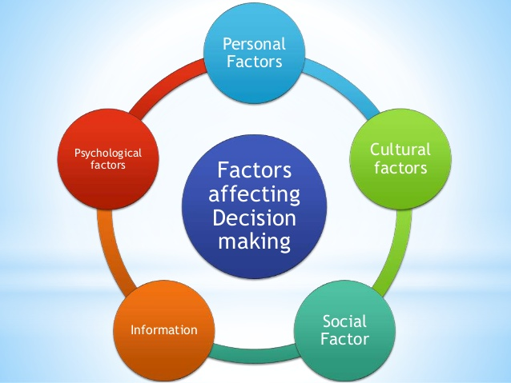

(Source: https://www.slideshare.net/ektabelwal/factors-affecting-decision-making, slide number 18)
4.4 Essentials for good decision making
The SWOT analysis is one of the best and helpful apparatus for comprehension and decision making for a wide range of circumstances in business and associations. SWOT is an abbreviation for Strengths, Weaknesses, Opportunities, and Threats. It will be better understand by the following picture.
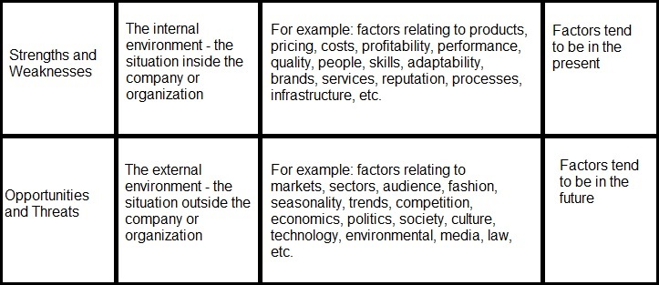
Now I will do a SWOT analysis on the basis of favouritism at my workplace.
Strengths
- Managers may know the capabilities of the individuals that they are hiring of favouring
- Individuals who are part of managers friends, family or may be familiar with the functioning of the organisation as they are close to the managers
- Close friends and individuals who are favoured by the manager usually possess a strong commitment to the manager. They are always willing to work long hours like evening shifts or during the weekends. Managers get the work done and the individual’s benefits from the extra payment as they work longer
Weakness
- A good friend or relative can exploit their status, realizing that it is progressively hard to fire somebody who is close to the manager.
- Jealousy within employees because of favouritism practice within the organisation
- It might be increasingly hard to make a fundamental change in the working environment when it may adversely influence manager's friend or relative that works for them
- Managers that have fallen into the snare of favouritism usually disregard or excuse the quality of work or invest individual energy with selected representatives, while barring others
- Favouritism creates low morale within the employees
- Low morale within the employees creates low productivity
- Low productivity within the employees influences the performance and profitability of the organisation
- Low motivation within the employees
Opportunities
- Favouritism practice at workplace benefits both the manager as well as the favoured employees
- Both the manager as well as the favoured employees has a chance of taking advantage of each other
- Getting promotion, bonuses, rewards etc without considering the performances
Threats
- In some cases favouritism can prompt to lawsuits, which notwithstanding having serious monetary consequences
- Unhappy employees may leave the job
- Manager can be sacked if the higher management has the proof of favouritism practice at the workplace
- Manager can be under hard legal action if he/she is favouring someone for sexual benefits
So from the above SWOT analysis I have found some information which will help me in the decision making of overcoming this problem.
Now it is important to do a PMI analysis which will give more insight to the problem. PMI which means plus, minus and intriguing is a conceptualizing, decision making and basic reasoning apparatus. It is utilized to energize the assessment of thoughts, ideas and encounters from more than one point of view. PMI was created by Dr. Edward de Bono, a defender of parallel and basic reasoning (Mike Clayton 2015).
P | M | I
- Managers may know the capabilities of the individuals that they are hiring of favouring  - Favoured people are familiar with the functioning of the organisation as they are close to the manager  - Favoured people have strong commitment to the manager as they are taking advantage | - Employees take advantage as they are close to the manager  - Jealousy within employees as there is no fair practice in the promotion and reward system  - It is hard to make a fundamental change in the working environment when it may adversely influence manager's friend or relative  - Low morale within employees  - Low motivational practice  - Low productivity  - Overall low performance and profitability | - The higher management should always need to keep their eyes open and they need to introduce a new policy to defend favouritism  - The higher management should hire new employees through third party organisation who are specialised for hiring effective people as per the demand of the organisation.  - The higher management should listen to their representatives. They should encourage a domain of open correspondence and also review information, surveys, feedback, input, and post-employment surveys

5.0 Ishikawa/ Fishbone analysis
I have already discussed my problems with favouritism at my workplace and based on that I will do an Ishikawa/ Fishbone analysis. This analysis usually expressed through a diagram. Before I start it is very important to define the Ishikawa/ Fishbone analysis. The diagram is a causal outlines that show the reasons for a particular occasion (Ishikawa, Kaoru 1968). The analysis is shown below based on the problem that I have identified at the workplace.
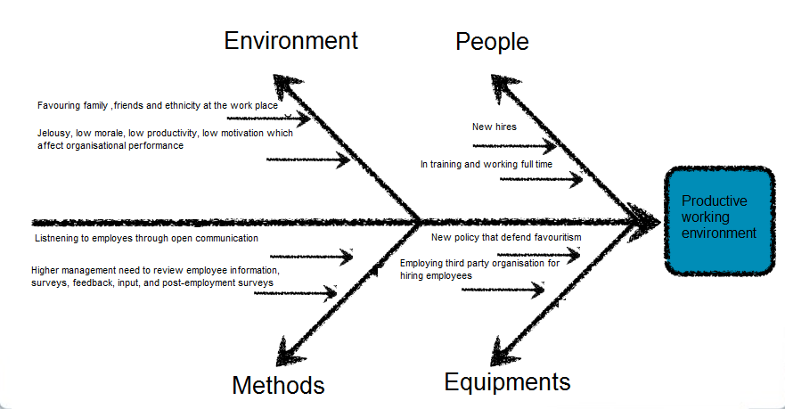
From the above diagram it is clear that favouring friends or family members at the workplace will end up with low morale, motivation in other employees. Favouring ethnicity at the workplace usually demolish the belief of hard work, dream, aim and better performance for career development. Lazy management practice will end up with low productivity within the employees which will influence the performance of the organisation. Open communication and reviewing employee information through surveys, feedback ongoing input and post-employment surveys can give the management a scope to resolve the problems that they are facing. It is also very important to realise that there are options like developing a new policy to defend favouritism practice at the workplace and also engaging a third party organisation for recruitment that are specialised for recruiting as per demand of the organisation.
6.0 Proposed solutions
Here I am going to discuss about two different solutions which are very important and necessary to overcome the problem. The two solutions discussed below.
Introduction of a new policy that can prevent favouritism: Introduction of new policy related to favouritism in the workplace environment is very essential. The policy can help with avoiding favouritism among employees and managers the same time. The policy should unmistakably recognize the desires of the employees from their working environment and if a protest is held up against favouritism then the procedure which will be pursued by the organisation. It is also important to make sure that every single worker within the organisation clearly knows and understand every details about the policy and can access the policy at any given time which will obviously clarify the principles expected all through within the working environment. Favouritism is a dirty practice and it is important to mention in the policy that whoever found guilty of practicing favouritism within the workplace would be a part of legal procedure.
Use of recruiting agency while recruiting employees can prevent favouritism: Recruiting agencies can assist an organisation with finding and shortlisting great applicants as well as can avoid favouritism. At the time of recruiting new employees, the higher management of the organisation can be biased and favoured their friends and family members for getting the jobs. Recruitment agencies don’t have any influence as they are third party organisation and concentrate on finding and shortlisting great applicants. Some of the important benefits of using recruitment agencies for recruiting employees are as follows.
- Quicker recruitment
- Finds out employees who have best qualities for the job
- Recruitment agencies has special knowledge of recruiting employees which saves time and difficulties of recruitment process for any organisation
- Don’t have any influence of favouritism

7.0 Evaluation of the proposed solutions
A new policy against favouritism within the workplace will create a great and motivated working environment because everyone within an organisation will have an understanding that a policy is not just a policy, it’s a law, and the law is same for everyone. If anyone within the organisation is a victim of favouritism or injustice, they will have the chance through the policy to defend them through a strong legal procedure. So the employees will feel safe & motivated and the people within the organisation that have the position & power to exercise favouritism will be aware about that they may lose their position by giving advantage to someone through a strong and policy bounded procedure. So I think that this policy will help creating a great working environment which will result in productivity.
Use of recruiting agency while recruiting new people for an organisation also can demolish the favouritism practice in the workplace. I have experienced favouritism practice in my workplace and seen the way friends and family members are recruited and getting promoted in a fast pace. I understand that if a third party organisation recruits people for an organisation, then there is no influence of the managers or some other persons from the higher management. The main aim of a recruiting agency is to carry out the recruiting process fast, finds out the best employees for the jobs, no influence of favouritism as they are a third party organisation and they can do it with ease as they are specialised in that. Every applicant will have the same chance for getting the jobs but as a specialised organisation for recruiting, recruiting agencies selects the applicants who are suitable for the job based on job requirement and job responsibility without any influence of favouritism.
8.0 Implementation of the plan for the proposed solution
When we create new policies in an existing company, we consider change, and at that point there are numerous thoughts and arrangements come around in our brain. We need to interface these plans to a vision so employees within the organisation can without much of a stretch comprehend and recollect the idea of change.
Implementing a strategy is a procedure which unites plan and systems and put them in to activity to accomplish the objectives of the organisation. Sainsbury’s is dealing with a change and they have developed a new policy for overcoming favouritism within the workplace also the organisation has decided that they will recruit new people with the help of a recruiting agency where the management’s influence won't work. Employees within the organisation definitely realize that what sort of progress is occurring in light of the fact that they were informed well ahead of time when the change was in arranging stage. Planning of the execution of the change has described underneath.
- It is clear from the SWOT and PMI analysis favouritism practice in workplace brings demotivated employees with low morale & low productivity. So we got the problem that need to sort out.
- In the nest step we got the issue like favouritism and the knowhow to prevent those issues through creating a policy for stopping favouritism practice at workplace and also recruit through a third party agency
- The third step is very important which includes winning the support of everyone who is an employee of Sainsbury's that includes people from the management as well.
- While changing policies or bringing new practice within an existing organisation, it is obvious that there will be obstacles as every individuals within an organisation are from different background, culture and views. It is important to determine the obstacles well in advance.
- While bringing change it is very important to know and understand about the factor related with risks and financial spending to implement the changing plan within Sainsbury's
- When we bring up a change within the organisation like Sainsbury's related to favouritism, we need to manage resistance to change as we know that there are people within the organisation who are involved with favouritism practice.
- Finally we will make it happen; we will bring the change and erase the favouritism practice in the workplace.
9.0 Monitor and review of the implementing plan
It is fundamental to monitor the advancement after the progressions has taken place. There are parcel of approaches to screen the advancement of a plan. From Salisbury's point of view, we pursue the accompanying measures relying upon the circumstances.
Target based Evaluation: Target or objective base assessment is a decent method for screen the advancement when the progressions are occurring. Our objective has been created well ahead of time and will assess the outcome dependent on that target.
Result based assessment: At the time of progressions, we usually look at the consequences of the advancement. It is one of the well-known methods for observing the change.
Time to time reports: We already established a group which is following up the plan execution and instructed to submit reports regularly to discover that the progressions are occurring effectively or not.
Meetings: Management has decided to have a meeting every month between the alliance groups to discover the progressions and the aftereffects of the meetings will give new idea about the expected change.
Progress surveys: During the evolving procedure, there will be a reporting system for the individuals who are working within the organisation and for the change and it will give ways to monitor the advancement.
10.0 Conclusion
From the above study it is clear that favouritism is a bad practice within Sainsbury's as well as in any other organisation. The first part of the study has given us idea about favouritism and its various aspects including problem solving and decision making and the second part of this study described that how it can be managed within the organisation. I hope that this study will clearly give an insight to Sainsbury’s to overcome the problems that they are experiencing in some of their stores and it will be very helpful lesson for other organisations in dealing with favouritism practice within a workplace.

References
Brockmann, E. N., & Anthony, W. P. (2002). Tacit knowledge, and strategic decision making. Group and Organization Management, 27, 436–455.
Favouritism 2019. BusinessDictionary.com. Web Finance, Inc. November 24, 2019 Available at http://www.businessdictionary.com/definition/favoritism.html
Ishikawa, Kaoru (1968). Guide to Quality Control. Tokyo: JUSE. Electronic sources of information. Available at https://en.wikipedia.org/wiki/Ishikawa_diagram, Accessed on 1st December 2019
John Bright 2019, A perfect life, Electronic sources of information, available at http://www.almostperfectlife.com/Favouritism.html. Accessed on 28th November 2019
Henry Kaiser 2019, Mind tools, Management Training and Leadership Training, Electronic sources of information, available at https://www.mindtools.com /pages/article/newTMC_00.htm, Accessed on 27th November 2019
Mike Clayton 10th March 2015. TAG: PMI ANALYSIS. EDWARD DE BONO: THINKING. MANAGEMENT POCKETBOOKS. (Online) Available at https://www.pocketbook.co.uk/blog/tag/pmi-analysis/. Accesses on 20th December 2019
Skills you need 2011, Decision Making, Electronic sources of information, available at https://www.skillsyouneed.com/ips/decision-making.html. Accessed on 26th November 2019
Sreeradha D Basu 11th June 2013. Five ways to deal with favouritism at work. ET Bureau. (Online) Available at https://economictimes.indiatimes.com/jobs/five-ways-to-deal-with-favouritism-at-work/articleshow/20532449.cms. Accessed on 20th December 2019

