Student name/ Sadaf Rashid
Student ID/ 1814941
Module/ Living with Care: The Older Person
Module Code/ BMHP6009
Lecturer/ Joanne Davis
Part/2

Introduction.
The national data of the UK highlights the well-off living of the people, as well as the nature of the rapidly ageing population and its impact on the country’s social behaviour and health industry. Surveys, such as the “English Housing Survey”, “Health Survey for England” and the “GP Patient Survey” reflect the constant growth of the older population in the UK, while the “Office for National Statistics” (ONS) also focuses on the concerned study. The essay will be developed by discussing the impact of ageing on the social and economic climate of the UK, and the changing nature of the health and social care sectors of the country. According to WHO most people worldwide are living longer then ever due to advance health care system and new medicines and advance immunisation programs.

Discussion.
According to BAIT, (2019), old age refers to the final stage of human life expectancy and the life cycle, while the biological development at this stage becomes stagnant and the organs become vulnerable. On the other hand, a report, developed by Baxter et al. (2018) suggests that old age refers to certain group of population, which comprises the “oldest members” of the population. The societal aspects of this certain age- based community are influenced by the “collective experiences” of the value sharing and the “psychological effects”. Moreover, the standpoints of sociology, biology, demography, employment, and other factors determine the old age group with different nations, though the range is considered between 65 and above in British society (England.nhs.uk, 2022).
The graph, depicted below, refers to the distribution of the elderly population in the UK from 176 to 2046, and a gradual increase in the number of viable in the study. According to the graph, steady growth is observed in the UK population after 2016, which reflects an estimation of 20.5%, 23.9% and 24.7% in the consecutive years of 2026, 2036 and 2046,

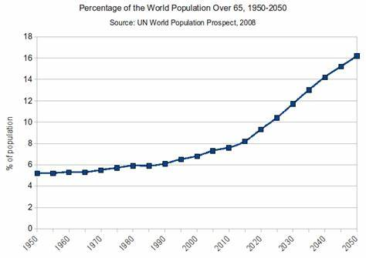

Source (World Population Growth)

A report by the “Centre for Ageing Better” suggests that the UK is currently experiencing a rapid shift in age, and currently, 11 million people are in the UK, age 65 (ageing-better.org, uk,2022). The report also suggests that the growth will be more viable in the next ten years, and the number will reach up to 13 million, which will be 22% of the British population. Though the longer span of life is celebrated throughout the world, as well as, in the UK, some major issue is also affecting their optimum needs and absolute essentials, vividly. Another report by Thom, (2018) mentions that the increasing numbers of the elder population is majorly driven by the decline of fertility and increasing character of life expectancy due to development of food value and health industries. Despite the technological and profound growth of medical norms and activities, the issues, such as discrimination and poverty affect their life and a healthy routine.
As Barja (2019) suggests that the “Damage of Error Theory” and “Activity Theory” of ageing in mostly viable in the UK, and the “cross-link theory” is found effective for the former one, where the cell damage are triggered due to cross-linked protein. On the other hand, in the case of the activity theory, the “psychological ageing process” becomes the core function and mental stress and dilemma become an issue for the people.
According to Dodds, (2018), a quarter of aged people in the UK live in a “non-decent household”. Which has a massive impact on their health, as well as, on the hitting bills, they pay. On the other hand, Spijker. And Schneider, (2021) mention that the increasing nature of the “health gap” has a constant impact on the concerned people in certain regains of the UK, and in the regards, the discrimination of earnings and lifestyles is the major reason behind it. Pensioners of 1.7 million experience under-poverty life, and among them Pakistani, Bangladeshi, and Caribbean people are also included. A report suggests that though the expenditure for pensioners has been estimated at £128 million in 2020, the discrimination of lifestyle and issues are still influential for them (parliament.uk, 2021). Apart from it, the rise of “fiscal pressure” is also viable in nature in the UK working field due to increase in the elder population. The aforesaid report suggests that the ratio of working people is estimated to fall to 2.7, within 2037.
The social effects of ageing have a critical impact on the country’s economic and social growth, while the changes, trends of living and activities have also influenced. The patterns of economic growth have changed due to lack of people, who can pursue hard work for more financial revenue through taxes (Groarke et al. 2020). Moreover, technological guidance has created certain development in the country’s business, education and other industries, the limited involvement of youth has made the benefits vulnerable, as the professionally and technically challenged people have increased in numbers. The social and economic changes have also failed to attain certain formulations and platforms according to the fast-moving world due to increase of elder people in the UK, though the economic outcomes and old-age customs in different parts of the UK economy have assisted the authority to maintain a minimum balance of traditional lifestyle in the UK.
The chart, depicted below, refers to loneliness and its impact on elder population of the UK. According to the graph, people, aged 65+ are affected by long-term mental conditions at 26% while people living with others are affected by 19%.

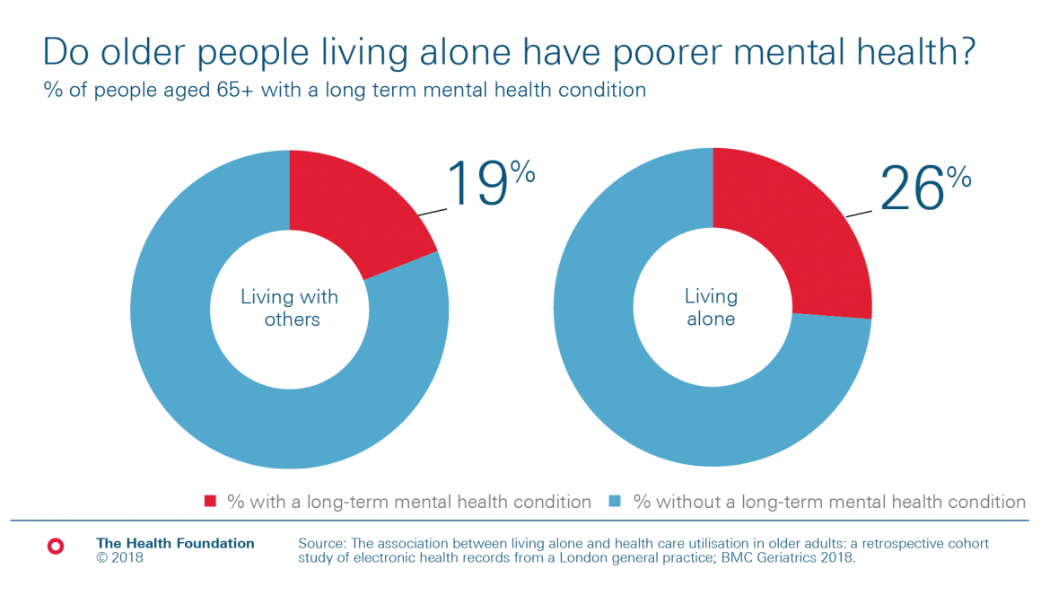

Figure 2: Mental health of the older people
Source: health.org.uk, 2018

. Issues and problems older people face in pandemic (Covid-19)
The outbreak of the pandemic has fostered a clear light on the condition of elder people in the UK, and the “Winter Resilience Campaign” reveals the condition the people face during the peak of the covid 19 scenario. As scenario. As Whig et al. (2022) highlight that a certain section of the elder community has faced tremendous pressure during the Pandemic due to anxiety and its consequences. The situation went extremely challenging in Covid for them, who suffered from threatening health conditions and live a discriminated life under the periphery of the UK economy. Even when, in summer, 2021 when the restrictions were loosened, they felt scared to go out due to such anxiety. Though in some cases, the cognitive issue triggered their fear of being affected, the psychological pressure and monetary deficiency were the real problems for them. According to Hui et al. (2020), 34% of the elder population felt extreme anxiety from the beginning of the pandemic, 36% felt lack of motivation in daily life. The report also highlights that 64% of the elder population of the UK did not feel confident enough to travel the public transport, and 18% of them did not feel strong enough to go out foot. A report by the office of National Statistics suggests that the higher class of elder people has been affected by the pandemic due to worries regarding the future by 70%, stress, worry by 54.1% and boredom by 43.3% (ons.gov.uk,2022). Older people were left alone in old homes and private residences. (NHS, 2020). Loneliness, Isolation, and depression made things worse for adults over 65. Mental health issues are linked to higher death rates in general, in elder population. But in Pandemic most elderly people find use of technology to continue to stay in touch with their loved ones. Like they learn to use watt sap, Facetime, Zoom and technologies like them kept the lonely and isolated elder people’s hopes alive. (Aging psychiatry, 2020). The Virus had largely affected the elderly people and their wellbeing. According to a survey 80% deaths in Covid was in over 65 old people. According to a survey elderly people with mobility issues have suffer the most in Lock down (2020-2021) as limitation of physical movement or no walk-in parks or public places, have made their mobility issues worse. Several studies have shown that even just 20 minutes of exercise or walk for elderly people can have significant, positive effect on their body and mind. Although lockdown and isolation were for temporary, but for most elderly population are likely to be long lasting.
The provision of the social care in the UK reflects wide range of variety regarding medical services and clinical guidance and the distribution of practices among children, women and elder people is focused on by the authority. According to Saxena et al. (2019), the value of local administration is higher regarding the identification of the essentials for the elder section of the regions, and diverse nature of handling the issue is also observed among them. The reports also suggests that the formal roles are also played by the local bodies regarding the assessment of the mental and physical health. Ozieranski (2019) mention that an integrated from of social and healthcare systems is followed by the UK authority to identify the issues of older population, and the patients with critical conditions are observed under certain guidelines, as well as the potential people are considered too. A report suggests that 7% of the UK population benefited from unpaid care by the government effort, where the elder citizens were also considered sincerely (lordslibrary.parliment.uk, 2021).
The health and social care authority of the UK priorities people’s health under the threat of Covid 19, while the challenges of the pandemic have affected people on a major scale, especially the elder citizens. The authority, apart from the physical issues, in elder people also focuses on the mental health of the citizens as well to assure their further betterment and better lifestyle. It also focuses on the sustainable and high quality of services at the time of need and in this regard, the infrastructure of the health industry has been facilitated with good tools and techniques for elder population. (Soley-Bori el al 2021). The legislative intervention to secure a certain amount for national health and hygiene has also played major role.
According to WHO “World Health Organization” by 2050, the proportion of the world’s population over 60 years will nearly double from 12% to 22%. People worldwide are living longer then ever.
The digitalisation of the healthcare system in the UK has also focused smart utilities by the management and the older patients need, while the role of the “Blue Box” has been identified sincerely (perry et al. 2020). The wireless and portable blue box assists people with several “long-term conditions”, such as diabetes, asthma, COPD, and coronary heart disease. The box also assists patients with short-term requirements. Monitoring of the box has been simplified by the management for emergency needs, and informal carers are also able to use it in the case of short-term requirements. A report suggests that the usage of Blue Box has reduced 22% of the ambulance request and it also reduced 46% of the usual days in hospital days for a patient (whzan.uk,2022). The reports also highlight that based on the usage of Blue Box a reduction of 33% in emergency admissions has been possible, while the reduction of “unplanned GP visits” in elder people and emergency calls have been reduced by 35% and 50% respectively. Apart from it, the usage of mobile applications, telecommunication, electronic, mail, and social media handles are also used by the management to make communication with the patients for fast services, while updated websites with the minimum number of FSQs (Frequently Asked Questions are provided for the public benefits (Boulding and Hinrichs-Krapels, 2021). The Graph depicted below refers to the growth rates of the UK and healthcare expenditure of the country. According to the graph, the gradual growth of the country’s annual revenue from the concerned industry refers to its collaborative success as an important industry in the UK, and in 2020, the growth rate reached 19.7%, higher among all.

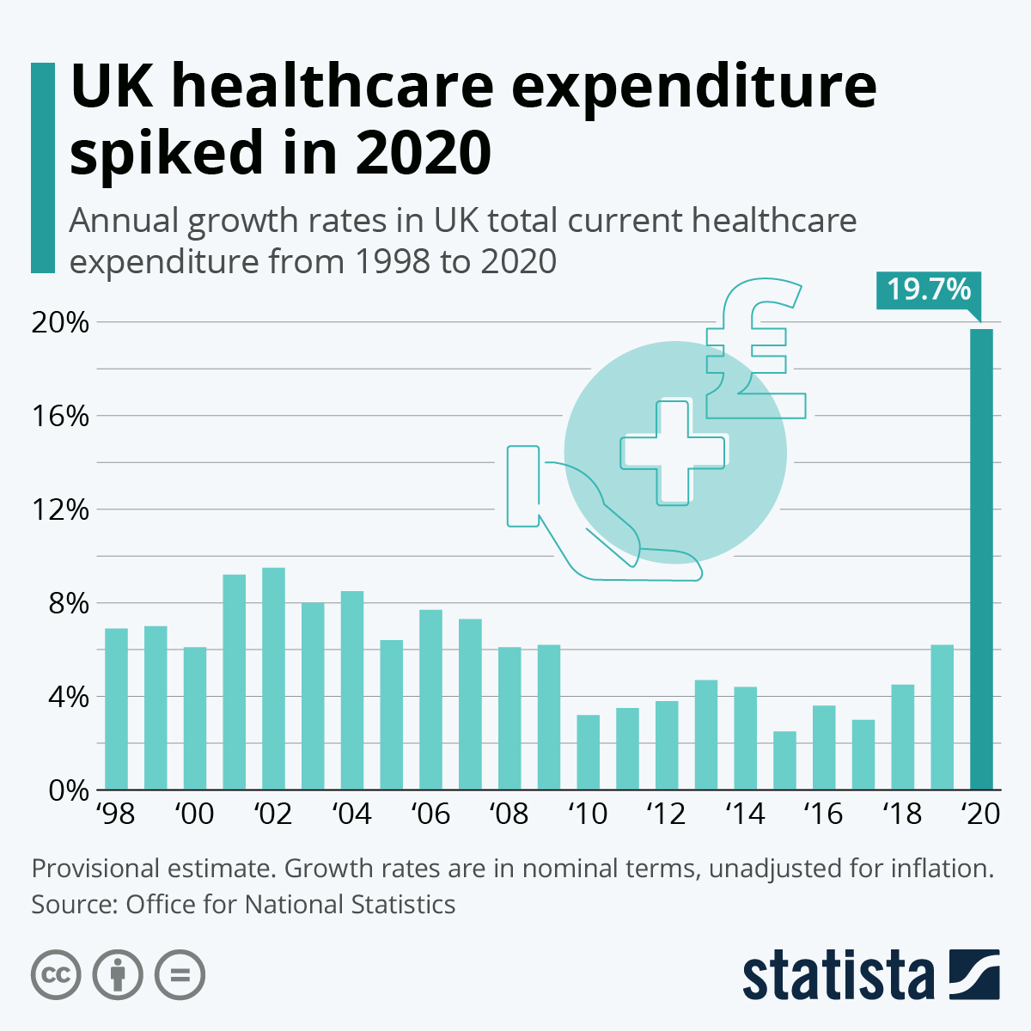

NHS England has estimated 37 major national healthcare polices for the national citizens while the elders have been prioritised effectively The UK healthcare polices include protection and safeguarding, first aid services, medical administration, safety and health, record keeping and confidentially and others. The polices ensure the patients’ rights regarding knowing the data and facts and experiencing quality services irrespective of gender, race, ethnicity, or any other public index (Riley et al. 2019). The national health services of the UK are legislated by the UK parliament, while the economics polices and social structure are kept in mind before formulating any laws, acts, or polices.
Illnesses and issues experienced by older people.
There are many illnesses and issues are experienced by elder people in their lifetime and here are few in report.
. Memory concerns (Dementia/ Alzheimer Disease).
Memory concerns often causes anxiety and stress in older people, even more importantly, evaluation can uncover treatable causes of decreased brain function, such as medication side- effects, thyroid problems, and a variety of other illness which are common in older people. (Leslie k, 2022). According to a survey Dementia and Alzheimer’s disease are start from memory issues. Dementia is most common in people over 65 years old. There are estimated 5.0 million adults with dementia in 2014 and projected to be nearly double in 2060. (NHS)
. Financial issues.
Money is one of the main and big issue in elderly people, as the cost of living is gone up and food prices sky high, elderly and pensioners are facing financial hardship more then ever. According to survey carried out through “WHO” over 15 million adults 65+ are economically insecure, with very low income and some of them are below poverty level. A report publishes by Age UK (Age UK, 2019) in 2019 stated that pensioner poverty is higher then ever, nearly 2 million pensioners now living in poverty and struggle to pay basic bills. Some older people have no other choice except turning to food bank.
. Mental and physical abuse in Elderly. According to “WHO” around 1 in 6 people elderly or over 65 experienced some form of abuse and neglection in communities. In Covid-19 these rates have doubled. Due to growing elderly people these abuses and neglection is growing very fast.

Conclusion.
The essay concludes with the profound impact of ageing in the UK society, and its social, economic, and political outcomes which have impacted the UK. The essay highlighted issues and problems of older population of UK and the challenges they face. Also, life in covid and lock down was not great for people over 65. Health care system and polices have been stated. How the technology (phones, laptop. Facetime video calls) have made older people life easy and connect them to their loved ones while they were in lockdown. Elder populations are faced many problems in Pandemic and after it as well, and Covid -19 effected elderly the most. The essay has highlighted the theories of ageing and impact of the outbreak of covid 19 0n elder citizens. The age gap in the UK and its impact on the country’s social, political, and economic nature have been discussed in the study for better understanding, and for statistics and competitive data, several graphs have been interpreted.

References.
. (2022) NHS Choices. NHS. Available at: https://www.england.nhs.uk/policies/ (Accessed: October 27, 2022).
. Ageing population (2022) Centre for Ageing Better. Available at: https://ageing-better.org.uk/ageing-popuation (Accessed: October 27, 2022)
. Altabaibeh, A, Caldwell, K.A. and Volante, M.A., 2020. Tracing healthcare organisation integration in the UK using actor-network theory. Journal of health organization and Management.
. Armstrong, M. and Richter, F. (2021) Infographic: UK Healthcare expendicure spiked in 2020, Statista infographics. Available at: https:// www.statista.com/chart/24994/uk-health-expenditure-annual-growth/(Accessed: October 27, 2022).
. BAIT, M., 2019. ‘Struggling to Cope’? Negotiating older people’s Identities on Age UK. Seniors, Foreign Caregivers, Families, Insitution: Linguistic and Multidisciplinary Perspectives, p.9.
. Barja, G., 2019. Towards a unified mechanistic theory of ageing. Experimental gerontology, 124, P. 110627.
. Baxter, S., Johnson, M., Chambers, D., Sutton, A., Goyder, E. and Booth, A., 2018. The effects of integrated care: a systematic review of UK and international evidence. BMC health services research, 18(1), pp.1-13.
. Blue box: Whzan Digital Health: Tele -health Digital kit (no data) Telecare Whzan Digital Health United Kingdom. Available at: https://www.whzan.uk/blue-box (Accessed: October 27, 2022).
. Boulding, H. and Hinrichs-krapels, S., 2021. Factors influencing procurement behaviour and decision-making: an exploratory qualitative study in a UK healthcare provider. BMC health services research, 21(1) , pp1-11.
. Challenges of an ageing population- UK parliament (no data). available at
https://www.parliment-2018/social-change/ageing/(Accessed 27/ October 2022
. 21st Century challenges. https://21stcenturychallanges.org/britains-ageing-population/
. Coronavirus and the social impacts on older people in Great Britain: 3 April to 10 May 2020, Coronavirus, and the social impacts on the older people. National Statistics
. Dodd’s, S., 2018. Systems engineering in healthcare-a personal UK perspective. Future healthcare journal, 5(3), p.160.
Groarke, J.M., Berry, E., Graham-Wisener, L., Mckenna-Plumley, P.E., McGlinchey, E, and Armour. C, 2020. Loneliness in the UK during Pandemic: cross- sectional results from the covid-19 psychological wellbeing study. PloS one, 15(9), p.e0239698.
. Health and health care use of older people living alone (2022) The Health Foundation. Available at: https://www.health.org.uk/chart/heath-and-health-care-use-of-older-people-living-alone. October 2022
. Hui, A., Latif, A., Hinslif-smith, K. and Chen, T., 2020. Exploring the impacts of organisational structure, policy, and practice on the health inequalities of marginalised communities: Illustrative cases from UK healthcare system. Health policy, 124(3), pp.298-302.
. Ozieranski, P.,Rickard, E. and Mulinari, S., 2019. Exposing drug industry funding of UK patient organisations. Bmj,365.
. Perry, J., Lomax, P., Taylor, F., Howson, S. and McCurdy K., 2020. The parliamentary Scholar Scheme: a way to engage doctors in healthcare policy and polices. BJPsych Bulletin, 44(3), pp.103-107.
. Saxena, N., Bhadoria, R.S., Branch, S., Dalley, L. and Churchill, N., 2019. Security and Privacy issues in UK healthcare. P.283
. Social Care Provision in the UK and the role of carers (no data). Available at: https://lordslibarary.parliment.uk/research-briefeing/2021-0014, October 2021
. Spijker, J. and Schneider, A., 2021. The myth of old age: Addressing the issue of dependency and contribution in old age using empirical examples from the United Kingdom. Sociological research online, 26(2) pp.343-359.
. World health organization, https://www.who.int/

