

Module title: Dissertation
Module No: LCBB6000

Research Proposal:
Dissertation title:
THE IMPACT OF COVID-19 ON THE CHANGE IN BUYING BEHAVIOUR

Student name: Emil Aleksov
Students ID: 1915955
Date:

Words: 2081

Contents
Introduction 3
Aims of research 3
Objectives of research 3
Research questions 3
Literature reviews 3
Research methods and methodology 4
Research philosophy 4
Research paradigm 4
Research approach 5
Methodology 5
Research design 5
Sampling 6
Data collection 6
Data analysis 7
Gantt Chart 7
Ethical research limitations 8
Conclusion 8
References 9

Introduction
This research proposal aims to present the conduct of a dissertation study on the topic: The impact of Covid-19 on the change in buying behaviour. This proposal presents the purpose, objectives, research questions, a brief literary analysis of the researched topic, and research methods and methodology. The current research proposal presents the research philosophy, paradigm, approach, design, samples, data collection and interpretation. A significant part of the ethical concerns encountered in research design is also touched upon. The current research proposal investigates changes in an Asda store's consumer behaviour. ASDA is a British company that is developing in the field of trade. The company has a supermarket chain and other stores for various goods. Asda is one of the largest British retail companies. Covid-19 has had a substantial impact on the social environment, changing and modelling in a certain way the behaviour of consumers towards their way of shopping and their preferences. Therefore, the research topic of the present research proposal is considered relevant, as it focuses on the problems resulting from external impacts such as Covid-19 on the consumer behaviour of consumers of the retail industry in the UK, namely the customers of the Asda company.

Aims of research
The purpose of the research is: "To analyse the change in buying behaviour of customers due to the impact of Covid-19 in Asda company, UK. "

Objectives of research
- To assess the concept of customer behaviour and its significance in the UK retail industry.
- To investigate the factors influencing customer purchasing behaviour in the UK retail industry.
- To assess the impact of COVID-19 on customer purchasing behaviours in the UK retail industry.

Research questions
- What are the implications of changing consumer behaviour in the UK retail sector due to COVID-19?
- What variables affect the shifts in consumer behaviour brought on by COVID-19 in the UK retail sector?
- What effect does COVID-19 have on consumer purchasing habits in the UK retail sector?

Literature reviews
Consumer behaviour is the psychological part of an individual that makes the difference in purchasing goods and services and everything else (Mooij, 2004). Consumer behaviour depends on many factors, significantly shaped by the company's marketing (Frago, 2021). This dissertation aims to investigate precisely this behaviour that changes as a result of external influences such as Covid-19 by examining the change in consumer behaviour of the Asda company (Newman et al., 2006). Asda is a supermarket chain operating in the United Kingdom. The company has over 600 stores, developing activity in the food industry and selling goods and furniture (Asda, 2022). The object of the present study is the consumers who shop at the Asda store, and the aim is to study the change in their behaviour due to the influence of external factors such as Covid-19 (Lashgari & Shahab, 2022). In 2020, a virus was spread that affected the respiratory tract of a person with acute cough and pneumonia. The virus led to significant negative impacts on human life, forcing the closure of various activities, including grocery stores, which led to a change in consumer behaviour (Tao et al., 2022). The study of consumer behaviour includes search, evaluation, purchase and post-purchase behaviour of consumers in the process of considering decisions due to the external environment surrounding them (Dennis et al., 2007).
In the year 2020, it was discovered that the occurrence of Covid-19 has a bearing on the growth of the retail industry in the United Kingdom. In 2020, retail sales volumes declined to 1.9% compared to 2019. According to the UK Government, this is the yearly decrease that has been the most severe for this business. On the other hand, sales over the internet increased by as much as 33 per cent. The retail business is significant to the UK and accounts for about 5.1% of the country's gross domestic product (GDP). Therefore, Covid-19 has had a detrimental effect across the board, influencing not only the economic element but also the social aspect and the behaviour of customers (National Statistics, 2021). The chart provides some data obtained from the government on the amount of football played over the period beginning on March 1, 2020, and ending on January 14, 2021. There is a moderate decline in attendance levels during the lockdowns, followed by a marginal improvement when the stores reopen after closing (Carmona, 2021).
Fig. 1 Volume of footfall (Source: National Statistic, 2021)
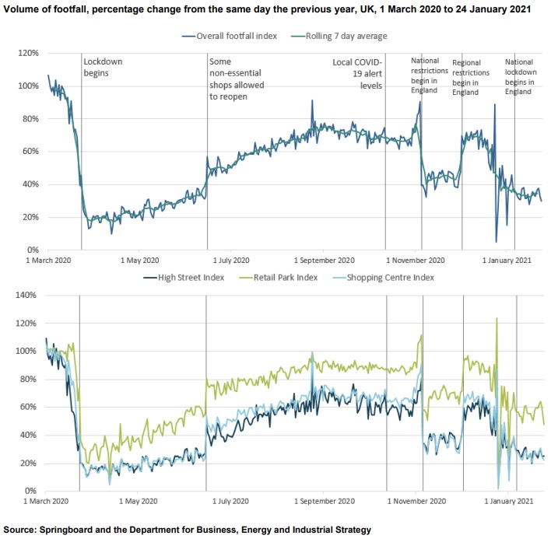
Because of the coronavirus, there was a significant decrease in retail sales in the UK. According to the data, retail sales dropped from March to April 2020. The total sales at retail establishments were down 19% from February's levels. However, some retention of consumer demand has been generated due to the relaxation of restrictions. The increase in online sales for May was 60% compared to all of this. As a result, sales progression eventually reached a point where it could be considered steady (National Statistics, 2021).

Research Gap
There still needs to be more research into the impact and impact of Covid-19 on consumer behaviour. There needs to be more research aimed at studying consumer behaviour in the retail industry due to the changes caused by covid-19, particularly regarding consumers of the Asda company. The long-term impact of human and economic impact of Covid-19 is yet to be explored in the next few years because these events are as recent as 2020. The elapsed period still needs to be longer to develop extensive studies concerning the researched topic of the present research proposal. For this, the present study is of topical importance.

Research methods and methodology

Research philosophy
In the direction of conducting the research, a research philosophy was conceived that would correspond to the selected research toolkit so that practical research goals could be reached (Boon & Van Baalen, 2019). Scientific philosophy represents the researcher's fundamental beliefs and ideas in implementing his philosophy as part of his research (Saunders et al., 2019). Applying a suitable research philosophy ensures that the group clarifies the information and its correct understanding. For this study, the positive research philosophy is the most appropriate. The main motive for choosing positivism as the philosophy of the present study is that it involves the analysis of qualitative information (Burrell & Morgan, 2016), covering the primary data collected from the questionnaire surveys conducted. Therefore, qualitative research methods are applied (Roberts et al., 2019).

Research paradigm
How researchers think and perceive the world is reflected in their research philosophies. Some of the most significant new schools of thought gaining popularity are pragmatism, interpretivism, positivism, and realism, to name a few. Each is unique and has different qualities that distinguish it (Saunders et al., 2019). Positivism is the philosophical approach used in this study because it is appropriate to the researcher's goals, subject matter, and perspective. On the one hand, positivism examines the external characteristics that lead to changes in consumer behaviour through observation and research (Sileyew, 2019).
On the other hand, various social contexts that lead to these social changes are examined. Therefore, Covid-19 is one of those external aspects that provokes and leads to a change in Asda's consumer behaviour and habits. The positivism paradigm observes consumer habits and their logical movement due to external impacts such as Covid-19 (Bolton et al., 2018).

Research approach
The present study will follow a deductive strategy. It consists of some essential components. First, it clarifies the concept of causality from the impact of Covid-19 on consumer behaviour change in the Asda company (Sauderes et al., 2019). The deductive strategy the research will follow is data analysis, information gathering, questionnaire creation, data sharing, data presentation, and data evaluation. Because it enables the consolidation of information obtained in the past, deductive reasoning is an essential component of this type of inquiry (Hair et al., 2019).

Methodology

Research design
The present study applied a mixed method of analysis. It includes quantitative that will be analyzed (Timans et al., 2019). Quantitative information will be sourced from primary sources such as literature theoretical analysis, and quantitative information will be sourced from the survey. Interpretive philosophy is often used in qualitative research because of the inherently subjective nature of research (Deniz & Lincoln, 2018).

Sampling
Researchers sometimes turn to a sample to determine which groups or subgroups will participate in a study. This is done since obtaining data from an excessive number of representatives is difficult (Bhardwaj, 2019). To do this, information must be gathered for a cross-sectional representative sample of all the different conceivable situations (Sauderes et al., 2019). The survey will include participants from the retail sector in the United Kingdom. This poll has received responses from 50 people, customers of Asda Company. The sampling method will be done via online Google Forms, and respondents will be contacted by email or traditional mail to complete the surveys (Crotty, 1998).

Data collection
The method of analysing the data gathered includes doing content analysis on the theoretical questions connected to the research and the primary one. The examination of the explicit content of communication through an objective, methodical, and quantitative description is referred to as content analysis. This section looks at both primary and secondary sources of information (Berelson, 1952). Secondary data is information from other sources, such as past research and studies. The survey was carried out so that preliminary data could be collected. The information may be organised into tables and compared graphically to identify trends and patterns. There are a variety of approaches that may be used when presenting graphical representations of data. First, specific language phrases are used to acquire qualitative data suitable for analysis. After that, quantitative data is evaluated, and a qualitative analysis of the data that has been given is carried out in order to extract pertinent features, such as one-of-a-kind interpretations, views, and insights, that have surfaced as a result of the data and the analysis. After going through some different analyses, the results are displayed in several different ways. In some circumstances, visual representations of data might make analysis easier. In certain circumstances, a concise description of the visible characteristics is essential.

Data analysis
The collected information from the conducted survey will be analysed using a descriptive method of analysis, which will include the presentation of the results obtained from the conducted survey through their graphic and tabular presentation. in this direction, a brief analysis will be made of the presented and collected information, which is presented in the graphs. After going through different analyses, the results are displayed in different ways. In certain circumstances, visual representation of data can facilitate analysis. In certain circumstances, a brief description of the visible features is essential.

Gantt Chart
Timeline | November 2022 | December 2022 | January 2023 |  | February 2023 |  |  | March 2023 |  | April 2023
Research proposal writing
Literature reviews
Survey
Data collection
Data interpretation
Report writing
Feedback adjustment
Dissertation submission

Ethical research limitations
Several significant issues are discussed as ethical considerations in the topic. First, to get things started, every individual who took part in the survey was given prior notice of the questionnaire, the questions, and the goals and tasks connected with the survey card. Third, every individual who participates in the study does so voluntarily, thereby preserving their right to anonymity and their other personal liberties. In the fourth step, participants are given all the pertinent information about the survey being presented to them and their participation in it. This ensures that all applicable ethical concerns and standards are always adhered to. In addition, disclosing any information about a person is utterly voluntary at all times. Each principle is strictly adhered to, including harm reduction, confidentiality, disclosure of results, and informed, voluntary engagement.

Conclusion
As a conclusion to the research proposal that has been prepared, the purpose of the current study is to analyse the behaviour of consumers, which is affected by various environmental factors. A few of these effects are outside of the company's ability to manage. For example, consumers' desire is the driving force behind consumer demand, which leads to the search for goods and products that consumers require. On the other hand, customers are always looking for new choices, and their behaviours are very susceptible to being influenced by various outside factors. People's shopping habits have been significantly influenced as a direct result of the powerful effect that Covid-19 has had on consumer behaviour. This has impacted many businesses operating in the retail sector in the UK, including Asda. The behaviours that ultimately result in impact and change are exciting in this study.

References
- Asda, (2022). Our story Available on https://corporate.asda.com/our-story (Accessed on 9 December 2022).
- Berelson, B. (1952) Content Analysis in Communication Research. Glencoe, IL: Free Press.
- Bhardwaj, P., (2019). Types of sampling in research. Journal of the Practice of Cardiovascular Sciences, 5(3), p.157.
- Boon, M. and Van Baalen, S., (2019). Epistemology for interdisciplinary research–shifting philosophical paradigms of science. European journal for philosophy of science, 9(1), pp.1-28.
- Carmona, M.(2021). The existential crisis of traditional shopping streets: The sun model and the place attraction paradigm. J. Urban Des. 2021, 27, 1–35
- Crotty, M. (1998) The Foundations of Social Research. London: Sage.
- Denzin, N.K. and Lincoln, Y.S. (2018) The Sage Handbook of Qualitative Research (5th edn). London: Sage
- Dennis C., Merrilees B., Jayawardhena C. and Wright L. T. (2007). E-consumer behavior. The European journal of Marketing, 43, 1121-1139
- Frago, L. (2021). Impact of COVID-19 Pandemic on Retail Structure in Barcelona: From Tourism-Phobia to the Desertification of City Center. Sustainability, 13, 8215.
- Lashgari, Y.S.; Shahab, S. (2022) The Impact of the COVID-19 Pandemic on Retail in City Centres. Sustainability, 14, 11463
- Mooij, D. (2004) Consumer Behaviour and Culture: Consequences for Global Marketing and Advertising, Thousand Oaks, CA: Sage Publications
- National Statistics, (2021). Impact of the coronavirus (COVID-19)
pandemic on retail sales in 2020
- Newman, J. N. K. and Chansarkar B. (2006).Consumer behaviour of luxury automobiles: A comparative study between Thai and UK customers’ perceptions. Industrial Engineering and Engineering Management
- Roberts, K., Dowell, A. and Nie, J.B., (2019). Attempting rigour and replicability in thematic analysis of qualitative research data; a case study of codebook development. BMC medical research methodology, 19(1), pp.1-8.
- Sandures, М.,Lewis, Ph., Thornhill, A. (2019) Research Methods for business students, 18th ed. Pearson
- Sileyew, K.J., (2019). Research design and methodology (pp. 1-12). Rijeka: IntechOpen
- Tao, H., Sun, X,, Liu, X., Tian, J,, Zhang, D. (2022). The Impact of Consumer Purchase Behavior Changes on the Business Model Design of Consumer Services Companies Over the Course of COVID-19 Front. Psychol., 03 March 2022, Sec. Organizational Psychology
- Timans, R., Wouters, P. and Heilbron, J., (2019). Mixed methods research: what it is and what it could be. Theory and Society, 48(2), pp.193-216.

