Hema Sharma (Manager of LIDL)
1812759
Methods to Analyse the Culture and Context of Organisations
LIDL

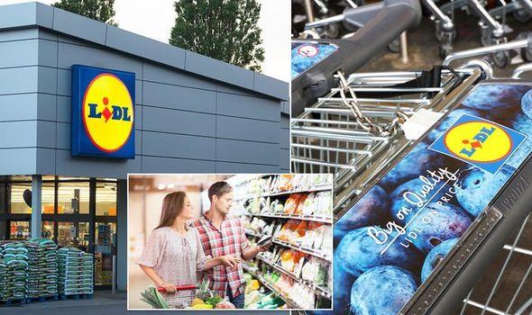

Organisational Culture
Johnson, 2013, as cited in Mullins, 2016: “It embodies the ethos and values of a particular organisation, which are expressed through the way it operates and the practice it undertakes”.
Culture can be affected by many conditions, such as uncertain economic conditions, for example- Brexit, pandemic
It can be affected by Social- for example increased demand for high quality food, goods and customer service.
Can be related to Technical development as in giving the employee proper IT trainings to keep them up to date with the technologies needed etc. (Mullins, 2016)
A good company should always welcome the change in culture in order to survive and achieve goals.
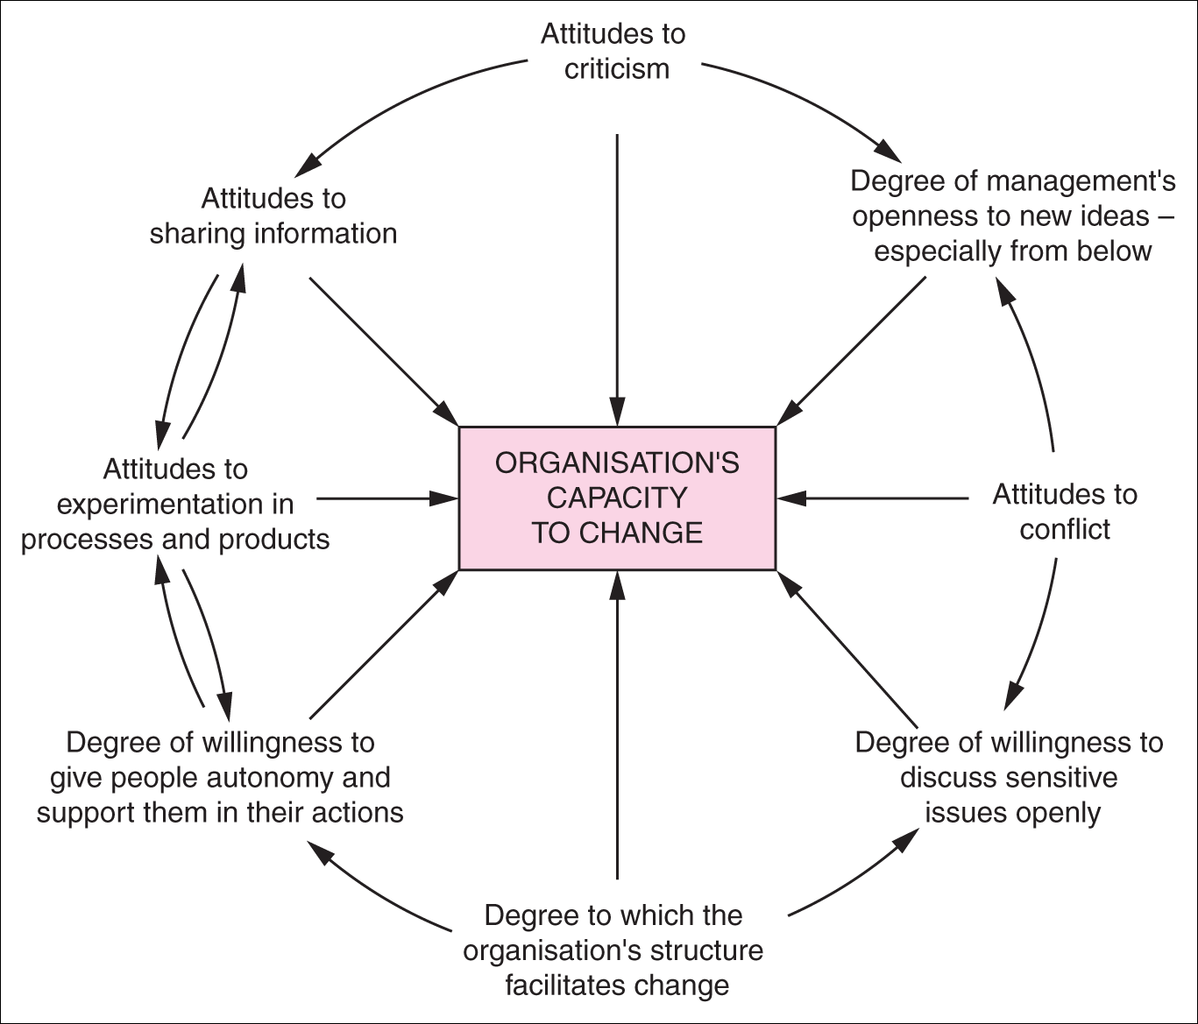

In terms of analyse culture, we can use The Cultural Web, Charles Handy, Deal and Kennedy, Action checklist from CMI, SWOT, PESTLE, Edgar Schein and T Hofstede’s Culture’s Consequence and Trompenaars and Hampden’s 7d Model.
Why we like to use Culture Web?
We use the Culture Web to look at how is the existing culture and how we want to see the culture in future and then we can identify the differences between the two and can make changes to achieve the culture with desired performance. (Mindtools, n.d.)
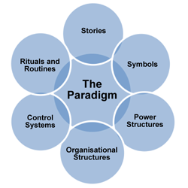

Lidl as a Company
Lidl was founded in Germany and open first in 1994 and at present are having more than 790 stores with employing 23,000 people. It develops as one of the Europe’s big food supermarket. Lidl is providing the customers with high quality products in low prices. More than two third of its product are sourced from local British suppliers that’s why it manages low prices, which is its strength. (Lidl, n.d.)

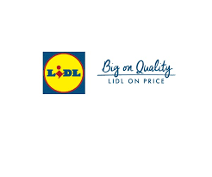

Cultural web
The Cultural Web was developed in 1992, by Gerry Johnsons and Kevan Scholes. It provides the picture how to look at and make desirable changes in an organisation’s culture.
There are six elements in the Cultural Web, these include: Stories, Routines and Rituals, Symptoms, Control System, Power Structure, and Organisational Structure.
- Stories- Example-

Our Mission
To provide best customer satisfaction with good quality and good price and to provide good trainings and development for our employees to build long term relationship. (Lidl, n.d)
- Routines and Rituals-
An article in Retail Week says about Lidl shows that, to satisfy the customers need Lidl is paying good quality product in less price and won many shares compared to its successful rivals. (Retail week, n.d.)

- Symbols-
Example-
The Lidl logo is having a circle, under a square and had a wordmark inside with all the three capital letters except “I”. The combination of blue, yellow and red shows happy and friendly. (1000LOGOS, 2016)
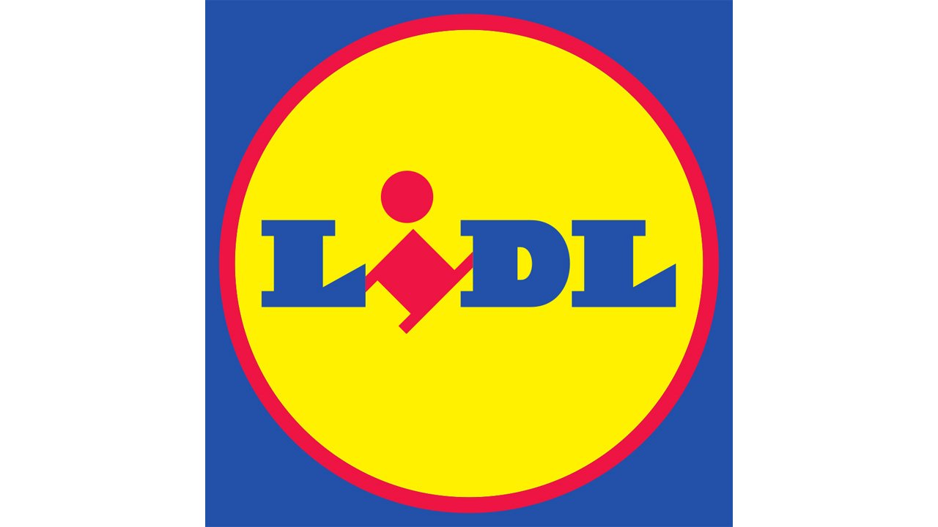
- Control Systems-

Example-
To build the long-term relationship Lidl is paying more than the living wage to its employee and give rewards to support and encourage them. (Retail week, n.d.)
Power Structure-
In Lidl power is basically in the hands of employers, customer and suppliers. Lidl always listen and gives attention to its employees, in order to support customers Lidl is doing survey, workshop and event to make desirable change in its culture. (Hartnagel, 2017)
We have also distributed our power structure in few areas. These are as follows:
Our head office structure
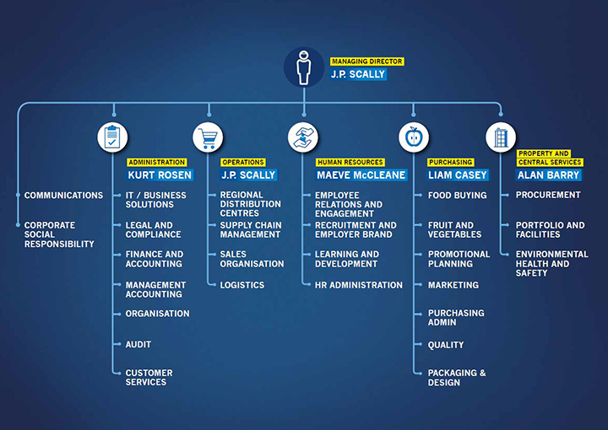

Our regional structure includes:
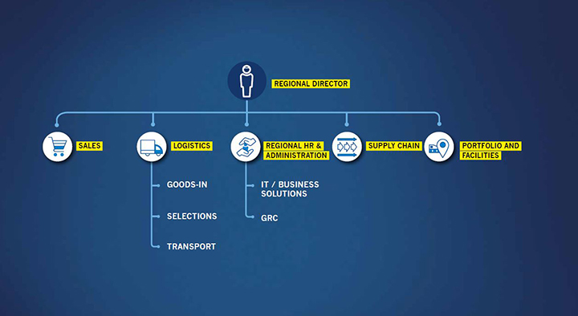
(Lidl, n.d.)
Organisational Structure-
Lidl is having hierarchical structure. It’s employees and customers are always listen by Lidl to get excellence and employees are having a lot of opportunities with variable positions. If we see it through Handy’s Model, it’s basically, a task culture. (Indeed.co.uk., n.d.)
SWOT & PESTEL Analysis:
Example-
Lidl is 7th largest supermarket in the UK with market share up to 6.0% and 5.6% in Spain. Lidl’s 70%products come from British suppliers and has a plan to open 600 stores in USA. Aldi, Tesco, Sainsbury’s, and Morrison’s are some of its strongest competitors. (Rahman, 2019).
Lidl has a target to open 770-1,000 stores in next four years due to its success in the market. Lidl is changing its hourly rate from £9.30 to £10.55 for its employee to make them happy, which is greater than the government set living wage. After all, happy employees make happy customers. (The Gardian.com, 2019)
Conclusion:
To achieve desired goals and improved culture you need to make the changes accordingly. In my opinion, culture web is probably the best method to analyse culture because it covers all attitudes of culture, it inspires how the workers in any organisation should behave with each other and with customers, you can use Cultural Web with Charles Handy’s culture Model to get better output. ‘After all a positive culture brings better results’
The link to my video presentation: https://web.microsoftstream.com/video/a6ba9949-ded4-48a2-9921-090dda6ce2ab?list=studio

References:
1000LOGOS (2016) LIDL LOGO [Online] Available: https://1000logos.net/lidl-logo/ (Accessed:1st June 2020)
Hartnagel, Christian (2017). Sustainability Report 2016/17 Efficient, Lean, Sustainable [Online] Available: file:///C:/Users/User/Downloads/Lidl_SR_Report_2017.pdf (Accessed: 4th June, 2020)

Indeed.co.uk (n.d.). Lidl Reviews [Online] Available: https://www.indeed.co.uk/cmp/Lidl/reviews?start=20 (Accessed: 5th June 2020)

Lidl (n.d.). Our Company Structure [Online] Available: https://jobs.lidl-ni.co.uk/en/1255.htm (Accessed: 4th June 2020)
Lidl (n.d.). About Lidl GB [Online] Available: https://corporate.lidl.co.uk/ (Accessed: 2nd June 2020)
Mindtools (n.d.). The Cultural Web: Aligning Your Organization’s Culture With Strategy [Online] Available: https://www.mindtools.com/pages/article/newSTR_90.htm (Accessed: 5th June 2020)
Mullins J. Laurie (2016). Management & Organisational Behaviour 11th edition, Harlow: Pearson Education Ltd.
Rahman, M. (2019). SWOT analysis of Lidl [Online] Available: https://www.howandwhat.net/swot-analysis-lidl-lidl-swot-analysis/ (Accessed: 5th June 2020)
Retail week (n.d.). Lidl [Online] Available: https://www.retail-week.com/companies/lidl?authent=1 (Accessed: 4th June, 2020)
The Gardian.com (2019). Lidl’s 19,000 UK staff to get pay rise in line with living wage [Online] Available: https://www.theguardian.com/business/2019/nov/19/lidls-19000-uk-staff-to-get-pay-rise-in-line-with-living-wage (Accessed: 8th June 2020)

