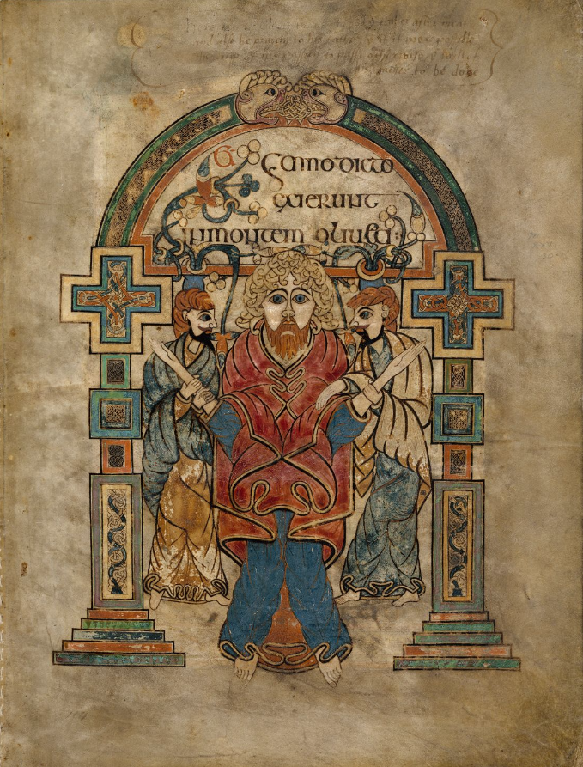

Mark A. Pierce
12/16/2023

Visual Culture and Historical Dimensions: An MHRA Commentary on Folio 114r 'Arrest of Christ,' in the Book of Kells

The Book of Kells is one of the most beautiful manuscripts ever made during the medieval period. It is considered a triumph of Celtic art and culture as well as being one of the most valuable books in the world. Just two pages of the manuscript were sold in 2012 for €10 million. One of the most beautiful pages within the text is that is located on Fol. 114r, more colloquially known as the famous “Arrest of Christ.” This study scrutinizes the profound artistic and historical dimensions of Folio 114r within the Book of Kells, exploring its content, aesthetic intricacies, artistic techniques, historical context, medium, producer(s), intended audience, and the broader significance, offering insights into visual culture through the unique medium of manuscript illumination.
The Book of Kells is an illuminated copy of the Gospels, Matthew, Mark, Luke, and John. It was written in the Latin Vulgate as a transcription of St. Jerome’s Translation of the Bible during late antiquity. Within the Book of Kells, the Gospels themselves are prefaced with many texts such as canon tables, concordances of Gospel passages common to two or more of the evangelists and Breves Causae, summaries of the gospel narratives. It was written on vellum, expensive, high-quality parchment made specifically from cow skins. The book measures 330 x 255 mm.
The Book of Kells is a brilliant example of Insular Script. Insular Script, also known as Insular Miniscule, is a writing system came out of the British Isles, Ireland and Great Britain. Having reached a high level of development by the close of the 6th century, insular script is renowned for its distinctive characteristics, including intricate decoration, elaborate knotwork, and interlacing patterns. This script frequently incorporates ornate initials, vibrant colors, and intricate designs, contributing to its visually striking appeal. French art historian Henri-Jean Martin proposed that three scribes wrote the Book of Kells. He refers to each as Scribes A, B, and C. Scribe A epitomized stoic perfectionism in his meticulous transcription of the Gospels, exhibiting a restrained and disciplined approach to the textual reproduction. Conversely, Scribe B gained renown for his flamboyant deployment of color, imbuing the manuscript with a vibrant chromatic palette. Notably, Scribe C distinguished himself through the creation of brilliant illuminations, seamlessly integrating pictorial elements with the textual fabric, thereby evincing a sophisticated fusion of image and script within the Book of Kells.
In numerous aspects, the Book of Kells is regarded as the quintessential manifestation of an Insular manuscript, amalgamating antecedent techniques employed in manuscripts such as the Lindisfarne Gospels (composed at a sibling monastery of Iona). Abundant with spirals and intricate curves which have been popular with the Celts since the dawn of history, the manuscript mirrors the stylistic predilections embraced by the emerging Christianized Celtic communities. Moreover, the "Arrest of Christ" employs analogous curvilinear motifs, characterized by intertwining vines gracefully curling across the page, thereby sustaining a visual continuity with the pervasive spirals and intricate curves present in the broader context of the Book of Kells.
Most scholars agree that it was made by the Celtic monks of the Monastery of Iona. Iona, the island, is located in the Hebrides Islands off the coast western Scotland. It was founded by St. Columba in the early 6th century, where it became a hub of Bible production and outreach to the Celtic and later Anglo Saxon Kingdoms. Scholars still debate when the Book of Kells was written. It was most likely written some time during the 9th Century; however, what complicates the dating is the fact that the Vikings raided Iona in the early 9th century, and the monks fled to safe refuge at Kells Monastery located in Meath County, Ireland. It is unknown if the book was completed on Iona or Kells or partially at both. Some parts of the text and adjoining illumination were never completed. The most dramatic reason for this being that the monks fled Iona with their unfinished masterpiece, a copy of the gospel without compare. Over fifty monks were killed in the attack, some of which may be the scribes that worked on this masterpiece.
The intended audience for the text was for the monks themselves. To them, copying this text was, in essence, an act of worship to God. One speculation floating around the academic community is that this particular book was written to honor the two hundredth anniversary of the death of Columba or to enshrine his remains for posterity. We know that the manuscript, at the very least, was associated with Columba. The Annals of Ulster (Cir. 1077) referred to the Book of Kells as "...the Great Gospel of Colum Cille [St. Columba]." Due to the sheer amount of time this took to product combined with the sheer amount of illumination within, it was most likely created and used as a Bible for the monks to use to conduct the liturgy.
Being over one thousand years old, the Book of Kells has been damaged over the centuries. During the High Middle Ages, the book was stolen. The monks eventually recovered the book, but the cover was cut off and stolen. Considering how beautiful the covers are from other Insular Gospels from the period, we can only imagine how beautiful and ornate this one was. “The manuscript has been rebound at least five times, the most horrendous being in 1821 when the Dublin binder, George Mullen, decided to soak some of the pages to get them flat and then compound his crime by cropping up to half an inch of the folios, remove some of the illumination in the process.” This most likely damaged the colored dyes used in the text as well. Additionally, there were additions by the enigmatic Gerald Pluncket. He was a man who lived in Dublin who translated random parts of the Book of Kells into English and signing his name above it, damaging the script.
There was a multitude of different paints and dyes used in the production of this magnificent manuscript. A recent study done in the early 2000s using the modern technique of micro-Ramen spectroscopy have deduced the makeup of the paints used, shedding light on the meticulous selection of colors and the artistic techniques that characterize this medieval illuminated manuscript. The paints utilized encompass a spectrum of hues, from the dark and brown tones achieved through the use of carbon black, iron gall ink, sepia, and brown ochre, to the vibrant reds derived from red lead, red ochre, cinnabar, realgar, and red folium. The manuscript's color palette extends to pink and purple shades through the application of kermes, shellfish purple, organic purple, organic red lake, madder, and purple folium. Yellow tones are achieved with yellow ochre, orpiment, ox gall, and yellow lake, while greens emerge using verdigris, vergaut, sap green, copper green, and malachite. The inclusion of blue hues is facilitated by ultramarine, indigo, and blue folium, and whites are produced using chalk white and lead white.
The appearance of all three men within the illustration is rather similar. It depicts a man in the center with blonde hair, blue eyes, a red beard, and a Caucasian complexion. The expression on his face is sad and somber with piercing blue eyes made from ultramarine eyes looking at the reader. There are two other men in the illustration one on each side of the figure, moving towards the man in the center. These men had red hair and black beards with blue eyes and are not facing the audience, but the man in the center of the illustration. The man on the left side is wearing a blue cloak with brown robes, while the man on the right of the main figure wears a brown cloak with blue clothes. What is of particular interest is that these two men have their hands laid on the central figure. The figure on the left is grabbing the central figures arm with both hands, while the man on right is laying one hand on the central figure with one hand while grabbing him with the other.
Vines surround the whole scene that tie into a brilliant arched border of the illustration. “…all three figures and the verse above are interlinked by the branches and leaves of vines that arise from pots positioned behind the heads of the flanking figures.” On the top of the page, within the arch is stylized Latin Script quoting Matthew 26:30. "Et hymno dicto exierunt in montem Oliueti." “The second word of this verse is usually transcribed as "ymno;” however, the "h" is in fact represented almost inverted by an upper branch of the left-hand vince, and this oblique orientation is repeated by the ninety-degree rotation of the upper bowl of the "y," the descender of which turns towards the “h,” while a large leaf at the foot of the “h” stretches up to just touch the “Et.” In this way the compilers of the Book contrived continuity between their illustration and the text.” In vernacular English it can be translated as “When they had sung a hymn, they went out to the Mount of Olives.”
The name for this illumination is the “Arrest of Christ.” This title was originally attributed to this particular illustration in 1843 by a publisher of facsimiles and has been widely accepted by the academic community ever since. The idea was that there are two Jews grabbing Jesus. That it was a depiction of the text is that of Christ being arrested by the Jews after the betrayal of Judas. (This can be found in Matthew 26:48-56.) However, this has recently come under fire from the academic community.
Circa twenty years later, George Petrie and Samuel Ferguson came up with a different explanation:

Here the Savior is drawn at the moment when, having risen from His last supper with His followers, He turns to walk forth to His passion and his death. There is no sense of heroism, no proud endurance in His form; but there is of sorrow and sinking. And there is deep tenderness in the way two of His followers are painted as coming to his side, and placing their arms beneath His arms, as if they would support and reassure Him while He utters the words, 'All ye shall be ashamed of me this night.

Both viewpoints agree that the text takes place on the Mount of Olives, hence the branches, and that the central figure is Jesus Christ. They also agree that the expression of somberness, for Christ would be upset if he knew he was to be betrayed later that night and of the betrayal themselves. Petrie and Fergusons viewpoint turns out to be much older that the former’s. Above the mentioned illumination within the Book of Kells, it states "Here Christ giveth thanks to God the Father after meat and also he prayeth to his father that if it were possible the cup of his passion to pass otherwise the wyll of his father to be done." This is attributed to Gerald Plunkett circa 1568.
There is additional evidence to support Petrie and Ferguson’s claims such as the betrayal of Christ is not mentioned for another few pages. The verse listed above the page, Matthew 26:30, comes right before Jesus says that his disciples will abandon Him.

“Then Jesus told them, “This very night you will all fall away on account of me, for it is written: ‘I will strike the shepherd, and the sheep of the flock will be scattered.’”

This verse is written on the next page of the document putting the illustration at the exact time it is discussed within the manuscript. I am persuaded that the portrayal commonly referred to as the "Arrest of Christ" signifies Jesus' journey to the Mount of Olives with his disciples. This conclusion is substantiated by a wealth of evidence, recent scholarly contributions, and a logical deduction.
From the preceding discourse, it becomes apparent that the "Arrest of Christ," in conjunction with the Book of Kells, constitutes a masterful creation wherein the monks of Iona applied a diverse array of techniques and invested considerable temporal resources to yield an object of extraordinary significance. Notwithstanding the considerable challenges posed by deliberate acts of destruction, exemplified by its literal tearing and assaults suffered by its scribes at the hands of Vikings, this manuscript has endured the passage of time resiliently. Its enduring relevance is underscored by its continued scholarly discourse, engaging the attention and analysis of academics globally up to the present era.

Bibliography
Unknown Author. “The Book of Kells.” Trinity College Dublin, 18 August 2021, <https://www.tcd.ie/library/research-collections/book-of-kells.php.> [accessed 15/12/2023]
Stalley, Roger, “Iona, the Vikings and the Making of the Book of Kells.” History Ireland 21, no. 3 (2013): p. 14–17. <http://www.jstor.org/stable/44897515>
Harbison, Peter. “‘Christ Praying on the Mount of Olives’—Not ‘The Arrest’—In the Book of Kells.” Archaeology Ireland 25, no. 1 (2011): 9–12. <http://www.jstor.org/stable/41206308>
McCarthy, Daniel. “The Illustration and Text on the Book of Kells, Folio 114RV.” Studies in Iconography, no. 35 (2014): 1–38. http://www.jstor.org/stable/23924786
Stalley, Roger. “Investigating the Book of Kells.” Irish Arts Review Yearbook, no. 10 (1994): 94–97. <http://www.jstor.org/stable/20492768>
Bioletti, S., Leahy, R., Fields, J., Meehan, B. and Blau, W. (2009), “The examination of the Book of Kells using micro-Raman spectroscopy.” J. Raman Spectrosc., no. 40 (2009): 1043-1049. <https://doi.org/10.1002/jrs.2231>
The Book of Kells (1996). Documentary. Uploaded by Wolf Éirinn, 2011. YouTube. <https://www.youtube.com/playlist?list=PL8nWyu-0eBa0c6TmwNIIJ3zBjudjYpWgk> [Accessed 14/12/2023]

"The Book of Kells," Trinity College Dublin, 18 August 2021, https://www.tcd.ie/library/research-collections/book-of-kells.php, [accessed 15/12/2023]
"The Book of Kells," Trinity College Dublin.
The Book of Kells (1996), YouTube, 2011. <https://www.youtube.com/playlist?list=PL8nWyu-0eBa0c6TmwNIIJ3zBjudjYpWgk> [Accessed 14/12/2023]
"The Book of Kells," Trinity College Dublin. (2021)
Roger Stalley, "Iona, the Vikings and the Making of the Book of Kells," History Ireland 21, no. 3 (2013): p. 15.
The Book of Kells (1996), YouTube, 2011.
Ibid.
Roger Stalley. “Investigating the Book of Kells.” Irish Arts Review Yearbook, no. 10 (1994): p. 94.
Stalley. “Investigating the Book of Kells,” p. 94.
Bioletti, S., Leahy, R., Fields, J., Meehan, B. and Blau, W. (2009), “The examination of the Book of Kells using micro-Raman spectroscopy.” J. Raman Spectrosc., no. 40 (2009): 1044.
Daniel McCarthy. “The Illustration and Text on the Book of Kells, Folio 114RV.” Studies in Iconography, no. 35 (2014): p. 2.
Ibid.
Bible, Matthew 26:30, New International Version (NIV)
McCarthy, p. 2.
McCarthy, p.2.
Bible, Matthew 26:31, New International Version (NIV)
McCarthy, p.2.

