University of Wales Trinity Saint David
School of Engineering
Can FEA replace physical testing?
Ewan Carter
P149336
17 April 2020
Advanced Stress Analysis & FEA
M6X00420

Contents
Introduction 3
1. Aims 3
2. Objectives 3
Why companies typically carry out FE analysis alongside physical testing 4
How a physical test may be correlated to an FE model. 7
Advantages and disadvantages of both Finite Element Analysis and physical testing 9
Should FEA replace Physical testing? 10
Conclusion 11
Works Cited 12

Introduction
Finite Element Analysis (FEA) is a method for predicting how a product may react to real-world forces acting upon it (Autodesk Inc., 2020). This shows whether this product would wear, wear out or fail in the way that it was designed to do; giving an engineer an idea of what is going to happen when the product is used.
The Finite Element method upon which FEA is based, is used in engineering to solve physical problems within a design (Bathe, 2014). This problem typically involves subjecting a structure to certain loads gathered from previous research or calculation. Turning this physical problem into a mathematical model may require certain assumptions that then lead to the creation of a mathematical model for the problem. As this is a numerical procedure, solution accuracy is something that must be considered when producing a finite element model. If the required accuracy is not met, this can be repeated with different solution parameters until the required accuracy is met.

Aims
The aim of this assignment is to discuss the following points in relation to Finite Element Analysis:
- Why companies typically carry out finite element analysis alongside physical testing
- How a physical test may be correlated to a finite element model
- If Finite Element Analysis can (or should) ever replace physical testing

Objectives
The objective of this assignment is to use case studies and research from various sources to discuss the above points in detail and make informed decisions on the third point listed above.

Why companies typically carry out FE analysis alongside physical testing
A company may typically carry out Finite Element Analysis (FEA) alongside physical testing for numerous reasons. One reason is to predict how a part may behave when loaded up under a buckling load, and when it may fail. (Caliber Design, 2015) To follow on from this, FEA can also be used to ensure that the design is on a suitable path to completion during the design process, as well as checking any calculations with the loading of the part when hand calculations may become too difficult to complete by hand.
A side effect of using FEA is that the use of this process will allow product designers to invest in virtual analysis earlier in the process than in the past. (Manor Tool & manunfacturing company, 2020) This makes it easier for the product design team to identify suspect results in the model without the use of a physical prototype, thus reducing the number of prototypes that may be required. The use of FEA to reduce the number of prototypes also saves time when creating the test simulations compared to testing a physical product by using a Finite Element model allows the design team to input a Computer Aided Design (CAD) file straight into an FEA package to test it in place of having to spend time manufacturing a part just to destructively test it, which also saves on manufacturing costs.
FEA may also be used to simulate the transmission of sound waves through a panel, as demonstrated in a report by (Gur, Wagner, & Morman, 1999), which measures the change in sound transmission through a 3mm thick aluminium panel at varying frequencies. This report is using this to compare various methods of FEA and their results, as shown in figure 1.
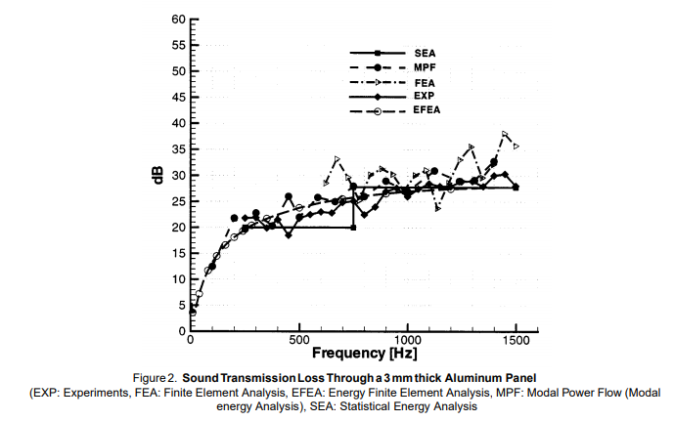
Figure 1 - A graph of results from Gur's report (Gur, Wagner, & Morman, 1999)
In terms of actual applications for real companies, this allows for car manufacturers, for whom noise, vibration and harshness are a large consideration, to predict how vibrations may propagate within the interior of a vehicle and thus take steps to reduce the effect of these before the vehicle reaches the prototyping stage. This again loops back into the point brought up by (Manor Tool & manunfacturing company, 2020), in that this process reduces the amount of physical prototyping required, thus reducing costs, meaning more money can be spent elsewhere in the development of a vehicle.
Another form of Finite element analysis is the field of computational fluid dynamics. What this does is study the flow of fluid, usually air, through a given domain. Within motorsports, this is used to help optimise the shape of a racing vehicle to both reduce drag and, where possible, increase the overall efficiency of a given design. An example of this is (Fuller, 2012)’s report into the effectiveness of swan-neck rear wing mounts for the 2009 LMP1 regulations used this to illustrate the changes caused by changing from a more conventional wing mounting mechanism to the newer swan-mount mechanism. The result was an increase in downforce of 280 lbs for the swan neck configuration over the more traditional wing mounting method, caused by a reduction in flow separation on the underside of the rear wing that would have been caused by the rear wing supports had they been mounted to the underside of the rear wing.
CFD is also a very powerful tool in the aerodynamicist’s toolbox because it allows for testing to be carried out on a number of test schemes without the use of a physical model in a wind tunnel. This reduces the cost required to both produce wind tunnel models, which can cost a large amount of money to produce, as well as the physical costs of running a wind tunnel, even when running scale models.

How a physical test may be correlated to an FE model.
In order to validate the results of a physical test, a finite element simulation may be employed. The way this is done may be to recreate the physical test’s conditions within a finite element software package. In this section, the use of a wind tunnel and a corresponding Computational Fluid Dynamics study will be discussed as well as the use of finite element analysis in other fields.
Computational Fluid Dynamics may be used in conjunction with a wind tunnel test not only to check the results, but also to better visualise any flow regimes that may have been picked up within a wind tunnel testing environment.
The first way to make a wind tunnel study correlate to a CFD study would be to closely mimic the conditions within the wind tunnel within the CFD software. This means that the domain of the CFD study needs to be sized appropriately to match the cross-sectional area of the wind tunnel. While this means that often the object being studied is larger than the 1-1.5% of the total cross-sectional area stated in (Lanfrit, 2005)’s report, that same report states that the 1-1.5% figure is not applicable when modelling the domain size of a real wind tunnel. This also means that the boundary conditions need to match that of the actual wind tunnel being tested, for example all the outer edges that aren’t being used as inlets or outlets would need to be set as walls within the CFD solver.
While on the topic of matching the conditions within the wind tunnel, it is imperative that the wind speeds within the wind tunnel and the CFD software match for correlation purposes. This is achieved by setting the wind speed to be as close as possible to the speed achieved in the wind tunnel.
Another thing to mention when talking about CFD correlation is the mesh settings. While a coarse mesh may solve quickly, a fine mesh of the domain will be much more accurate at the cost of increased solve time within the CFD package. The User should be able to determine which degree of resolution should be used to best suit the simulation.
In terms of getting correlation of results between a CFD study and a wind tunnel, there are a couple of ways to do this. One way is to physically calculate the forces produced by both methods of testing, which is good in automotive applications as it allows for a clear calculation of the lift and drag forces produced in the tests. What this doesn’t allow is for accurate visualisation of the flow structures, which can be done using a multitude of methods. Figure 2 shows a visualisation of flow structures for both a wind tunnel test and a CFD study.
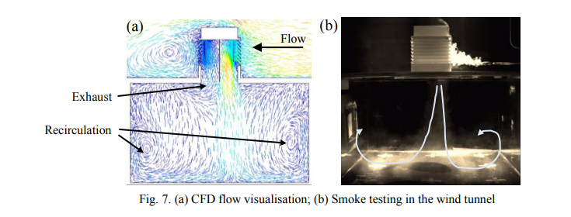
Figure 2 - Flow visualisation for the two different experiments tested. (Calautit, 2015)
Figure 2 shows the flow within a wind tower with Heat Transfer Devices inside and the recirculation of the air on the underside of it. From the annotations from (Calautit, 2015)’s report, it is made clear how the airflow circulates within the two testing methodologies. Judging by the fact that the two testing methodologies share common flow structures, which means the two testing methodologies have good correlation, showing that in this instance, a physical model is less likely to be needed.

Advantages and disadvantages of both Finite Element Analysis and physical testing
As a means of comparing FEA and physical testing, the disadvantages and advantages of both FEA and physical testing need to be discussed. While the advantages were discussed in the first section, for balance, the disadvantages need to be discussed as well as the advantages and disadvantages of using physical testing.
While Finite Element Analysis has its advantages, it also has a fair number of disadvantages to consider. For one, FEA results are only as good as the initial setup put into the simulation, meaning if the data is inaccurate or any of the simulation parameters such as mesh are wrong, this can lead to results that are wildly different from the actual results from a physical test or any hand calculations. Another disadvantage is that the accuracy of the results from the FEA study is linked directly to the density of the mesh. This means that too dense a mesh will take longer to solve, but too coarse a mesh will solve quickly but be largely inaccurate. An unskilled FEA technician may not be able to correctly identify where to use the correct mesh density, leading to extended solve times and increased operating costs.
On the side of physical testing however, the main advantage is the ability of a physical prototype to produce repeatable results given the same constraints as the corresponding FEA study, as evidenced in (Calautit, 2015)’s report. On the downside, Physical prototypes take much longer to produce, and can cost a large amount more than the equivalent Computer-Aided Design model and may be destroyed when tested, leading to more expense to produce another model. Another disadvantage that physical prototypes have is that if any physical changes need to be made to the model, a new version of either the whole prototype or a part of the prototype needs to be produced at cost to the manufacturing company, which takes much longer than the changes that would be required to amend a Computer-aided model.

Should FEA replace Physical testing?
Given the research conducted in this paper, while FEA is a potent tool in the engineer’s toolbox, it should not fully replace any physical testing that may need to be carried out during the development of a product. The reasoning for this is that all FEA results need to be correlated to either physical testing or hand calculations in order to be considered accurate within the development of a product. This means that at least some physical testing will need to be carried out at some stage of a product’s development cycle. What FEA can be used for however is to develop the concept of a product to be somewhere close to the final result before using a series of tests on a prototype to ensure their accuracy. An example of this is the report by (Nastov & Caples, 2019) detailing the aerodynamic development of the C7 generation Corvette ZR1. In this report, a wind tunnel model was used to test the extra aerodynamic additions to the car for this performance model, with a CFD test used to validate the flow structures on the underside of the front splitter, with the pressure loads used to feed into an FEA stress analysis to predict the stress and deformation on this structure, meaning that this modern approach with combining the Finite Element Methods with physical testing is a very good way to move forward when developing any product within the engineering space.

Conclusion
This report provides an overview of why an engineering company may decide to employ Finite Element Analysis within the development of a product. The relative advantages and disadvantages of using both Finite Element studies and physical testing using a prototype for testing have been discussed as well as how a company may correlate its results from an FEA study to a physical test using a CFD study and a physical wind tunnel test as an example.

Works Cited
Autodesk Inc. (2020). FINITE ELEMENT ANALYSIS. Retrieved from Autodesk: https://www.autodesk.co.uk/solutions/finite-element-analysis
Bathe, K.-J. (2014). An Introduction to the use of finite element procedures. In K.-J. Bathe, Finite Element Procedures (pp. 1-3). Watertown, MA: Massachussets Institute of Technology.
Calautit, J. K. (2015). CFD and Wind Tunnel Study of the performance of a Multi-Directional Wind Tower with Heat Transfer Devices. Sheffield: Elsevier Ltd. Retrieved from https://core.ac.uk/download/pdf/81930792.pdf
Caliber Design. (2015). Why Use FEA? - An introduction to finite element analysis. Retrieved from http://www.caliberdesign.co.nz/: https://www.caliberdesign.co.nz/wp-content/uploads/2015/05/Caliber-Design-HowToGuide-Intro-to-FEA.pdf
Fuller, M. J. (2012, January). The Rise of the Swan Neck. Racecar engineering.
Gur, Y., Wagner, D. A., & Morman, K. N. (1999). Energy Finite Element Analysis Methods for Mid-Frequency NVH Applications. Traverse City, Michigan: SAE International. Retrieved from https://saemobilus-sae-org.ezproxy.uwtsd.ac.uk/content/1999-01-1801/
Lanfrit, M. (2005). Best practise guidelines for handling Automotive External Aerodynamics with FLUENT. Darmstadt: Fluent Deutschland GmbH. Retrieved from https://www.southampton.ac.uk/~nwb/lectures/GoodPracticeCFD/Articles/Ext_Aero_Best_Practice_Ver1_2.pdf
Manor Tool & manunfacturing company. (2020). The Benefits of Finite Element Analysis in Manufacturing. Retrieved from Manor Tool: https://www.manortool.com/finite-element-analysis
Nastov, A., & Caples, D. (2019). Aerodynamic Development of the 2019 Chevrolet Corvette C7 ZR1. SAE International.

