it
Nazreen Akhtar (2128933)
Dale Clarke

Digital Skills and Research Methods
Research Report
(LCHS4002_BIRM)

Contents Page

Digital Skills and Research Methods 3
Research Report 3
Introduction 3
Research Design 3
Research Question: 3
Methods: 3
Ethical Conditions: 4
Results 5
Questionnaire Responses: 5
Discussion 7
Results: 7
Literature: 7
Hypothesis: 7
Conclusion 8
Reference List 8
10
Appendix 10

Digital Skills and Research Methods - Component 2

Research Report

Introduction

This report will examine which digitals tools is most used by students at UWTSD to collaborate. The report will contain the context of the chosen question, the type of methods used, and ethical considerations made.
All Programs, websites, and other online resources are examples of digital tools that can simplify jobs. You can access many of these both at home and at work because they can be accessible in web browsers without having to be downloaded. The importance of these tools is that processes can be improved in many ways using digital tools, including consistency, security, efficiency, and effectiveness. Digital tools also have the importance of being able to communicate with others, view each other’s work, and gain knowledge whilst studying together. The tools give access to students that need online lessons which develops there education further. The benefits on having digital tools available for students is that its quick and straightforward way to be educated as it develops students’ independence as they can research and gain knowledge independently and without assistance. The researcher that I have conducted is Emily R. Lia she has written a research report regarding collaboration. And its effects on students.

Research Design

Research Question:

Which digital tool is most used by students at UWTSD to collaborate?
The chosen research question informed the distinct types of digital tools used by the students at the university of Wales saint trinity David to communicate with one another. By having access to this information which digital tool is the most efficient for all students. The question gave an idea which digital tool is the most popular but also the easiest to use and gather more information which is suitable for students, in particularly the best tool that can replace the need of physical assistance.

Methods:

The type of method we decided to use to conduct our research regarding the chosen question was a Questionnaire. A questionnaire is a research tool that consists of a series of questions or other prompts intended to gather data from respondents. We recruited the data using quantitative and quantitative research. Depending on the type of questions, questionnaires can be categorised as either quantitative or qualitative methods. In the questionnaire we asked multiple questions regarding digital tools.
The questionnaire form was created on Microsoft Forms, the questionnaires were sent to students in the university online via email and were also handed out in person. Eighteen students answered the questionnaire, specifically, twelve people answered online, and six questionnaires were handed out in personal.

- How confident are you using Digital Tool?

- Confident
- Neutral
- Extremely not confident
This question was the first question on the questionnaire, it is a multiple-choice question with four different answers. The question suggests how confident the student is with using Digital tools, confidence can show how much they can rely on the tools. This question can also provide the information of how much they use digital tools and implies their feelings towards using them.
- How do you find using Digital Tools at UWTSD?

- Easy
- Hard
- Complicated
This question was the second question on the questionnaire, it was also a multiple-choice question, with three answers. This was specifically aimed at the students at UWTSD which was linked to the chosen question. The question will allow us to know how many people are comfortable with using digital tools.
4. Which digital app do you use mostly at UWTSD?
This question was the fourth question on the questionnaire, this question was provided with a text box to type out your personal answer. This question was directed to the chosen question. Giving them the opportunity to give any answer of their choice improves the accuracy of data.
9. Rate Digital tools at UWTSD?
This question was the nineth question on the questionnaire, this was a five-star ranting type of question which the individual had to rate their answer out of five. To gather comparative data regarding a particular research topic, a rating scale is a popular tool for data gathering. A rating scale is a multiple-choice question that enables survey participants to rate the tool. This can show us how they value tools at UWTSD.

Ethical Conditions:

A set of rules that direct your study designs and procedures are known as ethical considerations in research. When gathering information from people, researchers are required to always abide by a set of ethical principles. The diverse types of Ethical Considerations our group applied were:
Accurate analysis and Reporting of Date: This standard focuses on data analysis and reporting. To create accurate, unbiased results and conclusions, it involves choosing and organising pertinent, legitimate, and reliable data for analysis.
Ensuring confidentiality of Data: One aspect of information security and privacy is data confidentiality. A system or network must limit unauthorised users' access to sensitive data while permitting authorised users to do so to guarantee data confidentiality.

Results

Age | Men | Women | Total
Below 18 | 0 | 0 | 0
19 - 25 | 2 | 4 | 6
26 - 35 | 3 | 3 | 7
36 - 45 | 0 | 5 | 5
46 + | 0 | 1 | 1
Total | 5 | 13 | 18

Questionnaire Responses:

- How confident are you using Digital Tool?

The result for question implied that majority of the responses said they were confident in using Digital tools (70%). This suggest that most people find using digital tools are usable for students at UWTSD. 5/18 people who answered the questionnaire selected the neural choice and finally one answered extremely not confident. This is good as not many people struggle with using digital tools.

2. How do you find using Digital Tools at UWTSD?
For this question 80% of people answered easy this shows that more people find using digital tools simple and unchallenging. Ten people find using Digital tools at UWTSD hard this can show us there is some people that still need some practise and getting used to using tools. Finally, only ten people found using digital tools at UWTSD complicated this suggest that they will need more support and need more time and practise.

4. Which digital app do you use mostly at UWTSD?

This question can require any answer as there was a text box available, the results show that the UWTSD app was the most used digital tool app at UWTSD by having the result number of 8/10. This suggests the universities app is the most popular and can be known as the most efficient for the students to get access to.

. 9. Rate Digital tools at UWTSD?
This question resulted to all the respondents being five stars. This was incredibly positive feedback as it suggests that the digital tools at UWTSD are up to the student’s standards and are of high quality and suitable for connecting with one another. This allows students education experiences being at a better level. This result was the best ranking we could have received from the students.

Discussion

Results:

The results of our questionnaire did not have all respondents answer all questions this effected our totals for each question as we did not have everyone’s opinion in certain questions that could affect the final assumption. However, this can affect the results in a positive way as it may increase the percentage of a more beneficial answer.
The most surprising result received from the questionnaire was question 5 “Do you feel anxious using HWB app?” This suggests that 7/18 are either fully anxious or anxious suing the HWB app this was surprising as all the respondents rated the app 5 stars, due to this the result of people being anxious does not really match up.
In the questionnaire eighteen people took part specifically, twelve people answered online, and six questionnaires were handed out in personal. An advantage of an online survey is that respondents can select the time and location in which they complete it. Increased response rates can be achieved by giving respondents extra time to complete your survey and even the option to start it and finish it later. However, we decided to hand some out in person as this provides a definite response as they complete the questionnaire in front of you as an online questionnaire can be left in their emails or some students may not be confident with technology and may not be able to complete the questionnaire. All respondents were students this helps us as the chosen question to our research is aimed at students, this increases the accuracy and relations for our research.

Literature:

The researcher Emily R. Lia review on collaboration agrees with the results I received from the questionnaire as it shows how computer and online collaboration is very effective among students and the success of using online tools is very high. This relates to our results as they show that students find the hwb the most effective digital tool, which is an online tool. However, there is a slight contrast between the different results as it also suggests that online tools can reduce the number of face-to-face discussions this isn’t as compatible with the results we gathered as digital tools is an effective way to complete students’ fact to face discussions is there is a online lessons available that involve face interactions hat students use such as Microsoft teams.

Hypothesis:

The hypothesis that was made before going ahead with our research was that the UWTSD Hwb app was the most used digital tool for the students at UWTSD. In the questionnaire the UWTSD app was the most used app and highest rated digital tool from all students that answered the questionnaire, this suggests we were able to correctly predict the outcome of our research. The prediction was correct as all the students at UWTSD need the hwb to find out information about the university and collaborate with their peers and tutors as well as completing their work. The results in overall were not a surprise to us in the end as the questions were aimed at the students that took the questionnaire meaning we already had an idea on how they were going to respond as we are also students suggesting we have similar knowledge about what digital tools are suitable for us at UWTSD,

Conclusion

In conclusion, the discussion and proved that the most used digital tool at UWTSD is the UWTSD hwb app which follows our hypothesis made at the beginning of our research. By using a questionnaire, we were able to gather participants in our research which allowed us to conclude to our chosen question. The question that surprised us was the question regarding feeling anxious which was aimed towards the hwb app this result does not have a written solution however can be solved from continuously using the app by giving it time the students will be able to confidently use the digital tool. Our research gave us the knowledge on what to improve on the app, having more training course provided for students that aren’t confident enough with technology, this may increase the amount of people using this digital tools. This is evident in the results of the questionnaire as 50% of the people who answered the question “Do you think UWTSD needs more suitable trainees to deliver the best training to use the technology?” answered yes.

Reference List
- 2022. Digital Passport. Available at: <https://engage.dhsc.gov.uk/digitalpassport/tools/#:~:text=Digital%20tools%20are%20programs%2C%20websites%20or%20online%20resources,%E2%80%93%20see%20the%20Security%20module%20for%20more%20info.> [Accessed 1 August 2022]
- The Communications Network. 2022. The Value of (Digital) Tools. Available at: <https://www.comnetwork.org/insights/the-value-of-digital-tools/> [Accessed 2 August 2022]
- Insights, W., 2022. Top 5 Reasons to Use Digital Tools for Key Campus Processes. Watermarkinsights.com. Available at: <https://www.watermarkinsights.com/resources/blog/top-5-reasons-to-use-digital-tools-for-key-campus-processes> [Accessed 2 August 2022]
- Arya. 2022. ethical conditions – Arya. Available at: <https://arya0119.wordpress.com/tag/ethical-conditions/#:~:text=Ethical%20Conditions%20in%20Conditioning%20Human%20Behaviour%3A%20This%20type,that%20fear%20could%20be%20acquired%20through%20classical%20conditioning.> [Accessed 3 August 2022]
- Bhandari, P., 2022. Ethical Considerations in Research | Types & Examples. [online] Scribbr. Available at: <https://www.scribbr.com/methodology/research-ethics/> [Accessed 3 August 2022]
- Secoda.co. 2022. Data confidentiality is a set of rules or a promise that limits access or places restrictions on any information that is being shared. Data confidentiality is a component of information security and privacy. Available at: <https://www.secoda.co/glossary/data-confidentiality#:~:text=Data%20confidentiality%20is%20a%20component%20of%20information%20security,data%20while%20allowing%20authorized%20users%20to%20do%20so.> [Accessed 4 August 2022]
- Sqa.org.uk. 2022. Available at: <https://www.sqa.org.uk/files/aq/FE0H04.pdf#:~:text=Analyse%20and%20report%20data%20Overview%20This%20standard%20is,report%20on%20data%20as%20part%20of%20their%20role.> [Accessed 4 August 2022]
- Images.pearsonassessments.com. 2022. Available at: <http://images.pearsonassessments.com/images/tmrs/Collaboration-Review.pdf> [Accessed 4 August 2022].
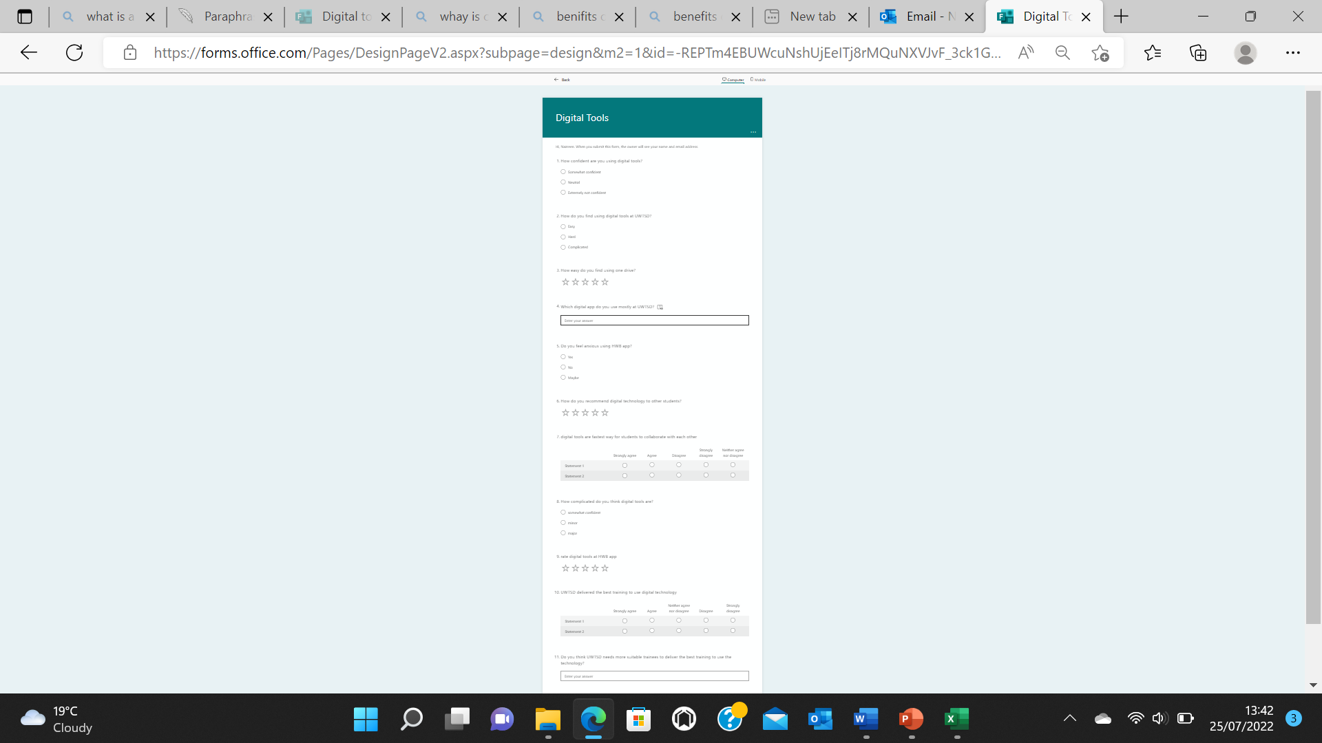

Appendix

Digital Tools (office.com)

