Programme: BA Business Management
Module: Entrepreneurship
Module code: LCBB5001
Assignment Title: Assessment 1

Konstantina Malamova
Student ID 2020492

Table of Contents
1.0 Introduction 3
2.0 Task 1: Essay 3
2.1 4Ps of marketing 3
2.1.1 Product/services 3
2.1.2 Place 4
2.1.3 Price 4
2.1.4 Promotion 4
2.2 Feasibility analysis 4
2.2.1 Product/service feasibility 4
2.2.2 Target Market feasibility 4
2.2.3 Organisational feasibility 5
2.2.4 Financial feasibility 5
2.3 Market research 5
Part 2: Reflection 7
Description 7
Feeling 7
Evaluation 8
Analysis 8
Conclusion 9
Action plan 9
Conclusion 9
References 10
Appendices 11

1.0 Introduction
The essay portrays the idea of entrepreneurship along with proper justification regarding its benefits and values in serving the community and the people present in it. The plan for entrepreneurship mainly accentuates the creation of cosmetics through wasted coffee bean paste. This could be fulfilled through the generation of a new startup defining the development of cosmetics and naming it Caffeination.

2.0 Task 1: Essay

2.1 4Ps of marketing

2.1.1 Product/services
Caffeination is the rising company that is going to utilise the coffee ground waste and convert it to skincare and hair care products that could be beneficial for the customers in managing their skin care and hair care routines on a daily basis. Since the coffee ground waste is going to be filtered and would be going through several processes for transforming it into authentic skin and hair care products in the most sustainable manner. The customers can search for information regarding the same and can make purchase decisions as the alternatives of these sustainable skin and hair care products have been low. The customers can evaluate their purchase decision after the use of their authentic skincare and haircare products. Nowadays, customers are always opting for sustainable or vegan products that mainly sustain a positive impact on the environment (Leow et al., 2021). The issues of lack of coffee bean waste management could create problems for the people, broader community and the world through its negative impact on the environment. Thus, environment-conscious people (mainly female) of all ages (especially young and professional ladies) will be the main customers of Caffeination products. Through the product life cycle analysis taught in the class, the products are at the introduction stages while the growth of awareness regarding the same can increase the product to the growth stage (Moon et al., 2019). With the rise of demand among the people, the interest of other companies will increase and they will be selling identical products which can reduce the number of new customers and the loyal customers will stay with the company at maturity. At last, the business will decline after a certain time.

2.1.2 Place
The place for selling authentic hair and skin care products through sustainable use of coffee ground waste by Caffeination will be online stores across the UK and physical stores across the metropolitan areas of London, Manchester, and others.

2.1.3 Price
As the products of Caffeination will be developed through the use of coffee ground waste through sustainable processes, the price will be a little higher than the identical products in the market. A balanced approach toward pricing will be taken where the customers can understand the value of the products (Phornlaphatrachakorn et al., 2020). Dynamic pricing will apply for the purchase of a bundle of products at a time. The products generally will range from GBP 6.50 to 55 based on the size of the products.

2.1.4 Promotion
Communication with the customers can be done through the message of sustainability. For the same, the use of social media, YouTube, and others can be done to attract customers. The use of paid promotion through social media influencers, online advertising on other websites and flyers will be done where development of the Caffeination website will also be done for the personalised experience of the customers.

2.2 Feasibility analysis

2.2.1 Product/service feasibility
The products of Caffeination are developed from the sustainable use of coffee ground extracts and are sustainable. The value of the Caffeine beauty products market across the world was valued at around $590.1mn in 2018 and the estimated CAGR of the same has been 5.1% till 2025. The sales of cosmetics products within the UK saw a boom in 2017 which has continued and it indicates the desirability and demand of the product.

2.2.2 Target Market feasibility
Industry rivalry: the industry rivalry has been high and concentrated among some established brands like L'Oréal Paris, The Body Shop, and others.
The threat of substitutes: the threat of substitute products has been high in the UK market.
Suppliers’ power: The power of suppliers has been medium to high as the reputed brands purchase most of the raw materials.
Buyers’ power: the power of buyers within the UK cosmetics industry has been high as the customers can buy identical products from others. Still, the same has been low to medium as the people mainly purchase from reputed brands irrespective of alternatives and cheap price
s.
The threat of new entrants: the threat of new entrants is medium to high as the industry is attractive.
Besides, the UK cosmetics market has been valued at US$17.32bn in 2022 which can increase by 4.07% CAGR till 2025. The largest segment of the market has been personal care which demonstrates the attractiveness of the target market of the UK (Statista, 2022).

2.2.3 Organisational feasibility
The organisation Caffeination has been new within the market and has not been tested. Still, the management of Caffeination has targeted the right customer profile where the opportunities are untapped. Firstly, the sustainable use of coffee grounds has been comparatively new in the market. Secondly, the customers are becoming increasingly aware of the environmental issues. Thus, solving the same through sustainable material use can increase the feasibility of the organisation.

2.2.4 Financial feasibility
The cosmetic formulations within the UK are valued from $0.10/pound to $3/pound while the average is around $1/pound. With an estimate of production of around 5000 pounds, the start-up cash needs are around $7500 which will include packaging, wages, and others. While the financial feasibility of the industry is concerned, L'Oréal generated €9.3Bn sales which has been a 16% growth compared to the earlier year (Loreal, 2021). Besides, online sales have increased by 25.7% in 2021 which indicates the chances of profitability for Caffeination.

2.3 Market research
As the product portfolio of different brands like L'Oréal and others are based on chemicals and chemical compounds, Caffeine products can increase the market share. As the primary survey in the present study indicates, the customers are aware of the benefits and disadvantages of using caffeine products and are willing to use their products as they think of environmental sustainability and there has been a growing awareness regarding the use of sustainable products.

Part 2: Reflection

Description
From the statement of McNutt and He (2019), coffee grounds are known to be the by-products that are mainly extracted from the process of brewing. Its structure of it is defined to be like beans, needles or small grains. Similarly, Leow et al. (2021), commented that if coffee waste is not manifested properly, then it is going to create massive environmental problems. It could mainly cause water pollution because of poor coffee waste management problems and the emission of toxic gases like methane. This gas is released when the coffee wastes are dumped in landfills. Therefore, the coffee bean or ground waste is needed to make it more sustainable for the management of the crops and proper optimisation of the use of water. It could be used as fertiliser for crops and also for skin care solutions (Leow et al., 2021). The transformation of the coffee ground waste into skin care products especially for the skin and hair is very much beneficial. This reason led to the creation and rise of Caffeination. Thus, from the participation in the module, I can understand that my entrepreneurial skills and knowledge of me can help to create the business idea of sustainable coffee ground use in the development of authentic hair and skin care products which can solve the problems of customers.

Feeling
From the understanding of the entrepreneurial skills within the class, I can feel that a successful entrepreneurial venture has been successful when the entrepreneur is able to think about the needs of the customers critically and the same can increase the customer purchase. From the understanding of the business idea I presented above, I consider myself as successful and think critically about the need for sustainable products among the customers for hair and skincare. Thus, the problem of the customers can be solved through the development of caffeine hair and skin care products which can rejuvenate people and that too by looking at the sustainability concern of the environment. Besides, I also consider myself successful to use the business mind and analytics to analyse the cosmetics industry which enabled me to identify the market gap and the opportunities to develop new products and be successful in the same. Further, I feel that the development of communication and active listening skills taught in the class can help me to communicate with others to envision the business idea and to make the same success in implementation.

Evaluation
From the understanding and learning throughout the present course, I can evaluate that I have tried to apply all the entrepreneurial skills in the present assignment in section 1. As stated in the earlier section, I have applied critical thinking skills and problem-solving skills while considering a new entrepreneurship venture has been done (Adeani et al., 2020). As an instance, I have described in section 1 that the present portfolio of reputed brands like The Body Shop, Loreal, and others has been based on the chemicals and chemical compounds like Polyethylene Glycols, Sulphates, paraben, and others which can actually damage the skin and hair (Draelos, 2012). On the contrary, there has been the use of organic chemicals like neem & tulsi extracts which can help the skin. In recent times, the use of coffee, tea, lemon, and other extracts is done in the cosmetics industry where the use of Caffeine as an active ingredient can cause success in the products of Caffeination. On the contrary, I can evaluate that I have to develop communication skills to describe the idea clearly.

Analysis
For the improvement of my communication skills, I would like to follow the 7Cs model where I would aim to improve my clarity and conciseness to describe a business idea with like-minded people. Besides, I would like to develop concreteness to describe the reasons behind the choice of the business. The same can help me to increase the strengths of my entrepreneurial skills where the verbal and non-verbal skills can describe my confidence in me to start the venture (Yaacob et al., 2021). Besides, to minimise the threats to the success of this entrepreneurial venture, I would like to develop contingency leadership which helps me act accordingly in different situations. I personally analyse from the development of section 1 that I have creativity, problem-solving, and business analytics skill to some extent which helped me to develop an innovative and sustainable business idea.

Conclusion
As a reflection on my personal development affiliations, my entrepreneurial skills mainly encompassed active listening and communication, customer servicing, critical thinking with networking skills and problem-solving. The idea of Caffeination is associated with solving the problem of sustainability and enhancing a cleaner environment that is going to let the communities grow. Secondly, through my uncountable evaluation of different journals and news articles, I have acknowledged the fact that coffee is the most appreciative element in the context of skin care solutions along with hair care. It exfoliates the skin and its antioxidants extract the dirt from the skin while coffee helps in faster hair growth, thus accentuating and fulfilling the needs of the customers.

Action plan
Development of objectives | Priorities | Activities to be taken | Control | Time-bound
Improving communication skills | High | Business communication courses | Review development through mock tests and simulation exercises with peers | 1 year
Time management | Medium | Following routine for each work | Completion of lessons and other activities within the time | 1 year

Conclusion
From the analysis, it is concluded that conversion of the coffee waste to skin and hair care solutions is very much suitable for making it more sustainable with the creation of the by-products. Caffeination utilises the waste coffee grounds to convert it into skin and hair care solutions accentuating the needs of the customers who prefer sustainable and vegan products.

References
Leow, Y., Yew, P.Y.M., Chee, P.L., Loh, X.J. and Kai, D. (2021). Recycling of spent coffee grounds for useful extracts and green composites. RSC Advances, [online] 11(5), pp.2682–2692. doi:10.1039/D0RA09379C.
McNutt, J. and He, Q. (Sophia) (2019). Spent coffee grounds: A review on current utilization. Journal of Industrial and Engineering Chemistry, [online] 71, pp.78–88. doi:10.1016/j.jiec.2018.11.054.
Diet, Skin Aging, and Glycation. Z Draelos. Cosmetic Dermatology, 2012, VOL. 25 NO. 5
Moon, H.S., Ryu, Y.U. and Kim, J.K., 2019. Enhanced collaborative filtering: A product life cycle approach. Journal of Electronic Commerce Research, 20(3), pp.155-168.
Phornlaphatrachakorn, K., Ngamsutti, S. and Ketchompu, D., 2020. Strategic pricing and firm performance: Evidence from cosmetics SMEs in Thailand. KKBS Journal of Business Administration and Accountancy, 4(2), pp.1-20.
Statista, 2022. Beauty & Personal Care - United Kingdom | Statista Market Forecast. [online] Statista. Available at: <https://www.statista.com/outlook/cmo/beauty-personal-care/united-kingdom> [Accessed 17 July 2022].
Loreal, 2021. Loreal 2021 ANNUAL REPORT – THE ESSENTIALS. [online] Loreal-finance.com. Available at: <https://www.loreal-finance.com/system/files/2022-03/LOREAL_2021_Annual_Report_0.pdf> [Accessed 17 July 2022].
Adeani, I.S., Febriani, R.B. and Syafryadin, S., 2020. USING GIBBS’REFLECTIVE CYCLE IN MAKING REFLECTIONS OF LITERARY ANALYSIS. Indonesian EFL Journal, 6(2), pp.139-148. Doi: 10.25134/ieflj.v6i2.3382.
Yaacob, A., Mohd Asraf, R., Hussain, R.M.R. and Ismail, S.N., 2021. Empowering Learners' Reflective Thinking through Collaborative Reflective Learning. International Journal of Instruction, 14(1), pp.709-726. Doi: https://doi.org/10.29333/iji.2021.14143a

Appendices
Appendix 1: Primary survey regarding Caffeine beauty products use
- Do you use caffeine hair and skincare products?
Yes | No
18 | 13
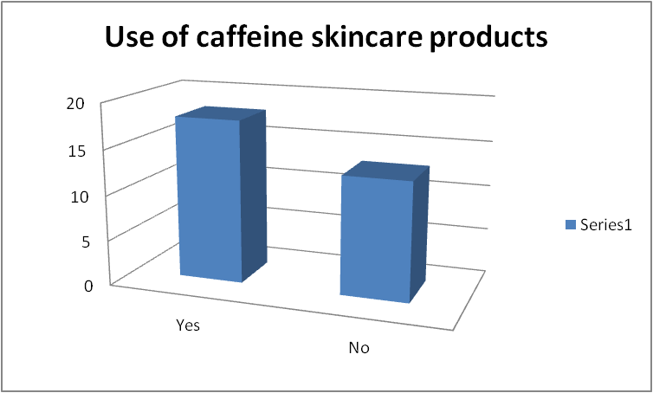
- Are you aware of the benefits/ negative effects of caffeine beauty products?
Yes | No
17 | 14
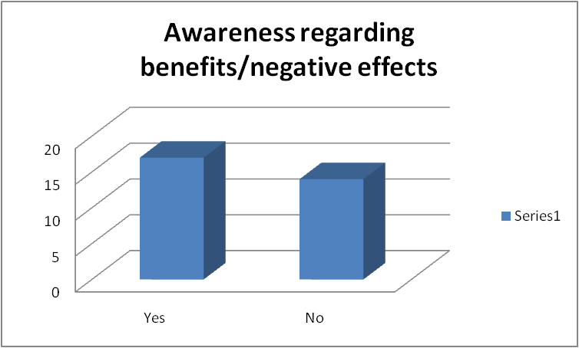
- Why do I use caffeine products? Are there any benefits?
Rich antioxidants | Brighten and energise skin | Fighting free radicals
12 | 10 | 9
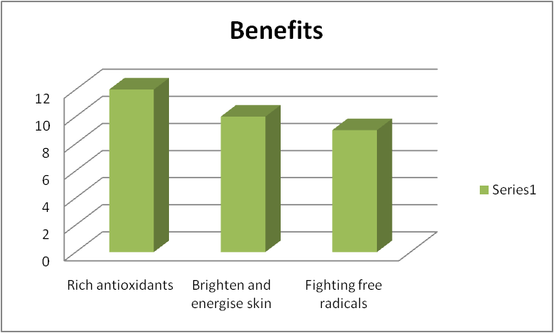
- What are the side effects of caffeine beauty products? Are you aware?
Dehydrating | Potential chances of acne | Harshness
16 | 8 | 7
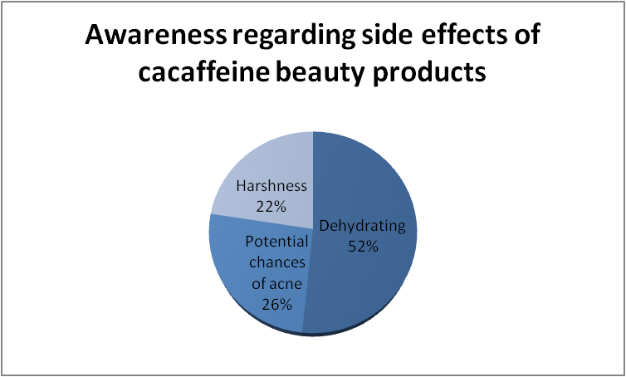
- Considering potential benefits/disadvantages, will you use caffeine beauty products?
Yes | No
19 | 12
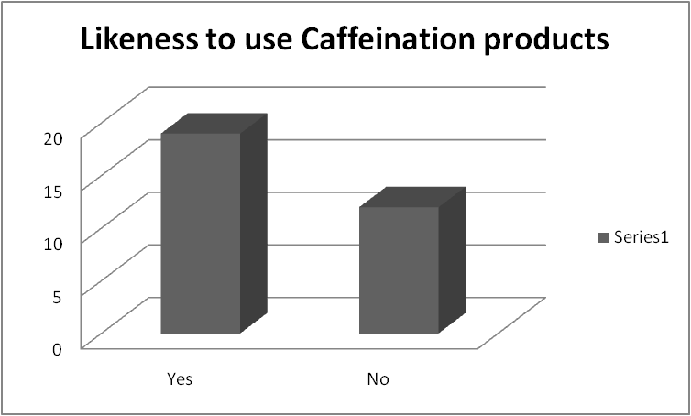
- Caffeination products are sustainable which minimise the environmental damage from coffee farming. Will you like to use our products, and why?
Yes, as it can restrict environmental damage | Yes, because it is sustainable | Yes, it is authentic | No, it is priced higher | No, caffeine products can damage my skin
7 | 6 | 8 | 7 | 3


