

Module Name: Problem Solving and Innovation

Title: Whitewashing in ‘Big Tech’a Root Cause Analysis (RCA)

Student Name: Ivelina Spirova

Student number: 2507826

AI Acknowledgement
I acknowledge the use of AI for the UWTSD library reasearch assistant for research purposes using the prompts:
- AI Washing (see appendix 3)
I acknowledge the use of ChatGPT for creative purposes using the prompt:
- Create me a Fishbone diagram worksheet (see appendix 1)
I acknowledge the use of Gemini for creative purposes using the prompt:
- Create me a Fishbone diagram worksheet (See appendix 2)
I confirm I have not presented any AI generated work as my own. I can confirm I have copies of my drafts I used before and after the use of AI which I may be asked to provide as evidence.

Speaker Notes
Slide 1: Title slide
- Discuss what AI washing is and the root cause analysis
- Identify why it happens
- The use of fishbone diagram and five whys method to find the cause
Slide 2: What is AI washing?
- Companies exaggerate their use of AI (BBC News, 2024)
- Misleads consumers and investors by creating unrealistic expectations
- If continuous might be investigated
Slide 3: Fishbone diagram
- Consumers see it as modern and intelligent
- Investors believe it is innovative and future focused
- Lack of knowledge causes not knowing what is real and what not
- Competitive pressure because they want to have an advantage over each other
Slide 4: Five Whys Method
- Consumer demand whys- ai makes everything better, want of ai products, believe of ai knowing the best, not knowing how it works
- Investor pressure- attracts more customers, believe of its strong future, ai companies receive more attention, believer of higher profits, make more money from investments
- Lack of knowledge- cannot tell difference between real or not, not understanding ai, not thought widely, develops rapidly, requires technology knowledge
- Competitive pressure- always competing with others, seen as innovative, want for modern products, attracting customers to increase sales
Slide 5: Research
- Companies blame ai for cutting jobs while it is because of business reasons (Berger, 2026)
- Trying to decrease the overhiring from the pandemic (Westerholm, 2026)
- Use of ai might need backing up (Sun et al, 2026)
- Microsoft cutbacks staffing because of focus in ai development (Clea Skopeliti, 2026)
Slide 6: Future hypothesis and recommendations
- Will continue to reduce public trust
- Misleading products could continue attracting customers
- Investors making decisions on false ai claims
- Increased regulation will help false marketing
- Education will help people understand AI
- Stronger ai regulations will keep consumers and investors protected
- Greater transparency will help provide evidence for use of ai
Slide 7: Conclusion
- Keeps becoming growing issue
- Education, transparency and regulation can help reduce it
- Honest marketing can help achieve trust in AI

Use of AI
For this assignment I have used ChatGPT and the Google Gemini AI. I have asked both to create me a Fishbone diagram to see how both would do it. ChatGPT diagram was not how I expected it as I thought it would be better looking than what it actually gave me (see appendix 1). I then went onto the Gemini AI tool and asked it to provide me with then same diagram, which was looking better than the previous one. The diagram Gemini made me was how I expected it look like as it was similar to the one we used in class (see appendix 2). I ended up not using both of them I just wanted to see two how two different AI softwares would work on the same thing asked to them. Doing this made me see how two different softwares could work entirely differently even though we think they do the exact same thing.
Another use of AI for this assignment I have done was for research. I used the universities online library ai tool to see how that would work as I have not used it before. The first thing that I did was go in the search bar and look up AI washing, it ended up giving me lots of articles books and all that about AI washing. Whereas when I tried to use the libraries ai feature it came back to me saying that it could not do it. This was not what I expected it to say as I hoped it would save me time from going over thousands of books (see appendix 3).

Presentation Slides
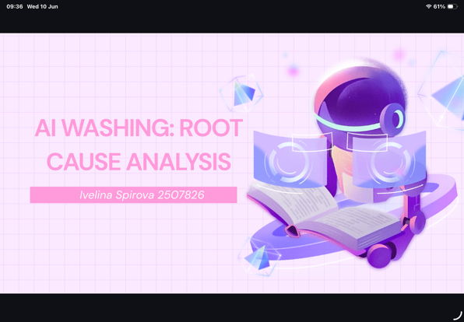
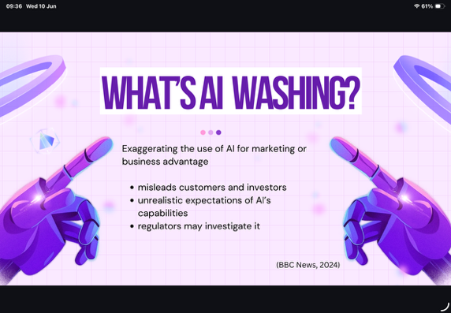

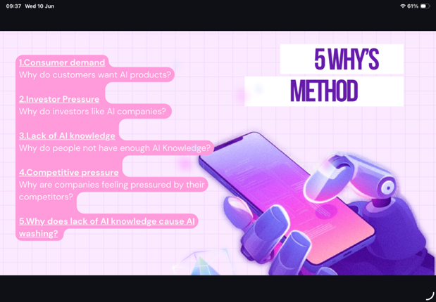
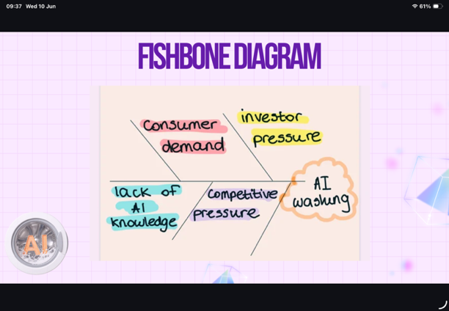

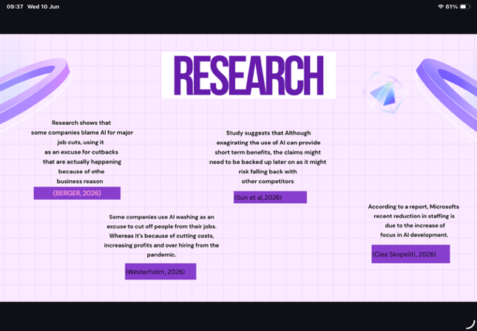
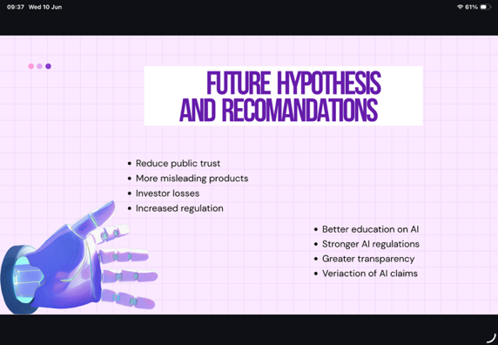

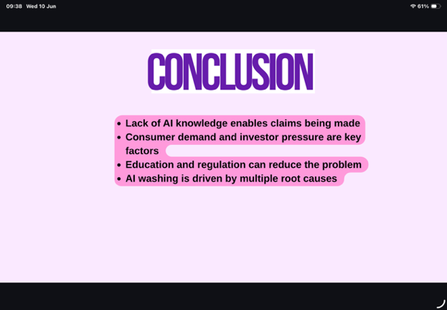

Reference list
BBC News. (2024). What is ‘AI washing’ and why is it a problem? Available at: https://www.bbc.co.uk/news/articles/c9xx8122893o
Berger, E. (2026). US companies accused of ‘AI washing’ in citing artificial intelligence for job losses. the Guardian. Available at: https://www.theguardian.com/us-news/2026/feb/08/ai-washing-job-losses-artificial-intelligence
Clea Skopeliti (2026). First Thing: Microsoft and Meta cut thousands of staff as they bet big on AI. the Guardian. Available at: https://www.theguardian.com/us-news/2026/apr/24/first-thing-microsoft-and-meta-cut-thousands-of-staff-as-they-bet-big-on-ai
Sun, Z., Wen, Y., Zhao, L., Intesar Almugren and Aradhana Galgotia (2026). Unveiling AI washing: Bridging corporate technological gaps through a cognitive dissonance lens. Technological Forecasting and Social Change, 225, pp.124511–124511. doi:https://doi.org/10.1016/j.techfore.2025.124511
Westerholm, T. (2026). MSN. Msn.com. Available at: https://www.msn.com/en-us/news/technology/what-is-ai-washing-new-theory-as-tech-industry-hits-scary-layoff-milestone/ar-AA20zat9

Appendices
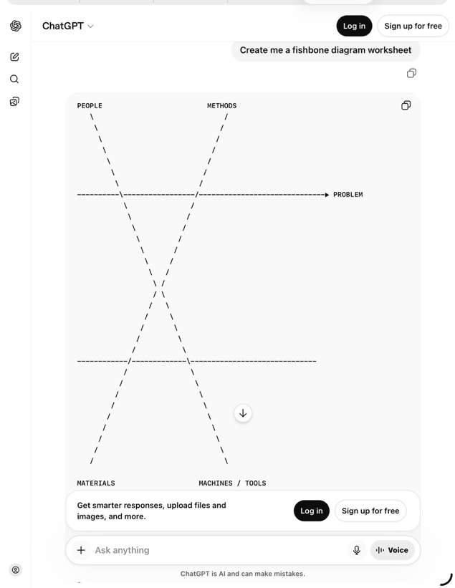
Appendix 1: ChatGPT Prompt

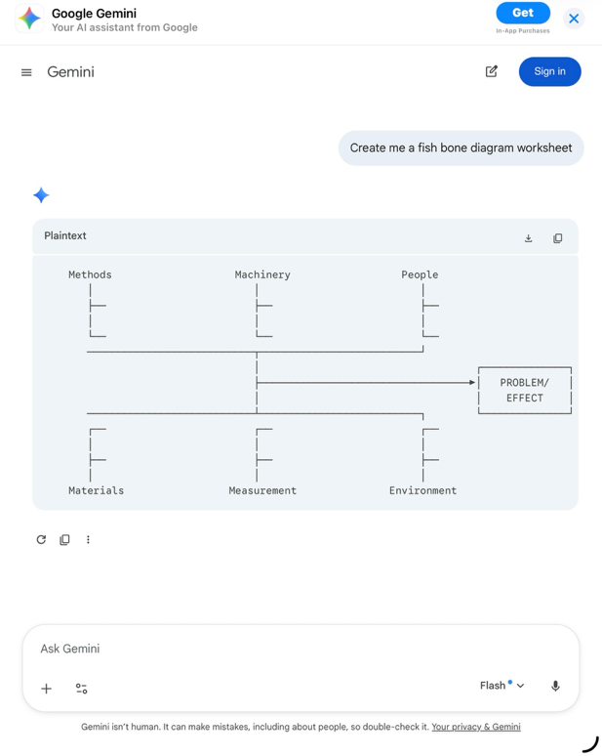

Appendix 2: Gemini Prompt

Appendix 3: UWTSD library ai assistant


